Exploratory Plots 20190113

Whitney Beck

January 13, 2019

## Data Prep from 1) Data Clean Script

## 1) script to clean and wrangle data  
library(tidyverse, verbose = F)

## Warning: package 'tidyverse' was built under R version 3.5.2

## -- Attaching packages --------------------------------------------------------------- tidyverse 1.2.1 --

## v ggplot2 3.0.0 v purrr 0.2.5  
## v tibble 1.4.2 v dplyr 0.7.6  
## v tidyr 0.8.1 v stringr 1.3.1  
## v readr 1.1.1 v forcats 0.3.0

## Warning: package 'ggplot2' was built under R version 3.5.1

## Warning: package 'dplyr' was built under R version 3.5.1

## -- Conflicts ------------------------------------------------------------------ tidyverse_conflicts() --  
## x dplyr::filter() masks stats::filter()  
## x dplyr::lag() masks stats::lag()

library(ggplot2)  
theme_mod <- function(){theme_bw() %+replace% theme(panel.grid = element_blank())}  
theme_set(theme_mod())   
  
## Data import  
Data_Beck=read.csv("raw-data/Beck Data/Beck Data.csv")  
Data_Elser=read.csv("raw-data/Elser-et-al-2007_Global-N-P-limitation/data/doi_10.5063_AA_nceasadmin.910.2-np-analysis-dataset-out-for-datasharing.csv")  
Data_Vanni=read.csv("raw-data/Vanni-et-al_2017_Animal-excretion/Aquatic_animal_excretion_data.csv")  
Data_Vanni$Temperature..C.=as.numeric(Data_Vanni$Temperature..C.)  
Data_Vanni$P.excretion.rate..ug.P.ind.h.=as.numeric(Data_Vanni$P.excretion.rate..ug.P.ind.h.)  
Data_Vanni$N.excretion.rate..ug.N.ind.h.=as.numeric(Data_Vanni$N.excretion.rate..ug.N.ind.h.)  
Data_Vanni$Excreted.N.P..molar.=as.numeric(Data_Vanni$Excreted.N.P..molar.)  
  
## Elser: set variables of interest  
var_names_Elser = c("id_study","system", "strata", "habitat", "cat", "tax_resp_class",  
 "l.n.c","l.p.c","l.int.c","temp","n_avail","n_total","p_avail",  
 "p_total", "light", "location", "latitud","longitud","elev","duration")  
  
#Filter to variables of interest that have temperature values in aquatic systems  
TempData_Elser <- Data_Elser %>%  
 select(var_names_Elser) %>%  
 filter(system %in% c("FRESHWATER", "MARINE")) %>%  
 filter(!is.na(temp))  
  
##Beck: set variables of interest  
var_names_Beck=c("Ref", "Site.Name", "Latitude_GoogleEarth", "Longitude_GoogleEarth", "Days", "Nitrogen.Molarity",  
 "Phosphorus.Molarity", "Elevation_m", "Depth_m", "Canopy_Percent", "Canopy_Qual", "Temp_C",  
 "NH4_ug_L", "NO3_ug_L", "DIN_ug_L", "TN_mg_L", "SRP_ug_L", "TP_ug_L", "NO3_SRP_Ratio",   
 "Control_mean_mg_m2", "Control.SE",   
 "N_mean_mg_m2", "N.SE", "N.LRR.Effect", "N.LRR.Variance",  
 "P_mean_mg_m2", "P.SE", "P.LRR.Effect", "P.LRR.Variance",  
 "NP_mean_mg_m2", "NP.SE", "NP.LRR", "NP.LRR.Variance")  
  
#Filter to variables of interest that have temperature values  
TempData_Beck <- Data_Beck %>%  
 select(var_names_Beck) %>%  
 filter(!is.na(Temp_C))  
  
##Vanni: set variables of interest  
  
#Many of these could be interesting to explore, and variable names are really strangely formatted  
#so I'm going to leave as-is for now  
  
TempData_Vanni <- Data_Vanni%>%  
 filter(!is.na(Temperature..C.))

## Elser Plots from 2) Exploratory script

#Temperature Range  
  
ggplot(TempData_Elser, aes(x = temp)) + geom_histogram(colour = 'black', fill = 'white')+  
 annotate('text', x = 1, y = 30,label = paste("n = ", nrow(subset(TempData_Elser, temp!="NA"))))+  
 ggtitle("Elser Temp")

## `stat_bin()` using `bins = 30`. Pick better value with `binwidth`.

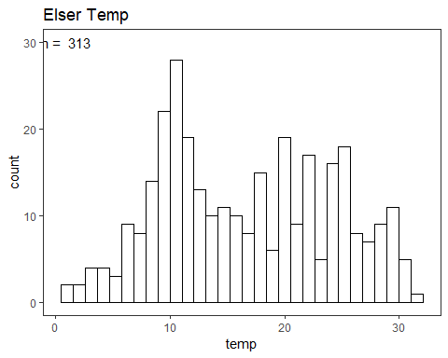

ggplot(TempData_Elser, aes(x = temp)) + geom_histogram(colour = 'black',fill = 'white') + facet_grid(cat ~ ., scales = 'free')+  
 ggtitle("Elser Temp by Ecosystem")

## `stat_bin()` using `bins = 30`. Pick better value with `binwidth`.

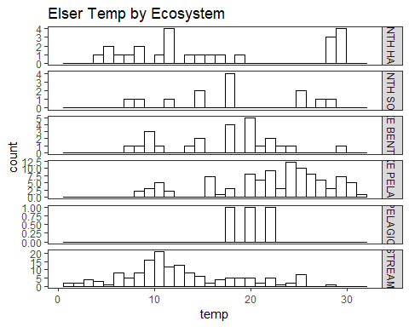

#Light Range  
  
ggplot(TempData_Elser, aes(x = light)) + geom_histogram(colour = 'black', fill = 'white')+  
 annotate('text', x = 1, y = 50,label = paste("n = ",nrow(subset(TempData_Elser, light!="NA"))))+  
 ggtitle("Elser Light")

## `stat_bin()` using `bins = 30`. Pick better value with `binwidth`.

## Warning: Removed 180 rows containing non-finite values (stat_bin).

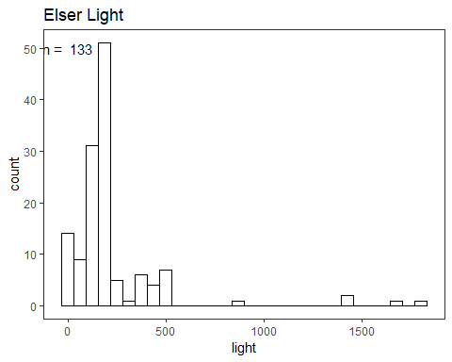

ggplot(TempData_Elser, aes(x = light)) + geom_histogram(colour = 'black',fill = 'white') + facet_grid(cat ~ ., scales = 'free')+  
 ggtitle("Elser Light by Ecosystem")

## `stat_bin()` using `bins = 30`. Pick better value with `binwidth`.

## Warning: Removed 180 rows containing non-finite values (stat_bin).

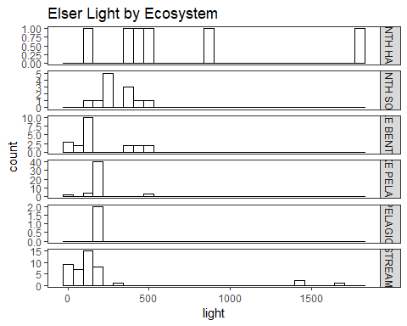

#Avail N Range  
  
Elser_log_n_avail = ggplotGrob(ggplot(TempData_Elser, aes(x = log10(n_avail))) + geom_histogram(colour = 'black', fill = 'white'))

## `stat_bin()` using `bins = 30`. Pick better value with `binwidth`.

## Warning: Removed 24 rows containing non-finite values (stat_bin).

ggplot(TempData_Elser, aes(x = n_avail)) + geom_histogram(colour = 'black', fill = 'white') +  
 annotate('text', x = 1, y = 220, label = paste("n =",nrow(subset(TempData_Elser, n_avail!="NA")))) +  
 annotation_custom(grob = Elser_log_n_avail, xmin = 250, xmax = 550, ymin = 100, ymax = 220)+  
 ggtitle("Elser Available N")

## `stat_bin()` using `bins = 30`. Pick better value with `binwidth`.

## Warning: Removed 24 rows containing non-finite values (stat_bin).

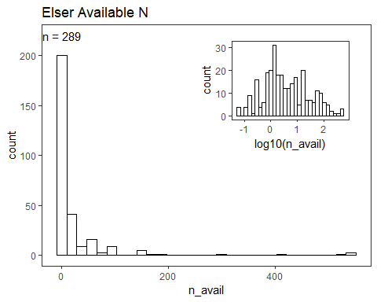

#Total N Range  
  
Elser_log_n_total = ggplotGrob(ggplot(TempData_Elser, aes(x = log10(n_total))) + geom_histogram(colour = 'black', fill = 'white'))

## `stat_bin()` using `bins = 30`. Pick better value with `binwidth`.

## Warning: Removed 205 rows containing non-finite values (stat_bin).

ggplot(TempData_Elser, aes(x = n_total)) + geom_histogram(colour = 'black', fill = 'white') +  
 annotate('text', x = 1, y = 20, label = paste("n =", nrow(subset(TempData_Elser, n_total!="NA")))) +  
 annotation_custom(grob = Elser_log_n_total, xmin = 250, xmax = 400, ymin = 10, ymax = 20)+  
 ggtitle("Elser Total N")

## `stat_bin()` using `bins = 30`. Pick better value with `binwidth`.

## Warning: Removed 205 rows containing non-finite values (stat_bin).

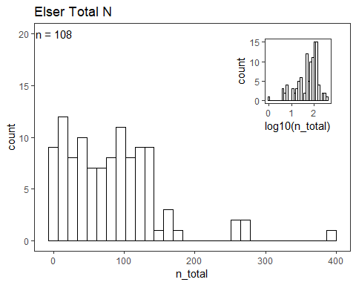

#Avail P Range  
  
Elser_log_p_avail = ggplotGrob(ggplot(TempData_Elser, aes(x = log10(p_avail))) + geom_histogram(colour = 'black', fill = 'white'))

## `stat_bin()` using `bins = 30`. Pick better value with `binwidth`.

## Warning: Removed 50 rows containing non-finite values (stat_bin).

ggplot(TempData_Elser, aes(x = p_avail)) + geom_histogram(colour = 'black', fill = 'white') +  
 annotate('text', x = .1, y = 135, label = paste("n =",nrow(subset(TempData_Elser, p_avail!="NA")))) +  
 annotation_custom(grob = Elser_log_p_avail, xmin = 5, xmax = 9, ymin = 50, ymax = 135)+  
 ggtitle("Elser Available P")

## `stat_bin()` using `bins = 30`. Pick better value with `binwidth`.

## Warning: Removed 48 rows containing non-finite values (stat_bin).

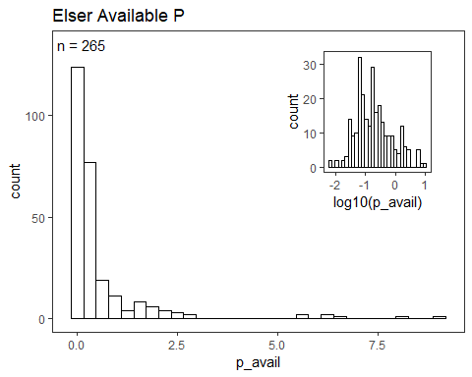

#Total P Range  
  
Elser_log_p_total = ggplotGrob(ggplot(TempData_Elser, aes(x = log10(p_total))) + geom_histogram(colour = 'black', fill = 'white'))

## `stat_bin()` using `bins = 30`. Pick better value with `binwidth`.

## Warning: Removed 188 rows containing non-finite values (stat_bin).

ggplot(TempData_Elser, aes(x = p_total)) + geom_histogram(colour = 'black', fill = 'white') +  
 annotate('text', x = .1, y = 45, label = paste("n =",nrow(subset(TempData_Elser, p_total!="NA")))) +  
 annotation_custom(grob = Elser_log_p_total, xmin = 10, xmax = 20, ymin = 20, ymax = 45)+  
 ggtitle("Elser Total P")

## `stat_bin()` using `bins = 30`. Pick better value with `binwidth`.

## Warning: Removed 188 rows containing non-finite values (stat_bin).

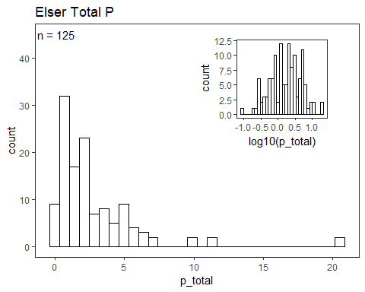

## Beck Plots from 2) Exploratory script

##Beck Plots  
  
#Temp Range  
  
ggplot(TempData_Beck, aes(x = Temp_C)) + geom_histogram(colour = 'black', fill = 'white')+  
 annotate('text', x = 1, y = 40,label = paste("n = ", nrow(subset(TempData_Beck, Temp_C!="NA"))))+  
 ggtitle("Beck Temp")

## `stat_bin()` using `bins = 30`. Pick better value with `binwidth`.

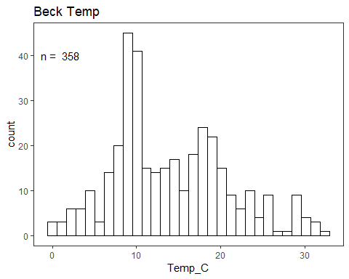

#Canopy % Range  
  
ggplot(TempData_Beck, aes(x = Canopy_Percent)) + geom_histogram(colour = 'black', fill = 'white')+  
 annotate('text', x = 1, y = 15,label = paste("n = ", nrow(subset(TempData_Beck, Canopy_Percent!="NA"))))+  
 ggtitle("Beck Canopy Percent")

## `stat_bin()` using `bins = 30`. Pick better value with `binwidth`.

## Warning: Removed 259 rows containing non-finite values (stat_bin).

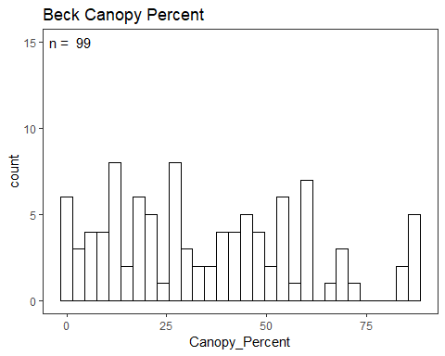

#DIN Range  
  
Beck_log_DIN = ggplotGrob(ggplot(TempData_Beck, aes(x = log10(DIN_ug_L))) + geom_histogram(colour = 'black', fill = 'white'))

## `stat_bin()` using `bins = 30`. Pick better value with `binwidth`.

## Warning: Removed 318 rows containing non-finite values (stat_bin).

ggplot(TempData_Beck, aes(x = DIN_ug_L)) + geom_histogram(colour = 'black', fill = 'white') +  
 annotate('text', x = 1, y = 10, label = paste("n =", nrow(subset(TempData_Beck, DIN_ug_L!="NA")))) +  
 annotation_custom(grob = Beck_log_DIN, xmin = 500, xmax = 800, ymin = 5, ymax = 10)+  
 ggtitle("Beck DIN")

## `stat_bin()` using `bins = 30`. Pick better value with `binwidth`.

## Warning: Removed 318 rows containing non-finite values (stat_bin).

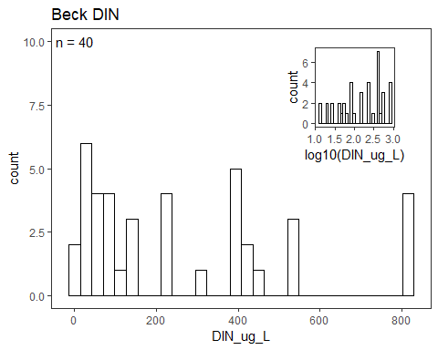

#TN Range  
  
Beck_log_TN = ggplotGrob(ggplot(TempData_Beck, aes(x = log10(TN_mg_L))) + geom_histogram(colour = 'black', fill = 'white'))

## `stat_bin()` using `bins = 30`. Pick better value with `binwidth`.

## Warning: Removed 311 rows containing non-finite values (stat_bin).

ggplot(TempData_Beck, aes(x = TN_mg_L)) + geom_histogram(colour = 'black', fill = 'white') +  
 annotate('text', x = 25, y = 40, label = paste("n =", nrow(subset(TempData_Beck, TN_mg_L!="NA")))) +  
 annotation_custom(grob = Beck_log_TN, xmin = 125, xmax = 225, ymin = 20, ymax = 40)+  
 ggtitle("Beck TN")

## `stat_bin()` using `bins = 30`. Pick better value with `binwidth`.

## Warning: Removed 311 rows containing non-finite values (stat_bin).

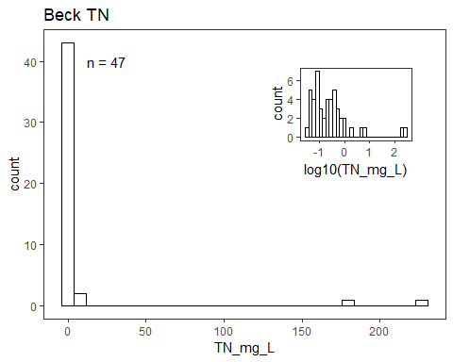

#SRP Range  
  
Beck_log_SRP = ggplotGrob(ggplot(TempData_Beck, aes(x = log10(SRP_ug_L))) + geom_histogram(colour = 'black', fill = 'white'))

## `stat_bin()` using `bins = 30`. Pick better value with `binwidth`.

## Warning: Removed 90 rows containing non-finite values (stat_bin).

ggplot(TempData_Beck, aes(x = SRP_ug_L)) + geom_histogram(colour = 'black', fill = 'white') +  
 annotate('text', x = 250, y = 250, label = paste("n =", nrow(subset(TempData_Beck, SRP_ug_L!="NA")))) +  
 annotation_custom(grob = Beck_log_SRP, xmin = 1000, xmax = 1750, ymin = 125, ymax = 250)+  
 ggtitle("Beck SRP")

## `stat_bin()` using `bins = 30`. Pick better value with `binwidth`.

## Warning: Removed 90 rows containing non-finite values (stat_bin).

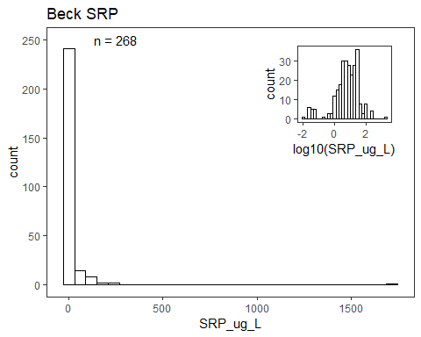

#TP Range  
  
Beck_log_TP = ggplotGrob(ggplot(TempData_Beck, aes(x = log10(TP_ug_L))) + geom_histogram(colour = 'black', fill = 'white'))

## `stat_bin()` using `bins = 30`. Pick better value with `binwidth`.

## Warning: Removed 309 rows containing non-finite values (stat_bin).

ggplot(TempData_Beck, aes(x = TP_ug_L)) + geom_histogram(colour = 'black', fill = 'white') +  
 annotate('text', x = 200, y = 50, label = paste("n =", nrow(subset(TempData_Beck, TP_ug_L!="NA")))) +  
 annotation_custom(grob = Beck_log_TP, xmin = 1500, xmax = 2500, ymin = 30, ymax = 50)+  
 ggtitle("Beck TP")

## `stat_bin()` using `bins = 30`. Pick better value with `binwidth`.

## Warning: Removed 309 rows containing non-finite values (stat_bin).

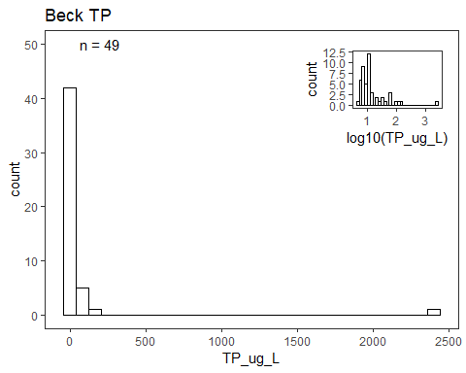

## Vanni Plots from 2) Exploratory script

#Temp Range  
  
ggplot(TempData_Vanni, aes(x = Temperature..C.)) + geom_histogram(colour = 'black', fill = 'white')+  
 annotate('text', x = 10, y = 1100,label = paste("n = ", nrow(subset(TempData_Vanni, Temperature..C.!="NA"))))+  
 ggtitle("Vanni Temp")

## `stat_bin()` using `bins = 30`. Pick better value with `binwidth`.

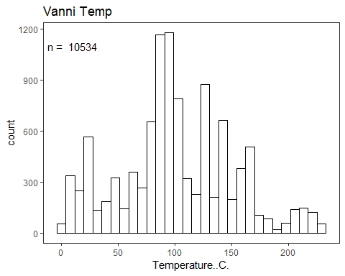

#Excretion SRP  
  
ggplot(subset(TempData_Vanni, P.form=="SRP"), aes(x = P.excretion.rate..ug.P.ind.h.)) + geom_histogram(colour = 'black', fill = 'white')+  
 annotate('text', x = 1000, y = 1200,label = paste("n = ", nrow(subset(TempData_Vanni, P.form=="SRP"& P.excretion.rate..ug.P.ind.h.!="NA"))))+  
 ggtitle("Vanni SRP Excretion Rate")

## `stat_bin()` using `bins = 30`. Pick better value with `binwidth`.

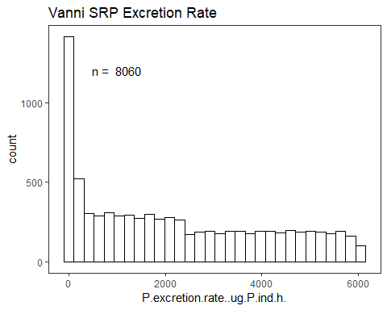

#Excretion TP  
  
ggplot(subset(TempData_Vanni, P.form=="TP"), aes(x = P.excretion.rate..ug.P.ind.h.)) + geom_histogram(colour = 'black', fill = 'white')+  
 annotate('text', x = 0, y = 100,label = paste("n = ", nrow(subset(TempData_Vanni, P.form=="TP"& P.excretion.rate..ug.P.ind.h.!="NA"))))+  
 ggtitle("Vanni TP Excretion Rate")

## `stat_bin()` using `bins = 30`. Pick better value with `binwidth`.

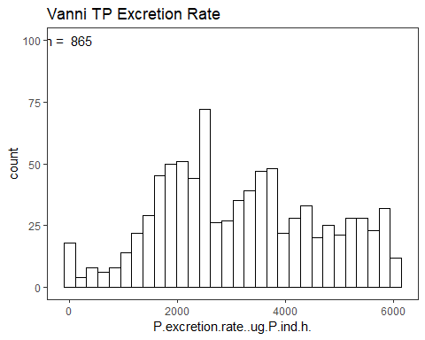

#Excretion Ammonium  
  
ggplot(subset(TempData_Vanni, N.form=="NH4"), aes(x = N.excretion.rate..ug.N.ind.h.)) + geom_histogram(colour = 'black', fill = 'white')+  
 annotate('text', x = 1000, y = 900,label = paste("n = ", nrow(subset(TempData_Vanni, N.form=="NH4" &N.excretion.rate..ug.N.ind.h.!="NA"))))+  
 ggtitle("Vanni NH4 Excretion Rate")

## `stat_bin()` using `bins = 30`. Pick better value with `binwidth`.

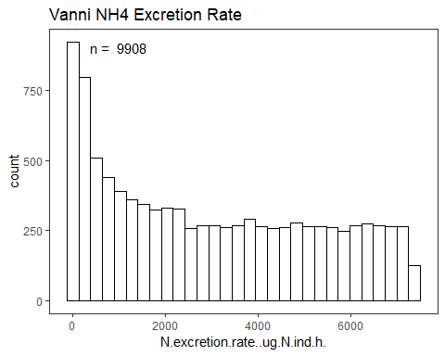

#Excretion TN  
  
ggplot(subset(TempData_Vanni, N.form=="TN"), aes(x = N.excretion.rate..ug.N.ind.h.)) + geom_histogram(colour = 'black', fill = 'white')+  
 annotate('text', x = 0, y = 20,label = paste("n = ", nrow(subset(TempData_Vanni, N.form=="TN" &N.excretion.rate..ug.N.ind.h.!="NA"))))+  
 ggtitle("Vanni TN Excretion Rate")

## `stat_bin()` using `bins = 30`. Pick better value with `binwidth`.

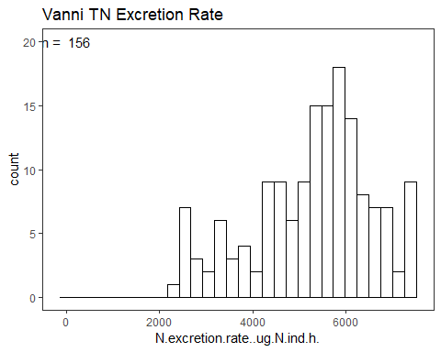

#Excretion N:P (If N excretion or P excretion was NA, value was calculated as "1",   
#so only included values >1)  
  
ggplot(subset(TempData_Vanni, Excreted.N.P..molar.>1), aes(x = Excreted.N.P..molar.)) + geom_histogram(colour = 'black', fill = 'white', bins=50)+  
 annotate('text', x = 500, y = 300,label = paste("n = ", nrow(subset(TempData_Vanni, Excreted.N.P..molar.!="NA" & Excreted.N.P..molar.>1))))+  
 ggtitle("Vanni Excretion N:P Molar")

