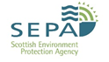  
Regulatory Evidence - Ecology Report

Screening Water Quality Using a Rapid Assessment Technique for Freshwater Invertebrate

12 January, 2022

# Location and purpose

# Results

Some results…

# Analysis

#### Determinand Summary

#### Sampling Location Map

# Conclusion

There are a total of sampling locations within this dataset…