

Regulatory Evidence - Ecology Report

Bankside Freshwater Invertebrates

## Location Code: 122676

## Survey Date: 21 January 2022

## Reason for visit: Vulnerable site

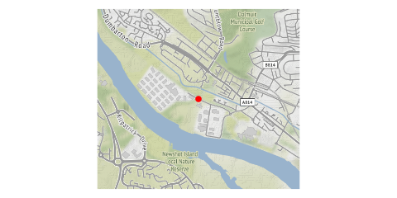

# RBMP Assessment: Good (2017)

# Bankside Assessment: Likely problem detected

# Proposed Action: Urgent discussion required with Ecology

## Interpretation

<<< Please delete and enter your interpretation >>>

### Reported Date:

### Report By:

### Sampler:

### NGR:

### Water Body: