CURRICULUM VITAE
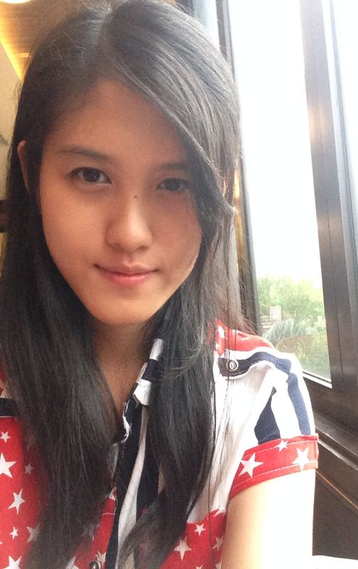
PERSONAL DETAILS

Full Name : Lavenia Clarabelle
Nick Name : Bella
Place & Date of Birth : Jakarta, 19 th January 1996
Home Address : Jl. Alpukat Raya Blok WM No. 6
Harapan Indah - Bekasi 17131
Mobile Phone : 087887120121
Email Address : lavenia.clarabelle@yahoo.com
Gender : Women
Religion : Catholic
Nationality : Indonesian
Hobby : Travelling
Healthy : Good
Height : 168 cm
Weight : 54 kg
Marital Status : Single

FORMAL EDUCATION

2000 – 2006 : Tunas Harapan Elementary School, Harapan Indah, Bekasi
2006 – 2009 : BPK Penabur Junior High School, Harapan Indah, Bekasi
2009 – 2012 : BPK Penabur Senior High School, Harapan Indah, Bekasi
2013 – Now : Trisakti Institute of Tourism, Tour and Travel Major

EXPERIENCES

June – August 2013 : Temporary job at PT Sinergy Utama Raya
December 2013 : Usher at Gratitude and Awarding Night PT Royal Timur Sejahtera
September & : Wedding Organizer
Oktober 2014
12-15 November 2014: SPG at InterFood Indonesia 2014
26 Maret 2015 : Tour Leader SD Bhinneka Tunggal Ika
April 2015 : SPG at Food and Hotel Indonesia 2015
: SPG product Munchy’s at Food Hall Kelapa Gading
: Technical Staff at Asian African Conference 2015
Mei 2015 : Usher at Grand Opening Sun Life Tower
September 2015 : Liaison Officer at Olimpiade Olahraga Siswa Nasional
I declare the details stated above to be true and complete.

Jakarta, 12th January 2016

Lavenia Clarabelle

