CURRICULUM VITAE

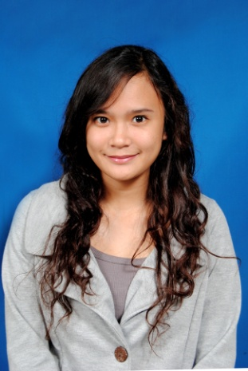

Biodata

Nama : Dina Octarina Lubis
Tempat Tanggal Lahir : Jakarta, 5 Oktober 1992
Umur : 22 Tahun
Jenis Kelamin : Wanita
Agama : Islam
Status : Single
Warga Negara : Indonesia
Alamat : Komplek Deplu Pondok Aren,
Jl. Delima Blok B/86
Pondok Betung - Tangerang
Mobile phone : 081291855380
Email : diinaoctarina@hotmail.com

Education

- TK CENDRAWASIH 1997-1998
- SD HANG TUAH 4 1998-2004
- SMPN 11 JAKARTA 2004-2007
- SMA BM 400 Jakarta 2007-2010
- BINA NUSANTARA University Marketting Communication ‘2010

Qualifications

- Internet Literate
- Computer Literate (MS Word, MS Excel, MS Power Point, MS Access, MS Outlook)

Experience

- 2009 Panitia bm smart (LO)
- 2010 Karang Taruna Taman Cipulir Estate
- 2010 Panitia event 17 Agustus Taman Cipulir Estate
- 2012 Usher Seminar 2012 JEITA – ESDM (Energy Saving Solution),
Direktorat Energi Sumber Daya Mineral (ESDM)
- 2012 Usher Executive Briefing Energy Management ISO 50001 and System Optimization in Industries, Direktorat Energi Sumber Daya Mineral (ESDM)
- 2014 Internship e-commerce Damniloveindonesia.com
- 2014 Shopkeeper brand SMITH (Jakcloth 2014)
- 2014 Crew PT. Graha Layar Prima (Bliztmegaplex)

