**Curriculum Vitae**

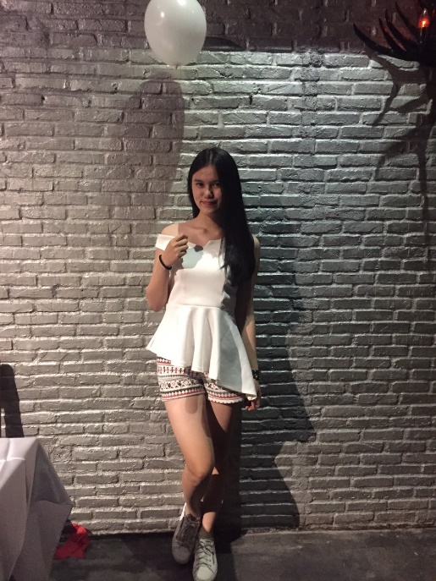

Full Name : Livie Meilinda

Place, Born Day : Jakarta, May 24th 1998

Gender : Female

Religion : Christian

Nationality : Indonesia

Address : Jl. Krendang Selatan I no. 11C RT 05/RW 007,

Kel. Krendang, Kec. Tambora, Jakarta Barat – 11260

Height / Weight : 169 cm / 53 kg

Telephone Number : 089630373224

E-mail : [liviemeilinda@gmail.com](mailto:liviemeilinda@gmail.com)

Education Details :

2004 – 2008 : SD Pelita 1

2008 – 2009 : SD Strada II, Karawaci

2009 – 2013 : SD & SMP Pelita 1

English Course FTBE II di CST

2013 – 2016 : SMIP Paramitha 2

Training / Experience :

1. Observation and Guiding at National Monument 2014
2. A part of Group Leaders on Bali Tour by Plane 2015
3. A part of Game Makers on Bali Tour by Plane 2015
4. Hotel Handling for Dwidaya Tours and Travel at Grand Mercure 2015
5. Industry Work Practice at Golden Rama Tours and Travel (Tour Div. China & Taiwan) 2015
6. Usher Wedding at Grand Hyatt 2014
7. Usher Birthday at Pullman Hotel 2014
8. SPG Nestworld at Central Park, Le Grandeur & Emporium Pluit Mall 2014
9. SPG Nutella at Emporium Pluit Mall 2014
10. SPG Grab at Epicentrum Walk 2016
11. SPG Mitra10 at Indobuiltech ICE BSD 2016
12. Usher Suzuki Motor at JI Expo (PRJ 2016)