# Identity

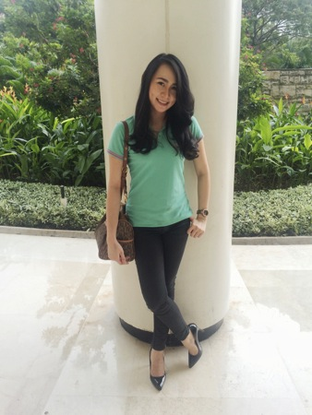

Name : Stefani Trifosa

Phone : 081927896333

Height/ Weight : 168cm/ 50kg

Adress : Pluit – Jakarta

Age : 22 years old

# Objective

I am currently looking for an Part-time/ full-time position in an environment that offers a greater challenge, utilize my idea, knowledge, skill and gain further experience, and the opportunity to socialize within people and environment.

# Experience

## Project Scheduler (Secretary) [January 2015-now]

* Responsible for priority schedule given to Team Leader everyday
* Increasing the well originizing skills
* Responsible in any reporting
* Have great team-work experience.
* Explore more how to communicate with client from different culture and countries.

## Sunday School Teacher (PIC) [2011-now]

* Responsible and manage the whole teaching activities.
* Do the team-work well.
* Gain more ability in leadership.
* Love and concern in growing up the children education.
* Patient in facing the all types of children.
* Love to enlarge creativity to attract children in teaching something new.

## Online Shop - Owner [2011- now]

* Responsible in managing the whole business activity.
* Gain more experience in entrepreneurship skills.
* Enlarge connection with the customers, suppliers, distributors, and shipping agencies.

## Binus Carrer Job Expo – Event Part-timer [March 2012, September 2012]

* Responsible in registration desk. Practicing how to face different characteristic of people.
* Responsible to work in team.
* Responsible in booth facilitator. Build good connection with the participants which is the companies representatives.

## PT. Karunia Wijaya Sentosa – Sales Executves [September 2011- January 2012]

* Get trained about how to be a person that can affected people to know and believe the company and its products.
* Responsible to gain good relationship with the customer while doing the gardening project,
* Responsible in managing the team-working doing the project well.
* Have team-work experience.

# Non-organizational Experience

## SPG EVENT [2012]

* 5 oktober 2012 = Financial Expo @ JCC
* 12 oktober 2012 = IGS – A.V.A Games. @ JCC

## USHER WEDDING [2010 - PRESENT ]

* More than 10x times in Usher Wedding

# Education

## BINUS Business School [2015 - Present]

* Master in Management (MM) with GPA : 3.7

## Bina Nusantara University [2011-2015]

* System information Major with GPA : 3,65.

## Xaverius Senior High School – Bandarlampung [2008-2011]

* Graduated with cumulative score : 8,60.

# Skills

* Tolerant and flexible to different situations
* Team Work.
* Strong verbal and personal communication skills.
* Self motivated, initiative, high level of energy.
* Organization and prioritization skills.
* C#, Java, Visio, Visual Basic, Dreamweaver, MySQL, Web Design, Business Analyst, UML, Object Oriented Design, Ms. Ofiice.

# Language

- English (Spoken and Written – Fluent)

* Indonesian (Spoken and Written – Native)