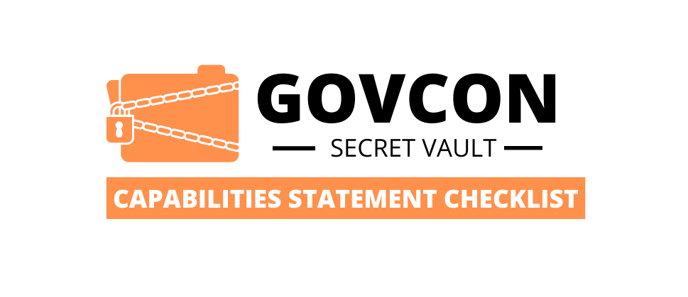
CONSULTANT:
You are responsible for helping your client develop an exceptional Capability Statement. Your business information does not go on the statement, the client’s information, past performance, NAICS, etc. If client permits you should list your name, phone and email as the POC.

5. Elementary Language
Can someone clearly read and understand what it is that I do?

Newspapers are written on middle school level. Make sure your audience is not confused about what services you are providing.
6. Laser Beam Focus
Is my capability statement focused on a single industry?

We know that some of you can do many things. But for the purpose of your cap statement, you should concentrate your marketing the firm based on your strongest industry. The one where you have the best TEAM, most experience and can deliver great service.
7. DO NOT
- Do not include MPIN
- Do not include EIN
- Do not include State logo’s
- Do not include 3rd Party Advertising
- No Long paragraphs

3. Did I include my DUNS# and Cage Code?
This is how the government looks up your information to verify SAM registration, NAICS codes and certification information.

*You DO NOT need to list your type of corporation
4. Short paragraphs
Is all of my information written clearly in short paragraph (2 to 3 sentences max) format?

People attention span is short. Anything more than 3 lines will NOT get read.
2. Professionalism
Is my capability statement professional looking?

It doesn’t have to be professionally done by a graphic artist. But it should be edited, spell checked, written concisely.
1. Point of Contact Information
Is the POC large and visible? This is the most important piece of information on the document.

Sometimes people put it at the bottom in the corner in tiny font. Don’t make that mistake. It should go at the Top of the page or in the Middle, large and bold so it can easily be read.

