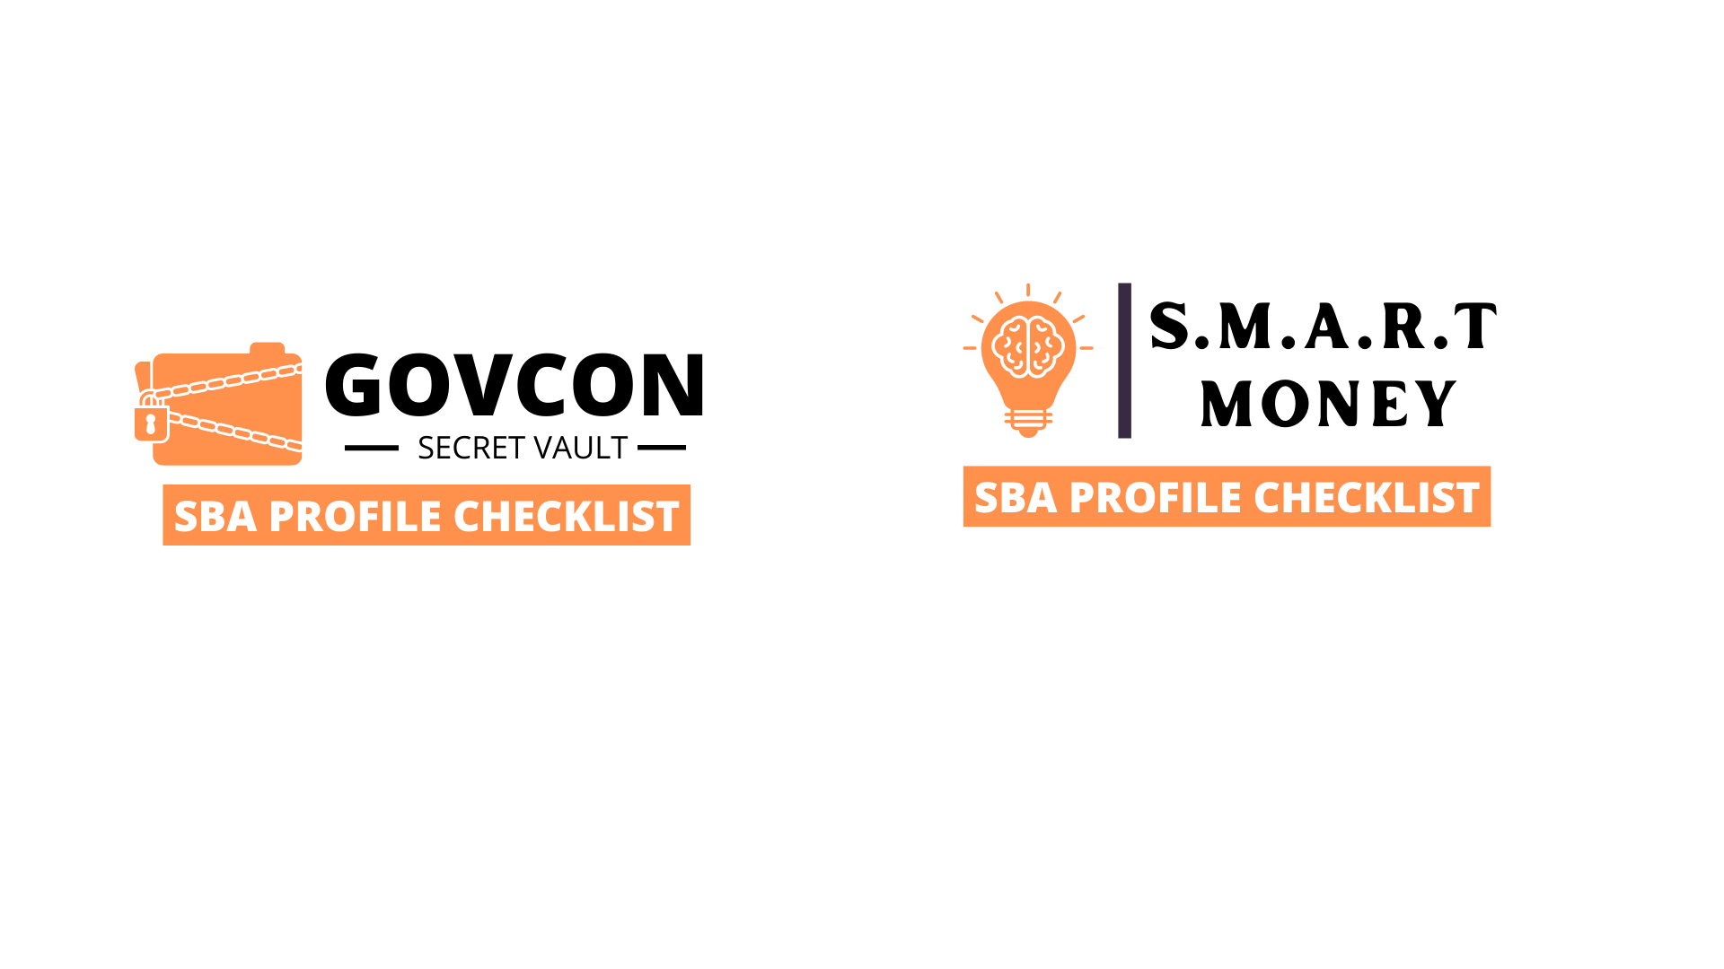
CONSULTANT:
Note: If you are a consultant this is one of the first tasks that you will be doing for your clients.

Normally I will print off their SBA profile and then mark up the changes in red and send back to them to make corrections.

I do all the research and tell the client exactly what to write for keywords and narrative. I make notes on the POC info slot and suggest the types of references they should use.

Include the year, value and name of contract as well as pertinent information like DOD, or Air Force Base. For scope of services, make sure to include any key words that show similar experience to profile.

Do no include actual client phone number for references, as this is a public site. Instead refer back to your office.

For references make sure to include the most recent and larger projects first.

6. Past Performance
Add both government and non-government past performance.

5. Key Words
Make sure to complete key words in this section.

Use this area to fill in missing key words not in narrative. Again model successful firms.
2. Phone numbers
Make sure your phone numbers are not going to answering systems that get lost or generic office numbers that no one answers.

Remember when doing market research the government won’t try too hard. I would list a cell phone number or direct line to a human that answers regularly.
3. Capabilities Narrative
Your narrative should be a combination of comma-separated key words. Model the big firms to see the types of phrases that apply to your business. Commonly searched words by the government.

No long paragraphs.
1. Point of contact
Make sure your contact information is up to date and accurate. Staff names, email addresses, fax number.
> Modeling
Look up industry leaders in your market to learn how the Top firms create their SBA profiles.

Geographical region is not important, just make sure that they are a Top firm and they operate in a similar space. You want to mimic their profile as close as possible.

