Results

Toph Allen

September 8, 2015

The final database contains information on 820 biosurveillance systems. Of these, 709 study humans, 181 study animals, and 65 study plants. We found 210 systems which conduct syndromic surveillance and 161 which did not, but were unable to find syndromic surveillance information for 449 systems. Government entities were involved in 689 surveillance systems, non-profits in 133, and for-profits in 30. More than one of these entity types were involved in 46 systems.

Table 1. Classes of biosurveillance conducted. Note: for "Syndromic" variable, "Blank" and "Not Found" entries were combined.

|  |  |  |  |  |
| --- | --- | --- | --- | --- |
|  | Humans | Animals | Plants | Syndromic |
|  | Yes :709 | Yes :181 | Yes : 65 | Yes :210 |
|  | No : 98 | No :613 | No :723 | No :161 |
|  | Not found: 13 | Not found: 26 | Not found: 32 | Not found:449 |

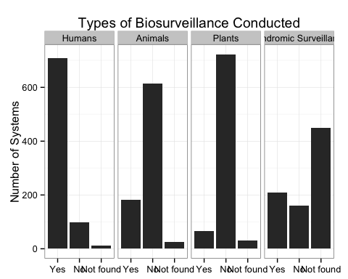

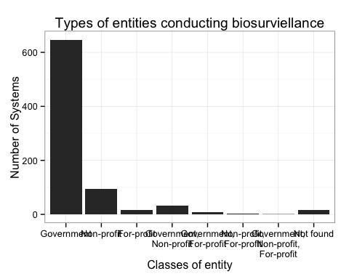

We examined data collected on surveillance system termination and creation. Of the 820 surveillance systems in the database, 682 have information on both year of creation and, unless currently active, year of termination. Surveillance system creation peaked in 2006, tailing off in subsequent years. Termination of active systems increased significantly after 2000, peaking in 2013. Accounting for system creation and termination, the largest concurrent number of active surveillance systems was 513, occurring in 2011.

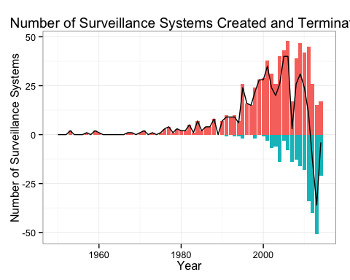

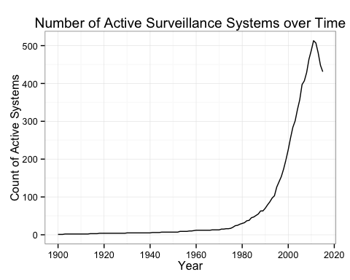

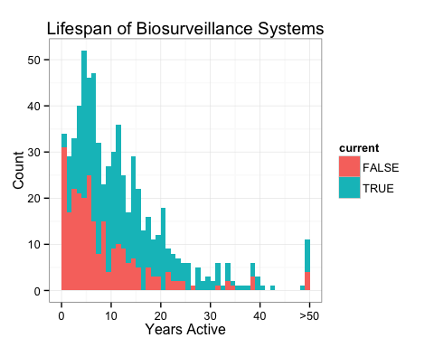

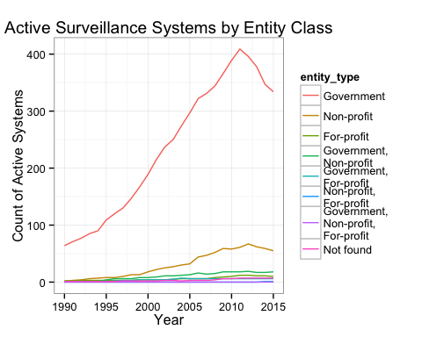

The United States was covered by the largest number of surveillane systems (295). However, the number of surveillance systems per country is not by itself a meaningful measure of surveillance effort, as the United States also covers a larger area and a larger population than many other countries. Plotting the number of surveillance systems per capita for each country shows a different aspect of surveillance system distribution.

## 184 codes from your data successfully matched countries in the map  
## 0 codes from your data failed to match with a country code in the map  
## 60 codes from the map weren't represented in your data

