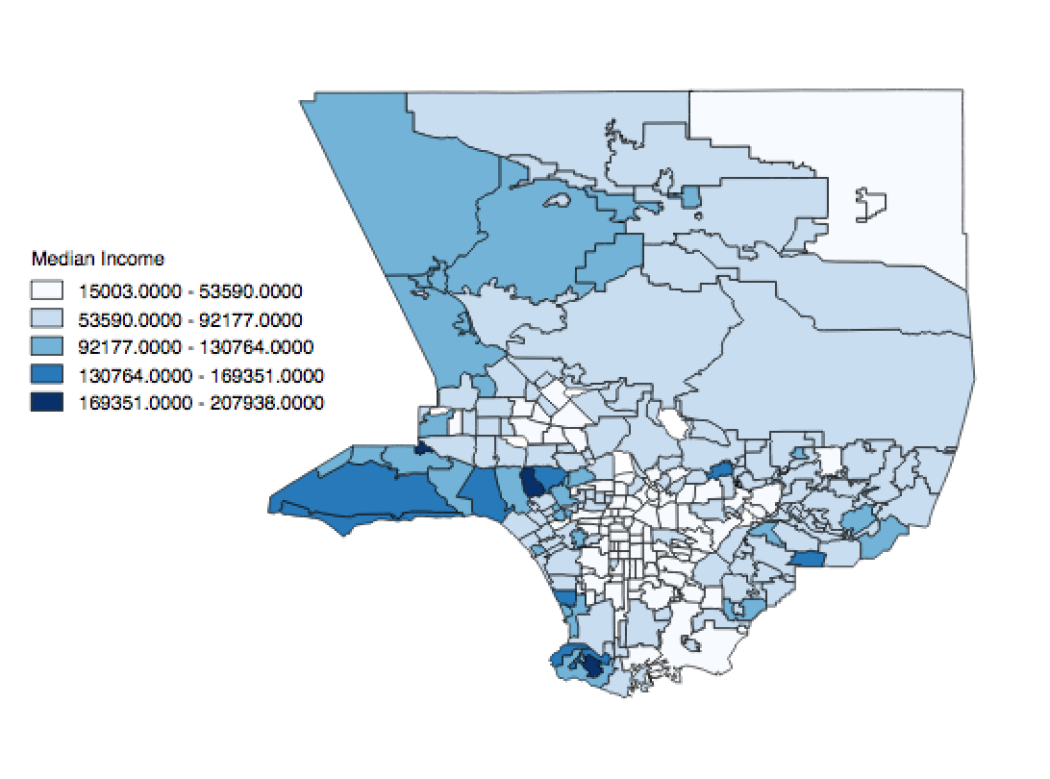**Possible Figures**

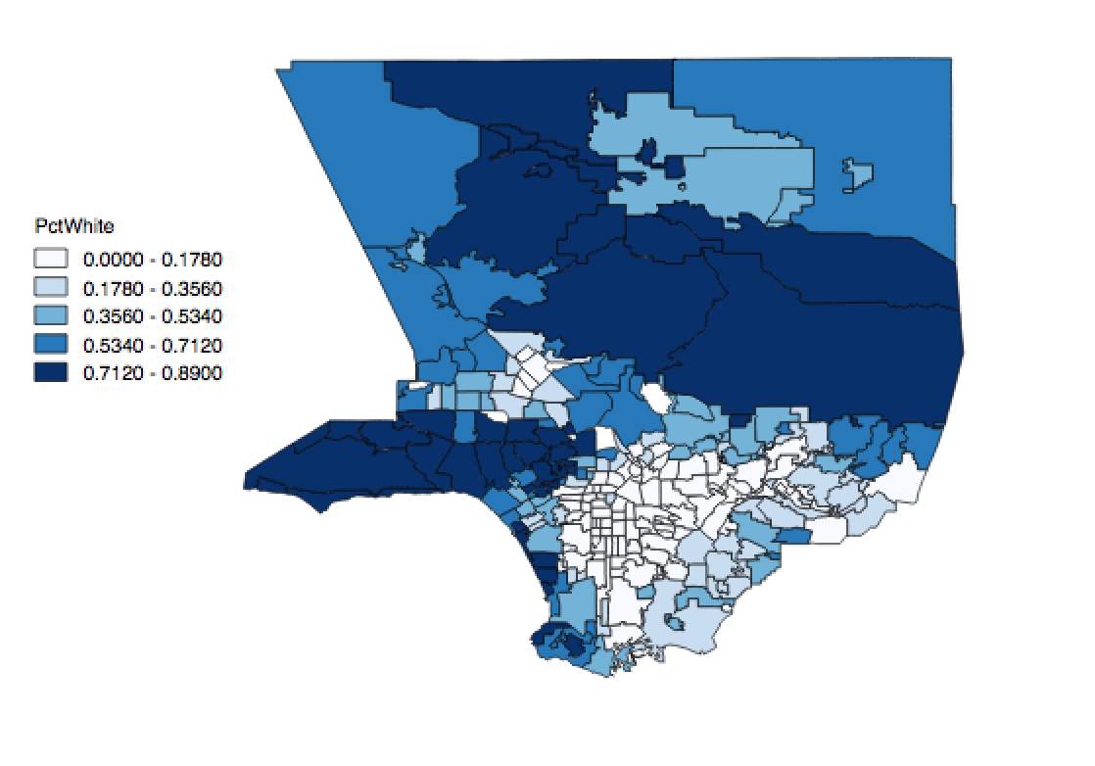

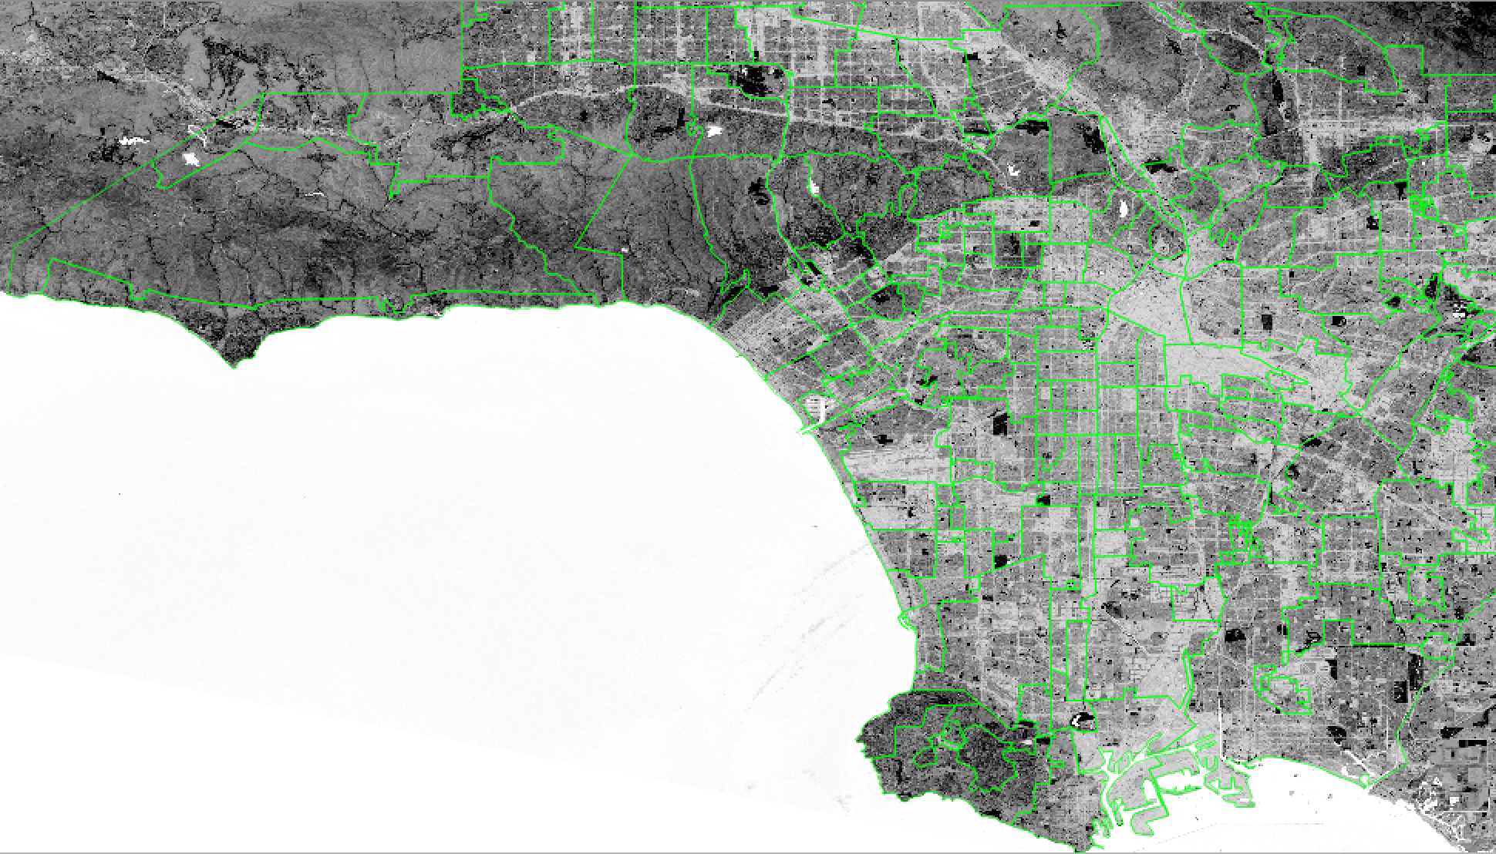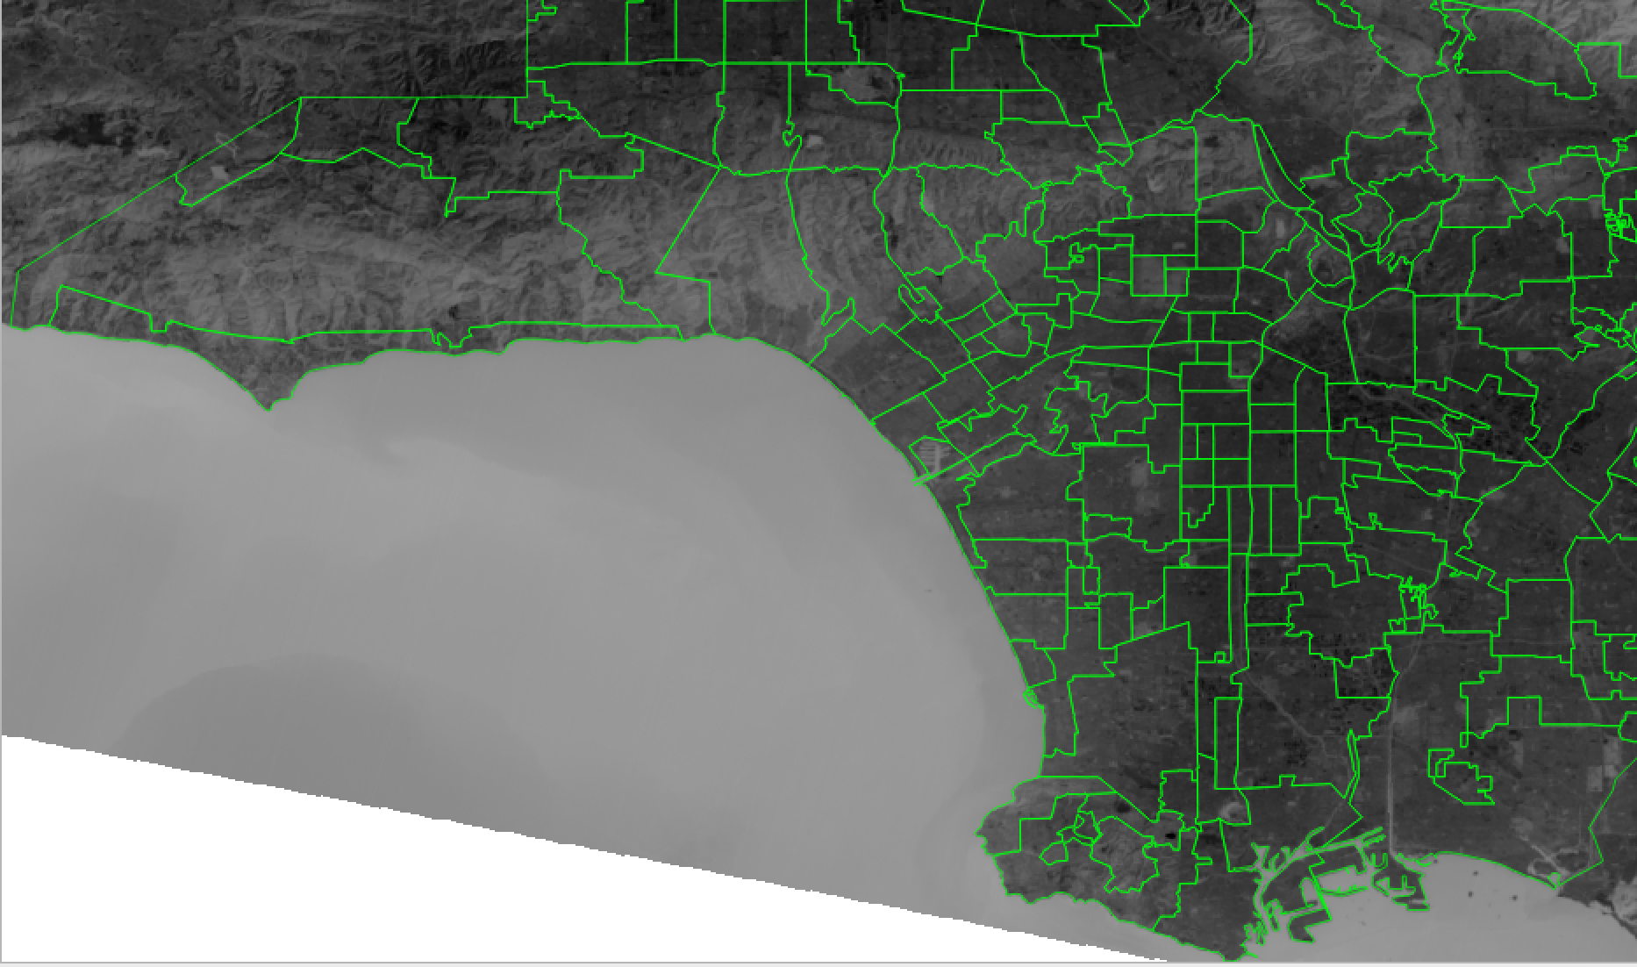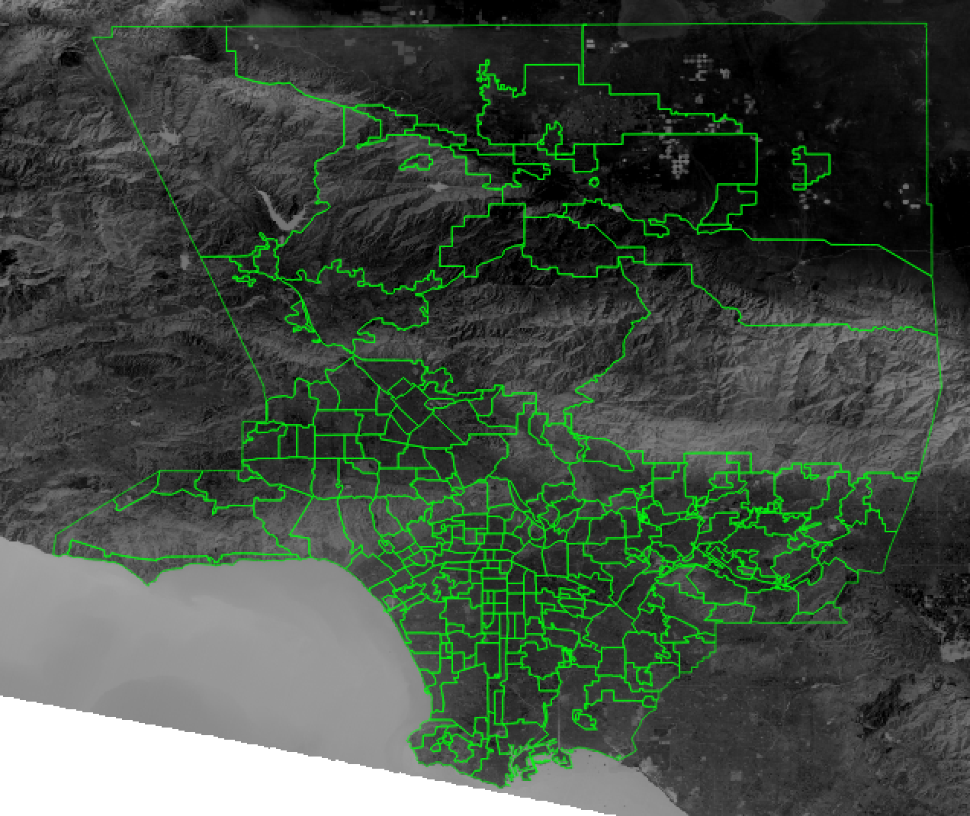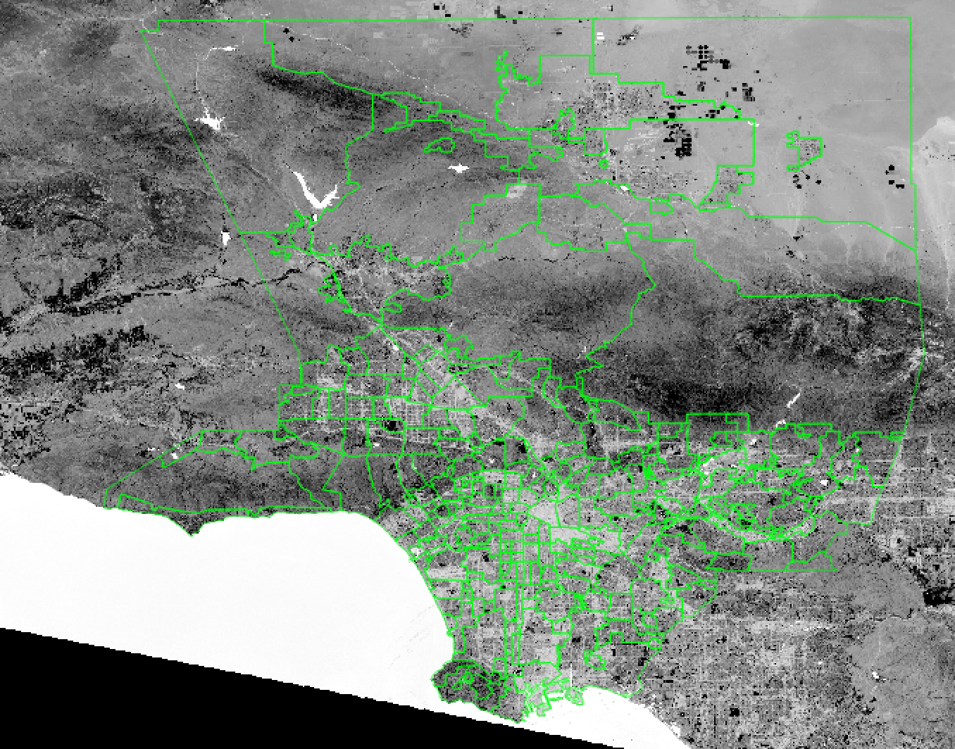

**Variables** (http://maps.latimes.com/neighborhoods/)

**neighborhood**  Residential area defined by LA times neighborhood boundary files

**ndvi_mean**  Mean NDVI calculated for each neighborhood derived from Landsat 8 OLI image (30m resolution) captured Aug. 31 2018

**temp_mean**  Mean land surface temperature (LST) calculated for each neighborhood derived from Landsat 8 OLI image (100m resolution) captured Aug. 31 2018

**median_inc** Median household income

**crime_percapita**  Rates of violent crime reported by LAPD from Feb. 5, 2018 to Aug. 5, 2018, the most recent six months for which complete data is available for all areas patrolled by the departments. Violent crime is defined as homicide, rape, aggravated assault and robbery. Bear in mind that in

areas with relatively low populations, a small number of crimes can generate a large per capita rate. For that reason, the chart below contains both per capita statistics and gross crime counts.

**crime_total** See above

**diversity_index**   Measures the probability that any two residents, chosen at random, would be of different ethnicities. If all residents are of the same ethnic group it's zero. If half are from one group and half from another it's .50.

**pct_black** Percentage of black residents in a neighborhood

**pct_white** Percentage of white residents in a neighborhood

**pct_latino** Percentage of Latino residents in a neighborhood

**pct_homeowner** Percentage of homeowners (as opposed to renters) in a neighborhood

**pct_single_parent** Percentage of single-parent households in a neighborhood

**pop_density** Population density (people per square mile)

**Possible Assignment Tasks & Questions**

* Why would land surface temperature and NDVI vary between so much within a given neighborhood?
  + Plot them
  + What about within a pixel?
* What factors of the composition built environment influence NDVI and LST?
* Which socioeconomic and demographic factors correlate with NDVI? Which with LST? Which socioeconomic and demographic factors do not correlate? Why?
* The Landsat scene was capture in Aug 2018. Why might using a single time point to build your environmental dataset be misleading?
  + Let’s say LA gets 10 inches of rain over two weeks this April and you pull calculate LST and NDVI from and Landsat scene the first week of May? How might it be different from the data included here?
    - Will there be differences in NDVI and LST for a scene captured at 9 am verses 4 pm? Why?