Data Flow Job Aid
USGS Publications Warehouse
04/09/24

- Start at USGS Publications Warehouse https://pubs.usgs.gov/
- Click "Advanced Search"
- Select (drop down menu) "Title"
- Type in one key term (example: "water")
- Select (drop-down menu) "Title" and repeat as necessary for all terms
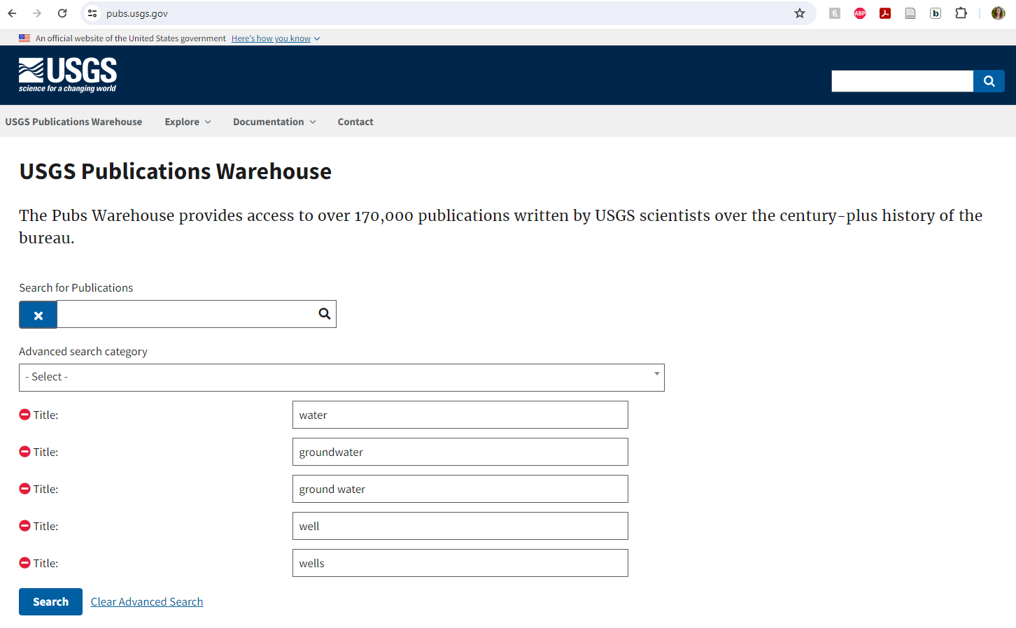
- Click "Search" button
- Click "Download all results as a CVS" to retrieve results as CSV file

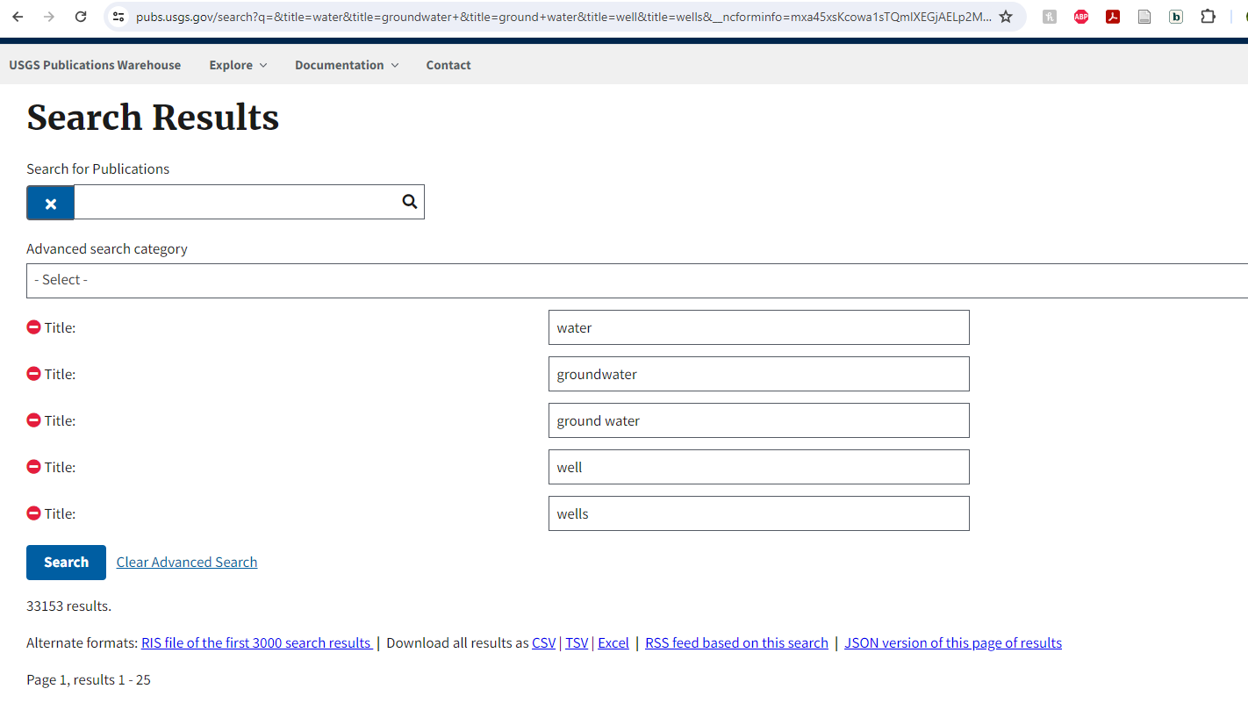
- Open .CSV file (Excel Doc)
- Add filters to the first row (headers)
- Sort by year (earliest to latest)
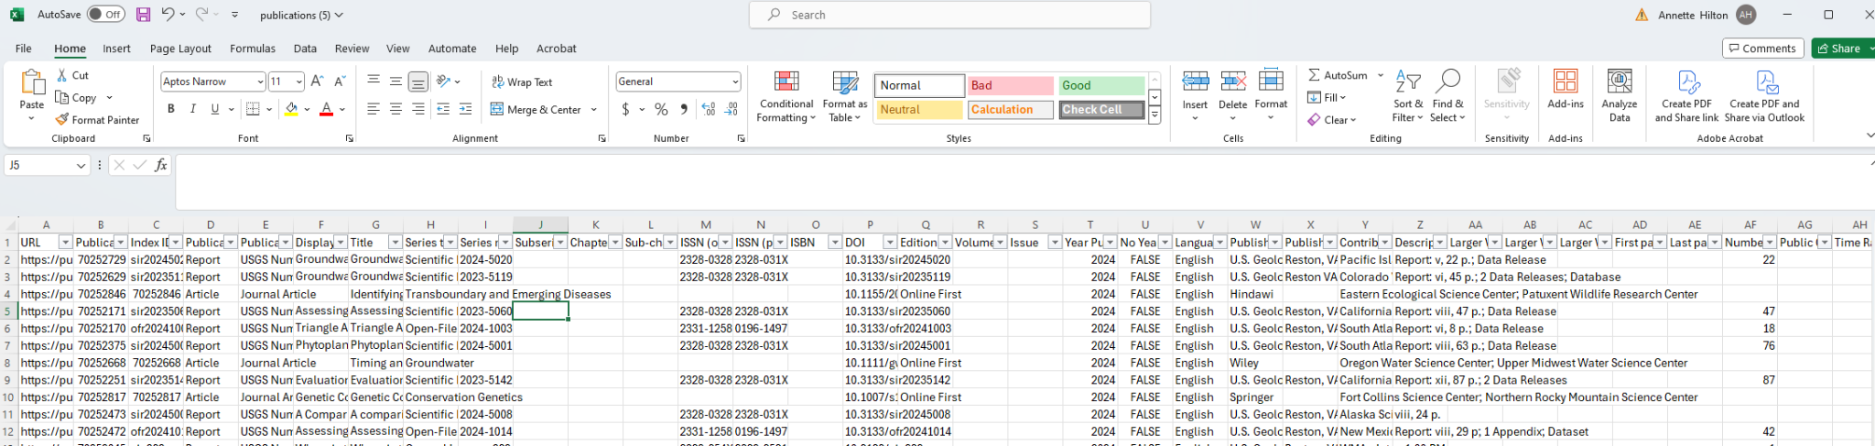
- Each entry links to its own metadata page (Example below)

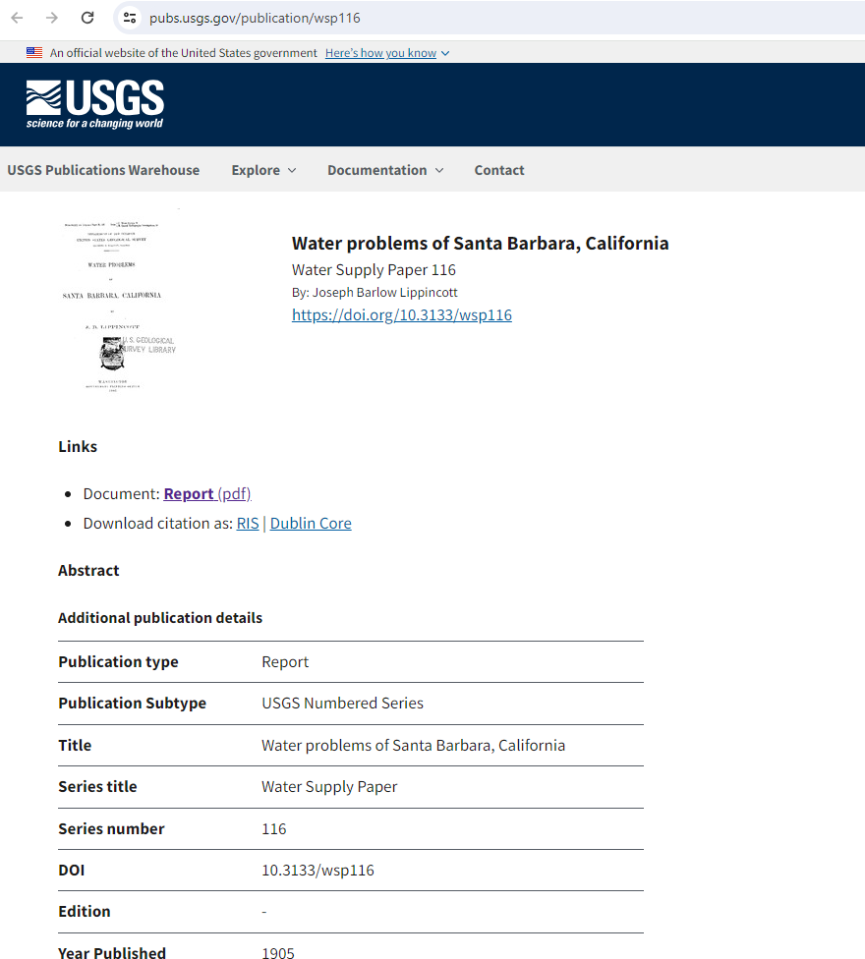

7547 results.

