COMPAT-ORIGINAL-ODT
江南项目 / Native ODF structure, generated from the public format specification.
Area | Budget
江南 | 4200
ODT-TABLE-SENTINEL | 7600
With an original illustration 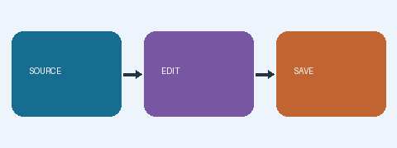
Offline-safe ODF hyperlink
ODT note
ODT-SECOND-PAGE

ODT-FOOTNOTE-PERSISTENT

