Eric Colburn

# Kickstart my Chart Homework

Kickstarters with the category of music have the best success rate at 77%. Conversely, out of the categories where at least one campaign has been successful, food kickstarters have the least likely chance for success at 17%.

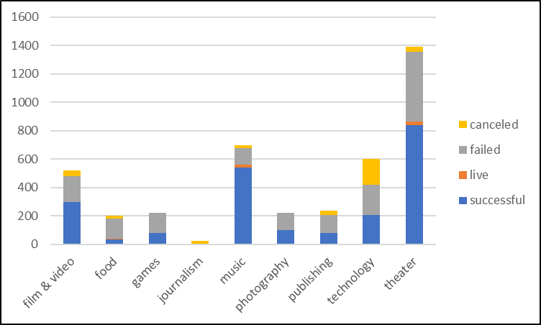

The least successful month for kickstarters is in December with a success rate of 44%. This is also the month with the least amount of total kickstarters. It is the only month that there are more failed kickstarters than successful ones. More research will be needed to find out the cause of this, but for now, avoiding December as the month to start the kickstarter is a good idea.

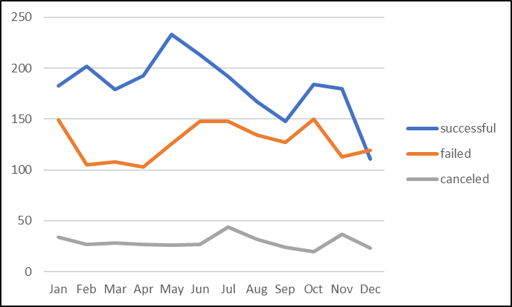

As the goal amount increases, the success rate decreases and the cancel rate increases. Intuitively, this makes sense that the more money needed to reach the goal, the less likely it will succeed. For someone starting a kickstarter, it may be useful to do a few smaller ones over a longer period of time rather than one big one.

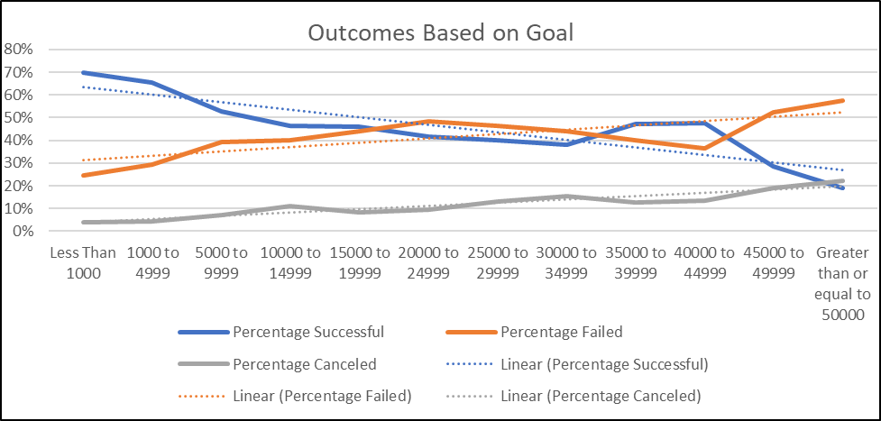

There are some limitations to the data. There are many different factors that could contribute to a campaign being successful that is not in the data. For example, we do not know how much “marketing” each campaign does. A project that markets their campaign more, will most likely have a better chance of being successful. The type of marketing they do could be interesting to analyze to see what is successful and what is not. Another useful piece of data for each campaign would be how well known was the project before the campaign. If a lot of people know about the project, it would be expected that it would be successful more often, compared to a company or project that is just starting and looking for funding. The reason for the campaign would be nice to have as well. This could help us see if people donate no matter what the reason is, or if there are some reasons that are more successful than others.

Another table that can be created is how successful a kickstarter is based on how long the campaign is. This can tell us if longer campaigns are more successful than shorter ones, or vice-versa. Shown below, the shorter the campaign is, the more likely it is to succeed. This is an interesting finding because it would make more sense for the ones that have a longer amount of time be more successful than the ones with a shorter amount of time. It is likely that the short campaigns are usually for less money than the longer ones. From the previous graph, the smaller goals are more likely to succeed than the higher ones.

Another chart that was interesting to look at was the number of successful music campaigns based on the goal amount. Music was the most successful category. From this chart, we can see that the music campaigns mostly have a goal amount of 1000 to 4999. From a previous chart, the lower the goal amount was, the more successful the campaign was. Food category was the least successful category. While it is a much smaller sample size, there still is a higher percentage of food campaigns that have a higher goal than the music category. It seems that the category may not be as important to the success rate of a campaign as the goal amount.

