A Pandemic of Mental Health

Ed Coleman, Jhavon Innocent, Sarah Kircher, Hugo Montesinos-Yufa, McKade Trauger

# Abstract

The direct impact of the COVID-19 pandemic and the indirect impact of the ensuing economic and political response have affected the United States on a large scale. Measuring both the direct and indirect effects of COVID-19 allows for better comprehension and analysis of individual states’ pandemic responses. In our research, the indirect impact of COVID-19 on mental health is analyzed through the stringency of individual states’ pandemic policies. Linear regression analysis is utilized to quantify state responses’ effect on the changes in anxiety or depression symptoms during the pandemic. The quantitative results and time-specific political-economic analysis enhance our understanding of the direct and indirect effects of the COVID-19 pandemic on public health. Our results indicate a wide variation in mental health-related issues by age group, with a higher prevalence in younger adult age categories. While we observe a slight decline in the share of the adult population experiencing anxiety and depression through January 2021- June 2022, the effects of the stringency index on other areas of health are complex and vary by state. We document a large surge in anxiety and depression symptoms from 2019 to 2020, as well as an increase in unexplained mass shootings (by quarter/year) since the pandemic started. After discussing implications for the overall quality of life, this research aims to add to the breadth of ongoing COVID-19 research and emphasize the importance of overall health in a large-scale health crisis.

# Introduction

On March 11, 2020, the world was disturbed by the World Health Organization’s declaration of the COVID-19 pandemic (CDC 2022; WHO.; Cucinotta and Vanelli 2020). The world suffered greatly, and many were isolated in their homes for significant periods of time (Mareike Ernst.; Clair et al. 2021). In the United States, a nationwide emergency was declared on March 13, and the immediate policy response was to “shut down” the country to significantly reduce transmission of the SARS-CoV-2 virus and to prevent hospitals from exceeding ICU capacity.

An example of the initial shutdown can be observed on March 14, when the Center for Disease

Control and Prevention (CDC) issued a “No Sail Order” to all cruises in U.S. waters and New

York City closed its public school system, affecting over 1 million students. Between March and May of 2020, all other U.S. states shut down.[1] Forty-three U.S. states issued explicit stay-athome orders for nonessential activities, and the other seven states (Arkansas, Iowa, Nebraska, North Dakota, South Dakota, Utah, and Wyoming) issued different executive orders preventing

social gatherings and closing malls, restaurants, theaters, gyms, schools, and adhered to CDC recommendations, at a minimum (Ballotpedia 2020).

This widespread pandemic-response policy strategy prioritized safeguarding the physical health of individuals, specifically by protecting them from contracting the SARS-CoV-2 virus. This strategy neglected, however, the mental health of the population (specifically the young). While mental health was being discussed by the WHO for its possible connection with the pandemic as early as March 2020, these considerations were vague and limited to uplifting messages and recommendations to the population, healthcare workers, managers in health facilities, caretakers of children, older adults (people with underlying health conditions and their caretakers), and people in isolation (WHO 2020). Mental health considerations were significantly absent in the policies and pandemic response measures taken by governments and government officials, suggesting concrete action was not taken.

The consequences of such omission are dangerous and potentially catastrophic, leading to a concerning cycle of negative mental health effects and an upsurge of mass shootings.

Researchers have already documented the necessity for additional mental health services because of the ensuing psychological trauma resulting from COVID-19, both from the lockdown itself and the related worldly changes afterward (Pereira-Sanchez et al. 2020; Kim, Nyengerai, and Mendenhall 2022) – including an increased risk of violence (Metzl, Jonathan M. 2015). We assert that while government policies were intended to limit the SARS-CoV-2 virus transmission, they also limited individuals from taking care of themselves and other potential ailments, scheduling regular doctor visits, outdoor activities, visiting friends and family, etc., with severe mental health unintended outcomes. In this paper, we investigate these outcomes by state location and age groups and associate them with the stringency of the policy response in each state.

We find a negative effect on mental health, specifically in young adults (18-29 years), driving up the reported anxiety and depression symptoms for the whole U.S. population from 2019 to 2020. Our findings suggest that the response to COVID-19 caused a “pandemic of mental health” – rapidly spreading mental health ailments throughout the country in 2020. While many factors may, directly and indirectly, influence this new “pandemic”, our analysis indicates that the approach taken by different U.S. states, and not the SARS-CoV-2 virus itself, caused an upsurge in a multitude of mental health categories including anxiety and depression, as well as a potential increase in unemployment, gun violence, and mass shootings.

Additionally, regression analysis indicates that the stringency of the response, including the initial containment and closure policies and the subsequent economic relief, health system, and vaccination policies, had a statistically significant effect in reducing peak anxiety and depression accrued during the first year of the pandemic. Although this reduction is not yet close to prepandemic levels, our overall findings are consistent with the effect of social climate and financial concerns associated with the COVID-19 pandemic (Cindy H Liu et al. 2022).

In sum, our analysis suggests that the pandemic had complex and multi-dimensional effects on the overall health of the population. While the SARS-CoV-2 virus itself had a direct effect on the health (both physical and mental health) of the old population, the policy response to the virus had a disproportionate, yet indirect, effect on the mental health of the young population. This effect comes with complex and dangerous ramifications to our society, including an upsurge in mass shootings.

The rest of our paper is organized as follows: Section 2 discusses the mental health situation in the U.S. before, during, and after the peak of the pandemic. Section 3 elaborates on the U.S.

pandemic response, first focusing on the vaccination rollout, and then introducing the stringency index to quantify the extent of the pandemic response and analyze variations across U.S. states.

Section 4 analyzes the recent upsurge in mass shootings in the U.S. considering the “pandemic” of mental health and provides a historical analysis of mass shootings. Section 5 employs regression analysis to estimate the effect of the stringency index on changes in reported anxiety and depression symptoms during the pandemic. Finally, sections 6 and 7 discuss limitations, future research, and conclude the paper.

# Mental Health Data for the U.S. Before and During the Pandemic

The National Center for Health Statistics (NCHS) partnered with the U.S. Census Bureau on an experimental data platform called the Household Pulse Survey in order to provide information about the impact of the COVID-19 pandemic in the United States. Specifically, the influence of the COVID-19 pandemic on “employment status, consumer spending, food security, housing, education disruptions, and dimensions of physical and mental wellness” (U.S. Census Bureau, Household Pulse Survey). The data collection began on April 23, 2020. Through the survey, several topics were covered regarding mental health, including anxiety, depression, and mental health care.

In the Household Pulse Survey, questions were asked to gain information on the frequency of anxiety and depression symptoms over seven-day periods throughout the pandemic. The questions were adapted from the two-item Patient Health Questionnaire (PHQ-2) and the twoitem Generalized Anxiety Disorder (GAD-2) scale.

The adapted PHQ-2 questions include:

“Over the last 7 days, how often have you been bothered by … having little interest or pleasure in doing things? Would you say not at all, several days, more than half the days, or nearly every day? Select only one answer.”

“Over the last 7 days, how often have you been bothered by … feeling down, depressed, or hopeless? Would you say not at all, several days, more than half the days, or nearly every day? Select only one answer.” The adapted GAD-2 questions include:

“Over the last 7 days, how often have you been bothered by the following problems … Feeling nervous, anxious, or on edge? Would you say not at all, several days, more than half the days, or nearly every day? Select only one answer.”

“Over the last 7 days, how often have you been bothered by the following problems … Not being able to stop or control worrying? Would you say not at all, several days, more than half the days, or nearly every day? Select only one answer.”

For each question, the answer choices were given a numerical value: “not at all = 0, several days

= 1, more than half the days = 2, and nearly every day = 3.” To calculate the individual’s score, their responses to the PHQ-2 and GAD-2 questionnaires are added together separately. On the PHQ-2, a sum score of three or greater is associated with major depressive disorder. On the GAD-2, a sum score of three or greater is associated with generalized anxiety disorder. When adults score above three, it is recommended that they are evaluated by a health professional.

In order to compare anxiety or depression reported symptoms rates from before and after the pandemic, data from the 2019 National Health Interview Survey by the National Center for Health Statistics was utilized in Figure 1. The 2019 National Health Interview Survey results were compared with 2020 data from the Household Pulse Survey to determine the approximate increase in rates due to the COVID-19 pandemic. Because data from January 2020 to April 2020 is currently unavailable, the months of May through December of both 2019 and 2020 are compared. The same questions from the PHQ-2 and GAD-2 questionnaires were used to evaluate anxiety or depression reported symptoms in 2019 and 2020. Within one year, as seen in Figure 1, anxiety or depression reported symptoms increased significantly from about 10 percent in MayDecember of 2019 to more than 35 percent during May-December of 2020.

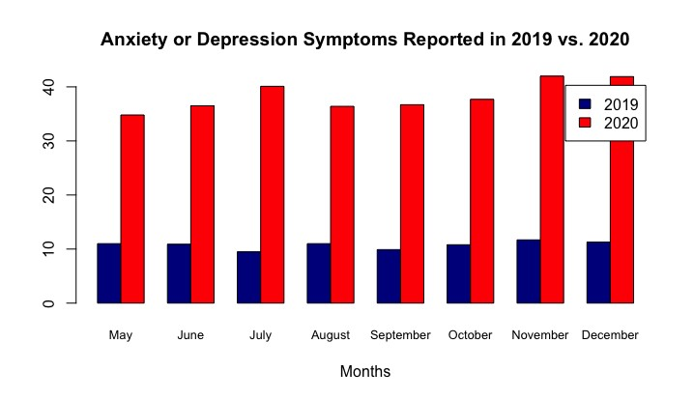

FIGURE 1: This graph compares the trends in reported anxiety or depression symptoms from May to December in 2019 and 2020 for adults aged 18-29 years to 80 years and above. Source: National Health Interview Survey, National Health Center for Statistics, 2019. U.S. Census Bureau, Household Pulse Survey, 2020-2022.

Since the SARS-CoV-2 virus affected significantly and disproportionally the older population relative to the younger population, it is natural to expect that the increase in anxiety and depression observed in Figure 1 was driven mostly by the older-age categories. To investigate this hypothesis in more depth, we need to break down the mental health related symptoms by age groups. This is the focus of the next subsection.

## Anxiety and Depression by Age in the United States

Using data from the Household Pulse Survey accessed by the Centers for Disease Control and Prevention, Figures 2 and 3 show the trends in anxiety and depression in varying adult age groups from April 23, 2020, to June 13, 2022. Figures 2 and 3 illustrate a large variation among each age group regarding anxiety and depression over time. As seen in the figures, young adults (aged 18-29 years) had the highest rates of anxiety and depression throughout the pandemic, while older adults (aged 80 years or above) had the lowest rates of anxiety and depression. In Figure 3, the depression rates for adults aged 18-29 remain significantly greater compared to other age groups throughout the survey collection period. Each age group follows a similar trend of a slight decrease in both anxiety and depression rates from December 2020 to July 2021. This decline in anxiety and depression rates coincides with (and could be explained by) the rollout of COVID-19 vaccinations directly or indirectly.

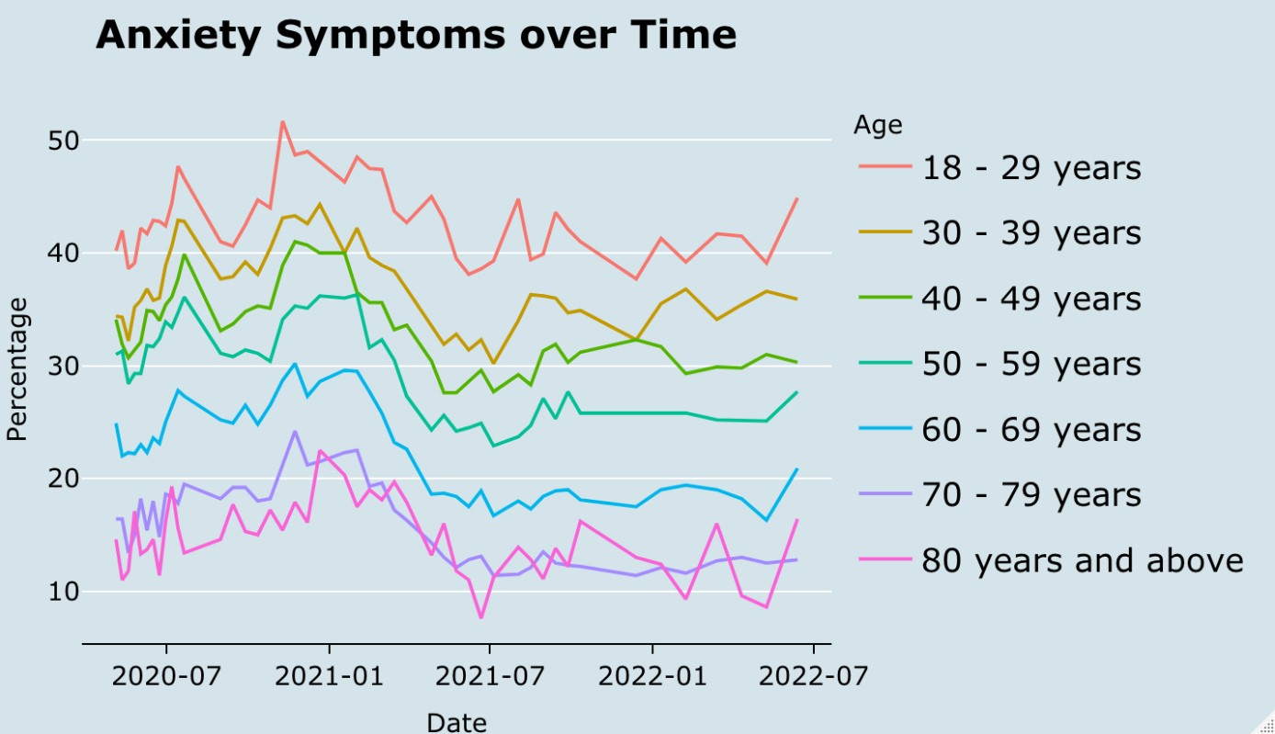

FIGURE 2: This graph shows the trends in anxiety symptoms over time for adults aged 18-29 years to 80 years and above. Source: U.S. Census Bureau, Household Pulse Survey, 2020-2022.

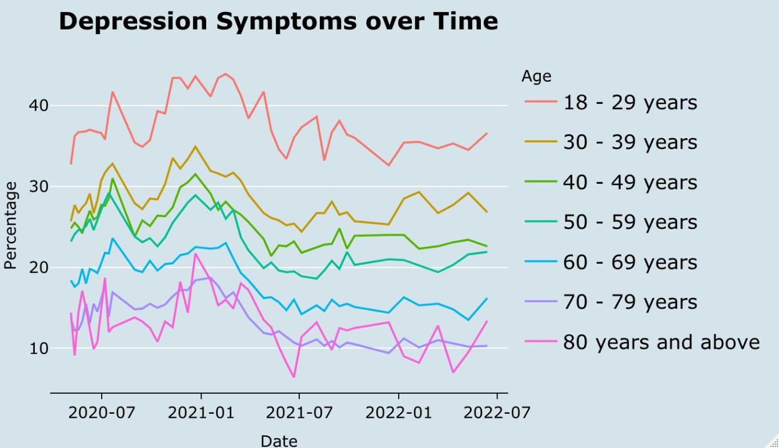

FIGURE 3: This graph shows the trends in depression symptoms over time for adults aged 18-29 years to 80 years and above. Source: U.S. Census Bureau, Household Pulse Survey, 2020-2022.

Figures 2 and 3 reveal that the hypothesis stated at the end of last section cannot hold true. That is, contrary to our expectations, the empirical evidence indicates that the significant increase in mental health symptoms is driven by the younger generations (18-29 age category). This provides insight into the fundamental cause of the significant increase in mental health problems from 2019 to 2020. Was the increase due to the direct effect of the SARS-CoV-2 virus itself? Or, instead, was it due to something else?

If the increase in mental health problems were due to the SARS-CoV-2 virus itself and nothing else, it would presumably disproportionally affect the older age generations, as they are most directly affected by the virus itself (Shahid et al. 2020; Yanez et al. 2020; Caramelo, Ferreira, and Oliveiros 2020). This, however, is not what we observe in the data. Because the data indicate that younger generations are disproportionally affected by mental health problems resulting from the pandemic, we must reject the hypothesis that the cause of this phenomenon is the SARSCoV-2 virus itself. Instead, we must logically conclude that something else is the cause of the mental health problems among the younger generations.

To investigate this conclusion, we must naturally explore the human response to the SARS-CoV-

2 virus. The “human response” to the virus, in this context, is the indirect effect of the virus on mental health through human actions propitiated by the virus. In other words, if it is not the SARS-CoV-2 virus itself driving the increased anxiety and depression among younger generations, it must be the human response to the virus.

For our purposes, it is convenient to subdivide the “human response” into formal responses and informal responses. Formal responses include the policies, laws, executive orders, mandates, stimulus bills, etc., formally enacted by governments, government officials, and official organizations, comparable to recommendations provided by the CDC. Informal responses include unspoken norms, beliefs, fears, and behaviors that shaped the interactions among individuals since March of 2020. While we recognize that the latter is difficult to quantify, we believe it must be acknowledged and further studied in future research. Our analysis will focus on the former, formal human responses, to the extent they can be (imperfectly) quantified.

Before we turn our analysis to the formal responses to the pandemic, it is important to investigate additional characteristics of the mental and overall health situation by age since the beginning of the pandemic. The following subsection breaks down by age the mental health care in the U.S. since the data first became available in August 2020.

## Mental Health Care by Age in the United States

In the Household Pulse Survey, three additional questions were asked to determine the influence of the COVID-19 pandemic on mental health care over a four-week period from August 11, 2020, to May 9, 2022. The mental health care topics of prescription medications, counseling and therapy, and unmet mental health needs were included in the survey.

The mental health care questions include:

“At any time in the last 4 weeks, did you take prescription medication to help you with any emotions or with your concentration, behavior, or mental health?”

“At any time in the last 4 weeks, did you receive counseling or therapy from a mental health professional such as a psychiatrist, psychologist, psychiatric nurse, or clinical social workers? Include counseling or therapy online or by phone.”

“At any time in the last 4 weeks, did you need counseling or therapy from a mental health professional, but DID NOT GET IT for any reason?”

For each question on the topic of mental health care, the participants could answer either “Yes” or “No”. If the participant’s answer was “Yes,” then their response was added to the overall percentage of the specific question.

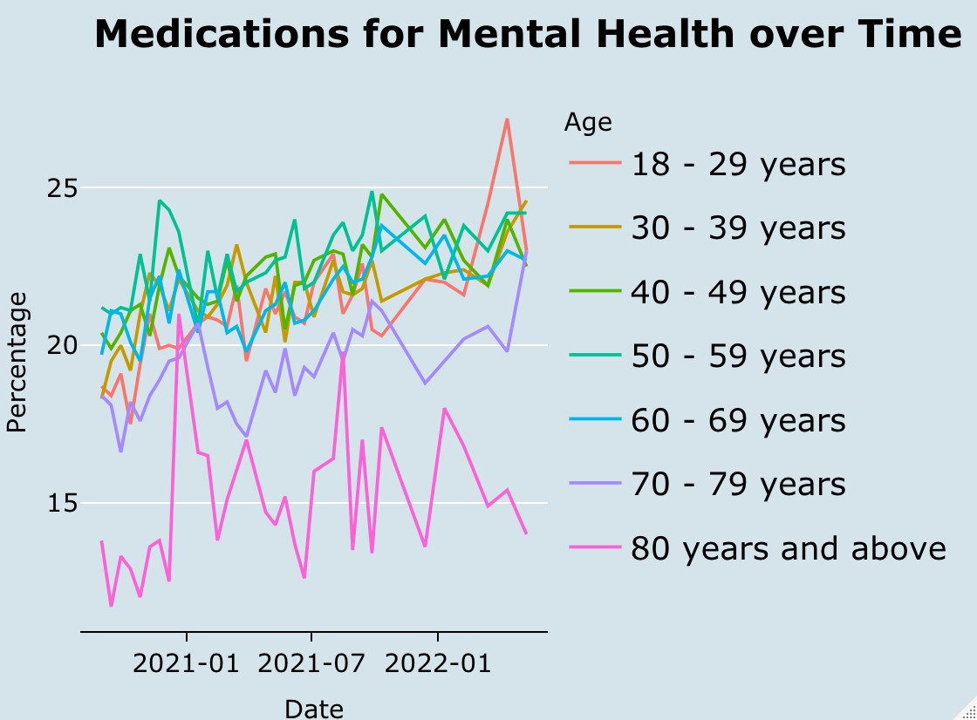

FIGURE 4: This graph shows the trends in prescription medications taken for mental health over time for adults aged 18-29 years to 80 years and above. Source: U.S. Census Bureau, Household Pulse Survey, 2020-2022.

Using mental health care data from the Household Pulse Survey, Figure 4 shows the trends in prescription medications taken for mental health in varying adult age groups. Throughout the collection period, the adults in age categories 18-29, 30-39, 40-49, 50-59, and 60-69 years were clustered together with little variation, which contrasts with the large variation and fluctuation of the 80 year and above age category.

Looking at the adults aged 18-29 years in Figure 4, the spike in prescription medications taken for mental health is notable during 2022. After analyzing Figures 2 and 3, it is evident that the youngest adult population struggled with mental health throughout the pandemic. In May 2022, the Household Pulse Survey reported that 45.7% of adults aged 18-29 years indicated having anxiety or depression symptoms within the previous seven-day period. As seen in Figure 4, during May 2022, 23.0% of adults aged 18-29 years indicated having taken medications for mental health, which is almost half the percentage previously mentioned.

Adults aged 18-29 years may face the problem of accessibility to mental health treatment, specifically prescription medications as well as counseling and therapy, due to financial limitations and lack of health insurance coverage compared to older adult populations. People with mental health concerns struggled with inequitable access to preventive actions and treatment during the COVID-19 pandemic response (Kola et al. 2021).

One obstacle that young adults face in receiving mental health treatment is the lack of health insurance coverage. According to the health insurance coverage data from the Household Pulse Survey, 16.0% of adults aged 18-24 years were uninsured from April 23, 2020, to June 13, 2022, resulting in difficulty treating their declining mental health with prescription medication. On average, 8.8% of adults aged 45-64 years were uninsured during the collection period allowing greater access to prescription medications. It is interesting to note that the youngest adult population with the greatest need for mental health resources are the most uninsured compared to other age categories, resulting in difficulty accessing mental health treatment.

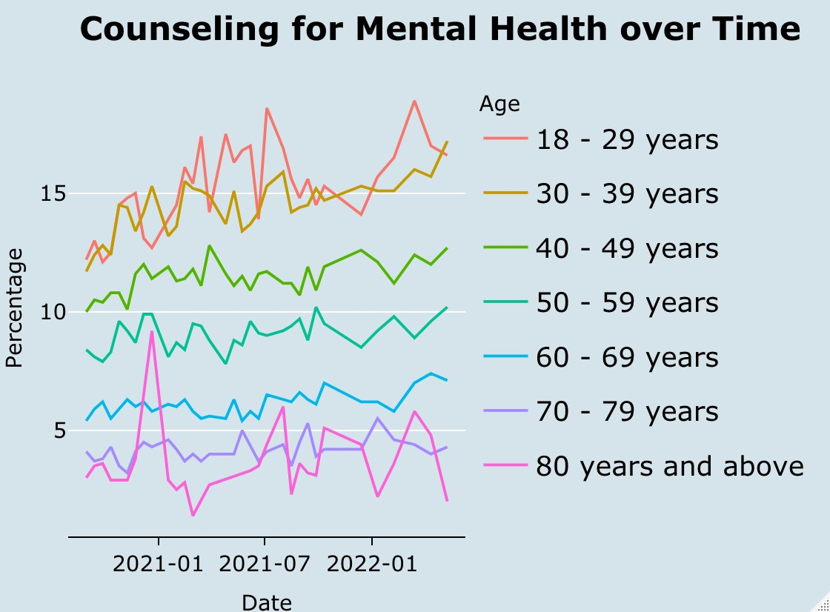

FIGURE 5: This graph shows the trends in counseling or therapy received for mental health purposes over time for adults aged 18-29 years to 80 years and above. Source: U.S. Census Bureau, Household Pulse Survey, 2020-2022.

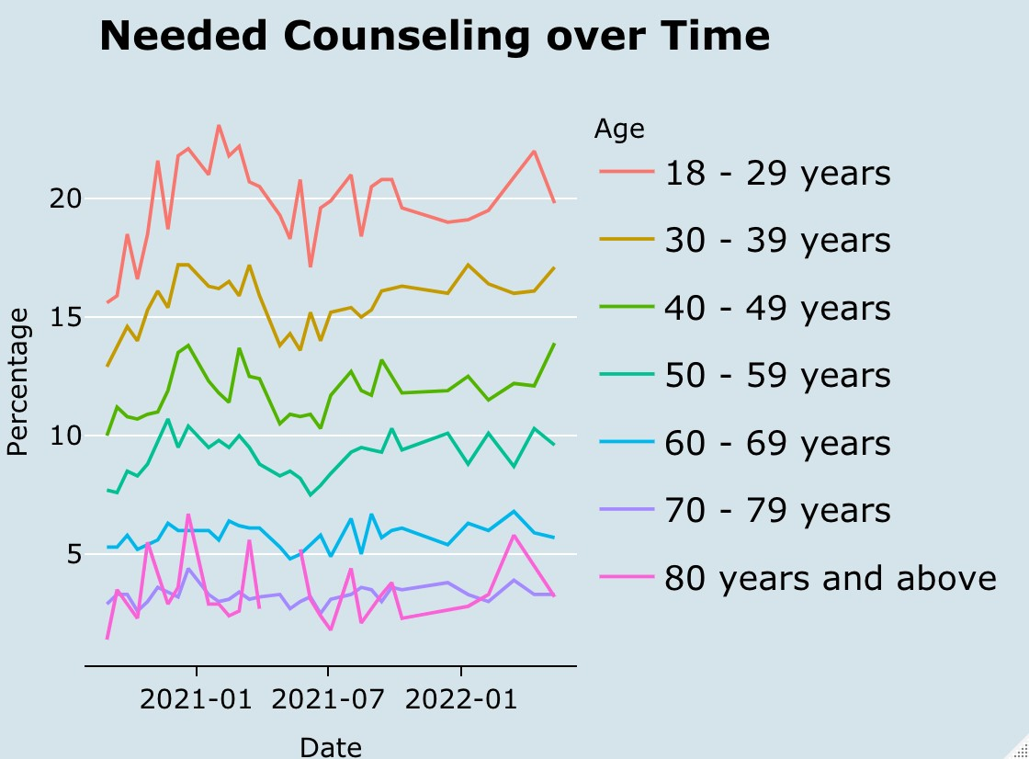

FIGURE 6: This graph shows the trends in the percentage of people who needed counseling or therapy for mental health but did not receive it over time for adults aged 18-29 years to 80 years and above. Source: U.S. Census Bureau, Household Pulse Survey, 2020-2022.

Figures 5 and 6 show different trends related to counseling or therapy for mental health in varying age groups from August 11, 2020, to May 9, 2022. Figure 5 displays the percentage of the adult population who has received counseling or therapy over time, and Figure 6 depicts the percentage of the adult population who needed counseling or therapy but did not receive it. In Figures 5 and 6, the variation between all the age categories is like the variation seen in Figures 2 and 3 on reported anxiety and depression symptoms.

In Figure 5, there is a clear increase in counseling and therapy received by adults aged 18-29 years throughout the collection period, indicating that counseling and therapy are most prevalent among the younger adult population, specifically after the pandemic. One scholarly article suggested that policymakers and medical professionals needed to prioritize people with mental health concerns throughout the COVID-19 response, because if they are not properly supported, then they will struggle with long-term mental health consequences (Kola et al. 2021). As seen in Figures 5 and 6, there is not a distinct sign of decline in needing as well as receiving counseling and therapy among the younger adult population during and after the pandemic. If the young adult population continues to go untreated for mental health concerns, this age group may struggle with long-term mental health consequences.

# United States Pandemic Response

## Vaccinations

In response to the COVID-19 pandemic, vaccine rollouts for each state varied greatly. While vaccines have been shown to decrease the negative mental health effects of COVID-19 (Koltai et al. 2021) and the safety and efficacy of COVID-19 vaccinations have been studied (Polack et al. 2020), states continue to take divergent approaches to vaccination distribution. In order to understand how COVID-19 impacted mental health, differences in U.S. state approaches must be studied.

Incentives have been used during the COVID-19 vaccine distribution as a method to increase overall vaccination rate. Providing direct guaranteed cash payments for vaccinations was the most successful incentive, specifically when compared to alternative non-monetary or lotterystyle incentive strategies (Brewer et al. 2022). More effective vaccines help incentivize vaccinations in public perception - while the prevalence of side effects and Emergency Use Authorization to fast-track the vaccine tend to increase hesitancy towards vaccination. The manufacturer of the vaccine had no influence on vaccination willingness (Kreps et al. 2021).

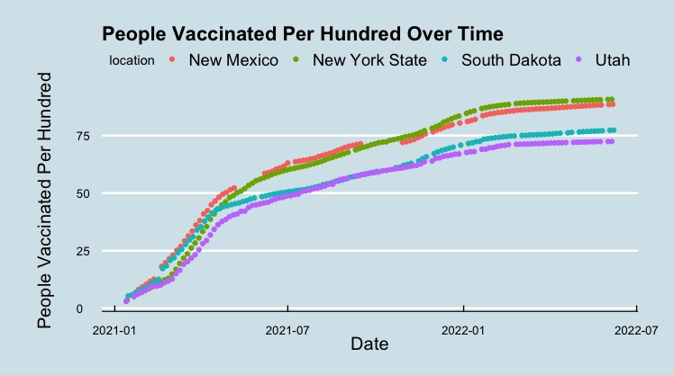

FIGURE 8: This graph displays the people vaccinated controlled for population size from January 2021 – June 2022 in New Mexico, New York, South Dakota, and Utah. Source: CDC, 2021-2022.

Figure 8 depicts the trend in the number of people vaccinated (per hundred thousand) in a selection of U.S. States. While an overall increase in vaccinations is observed from January 2021 – July 2022 in all states, New Mexico and New York State display a noticeably higher rate of vaccinations when compared to South Dakota and Utah starting in June of 2021. This trend in vaccination rate continues until July of 2022, and it reflects a broader pattern of states responses to COVID-19. The next subsection explores this broader pattern of responses using a stringency index.

## Stringency Index

The stringency index provides a quantitative representation (1-100) to estimate the rigidity of individual state responses to COVID-19 in the United States. Within the stringency index is a collection of five subcategories, each representing a different area of pandemic response. The subcategories of the stringency index include virus containment and closure restrictions, economic support, health system mandates, vaccination administration, and other miscellaneous components. All five subcategories are combined into one stringency index value for each U.S. state. The stringency index for each U.S. state is shown in Figure 9.

In order to understand the stringency indices of U.S. states in Figure 9, pandemic response policies and mandates are investigated. In many of the midwestern and southern states, a less stringent approach was taken with lenient policy responses as well as less generous income support (Laura Hallas et al. 2020). In contrast, the northeastern states implemented more stringent policies, specifically regarding facial coverings, with a near two-fold difference in ‘days on average with facial covering requirements in place’ (Laura Hallas et al. 2020). The varying degree of the stringency index throughout the United States as seen in Figure 9 reflects varying U.S. state policies in response to the pandemic.

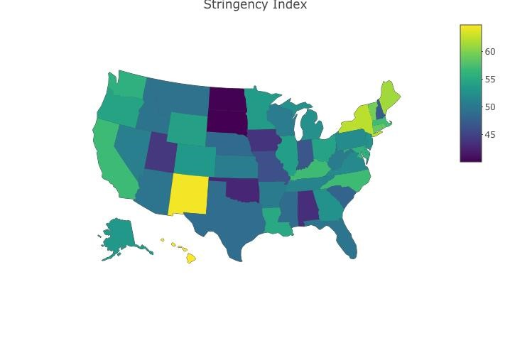

FIGURE 9: The United States heat map depicts the stringency index by state from January 2020 to April 2021 in which the lighter colors represent a higher stringency index. Source: Oxford Coronavirus Government Response Tracker, 2020-2021.

Prior literature suggests that certain factors have an influence on the ability for a government to respond to a pandemic. These factors include weak institutional systems and inadequate funds and resources. Government health intervention response also relies on the initial success of the intervention and incidence of related, unintended repercussions (Oliver 2006).

The public's perception of stringency is significantly influenced by many factors including health risk, social climate, financial concerns, and political ideology (Lee et al. 2021, Cindy H Liu et al. 2022). It is also documented that the public's perception of stringency has a significant impact on the efficacy of the public's prevention behaviors (Lee et al. 2021), similar to the documented correlation between rising COVID-19 case reports and increases in mitigating risk behaviors (Bilinski et al. 2021). This finding offers important insights into the potential for a change in policy effectiveness depending on public reception of COVID-19 prevention policies. This would also suggest that states’ stringency must be, at least in part, a function of their demographic and their unique demographic beliefs, as intervention is more successful with better public perception.

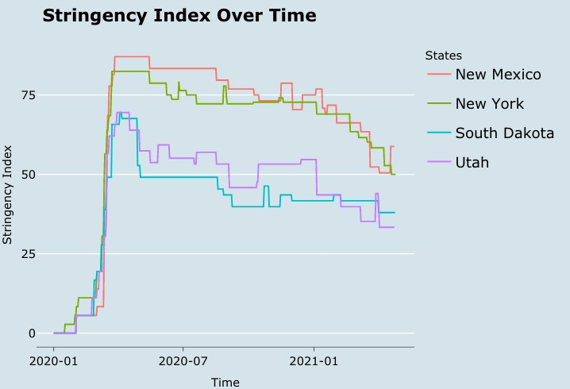

FIGURE 10: Trends in stringency index for New Mexico, New York, South Dakota, and Utah from January 2020 to April 2021. Source: Oxford Coronavirus Government Response Tracker, 2020-2021.

Figure 10 shows similar trends in the stringency index for the same selection of US states as in Figure 8 (New Mexico, New York, South Dakota, and Utah). Up until April of 2020, every state exhibited a significant spike in the stringency of COVID-19-related policy responses. From this point forward, the variation in the responses widened as states implemented different policies. This observation is consistent with the patterns of location and income support as documented by Laura Hallas et al. (2020) and may be influenced by weak institutional systems, inadequate funds and the initial success of government health interventions as described by Oliver (2006). The United States’ approach to the pandemic requires further investigation as time progresses to better understand specific causes of the trends observed.

# Mental Health and Mass Shootings

*4.1. Mental Health and Mass Shootings: A Doom Loop?*

Like the negative trend in the mental health of the youth, modern-day mass shootings have experienced a recent uptick in the United States. The goal of this section is to investigate if there is a connection between mass shootings and the COVID-19 pandemic.

Today, there are almost daily occurrences of mass shootings in the United States. A "mass shooting" is defined as an event caused by a shooter that results in four or more casualties. Most of these shootings go unreported, but reported cases receive nationwide news, potentially exacerbating the anxiety of the population. According to The Violence Project database - which studies 179 mass shooters between the years 1966 and 2022 and their characteristics – two-thirds of these criminals suffered from some form of mental illness (Peterson, J., & Densley, J. 2022). Indeed, severe or untreated mental illness have been found to increase the risk for violence (Metzl, Jonathan M. 2015). Therefore, the higher the share of the population with mental illness, the higher the likelihood that a new and unexplained massacre would occur.

Increased awareness of this phenomenon is more necessary than ever due to the potential correlation to the way each country, state, or jurisdiction responded to the pandemic. This may relate to the prominence of mental illness in the United States - which can be studied before, during, and after the pandemic. Further investigation is required to understand the magnitude by which a states’ response to the pandemic impacted increased rates of violence and mass shootings to occur in the United States. Among the key questions to investigate is how much the country's response impacts more violence and mass shootings to occur in the United States?

A majority of people understand mass shootings to be an event outside of social norms (Semenza, Daniel Charles, and John A. Bernau. 2022). If such an event can be understood as irregular, then why do they occur so frequently? In their paper, the authors talk about Collective Threat Perception - which they describe by saying, “...groups of people may perceive violent events that happen to others in the present as threatening to themselves in the future, resulting in feelings of powerlessness, mistrust, and fear that shape the cognitive worldview of the group”. It was also found that the trend for Google searches like “gun control” or “gun rights” are often dependent on the amount of media coverage given to a shooting – which, in turn, depends on the amount of damage caused by a given shooting. “Every additional news article about a mass shooting increases search traffic for gun control and gun rights by 3.7 and 2.9 percent”. This could potentially lead to even more mass shootings, strengthening even further the “doom loop” of mental health issues and mass shootings.

*4.2. Brief Recount of Mass Shooting Tragedies and Mental Health.*

Some of the shootings that have caught the nation's attention include Sandy Hook Elementary School in 2012, the Columbine High School shooting in 1999, and the Parkland High School shooting in 2018, which helped set the stage for the debate on gun control in the country. This subsection briefly recounts these tragedies and lessons learned regarding the importance of mental health and the roles of the media, and most recently social media, providing widespread attention to these isolated events. The COVID-19 pandemic, and more precisely the government response, significantly increased the loneliness and digital screentime of the population (Mareike Ernst; Sultana et al. 2021). Similarly, Google searches for things like suicide rates mental health factors spiked after the pandemic “These results broadly indicate that as mobility decreased (i.e., more time at home), search volumes for terms within these categories increased at the same time.” (Gimbrone et al. 2021). Because of this nonstop news coverage, the population, especially the younger generations, was exposed to a higher share of negatively inclined news media, potentially causing a spike in fear among the people and reinforcing the nature of the “doom loop”.

Columbine High School (Littleton, Colorado) (1999):

The Columbine High School shooting took the world by a huge surprise - since there had never been any event like it in the past. Two teenagers killed 15 people, including themselves, and injured 20 others in the process. The teens had apparently been planning this for almost an entire year and had debated about bombing the school instead – violent video games and music were possible explanations for this, but nothing was ever proved. One of the teens was described as the mastermind whereas the other was a helpless depressed romantic who journaled a lot. Discussions about gun control and school safety and policies were brought up consistently after this event. The nationwide coverage of this event could have caused an increase in mass shootings in the country as well, specifically school shootings.

Sandy Hook Elementary School (Newtown, Connecticut) (2012):

In December 2012, a 20-year-old man shot up an elementary school in what would be known at the time as the second-deadliest mass shooting after the Virginia Tech massacre where 32 people were killed. The state attorney stated that the shooter had a history of "significant mental health issues" and they "did not see anything that would have predicted his future behavior". New gunsafety protocols were attempted to be put into place by Barack Obama, however, the Senate blocked the bill proposed by him.

Stoneman Douglas High School (Parkland, Florida) (2018):

In February 2018, 17 people were killed in the second deadliest high school shooting in the nation at the time in Parkland, Florida at Stoneman Douglas High School. The shooter was a previously expelled student from the school and had returned with automatic weapons he had purchased legally. Many of the students who survived the attack acted against gun regulations and spoke out against corporations like the NRA who were protecting gun owners' rights instead of protecting the citizens of the nation. What came out of it was a bill that required a person to be

21 years old to legally buy a gun - there must be a three-day waiting period between all transactions. In some states, teachers or school staff were allowed to be armed with guns, which caused further debate.

These three tragedies substantially shaped how mass shootings are perceived in the United States. All of them left ramifications and bolstered the gun control debate. But how did COVID19 affect these issues? The following subsection investigates this question.

*4.3 COVID-19 and Its Effect on Mass Shootings:*

The COVID-19 pandemic took the world by storm in an analogous way that the Columbine shooting did in 1999. The Columbine shooting ended up inspiring more active shooter training in public schools and stricter rules on the purchasing of guns. This changed the mindset of many citizens and voters - as the second amendment claims that all citizens have the right to bear arms. That amendment has been a key discussion point in the topic of mass shootings and has been brought up several times - mostly after a major shooting like the ones mentioned above. The COVID-19 pandemic also changed the world and how we view things as well. The world was used to going to school and knowing that they would be safe before the Columbine shooting. Now, the world is getting used to the idea of COVID-19 being a prominent disease in our lifetime. This is another obstacle for us to get over, but do these two events have any significant correlation? During the quarantine period, there were few shootings in the country. However, the numbers for injuries and the number of people killed spiked around the June 2020 - July 2020 period when the Black Lives Matter Movement was at its climax. Could this be because the pandemic brought out more stress and depression and anger in the people of the United States?

Figures 12 and 13 investigate this question by providing quarterly information on the "Number of Injuries" and "Number of People Killed", respectively, for mass shootings that occurred between 2018 and 2022. A shooting is classified as a "mass shooting" in this dataset if four or more people were injured.

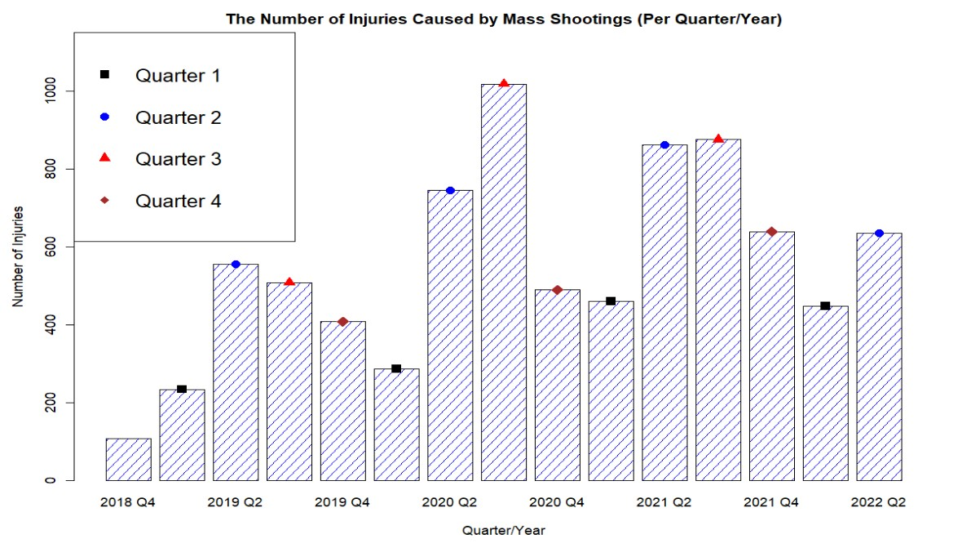

FIGURE 11: This graph shows the trends (by quarter/year) in the number of injuries caused by mass shootings over time. Source: Gun Violence Archive 2018-2022.

Figure 11 shows that through most of the quarters there is an increase in the number of injuries caused by mass shootings. We can see that in "2020 Q2", the number of injuries spiked - this was due to the Black Lives Matter Movement mixed with the fact that most people were coming out of quarantine at that time. The number of injuries in "2020 Q1" was lower than most of the other quarter/years because most people were quarantining due to the COVID-19 pandemic.

There seems to be a pattern of more injuries due to mass shootings occurring specifically in Quarters 2 and 3. This being the middle of the year, this is also when people will become most active during the summertime - whereas Quarters 1 and 4 seem to have a trend of fewer injuries occurring - most likely because of them taking place during the wintertime.

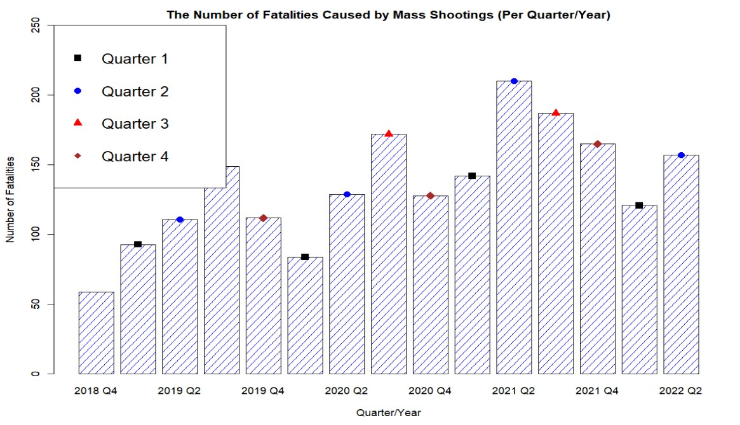

FIGURE 12: This graph shows the trends (by quarter/year) in the number of fatalities caused by mass shootings over time. Source: Gun Violence Archive 2018-2022.

Figure 12 shows that through, most of the quarters, there is an increase in the number of people killed during a mass shooting. The quarters with increases throughout each year on the graph are especially concerning because most of them took place during the pandemic. Looking at this, we would assume that the response to COVID-19 influenced the fluctuation of mass shootings throughout the country.

There seems to be a clear increase of more fatalities due to mass shootings occurring after the COVID-19 pandemic. This may be because of the way the United States responded to the situation - quarantining its citizens and deteriorating their mental health. During quarantine, numbers are much lower than previous quarters. After requiring people to isolate themselves, the number of fatalities caused by mass shootings increase significantly.

*4.4 Mass Shootings in the U.S. and Other Developed Countries.*

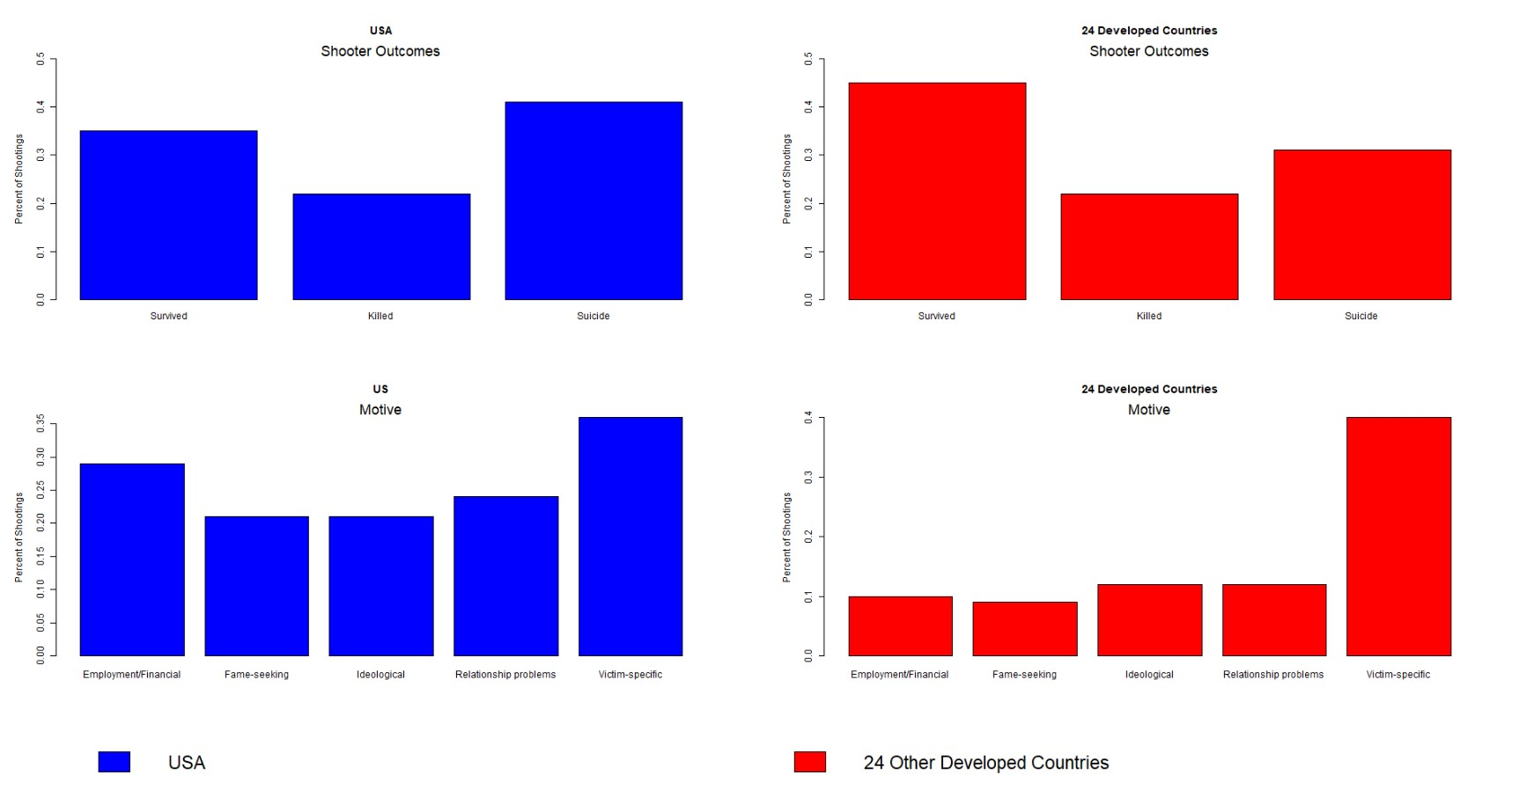

FIGURE 13: This graph compares the United States versus 24 other developed countries by their mass shooting characteristics. Above, we analyze the possible shooter outcomes and motives. Source: Silva 1998-2019

Using the data from Silva (2021), this section investigates the shooter outcomes and motives behind mass shootings in the United States and 24 other developed countries. Figure 13 studies two variables – the “Shooter Outcome”, or what happens to the shooter after the incident occurs, and “Motive”, or one of the motivations that may have caused the mass shooter to commit this crime. Looking at the figure above, we can see some of the major differences in mass shootings between the United States and 24 other developed countries. These numbers include those before (1998-2019), during, and after the pandemic. These comparative figures shed light on the mental health problems as drivers of mass shootings in the United States and other developed countries.

The “Shooter Outcome” graphs are especially interesting to look at – most shooters end up committing suicide by the end of their crime in the U.S. This could be directly correlated with the mental health increasing in the country – but this shows just how much of a problem this is in the country compared to developed ones. In developed countries, most shooters will end up surviving by the end of the incident – with a survivability rate larger than the U.S. by almost 10%.

The unemployment situation before and after the pandemic is another key factor influencing both mental health and mass shootings. About 30% of mass shooters were motivated by their

“employment/financial” situation. The unemployment rate fluctuated substantially during the

COVID-19 era, and this wild variation raises concerns about mental health problems and potential mass shootings. In the other 24 developed countries, most shooters’ motives are victimspecific – meaning they aren’t trying to take out a large group of people necessarily. In contrast, the U.S. mass shooters seem more interested in large-scale situations than taking out just one individual. Figure 13 illustrates this point. This could have to do with the mental illness in the country before the pandemic, but the pandemic itself left the country with more mental illness from before as we can see earlier in our data.

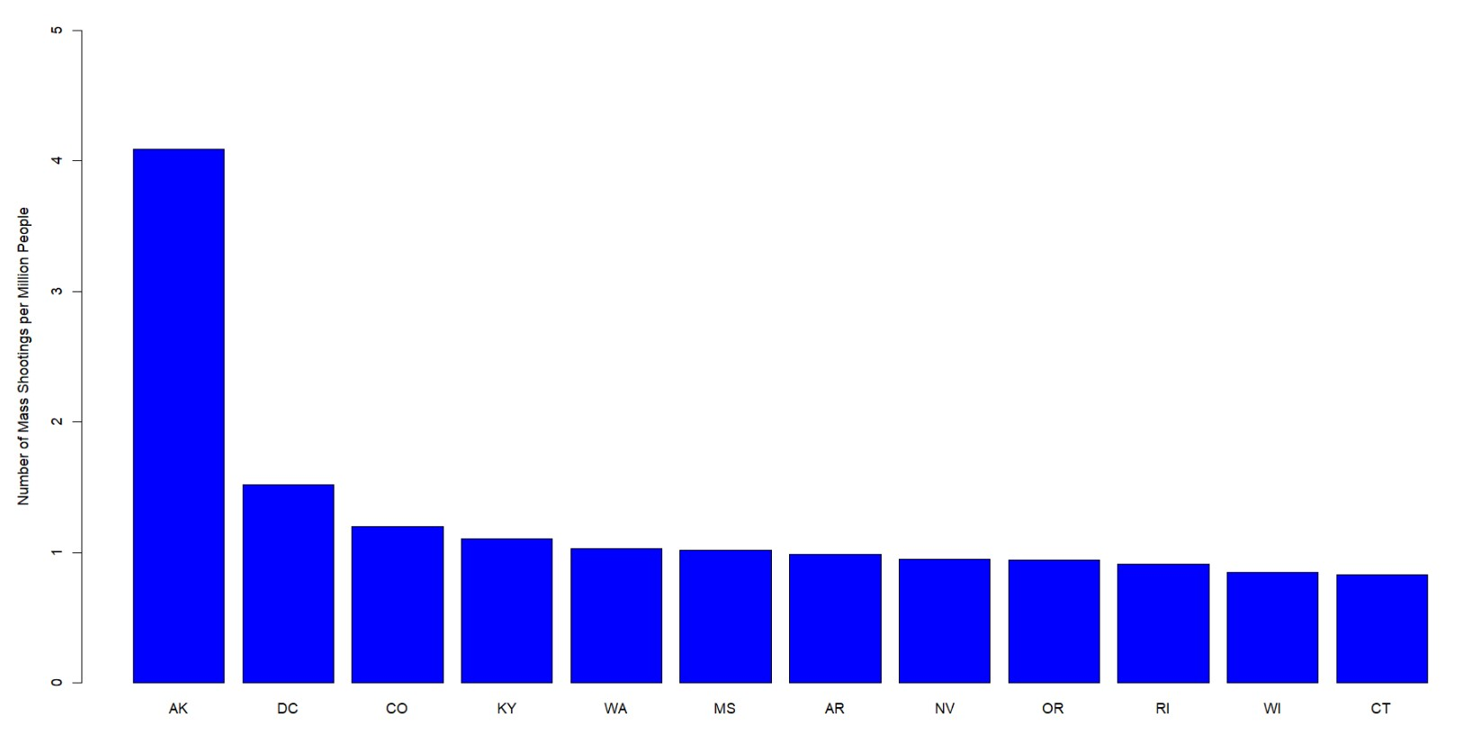

FIGURE 14: This graph compares the states with the highest number of mass shootings per million people. Source: The Violence Project 1966-2022, Bureau of Economic Analysis (BEA)

Figure 14 shows the twelve states with the highest rates of mass shootings per million people.

From high to low, Alaska (4 shootings per million), District of Columbia, Colorado, Kentucky,

Washington, Mississippi, Arkansas, Nevada, Oregon, Rhode Island, Wisconsin, and Connecticut (1 shootings per million). The data comes from the Violence Project corresponding to the period 1966-2022.

Except for Wisconsin, all states in the graph depicted in Figure 14 were among the countries with the highest anxiety and depression levels during the pandemic, as seen in Figure 15 below. The states most affected by mass shootings relative to their population size during 1966-2022 had above-average anxiety and depression levels during the pandemic. These data illustrate the state-wide correlation between historical mass shooting rates and anxiety or depression during the pandemic.

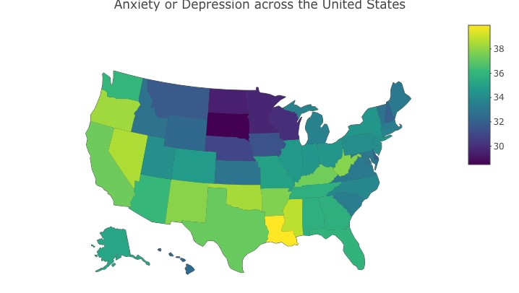

FIGURE 15: Mean Anxiety or Depression Levels by State, May/2020-June/2022. Source: Household Pulse Survey

# Correlation and Regression Analysis

In order to investigate the association between the response to the pandemic and mental health more thoroughly, this section uses correlation and regression analysis. We focus on the formal policy response as imperfectly measured by the stringency index defined in section 3.2. More precisely, the average stringency index from January 2020 to April 2021 was calculated as well as the change in the percentage of the population showing anxiety or depression symptoms in each U.S. state from the pandemic peak period (May-2020 to Jul-2021) to the post-pandemic peak period (Jul-2021 to Jun-2022). We then use regression analysis to investigate the relationship between these two key variables. We lag the stringency index (our key explanatory variable) relative to the change in the percentage of the population showing anxiety or depression (our key dependent variable) to minimize reverse causality concerns. Results are presented in Table 1.

*Dependent variable:*

Anxiety or Depression Difference

*Average during Jul2021*–*Jun2022 minus May2020*–*Jul2021*

(1) (2) (3) (4) (5)

Mean of the Stringency Index -0.096*** -0.100*** -0.114*** -0.128*** -0.122***

(Jan2020 – Apr2021) (0.033) (0.034) (0.032) (0.030) (0.032)

Population Over 65 5.608 3.807 4.421 3.350

Population)(Percentage of the Adult (9.104) (8.497) (7.857) (8.069)

Growth Rate of *per capita* GDP -73.124*** -68.841*** -67.535***

(Annual Rate During 2019–2022) (25.454) (23.574) (23.803)

All-Cause Mortality Rate -822.474*** -775.196***

(Jan2020 – Apr2021) (276.778) (287.465)

Anxiety and Depression Peak -0.043

(May2020 – Jul2021) (0.065)

|  |  |  |  |  |  |
| --- | --- | --- | --- | --- | --- |
| Model Intercept | 0.308 | -0.731 | 3.655 | 5.339** | 6.666** |
|  | (1.735) | (2.428) | (2.727) | (2.584) | (3.279) |
| Observations | 50 | 50 | 50 | 50 | 50 |
| Adjusted R2 | 0.131 | 0.119 | 0.237 | 0.348 | 0.340 |

*Note:* *p<0.1, **p<0.05, ***p<0.01

TABLE 1: Determinants of Anxiety or Depression during the Pandemic: Multivariate Regression Analysis. Source: Household Pulse Survey, the CDC, and the Federal Reserve Economic Database (FRED).

Column 1 of Table 1 shows a statistically significant relationship between the stringency index and the change in the percentage of the population showing symptoms of anxiety or depression from the first year of the pandemic to the second year. This significant value of –0.096 indicates that U.S. states with higher stringency indices during January 2020 to April 2021 experienced a reduction in anxiety or depression symptoms between the periods May-2020 to Jul-2021 and Jul2021 to Jun-2022.

Column 2 of Table 1 adds the percentage of the adult population over 65 to the model. Adding this demographic variable means holding it constant in the model when interpreting the other variables. The coefficient for the stringency index became larger in magnitude (-0.100) and remained statistically significant at the 1 percent significance level.

Next, column 3 holds constant the annual growth rate of *per capita* GDP for each state during 2019-2022. As a result, the coefficient associated with the stringency index increased in magnitude, confirming the association between the stringency index and mental health during and after the pandemic. Because this significant value is beyond three standard deviations, this observation cannot be due to chance. Our findings suggest that different COVID-19 pandemic responses across U.S. states impacted adults' mental health as measured by the stringency index.

However, how mental health was affected depends on each state's specific characteristics and policy response.

In addition to the percentage of the adult population over 65 years old and the annual growth rate of *per capita* GDP for each U.S. state, Column 4 also adds the all-cause mortality rate during the first leg of the pandemic (specifically Jan 2020 – April 2021). Adding this variable increased the magnitude and significance of the stringency index. The coefficient changed from (-0.114) in column 3 to (-0.128) in column 4.

Finally, the reduction in anxiety and depression levels in the second leg of the pandemic (specifically July-2021 to June 2022) may be associated with the peak of mental health issues accrued during the first leg (prior to July 2021). To investigate this, column 5 also controls for the average anxiety and depression levels from May 2020 to July 2021. Interestingly, the coefficient associated with the Stringency Index was virtually unchanged and remained statistically significant. This finding suggests that the reduction in anxiety or depression levels during the second leg of the pandemic was more associated with the stringency index than with the peak mental health issues of the first leg.

The negative coefficient for the Stringency Index is an encouraging sign, indicating that states with a larger stringency index before April 2021 experienced, on average, a larger reduction in anxiety or depression levels after July 2021. This finding may be partly explained by the economic relief and stimulus packages that are included in the stringency index prior to April 2021, marginally improving the social climate and reducing financial concerns for U.S. families

(Cindy H Liu et al. 2022). Nevertheless, while the decrease in anxiety or depression levels after July 2021 was statistically significant, it was relatively small in magnitude and not large enough to mitigate the drastic increase observed from 2019 to 2020. In other words, the anxiety and depression levels as of June 2022 are still far higher than the pre-pandemic levels.

# Discussion, Future Research, and Limitations

The SARS-CoV-2 virus has been shown to present a disproportionate mortality risk to the older adult population (Shahid et al. 2020; Yanez et al. 2020; Caramelo, Ferreira, and Oliveiros 2020). This is likely to result in a negative effect on their mental health. Conversely, the young adult population is at low mortality risk (Sunil S Bhopal et al. n.d.). Thus, we expect the older adult population to experience a more negative mental health impact from the SARS-CoV-2 virus than the younger adult population. As seen in Figures 2 and 3, however, the empirical evidence suggests the opposite has occurred. Mental health issues have increased disproportionately among the young. This suggests that the SARS-CoV-2 virus itself cannot be causing the outstanding negative mental health impact we observe among the young. Rather, the indirect effects of the virus must be the cause.

The indirect effects of the virus, however, are complex, multidimensional, and difficult to quantify. Future research is necessary to investigate the symptoms associated with the pandemic not resulting from the SARS-CoV-2 virus itself. In this paper, we classified the indirect effects of the virus as formal and informal human responses but focused on the formal responses alone. Future research needs to investigate and potentially quantify the informal responses.

Our findings create an opportunity to investigate the indirect effects of the virus including the symptoms associated with the pandemic that are not a direct result from the SARS-CoV-2 virus itself. For example, this paper focuses on the general formal response to COVID-19, but the informal response (e.g., social norms, personal beliefs, political convictions) is subject to future research. While the informal response is both difficult to understand and quantify, its’ influence on the US and the world must be investigated. In addition, our research on the relationship between mental health and mass shootings does not prove causation. Therefore, this area requires future research to better comprehend this alarming US problem. Finally, case studies can complement our research by providing fundamental insights into the specific causes driving the mental health changes in each state.

While the objective of our research is not to investigate overall quality of life directly, our results have significant implications for overall wellbeing that can be investigated in the future. While quality of life is both subjective and multidimensional (Cella 1994), this paper assumes that mental health significantly contributes to one’s overall quality of life. Consistent with this assumption, our quantitative results suggest a significant negative effect on overall quality of life in all age categories, and specifically young adults. This effect may be a result of a combination of the SARS-CoV-2 virus itself and the human response to it. Our results suggest, however, that the human response to it is significantly more relevant to mental health and the subsequent quality of life.

Our research is also limited by the available data. Due to the lack of available mental health data resulting from COVID complications from January 2020-April 2020, our mental health dataset from the Household Pulse Survey starts in May 2020. In other words, research on the mental health reaction to the pandemic is limited by the difficulty of collecting data prior to May of 2020. In addition, the mental health data used in our investigation is self-reported, which lends itself to potential response bias. This could potentially affect the accuracy of our results. For example, if the young are more likely to over-report symptoms than the old following the COVID-19 pandemic, our results would be biased.

There are no other events like the COVID-19 pandemic in recent history. Thus, the potential for comparative analysis is significantly limited, especially when analyzing mental health. Although some comparisons could be made between the COVID-19 and the 1918 Spanish Flu pandemic, the state of the world in 1918 is not comparable to 2020. Our recommendations are in line with Aknin et al. 2022 regarding the need for large-scale research on the long-term consequences of both COVID-19 itself and the human response to it on mental health. However, this suggests to us, and other researchers (Aknin et al. 2022), the potential and necessity for further research into this area. We believe future research could forecast the effects of the pandemic over time, on mental health, overall health, and the society at large. While our analysis focuses on analyzing available data without projecting towards the future, we believe there is value in doing so.

# Conclusion

This paper finds that the mental health of the younger adult population (18-29 years) in the United States was significantly affected by the COVID-19 pandemic, both directly and indirectly. While the approaches of U.S. states’ pandemic responses varied, the main goal was to protect the health and safety of Americans, specifically the elderly population. We hypothesized that during the pandemic, the older adult population would have the highest reported anxiety and depression symptoms. However, our results indicate a massive surge in reported anxiety and depression symptoms in the younger adult population throughout the pandemic. This rejects our initial hypothesis that the older adult populations would suffer the greatest from mental health issues due to a greater physical health risk from COVID-19.

Possible explanations for the increase in reported anxiety and depression symptoms of the younger adult population are complex and vary by state. On the one hand, our analysis suggests that the indirect effect of the SARS-CoV-2 virus, categorized as formal and informal human responses, is a vital factor driving the spike in mental health problems among the younger generations. On the other hand, while we recognize that the stringency index is an imperfect measure of the formal response, we find a small (yet statistically significant) reduction in peak anxiety and depression levels during the first year of the pandemic associated with the stringency of the response. The reduction is not close to pre-pandemic levels, suggesting that the informal human response plays a considerable role in understanding mental health and needs further investigation.

Finally, we investigate the potential influence of mental health problems on modern-day mass shootings in the United States relative to 24 other developed countries. The high rates of reported anxiety and depression symptoms in the younger adult population (18-29 years) raise concerns about future occurrences of mass shootings, which are predominantly carried out by adults in this age group. In addition, a negative feedback loop between mass shootings and the mental health of the young population is investigated. Because of the recent spike in mass shootings across the country, we believe that further research is necessary to determine the long-term effects of the COVID-19 pandemic response on the mental health of the younger adult population.

# References

Aknin, Lara B., Jan-Emmanuel De Neve, Elizabeth W. Dunn, Daisy E. Fancourt, Elkhonon

Goldberg, John F. Helliwell, Sarah P. Jones, et al. 2022. “Mental Health During the First Year of the COVID-19 Pandemic: A Review and Recommendations for Moving Forward.” *Perspectives on Psychological Science* 17 (4): 915–36. [https://doi.org/10.1177/17456916211029964.](https://doi.org/10.1177/17456916211029964)

BallotPedia. 2020. “States That Did Not Issue Stay-at-Home Orders in Response to the Coronavirus (COVID-19) Pandemic, 2020.” *BallotPedia*. [https://ballotpedia.org/States_that_did_not_issue_stay-athome_orders_in_response_to_the_coronavirus_(COVID-19)_pandemic,_2020.](https://ballotpedia.org/States_that_did_not_issue_stay-at-home_orders_in_response_to_the_coronavirus_(COVID-19)_pandemic,_2020)

Bilinski, Alyssa, Ezekiel Emanuel, Joshua A. Salomon, and Atheendar Venkataramani. 2021.

“Better Late Than Never: Trends in COVID-19 Infection Rates, Risk Perceptions, and Behavioral Responses in the USA.” *Journal of General Internal Medicine* 36 (6): 1825– 28. [https://doi.org/10.1007/s11606-021-06633-8.](https://doi.org/10.1007/s11606-021-06633-8)

Brewer, Noel T., Alison M. Buttenheim, Chelsea V. Clinton, Michelle M. Mello, Regina M.

Benjamin, Timothy Callaghan, Arthur Caplan, et al. 2022. “Incentives for COVID-19 Vaccination.” *The Lancet Regional Health - Americas* 8 (April): 100205. [https://doi.org/10.1016/j.lana.2022.100205.](https://doi.org/10.1016/j.lana.2022.100205)

Caramelo, F., N. Ferreira, and B. Oliveiros. 2020. “Estimation of Risk Factors for COVID-19 Mortality - Preliminary Results.” medRxiv. [https://doi.org/10.1101/2020.02.24.20027268.](https://doi.org/10.1101/2020.02.24.20027268)

CDC. 2020. “COVID Data Tracker.” Centers for Disease Control and Prevention. March 28, 2020. [https://covid.cdc.gov/covid-data-tracker.](https://covid.cdc.gov/covid-data-tracker) CDC. 2022. “CDC Museum COVID-19 Timeline.” Centers for Disease Control and Prevention. January 5, 2022. [https://www.cdc.gov/museum/timeline/covid19.html.](https://www.cdc.gov/museum/timeline/covid19.html)

Cella, David F. 1994. “Quality of Life: Concepts and Definition.” *Journal of Pain and Symptom Management* 9 (3): 186–92. [https://doi.org/10.1016/0885-3924(94)90129-5.](https://doi.org/10.1016/0885-3924(94)90129-5)

Cindy H Liu, Ga Tin Finneas Wong, Sunah Hyun, and Hyeouk Chris Hahm. 2022. “Concerns about the Social Climate, Finances, and COVID-19 Risk on Depression and Anxiety: An Analysis on U.S. Young Adults across Two Waves - PubMed.” April 2022. [https://pubmed.ncbi.nlm.nih.gov/35189512/.](https://pubmed.ncbi.nlm.nih.gov/35189512/)

Clair, Ruta, Maya Gordon, Matthew Kroon, and Carolyn Reilly. 2021. “The Effects of Social Isolation on Well-Being and Life Satisfaction during Pandemic.” *Humanities and Social Sciences Communications* 8 (1): 1–6. [https://doi.org/10.1057/s41599-021-00710-3.](https://doi.org/10.1057/s41599-021-00710-3)

Cucinotta, Domenico, and Maurizio Vanelli. 2020. “WHO Declares COVID-19 a Pandemic.” *Acta Bio-Medica: Atenei Parmensis* 91 (1): 157–60. [https://doi.org/10.23750/abm.v91i1.9397.](https://doi.org/10.23750/abm.v91i1.9397)

Esai Selvan, Myvizhi. 2020a. “Publisher Correction: Risk Factors for Death from COVID-19.” *Nature Reviews Immunology* 20 (7): 448–448. [https://doi.org/10.1038/s41577-020-0371-](https://doi.org/10.1038/s41577-020-0371-9)

[9.](https://doi.org/10.1038/s41577-020-0371-9)

Esai Selvan. 2020b. “Risk Factors for Death from COVID-19.” *Nature Reviews Immunology* 20

(7): 407–407. [https://doi.org/10.1038/s41577-020-0351-0.](https://doi.org/10.1038/s41577-020-0351-0)

Gimbrone, Catherine, Caroline Rutherford, Sasikiran Kandula, Gonzalo Martínez-Alés, Jeffrey Shaman, Mark Olfson, Madelyn S. Gould, Pei Sen, Marta Galanti, and Katherine M.

Keyes. 2021. “Associations between COVID-19 Mobility Restrictions and Economic, Mental Health, and Suicide-Related Concerns in the US Using Cellular Phone GPS and Google Search Volume Data.” *PLoS One* 16 (12): e0260931. [https://doi.org/10.1371/journal.pone.0260931.](https://doi.org/10.1371/journal.pone.0260931)

Jonathan M Metzl. 2015. “Gun Violence, Stigma, and Mental Illness: Clinical Implications.” March 25, 2015. [https://www.psychiatrictimes.com/view/gun-violence-stigma-andmental-illness-clinical-implications.](https://www.psychiatrictimes.com/view/gun-violence-stigma-and-mental-illness-clinical-implications)

Kim, Andrew Wooyoung, Tawanda Nyengerai, and Emily Mendenhall. 2022. “Evaluating the

Mental Health Impacts of the COVID-19 Pandemic: Perceived Risk of COVID-19 Infection and Childhood Trauma Predict Adult Depressive Symptoms in Urban South Africa.” *Psychological Medicine* 52 (8): 1587–99. [https://doi.org/10.1017/S0033291720003414.](https://doi.org/10.1017/S0033291720003414)

Kola, Lola, Brandon A. Kohrt, Bibhav Acharya, Byamah B. Mutamba, Christian Kieling, Manasi Kumar, Charlene Sunkel, Wufang Zhang, and Charlotte Hanlon. 2021. “The Path to Global Equity in Mental Health Care in the Context of COVID-19.” *The Lancet* 398 (10312): 1670–72. [https://doi.org/10.1016/S0140-6736(21)02233-9.](https://doi.org/10.1016/S0140-6736(21)02233-9)

Koltai, Jonathan, Julia Raifman, Jacob Bor, Martin McKee, and David Stuckler. 2021. “Does COVID-19 Vaccination Improve Mental Health? A Difference-in-Difference Analysis of the Understanding Coronavirus in America Study.” *MedRxiv*, July,

2021.07.19.21260782. [https://doi.org/10.1101/2021.07.19.21260782.](https://doi.org/10.1101/2021.07.19.21260782)

Kreps, Sarah, Nabarun Dasgupta, John S. Brownstein, Yulin Hswen, and Douglas L. Kriner.

2021. “Public Attitudes toward COVID-19 Vaccination: The Role of Vaccine Attributes, Incentives, and Misinformation.” *Npj Vaccines* 6 (1): 1–7. [https://doi.org/10.1038/s41541-021-00335-2.](https://doi.org/10.1038/s41541-021-00335-2)

Laura Hallas, Ariq Hatibie, Saptarshi Majumdar, Monika Pyarali, and Thomas Hale. 2020.

“Variation in US States’ Responses to COVID-19.” *University of Oxford*, December. [https://www.bsg.ox.ac.uk/sites/default/files/2020-12/BSG-WP-2020-034-v2_0.pdf.](https://www.bsg.ox.ac.uk/sites/default/files/2020-12/BSG-WP-2020-034-v2_0.pdf)

Lee, Sanguk, Tai-Quan Peng, Maria Knight Lapinski, Monique Mitchell Turner, Youjin Jang, and Andrea Schaaf. 2021. “Too Stringent or Too Lenient: Antecedents and Consequences of Perceived Stringency of COVID-19 Policies in the United States.” *Health Policy OPEN* 2 (December): 100047. [https://doi.org/10.1016/j.hpopen.2021.100047.](https://doi.org/10.1016/j.hpopen.2021.100047)

Mareike Ernst. 2022. “COVID-19 Pandemic Led to Increase in Loneliness around the World.” [Https://Www.Apa.Org.](https://www.apa.org/) May 9, 2022. [https://www.apa.org/news/press/releases/2022/05/covid-19-increase-loneliness.](https://www.apa.org/news/press/releases/2022/05/covid-19-increase-loneliness)

Meini, Simone, Andrea Zanichelli, Rodolfo Sbrojavacca, Federico Iuri, Anna Teresa Roberts,

Chiara Suffritti, and Carlo Tascini. 2020. “Understanding the Pathophysiology of COVID-19: Could the Contact System Be the Key?” *Frontiers in Immunology* 11. [https://www.frontiersin.org/articles/10.3389/fimmu.2020.02014.](https://www.frontiersin.org/articles/10.3389/fimmu.2020.02014)

Oliver, Thomas. 2006. “The Politics of Public Health Policy.” *Annual Review of Public Health*

27 (February): 195–233. [https://doi.org/10.1146/annurev.publhealth.25.101802.123126.](https://doi.org/10.1146/annurev.publhealth.25.101802.123126)

Pereira-Sanchez, Victor, Frances Adiukwu, Samer El Hayek, Drita Gashi Bytyçi, Jairo M.

Gonzalez-Diaz, Ganesh Kudva Kundadak, Amine Larnaout, et al. 2020. “COVID-19 Effect on Mental Health: Patients and Workforce.” *The Lancet Psychiatry* 7 (6): e29–30. [https://doi.org/10.1016/S2215-0366(20)30153-X.](https://doi.org/10.1016/S2215-0366(20)30153-X)

Peterson, J, and J Densley. 2022. “Most Comprehensive Mass Shooter Database.” The Violence Project. 2022. [https://www.theviolenceproject.org/mass-shooter-database/.](https://www.theviolenceproject.org/mass-shooter-database/)

Polack, Fernando P., Stephen J. Thomas, Nicholas Kitchin, Judith Absalon, Alejandra Gurtman,

Stephen Lockhart, John L. Perez, et al. 2020. “Safety and Efficacy of the BNT162b2 MRNA Covid-19 Vaccine.” *New England Journal of Medicine* 383 (27): 2603–15. [https://doi.org/10.1056/NEJMoa2034577.](https://doi.org/10.1056/NEJMoa2034577)

Semenza, Daniel Charles, and John A. Bernau. 2022. “Information-Seeking in the Wake of Tragedy: An Examination of Public Response to Mass Shootings Using Google Search Data.” *Sociological Perspectives* 65 (1): 216–33. [https://doi.org/10.1177/0731121420964785.](https://doi.org/10.1177/0731121420964785)

Shahid, Zainab, Ricci Kalayanamitra, Brendan McClafferty, Douglas Kepko, Devyani Ramgobin, Ravi Patel, Chander Shekher Aggarwal, et al. 2020. “COVID-19 and Older Adults: What We Know.” *Journal of the American Geriatrics Society* 68 (5): 926–29.

[https://doi.org/10.1111/jgs.16472.](https://doi.org/10.1111/jgs.16472)

Sultana, Abida, Samia Tasnim, Md Mahbub Hossain, Sudip Bhattacharya, and Neetu Purohit.

2021. “Digital Screen Time during the COVID-19 Pandemic: A Public Health Concern.” F1000Research. [https://doi.org/10.12688/f1000research.50880.1.](https://doi.org/10.12688/f1000research.50880.1)

Sunil S Bhopal, Jayshree Bagaria, Baynne Olabi, and Raj Bhopal. 2021. “Children and Young People Remain at Low Risk of COVID-19 Mortality - The Lancet Child & Adolescent Health.” March 10, 2021. [https://www.thelancet.com/journals/lanchi/article/PIIS23524642(21)00066-3/fulltext.](https://www.thelancet.com/journals/lanchi/article/PIIS2352-4642(21)00066-3/fulltext)

Wandi Bruine de Bruin. 2020. “Age Differences in COVID-19 Risk Perceptions and Mental Health: Evidence From a National U.S. Survey Conducted in March 2020 | The Journals of Gerontology: Series B | Oxford Academic.” May 29, 2020.

[https://academic.oup.com/psychsocgerontology/article/76/2/e24/5848594?login=true.](https://academic.oup.com/psychsocgerontology/article/76/2/e24/5848594?login=true)

WHO. 2020a. “WHO Director-General’s Opening Remarks at the Media Briefing on COVID-19

- 11 March 2020.” March 11, 2020. [https://www.who.int/directorgeneral/speeches/detail/who-director-general-s-opening-remarks-at-the-media-briefingon-covid-19---11-march-2020.](https://www.who.int/director-general/speeches/detail/who-director-general-s-opening-remarks-at-the-media-briefing-on-covid-19---11-march-2020)

WHO. 2020b. “Mental Health and Psychosocial Considerations during the COVID-19 Outbreak.” *World Health Organization*, March. [https://www.who.int/docs/defaultsource/coronaviruse/mental-health-considerations.pdf.](https://www.who.int/docs/default-source/coronaviruse/mental-health-considerations.pdf)

Yanez, N. David, Noel S. Weiss, Jacques-André Romand, and Miriam M. Treggiari. 2020.

“COVID-19 Mortality Risk for Older Men and Women.” *BMC Public Health* 20 (1):

1742. [https://doi.org/10.1186/s12889-020-09826-8.](https://doi.org/10.1186/s12889-020-09826-8)

1. A good timeline for the COVID-19 pandemic in the U.S. is: [https://www.cdc.gov/museum/timeline/covid19.html.](https://www.cdc.gov/museum/timeline/covid19.html)