Supplementary Information

GcDUO: an open-source software for GC×GC-MS data analysis

Maria Llambrich¹, Frans M. van der Kloet², Lluc Sementé³, Anaïs Rodrigues⁴, Saer Samanipour⁵, Pierre-Hugues Stefanuto⁴, Johan A. Westerhuis², Raquel Cumeras^{3,1*}, Jesús Brezmes¹

¹ Department of Electrical Electronic Engineering and Automation, Universitat Rovira i Virgili (URV), IISPV, 43007 Tarragona, Spain.
² Biosystems Data Analysis Group, Swammerdam Institute for Life Sciences, University of Amsterdam, Amsterdam, The Netherlands
³ Oncology Department, Hospital Universitari Sant Joan de Reus, Institut d’Investigació Sanitària Pere Virgili (IISPV), CERCA, 43204 Reus, Spain.
⁴ Organic and Biological Analytical Chemistry Group, MolSys Research Unit, University of Liège, 4000 Liège, Belgium.
⁵ Van’t Hoff Institute for Molecular Sciences (HIMS), University of Amsterdam, 1090 GD Amsterdam, the Netherlands

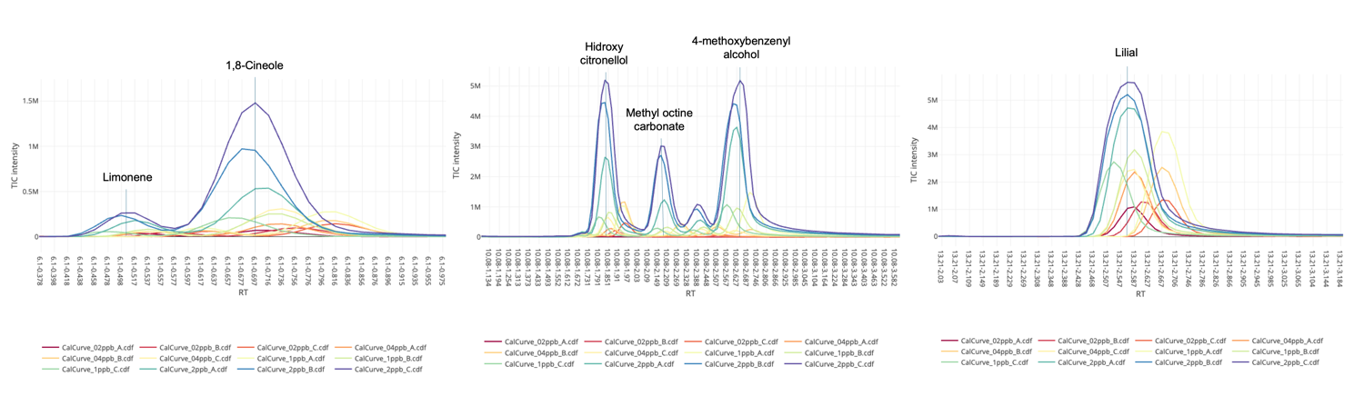
Figure S1: 2D representation of the raw standards training dataset for Limonene, 1,8-Cineole, 4-Methoxybenzenyl alcohol, and Lilial. Each color represents a sample.
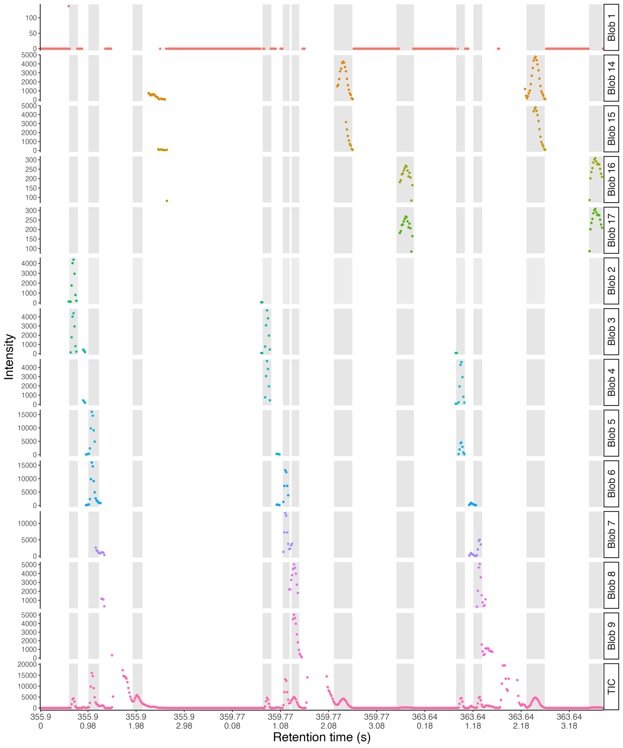
Figure S2: Data unfolding to evaluate the peaks characteristics (Gaussian form + signal-to-noise) of the unselected blobs inside one window as they do not achieve the threshold or the Gaussian form. Grey areas show the chromatographic peaks detected in the samples total ion chromatogram (TIC). The TIC peaks higher than the threshold have been removed for graphical purposes. Bottom pink is the TIC, other colors represent specific blobs.

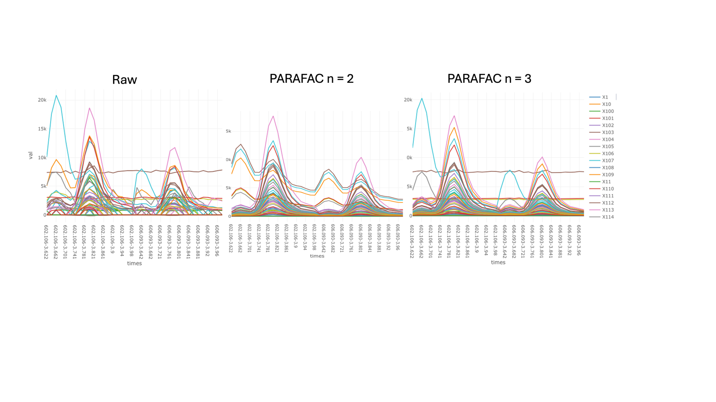

Figure S3: Section of one sample chromatogram showing how the mass-to-charge fragments are modeled depending on the number of components extracted using the PARAFAC algorithm.

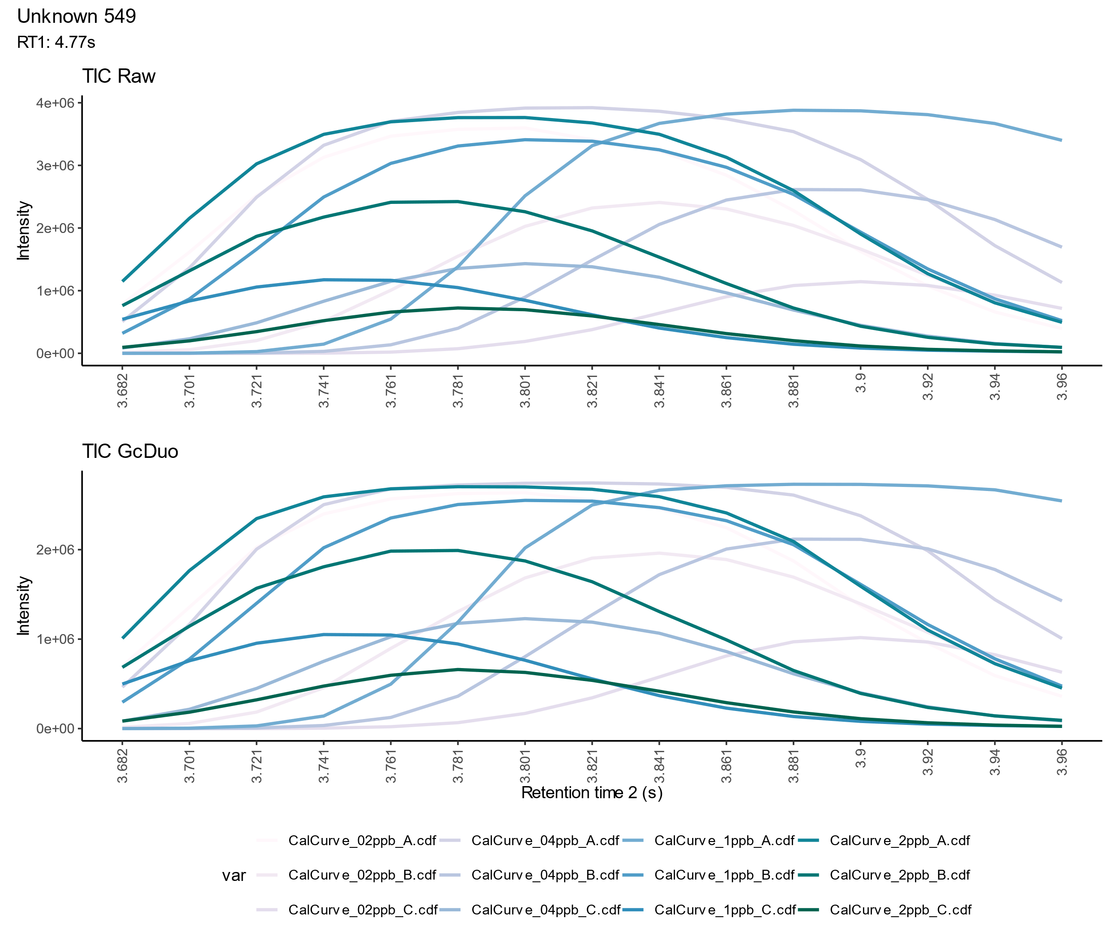
Figure S4: Section of chromatogram corresponding to baseline noise but detected as a component in Module III Blind PARAFAC if no Gaussian form is imposed. Each line/color represents a sample.

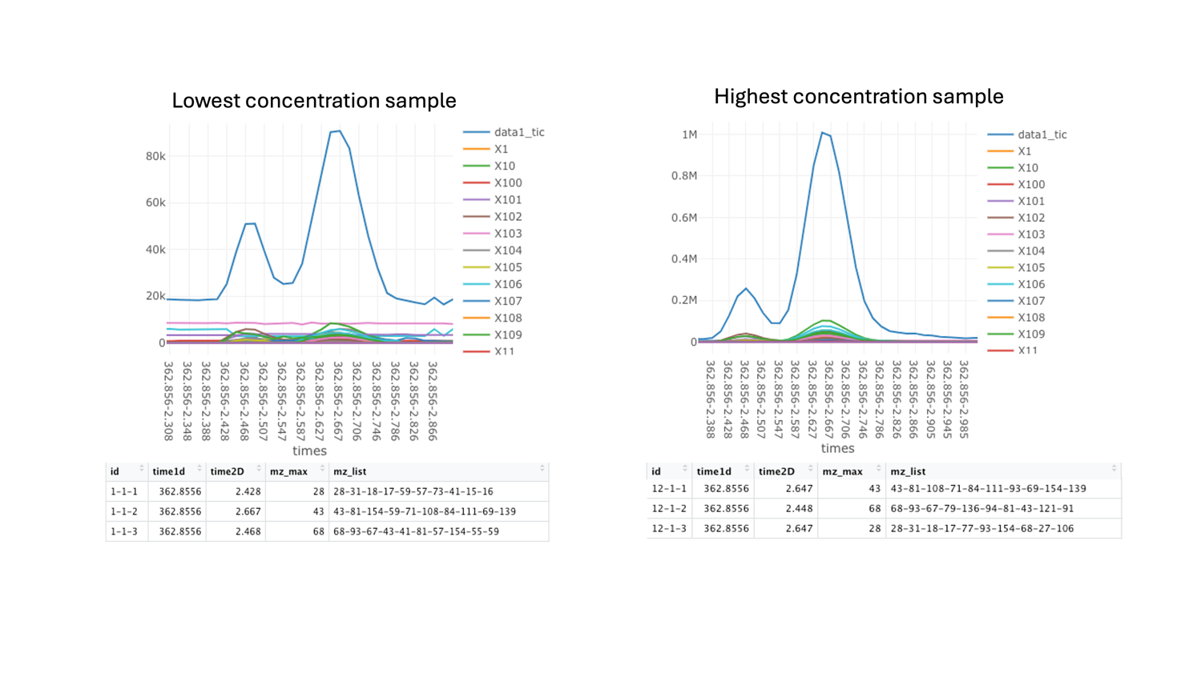
Figure S5: Comparison of Module III Blind PARAFAC results for low (left) and high (right) concentrated samples. When the same number of components are extracted using PARAFAC, the low concentration sample first component corresponds to noise (pink line, mass-to-charge fragment 28) while in the high concentration sample it corresponds to the last component (third component in the table below). The tables show the 3 components extracted using PARAFAC, with the maximum point of the elution profile in the first dimension (time1d); the second dimension (time2D); and the mass-to-charge fragments extracted (mz_list).

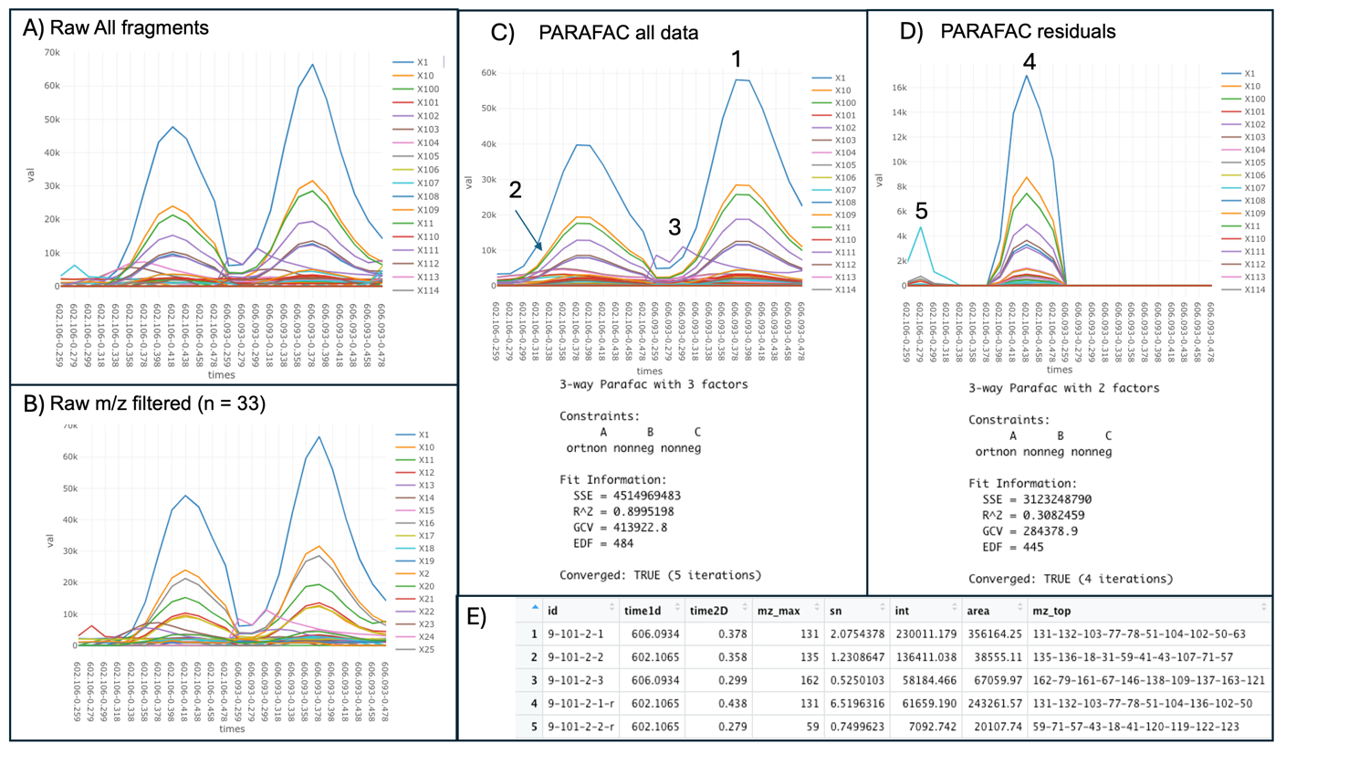

Figure S6: Section of one sample chromatogram for a specific blob, and its various mass-to-charge fragments (color-coded). A) Raw data, including all the mass-to-charge fragments (n=465); B) Top 5% of fragments (n=33) selected to iterate the PARAFAC model; C) Reconstructed chromatogram after applying the Module III Blind PARAFAC with three factors indicated as 1, 2, 3; D) Reconstructed residuals from the PARAFAC model shown at C; E) Extracted components (data and residuals), highlighting differences in the obtained spectra. The table includes: the maximum point of the elution profile in the first dimension (time1d); the maximum point of the elution profile in the second dimension (time2D); the signal-to-noise of the component (sn), the intentsity (int), the area (area), and the mass-to-charge fragments extracted (mz_list).

Table S1: Chemical composition of the in-house QC solutions, Breath Mix, prepared at 1 ppm in methanol.

Compound | Formula | MW (g.mol⁻¹) | CAS
2-Hexanone | C₆H₁₂O | 100.16 | 591-78-6
p-xylene | C₈H₁₀ | 106.17 | 106-42-3
Cyclohexanone | C₆H₁₀O | 98.15 | 108-94-1
6-Methyl-5-hepten-2-one | C₈H₁₄O | 126.2 | 110-93-0
Acetophenone | C₈H₈O | 120.15 | 98-86-2
Decane | C₁₀H₂₂ | 142.28 | 124-18-5
Undecane | C₁₁H₂₄ | 156.31 | 1120-21-4
Nonanal | C₉H₁₈O | 142.24 | 124-19-6
1-Tetradecene | C₁₄H₂₈ | 196.34 | 1120-36-1
6,10-Dimethyl-5,9-undecadien-2-one, (Z) | C₁₃H₂₂O | 194.31 | 3879-26-3
6,10-dimethyl-5,9-undecadien-2-one, (E) | C₁₃H₂₂O | 194.31 | 3796-70-1
1-Pentadecene | C₁₅H₃₀ | 210.37 | 13360-61-7

Table S2: Comparison of identification efficiency with and without using retention index (RI) for the standard curve’s dataset.
Reported by the Authors | GcDUO
Compound | Match without RI | Sim | Match with RI | Sim
d-limonene | Limonene | 0.93 | Limonene | 0.93
1,8-cineole | Hexadienol isobutanoate<2E,4E-> | 0.83 | Cineole<1,8-> | 0.79
benzyl alcohol | Benzyl alcohol | 0.96 | Benzyl alcohol | 0.96
phenylacetaldehyde | Benzene acetaldehyde | 0.98 | Benzene acetaldehyde | 0.98
linalool | Terpinen-4-ol | 0.86 | Linalool | 0.85
camphor | Camphor | 0.80 | Camphor | 0.80
methyl 2-octynoate | Methyl heptine carbonate | 0.79 | Methyl heptine carbonate | 0.79
1-fluoronaphthalene | Cuparenal | 0.77 | Cuparenal | 0.77
4-allylanisole | Methyl chavicol | 0.89 | Methyl chavicol | 0.89
citronellol | Butanoate<3-methyl-2-butenyl 2-methyl-> | 0.93 | No match
geraniol | Fruitaleur | 0.93 | Geraniol | 0.89
citral | Geranial | 0.96 | Geranyl formate | 0.95
3,7-dimethyl-7-hydroxyoctanal | Hydroxy citronellal | 0.94 | Hydroxy citronellol | 0.92
methyl 2-nonynoate | Norborneol<exo-2-> | 0.84 | Mentha-1,4,-dien-7-ol<para-> | 0.71
cinnamal | Cinnamaldehyde<E-> | 0.96 | Methyl cinnamate<E-> | 0.94
4-methoxybenzyl alcohol | Anisyl alcohol<para-> | 0.78 | Anisyl alcohol <para-> | 0.78
safrole | Isosafrole<E-> | 0.97 | Isosafrole<E-> | 0.97
cinnamyl alcohol | Cinnamyl alcohol<E-> | 0.87 | Cinnamyl alcohol<E-> | 0.86
eugenol | Eugenol | 0.94 | Isoeugenol<E-> | 0.81
methyl eugenol | Methyl eugenol | 0.94 | Methyl eugenol | 0.94
isoeugenol | Eugenol acetate | 0.93 | Eugenol acetate | 0.93
coumarin | Coumarin | 0.97 | Coumarin | 0.97
iso-α-methylionone | Ionone<methyl-gamma-> | 0.92 | Ionone<methyl-gamma-> | 0.92
lilial | Lilial | 0.83 | Lilial | 0.83
α-amylcinnamaldehyde_isomer1 | Amyl cinnamaldehyde<Z-> | 0.90 | Amyl cinnamaldehyde<Z-> | 0.90
α -amylcinnamaldehyde_isomer2 | Amyl cinnamaldehyde<E-> | 0.88 | Amyl cinnamaldehyde<E-> | 0.88
lyral_isomer1 | No spectra in the library
lyral_isomer2 | No spectra in the library
farnesol_isomer1 | Damascone<(E)-alpha-> | 0.94 | Geranyl linalool<E,Z-> | 0.88
α -amylcinnamic alcohol | Amyl cinnamyl alcohol<alpha-> | 0.87 | Amyl cinnamyl alcohol<alpha-> | 0.87
farnesol_isomer2 | Damascone<(E)-alpha-> | 0.95 | Geranyl linalool<E,E-> | 0.89
α -hexylcinnamaldehyde_isomer1 | Isoquinoline | 0.75 | Cinnamaldehyde<alpha-methyl-> | 0.84
α -hexylcinnamaldehyde_isomer2 | Cinnamaldehyde<2-hexyl-(Z)-> | 0.92 | Cinnamaldehyde<2-hexyl-(E)-> | 0.92
benzyl benzoate | Benzyl benzoate | 0.98 | Benzyl benzoate | 0.98
benzyl salicylate | Benzyl salicylate | 0.99 | Benzyl salicylate | 0.99
benzylcinnamate | Benzyl cinnamate | 0.91 | Benzyl cinnamate | 0.91

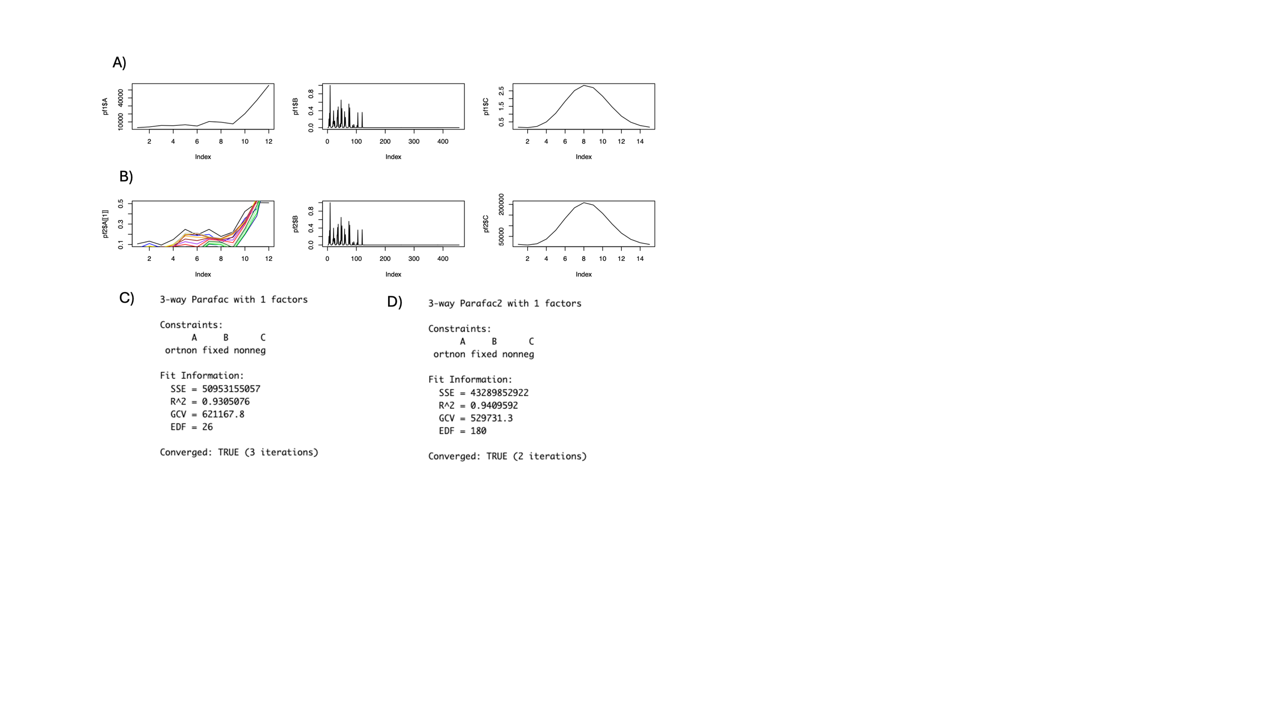
Figure S7: Results for 1,8-Cineole peak from the training dataset (peak shown in Figure 3). A) PARAFAC model loadings and scores; B) PARAFAC2 model loadings and scores; C) PARAFAC model metrics; D) PARAFAC2 model metrics. PARAFAC2 demonstrates a higher R² and a lower sum of squared errors (SSE), indicating a better fit to the raw data. These results emphasize the ability of PARAFAC2 to capture spurious peaks and accurately model chemical profiles.

Table S3: Comparison of PARAFAC and PARAFAC2 areas results in blind and constrained modes for three compounds. In all cases, PARAFAC constrained was built upon PARAFAC blind.
Compound | File + concentration | Raw | PARAFAC Blind | PARAFAC2  Blind | PARAFAC Blind + PARAFAC  Constrained | PARAFAC Blind + PARAFAC2  Constrained | ChromaTOF
Lilial | A_02ppb | 1.30E+06 | 1.42E+06 | 1.42E+06 | 1.48E+06 | 1.34E+06 | 1.39E+06
 | B_02ppb | 1.58E+06 | 1.73E+06 | 1.73E+06 | 1.80E+06 | 1.62E+06 | 1.72E+06
 | C_02ppb | 1.71E+06 | 1.86E+06 | 1.86E+06 | 1.86E+06 | 1.75E+06 | 1.85E+06
 | A_04ppb | 2.94E+06 | 3.25E+06 | 2.83E+06 | 3.33E+06 | 3.05E+06 | 3.13E+06
 | B_04ppb | 3.27E+06 | 3.66E+06 | 3.50E+06 | 3.62E+06 | 3.38E+06 | 3.62E+06
 | C_04ppb | 3.18E+06 | 3.64E+06 | 3.51E+06 | 3.42E+06 | 3.29E+06 | 3.54E+06
 | A_1ppb | 5.19E+06 | 6.03E+06 | 5.65E+06 | 5.86E+06 | 5.47E+06 | 3.08E+06
 | B_1ppb | 4.17E+06 | 4.95E+06 | 4.52E+06 | 4.67E+06 | 4.35E+06 | 3.10E+06
 | C_1ppb | 3.55E+06 | 4.30E+06 | 3.87E+06 | 3.95E+06 | 3.67E+06 | 3.90E+06
 | A_2ppb | 7.07E+06 | 8.41E+06 | 7.74E+06 | 7.76E+06 | 7.57E+06 | 6.01E+06
 | B_2ppb | 8.13E+06 | 9.56E+06 | 9.06E+06 | 8.63E+06 | 8.83E+06 | 9.34E+06
 | C_2ppb | 9.30E+06 | 1.08E+07 | 1.03E+07 | 9.41E+06 | 1.02E+07 | 1.39E+06
4-Methoxy  benzenyl alcohol | A_02ppb |  |  |  | 1.05E+02 | 5.95E+02 | 2.70E+04
 | B_02ppb |  |  |  | 4.35E+02 | 1.72E+03 | 3.47E+04
 | C_02ppb |  |  |  | 4.64E+03 | 1.16E+04 | 2.80E+04
 | A_04ppb | 1.69E+04 | 1.55E+04 |  | 2.66E+04 |  | 2.56E+05
 | B_04ppb | 2.08E+05 | 2.81E+05 |  | 2.77E+05 | 3.07E+05 | 2.73E+05
 | C_04ppb | 1.84E+05 |  |  | 2.41E+05 | 2.68E+05 | 2.92E+05
 | A_1ppb | 1.38E+06 |  |  | 1.78E+06 | 1.74E+06 | 1.59E+06
 | B_1ppb | 8.99E+05 |  |  | 1.16E+06 | 1.14E+06 | 1.06E+06
 | C_1ppb | 1.01E+06 | 1.25E+06 | 1.17E+06 | 1.32E+06 | 1.26E+06 | 1.19E+06
 | A_2ppb | 3.69E+06 | 4.25E+06 |  | 4.81E+06 | 4.64E+06 | 3.49E+06
 | B_2ppb | 5.02E+06 | 5.75E+06 |  | 6.35E+06 | 6.28E+06 | 5.77E+06
 | C_2ppb | 6.23E+06 | 7.10E+06 |  | 7.64E+06 | 7.82E+06 | 7.97E+05
1,8-Cineole | A_02ppb | 5.04E+04 | 4.76E+04 | 4.88E+04 | 5.17E+04 | 5.33E+04 | 4.86E+04
 | B_02ppb | 6.37E+04 | 6.20E+04 |  | 6.88E+04 | 7.24E+04 | 6.37E+04
 | C_02ppb | 9.44E+04 | 9.07E+04 | 9.17E+04 | 1.02E+05 | 1.00E+05 | 9.44E+04
 | A_04ppb | 9.13E+04 | 8.92E+04 | 8.97E+04 | 9.76E+04 | 9.95E+04 | 9.06E+04
 | B_04ppb | 1.15E+05 | 1.14E+05 | 1.15E+05 | 1.17E+05 | 1.31E+05 | 1.15E+05
 | C_04ppb | 9.29E+04 |  |  | 8.92E+04 | 1.05E+05 | 9.29E+04
 | A_1ppb | 1.82E+05 | 1.76E+05 | 1.76E+05 | 1.91E+05 | 1.95E+05 | 1.82E+05
 | B_1ppb | 1.63E+05 | 1.60E+05 | 1.60E+05 | 1.75E+05 | 1.76E+05 | 1.64E+05
 | C_1ppb | 1.37E+05 | 1.32E+05 | 1.32E+05 | 1.36E+05 | 1.48E+05 | 1.35E+05
 | A_2ppb | 3.46E+05 | 3.38E+05 | 3.37E+05 | 3.68E+05 | 3.76E+05 | 3.55E+05
 | B_2ppb | 6.21E+05 | 6.15E+05 | 6.19E+05 | 6.70E+05 | 6.71E+05 | 6.37E+05
 | C_2ppb | 9.45E+05 | 9.23E+05 | 9.28E+05 | 1.01E+06 | 9.96E+05 | 9.71E+05

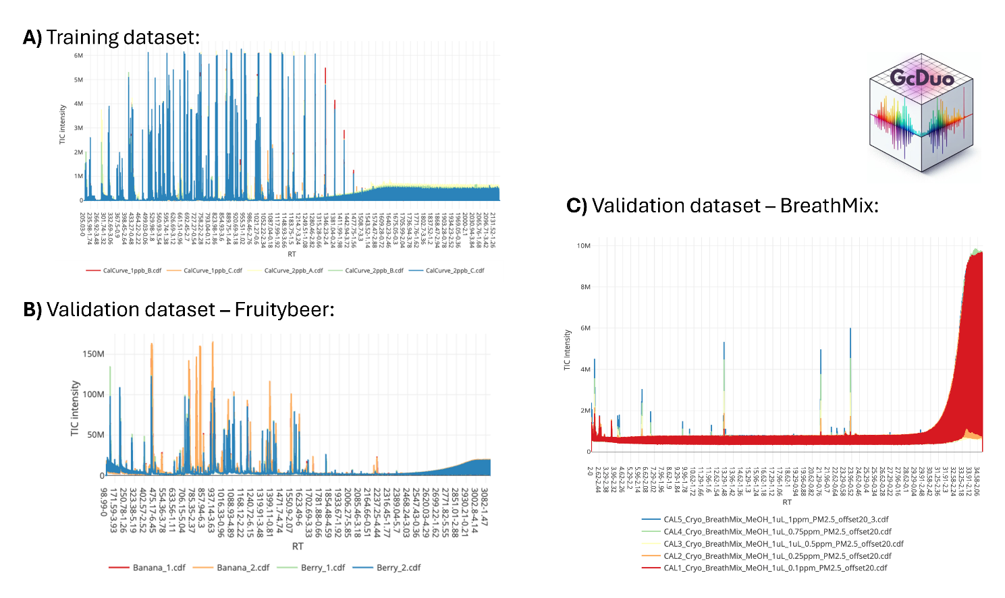
Figure S8: Representative chromatograms illustrating the complexity of datasets processed by GcDUO. A) training dataset (diluted series of a commercial mix of fragrances and allergen standards), for two different concentrations (1 and 2ppb) and replicates (‘A’, ‘B’, ‘C’). B) the first validation dataset (Fruitybeer), highlighting the variation across beer samples and the diversity of volatile compounds present (two banana and two berry samples are shown). C) the second validation dataset (BreathMix), an in-house set of 5 dilutions (0.1 to 1 ppm) of a breath mix solution containing 12 compounds (the five dilution chromatograms are shown: 0.1, 0,25, 0.5, 0.75 and 1 ppm).

Table S4: Fruitybeer dataset results (validation). Compounds ID matched with GcDUO are indicated in bold.
Data from authors |  |  | Obtained with GcDUO
Tentative ID | Unique Flavour | RI | Retention Time (s) | ID | Comments
(E)-hex-2-enal | Apple | 843 | 409.17, 6.57 | Hexenal<2E->
3-methylbutanoic acid (Isovaleric acid) | Apple | 862 | 679.75, 2.69 | Hexanoic acid | isovaleric acid position 7
2-methylbutyl acetate | Banana | 877 | 475.98, 2.54 | Methyl butyl acetate<2->
3-methyl-3-butenyl acetate | Banana | 879 | 733.96, 5.74 | Hexenyl acetate<3E-> | Compound not in library
Butyl butanoate | Apple | 999 | 818.34, 2.02 | Butyl pentanoate
Phenylmethanol (Benzyl alcohol) | Cherry | 1040 | 793.96, 1.08 | Benzyl alcohol
4-methyl-2-(2-methylprop-1-enyl)oxane (Cis-rose oxide) | Berry | 1116 | 943.73, 5.78 | Rose oxide<cis->
4-methyl-2-(2-methylprop-1-enyl)oxane (Trans-rose oxide) | Berry | 1134 | 950.33, 2.16 | Rose oxide<cis-> | Rose oxide <trans-> position 2
(E)-non-3-en-2-one (Trans-3-nonen-2-one) | Peach | 1147 | 829.95, 2.74 | Not found
5-methyl-2-propan-2-ylcyclohexan-1-one (Iso-menthone) | Berry | 1175 | 1029.53, 1.37 | Menthone<iso->
5-methyl-2-propan-2-ylcyclohexan-1-ol (Menthol) | Berry | 1184 | 1062.53, 4.12 | Menthol<neo-> | Menthol position 2
2-(4-methylphenyl)propan-2-ol (Para-cymen-8-ol) | Apple | 1197 | 1027.80, 0.10 | Cymene<ortho-> | Cymene<para-> position 2
5-methyl-2-propan-2-ylidenecyclohexan-1-one (Pulegone) | Peach | 1212 | 1183.93, 3.45 | Pulegone
2-methyl-5-prop-1-en-2-ylcyclohex-2-en-1-one (Carvone) | Peach | 1219 | 1189.93, 3.6 | Carvone
4-methoxybenzaldehyde (Para-anisaldehyde) | Cherry | 1265 | 1207.93, 4.69 | Not found
(E)-3-phenylprop-2-enal (Trans-cinnamaldehyde) | Cherry | 1283 | 1237.93, 1.58 | Cinnamaldehyde<E->
Methyl (E)-3-phenylprop-2-enoate (Methyl trans-cinnamate) | Berry | 1394 | 1418.9, 2.98 | Methyl cinnamate<Z->
Benzyl butanoate | Banana | 1356 | 1357.92, 3.55 | Benzyl butanoate
3,7-dimethyloct-6-enyl acetate (Citronellyl acetate) | Berry | 1356 | 1366.11, 3.32 | Citronellyl acetate
2-methoxy-4-prop-2-enylphenol (Eugenol) | Banana | 1370 | 1381.92, 0.71 | Isoeugenol<E-> | Eugenol position 3
Undec-10-en-1-ol | Banana | 1372 | 1387.92, 2.71 | Undecenol<10->
Methyl (E)-3-phenylprop-2-enoate (Methyl trans-cinnamate) | Berry | 1394 | 1418.90, 2.98 | Methyl cinnamate<Z-> | Methyl cinnamate<E-> position 3
(E)-1-(2,6,6-trimethylcyclohexen-1-yl)but-2-en-1-one (β-damascone) | Apple | 1401 | 1425.50, 1.58 | Damascenone<(E)-beta->
(E)-4-(2,6,6-trimethylcyclohex-2-en-1-yl)but-3-en-2-one (α-ionone) | Peach | 1440 | 1363.92, 5.89 | Terpinene<alpha-> | Ionone<(E)-alpha-> position 16
2-phenylethyl butanoate | Peach | 1455 | - | Not found
Dodecan-1-ol | Banana | 1491 | 1549.91, 5.45 | Dodecanol<n->
2-phenylethyl (E)-2-methylbut-2-enoate (Phenethyl tiglate) | Berry | 1599 | 1723.68, 0.90 | Phenyl ethyl tiglate<2->

Table S5: Breath standards dilutions dataset results (validation). A signal-to-noise (S/N) ratio of 3 was used for all compounds, except for Decane, for which the S/N threshold was lowered to 1.
Compound | RT1 (s), RT2 (s) | 0.1 ppm | 0.25 ppm | 0.5 ppm | 0.75 ppm | 1 ppm | R²
2-Hexanone | 259.98, 1.670 | 5.22E+05 | 9.11E+05 | 3.10E+06 | 6.33E+06 | 1.11E+07 | 0.912
Ethylbenzene | 374.97, 1.820 | 2.67E+06 | 5.50E+06 | 9.82E+06 | 1.47E+07 | 1.95E+07 | 0.991
Cyclohexanone | 417.47, 2.465 | 3.45E+05 | 6.97E+05 | 2.04E+06 | 4.17E+06 | 6.29E+06 | 0.943
6-Methyl-5-octen-2-one | 579.96, 2.070 | 3.48E+05 | 5.75E+05 | 1.37E+06 | 3.27E+06 | 4.69E+06 | 0.926
ethanone, 2-chloro-2,2-difluoro-1-phenyl- | 727.45, 0.430 | 1.08E+05 | 3.63E+05 | 1.52E+06 | 4.05E+06 | 5.90E+06 | 0.927
Decane | 604.80,1.640 | 3.81E+05 | 4.19E+05 | 4.53E+05 | 4.49E+05 | 5.09E+05 | 0.918
Undecane | 789.94, 1.430 | 2.16E+06 | 4.07E+06 | 6.76E+06 | 1.07E+07 | 1.29E+07 | 0.986
2-Undecene, (Z)- | 797.44, 1.960 | 4.09E+05 | 6.67E+05 | 1.05E+06 | 1.75E+06 | 2.45E+06 | 0.961
1-Tetradecene | 1279.91, 1.575 | 1.09E+06 | 1.98E+06 | 3.22E+06 | 4.99E+06 | 6.65E+06 | 0.984
5,9-Undecadien-2-one, 6,10-dimethyl-, (E)- | 1332.41, 2.205 | 4.92E+05 | 8.35E+05 | 1.31E+06 | 2.33E+06 | 3.27E+06 | 0.955
5,9-Undecadien-2-one, 6,10-dimethyl-, (Z)- | 1359.91, 2.230 | 3.55E+05 | 6.91E+05 | 1.23E+06 | 2.54E+06 | 3.71E+06 | 0.940
3-Heptafluorobutyroxytetradecane | 1429.90, 1.595 | 2.16E+06 | 2.16E+06 | 3.75E+06 | 6.15E+06 | 8.25E+06 | 0.924

Table S6: Comparison of areas obtained using ChromaTOF, GcDUO with PARAFAC2 algorithms and GcDUO with MCR algorithm (module V), for the breath standards dataset sample at 1ppm. A signal-to-noise (S/N) ratio of 3 was used for all compounds, except for Decane, for which the S/N threshold was lowered to 1.
 | ChromaTOF | GcDUO– PARAFAC2 | GcDUO- MCR
Compound | Area 1ppm | Area 1ppm | Area 1ppm
2-Hexanone | 1.16E+07 | 1,04E+07 | 1,95E+07
Ethylbenzene | 2.44E+07 | 1,77E+07 | 2,45E+07
Cyclohexanone | 8.49E+06 | 5,39E+06 | 2,52E+07
6-Methyl-5-octen-2-one | 4.52E+06 | 3,32E+06 | 4,52E+06
ethanone, 2-chloro-2,2-difluoro-1-phenyl- | 1.11E+07 | 5,87E+06 | 1,39E+07
Decane | 1.90E+05 | 5,09E+05 | 1,60E+06
Undecane | 9.34E+06 | 9,79E+06 | 9,63E+06
2-Undecene, (Z)- | 2.05E+06 | 2,33E+06 | 8,99E+06
1-Tetradecene | 5.17E+06 | 7,61E+06 | 3,80E+07
5,9-Undecadien-2-one, 6,10-dimethyl-, (E)- | 1.98E+06 | 3,15E+06 | 1,01E+07
5,9-Undecadien-2-one, 6,10-dimethyl-, (Z)- | 3.29E+06 | 2,72E+06 | 6,18E+06
3-Heptafluorobutyroxytetradecane | 5.21E+06 | 9,22E+06 | 4,86E+07

