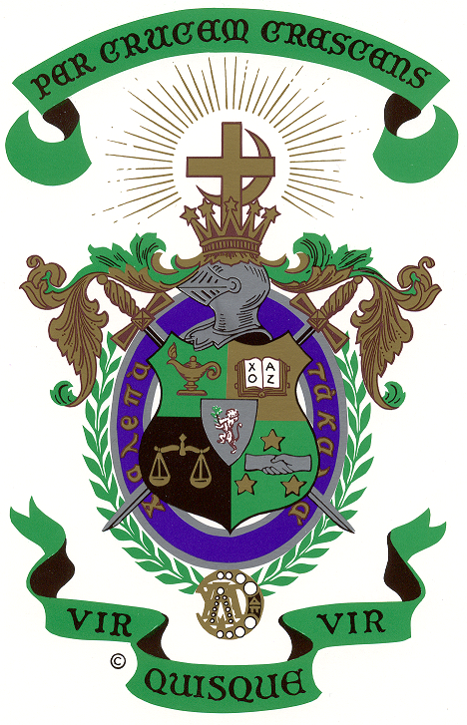 THETA UPSILON ZETA
LAMBDA CHI ALPHA

THETA UPSILON ZETA

REUNION 2006

Cruising Brothers ………………….

Since someone has inquired about final payment, I thought it would be a good time to send all those presently booked an update of information.

Final payment which is due August 20, can be made anytime before by calling 1-800-205-9812, group bookings. Be sure to have your booking number and credit card number. If you prefer to pay by check, it can be sent to Royal Caribbean Cruise Line, PO Box 025511, Miami FL 33102. It should be sent at least 2 weeks prior to due date.

You can arrange for transfers to and from either Newark Airport ($50 round trip) or LaGuardia ($130 round trip) at time of payment.

RCCL does not handle travel insurance for group bookings. If you would like to purchase travel insurance, they recommend calling Berkley Care at 1-800-453-4022.

We have secured a meeting room the first night on board at 5:00PM and also the last evening after dinner. We have been assigned the “Bermuda Room” for both occasions. There are many other places on board to get together at other times.

There will be one Formal Night on the cruise. We will find out which night after boarding. Halloween will occur during the trip and we were told that other than decorations, RCCL has no other plans. Suppose that means no costumes are required.

If you are driving and plan to park at the pier, the City of Bayonne website www.bayonnenj.org Cape Liberty Cruise Port Info states there is plenty of space available and no reservations are needed. They require payment in cash - no checks or credit cards. At this writing the cost is $15/day.

A couple of Brothers have asked about booking cabins for friends or family. Of course, we would be happy to book them in the group. If you know of any other Brothers who might be interested let us know.

After you make final payment, RCCL will send you a packet of information and tickets. Excursions in Bermuda can be booked on-line before, or once you get on board.

We will send a reminder again before final payment is due. If you have any questions, please don’t hesitate to call or email.

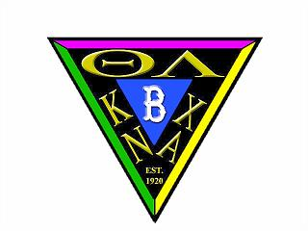
Charlie Opalek
152 Roberts Drive
Somerdale NJ 08083
856-627-5020
856-346-9804 (w)
opalek@verizon.net (w)
mopalek@comcast.net

