Package compilation and basic run

Emmanuelle Comets

02/02/2021

## Compilation

* structure
  + **tests** : removed all other folders and files except testthat from the package otherwise warnings about RDS files
  + **data** : removed remifentanil example from data folder
* **roxygen** documentation
  + warnings for ggplot (no visible global function definition)
  + added import command for pnorm (found in distribution plot) and median (found nowhere, so suspect it’s the name median used in the ggplot plots, but added it all the same)
* **package size**: still 5.9 Mb so much too large for CRAN
  + the 3 simulated data files for warfarin and viral load data are all around 5Mb, consider making them available only on bookdown/website
* necessary files
  + added a DESCRIPTION file
  + added a CHANGES file
* for compilation:
  + removed NAMESPACE
  + removed man pages
* Compilation steps from Build menu
  + Document => create NAMESPACE, DESCRIPTION (update collate directive), create man pages
  + Check => update documentation, create NAMESPACE
* **FINAL COMPILATION FOR CRAN**
  + removed documentation (too large)
  + removed simwarfarineBase
  + still over 5Mo but seems to be ok
* CRAN pre-test doesn’t pass :-/
  + added importFrom for ggplot functions, also for gridExtra (grid.arrange) and grid
  + ‘solved’ problem by adding a dependency on rlang
    - partially fixed with rlang
    - workaround by defining global variables so check won’t complain about them, but we need to use the .data systematically in ggplot aes() => **Romain TODO**
* **March 2021**
  + mail Fu (15/03): added again the option to save the output in autonpde (probably removed by Romain :-/ )

# Reduce size of viral load simulation data (to 500 simulations) for CRAN  
if(FALSE) {  
 cmd<-paste("mv ", file.path(workDir,"npde","data","simvirload.tab")," ", file.path(workDir,"keep","data","/"),sep="")  
 system(cmd)  
 tab<-read.table(file.path(workDir,"npde","data","simvirload.tab"), header=TRUE)  
 tab1<-tab[1:(dim(tab)[1]/2),]  
 write.table(tab1, file.path(workDir,"npde","data","simvirload.tab"), quote=FALSE, row.names=FALSE, col.names=TRUE)  
}  
  
cmd<-paste("rm -r ",file.path(compilDir,"*"),sep="")  
system(cmd)  
dir.create(compilDir)

## Warning in dir.create(compilDir): '/home/eco/work/npde/compileNpde' existe déjà

dir.create(file.path(compilDir,"npde"))  
dir.create(file.path(compilDir,"npde","inst"))  
# File too large  
if(FALSE) {  
 cmd<-paste("cp ", file.path(workDir,"latexDoc","userguide_3_3.pdf")," ", file.path(compilDir,"inst","userguide_npde_3.3.pdf"),sep="")  
 system(cmd)  
}  
  
cmd<-paste("cp -rp ",file.path(workDir,"npde","R")," ", file.path(compilDir,"npde"),sep="")  
system(cmd)  
cmd<-paste("cp -rp ",file.path(workDir,"data")," ", file.path(compilDir,"npde"),sep="")  
system(cmd)  
for(ifile in c("CHANGES","DESCRIPTION")) {  
 cmd<-paste("cp ",file.path(workDir,"keep",ifile)," ", file.path(compilDir,"npde"),sep="")  
 system(cmd)  
}  
for(ifile in c("CITATION")) {  
 cmd<-paste("cp ",file.path(workDir,"keep",ifile)," ", file.path(compilDir,"npde","inst"),sep="")  
 system(cmd)  
}  
# cmd<-paste("cp ",file.path(workDir,"LICENSE")," ", file.path(compilDir,"inst"),sep="")  
# system(cmd)  
  
# Compile  
setwd(file.path(compilDir,"npde"))  
devtools::document()

## ℹ Updating npde documentation  
## Setting `RoxygenNote` to "7.2.2"  
## ℹ Loading npde  
## Writing ']8;;file:///home/eco/work/npde/compileNpde/npde/NAMESPACENAMESPACE]8;;'  
## Writing ']8;;file:///home/eco/work/npde/compileNpde/npde/NAMESPACENAMESPACE]8;;'  
## Writing ']8;;ide:run:pkgload::dev_help('NpdeSimData-class')NpdeSimData-class.Rd]8;;'  
## Writing ']8;;ide:run:pkgload::dev_help('[,NpdeSimData-method')extract-methods.Rd]8;;'  
## Writing ']8;;ide:run:pkgload::dev_help('NpdeData-class')NpdeData-class.Rd]8;;'  
## Writing ']8;;ide:run:pkgload::dev_help('read')read.Rd]8;;'  
## Writing ']8;;ide:run:pkgload::dev_help('show')show.Rd]8;;'  
## Writing ']8;;ide:run:pkgload::dev_help('npdeData')npdeData.Rd]8;;'  
## Writing ']8;;ide:run:pkgload::dev_help('npdeSimData')npdeSimData.Rd]8;;'  
## Writing ']8;;ide:run:pkgload::dev_help('print.NpdeData')print.NpdeData.Rd]8;;'  
## Writing ']8;;ide:run:pkgload::dev_help('showall')showall.Rd]8;;'  
## Writing ']8;;ide:run:pkgload::dev_help('summary.NpdeData')summary.NpdeData.Rd]8;;'  
## Writing ']8;;ide:run:pkgload::dev_help('subset.NpdeData')subset.NpdeData.Rd]8;;'  
## Writing ']8;;ide:run:pkgload::dev_help('NpdeRes-class')NpdeRes-class.Rd]8;;'  
## Writing ']8;;ide:run:pkgload::dev_help('kurtosis')kurtosis.Rd]8;;'  
## Writing ']8;;ide:run:pkgload::dev_help('skewness')skewness.Rd]8;;'  
## Writing ']8;;ide:run:pkgload::dev_help('gof.test')gof.test.Rd]8;;'  
## Writing ']8;;ide:run:pkgload::dev_help('NpdeObject-class')NpdeObject-class.Rd]8;;'  
## Writing ']8;;ide:run:pkgload::dev_help('dist.pred.sim')dist.pred.sim.Rd]8;;'  
## Writing ']8;;ide:run:pkgload::dev_help('computenpde')computenpde.Rd]8;;'  
## Writing ']8;;ide:run:pkgload::dev_help('npde.decorr.method')npde.decorr.method.Rd]8;;'  
## Writing ']8;;ide:run:pkgload::dev_help('computepd')computepd.Rd]8;;'  
## Writing ']8;;ide:run:pkgload::dev_help('compute.ploq')compute.ploq.Rd]8;;'  
## Writing ']8;;ide:run:pkgload::dev_help('autonpde')autonpde.Rd]8;;'  
## Writing ']8;;ide:run:pkgload::dev_help('pdemenu')pdemenu.Rd]8;;'  
## Writing ']8;;ide:run:pkgload::dev_help('npde.main')npde.main.Rd]8;;'  
## Writing ']8;;ide:run:pkgload::dev_help('npde.save')npde.save.Rd]8;;'  
## Writing ']8;;ide:run:pkgload::dev_help('npde.graphs')npde.graphs.Rd]8;;'  
## Writing ']8;;ide:run:pkgload::dev_help('npde-package')npde-package.Rd]8;;'  
## Writing ']8;;ide:run:pkgload::dev_help('theopp')theopp.Rd]8;;'  
## Writing ']8;;ide:run:pkgload::dev_help('simtheopp')simtheopp.Rd]8;;'  
## Writing ']8;;ide:run:pkgload::dev_help('warfarin')warfarin.Rd]8;;'  
## Writing ']8;;ide:run:pkgload::dev_help('virload')virload.Rd]8;;'  
## Writing ']8;;ide:run:pkgload::dev_help('npde.cens.method')npde.cens.method.Rd]8;;'  
## Writing ']8;;ide:run:pkgload::dev_help('npdeControl')npdeControl.Rd]8;;'  
## Writing ']8;;ide:run:pkgload::dev_help('set.plotoptions')set.plotoptions.Rd]8;;'  
## Writing ']8;;ide:run:pkgload::dev_help('replace.plotoptions')replace.plotoptions.Rd]8;;'  
## Writing ']8;;ide:run:pkgload::dev_help('npde.binning')npde.binning.Rd]8;;'  
## Writing ']8;;ide:run:pkgload::dev_help('npde.plot.covariate')npde.plot.covariate.Rd]8;;'  
## Writing ']8;;ide:run:pkgload::dev_help('npde.plot.dist')npde.plot.dist.Rd]8;;'  
## Writing ']8;;ide:run:pkgload::dev_help('npde.plot.loq')npde.plot.loq.Rd]8;;'  
## Writing ']8;;ide:run:pkgload::dev_help('plot.NpdeData')plot.NpdeData.Rd]8;;'  
## Writing ']8;;ide:run:pkgload::dev_help('plot.NpdeRes')plot.NpdeRes.Rd]8;;'  
## Writing ']8;;ide:run:pkgload::dev_help('plot.NpdeObject')plot.NpdeObject.Rd]8;;'  
## Writing ']8;;ide:run:pkgload::dev_help('npde.plot.select')npde.plot.select.Rd]8;;'  
## Writing ']8;;ide:run:pkgload::dev_help('default.npde.plots')default.npde.plots.Rd]8;;'  
## Writing ']8;;ide:run:pkgload::dev_help('npde.plot.splitcov')npde.plot.splitcov.Rd]8;;'  
## Writing ']8;;ide:run:pkgload::dev_help('npde.plot.npde')npde.plot.npde.Rd]8;;'  
## Writing ']8;;ide:run:pkgload::dev_help('npde.plot.data')npde.plot.data.Rd]8;;'  
## Writing ']8;;ide:run:pkgload::dev_help('npde.plot.default')npde.plot.default.Rd]8;;'  
## Writing ']8;;ide:run:pkgload::dev_help('npde.plot.scatterplot')npde.plot.scatterplot.Rd]8;;'

roxygenise()

## ℹ Loading npde

setwd(compilDir)  
system("R CMD build npde")  
system("R CMD check --as-cran --run-donttest npde_3.3.tar.gz")

#### npde 3.1

Apres correction, la compilation du package passe sans erreurs et avec 2 notes restantes.

* **notes**
  + previous version archived
  + package size too large (recommended size less than 5Mb): reduce nb of simulations for warfarin ?
  + ggplot variables (rien a faire pour ça)
* **warnings** corriges
  + jeux de donnees non documentes: removed remifentanil, added virload documentation (used to be a specific man page, reintegrated them into roxygen format in npde.R like warfarin)
  + duplicated alias: fixed !

#### npde 3.2, 3.3

* **notes**
  + time to run examples Examples with CPU or elapsed time > 5s user system elapsed npde.cens.method 7.51 0.019 7.605

### Warnings

* ggplot warnings

Undefined global functions or variables:  
 .x X2.5. X50. X97.5. Y0.025 Y0.025.1 Y0.5 Y0.5.1 Y0.975 Y0.975.1 aes  
 annotation_logticks category coord_cartesian coord_flip element_blank  
 element_line element_rect element_text expand_limits facet_wrap  
 geom_bar geom_boxplot geom_crossbar geom_hline geom_line geom_point  
 geom_ribbon ggplot ggtitle gpar grid.arrange group grp guides labs  
 lower name obs.inf obs.median obs.sup pinf.lower pinf.median  
 pinf.upper pmid.lower pmid.median pmid.upper psup.lower psup.median  
 psup.upper scale_fill_manual scale_x_continuous scale_x_discrete  
 scale_x_log10 scale_y_continuous scale_y_log10 textGrob theme upper  
 value x x1 x2 x_area_0.25 x_area_0.5 x_area_0.975 xcent y y1 y2  
 y_area_0.25 y_area_0.5 y_area_0.975

* Warnings in first compilation (solved)

checking Rd metadata ...  
 Rd files with duplicated alias 'aux.npdeplot.computepi':  
 ‘npde.plot.default.Rd’ ‘npde.plot.scatterplot.Rd’  
 Rd files with duplicated alias 'compute.bands':  
 ‘npde.plot.default.Rd’ ‘npde.plot.scatterplot.Rd’  
 Rd files with duplicated alias 'compute.bands.true':  
 ‘npde.plot.default.Rd’ ‘npde.plot.scatterplot.Rd’  
 Rd files with duplicated alias 'npde':  
 ‘npde-package.Rd’ ‘npde.Rd’  
W checking for missing documentation entries (346ms)  
 Undocumented code objects:  
 ‘remifent’ ‘simremifent’ ‘simremifent_base’ ‘simvirload’ ‘virload’  
 ‘virload20’ ‘virload50’ ‘virloadMDV20’  
 Undocumented data sets:  
 ‘remifent’ ‘simremifent’ ‘simremifent_base’ ‘simvirload’ ‘virload’  
 ‘virload20’ ‘virload50’ ‘virloadMDV20’  
 All user-level objects in a package should have documentation entries.  
 See chapter ‘Writing R documentation files’ in the ‘Writing R  
 Extensions’ manual.

### Install package in development mode

dev_mode() # development mode

## ✔ Dev mode: ON

install.packages(pkgs=file.path(compilDir,"npde_3.3.tar.gz"),repos=NULL)

## Installation du package dans '/home/eco/R-dev'  
## (car 'lib' n'est pas spécifié)

library(npde)  
library(ggplot2)  
library(gridExtra)  
library(mclust)

## Package 'mclust' version 6.0.0  
## Type 'citation("mclust")' for citing this R package in publications.

library(testthat)

##   
## Attachement du package : 'testthat'  
##   
## L'objet suivant est masqué depuis 'package:devtools':  
##   
## test_file

library(grid)

# Theophylline

## ---------------------------------------------  
## Distribution of npde :  
## nb of obs: 120   
## mean= 0.0668 (SE= 0.095 )  
## variance= 1.074 (SE= 0.14 )  
## skewness= 0.511   
## kurtosis= 0.2912   
## ---------------------------------------------  
## Statistical tests (adjusted p-values):  
## t-test : 1  
## Fisher variance test : 1  
## SW test of normality : 0.00819 **  
## Global test : 0.00819 **  
## ---  
## Signif. codes: '***' 0.001 '**' 0.01 '*' 0.05 '.' 0.1   
## ---------------------------------------------

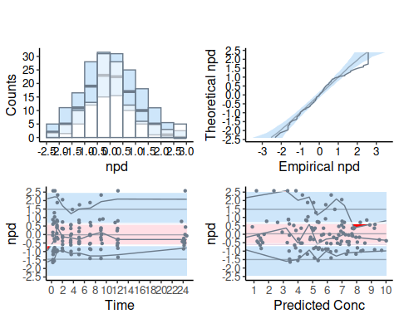

## ypred ycomp pd ydobs npde  
## 1 NaN NaN NaN NA NA  
## 2 2.923864 2.84 0.55 -0.05124648 0.1256613  
## 3 4.682299 6.57 0.85 1.96398150 2.0537489  
## 4 6.264357 10.50 0.99 2.56602650 2.3263479  
## 5 6.986255 9.66 0.98 0.41616411 0.5244005  
## 6 6.511039 8.58 0.93 0.28430866 0.2533471

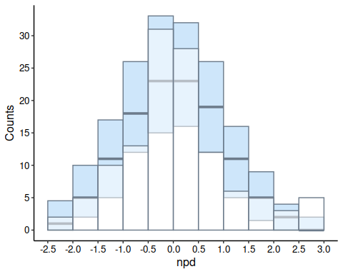

# Viral load, base plots

## ---------------------------------------------  
## Distribution of npde :  
## nb of obs: 300   
## mean= -0.01076 (SE= 0.054 )  
## variance= 0.8704 (SE= 0.071 )  
## skewness= 0.02492   
## kurtosis= -0.3614   
## ---------------------------------------------  
## Statistical tests (adjusted p-values):  
## t-test : 1  
## Fisher variance test : 0.308  
## SW test of normality : 0.937  
## Global test : 0.308  
## ---  
## Signif. codes: '***' 0.001 '**' 0.01 '*' 0.05 '.' 0.1   
## ---------------------------------------------

## ---------------------------------------------  
## Distribution of npde :  
## nb of obs: 221   
## mean= 0.09917 (SE= 0.062 )  
## variance= 0.8611 (SE= 0.082 )  
## skewness= -0.1174   
## kurtosis= -0.1955   
## ---------------------------------------------  
## Statistical tests (adjusted p-values):  
## t-test : 0.341  
## Fisher variance test : 0.402  
## SW test of normality : 1  
## Global test : 0.341  
## ---  
## Signif. codes: '***' 0.001 '**' 0.01 '*' 0.05 '.' 0.1   
## ---------------------------------------------

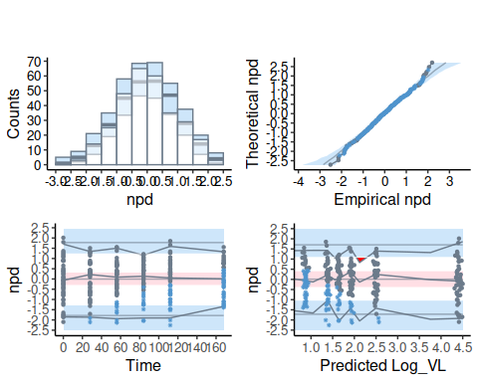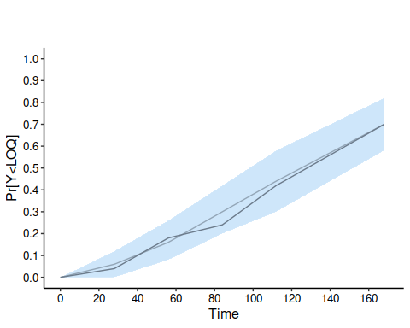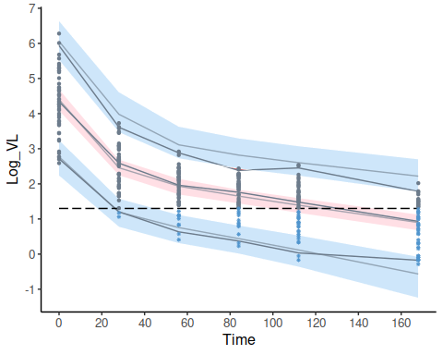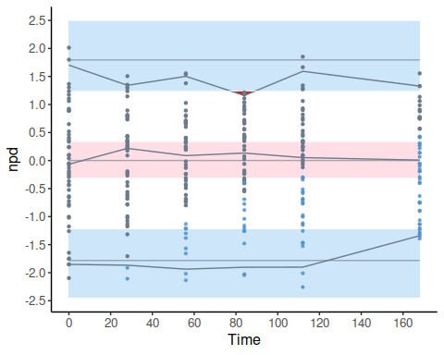

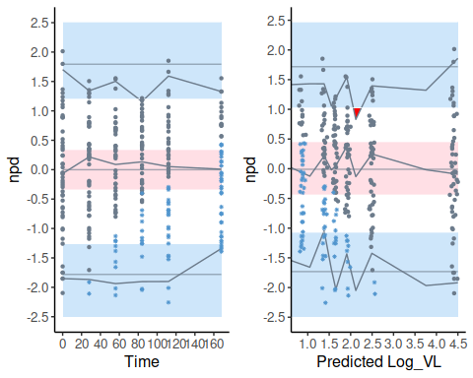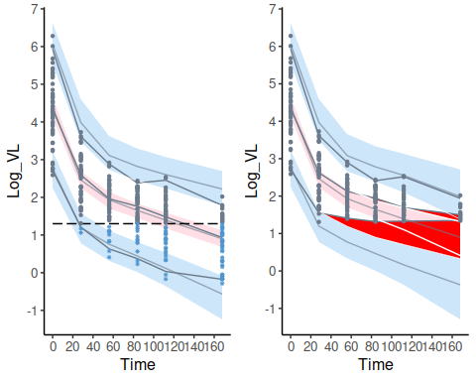

## End of file, deactivating development mode

## ✔ Dev mode: OFF

### Bugs to sort

### Sort out covariate plots

There were two functions with almost the same name - npde.plot.covariates: regular plots split by covariates, only for x, pred, ecdf => renamed to **npde.plot.splitcov** and added options hist and qqplot - do we need those subplots, or maybe just simplify call to function (use covsplit and capture arguments instead of using which.plot) - npde.plot.covariate: covariate plots as in Brendel => kept as is

#### plot.NpdeRes (dans plotNpde-methods.R)

* **Romain TODO**: la fonction devrait prendre un objet NpdeRes et pas un objet NpdeObject (NpdeRes n’a pas d’element data, c’est juste le slot res d’un element NpdeObject !!!)
  + il faut lui donner des defauts pour xlab, ylab (et la possiblite de passer outre en passant des arguments en …)
  + normalement il doit y avoir l’equivalent de xobs dans le dataframe res de l’objet
  + pas sure qu’on ait not.miss mais dans ce cas le reconstruire (a tester +++)
  + il n’y a pas de liste plot.opt donc prendre des defauts dans set.default.options()
* faire un testthat pour verifier que cette fonction marche par elle-meme (use testthat for class to generate an object npdeData and plot it)

#### plot.NpdeData (dans plotNpde-methods.R)

* **Romain TODO**: faire un testthat pour veeifier que la fonction et les options passent (use testthat for class to generate an object npdeData and plot it)