7/18/2022

Proposal



To develop a dynamic website, database driven e-commerce website

|  |
| --- |
|  |
| Proposal  UPtrend  For Scott-Media |
| |  |  |  | | --- | --- | --- | |  |  | Capstone Project | |

Contents

UPtrend 2

1.0 Description 2

2.0 Target Audience 2

Primary Audience 3

Secondary Audience 3

3.0 Project Details 3

4.0 Proposed Design Solution 4

Home Page: 4

Shop page (Dynamically loading data) 7

Product Details Page (Dynamically loading data): 8

Registration Page: 9

Login Page: 9

5.0 Use Cases 10

Guest 10

Authenticated users 10

Admin users 10

6.0 Sitemap 11

Front End Sitemap 11

Back End Sitemap 12

7.0 Server 12

8.0 Security 13

**On the Server** 13

UFW - Uncomplicated Firewall 13

SSL certificate 13

**In the Web App** 13

XSS Protection 13

CSRF Protection 13

SQL Injection protection 13

9.0 Database 14

10.0 Value adds 14

11.0 Revised ERD for Value Adds 15

12.0 Our Team 15

Proposal

# UPtrend

Website Development Project

From:

Dhruval Viradiya [dhruvalviradiya@gmail.com](mailto:dhruvalviradiya@gmail.com)

Lakshita [lXX@webmail.uwinnipeg.ca](mailto:lXX@webmail.uwinnipeg.ca)

Lihang Yao <leonjohnson377@gmail.com>

Pui Ching Chung <lawchunni@yahoo.com.hk>

To:

Steve George <<edu@pagerange.com>>

Date: May 5, 2021

# 1.0 Description

UPtrend Inc is an organization that sells clothing outfits mainly for men, women, and kids for different occasions and also allows customers to schedule their orders according to their needs. Customers can explore a variety of outfits such as shirts, dresses, tuxedos, ethnic wear, and a lot more through the help of the online selling store UPtrend. The UPtrend has its own brand. All the selected apparel will be delivered at their desired destination in new condition only.

# 2.0 Target Audience

## Primary Audience

* The website is targeting dominantly women and men of every age range. Either they or their parents should have an income greater than $35,000 and should be outgoing. The website appearance would be subtle and would have white color as the background so the outfits that we are selling stand out. The white color helps to establish contrast for all other colors. It will add to the overall appealing products of the website. Also, the website's color contrast and appearance would tempt the customers to make larger purchases which would help increase the revenue.
* The audience will consist of the middle class to elite class people.
* The audience should have at least a 5mbps internet connection.

## Secondary Audience

* The secondary audience would primarily consist of parents of girls and boys who may be looking to purchase perfect outfits for their sons/daughters casually or occasionally.
* The secondary audience will also consist of wholesalers who might want to buy dresses and sportswear stocks in large quantities for their shops.

# 3.0 Project Details

The site will be designed in such a way that it could deliver service-specific information to the user in an intuitive and easy-to-use way. The website will be user-friendly. The navigation would be easily accessible. Also, the content would be structured in an organized manner. The website will be designed in an MVC with Front Controller Framework and will have the following features:

* The Customers can add products to their wish list, as well as remove products from their wish list. They can also save the list for later use.
* Registration authentication – when a customer registers, the email provided will be verified, and make sure it is unique in the database.
* After Logging in, customers can view their profile, wish list, and previous orders and make new orders.
* Login and Logout Authentication – The password entered will be encoded for website security.
* Customers can search products by keyword. The search bar is located at the top of each page.
* Customers can view products sorted by different categories and sizes.
* Customers can add products to the shopping bags, edit quantities, view order subtotals, and make payments.
* Easy to use Navigation to obtain any information about the organization or services offered.
* The website would be Vibrant and appealing to women, men, boys, and girls looking for perfect outfits since they will be our primary audience.

# 4.0 Proposed Design Solution

## Home Page:

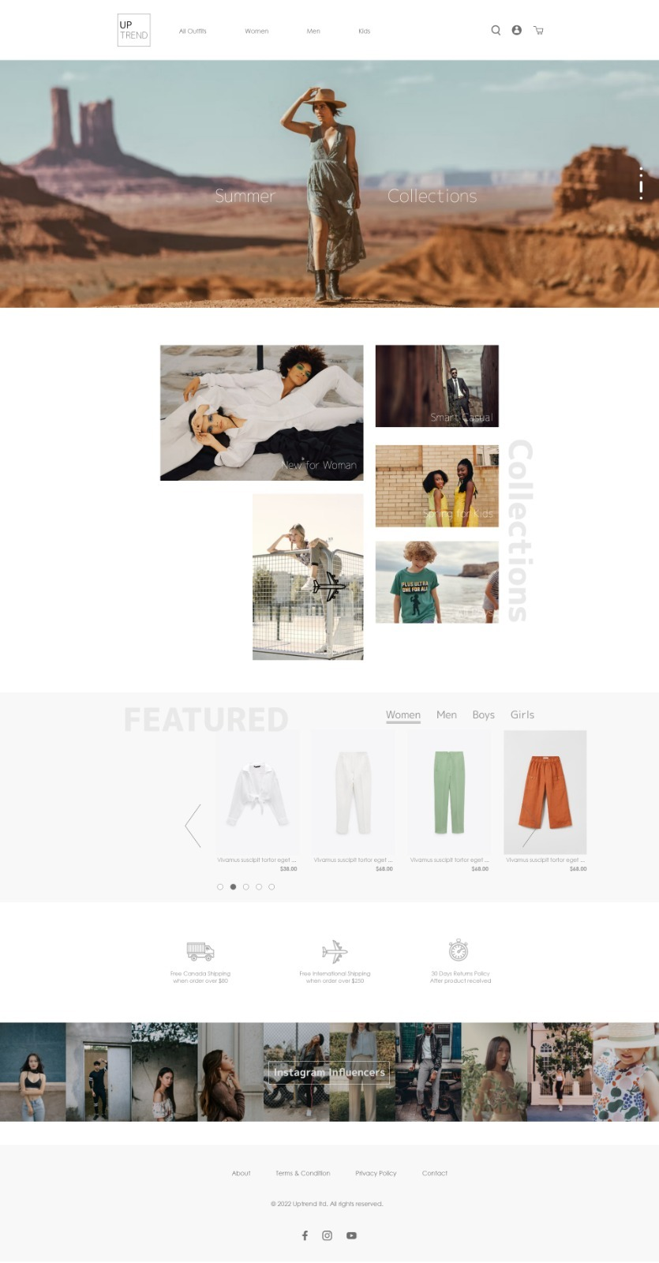

## Shop page (Dynamically loading data)

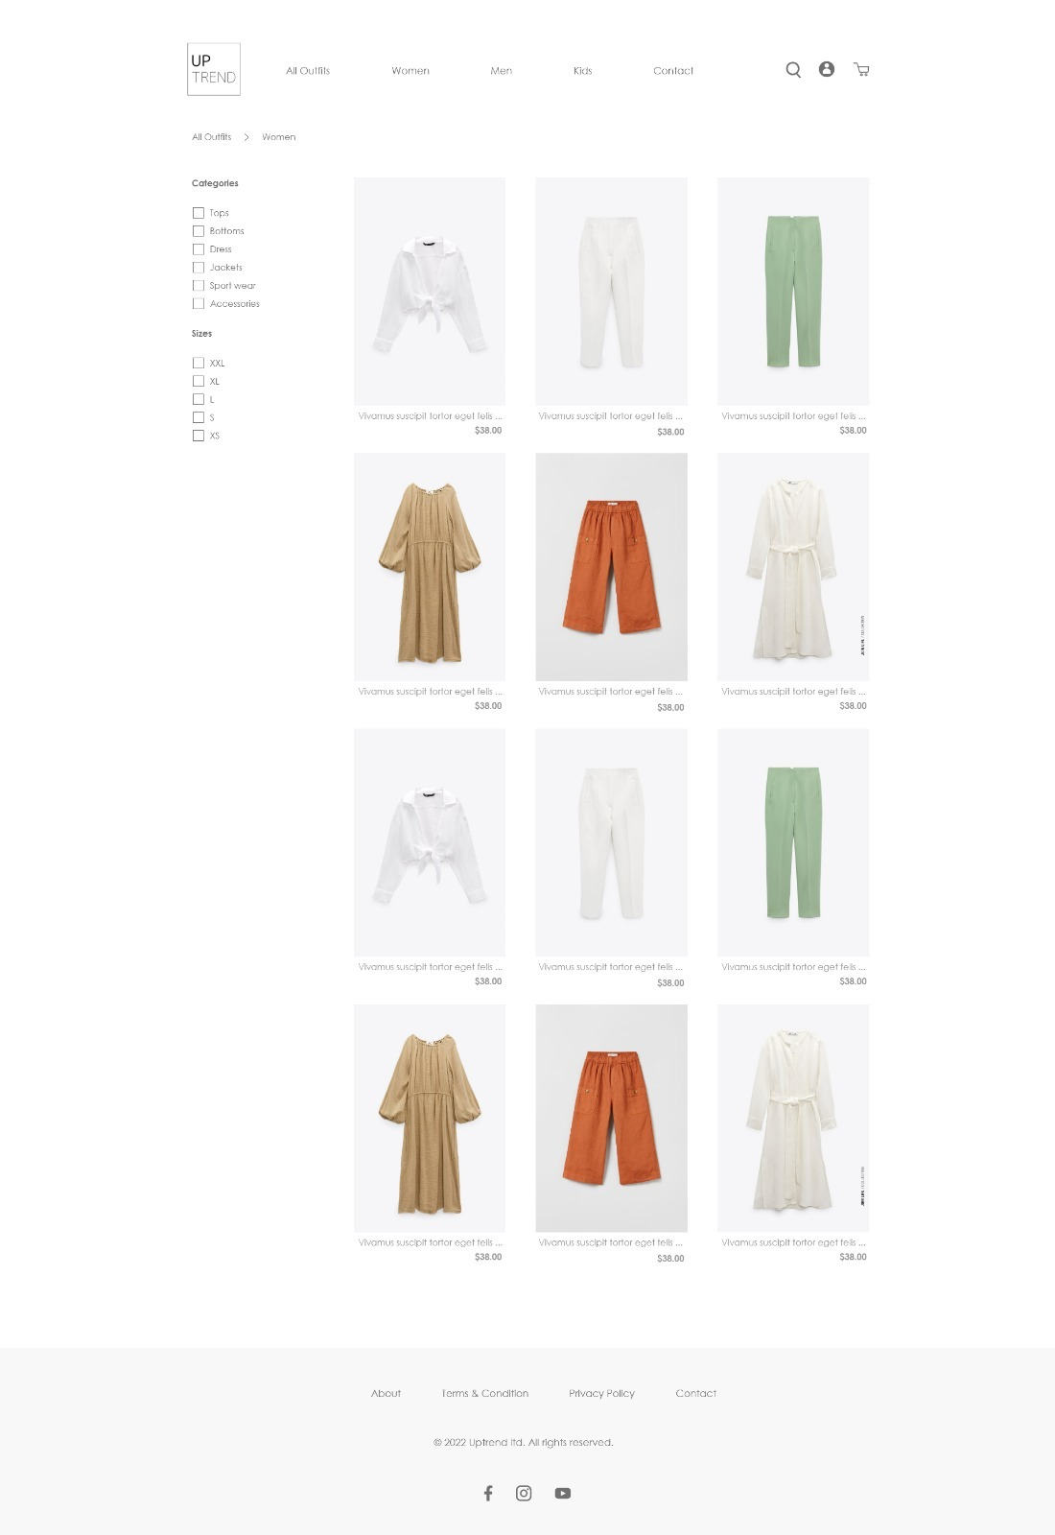

## Product Details Page (Dynamically loading data):

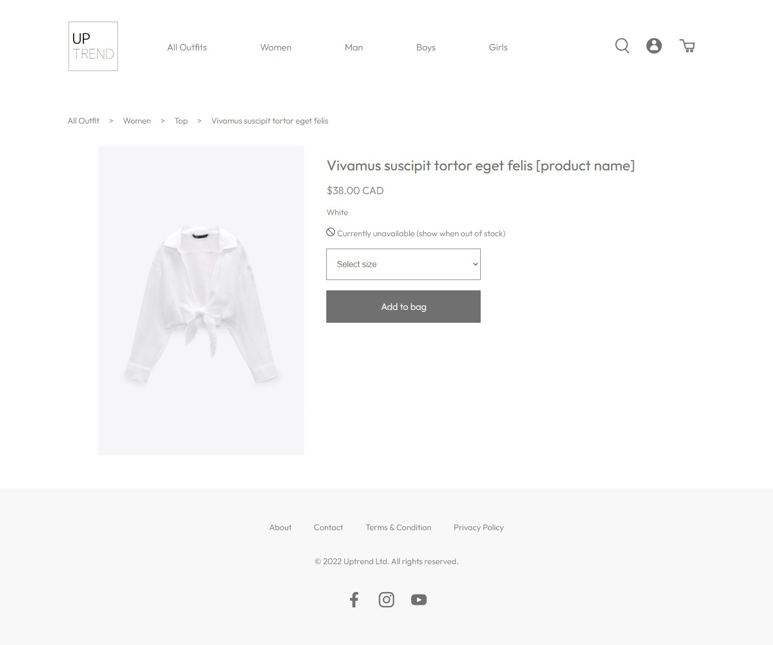

## Registration Page:

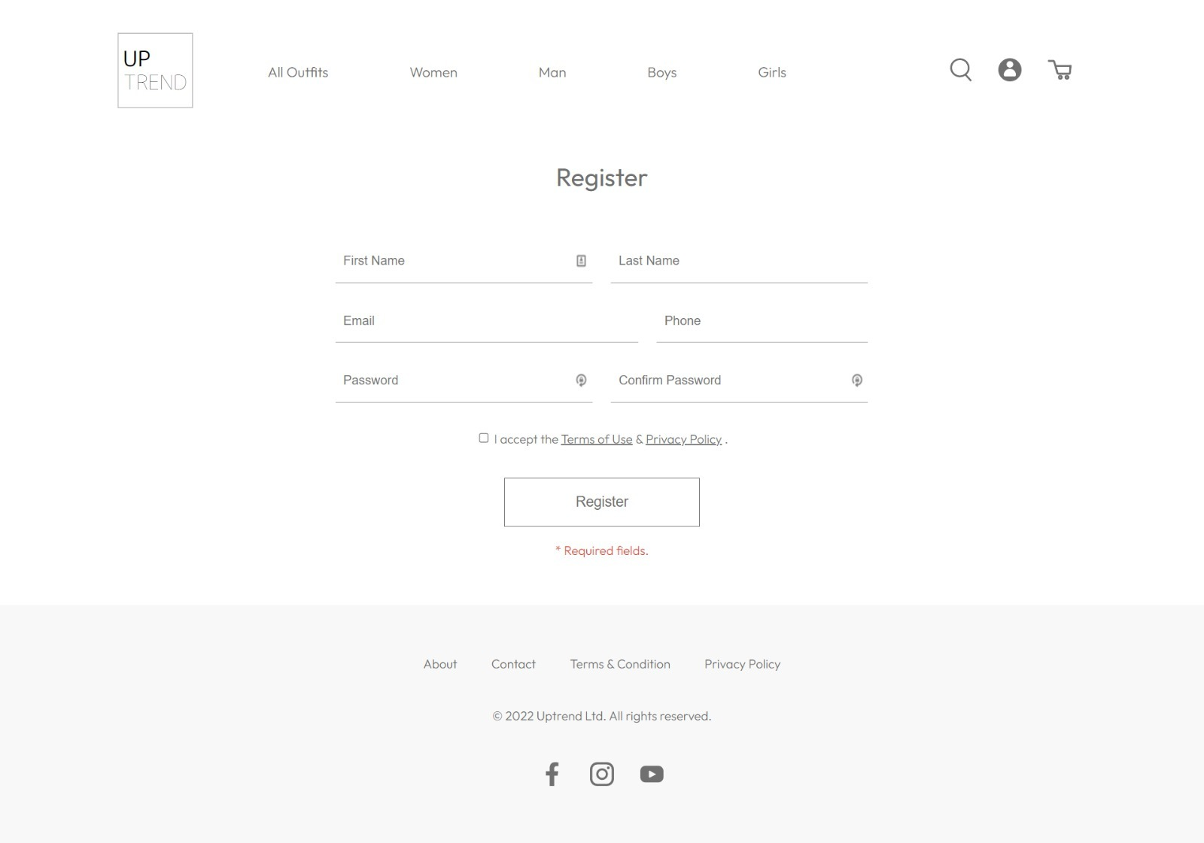

## Login Page:

## ­­

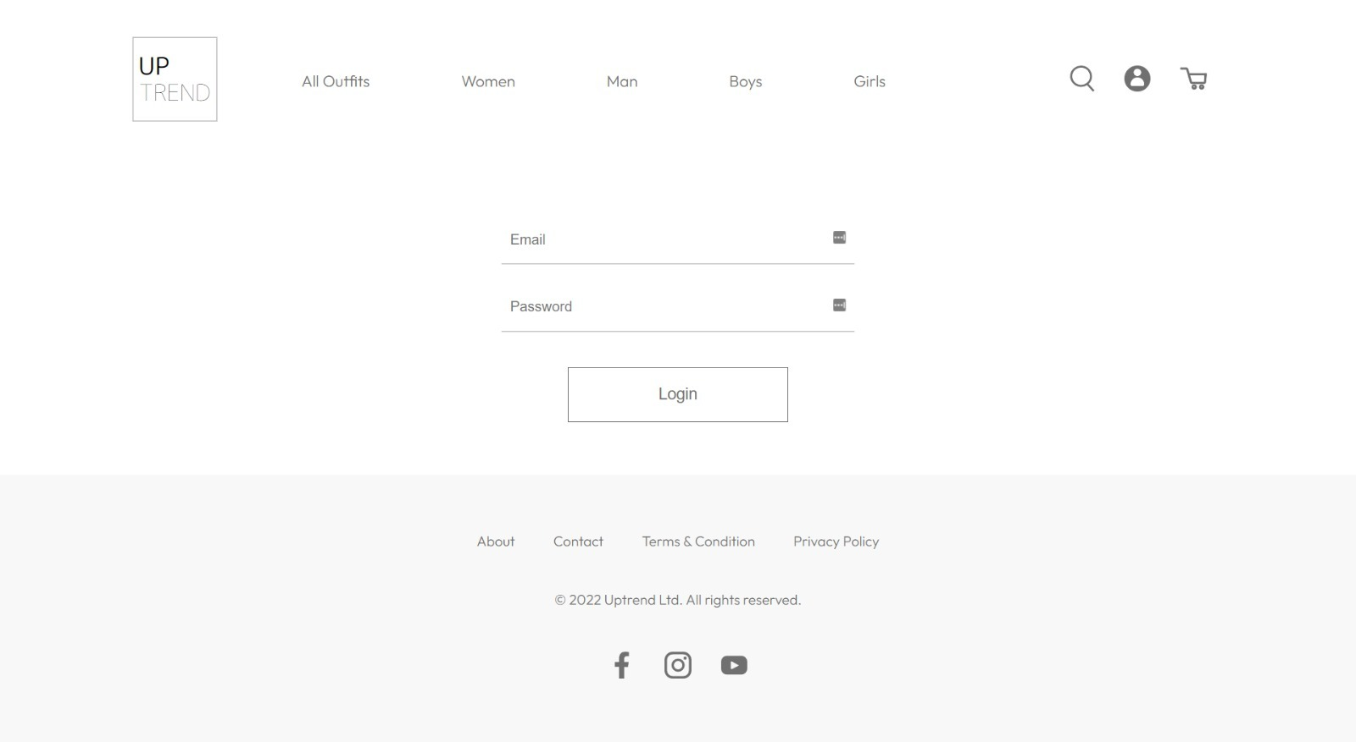

# 5.0 Use Cases

## Guest

A Guest user can visit all the pages through the main menu, they can view product list and detailed information, search for a certain product, add products to a shopping bag and wish list, view the shopping bag, edit product quantities and remove products but they cannot view the wish list or proceed to checkout to place an order.

## Authenticated users

An authenticated user can register or log in to become an authenticated user. Once a user register or logs in successfully, they will be redirected to the profile page. Users can access the “My Orders” page to view all previous orders. “My Wishlist” page to view the products saved in the wish list. They can also remove products from the wish list, and add products to the shopping bag directly from the wish list. Proceed to check out and make an order.

## Admin users

Admin users can access the backend admin site. Once an admin user signs in successfully, they will be redirected to the admin dashboard. The admin users can view, add, edit, remove and search products from the “Products” page. Admin can create, view, edit and delete the users from the “Users” page; view, edit and delete the orders sorted by created time from the “Orders” page; create, edit, view, and delete tax from the “Tax” page; and view the “inventory” table.

# 6.0 Sitemap

## Front End Sitemap

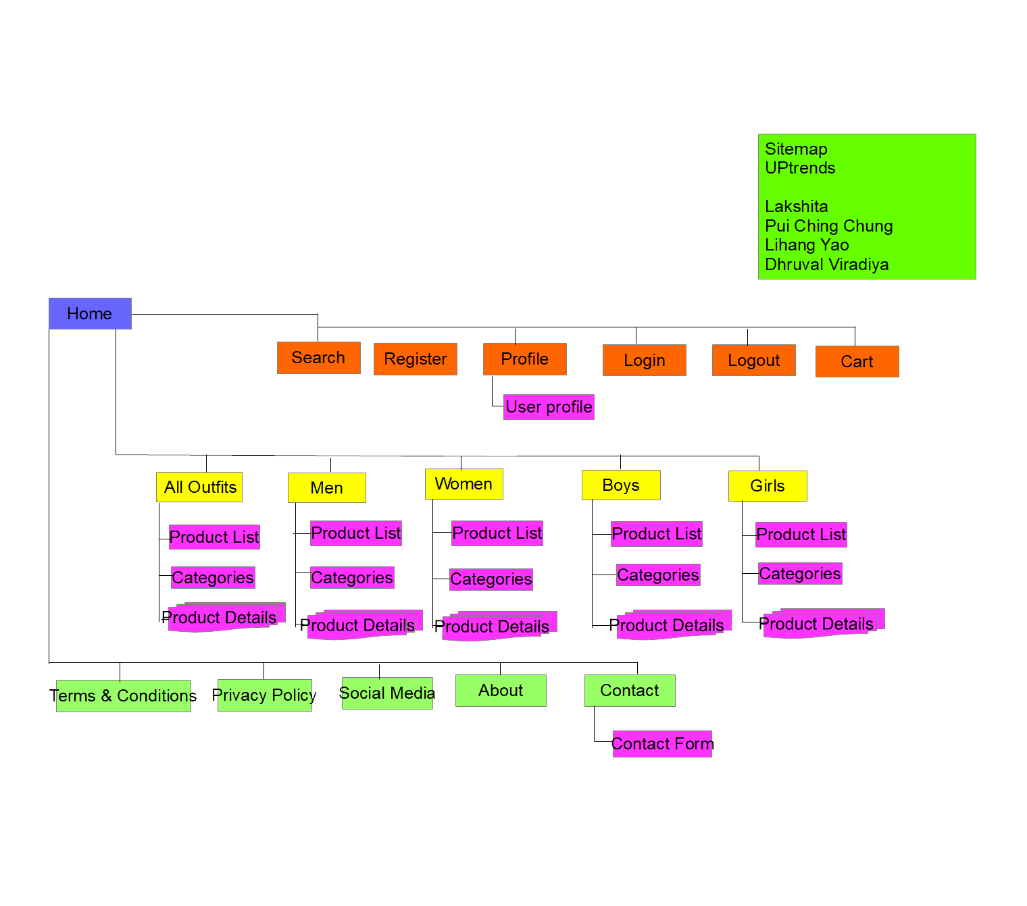

## Back End Sitemap

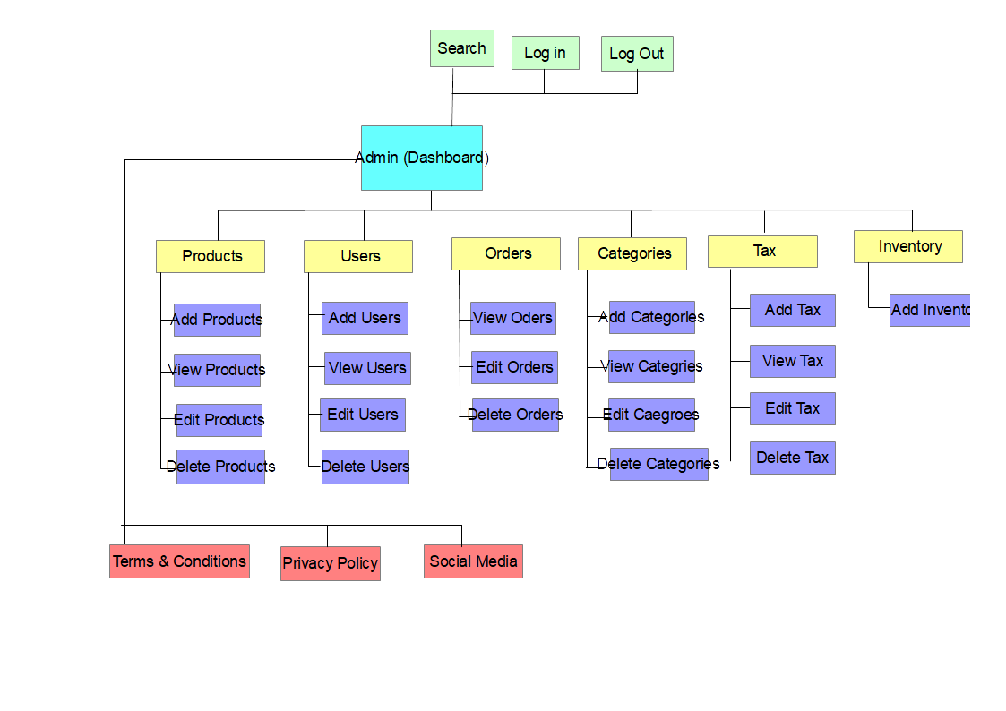

# 7.0 Server

We have installed the following server, packages, and softwares for this website.

Laravel Framework version 9.20.0

Composer version 2.3.10

npm version 8.5.5

node version 16.15.0

Ubuntu version 22.04 LTS

Mysql version 8.0.29

apache version 2.4.52

PHP version 8.1.2

zip/unzip

All the above software and packages have been installed and are being hosted on <http://team3.uwpace.ca/>

# 8.0 Security

## **On the Server**

### UFW - Uncomplicated Firewall

### SSL certificate

## **In the Web App**

### XSS Protection

Cross-side script injections are prevented by using PHP in-built htmlentities() function to sanitize data. This makes sure that all data gets sanitized before getting used throughout the website.

### CSRF Protection

Cross-site forgery attacks are prevented by adding CSRF tokens to forms and sessions. Tokens are random and encoded values. When submitting the token will be verified, and the form will be submitted only if the token matches the setting.

### SQL Injection protection

SQL injections are prevented by using prepared statements. When interacting with the database, to avoid the input being taken as part of SQL Command, we bind parameters and thus force the input to be handled a parameters

# 9.0 Database

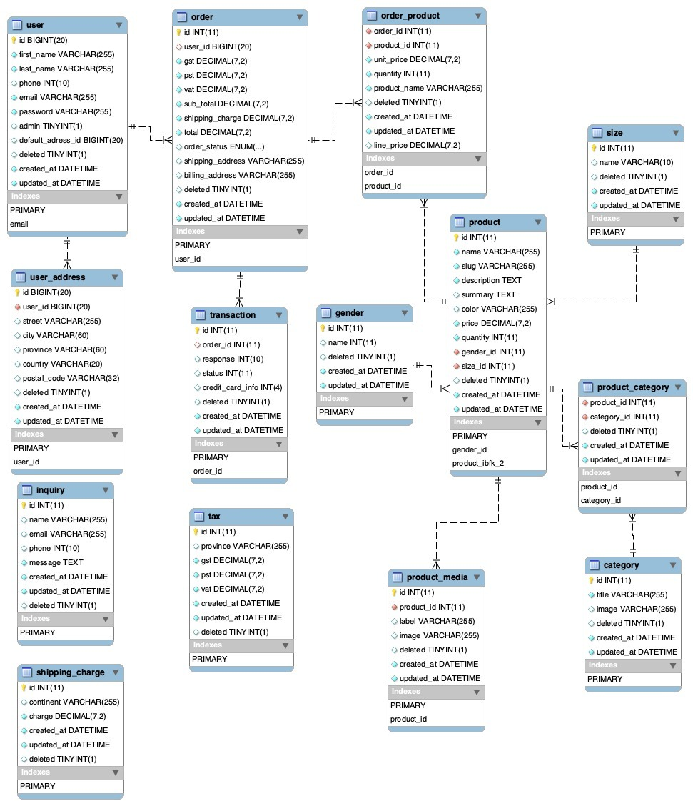

# 10.0 Value adds

We will be adding advertisements on the page as a value add so admin can easily add the special advertisement on some special occasions of some discounts or offers which would attract the potential customers seeking to buy outfits at a lower range or package deals.

# 11.0 Revised ERD for Value Adds

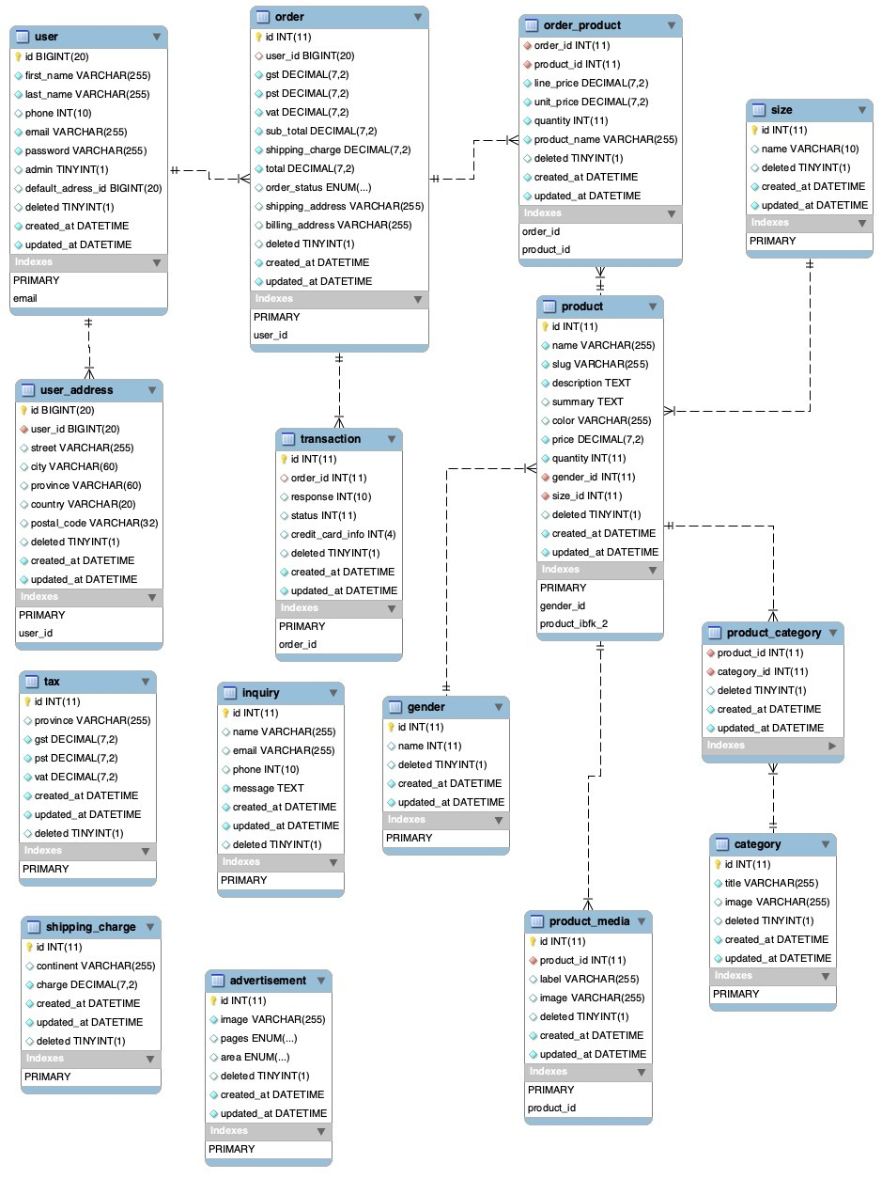

# 12.0 Our Team

We have an extremely skilled team working day in-out to meet your requirements and deliver quality work.

Here is the list of our team members that will be working on the Development of the website:

|  |  |  |
| --- | --- | --- |
| **Name** | **Role** | **Qualifications** |
| Lakshita | Project Manager | 10 Years |
| Pui Ching Chung | Frontend Designer | 5 Years |
| Lihang Yao | Git and Database Administrator | 7 Years |
| Dhruval Viradiya | Backend PHP Programmer | 15 Years |

# 