7/18/2022

Proposal



To develop a dynamic website, database driven e-commerce website

|  |
| --- |
|  |
| Proposal  UPtrend  For Scott-Media |
| |  |  |  | | --- | --- | --- | | Dhruval Viradiya-367 |  | Capstone Project | |

Contents

UPtrend 2

1. Description 2

2. Target Audience 2

Primary Audience 2

Secondary Audience 3

3. Project Details 3

4. Proposed Design Solution 4

Home Page 4

Product List Page (Dynamically loading data) 5

Product Details Page (Dynamically loading data) 6

Registration Page 7

Login Page 7

5. Use Cases 8

Guest 8

Authenticated users 8

Admin users 8

6. Sitemap 8

Front End Sitemap 8

Back End Sitemap 9

7. Server 9

8. Security 10

On the Server 10

Secured Firewall 10

SSL Certificate 10

SSH Root Access Disabled 10

In the Web App 10

XSS Protection 10

CSRF Protection 10

SQL Injection protection 10

9. Database 11

10. Value adds 11

11. Revised ERD for Value Adds 12

12. Our Team 13

Proposal

# UPtrend

Website Development Project

From:

Dhruval Viradiya [dhruvalviradiya@gmail.com](mailto:dhruvalviradiya@gmail.com)

Lakshita [lXX@webmail.uwinnipeg.ca](mailto:lXX@webmail.uwinnipeg.ca)

Lihang Yao leonjohnson377@gmail.com

Pui Ching Chung lawchunni@yahoo.com.hk

To:

Steve George <edu@pagerange.com>

Date: July 18, 2022

# 1. Description

UPtrend Inc. is an organization that sells clothing outfits mainly for men, women, and kids for different occasions and also allows customers to schedule their orders according to their needs. Customers can explore a variety of outfits such as shirts, dresses, tuxedos, ethnic wear, and a lot more in different sizes through the wide range of categories that UPtrend offers. The UPtrend itself is a brand. All the selected apparel of the UPtrend will be delivered to the customer's desired destination in the new condition.

# 2. Target Audience

## Primary Audience

* The website is targeting dominantly women and men of every age range. Either they or their parents should have an income higher than $35,000 and should be outgoing. The website appearance would be subtle and would have white color as the background so the outfits that we are selling stand out. The white color helps to establish contrast for all other colors. It will add to the overall appealing products of the website. Also, the website's color contrast and appearance would tempt the customers to make larger purchases which would help increase the revenue.
* The audience will consist of the middle class to elite class people.
* The audience should have at least a 5mbps internet connection.

## Secondary Audience

* The secondary audience would primarily consist of parents of girls and boys who may be looking to purchase perfect outfits for their sons/daughters casually or occasionally.
* The secondary audience will also consist of wholesalers who might want to buy dresses and sportswear stocks in large quantities for their shops.

# 3. Project Details

The site will be designed in such a way that it can deliver service-specific information to the user in an intuitive and easy-to-use way. The website will be user-friendly. The navigation would be easily accessible. Also, the content would be structured in an organized manner. The website will be designed in an MVC with Front Controller Framework and will have the following features:

* Registration authentication – when a customer registers, the email provided will be verified, and make sure it is unique in the database.
* After Logging in, customers can view their profile and previous orders and make new orders.
* Login and Logout Authentication – The password entered will be encoded for website security.
* Customers can search products by keyword. The search bar is located at the top of each page.
* Customers can view products sorted by different categories and sizes.
* Customers can add products to the shopping bags, edit quantities, view order subtotals, and make payments.
* The shopping cart items will be stored in the local storage. Customers will be able to check out the cart list they have created after they close and re-open the browser.
* Easy to use the navigation to obtain information about the organization or contact the organization.
* The website would be vibrant and appealing to women, men, boys, and girls looking for perfect outfits since they will be our primary audience.

# 4. Proposed Design Solution

## Home Page

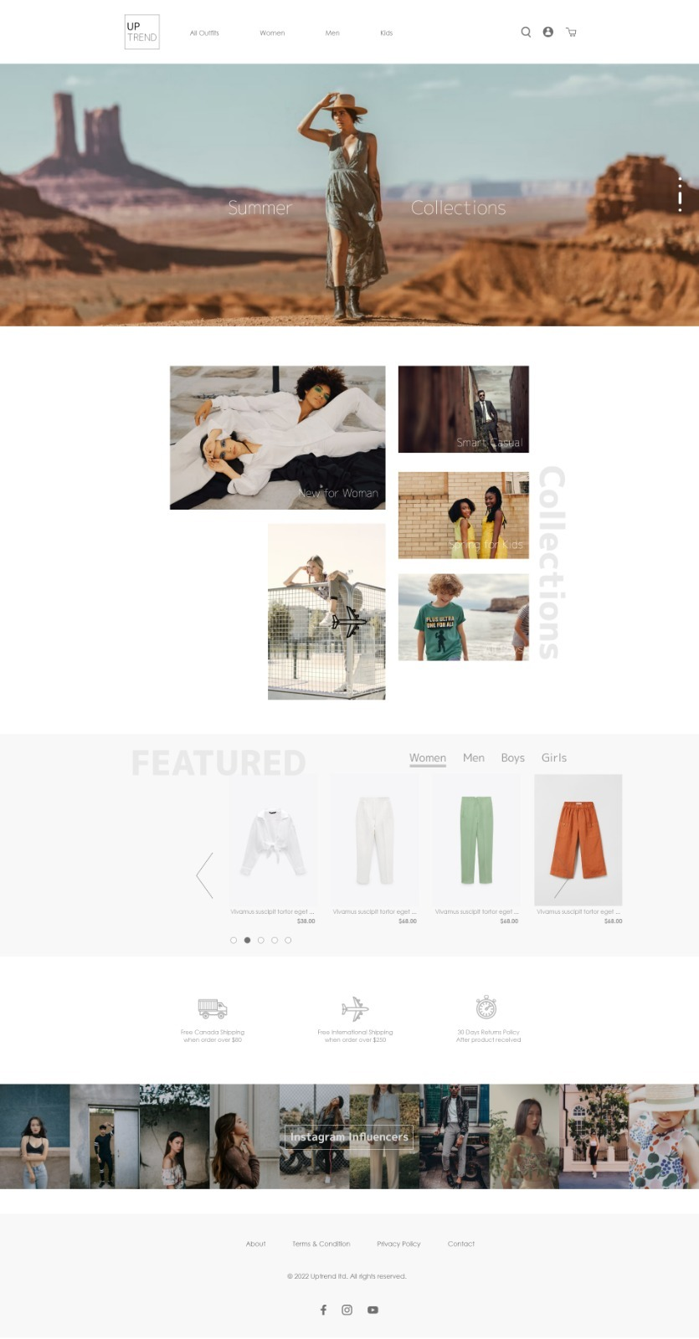

## Product List Page (Dynamically loading data)

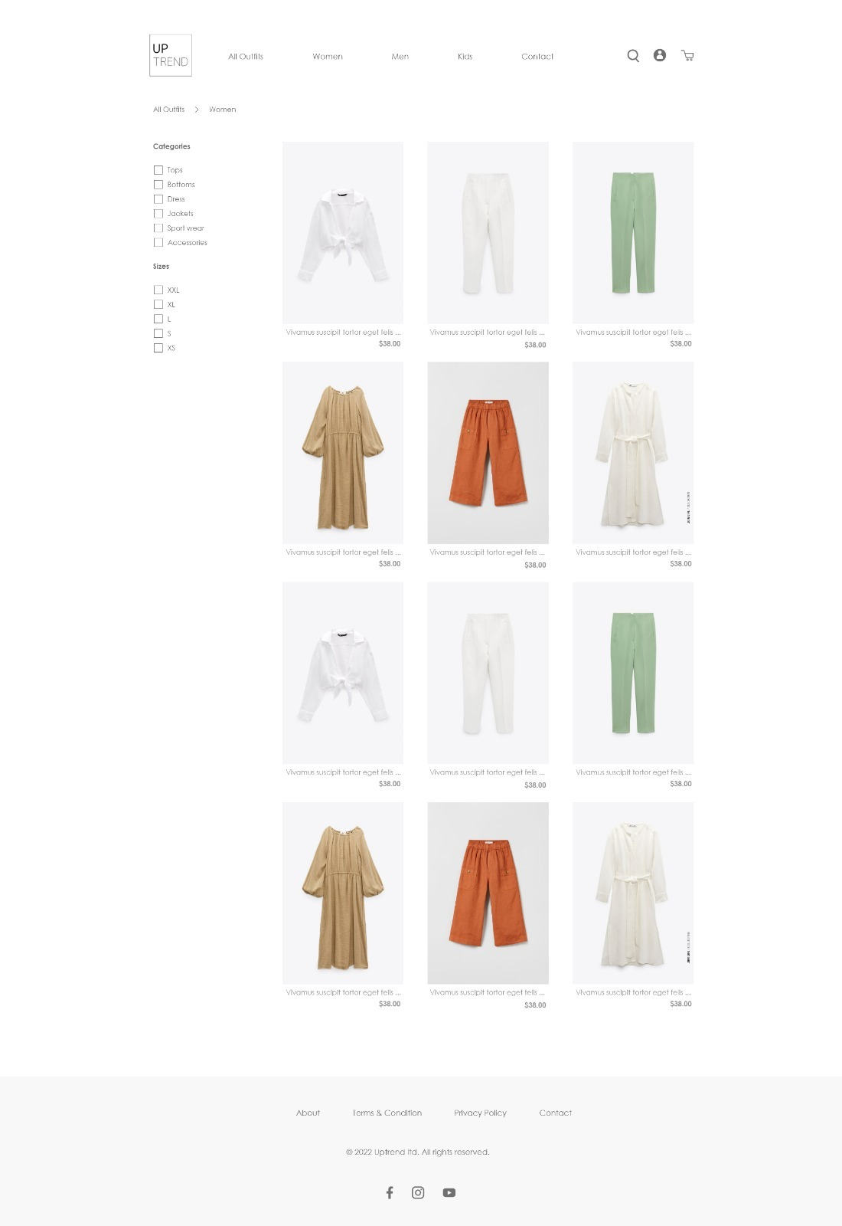

## Product Details Page (Dynamically loading data)

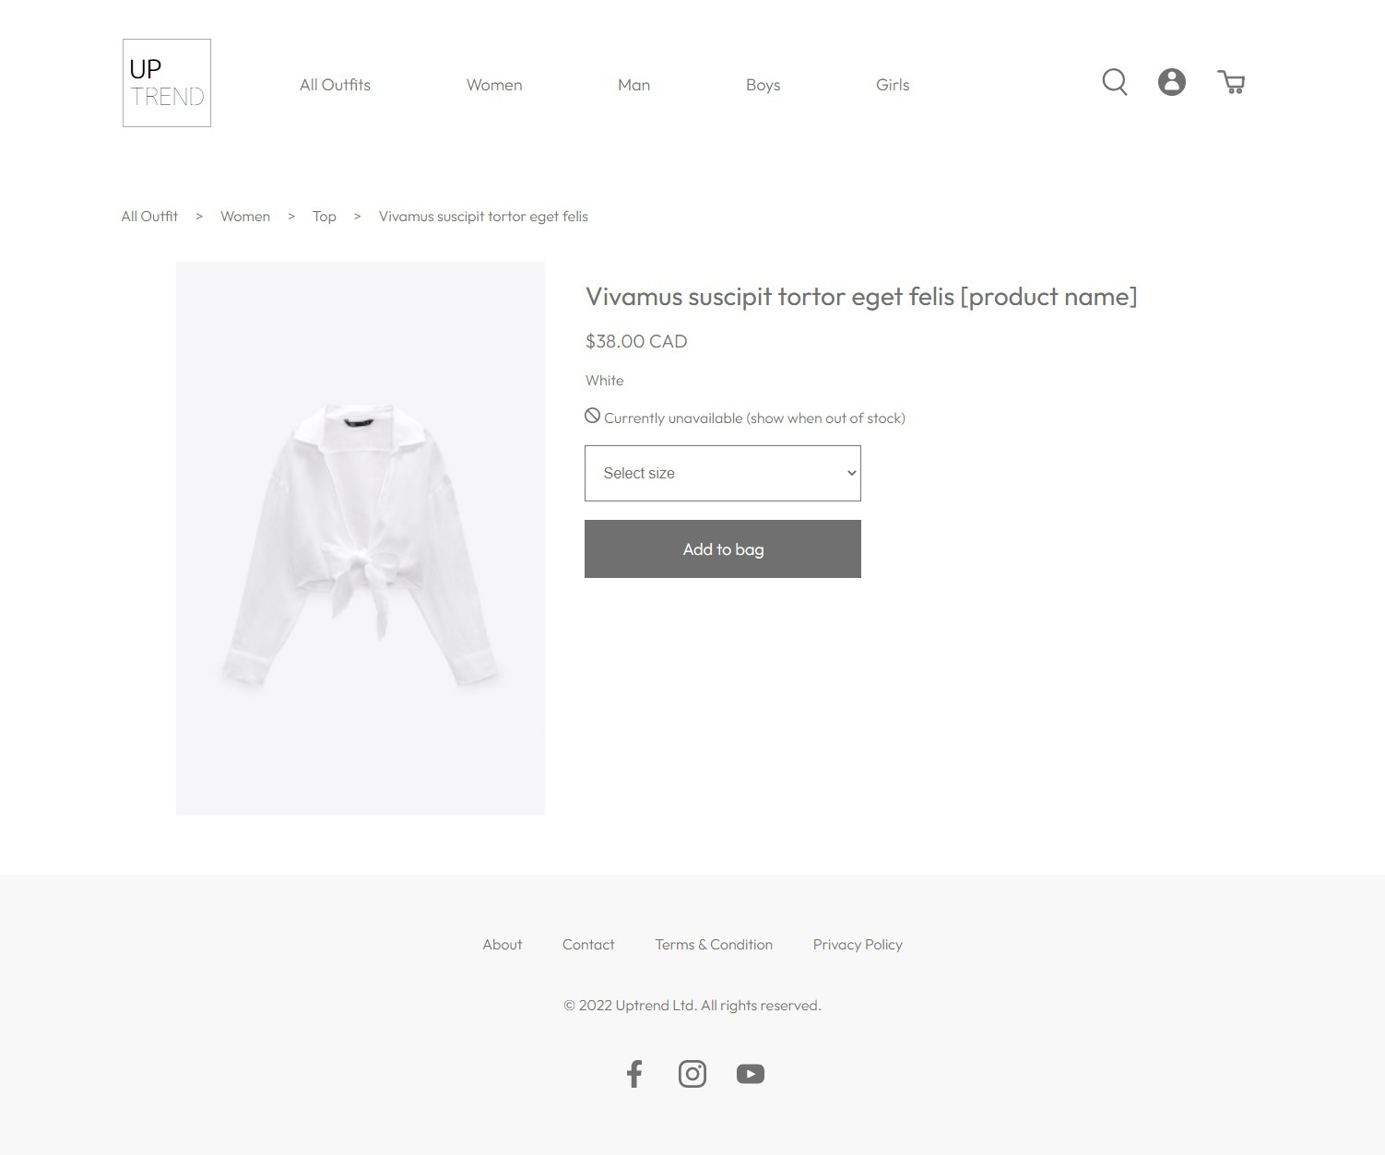

## Registration Page

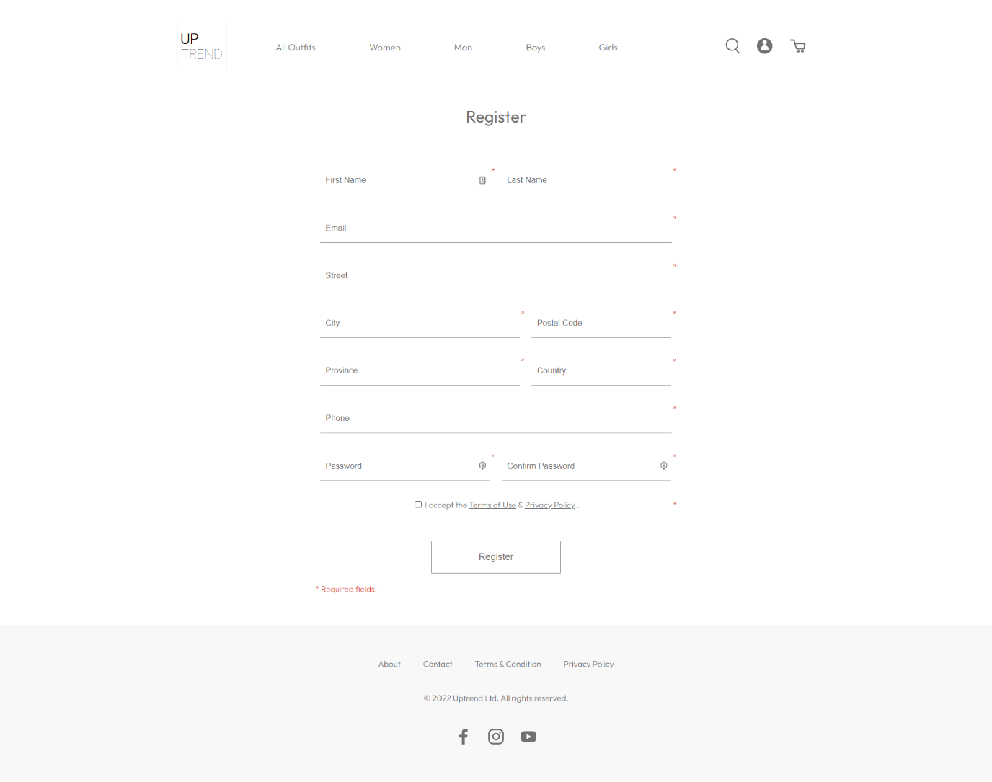

## Login Page

## ­

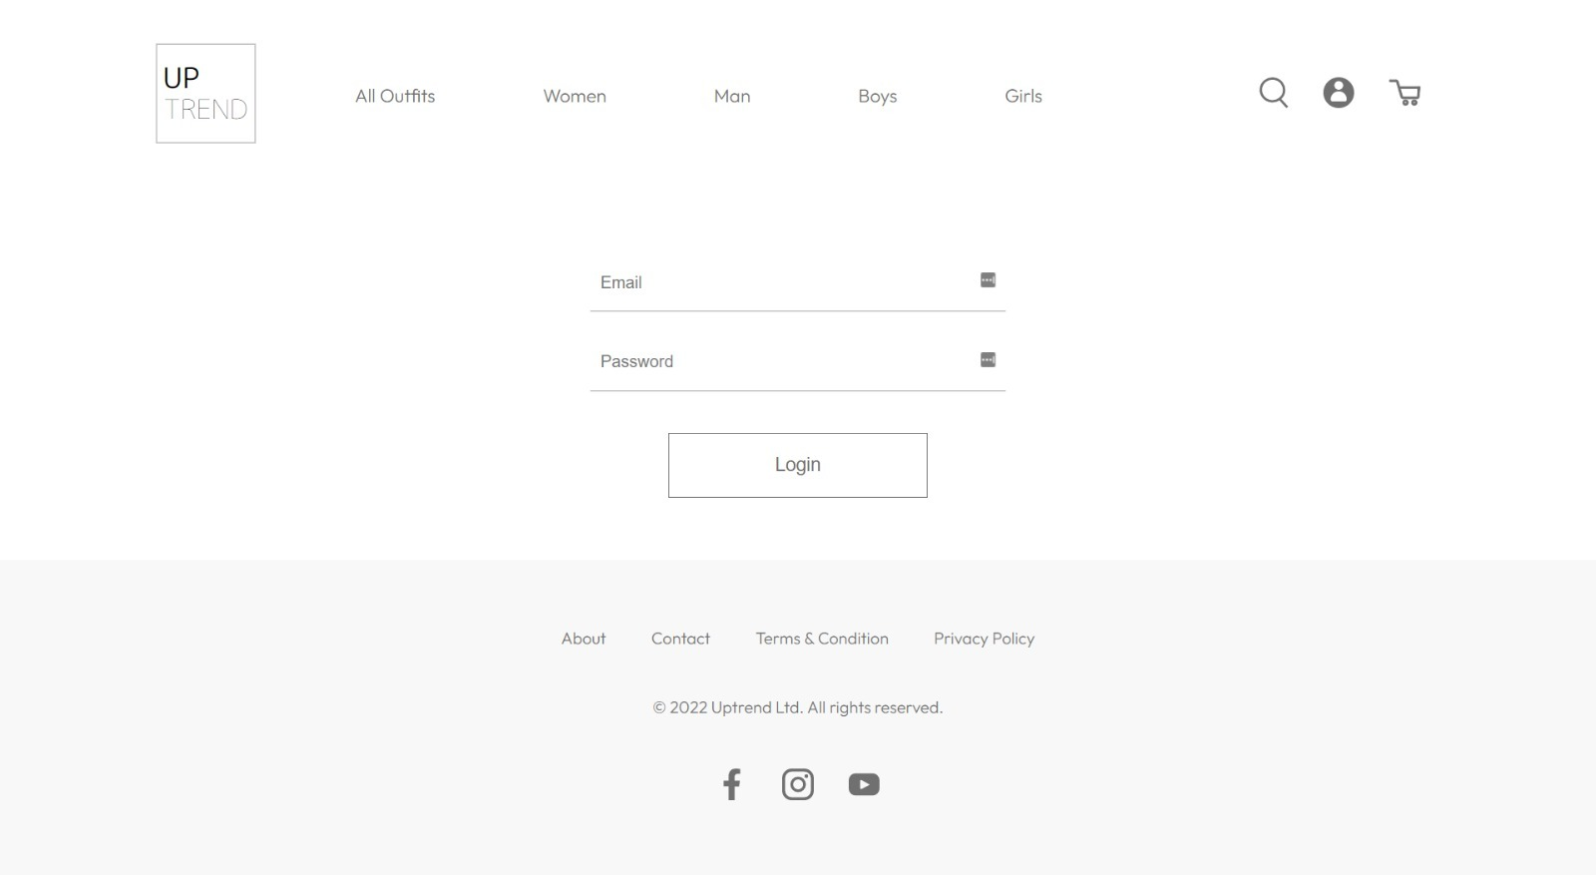

# 5. Use Cases

## Guest

A guest user can visit all the pages through the main menu. They can view a product list and detailed information, search for a specific product, add products to a shopping bag and wish list, view the shopping bag, edit product quantities and remove products. However, they cannot proceed to checkout to place an order.

## Authenticated users

An authenticated user can register or log in to become an authenticated user. Once a user register or logs in successfully, they will be redirected to the profile page. Users can access the “My Orders” page to view all previous orders. They can also proceed to check out and make an order.

## Admin users

Admin users can access the backend admin site. Once an admin user signs in successfully, they will be redirected to the admin dashboard. The admin users can view, add, edit, remove and search products from the “Products” page. Admin can create, view, edit and delete the users from the “Users” page; view, edit and delete the orders sorted by created time from the “Orders” page; create, edit, view, and delete tax from the “Tax” page; and view the “inventory” table.

# 6. Sitemap

## Front End Sitemap

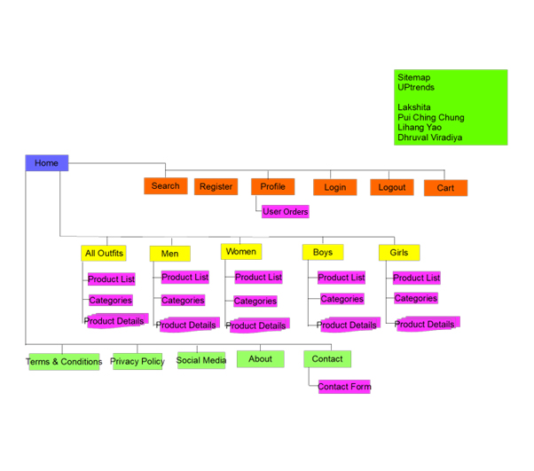

## Back End Sitemap

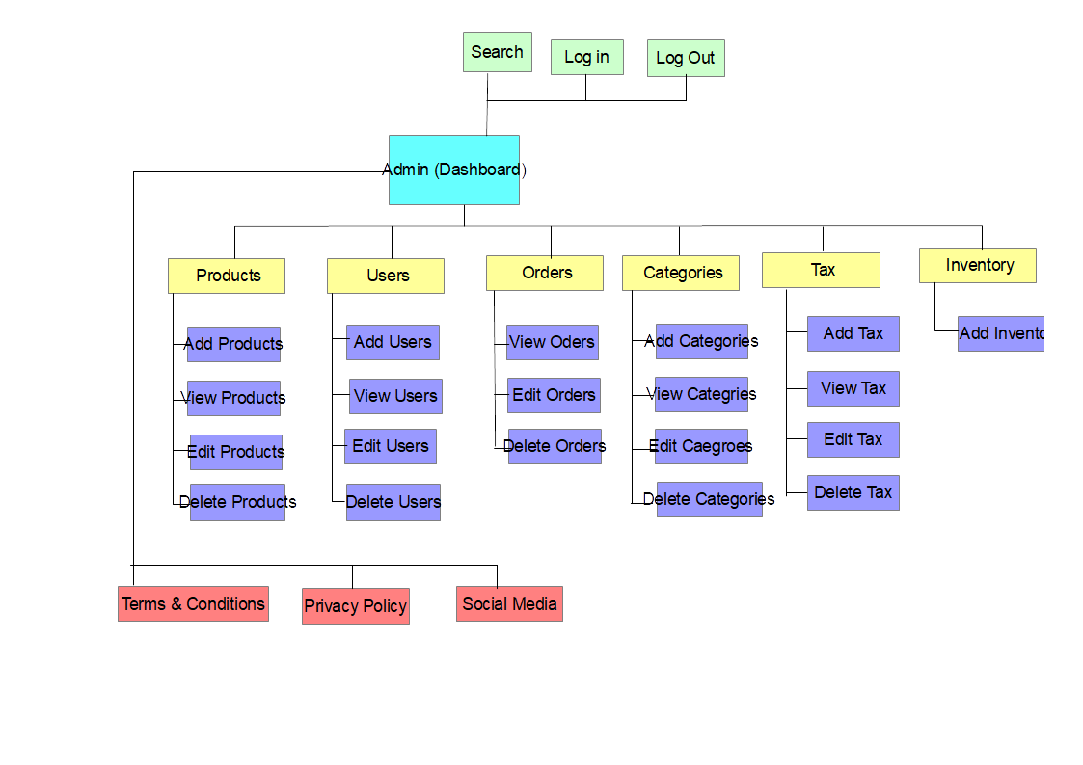

# 7. Server

All the below software and packages have been installed and are being hosted on <http://team3.uwpace.ca/>

* Operating System: Ubuntu (22.04)
* Web Server: Apache (2.4.52)
* Scripting Language: PHP (8.1.2)
* Framework: Laravel (9.20.0)
* Package Manager: Composer (2.3.10) and NPM (8.5.5)
* Runtime Environment: Node (16.15.0)
* Database: MySql (8.0.29)
* Other library/package: zip/unzip, mysql-server, php-mbstring, php-xml, php-zip, php-mysql, php-sqlite3, php-gd, php-zip, and php-curl

# 8. Security

## On the Server

### Secured Firewall

As part of the Ubuntu distribution, UFW (Uncomplicated Firewall) is a tool for configuring iptables firewall rules. Its goal is to make managing firewall rules easier. By using UFW, all ports on the system except 80, 443, and 22 are closed.

### SSL Certificate

Websites can establish encrypted connections by authenticating their identities using HTTPS certificates. Security protocols such as SSL create encrypted connections between web servers and browsers. A secure SSL certificate protects the website, which can be accessed via HTTPS.

### SSH Root Access Disabled

SSH root access shouldn't be enabled for unauthorized users for security reasons. Hackers can brute force your password and gain access to your system by brute force. The server is configured to prevent root access with SSH.

## In the Web App

### XSS Protection

Cross-side script injections are prevented by using PHP in-built htmlentities() function to sanitize data. This function ensures that all data gets sanitized before being used throughout the website.

### CSRF Protection

Cross-site forgery attacks are prevented by adding CSRF tokens to forms and sessions. Tokens are random and encoded values. When submitting, the token will be verified, and the form will be submitted only if the token matches the setting.

### SQL Injection protection

SQL injections are prevented by using prepared statements. When interacting with the database, to avoid the input being taken as part of SQL Command, we bind parameters and thus force the input to be handled a parameters

# 9. Database

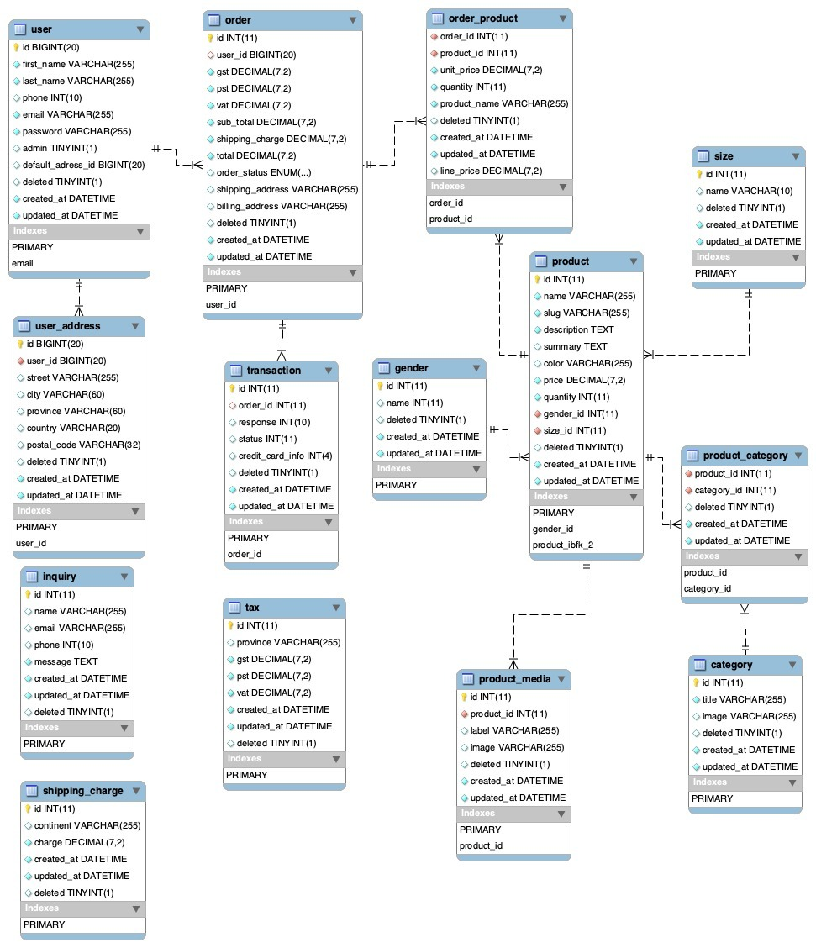

# 10. Value adds

We will be adding advertisements on the page as a value add so admin can easily add the special advertisement on some special occasions offering some discounts or offers which would attract the potential customers looking to buy outfits at a lower range or in package deals.

# 11. Revised ERD for Value Adds

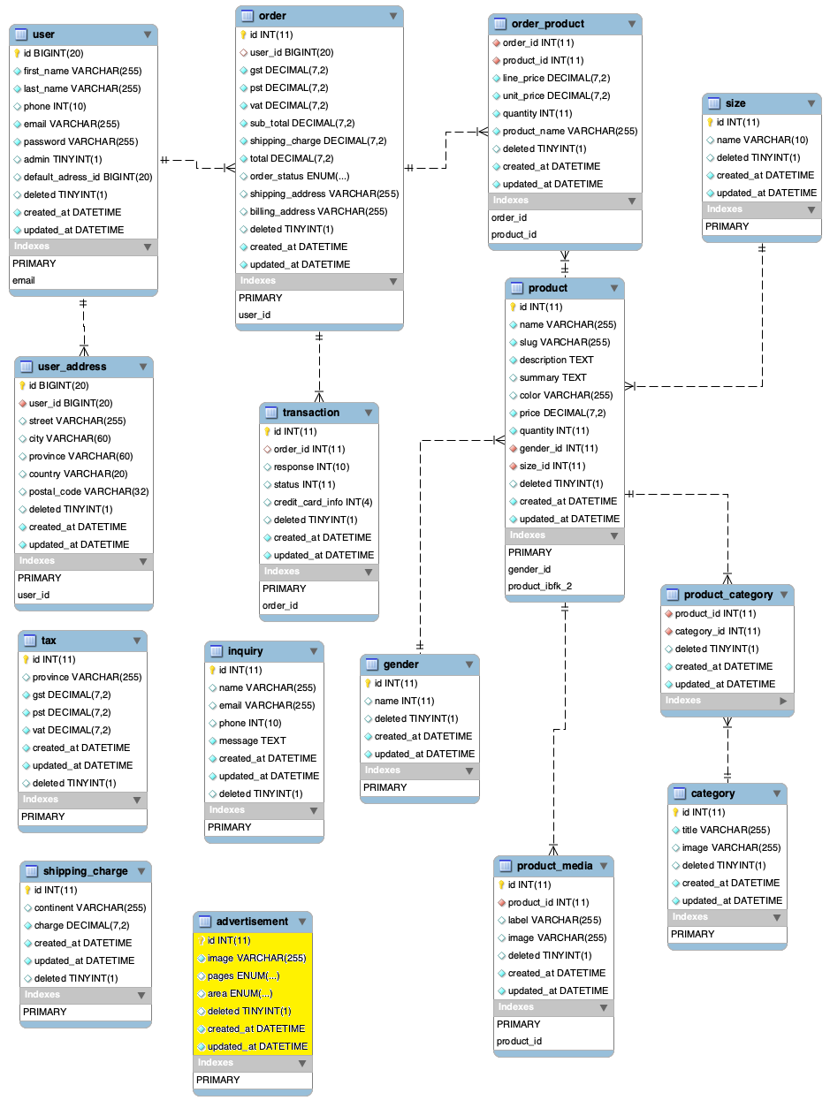

# 12. Our Team

We have an extremely skilled team working day in-out to meet your requirements and deliver quality work.

Here is the list of our team members that will be working on the Development of the website:

|  |  |  |
| --- | --- | --- |
| **Name** | **Role** | **Qualifications** |
| Lakshita | Project Manager | 10 Years |
| Pui Ching Chung | Frontend Designer | 5 Years |
| Lihang Yao | Git and Database Administrator | 7 Years |
| Dhruval Viradiya | Backend PHP Programmer & Server Administrator | 15 Years |

Lakshita: She is responsible for managing the entire project, delegating the tasks to the team, and also making sure to get all the deliverables finished before the deadline bug-free.

Pui Ching Chung: She is responsible for designing the front end of the website including HTML.

Lihang Yao: He is responsible for managing the database along with maintaining the GIT (version control).

Dhruval Viradiya: He is responsible for the PHP programming of the website. In other words, he will be managing the backend of the website. He is also administering the server with all the configurations.