## Blank environment

1. After signing up click “+ New Space”



1. Enter in the information and click “Create”

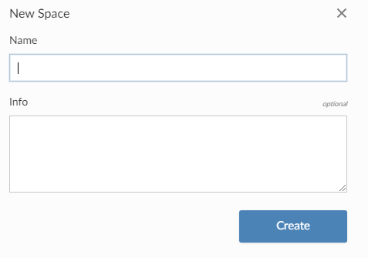

1. You can click “new project” to start a blank R studio IDE. You will see a loading icon while the instance initializes.



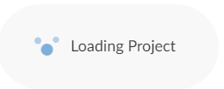

1. The Rstudio IDE will be hosted in your browser but functions similarly to the local version.

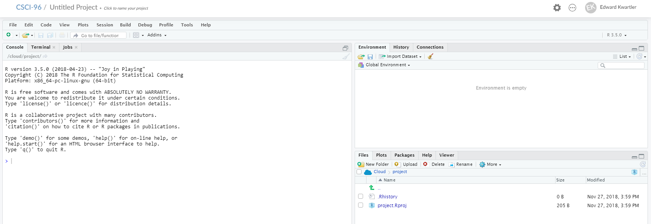

1. If you click at the top you can name your project whatever you want. Here it is “ClassWork”



1. To start a new script navigate to FILE>New File> R Script

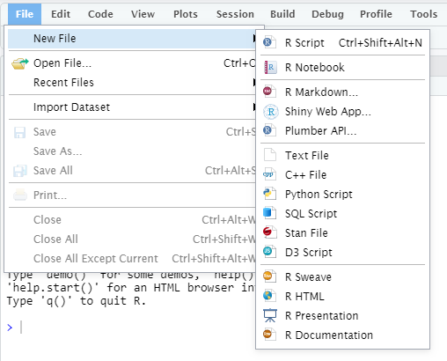

## Clone a github Repo

1. Click on a workspace.



1. Click the “down arrow” in the icon. Select “New Project from Git Repo”

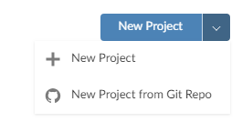

1. In the dialogue, paste the URL of the class repo and click “OK”. You will see a loading icon. DO NOT USE THE LINK IN THE PICTURE. COPY/PASTE THE SPRING URL BELOW.

<https://github.com/kwartler/HarvardSpringStudent2019>

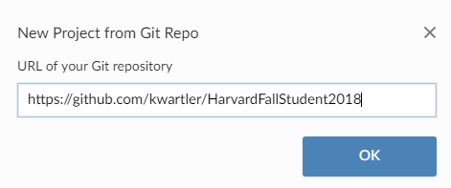



1. First the R studio is instantiated and then a dialogue opens up similar to below as it gets all the files.

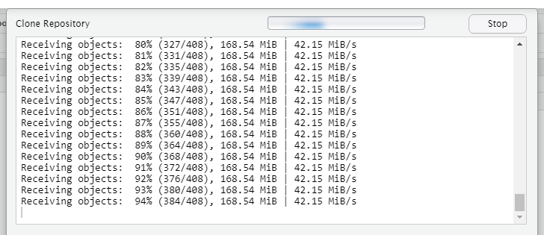

1. Now your environment will have files in the lower right hand pane.

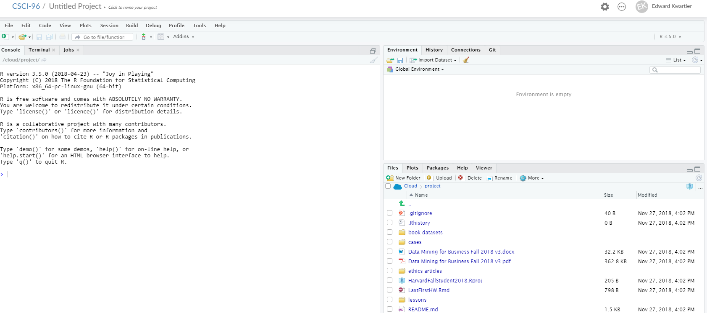

1. It’s a good idea to click on the untitled project at the top and give it a proper name.



1. To refresh your files each week simply perform a git pull (down arrow).



## Uploading files

1. Because you are now working on a server you may need to get files from your local computer into the R environment. An easy way to do this is with the “upload” icon.



1. From there simply navigate to the file from the dialogue box and click “OK”

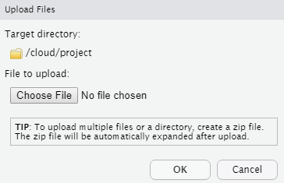

## Downloading files

1. Downloading files may seem more tricky only because the icon is hidden. The first thing to do is to click on a file or files to download from the server to your local computer. Here I have selected 2 files.

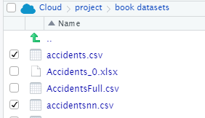

1. Next click “more” to open up a drop down. Click “export” to start the download.

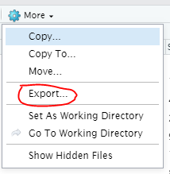

1. If you selected a single file it will be downloaded from your browser. If you selected more than one a .zip file will be created and it will also be in your downloads folder.