Module 3
Set up your data analytics toolbox

Spreadsheets, query languages, and data visualization tools are all a big part of a data analyst’s job. In this part of the course, you’ll learn the basic concepts to use them for data analysis. You’ll also understand how they work through interesting examples.

Learning Objectives

- Describe spreadsheets, query languages, and data visualization tools, giving specific examples
- Demonstrate an understanding of the uses, basic features, and functions of a spreadsheet
- Explain the basic concepts involved in the use of SQL including specific examples of queries
- Identify the basic concepts involved in data visualization, giving specific examples

Master spreadsheed basics
Step-by-Step: Make spreadsheets your friend

This reading outlines the steps the instructor performs in the next video, Make spreadsheets your friend.
In the video, the instructor demonstrates some spreadsheet basics and discusses how to use them to organize and analyze data.
Keep this step-by-step guide open as you watch the video. It can serve as a helpful reference if you need additional context or clarification while following the video steps. This is not a graded activity, but you can complete these steps to practice the skills demonstrated in the video.
What you’ll need
Use this guide as a reference if you need additional context or clarification as you watch the next video. If you’d like to follow along with the video, choose a spreadsheet tool and open a blank sheet.

Example 1: Get started
Enter basic data:
- Begin with a new spreadsheet.
- Select cell A2.
- Enter your first name.
- Select cell B2.
- Enter your last name.
Adjust the size of rows and columns:
To make the text fit in the rows and columns, adjust their sizes. Use either of the following methods:
- If your name is longer than the width of the column, select and drag the right edge of the corresponding column until it fits.
- To wrap text, select the cells, columns, or rows with text that you want to reformat.
- Select the Format menu.
- Under Wrapping, select Wrap.

Example 2: Add labels
Add labels, or attributes, to help you keep track of the data:
- Select cell A1.
- Enter First Name.
- Select cell B1.
- Enter Last Name.
- Select cells A1 and B1. To do this, select a single cell and drag your cursor over to the other cell to include it in the selection.
- From the toolbar, select the bold icon.

Example 3: Add more attributes and data
Add more attributes and data to your spreadsheet:
- Select cell C1 and enter Siblings.
- Select cell D1 and enter Favorite Color.
- Select cell E1 and enter Favorite Dessert.
- Select all three cells and make them bold by selecting the bold icon from the toolbar.
- Adjust the columns to fit the new text.
- Enter the corresponding data in cells C2, D2, and E2 (your number of siblings, favorite color, and favorite dessert).
- Add data about two more people in rows 3 and 4. These can be people you know or people you’ve just made up.

Example 4: Organize your data
One way to organize your data is by sorting it.
- Select all columns that contain data. There are a few ways to select multiple cells:
  - To select nonadjacent cells and/or cell ranges, hold the Command (Mac) or Ctrl (PC) key and select the cells.
  - To select a range of cells, hold the Shift key and either drag your cursor over which cells you want to include or use the arrow keys to select a range.
  - Select a single cell and drag your cursor over the cells you want to include in your selection.
- Select the Data menu.
- Select Sort range, then select Advanced range sorting options.
- In the Advanced range sorting options window, select the checkbox for Data has header row. Make sure that A to Z is selected.
- Select the Sort by drop-down menu, then select Siblings.
- Select Sort. This will organize the spreadsheet by the number of siblings, from lowest to highest.

Example 5: Use a formula
Spreadsheets enable data professionals to analyze data. In this example, the instructor uses a formula to calculate a sum.
- Select the next empty cell in the Siblings column (C5).
- Enter the formula =C2+C3+C4.
- Press Enter on your keyboard to complete the formula.
- The formula calculates the total number of siblings.
---
In a table, an attribute is a characteristic or quality of data used to label a column.

Hands-On Activity: Generate a chart from a spreadsheet

Step 4: Create a chart
To make it easier to understand monthly sales trends, use these steps to create a chart:
- Select cell A1.
- Choose Insert > Chart. Google Sheets inserts a chart to the right of the data. By default, Google Sheets creates a line chart.
- Notice that Google Sheets generated a title automatically for the chart, “Total Sales vs. Month,” and added labels of “Total Sales,” for the vertical axis, and “Month” for the horizontal axis. It also automatically opens the Chart editor panel on the right side of the window, with the Setup tab opened.
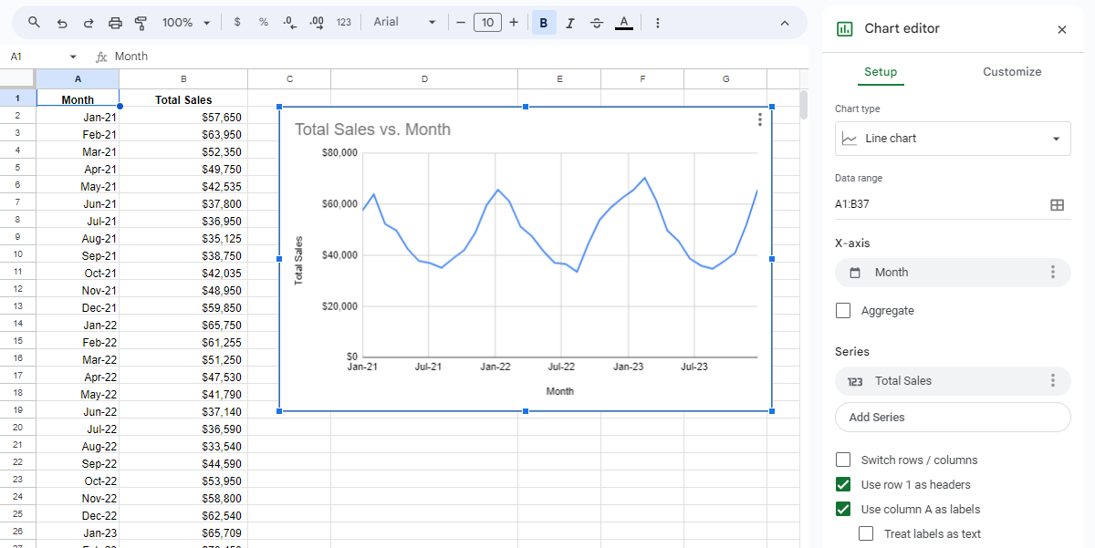

Step 5: Adjust the chart
Use the Chart editor panel to make changes to the chart. In the Setup tab, you can change the chart type, data range, axis labels, and more. For example, the chart type drop-down list changes the type of chart from line chart to a different style, such as a bar chart. In the Customize tab, you can change many other options, such as the chart’s style.
If the Chart editor panel isn’t open, double-click on the chart to open it. Then, change the various components of the chart by selecting them within the chart or by navigating to them from the Chart editor panel.
In this example, change the chart title to “Monthly sales.” Follow these steps:
- If necessary, open the Chart editor panel by double-clicking on the chart.
- In the Chart editor panel, select the Customize tab.
- Expand the Chart & axis titles section.
- Verify that the Chart title is selected from the dropdown, then change the title to Monthly sales. Your chart will nowdisplay the title “Monthly sales”
- If you’re using Microsoft Excel, double-click on the title in the chart to edit directly.
Get creative! Don’t be afraid to play around with the options. You can always save or download another copy of the template if you want to start fresh!

More spreadsheet resources

In the spirit of lifelong learning, it is good to have resources to turn to when you want to know more about using spreadsheets. Two of the most well known and used spreadsheet platforms are Google Sheets and Microsoft Excel. Both provide free online training resources that you can access anytime you need them. Bookmark these links if you want to access them later.
Google Sheets Training and Help
Learn even more ways to move, store, and analyze your data with the Google Sheets Training and Help page, located in the Google Workspace Learning Center. This hub offers an expanded list of tips, from beginner to advanced, along with cheat sheets, templates, guides, and tutorials.
Google Sheets Quick Tips
Want to learn more about Google Sheets? This online help article features a short list of the most important functions you will use, including rows, columns, cells, and functions.
Microsoft Excel for Windows Training
Get to know Excel spreadsheets a little better by visiting this free online training center. Offering everything from a quick-start guide and introduction to tutorials and templates, you will find everything you need to know, all in one place.

Get started with SQL and data visualization
SQL guide: Getting started

Just as humans use different languages to communicate with others, so do computers. Structured Query Language (or SQL, often pronounced “sequel”) enables data analysts to talk to their databases. SQL is one of the most useful data analyst tools, especially when working with large datasets in tables. It can help you investigate huge databases, track down text (referred to as strings) and numbers, and filter for the exact kind of data you need—much faster than a spreadsheet can.
If you haven’t used SQL before, this reading will help you learn the basics so you can appreciate how useful SQL is and how useful SQL queries are in particular. You will be writing SQL queries in no time at all.

What is a query?
A query is a request for data or information from a database. When you query databases, you use SQL to communicate your question or request. You and the database can always exchange information as long as you speak the same language.
Every programming language, including SQL, follows a unique set of guidelines known as syntax. Syntax is the predetermined structure of a language that includes all required words, symbols, and punctuation, as well as their proper placement. As soon as you enter your search criteria using the correct syntax, the query starts working to pull the data you’ve requested from the target database.
The syntax of every SQL query is the same:
- Use SELECT to choose the columns you want to return.
- Use FROM to choose the tables where the columns you want are located.
- Use WHERE to filter for certain information.
A SQL query is like filling in a template. You will find that if you are writing a SQL query from scratch, it is helpful to start a query by writing the SELECT, FROM, and WHERE keywords in the following format:
SELECT
FROM
WHERE
Next, enter the table name after the FROM; the table columns you want after the SELECT; and, finally, the conditions you want to place on your query after the WHERE. Make sure to add a new line and indent when adding these, as shown below:
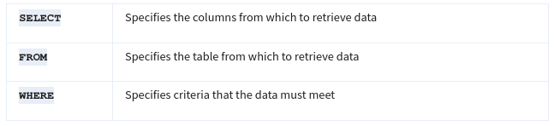
Following this method each time makes it easier to write SQL queries. It can also help you make fewer syntax errors.

Example of a query
Here is how a simple query would appear in BigQuery, a data warehouse on the Google Cloud Platform.
- SELECT first_name
- FROM customer_data.customer_name
- WHERE first_name = 'Tony'

The above query uses three commands to locate customers with the first_name, 'Tony':
- SELECT the column named first_name
- FROM a table named customer_name (in a dataset named customer_data) (The dataset name is always followed by a dot, and then the table name.)
- But only return the data WHERE the first_name is 'Tony'
The results from the query might be similar to the following:
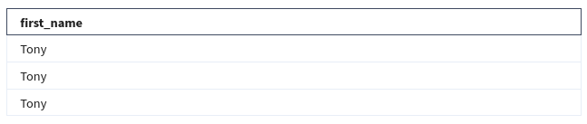
As you can conclude, this query had the correct syntax, but wasn't very useful after the data was returned.

Multiple columns in a query
Of course, as a data professional, you will need to work with more data beyond customers named Tony. Multiple columns that are chosen by the same SELECT command can be indented and grouped together.
If you are requesting multiple data fields from a table, you need to include these columns in your SELECT command. Each column is separated by a comma as shown below:
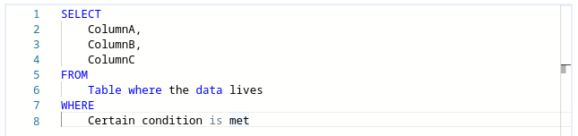
Here is an example of how it would appear in BigQuery:
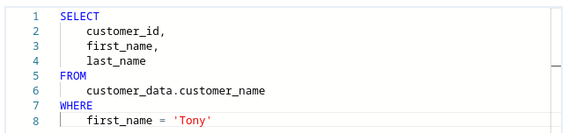
The above query uses three commands to locate customers with the first_name, 'Tony'.
- SELECT the columns named customer_id, first_name, and last_name
- FROM a table named customer_name (in a dataset named customer_data) (The dataset name is always followed by a dot, and then the table name.)
- But only return the data WHERE the first_name is 'Tony'
The only difference between this query and the previous one is that more data columns are selected. The previous query selected first_name only while this query selects customer_id and last_name in addition to first_name. In general, it is a more efficient use of resources to select only the columns that you need. For example, it makes sense to select more columns if you will actually use the additional fields in your WHERE clause. If you have multiple conditions in your WHERE clause, they may be written like this:
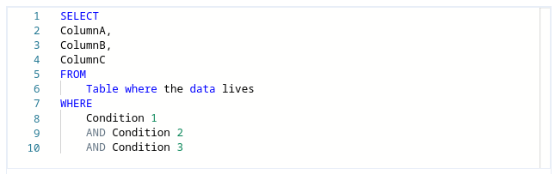
Notice that unlike the SELECT command that uses a comma to separate fields / variables / parameters, the WHERE command uses the AND statement to connect conditions. As you become a more advanced writer of queries, you will make use of other connectors / operators such as OR and NOT.
Here is a BigQuery example with multiple fields used in a WHERE clause:
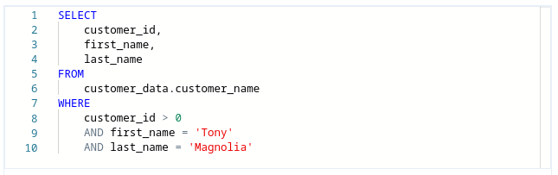
The above query uses three commands to locate customers with a valid (greater than 0), customer_id whose first_name is 'Tony' and last_name is 'Magnolia'.
- SELECT the columns named customer_id, first_name, and last_name
- FROM a table named customer_name (in a dataset named customer_data) (The dataset name is always followed by a dot, and then the table name.)
- But only return the data WHERE customer_id is greater than 0, first_name is Tony, and last_name is Magnolia.
Note that one of the conditions is a logical condition that checks to see if customer_id is greater than zero.
If only one customer is named Tony Magnolia, the results from the query could be:
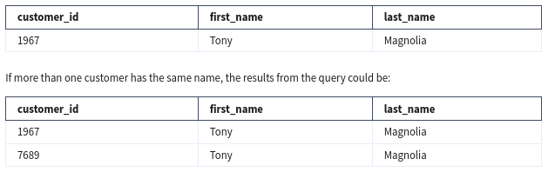

Key takeaways
The SELECT, FROM, and WHERE clauses are the essential building blocks of SQL queries. Queries with multiple fields will become simpler after you practice writing your own SQL queries later in the program.
Endless SQL possibilities

You have learned that a SQL query uses SELECT, FROM, and WHERE to specify the data to be returned from the query. This reading provides more detailed information about formatting queries, using WHERE conditions, selecting all columns in a table, adding comments, and using aliases. All of these make it easier for you to understand (and write) queries to put SQL in action. The last section of this reading provides an example of what a data analyst would do to pull employee data for a project.

Capitalization, indentation, and semicolons
You can write your SQL queries in all lowercase and don’t have to worry about extra spaces between words. However, using capitalization and indentation can help you read the information more easily. Keep your queries neat, and they will be easier to review or troubleshoot if you need to check them later on.
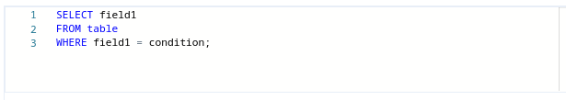
Notice that the SQL statement shown above has a semicolon at the end. The semicolon is a statement terminator and is part of the American National Standards Institute (ANSI) SQL-92 standard, which is a recommended common syntax for adoption by all SQL databases. However, not all SQL databases have adopted or enforce the semicolon, so it’s possible you may come across some SQL statements that aren’t terminated with a semicolon. If a statement works without a semicolon, it’s fine.

WHERE conditions
In the query shown above, the SELECT clause identifies the column you want to pull data from by name, field1, and the FROM clause identifies the table where the column is located by name, table. Finally, the WHERE clause narrows your query so that the database returns only the data with an exact value match or the data that matches a certain condition that you want to satisfy.
For example, if you are looking for a specific customer with the last name Chavez, the WHERE clause would be:
WHERE field1 = 'Chavez'
However, if you are looking for all customers with a last name that begins with the letters “Ch," the WHERE clause would be:
WHERE field1 LIKE 'Ch%'
You can conclude that the LIKE clause is very powerful because it allows you to tell the database to look for a certain pattern! The percent sign % is used as a wildcard to match one or more characters. In the example above, both Chavez and Chen would be returned. Note that in some databases an asterisk * is used as the wildcard instead of a percent sign %.

SELECT all columns
Can you use SELECT * ?
In the example, if you replace SELECT field1 with SELECT *, you would be selecting all of the columns in the table instead of the field1 column only. From a syntax point of view, it is a correct SQL statement, but you should use the asterisk * sparingly and with caution. Depending on how many columns a table has, you could be selecting a tremendous amount of data. Selecting too much data can cause a query to run slowly.

Comments
Some tables aren’t designed with descriptive enough naming conventions. In the example, field1 was the column for a customer’s last name, but you wouldn’t know it by the name. A better name would have been something such as last_name. In these cases, you can place comments alongside your SQL to help you remember what the name represents. Comments are text placed between certain characters, /* and */, or after two dashes --) as shown below.
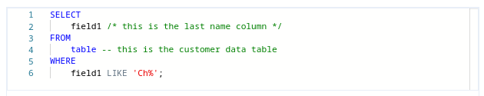
Comments can also be added outside of a statement as well as within a statement. You can use this flexibility to provide an overall description of what you are going to do, step-by-step notes about how you achieve it, and why you set different parameters/conditions.

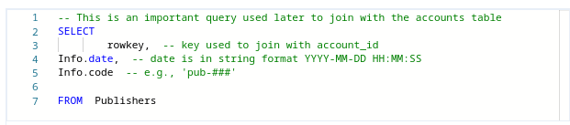
The more comfortable you get with SQL, the easier it will be to read and understand queries at a glance. Still, it never hurts to have comments in a query to remind yourself of what you’re trying to do. This also makes it easier for others to understand your query if your query is shared. As your queries become more and more complex, this practice will save you a lot of time and energy to understand complex queries you wrote months or years ago.

Example of a query with comments
Here is an example of how comments could be written in BigQuery:
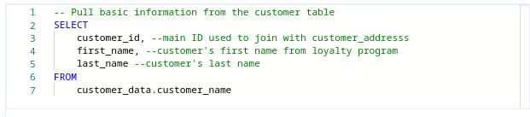
In the above example, a comment has been added before the SQL statement to explain what the query does. Additionally, a comment has been added next to each of the column names to describe the column and its use. Two dashes -- are generally supported. So it is best to use -- and be consistent with it. You can use # in place of -- in the above query, but # is not recognized in all SQL versions; for example, MySQL doesn’t recognize #. You can also place comments between /* and */ if the database you are using supports it.
As you develop your skills professionally, depending on the SQL database you use, you can pick the appropriate comment delimiting symbols you prefer and stick with those as a consistent style. As your queries become more and more complex, the practice of adding helpful comments will save you a lot of time and energy to understand queries that you may have written months or years prior.

Aliases
You can also make it easier on yourself by assigning a new name or alias to the column or table names to make them easier to work with (and avoid the need for comments). This is done with a SQL AS clause. In the example below, aliases are used for both a table name and a column. Within the database, the table is called actual_table_name and the column in that table is called actual_column_name. They are aliased as my_table_alias and my_column_alias, respectively. These aliases are good for the duration of the query only. An alias doesn’t change the actual name of a column or table in the database.

Example of a query with aliases
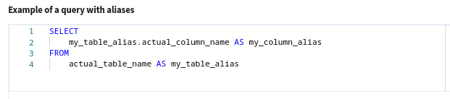

Putting SQL to work as a data analyst
Imagine you are a data analyst for a small business and your manager asks you for some employee data. You decide to write a query with SQL to get what you need from the database.
You want to pull all the columns: empID, firstName, lastName, jobCode, and salary. Because you know the database isn’t that big, instead of entering each column name in the SELECT clause, you use SELECT *. This will select all the columns from the Employee table in the FROM clause.
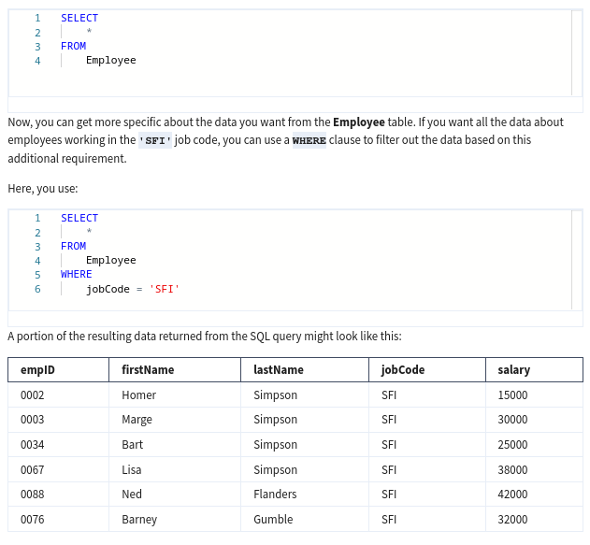

Suppose you notice a large salary range for the 'SFI' job code. You might like to flag all employees in all departments with lower salaries for your manager. Because interns are also included in the table and they have salaries less than $30,000, you want to make sure your results give you only the full time employees with salaries that are $30,000 or less. In other words, you want to exclude interns with the 'INT' job code who also earn less than $30,000. The AND clause enables you to test for both conditions.
You create a SQL query similar to below, where <> means "does not equal":
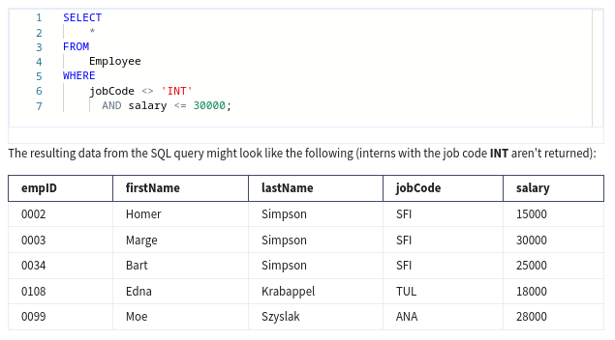

With quick access to this kind of data using SQL, you can provide your manager with tons of different insights about employee data, including whether employee salaries across the business are equitable. Fortunately, the query shows only an additional two employees might need a salary adjustment and you share the results with your manager.
Pulling the data, analyzing it, and implementing a solution might ultimately help improve employee satisfaction and loyalty. That makes SQL a pretty powerful tool.

Resources to learn more
Nonsubscribers may access these resources for free, but if a site limits the number of free articles per month and you already reached your limit, bookmark the resource and come back to it later.
- W3Schools SQL Tutorial
- : If you would like to explore a detailed tutorial of SQL, this is the perfect place to start. This tutorial includes interactive examples you can edit, test, and recreate. Use it as a reference or complete the whole tutorial to practice using SQL. Click the green Start learning SQL now button or the Next button to begin the tutorial.
- SQL Cheat Sheet
- : For more advanced learners, go through this handy 3-page resource to gain an overview of additional SQL functions and formulas. By the time you are finished looking through the cheat sheet, you will know a lot more about the various SQL techniques and will be prepared to use it for business analysis and other tasks.

Key takeaways
SQL queries use SELECT, FROM, and WHERE to specify the data to be returned from the query. Capitalization, indentation, and semicolons are useful for making your SQL queries easier to read. In addition, comments can be added to explain queries to others. As you progress through this course, you will continue discovering many ways in which SQL can be a very powerful tool for retrieving, analyzing, and interpreting data.

Plan a data visualization

Earlier, you learned that data visualization is the graphical representation of information. As a data analyst, you will want to create visualizations that make your data easy to understand and interesting to look at. Because of the importance of data visualization, most data analytics tools (such as spreadsheets and databases) have a built-in visualization component while others (such as Tableau) specialize in visualization as their primary value-add. In this reading, you will explore the steps involved in the data visualization process and a few of the most common data visualization tools available.

Steps to plan a data visualization
Let’s go through an example of a real-life situation where a data analyst might need to create a data visualization to share with stakeholders. Imagine you’re a data analyst for a clothing distributor. The company helps small clothing stores manage their inventory, and sales are booming. One day, you learn that your company is getting ready to make a major update to its website. To guide decisions for the website update, you’re asked to analyze data from the existing website and sales records. Let’s go through the steps you might follow.

Step 1: Explore the data for patterns
First, you ask your manager or the data owner for access to the current sales records and website analytics reports. This includes information about how customers behave on the company’s existing website, basic information about who visited, who bought from the company, and how much they bought.
While reviewing the data you notice a pattern among those who visit the company’s website most frequently: geography and larger amounts spent on purchases. With further analysis, this information might explain why sales are so strong right now in the northeast—and help your company find ways to make them even stronger through the new website.

Step 2: Plan your visuals
Next it is time to refine the data and present the results of your analysis. Right now, you have a lot of data spread across several different tables, which isn’t an ideal way to share your results with management and the marketing team. You will want to create a data visualization that explains your findings quickly and effectively to your target audience. Since you know your audience is sales oriented, you already know that the data visualization you use should:
- Show sales numbers over time
- Connect sales to location
- Show the relationship between sales and website use
- Show which customers fuel growth

Step 3: Create your visuals
Now that you have decided what kind of information and insights you want to display, it is time to start creating the actual visualizations. Keep in mind that creating the right visualization for a presentation or to share with stakeholders is a process. It involves trying different visualization formats and making adjustments until you get what you are looking for. In this case, a mix of different visuals will best communicate your findings and turn your analysis into the most compelling story for stakeholders. So, you can use the built-in chart capabilities in your spreadsheets to organize the data and create your visuals.
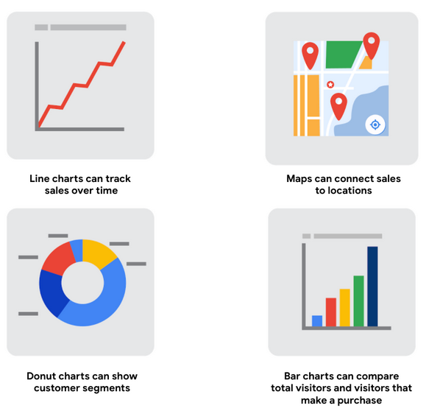

Build your data visualization toolkit
There are many different tools you can use for data visualization.
- You can use the visualizations tools in your spreadsheet to create simple visualizations such as line and bar charts.
- You can use more advanced tools such as Tableau that allow you to integrate data into dashboard-style visualizations.
- If you’re working with the programming language R you can use the visualization tools in RStudio.
Your choice of visualization will be driven by a variety of drivers including the size of your data, the process you used for analyzing your data (spreadsheet, or databases/queries, or programming languages). For now, just consider the basics.

Spreadsheets (Microsoft Excel or Google Sheets)
In our example, the built-in charts and graphs in spreadsheets made the process of creating visuals quick and easy. Spreadsheets are great for creating simple visualizations like bar graphs and pie charts, and even provide some advanced visualizations like maps, and waterfall and funnel diagrams (shown in the following figures).
But sometimes you need a more powerful tool to truly bring your data to life. Tableau and RStudio are two examples of widely used platforms that can help you plan, create, and present effective and compelling data visualizations.

Visualization software (Tableau)
Tableau is a popular data visualization tool that lets you pull data from nearly any system and turn it into compelling visuals or actionable insights. The platform offers built-in visual best practices, which makes analyzing and sharing data fast, easy, and (most importantly) useful. Tableau works well with a wide variety of data and includes an interactive dashboard that lets you and your stakeholders click to explore the data interactively.
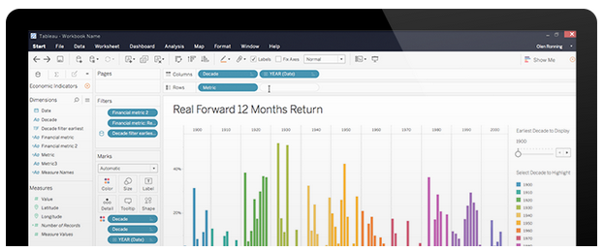

You can start exploring Tableau from the How-to Video resources. Tableau Public is free, easy to use, and full of helpful information. The Resources page is a one-stop-shop for how-to videos, examples, and datasets for you to practice with. To explore what other data analysts are sharing on Tableau, visit the Viz of the Day page where you will find beautiful visuals ranging from an overview of the Lighthouses of Greece to Who’s Talking in Popular Films.

Programming language (R with RStudio)
A lot of data analysts work with a programming language called R. Most people who work with R end up also using RStudio, an integrated developer environment (IDE), for their data visualization needs. As with Tableau, you can create dashboard-style data visualizations using RStudio.
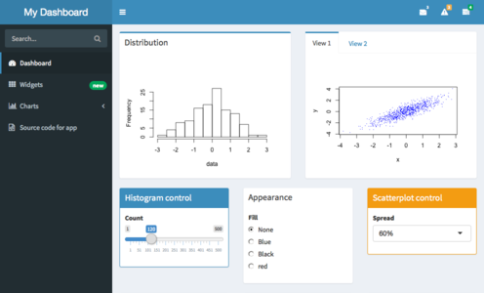

Check out their website to learn more about RStudio.
You could easily spend days exploring all the resources provided at RStudio.com, but the RStudio Cheatsheets and the RStudio Visualize Data Primer are great places to start. When you have more time, check out the webinars and videos which offer advice and helpful perspectives for both beginners and advanced users.

Key takeaways
The best data analysts use lots of different tools and methods to visualize and share their data. As you continue learning more about data visualization throughout this course, be sure to stay curious, research different options, and continuously test new programs and platforms to help you make the most of your data.
https://posit.co/resources/cheatsheets/

Module 3 challenge
Glossary terms from module 3

Terms and definitions for Course 1, Module 3
Attribute: A characteristic or quality of data used to label a column in a table
Observation: The attributes that describe a piece of data contained in a row of a table
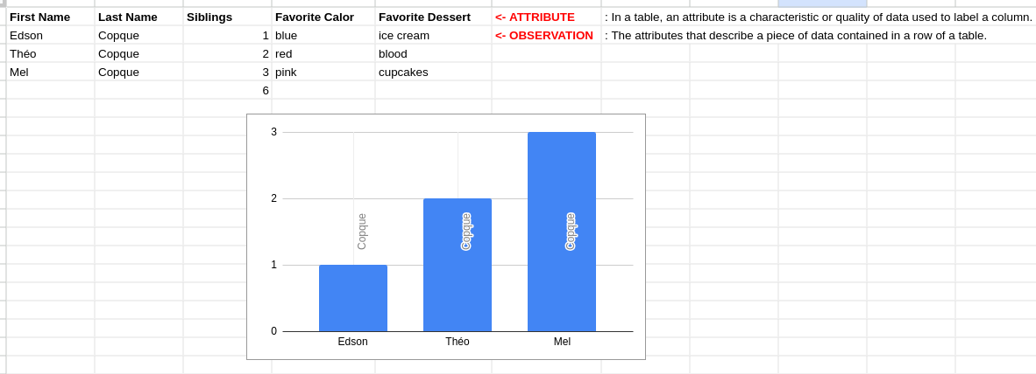

Module 3 challenge
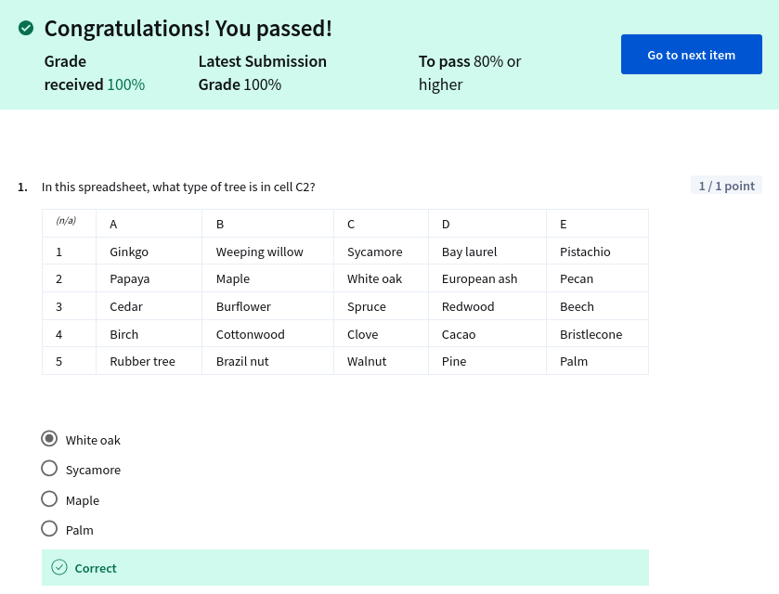
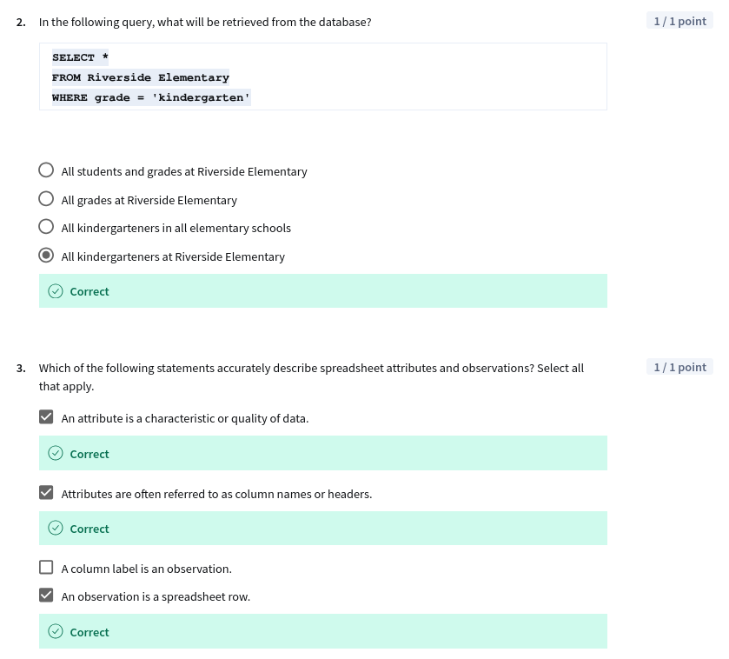
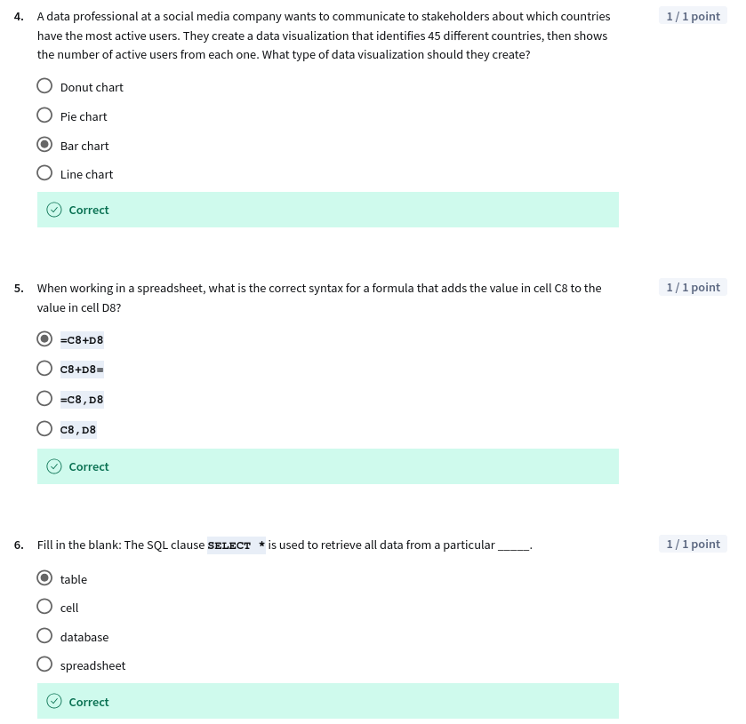

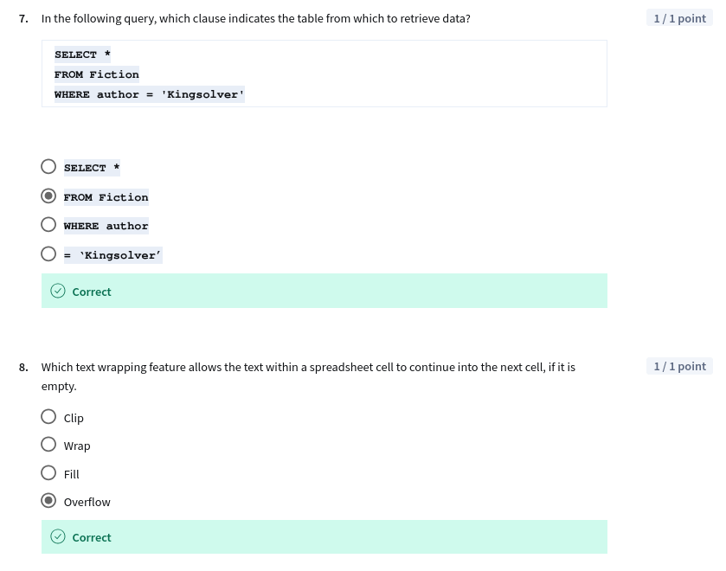
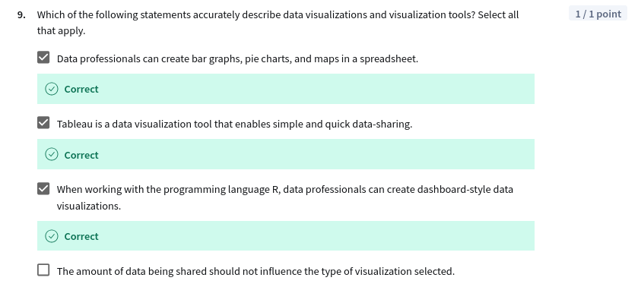

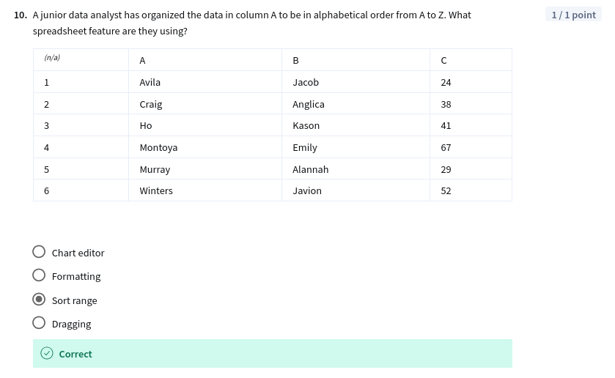

Fim

