Module 4
Become a fair and impactful data professional

In this part of the course, you’ll examine different types of businesses and the jobs and tasks that analysts do for them. You’ll also learn how a Google Data Analytics Certificate will help you meet many of the requirements for an analyst position with these organizations.

Learning Objectives

- Describe the role of a data analyst with specific reference to job roles
- Discuss how the Google Data Analytics Certificate can help a candidate meet the requirements of a given job
- Explain how a business task may be appropriate for a data analyst, with reference to fairness and the value of the data analyst
- Identify companies that would potentially hire data analysts
- Describe how one's prior experiences may be applied to a career as a data analyst
- Determine whether the use of data constitutes fair or unfair practices
- Understand the different ways organizations use data
- Explain the concept of data-driven decision-making including specific examples

The importance of fair business decisions
Consider fairness

Previously, you learned that part of a data professional’s responsibility is to make certain that their analysis is fair. Fairness means ensuring your analysis doesn't create or reinforce bias. This can be challenging, but if the analysis is not objective, the conclusions can be misleading and even harmful. In this reading, you’re going to explore some best practices you can use to guide your work toward a more fair analysis!

Consider fairness
Following are some strategies that support fair analysis:

Best practice | Explanation | Example
Consider all of the available data | Part of your job as a data analyst is to determine what data is going to be useful for your analysis. Often there will be data that isn’t relevant to what you’re focusing on or doesn’t seem to align with your expectations. But you can’t just ignore it; it’s critical to consider all of the available data so that your analysis reflects the truth and not just your own expectations. | A state’s Department of Transportation is interested in measuring traffic patterns on holidays. At first, they only include metrics related to traffic volumes and the fact that the days are holidays. But the data team realizes they failed to consider how weather on these holidays might also affect traffic volumes. Considering this additional data helps them gain more complete insights.
Identify surrounding factors | As you’ll learn throughout these courses, context is key for you and your stakeholders to understand the final conclusions of any analysis. Similar to considering all of the data, you also must understand surrounding factors that could influence the insights you’re gaining. | A human resources department wants to better plan for employee vacation time in order to anticipate staffing needs. HR uses a list of national bank holidays as a key part of the data-gathering process. But they fail to consider important holidays that aren’t on the bank calendar, which introduces bias against employees who celebrate them. It also gives HR less useful results because bank holidays may not necessarily apply to their actual employee population.
Include self-reported data | Self-reporting is a data collection technique where participants provide information about themselves. Self-reported data can be a great way to introduce fairness in your data collection process. People bring conscious and unconscious bias to their observations about the world, including about other people. Using self-reporting methods to collect data can help avoid these observer biases. Additionally, separating self-reported data from other data you collect provides important context to your conclusions! | A data analyst is working on a project for a brick-and-mortar retailer. Their goal is to learn more about their customer base. This data analyst knows they need to consider fairness when they collect data; they decide to create a survey so that customers can self-report information about themselves. By doing that, they avoid bias that might be introduced with other demographic data collection methods. For example, if they had sales associates report their observations about customers, they might introduce any unconscious bias the employees had to the data.
Use oversampling effectively | When collecting data about a population, it’s important to be aware of the actual makeup of that population. Sometimes, oversampling can help you represent groups in that population that otherwise wouldn’t be represented fairly. Oversampling is the process of increasing the sample size of nondominant groups in a population. This can help you better represent them and address imbalanced datasets. | A fitness company is releasing new digital content for users of their equipment. They are interested in designing content that appeals to different users, knowing that different people may interact with their equipment in different ways. For example, part of their user-base is age 70 or older. In order to represent these users, they oversample them in their data. That way, decisions they make about their fitness content will be more inclusive.
Think about fairness from beginning to end | To ensure that your analysis and final conclusions are fair, be sure to consider fairness from the earliest stages of a project to when you act on the data insights. This means that data collection, cleaning, processing, and analysis are all performed with fairness in mind. | A data team kicks off a project by including fairness measures in their data-collection process. These measures include oversampling their population and using self-reported data. However, they fail to inform stakeholders about these measures during the presentation. As a result, stakeholders leave with skewed understandings of the data. Learning from this experience, they add key information about fairness considerations to future stakeholder presentations.

Key takeaways
As a data professional, you will need to ensure you always consider fairness. This will allow you to avoid creating or reinforcing bias or accidentally drawing misleading conclusions. Using these best practices can help guide your analysis and make you a better data professional!
Test your knowledge on making fair business decisions

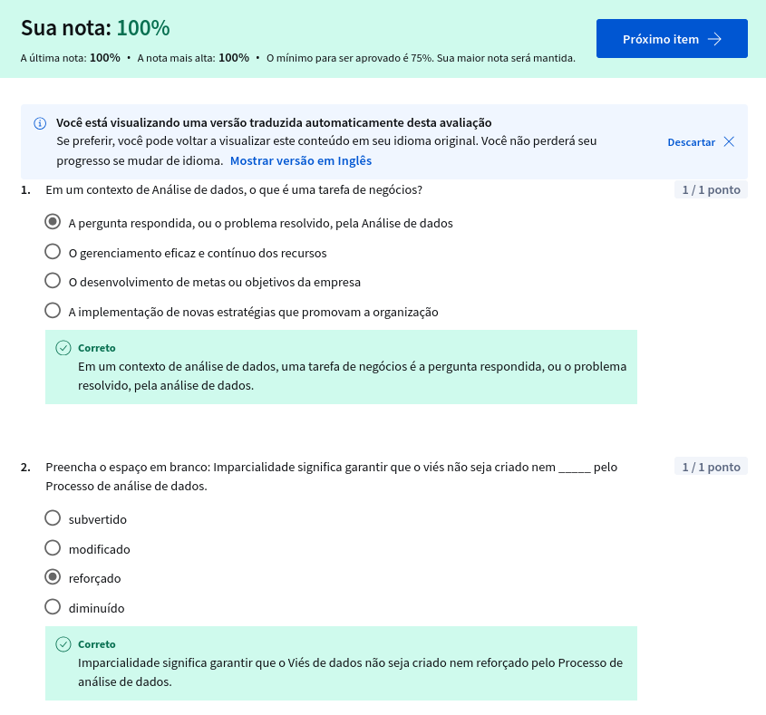

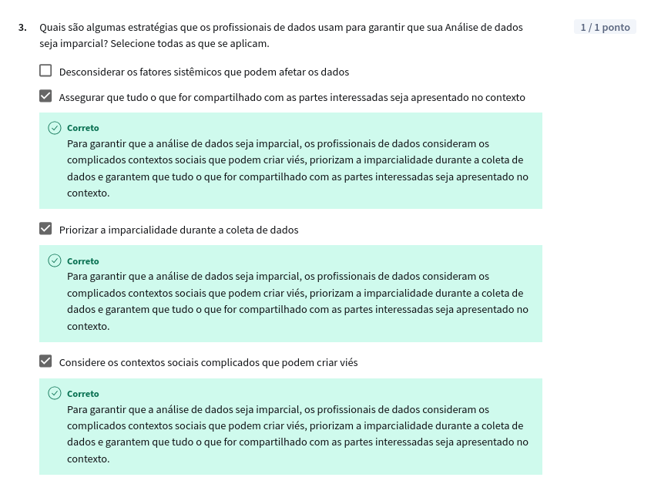
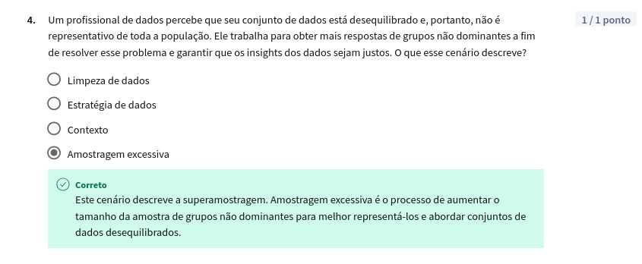

Data analyst roles and job descriptions

As technology continues to advance, being able to collect and analyze the data from that new technology has become a huge competitive advantage for a lot of businesses. Everything from websites to social media feeds are filled with fascinating data that, when analyzed and used correctly, can help inform business decisions. A company’s ability to thrive now often depends on how well it can leverage data, apply analytics, and implement new technologies.
This is why skilled data analysts are some of the most sought-after professionals in the world. A study conducted by IBM estimates that there are over 380,000 job openings in the Data Analytics field in the United States*. Because the demand is so strong, you’ll be able to find job opportunities in virtually any industry. Do a quick search on any major job site and you’ll notice that every type of business from zoos, to health clinics, to banks are seeking talented data professionals. Even if the job title doesn’t use the exact term “data analyst,” the job description for most roles involving data analysis will likely include a lot of the skills and qualifications you’ll gain by the end of this program. In this reading, we’ll explore some of the data analyst-related roles you might find in different companies and industries.
* Burning Glass data, Feb 1, 2021 - Jan 31, 2022, US

Decoding the job description
The data analyst role is one of many job titles that contain the word “analyst.”
To name a few others that sound similar but may not be the same role:
- Business analyst—analyzes data to help businesses improve processes, products, or services
- Data analytics consultant—analyzes the systems and models for using data
- Data engineer—prepares and integrates data from different sources for analytical use
- Data scientist—uses expert skills in technology and social science to find trends through data analysis
- Data specialist—organizes or converts data for use in databases or software systems
- Operations analyst—analyzes data to assess the performance of business operations and workflows
Data analysts, data scientists, and data specialists sound very similar but focus on different tasks. As you start to browse job listings online, you might notice that companies’ job descriptions seem to combine these roles or look for candidates who may have overlapping skills. The fact that companies often blur the lines between them means that you should take special care when reading the job descriptions and the skills required.
The table below illustrates some of the overlap and distinctions between them:
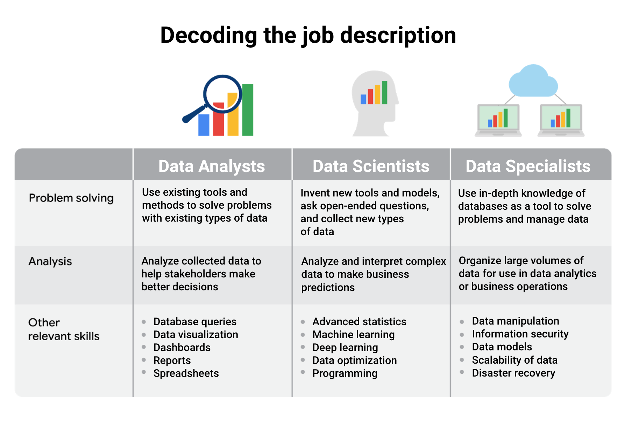
We used the role of data specialist as one example of many specializations within data analytics, but you don’t have to become a data specialist! Specializations can take a number of different turns. For example, you could specialize in developing data visualizations and likewise go very deep into that area.

Job specializations by industry
We learned that the data specialist role concentrates on in-depth knowledge of databases. In similar fashion, other specialist roles for data analysts can focus on in-depth knowledge of specific industries. For example, in a job as a business analyst you might wear some different hats than in a more general position as a data analyst. As a business analyst, you would likely collaborate with managers, share your data findings, and maybe explain how a small change in the company’s project management system could save the company 3% each quarter. Although you would still be working with data all the time, you would focus on using the data to improve business operations, efficiencies, or the bottom line.
Other industry-specific specialist positions that you might come across in your data analyst job search include:
- Marketing analyst—analyzes market conditions to assess the potential sales of products and services
- HR/payroll analyst—analyzes payroll data for inefficiencies and errors
- Financial analyst—analyzes financial status by collecting, monitoring, and reviewing data
- Risk analyst—analyzes financial documents, economic conditions, and client data to help companies determine the level of risk involved in making a particular business decision
- Healthcare analyst—analyzes medical data to improve the business aspect of hospitals and medical facilities

Key takeaways
Explore data analyst job descriptions and industry-specific analyst roles. You will start to get a better sense of the different data analyst jobs out there and which types of roles you’re most interested to go after.

Glossary terms from module 4

Terms and definitions for Course 1, Module 4
Business task: The question or problem data analysis resolves for a business
Fairness: A quality of data analysis that does not create or reinforce bias
Oversampling: The process of increasing the sample size of nondominant groups in a population. This can help you better represent them and address imbalanced datasets
Self-reporting: A data collection technique where participants provide information about themselves
Module 4 challenge
