Module 1
Introduction data analytics and analytical thinking

Data helps us make decisions in both everyday life and in business. In this part of the course, you’ll learn how data analysts use a variety of tools and skills to inform those decisions. You’ll also get to know more about this course and the overall program expectations.

Learning Objectives

- Define key concepts involved in data analytics including data, data analysis, and data ecosystem
- Discuss the use of data in everyday life decisions
- Identify the key features of the learning environment and their uses
- Describe principles and practices that will help to increase one's chances of success in this certificate
- Explain the use of data in organizational decision-making
- Describe the key concepts to be discussed in the program, including learning outcomes

Get Started
Program description and course 1 overview: Set your expectations
Every day, the amount of data out there grows and grows. So the ability to interpret it effectively is more important than ever before. Data analytics is becoming one of the fastest-growing and most rewarding career choices in the world.
Currently, there are nearly 500,000 open jobs in data analytics, with a median entry-level salary of $92,000 and a 20% annual growth rate [Source: Lightcast™ US Job Postings (2022: Jan. 1, 2022 - Dec. 31, 2022)]. Companies in all kinds of industries need qualified data analysts to solve problems and help make the best possible business decisions. And once you complete this program, you’ll be prepared to make smart, strategic, data-driven recommendations for organizations of all kinds.
Throughout the courses in this program, you’ll complete many assignments and projects based on both the practical activities and the day-to-day life of a data analyst. Along the way, you’ll learn how to ask the right questions and understand objectives. You’ll also discover how to effectively clean and organize large amounts of data to make it ready for high-quality analysis. On top of that, you’ll gain experience using all kinds of tools and techniques that will help you recognize patterns and uncover relationships between data points. Further, to help you communicate the results of your analysis, you’ll learn how to design visuals and dashboards. There’s even an opportunity to create a case study, which you can highlight in your resume to demonstrate what you have learned to potential employers.

Program overview
The program is composed of eight courses:
Foundations: Data, Data, Everywhere (this course)
- Ask Questions to Make Data-Driven Decisions
- Prepare Data for Exploration
- Process Data from Dirty to Clean
- Analyze Data to Answer Questions
- Share Data Through the Art of Visualization
- Data Analysis with R Programming
- Google Data Analytics Capstone: Complete a Case Study

Foundations: Data, Data, Everywhere is the first course in this program.

Course 1 content
Each course is broken into modules. Here’s a quick overview of the skills you'll gain in each of the four Course 1 modules.

Module 1: Introducing data analytics and analytical thinking
Data helps us make decisions in both everyday life and in business. In this part of the course, you’ll learn how data analysts use a variety of tools and skills to inform those decisions. You’ll also get to know more about this course and the overall program expectations.

Module 2: The wonderful world of data
In this part of the course, you'll learn about the data life cycle and data analysis process. They are both relevant to your work in this program and on the job. You’ll also be introduced to applications that help guide data through the data analysis process.

Module 3: Set up your data analytics toolbox
Spreadsheets, query languages, and data visualization tools are all a big part of a data analyst’s job. In this part of the course, you’ll learn the basic concepts to use them for data analysis. You’ll also understand how they work through interesting examples.

Module 4: Become a fair and impactful data professional
In this part of the course, you’ll examine different types of businesses and the jobs and tasks that analysts do for them. You’ll also learn how a Google Data Analytics Certificate will help you meet many of the requirements for an analyst position with these organizations.

What to expect
Each module includes a series of lessons with many types of learning opportunities. These include:
- Videos for instructors to teach new concepts and demonstrate the use of tools
- In-video questions that pop up from time to time to help you to check your understanding of key concepts and skills
- Step-by-step guides you can use to follow along with instructors as they demonstrate tools
- Readings to explore topics more in-depth and build on the concepts from the videos
- Discussion forums to share, explore, and reinforce lesson topics
- Discussion prompts to promote thinking and engagement in the discussion forums
- Practice quizzes to prepare you for graded quizzes
- Graded quizzes to measure your progress and give you valuable feedback
This program was designed to let you work at your own pace—your personalized deadlines are just a guide. There is no penalty for late assignments. To earn your certificate, you simply need to complete all of the work.
If you miss two assessment deadlines in a row, or if you miss an assessment deadline by two weeks, you'll see a Reset deadlines option on the Grades page. Click it to switch to a new course schedule with updated deadlines. You can use this option as many times as you need—it won’t remove any progress you’ve already made in the course, but you may find new course content if the instructor updated the course after you started. If you cancel a subscription and then reactivate it, your deadlines will automatically reset.
Throughout the program, you'll be assessed with graded quizzes and activities. Both are based on the wide variety of learning materials and activities that reinforce the important skills you’ll develop. And both can be taken more than once.
Congratulations on choosing to become part of the wonderful world of data analytics!

Helpful resources and tips
As a learner, you can choose to complete one or multiple courses in the Google Data Analytics Certificate program. However, to obtain the certificate, you must complete all eight courses in the program and submit all graded assignments. This reading describes what is required to obtain a certificate, as well as best practices for you to have a successful learning experience on Coursera.

Course completion to obtain a certificate
To receive your official Google Data Analytics Certificate, you must:
- Pass all graded assignments in all eight courses of the certificate program. Each graded assignment is part of a cumulative graded score for the course, and the passing grade for each course is 80%.
AND one of the following:
- Pay the course certificate fee,
- Be approved for Coursera Financial Aid, or
- Complete the certificate through an educational institution, employer, or agency that's sponsoring your participation.

Evaluate your current data analytics skills
If you’re a learner who has some experience with data analytics, you may wish to bypass this certificate program and proceed directly to a more advanced program such as the Google Advanced Data Analytics Certificate or the Google Business Intelligence Certificate. Determine whether you’re ready for one of these programs in an upcoming reading, Evaluate your current data analytics skills
.

Healthy habits for successfully completing the certificate

Here are some best practices to help you successfully complete the courses in the program:
- Plan your time: Setting regular study times and following them each week helps make learning a part of your routine. Use a calendar or timetable to create a schedule, and list what you plan to do each day in order to set achievable goals. Find a space that allows you to focus.
- Work at your own pace: Everyone learns differently, so this program has been designed to let you work at your own pace. Although your personalized deadlines start when you enroll, feel free to progress through the program at the speed that works best for you. There is no penalty for late assignments; to earn your certificate, all you have to do is complete all of the work. If you miss two assessment deadlines in a row, or if you miss an assessment deadline by two weeks, you'll see a Reset deadlines option on the Grades page. Click it to switch to a new course schedule with updated deadlines. You can use this option as many times as you need.
- Be curious: If you find an idea that gets you excited, act on it! Ask questions, search for more details online, explore the links that interest you, and take notes on your discoveries. The steps you take to support your learning will advance your knowledge, create more opportunities for you in this high-growth field, and help you qualify for jobs.
- Follow along with instructors: Each instructional video with an onscreen software or programming demonstration has a corresponding step-by-step guide. This guide is a reading that outlines each step an instructor performs in the video. You’ll also find additional information in the guide that explains the purpose of the concepts covered, why a step is done a certain way, and tips for using the tool.
- Take notes: Notes will help you remember information in the future, especially as you’re preparing to enter a new job field. In addition, taking notes is an effective way to make connections between topics and gain a better understanding of those topics.
- Review exemplars: Exemplars are completed assignments that fully meet an activity's criteria; many activities in this program have exemplars that you can compare to your own work. Although there are often many different ways to complete an assignment, exemplars offer you guidance and inspiration about how to complete the activity.
- Build your career identity: Your career identity is the unique value you bring to the workforce. Watch this video
- to learn about the key components of career identity and write your own career identity statement. Discovering and defining your own career identity makes you better equipped to choose a career path that aligns with your strengths, values, and goals and is more effective in your chosen profession.
- Study together: It can be hard to find the time to progress through a Google Career Certificate with all life’s distractions. Register for Study Group
- – live study sessions hosted Monday through Thursday that offer you dedicated time and space to focus on your coursework alongside a community of your peers. Participation in Study Group is optional for our learners.
- Connect with other learners: If you have a question, chances are, you’re not alone. Reach out in the discussion forum to ask for help from other learners in this program. You can also visit Coursera’s private Google Data Analytics Community to expand your network, discuss career journeys, and share experiences. Check out the quick start guide
- Update your profile: Update your profile on Coursera to include your photo, career goals, and more. When other learners find you in the discussion forums, they can click on your name to access your profile and get to know you better.

Documents and files for course activities
To complete certain activities in the program, you will need to use digital documents, spreadsheets, presentations, and/or labs. Data analytics professionals use these software tools to collaborate within their teams and organizations. If you need more information about using a particular type of document, refer to these resources:
- Microsoft Word: Help and learning
- : Microsoft Support page for Word
- Google Docs
- : Help Center page for Google Docs
- Microsoft Excel: Help and learning
- : Microsoft Support page for Excel
- Google Sheets
- : Help Center page for Google Sheets
- Microsoft PowerPoint: Help and learning
- : Microsoft Support page for PowerPoint
- How to use Google Slides
- : Help Center page for Google Slides

Module, course, and certificate glossaries
This program covers a lot of terms and concepts, some of which you may already know and some of which may be unfamiliar to you. To review terms and help you prepare for graded quizzes, refer to the following glossaries:
- Module glossaries: At the end of each module’s content, you can review a glossary of terms from that module. The module glossaries are not downloadable; however, all of the terms and definitions are included in the course and certificate glossaries, which are downloadable.
- Course glossaries: At the end of each course, you can access and download a glossary that covers all of the terms in that course.
- Certificate glossary: The certificate glossary includes all of the terms in the entire certificate program and is a helpful resource that you can reference throughout the program or at any time in the future.
Find the course and certificate glossaries using the course’s Resources tab. Access and download the certificate glossaries, then save them on your computer. To access the Data Analytics Certificate program glossary, click the following link and select Use Template.
Link to the glossary: Google Data Analytics Certificate glossary
OR
If you don’t have a Google account, download the glossary directly from the following attachment.

Course feedback
Providing feedback on videos, readings, and other materials is easy. With the resource open in your browser, locate the thumbs-up and thumbs-down symbols.
- Click thumbs-up for materials that are helpful.
- Click thumbs-down for materials that are not helpful.
If you want to flag a specific issue with an item, click the flag icon, select a category, and enter an explanation in the text box. This feedback goes to the course development team and isn’t visible to other learners. All feedback received helps to create even better certificate programs in the future.
For technical help on the Coursera platform, visit the Learner Help Center.

Evaluate your current data analytics skills
The Google Data Analytics Certificate program is designed for anyone who wants to gain the skills required to become an entry-level data analyst. If that sounds like you, move on to the next item in this course, Commit to completing the program
. However, if you already have some experience with data analytics, you may consider earning the Google Advanced Data Analytics Certificate or the Google Business Intelligence Certificate instead. In this reading, you’ll learn more about the knowledge and skills you need for one of the advanced certificate programs. You’ll also discover more about those programs and why they might be a great next step for you!

Data analytics knowledge and skills
Data analysts must have a comprehensive understanding of the data analytics process, as well as the technical skills that allow them to complete the data analysis process. In this section, you’ll consider questions about the data analytics process and specific technical skills to determine your readiness for the advanced certificate programs.
First, evaluate your knowledge of the data analytics process by considering whether the following statements apply to you:
- I have a thorough understanding of data-driven decision-making and how it helps organizations guide their business strategy based on facts.
- I’m able to ask questions and make hypotheses about business problems and use them to guide me through the data analysis process.
- I know the steps to verify data credibility and perform data validation.
- I understand data modeling and know how organizations use it as a tool to understand their data.
- I can select and design visualizations that help me effectively communicate analysis insights to stakeholders.
If the previous statements apply to you, you probably know the basics of the data analysis process. Continue reading to evaluate your technical skills.
Data analysts use a variety of tools, including software and programming languages, to analyze data. You will be most successful in an advanced certificate program if you’re able to use spreadsheets, SQL, Tableau, and R, which are covered in this program. Consider whether the following statements apply to you:
- I’m able to join data from multiple sources to use for data analysis.
- I can sort data in both a spreadsheet and a database.
- I’m able to clean data by ensuring it contains no duplicate or incorrect entries and is in the correct format.
- I know how to create data visualizations using a spreadsheet, Tableau, and R.
- I can write a SQL command that would select several columns from a table.
- I understand packages in R and can select and install the packages I need to complete specific tasks.

Choose your next certificate program
If you confidently answered “yes” to all of the questions in the previous section, you might choose to pursue the Google Advanced Data Analytics Certificate or Google Business Intelligence Certificate to further your knowledge of data analytics.
In the Google Advanced Data Analytics Certificate program, you’ll build on your data analytics skills and explore what it means to be a data scientist throughout seven courses. You’ll enhance your Tableau skills. And you’ll learn another programming language, Python, and practice using it to prepare, process, clean, analyze, and visualize data. Finally, you’ll delve into statistics and use statistical techniques such as regression and machine learning to answer business questions. This program is ideal for individuals preparing for data science or more advanced data analytics roles.
The Google Business Intelligence Certificate program is composed of three courses, which will expand your knowledge through practical, hands-on projects featuring tools and platforms such as BigQuery, Dataflow, and Tableau. You’ll learn about data management and the systems required to successfully manage it in a business environment. Throughout the program, you’ll discover how to design and interpret dashboards that provide dynamic, live data insights to stakeholders. The Google Business Intelligence Certificate program is ideal for individuals seeking entry-level business intelligence roles.

Key takeaways
If you’re already familiar with the data analytics concepts and skills presented in the Google Data Analytics Certificate, you may wish to proceed directly to the more advanced programs:
- Google Advanced Data Analytics Certificate
- Google Business Intelligence Certificate

If you’re not sure which program to take, feel free to explore each of them. You can return to the Google Data Analytics Certificate program at any time if you decide it’s the best starting point for you!

Share and connect in the discussion forums
Connecting with your classmates is an essential part of any online course. Get to know each other using the discussion forums and prompts. Discussion prompts are course items that have associated threads in the discussion forums. When you answer a discussion prompt, your response goes to the associated forum, along with the responses of your peers.
Establishing personal interaction with other learners will make your online learning experience much more enjoyable and engaging. And given the probability that many workplaces will have virtual meetings and hybrid or remote work environments, it's also important to begin practicing building relationships and giving and receiving feedback online. We encourage you to use the forums to deepen your learning and peer relationships.

Share with other learners
How should you begin? Tell everyone a bit about yourself! Then, read some of your classmates' postings. Pick at least two postings that are the most interesting to you and add a friendly or encouraging response back.
Go to the discussion forum
and click the New Thread button to begin a new thread. You can also go to the Meet and Greet discussion prompt
to add your introduction story there.

Update your profile
Additionally, consider updating your profile
, which can be accessed by clicking the Profile link. When classmates find you in the discussion forums, they can click on your name to view your complete profile and get to know you more.

Upvote posts
When you enter the discussion forum for your course, you will find an Upvote button under each post. We encourage you to upvote posts that you find thoughtful, interesting, or helpful. This is the best way to ensure that other learners will read quality posts in the course. Upvoting also increases the likelihood that important questions get addressed and answered.

Report abuse
Coursera's Code of Conduct prohibits:
- Bullying or threatening other users
- Posting spam or promotional content
- Posting mature content
- Posting assignment solutions (or other violations of the Honor Code
- )
Please report any posts that infringe upon copyright, are abusive, offensive, or that otherwise violate Coursera's Honor Code
. Use the Report This option found under the menu arrow to the right of each post.

Follow threads
If you find a particular thread interesting, click the follow button under the original post of that thread page. When you follow a post, you will receive an email notification any time a new comment is added.

Improve your posts
Course discussion forums are your chance to interact with thousands of like-minded individuals around the world. In any social interaction, certain rules of etiquette are expected and contribute to more respectful and productive communication.
- Stay on topic in existing forums and threads. Off-topic posts make it difficult for other learners to find information they need.
- Post in the most appropriate forum for your topic, and don’t post the same thing in multiple forums.
- Use the filters at the top of the forum page (Latest, Top, and Unanswered) to find active, interesting content.
- Upvote posts that you find helpful and interesting.
- Be civil. If you disagree, explain your position with respect and refrain from any and all personal attacks. You will be communicating with learners from around the world, with different styles of engaging. Remember to be respectful when discussing concepts or asking for clarification.
- Make sure you are understood. To be helpful to learners using English as a second language, try to write full sentences, and avoid text-message abbreviations or slang. Be careful when you use humor and sarcasm, as these can be easy to misinterpret.
- If you are asking a question, provide as much information as possible before or after posing your question. For example, you might write what you’ve already considered, what you’ve already read, etc.
- Cite appropriate references when using someone else’s ideas, thoughts, or words.
- Don’t use a forum to promote your product, service, or business.
- Invite other learners to extend the discussion with an open-ended statement or question. For example, you might write something like, “I would love to understand what others think.”
- Don’t post personal information about other posters or yourself in the forum.
- Report spam and spammers.
For more details, please refer to Coursera's Code of Conduct
.
These tips and tools for interacting in this course via the forums were adapted from guidelines originally outlined by The University of Illinois. Curtis, S.. Professional Responsibility and Ethics for Accountants
[MOOC]. Coursera.

Program surveys
During this program, you will be asked to complete a few short surveys. These are part of a research study to understand how effective the certificate has been for you. Please see below for a summary of what each survey will cover. Your survey participation is optional, but extremely helpful in making this course as effective as possible. There are no correct answers, and your responses and personal data will:
- Not affect your course experience, scores, or ability to receive a certificate or job in any way.
- Be kept confidential, with your name separated from your data.
- Not be shared outside of our research team, except where you give permission to share contact information with hiring partners.
Thanks for your consideration and time!

Entry survey
Up next, you will have the opportunity to fill out a brief survey to help us understand why you have enrolled in this certificate program. If you don’t fill it out now, you will receive an invitation to fill out the survey after completing one lecture or assignment.
The survey will ask about your experiences leading up to this course and the goals you hope to accomplish. This is critical information for making sure we can meet the needs of learners like you, and can continue offering this program in the future.

Individual course feedback
When you complete the last graded assignment within an individual course, you may be asked to complete a survey that revisits earlier questions and asks what you have learned up to that point in the program. Again, filling out this information is voluntary, but extremely beneficial to the program and future learners.

Certificate completion survey
After you complete the last graded assignment in the final course of the certificate, you will be asked to answer a survey that revisits some earlier questions and asks what you have learned throughout the duration of the program. This survey also asks if you would like to share your contact information with prospective employers. Both filling out the survey and sharing your contact information with prospective employers is completely optional. Again, participating in the survey or sharing your information with future employers will not affect your course experience, scores, or ability to receive a certificate or job in any way.

Transform data into insights
New data perspectives
As you have been learning, you can find data pretty much everywhere. Any time you observe and evaluate something in the world, you’re collecting and analyzing data. Your analysis helps you find easier ways of doing things, identify patterns to save you time, and discover surprising new perspectives that can completely change the way you experience things.
Here is a real-life example of how one group of data analysts used the six steps of the data analysis process to improve their workplace and its business processes. Their story involves something called people analytics—also known as human resources analytics or workforce analytics. People analytics is the practice of collecting and analyzing data on the people who make up a company’s workforce in order to gain insights to improve how the company operates.
Being a people analyst involves using data analysis to gain insights about employees and how they experience their work lives. The insights are used to define and create a more productive and empowering workplace. This can unlock employee potential, motivate people to perform at their best, and ensure a fair and inclusive company culture.
The six steps of the data analysis process that you have been learning in this program are: ask, prepare, process, analyze, share, and act. These six steps apply to any data analysis. Continue reading to learn how a team of people analysts used these six steps to answer a business question.
An organization was experiencing a high turnover rate among new hires. Many employees left the company before the end of their first year on the job. The analysts used the data analysis process to answer the following question: How can the organization improve the retention rate for new employees?
Here is a break down of what this team did, step by step.
First up, the analysts needed to define what the project would look like and what would qualify as a successful result. So, to determine these things, they asked effective questions and collaborated with leaders and managers who were interested in the outcome of their people analysis. These were the kinds of questions they asked:
- What do you think new employees need to learn to be successful in their first year on the job?
- Have you gathered data from new employees before? If so, may we have access to the historical data?
- Do you believe managers with higher retention rates offer new employees something extra or unique?
- What do you suspect is a leading cause of dissatisfaction among new employees?
- By what percentage would you like employee retention to increase in the next fiscal year?
It all started with solid preparation. The group built a timeline of three months and decided how they wanted to relay their progress to interested parties. Also during this step, the analysts identified what data they needed to achieve the successful result they identified in the previous step - in this case, the analysts chose to gather the data from an online survey of new employees. These were the things they did to prepare:
- They developed specific questions to ask about employee satisfaction with different business processes, such as hiring and onboarding, and their overall compensation.
- They established rules for who would have access to the data collected - in this case, anyone outside the group wouldn't have access to the raw data, but could view summarized or aggregated data. For example, an individual's compensation wouldn't be available, but salary ranges for groups of individuals would be viewable.
- They finalized what specific information would be gathered, and how best to present the data visually. The analysts brainstormed possible project- and data-related issues and how to avoid them.
The group sent the survey out. Great analysts know how to respect both their data and the people who provide it. Since employees provided the data, it was important to make sure all employees gave their consent to participate. The data analysts also made sure employees understood how their data would be collected, stored, managed, and protected. Collecting and using data ethically is one of the responsibilities of data analysts. In order to maintain confidentiality and protect and store the data effectively, these were the steps they took:
- They restricted access to the data to a limited number of analysts.
- They cleaned the data to make sure it was complete, correct, and relevant. Certain data was aggregated and summarized without revealing individual responses.
- They uploaded raw data to an internal data warehouse for an additional layer of security.

Then, the analysts did what they do best: analyze! From the completed surveys, the data analysts discovered that an employee’s experience with certain processes was a key indicator of overall job satisfaction. These were their findings:
- Employees who experienced a long and complicated hiring process were most likely to leave the company.
- Employees who experienced an efficient and transparent evaluation and feedback process were most likely to remain with the company.
The group knew it was important to document exactly what they found in the analysis, no matter what the results. To do otherwise would diminish trust in the survey process and reduce their ability to collect truthful data from employees in the future.

Just as they made sure the data was carefully protected, the analysts were also careful sharing the report. This is how they shared their findings:
- They shared the report with managers who met or exceeded the minimum number of direct reports with submitted responses to the survey.
- They presented the results to the managers to make sure they had the full picture.
- They asked the managers to personally deliver the results to their teams.
This process gave managers an opportunity to communicate the results with the right context. As a result, they could have productive team conversations about next steps to improve employee engagement.
The last stage of the process for the team of analysts was to work with leaders within their company and decide how best to implement changes and take actions based on the findings. These were their recommendations:
- Standardize the hiring and evaluation process for employees based on the most efficient and transparent practices.
- Conduct the same survey annually and compare results with those from the previous year.
A year later, the same survey was distributed to employees. Analysts anticipated that a comparison between the two sets of results would indicate that the action plan worked. Turns out, the changes improved the retention rate for new employees and the actions taken by leaders were successful!

Is people analytics right for you?
One of the many things that makes data analytics so exciting is that the problems are always different, the solutions need creativity, and the impact on others can be great—even life-changing or life-saving. As a data analyst, you can be part of these efforts. Maybe you’re even inspired to learn more about the field of people analytics. If so, consider learning more about this field and adding that research to your data analytics journal. You never know: One day soon, you could be helping a company create an amazing work environment for you and your colleagues!

Additional Resource
To learn more about some recent applications of data analytics in the business world, check out the article “4 Examples of Business Analytics in Action”
from Harvard Business School. The article reveals how corporations use data insights to optimize their decision-making process.

How data analysts approach tasks
The data analysis process is composed of the six phases of ask, prepare, process, analyze, share, and act. Their purpose is to gain insights that drive informed decision-making. Earlier in this course, you explored a case study about a group of data analysts using the six phases of data analysis to improve employee retention at their company. In this reading, you’ll focus on the phases themselves and explore how a data analyst might use this process to help a fictional company make data-driven decisions about investing in training.

The six phases of data analysis
The data analysis process helps analysts break down business problems into a series of manageable tasks:
In the ask phase, you’ll work to understand the challenge to be solved or the question to be answered. It will likely be assigned to you by stakeholders. As this is the ask phase, you’ll ask many questions to help you along the way.
Next, in the prepare phase, you’ll find and collect the data you'll need to answer your questions. You’ll identify data sources, gather data, and verify that it is accurate and useful for answering your questions.
The process phase is when you will clean and organize your data. Tasks you perform here include removing any inconsistencies; filling in missing values; and, in many cases, changing the data to a format that's easier to work with. Essentially, you’re ensuring the data is ready before you begin analysis.
The analyze phase is when you do the necessary data analysis to uncover answers and solutions. Depending on the situation and the data, this could involve tasks such as calculating averages or counting items in categories so you can examine trends and patterns.
Next comes the share phase, when you present your findings to decision-makers through a report, presentation, or data visualizations. As part of the share phase, you decide which medium you want to use to share your findings and select the data to include. Tools for presenting data visually include charts made in Google Sheets, Tableau, and R.
Last is the act phase, in which you and others in the company put the data insights into action. This could mean implementing a new business strategy, making changes to a website, or any other action that solves the initial problem.

Putting the process into practice
Now, think about how the phases in this process can be applied to a business situation.

The retirement contribution dilemma
The management team at a fictional midsized tech company, Geo-Flow, Inc., noticed that employee participation in the company’s retirement contribution program was lower than expected. The company had invested a lot of resources in establishing its world-class benefit program, with the goal of reducing employee turnover. Because so few employees were using the program, leaders wondered if they should develop educational training to explain the benefits to employees. They wanted to make a well-informed decision before committing to the investment, so they asked their data analytics department to make a recommendation.
The analysts used the six phases framework and began by defining the problem. They asked, “Are employees investing in the company's retirement contribution program?”And, if not, “Should we create an educational program to encourage participation?” Satisfied with their research questions, they prepared their analysis project by gathering data from HR, such as employee demographics, salary levels, and current retirement contributions.
Next, they processed the data by cleaning and organizing it. They removed duplicates and data from individuals who had retired or left the company, then sorted the data by the employees’ ages, departments, and length of employment. Their analysis showed that some employee groups were less likely to contribute to the plan or to be aware that the company offers a matching contribution. They interpreted these results to mean that these employee groups were not receiving enough education on the company’s retirement contribution matching program. They also studied the data to find trends and insights and used data visualization to review their analysis by exploring it in different contexts.
The analysts shared their findings with the management team using visualizations including bar and pie charts that illustrated the facts clearly so decision-makers could easily interpret the data. The report showed that, while overall participation was decent, some employee groups were not taking full advantage of the retirement program—but they might, if they knew more about the program and the matching contribution the company offers.
Based on these findings, the company took action, creating a targeted educational program focusing on the benefits of retirement contributions, specifically aimed at the employee groups identified as low contributors. Results showed that a few months after implementing this training, there was a significant increase in retirement contributions among the targeted groups.

Iteration during the data analysis process
The data analysis process is designed to build on itself, so the results from each step are the inputs for the next step. Keep in mind, however, that you might not always move through the steps linearly. For example, you might be in the analyze phase and find out your data was pulled from the wrong database. Or, you could learn while cleaning the data that your original question didn’t adequately define the problem.
In cases such as these, you may have to go back to an earlier stage and work through the process with new, better information. The important thing is not to skip steps and miss something that’s important. In fact, the biggest mistake analysts make when using this framework is looking for quick and easy answers.
Finally, make sure to review your work in each phase of the analysis. This helps you learn more about the situation and your own skill set, which will lead to the kind of continuous growth that helps data professionals succeed.

Key takeaways
The six phases of the data analysis process help answer business challenges, such as understanding how to improve a retirement program. Additionally, iterating on and reviewing your work throughout the data analysis process is critical for obtaining quality results.

Understand the data ecosystem
Origins of the data analysis process
When you decided to join this program, you proved that you are a curious person. So now, tap into your curiosity and explore the origins of data analysis. No one knows when or why the first person decided to record data about people and things. But it was certainly a smart idea!
Data analysis is rooted in statistics, which has a pretty long history itself. Archaeologists mark the start of statistics in ancient Egypt with the building of the pyramids. The ancient Egyptians were masters of organizing data. They documented their calculations and theories on papyri (paper-like materials), which are now viewed as the earliest examples of spreadsheets and checklists. Today’s data analysts owe a lot to those brilliant scribes, who helped create a more technical and efficient process.
It is time to enter the data analysis process—how industry professionals move from data to decision. All team members can drive success by planning work both upfront and at the end of the data analysis process. While the data analysis process is well known among experts, there isn't a single defined structure or single architecture that’s uniformly followed by every data analyst. But there are some shared fundamentals. This reading provides an overview of several processes, starting with the one that forms the foundation of the Google Data Analytics Certificate.
The process presented as part of the Google Data Analytics Certificate is one that will be valuable to you as you keep moving forward in your career:
- Ask: business challenge, objective, or question
- Prepare: data generation, collection, storage, and data management
- Process: data cleaning and data integrity
- Analyze: data exploration, visualization, and analysis
- Share: communicating and interpreting results
- Act: putting insights to work to solve the problem
Understanding this process—and all of the iterations that helped make it popular—will be a big part of guiding your own analysis and your work in this program. Let’s go over a few other variations of the data analysis process.

EMC's data analysis process
EMC Corporation's data analytics process is cyclical with six steps:
- Discovery
- Pre-processing data
- Model planning
- Model building
- Communicate results
- Operationalize
EMC Corporation is now Dell EMC. This model, created by David Dietrich, reflects the cyclical nature of typical business projects. The phases aren’t static milestones; each step connects and leads to the next, and eventually repeats. Key questions help analysts test whether they have accomplished enough to move forward and ensure that teams have spent enough time on each of the phases and don’t start modeling before the data is ready. It is a little different from the data analysis process on which this program is based on, but it has some core ideas in common: the first phase is interested in discovering and asking questions; data has to be prepared before it can be analyzed and used; and then findings should be shared and acted on.
For more information, refer to this e-book, Data Science & Big Data Analytics
. Select PDF under the section that reads Free Access.

SAS's iterative process
An iterative data analysis process was created by a company called SAS, a leading data analytics solutions provider. It can be used to produce repeatable, reliable, and predictive results:
- Ask
- Prepare
- Explore
- Model
- Implement
- Act
- Evaluate
The SAS model emphasizes the cyclical nature of their model by visualizing it as an infinity symbol. Its process has seven steps, many of which mirror the other models, like ask, prepare, model, and act. But this process is also a little different; it includes a step after the act phase designed to help analysts evaluate their solutions and potentially return to the ask phase again.

Project-based data analytics process
A project-based data analytics process has five simple steps:
- Identifying the problem
- Designing data requirements
- Pre-processing data
- Performing data analysis
- Visualizing data
This data analytics project process was developed by Vignesh Prajapati. It doesn’t include the sixth phase, or the act phase. However, it still covers a lot of the same steps described. It begins with identifying the problem, preparing and processing data before analysis, and ends with data visualization.
For more information, refer to Understanding the data analytics project life cycle.

Big data analytics process
Authors Thomas Erl, Wajid Khattak, and Paul Buhler proposed a big data analytics process in their book, Big Data Fundamentals: Concepts, Drivers & Techniques. Their process suggests phases divided into nine steps:
- Business case evaluation
- Data identification
- Data acquisition and filtering
- Data extraction
- Data validation and cleaning
- Data aggregation and representation
- Data analysis
- Data visualization
- Utilization of analysis results
This process appears to have three or four more steps than the previous models. But in reality, they have just broken down what has been referred to as prepare and process into smaller steps. It emphasizes the individual tasks required for gathering, preparing, and cleaning data before the analysis phase.
For more information, refer to Big Data Adoption and Planning Considerations.

Key takeaway
From a journey to the pyramids and data in ancient Egypt to now, the way people analyze data has evolved (and continues to do so). The data analysis process is like real life architecture: There are different ways to do things but the same core ideas still appear in each model of the process. Whether you use the structure of this Google Data Analytics Certificate or one of the many other iterations you have learned about, your approach will be effective.

Data and gut instinct
Detectives and data analysts have a lot in common. Both depend on facts and clues to make decisions. Both collect and look at the evidence. Both talk to people who know part of the story. And both might even follow some footprints to see where they lead. Whether you’re a detective or a data analyst, your job is all about following steps to collect and understand facts.
Analysts use data-driven decision-making and follow a step-by-step process. You have learned that there are six steps to this process:
- Ask questions and define the problem.
- Prepare data by collecting and storing the information.
- Process data by cleaning and checking the information.
- Analyze data to find patterns, relationships, and trends.
- Share data with your audience.
- Act on the data and use the analysis results.
But there are other factors that influence the decision-making process. You may have read mysteries where the detective used their gut instinct, and followed a hunch that helped them solve the case. Gut instinct is an intuitive understanding of something with little or no explanation. This isn’t always something conscious; we often pick up on signals without even realizing. You just have a “feeling” it’s right.

Why gut instinct can be a problem
At the heart of data-driven decision making is data. Therefore, it's essential that data analysts focus on the data to ensure they make informed decisions. If you ignore data by preferring to make decisions based on your own experience, your decisions may be biased. But even worse, decisions based on gut instinct without any data to back them up can cause mistakes.
Consider an example of a restaurant entrepreneur, partnering with a well-known chef to develop a new restaurant in a bustling part of the city’s central shopping district. The chef has several restaurants across the city. Banking on their reputation, the restaurant entrepreneur and chef followed gut instinct and created another uniquely themed restaurant. However, fundraising efforts fell short to fund the opening of the restaurant after months of planning and preparation. The property will go back on the market to be sold at a loss. Had the entrepreneur done more research, they would've found data showing prospective customers in this new restaurant location were very different from the chef's other restaurants.
The more you understand the data related to a project, the easier it will be to figure out what is required. These efforts will also help you identify errors and gaps in your data so you can communicate your findings more effectively. Sometimes past experience helps you make a connection that no one else would notice. For example, a detective might be able to crack open a case because they remember an old case just like the one they’re solving today. It's not just gut instinct.

Data + business knowledge = mystery solved
Blending data with business knowledge, plus maybe a touch of gut instinct, will be a common part of your process as a junior data analyst. The key is figuring out the exact mix for each particular project. A lot of times, it will depend on the goals of your analysis. That is why analysts often ask, “How do I define success for this project?”
In addition, try asking yourself these questions about a project to help find the perfect balance:
- What kind of results are needed?
- Who will be informed?
- Am I answering the question being asked?
- How quickly does a decision need to be made?
For instance, if you are working on a rush project, you might need to rely on your own knowledge and experience more than usual. There just isn’t enough time to thoroughly analyze all of the available data. But if you get a project that involves plenty of time and resources, then the best strategy is to be more data-driven. It’s up to you, the data analyst, to make the best possible choice. You will probably blend data and knowledge a million different ways over the course of your data analytics career. And the more you practice, the better you will get at finding that perfect blend.

Key takeaways
Data analysts and detectives share a similar approach to problem-solving, both relying on evidence and facts to make decisions. Data-driven decision-making is essential for analysts, but gut instinct can also play a role in identifying patterns and connections. Balancing data and gut instinct is crucial for making informed decisions, and the right mix depends on the project's goals and time constraints.
Embrace your data analyst skills
Use data analytics skills in a business scenario
As you’ve been learning, data analysts have inherent analytical skills, whether they know it or not. In other words, the interests that have led you to pursue a career as a data analyst create a foundation that you will build on throughout your career. To review, these skills are:
- Curiosity
- Understanding of context
- Technical mindset
- Data design
- Data strategy
It’s important to recognize these skills and begin applying them to all sorts of situations. In this reading, you’ll do that through a case study based on a fictitious film production company, Mega-Pik International.

Scenario: Use data to create better movies
The movies Mega-Pik has released recently aren’t having the impact they used to. Five of their last six releases barely broke even at the box office, and the sixth film lost a lot of money. The lead executives at Mega-Pik have noticed that their competitors went through a similar slump, but recovered when they started producing remakes of past successes and marketing them to a new audience.
Mega-Pik is interested in following this trend. They want to do this based on data-driven strategies, so they hire your analytics company to help them make popular movies again. Specifically, they ask for exploratory data analysis (EDA) to help them understand what audiences have liked in the past and determine if the successes of those films can be replicated.
You and your team develop the following objectives for Mega-Pik’s EDA:
- Identify key factors that contribute to a movie's opening weekend success.
- Understand the relationship between a movie's budget and its revenue.
- Determine which genres are most successful.

The right dataset
Your company collects, cleans, and organizes the following relevant information into a dataset:
- Movie name
- Release date
- Opening night revenue
- Opening weekend revenue
- Budget (cost to create)
- Marketing costs
- Ratings
- Genre

Use your skills
Now you’ll examine how inherent data analysis skills can help you guide Mega-Pik to make data-driven decisions about which movies to produce.

Curiosity
If you worked for the company performing this data analysis, what kinds of questions would you ask based on the data and how it relates to the objectives of the EDA? Curiosity is critical here, because it will help you come up with questions you can answer.
For example, you might wonder if there’s a relationship between a movie’s budget and the revenue it generates on opening night or over the opening weekend. You might also be curious about combining columns to make new metrics, such as which genres tend to perform better on opening weekend—both overall and in the seasons in which the movies were released. You might even ask if there should be additional columns of data that you don’t already have, such as audience demographics.
Curiosity is a skill that drives analysts to discover just how much information they can coax out of the data in expected or unexpected ways. Keep in mind that curiosity isn’t the only skill that compels analysts to ask probing questions about their data.

Understanding context
Context is crucial for any kind of meaningful data analysis. By contextualizing data, you start to understand why the data shows what it does. Factors including the time of year a movie is released, holidays, and competing events can all have an effect on revenue, which is the gauge Mega-Pik uses to determine success. Audience demographics such as age, gender, education, and income levels can help you understand who is going to the movies. This context might clarify which genres or storylines are most interesting to movie-goers.
Analysts determine context by looking for patterns or anomalies in a dataset. It also helps to understand the entertainment industry, which provides a whole other set of contextual clues. For example, family films typically generate more revenue when children are on vacation from school. This provides important context about the relationship between genre and revenue over a short timeframe. To understand the relationship between family films and revenue, you might have to search over a time period of more than one year to avoid inaccurate conclusions based on school schedule. Further the “season” in which children are on vacation from school differs by country, which is another contextual clue you have to take into account. An accurate analysis of this data needs to come from cross-referencing all of the various contexts, including external data or historical trends.
Understanding context helps you solve problems by narrowing down variables that are most likely to influence the outcome, which in turn enables you to come up with more meaningful insights.

Technical mindset
As you have discovered, having a technical mindset means approaching problems (and datasets) in a systematic and logical manner. This starts with the way you clean, organize, and prepare your data. It can also guide the tools or software you use to break down data and help you identify and fix incorrect data that can skew your analysis.
Remember that problems aren't always technical, but a technical mindset is the skill that you use to break down any complex issue into manageable parts. Focusing on implementing a process, regardless of what that looks like, is a great first step to exercising your technical mindset.

Data design
The skill of data design is an extension of your technical mindset. It deals with how information is organized. Suppose the dataset here is presented in a spreadsheet. You would be able to shift the cells to organize the data to find different patterns. For example, you might organize the data by revenue and then by genre, which could reveal that comedies are more profitable than dramas. Basically, how you choose to structure your data makes analysis easier and more insightful.

Data strategy
Data strategy is the management of the people, processes, and tools used in data analysis. In this scenario, think of it as the approach you use to analyze your dataset. One element might be the tools you use. If Mega-Pik wants a relatively simple dashboard, you might use Google Sheets or Excel because there are only a few columns of data. On the other hand, if Mega-Pik wants a dashboard where information updates every time new data comes in, you’d need a robust tool like Tableau.
The data strategy you select should be based on the dataset and the deliverables. Think about a data strategy as a kind of resource allocation—the tools, time, and effort that you put into a project will vary based on what you need to accomplish. One strategy you might use for this case study is to prioritize any analyses that would directly affect the next quarter's revenue. The way you allocate resources can lead you to quicker, more actionable insights.

Key takeaways
Your inherent analytical skills are essential for conducting data analysis and will be even more critical when you combine them with the tools and techniques from this program. Understanding how to use these skills in business scenarios is the first step toward developing them further and using them effectively in your career.

Practice data analyst skills
Flashcard exercise
Description
The qualities and characteristics associated with solving problems using facts
Skill
Analytical skills
Description
The analytical skill that involves breaking processes down into smaller steps and working with them in an orderly, logical way
Skill
A technical mindset
Description
The analytical skill that involves how you organize information
Skill
Data design
Description
The analytical skill that has to do with how you group things into categories
Skill
Understanding context
Description
The analytical skill that involves managing the processes and tools used in data analysis
Skill
Data strategy
Analytical thinking for effective outcomes
Use the five whys for root cause analysis

Use the five whys for root cause analysis
Recently, you’ve been learning why business solutions almost always require some data detective work. This is one way critical thinking helps data professionals determine the right questions to ask in order to arrive at those solutions. One very common question is, “What is the root cause of the problem?” A root cause is the reason why a problem occurs. So, by identifying and eliminating the root cause, data professionals can help stop that problem from occurring again.
The five whys is a simple but effective technique for identifying a root cause. It involves asking "Why?" repeatedly until the answer reveals itself. This often happens at the fifth “why,” but sometimes you’ll need to continue asking more times, sometimes fewer.
You recently explored a case involving lacking the necessary ingredients to bake pies; now, you’ll go more in-depth with some business applications of the five whys technique to do root cause analysis.

Boost customer service
An online grocery store was receiving numerous customer service complaints about poor deliveries. To address this problem, a data analyst at the company asked their first “why?”
Why #1. “Customers are complaining about poor grocery deliveries. Why?”
The data analyst began by reviewing the customer feedback more closely. They noted the vast majority of complaints dealt with products arriving damaged. So, they asked “why?” again.
Why #2. “Products are arriving damaged. Why?”
To answer this question, the data analyst continued exploring the customer feedback. It turned out that many customers said products were not packaged properly.
Why #3. “Products are not packaged properly. Why?”
After asking their third “why,” the data analyst did some further detective work. They ultimately learned that their company’s grocery packers were not adequately trained on packing procedures.
Why #4. “Grocery packers are not adequately trained. Why?”
This “why” enabled the data analyst to uncover that nearly 35% of all packers were new to the company. They had not yet had the chance to complete all required training, yet they were already being asked to pack groceries for customer orders.
Why #5. “Packers have not completed required training. Why?”
This final “why?” led the data analyst to find out that the human resources department had not provided necessary training to any newly hired packers. This was because HR was in the middle of reworking the training program. Rather than training new hires using the old system, they had provided them with a quick one-page guide, which was insufficient.
So, in this example, the root cause of the problem was that HR had not completed the training program updates and was using a less-thorough guide to train new packers. Fortunately, this was a problem that the grocer could control. And thanks to the data analyst’s work, they provided more support to the HR department to complete the training and retrain all newly hired grocery packers!

Advance quality control
An irrigation company was experiencing an increase in the number of defects in their water pumps. The company's data team used the five whys to analyze the situation:
Why #1. “There has been an increase in the number of defects in water pumps. Why?”
To answer this question, the data team set up a meeting with shop floor engineers. They asked for some insights into machine performance and manufacturing processes. After some exploration, it was discovered that the machines used to produce the pumps were not properly calibrated.
Why #2. “The machines are not properly calibrated. Why?”
After more brainstorming with the engineering team, it was determined that the machines were miscalibrated during the last maintenance cycle.
Why #3. “The machines were miscalibrated during maintenance. Why?”
Next, the data team investigated the procedures involved with machine calibration. They found out that the current method was inappropriate for the machines.
Why #4. “The calibration method is inappropriate for the machines. Why?”
This “why” led them to discover that the company had recently installed new software in their machines. Because it was a minor software upgrade, the engineers didn’t realize it would affect calibration. They didn’t have the information they needed to properly calibrate the upgraded machines.
Why #5. “The engineers don’t have the information they need to calibrate the upgraded machines. Why?”
The fifth and final “why” turned up even more evidence: The installation team had upgraded machine software, but had failed to share the corresponding calibration procedures with the engineers.
So, in this example, the root cause of the problem was that the engineers lacked important information about how to calibrate the machines using the new software system. The solution was found, and the irrigation company was able to implement it right away. Soon, the engineers had the necessary calibration instructions, and the pump defects were eliminated!

Key takeaways
The five whys is a powerful tool for root cause analysis. It’s simple, effective, and a great way to collaborate with colleagues and learn about other areas of the business. Plus, the five whys can be used to analyze problems in any industry, helping organizations of all kinds identify and fix business problems. As a data professional, you can turn to the five whys whenever you feel stumped by a problem and need to approach it from a different perspective.

Module 1 challenge
Glossary terms from module 1

Terms and definitions for Course 1, Module 1
Analytical skills: Qualities and characteristics associated with using facts to solve problems
Analytical thinking: The process of identifying and defining a problem, then solving it by using data in an organized, step-by-step manner
Context: The condition in which something exists or happens
Data: A collection of facts
Data analysis: The collection, transformation, and organization of data in order to draw conclusions, make predictions, and drive informed decision-making
Data analyst: Someone who collects, transforms, and organizes data in order to draw conclusions, make predictions, and drive informed decision-making
Data analytics: The science of data
Data design: How information is organized
Data-driven decision-making: Using facts to guide business strategy
Data ecosystem: The various elements that interact with one another in order to produce, manage, store, organize, analyze, and share data
Data science: A field of study that uses raw data to create new ways of modeling and understanding the unknown
Data strategy: The management of the people, processes, and tools used in data analysis
Data visualization: The graphical representation of data
Dataset: A collection of data that can be manipulated or analyzed as one unit
Gap analysis: A method for examining and evaluating the current state of a process in order to identify opportunities for improvement in the future
Root cause: The reason why a problem occurs
Technical mindset: The ability to break things down into smaller steps or pieces and work with them in an orderly and logical way
Visualization: (Refer to data visualization)

Assessment-taking strategies
As you progress through this program, you will complete graded assessments at the end of each module. Assessments are a useful signpost for you to note your progress or identify concepts or skills you need to review. However, assessments can sometimes feel overwhelming. Approaching them with a strategy can make them more manageable. To help you do just that, this reading will give you a list of tips and strategies you can use to set yourself up for success and feel confident in your ability to overcome these challenges.

Before taking an assessment:
- Review your notes, the videos, the readings, and the most recent glossary to refresh yourself on the content.
- Find a picture of something or an object that makes you feel happy. For example, you might look at a photograph of a beautiful beach or a peaceful forest when you feel overwhelmed.

During the assessment:
- Review the test before filling in answers. Remember to check your work before you click Submit.
- Answer the easy questions first; skip the ones you don’t know the answer to right away.
- For multiple choice questions, focus on eliminating the wrong answers first.
- Read each question twice. There are often clues that are easy to miss the first time.
- Remember to slow down and trust your knowledge. You probably know more than you give yourself credit for.
- Take some time during the assessment to rest for a few seconds. This can really help calm your nerves.

If you start to feel anxious:
- Spell your name backwards or do an easy math problem. This brings you back to the frontal lobe of your brain, which helps you recall information more easily.
- Focus on calm, steady breathing.
- Visualize success.

Before you submit the assessment:
- Check your work, but be confident. Sometimes people change correct answers because they feel wrong, but they’re actually right. Your first instinct is usually correct.

After you submit the assessment:
- Take a deep breath and give yourself some positive feedback. Regardless of your score, your effort was a worthwhile learning experience!
- Remember, you can retake the assessment if you aren’t satisfied with your score.

Module 1 challenge
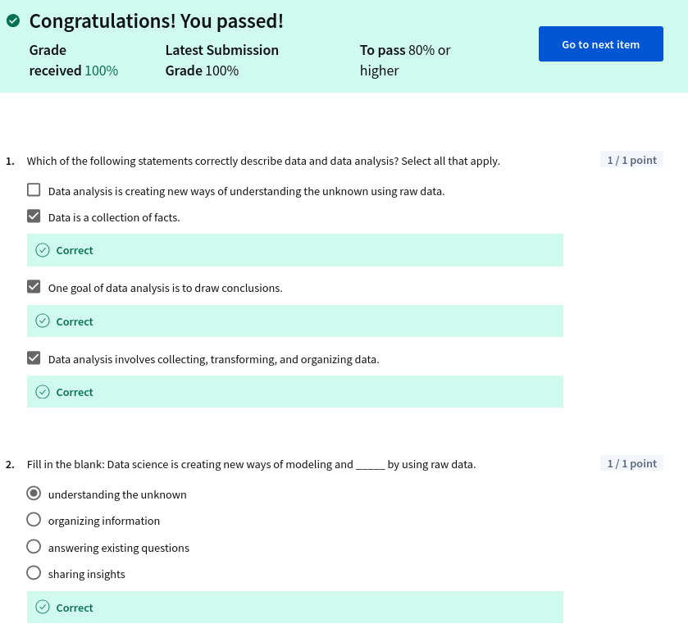
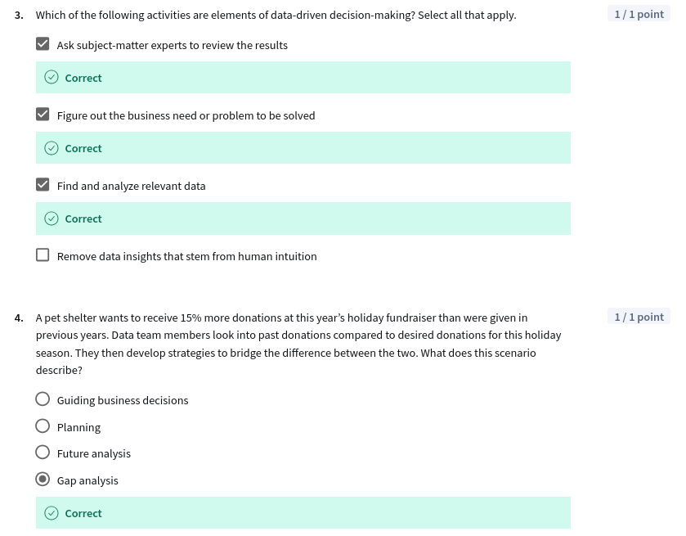
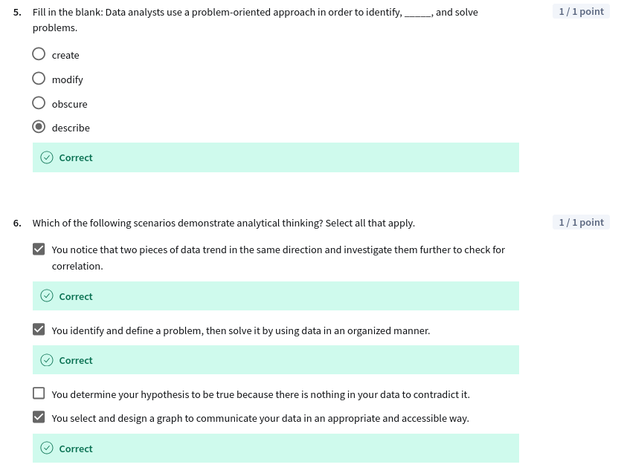
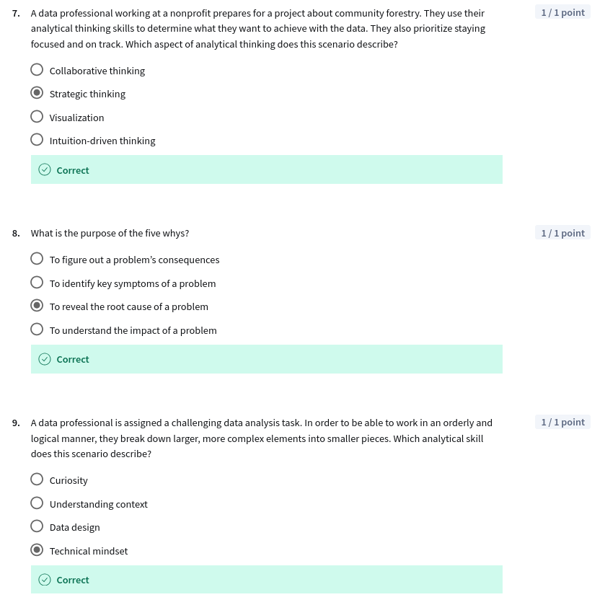

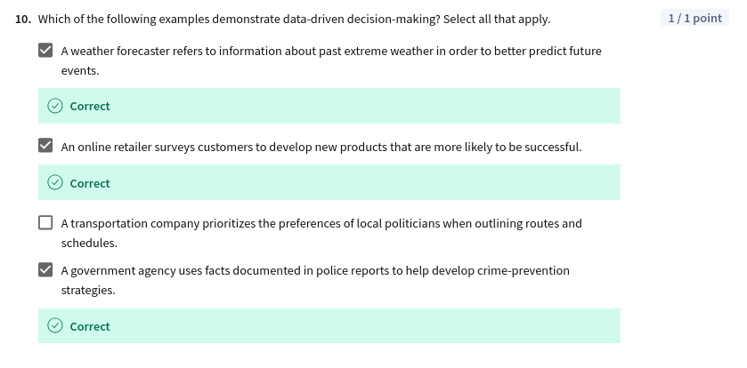
Fim.

