Interactive Reporting Examples for NPS Terrestrial Vegetation Monitoring

[github.com/ecoquants/nps-veg](https://github.com/ecoquants/nps-veg)

Ben Best

2018-04-26

Table of Contents

# Background

## Protocol Report

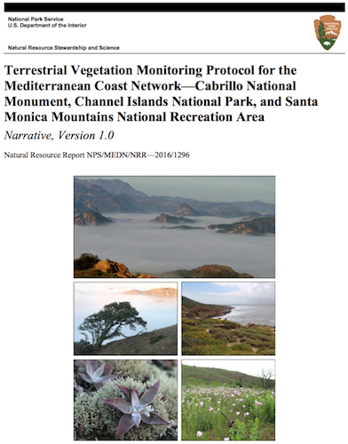

## Table 15. Data and summary statistics for annual report

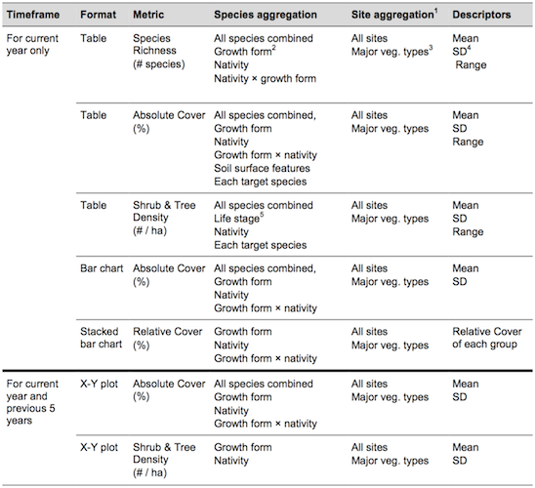

## Appendix E: Template for Annual Terrestrial Vegetation Monitoring Report

**Figures**

* Figure E1. Map showing locations of sites monitored in 20XX at [PARK].
* Figure E2. Absolute foliar cover (%) of various plant groups observed during 20XX monitoring at [PARK].
* Figure E3. Relative plant cover by nativity in plant communities at [PARK] observed during 20XX monitoring.
* Figure E4. Relative plant cover by nativity and lifeform in plant communities at [PARK] observed during 20XX monitoring.
* Figure E5. Absolute foliar cover of all species and of all native species for each of the last 6 years of monitoring at [PARK].
* Figure E6. Density of native and non-native shrubs for each of the last 6 years of monitoring at [PARK].

**Tables**

* Table E1. Potential [PARK] monitoring sites that were visited and rejected in 20XX. Table E.2. [PARK] monitoring sites installed in 20XX.
* Table E3. [PARK] sites monitored in 20XX.
* Table E4. [PARK] sites scheduled for monitoring, but not monitored in 20XX. Table E.5. Burned sites monitored at [PARK] in 20XX.
* Table E6. Species richness (per transect) observed during 20XX monitoring of [PARK] vegetation.

# Examples

## Figure E1. Map of locations

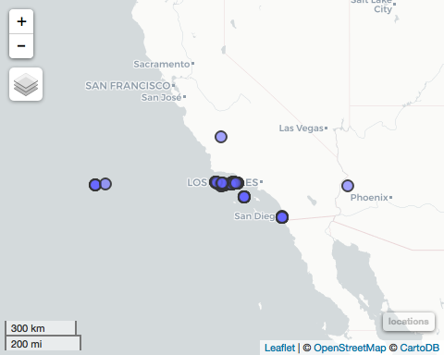

## Figure E1. Map of locations - clustered

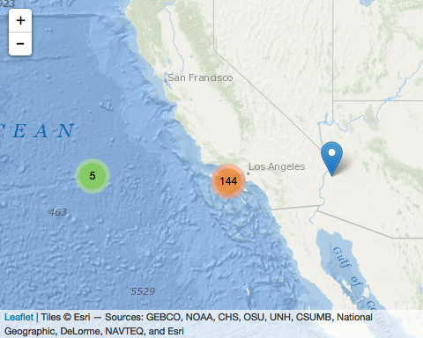

## Figure E2. Absolute foliar cover (%) - Static

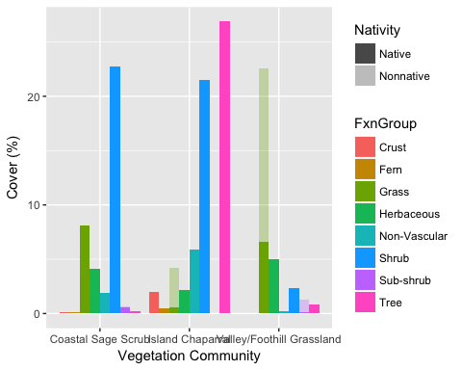

## Figure E2. Absolute foliar cover (%) - Dynamic

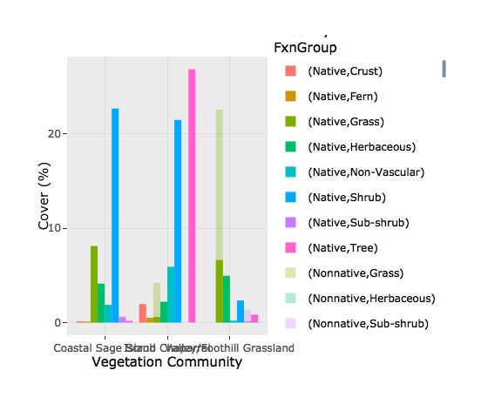

## Table E6. Species by site

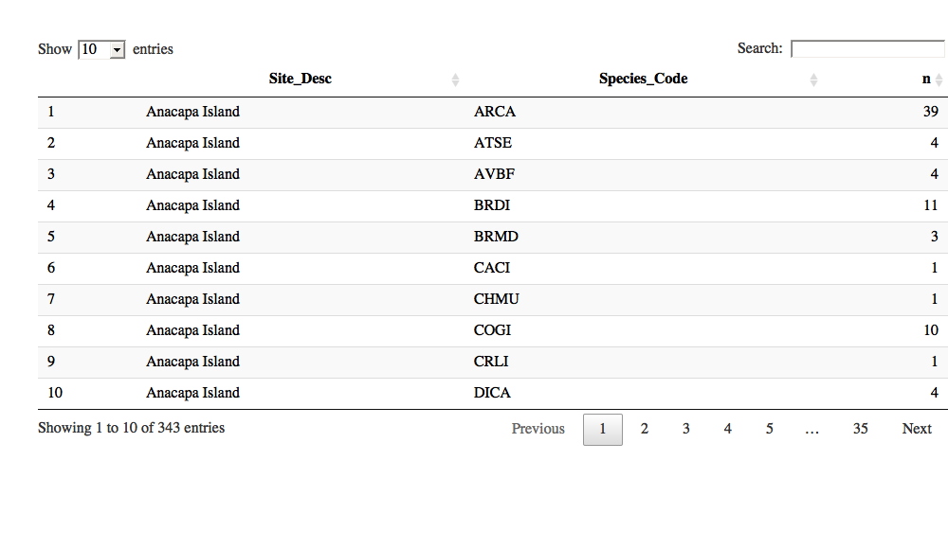

## Table E6. Species richness by site - static

|  |  |
| --- | --- |
| Site_Desc | n_species |
| Anacapa Island | 28 |
| San Miguel Island | 42 |
| Santa Barbara Island | 30 |
| Santa Cruz Island | 77 |
| Santa Rosa Island | 166 |

# Database & Apps

## MS Access DB on Windows

* Fixed VBA errors with 32-bit Declare Function to 64-bit Private Declare PtrSafe Function using MS Access 2013

Windows only connection option:

library(RODBC)  
  
accdb <- "Z:/bbest On My Mac/Google Drive/projects/nps-ecoquants/data/CHISLandVegetationMonitoringDatabase/LandVegetationMonitoring_DATA_be.accdb"  
  
odbcDataSources()  
db <- odbcConnectAccess2007(accdb)  
  
sqlTables(db)  
sqlQuery("SELECT * FROM tbl_Locations")

## MS Access DB & Postgres

Connect Access Front-End to Postgres Backend:

* [Connect Microsoft Access to PostgreSQL - iShare Help - Confluence](https://astuntech.atlassian.net/wiki/spaces/ISHAREHELP/pages/38502755/Connect+Microsoft+Access+to+PostgreSQL)
* [Using MS Access with PostgreSQL - Postgres OnLine Journal](http://www.postgresonline.com/journal/archives/24-Using-MS-Access-with-PostgreSQL.html)

Assistant applications to handle conversion / synchronization:

* [Access To PostgreSQL $49](http://www.bullzip.com/products/a2p/info.php)
* [Access To PostgreSQL: DBConvert $149, DBSync $149](http://www.bullzip.com/products/a2p/info.php)

## Create New Front-End App

For example, with Shiny:

* [Creating Interactive Web Applications with R & Shiny](http://bit.ly/shiny-2018-04)

Working with databases & Shiny:

* [Databases using R](http://db.rstudio.com/)
* [Shiny - Database basics - dplyr and DBI](https://shiny.rstudio.com/articles/overview.html)
* [Shiny - Persistent data storage in Shiny apps](https://shiny.rstudio.com/articles/persistent-data-storage.html)
* [Enterprise-ready dashboards with Shiny and databases · R Views](https://rviews.rstudio.com/2017/09/20/dashboards-with-r-and-databases/)
* [Create an R Shiny Database CRUD app](https://ipub.com/shiny-crud-app/)

# Rmarkdown

## Rmarkdown formats

From the same Rmarkdown document:

* [index.Rmd](https://github.com/ecoquants/nps-veg/blob/master/docs/index.Rmd)

You can generate these (and more):

* [ioslides_presentation](https://ecoquants.github.io/nps-veg)
* [html_document](http://ecoquants.github.io/nps-veg/index_htmldoc.html)
* [pdf_document](https://github.com/ecoquants/nps-veg/raw/master/docs/index.pdf)
* [word_document](https://github.com/ecoquants/nps-veg/raw/master/docs/index.docx)