Submarine Cable Analysis for US Marine Renewable Energy Development

Benjamin D. Best 1

Levi F. Kilcher 2

2017-09-30  
1: EcoQuants, Santa Barbara, CA  
2: National Renewable Energy Lab, Golden, CO

Table of Contents

# Executive Summary

Marine energy (offshore wind, tidal, wave) promises to diversify the U.S. renewable energy porfolio, which is important to reducing greenhouse gas emissions that contribute to climate change and reducing reliance on foreign non-renewable energy sources for national security. Development of these marine energy resources in the U.S. lags considerably behind Europe and other developed countries. The first (and currently only) U.S. commercial facility in Block Island, Rhode Island went into production December of 2016. As implementation costs for these technologies continue to drop and increasingly ambitious targets for renewable energy are set, planning of new marine renewable energy development needs to effectively evaluate competing ocean uses that may come into conflict. Marine renwable energy is complementary to other large scale renewablesby offering consistent energy in high demand times during morning and evening hours when solar is less available and in proximity to coastal areas where populations tend to concentrate.

Operation and maintenance of submarine cables may conflict with marine renewable energy development. The submarine cable industry handles 99% of internet and other forms of telecommunication between land masses for commercial and military purposes, and is thus vital to the larger US economy. Repair and maintenance of cables traditionally involves grappling the cable and floating it to the surface, so allowance for drift of the repairing vessel and laying down of the additional splice of cable is depedent on bottom depth. Although submarine cable locations are publicly accessible through electronic navigation charts, safe setback distances are not yet available for planning new marine renewable energy development.

We applied industry-advised safety buffers that varied with depth to existing submarine cables for new "facilities" (2*depth, i.e. "2z") and new "cables" (3*depth, i.e. "3z") horizontal distances, both having a minimum 500 m buffer on either side. Of the original 230,835 km in the "NOAA Charted Submarine cables in the United States as of December 2012" dataset (Figure 1), 97,321 km fell within the 200 nm of the US exclusive economic zone (EEZ), which was analyzed across 12 territories that overlapped with the cables (Figure 1). A custom Equal Area Albers projection based on 1/6th the extent of each territory was individually applied to minimize spatial distortion when buffering distances at 100 m depth increments using the GEBCO 30 arc-second global grid (Weatherall et al. 2015). The cable buffer area ranged from 29.35% (242,031 km2 [3z] of 824,679 km2 total) in the West owing to many cables present and the steep continental shelf, to virtually nill 0.39% (6,133 km2 [2z] of 1,553,288 km2 total) in the Gulf of Mexico (Table 2).

Overlap of cable buffers with marine renewable energy was assessed for tidal, wave and wind energy based on energy resource characterizations available through the National Renewable Energy Lab (NREL). Assessment of overlap with the advised seperation schemes and energy resource was limited to maximum depths (tidal: < 100 m, wave: < 200 m, wind: < 1,000 m) and minimum energy classes (tidal: > 500 , wave: > 10 , wind: > 7 ) viable for energy development. Areas of viable tidal resource are orders of magnitude less than wave or wind owing to requirements for channelized bathymetry (Figure 2) and have up to 4.7% overlap for the lowest energy class (500 - 1,000 ) with only 2.3% and 0.9% overlap at higher power classes 1,000 - 1,500 and > 1,500 respectively. Wave energy at either depth bin of 0 - 100 or 100 - 200 m is very low with at most 2% overlap for the lower energy class (10-20 ) at depths 100 - 200 m. The most abundant viable wind in shallow depth (0 - 100 m) and lower energy (7 - 8 and 8 - 9 ) overlaps at most 3.1%, but overlaps more at higher speeds (9.6% at 9 - 10 ) and in deeper waters (7.8% and 10.5% at 7 - 8 and 8 - 9 respectively in depths 200 - 1,000 m). Small areas at the highest wind speeds > 10 overlap up to 42.1% for the deepest bin (200 - 1,000 m) and highest wind speeds (11 - 12 ).

Energy resources are unevenly distributed across territories. Tidal power (Figure 3, Table 3) is most abundant in Alaska (691 at 500 - 1,000 ; Table 3), the East (390 at 500 - 1,000 ) and the West (46 at 500 - 1,000 ), which is where overlap with cable buffers is most significant (23.4 - 31.5%) such as around Port Townsend, WA (Figure 11). Wave energy (Figure 4, Table 4) is most abundant in the Pacific territories having the most exposure to storm activity across the largest ocean. Alaska has the most abundant energy across all viable energy classes. Wind speeds (Figure 5, Table 5) in excess of 9 are not found in the Gulf of Mexico and limited to the offshore New England area of the East (Figure 19), offshore areas of California and Oregon in the West (Figure 19) and dispersed locations in Hawaii (Figure 19).

# Background

Demand for abundant and diverse resources in the oceans is growing, necessitating marine spatial planning. To inform development of Marine Hydrokinetic (MHK) and Offshore Wind (OSW) resources, the Department of Energy (DOE) has asked NREL to identify — and mitigate where possible — the competing uses between MHK/OSW technologies and subsea power/telecom cables. The first step in this work is to identify and quantify the overlap between the MHK/OSW resource availability and existing cable routes. Several publicly available data layers are available that identify cable routes (e.g. MarineCadastre.gov currently hosts an offshore cables geographical information system (GIS) data layer) and MHK/OSW resource density (MHK Atlas, Wind Prospector). The cable route linear features, however, do not indicate the setback distance necessary to accommodate subsea cable maintenance requirements. Preliminary work was done within NREL to evaluate the influence of subsea cable setback distance on the overlap with MHK/OSW for the west coast of the U.S (Amante et al. 2016). Industry reports (Communications Security, Reliability and Interoperability Council IV 2014, 2016) from the International Cable Protection Committee (ICPC) of the North American Submarine Cable Association (NASCA)[1] advise on setback distances that inform this analysis.

# Methods

## Study Area, Submarine Cables, Depth and Energy Data

The study area consisted of the US waters (Flanders Marine Institute 2016), i.e. the 200 nm extent deemed the exclusive economic zone (EEZ), that overlapped with the offshore cable dataset "NOAA Charted Submarine cables in the United States as of December 2012" available through MarineCadastre.gov.[2] The territory of the contiguous US was further divided into West, East and Gulf of Mexico territories based on the Gulf of Mexico description from the International Hydrographic Organization (IHO) Sea Areas (VLIZ 2017). To accomodate territories overlapping the international dateline (Hawaii and Alaska), all input and output products were shifted from [-180,180] to [0,360]. For more details on the 12 territories used in this analysis, see Table 1 and Figure 1.

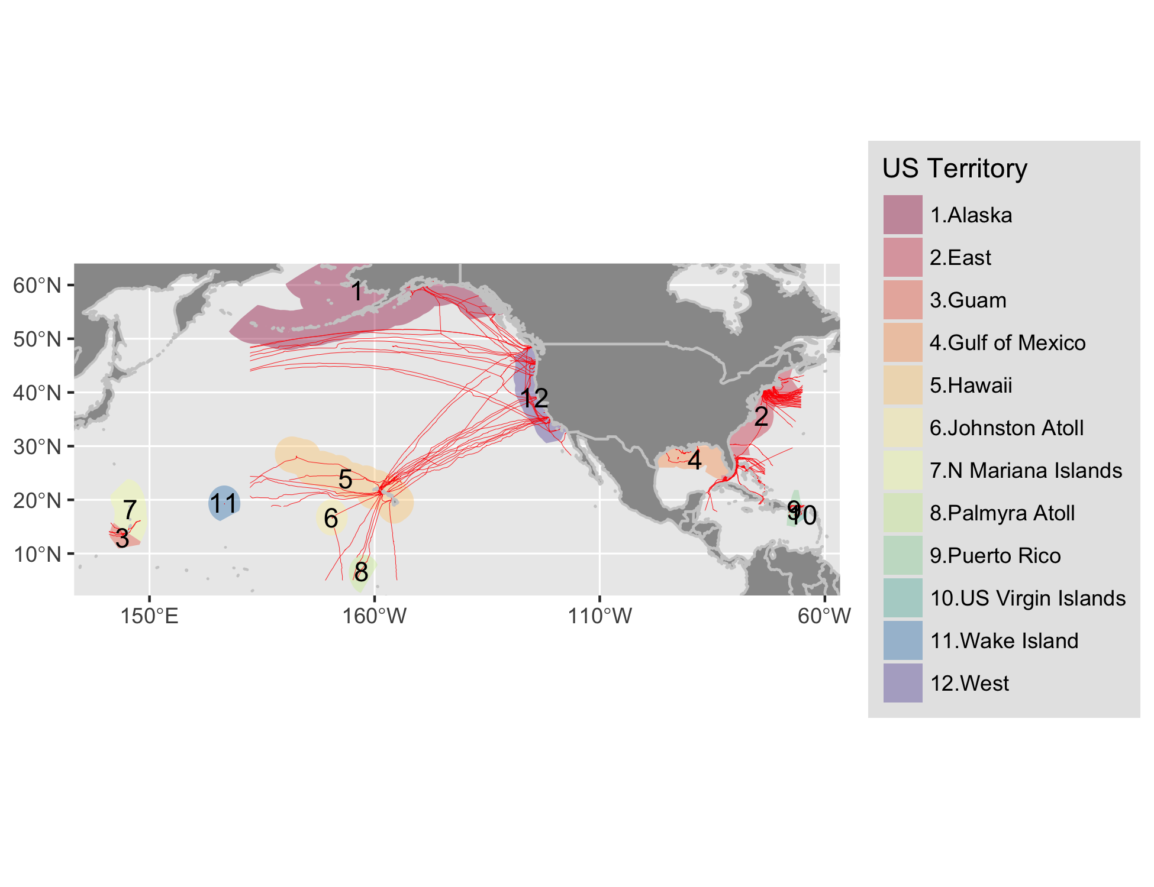

Figure 1 Map of NOAA charted submarine cables (red lines) as of December 2012 within the exclusive economic zone (EEZ; 200 nm) overlapping with United States territories.

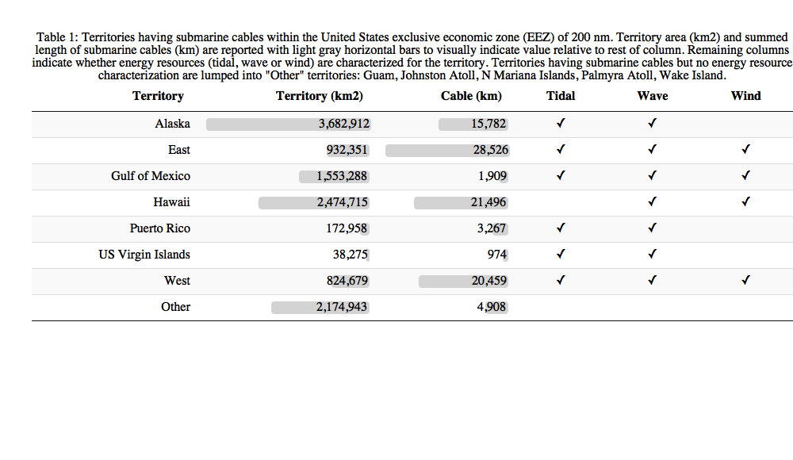

Bathymetric depth comes from the [GEBCO 30 arc-second grid](http://www.gebco.net/data_and_products/gridded_bathymetry_data/gebco_30_second_grid/)[3].

The marine renewable energy datasets are from NREL and accessible online via NREL's Wind Prospector[4] and MHK Atlas[5]. Tidal data were modeled using the Regional Ocean Modeling System and calibrated with available measurements of tidal current speed and water level surface in terms of watts per square meter (W/m2) (Haas et al. 2011). Wave data is based on a 51-month Wavewatch III hindcast database developed by the National Oceanographic and Atmospheric Administration’s (NOAA’s) National Centers for Environmental Prediction for estimation of wave power density in terms of kilowatts per meter (kW/m) (P. T. Jacobson et al. 2011). Wind data is for average offshore wind speed in meters per second (m/s) at a 90 m hub height.[6]

## Submarine Cable Avoidance Zones

The International Cable Protection Committee (ICPC) of the North American Submarine Cable Association (NASCA) outlined recommendations for siting new offshore renewable wind energy facilities and routing new cables. For new facilities they recommend a minimum of 500 m and further offshore twice the depth to the seafloor, per ICPC Recommendation 13 No. 2 (Communications Security, Reliability and Interoperability Council IV 2014). So for depths <= 250 m, a 500 m buffer from the cables applies and for depths > 250 m, 2 * depth is to be used. For placing new submarine cables, seperation distances are specified for minimum (2 * depth) and recommended (3 * depth), per related to ICPC Recommendation 2 No. 10 (Communications Security, Reliability and Interoperability Council IV 2014). We combined these two criteria into 2 sets of buffer distances for siting new facilities ("2z": 2 * depth) and cables ("3z": 3 * depth) avoidance zones, both with a minimum 500 m width.

## Depth-Varying Cable Buffer

A depth-varying buffer from existing submarine cables for new facilities (2z) and cables (3z) was achieved by intersecting depth with cables and buffering out by depth. Depth from the GEBCO grid was reclassed into 100 m increments starting with 250 m to apply a 500 m minimum for the 2z and 3z products, and converted to polygons for intersecting with the cable linear features. A custom Albers Equal Area Conic projection based on 1/6th the extent[7] of each territory was individually applied to minimize spatial distortion when buffering.

# Results

All analytical code to generate outputs, including this data driven report, are available in a publicly accessible online repository: <http://github.com/ecoquants/nrel-cables>. Here are particularly noteworthy files:

* data/
  + [lns_d1x.geojson](https://github.com/ecoquants/nrel-cables/blob/master/data/lns_d1x.geojson): lines of submarine cables segmented at 100 m increments with depth value for buffering, ie minimum 500 m and depth (z) for multiplying by 2 (2z) or 3 (3z).
  + [buf_2xdepth_incr100m.geojson](https://github.com/ecoquants/nrel-cables/blob/master/data/buf_2xdepth_incr100m.geojson): polygons for siting new facilities buffered from existing submarine cables at twice the depth (2z), mimimum 500 m.
  + [buf_3xdepth_incr100m.geojson](https://github.com/ecoquants/nrel-cables/blob/master/data/buf_3xdepth_incr100m.geojson): polygons for siting new cables buffered from existing submarine cables at three times the depth (3z), mimimum 500 m.
* docs/
  + [packages_vars.R](https://github.com/ecoquants/nrel-cables/blob/master/docs/packages_vars.R): R code with variables and packages used across analysis (create_cable-buffer.R, extract_cable-energy.R) and reporting (report.Rmd)
  + [create_cable-buffer.R](https://github.com/ecoquants/nrel-cables/blob/master/docs/create_cable-buffer.R): R code to generate cable buffers at 100 m depth increments.
  + [extract_cable-energy.R](https://github.com/ecoquants/nrel-cables/blob/master/docs/extract_cable-energy.R): R code to extract renewable energy for cabled territories.
  + [report.Rmd](https://github.com/ecoquants/nrel-cables/blob/master/docs/report.Rmd): R markdown document for reproducible, data-driven generation of various report output file formats (report.pdf, report.docx, report.html)

## Cable Buffer

Of the original 230,835 km in the "NOAA Charted Submarine cables in the United States as of December 2012" dataset (Figure 1), 97,321 km fell within the 200 nm of the US exclusive economic zone (EEZ), which was analyzed across 12 territories that overlapped with the cables (Figure 1). The cable buffer area ranged from 29.35% (242,031 km2 [3z] of 824,679 km2 total) in the West owing to many cables present and the steep continental shelf, to virtually nill 0.39% (6,133 km2 [2z] of 1,553,288 km2 total) in Gulf of Mexico (Table 2).

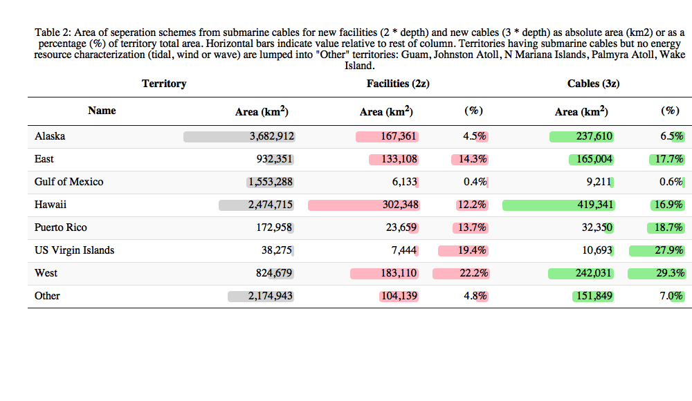

## Overlap of Cable Buffer with Renewable Energy

Overlap of cable buffers with marine renewable energy was assessed for tidal, wave and wind energy based on energy resource characterizations available through the National Renewable Energy Lab (NREL). Assessment of overlap with the advised seperation schemes and energy resource was limited to maximum depths (tidal: < 100 m, wave: < 200 m, wind: < 1,000 m) and minimum energy classes (tidal: > 500 , wave: > 10 , wind: > 7 ) viable for energy development. Areas of viable tidal resource are orders of magnitude less than wave or wind owing to requirements for channelized bathymetry (Figure 2) and have up to 4.7% overlap for the lowest energy class (500 - 1,000 ) with only 2.3% and 0.9% overlap at higher power classes 1,000 - 1,500 and > 1,500 respectively. Wave energy at either depth bin of 0 - 100 or 100 - 200 m is very low with at most 2% overlap for the lower energy class (10-20 ) at depths 100 - 200 m. The most abundant viable wind in shallow depth (0 - 100 m) and lower energy (7 - 8 and 8 - 9 ) overlaps at most 3.1%, but overlaps more at higher speeds (9.6% at 9 - 10 ) and in deeper waters (7.8% and 10.5% at 7 - 8 and 8 - 9 respectively in depths 200 - 1,000 m). Small areas at the highest wind speeds > 10 overlap up to 42.1% for the deepest bin (200 - 1,000 m) and highest wind speeds (11 - 12 ).

Energy resources are unevenly distributed across territories. Tidal power (Figure 3, Table 3) is most abundant in Alaska (691 at 500 - 1,000 ; Table 3), the East (390 at 500 - 1,000 ) and the West (46 at 500 - 1,000 ), which is where overlap with cable buffers is most significant (23.4 - 31.5%) such as around Port Townsend, WA (Figure 11). Wave energy (Figure 4, Table 4) is most abundant in the Pacific territories having the most exposure to storm activity across the largest ocean. Alaska has the most abundant energy across all viable energy classes. Wind speeds (Figure 5, Table 5) in excess of 9 are not found in the Gulf of Mexico and limited to the offshore New England area of the East (Figure 19), offshore areas of California and Oregon in the West (Figure 19) and dispersed locations in Hawaii (Figure 19).

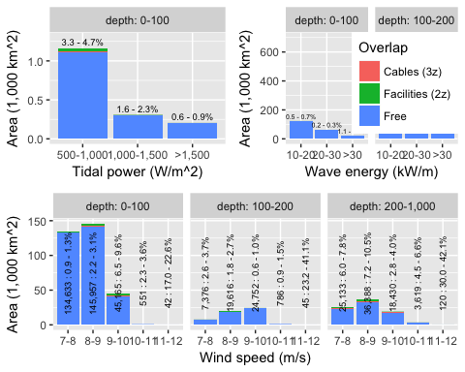

Figure 2 Area of energy classes per depth bin across forms of energy resource characterization (tidal, wave and wind) with percent overlap of horizontal safety seperation scheme from existing submarine cables for new facilities (2 * depth) and new cables (3 * depth). Overlap of new cables buffer (3z) is inclusive of the new facilities buffer (2z) so the height of the bar represents total area for the energy class. Assessed area of overlap with energy resource characterization is limited to a maximum depth (tidal: < 100 m; wave: < 200 m; wind: < 1000 m) and minimum energy classes (tidal: > 500 ; wave: > 10 ; wind > 7 ) for viable renewable energy development.

### Tidal

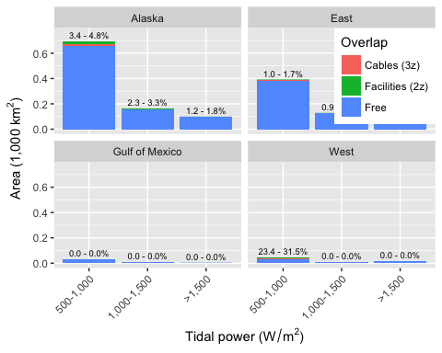

Figure 3 Area of tidal power classes () per US territory with percent overlap of horizontal safety seperation scheme from existing submarine cables for new facilities (2 * depth) and new cables (3 * depth). Overlap of new cables buffer (3z) is inclusive of the new facilities buffer (2z) so the height of the bar represents total area for the energy class. Assessed area of overlap with tidal energy resource characterization is limited to a maximum depth (< 100 m) and minimum energy classes (> 500 ) for viable tidal energy development.

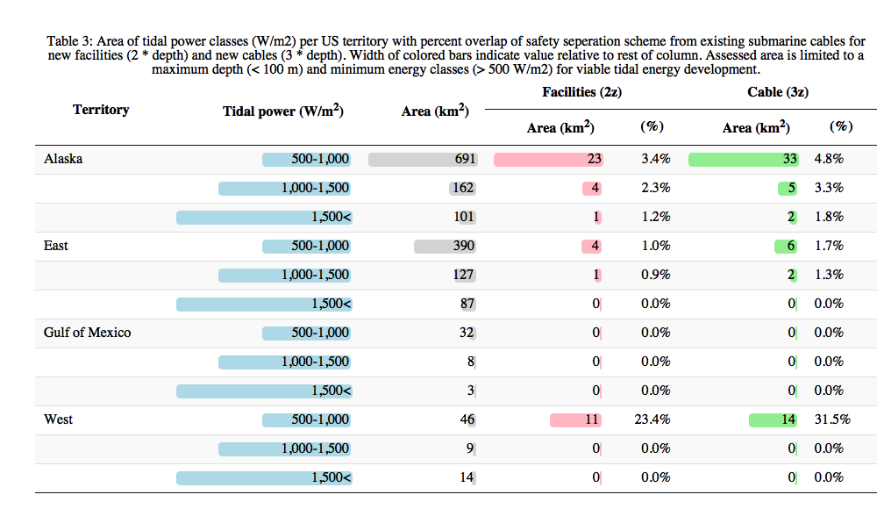

### Wave

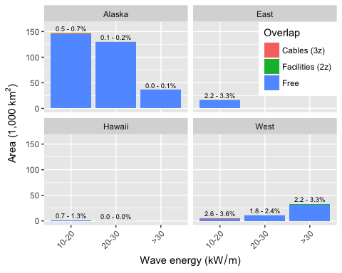

Figure 4 Area of wave energy classes () per US territory with percent overlap of horizontal safety seperation scheme from existing submarine cables for new facilities (2 * depth) and new cables (3 * depth). Overlap of new cables buffer (3z) is inclusive of the new facilities buffer (2z) so the height of the bar represents total area for the energy class. Assessed area is limited to a maximum depth (> 200 m) and minimum energy classes (> 10 ) for viable wave energy development.

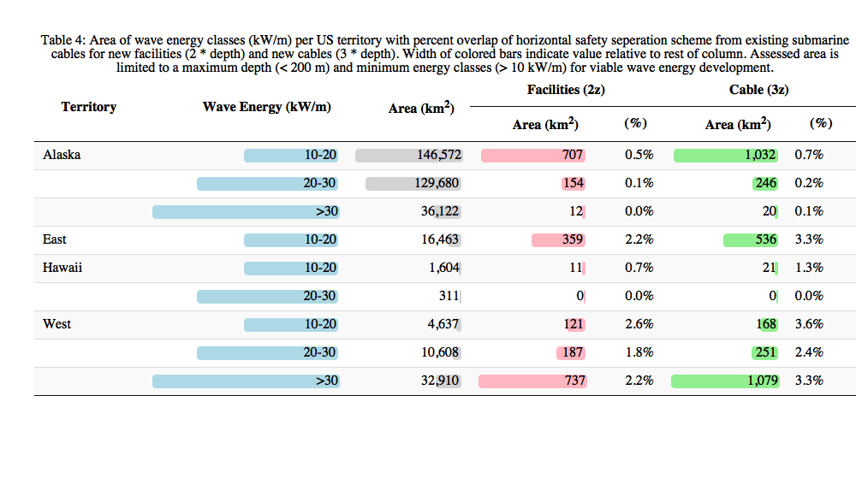

### Wind

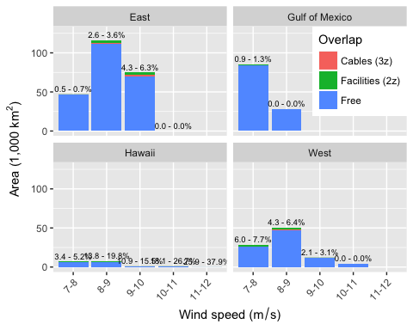

Figure 5 Area of wind speed classes () per US territory with percent overlap of horizontal safety seperation scheme from existing submarine cables for new facilities (2 * depth) and new cables (3 * depth). Overlap of new cables buffer (3z) is inclusive of the new facilities buffer (2z) so the height of the bar represents total area for the energy class. Assessed area is limited to a maximum depth (< 1,000 m) and minimum energy classes (> 7 ) for viable wind energy development.

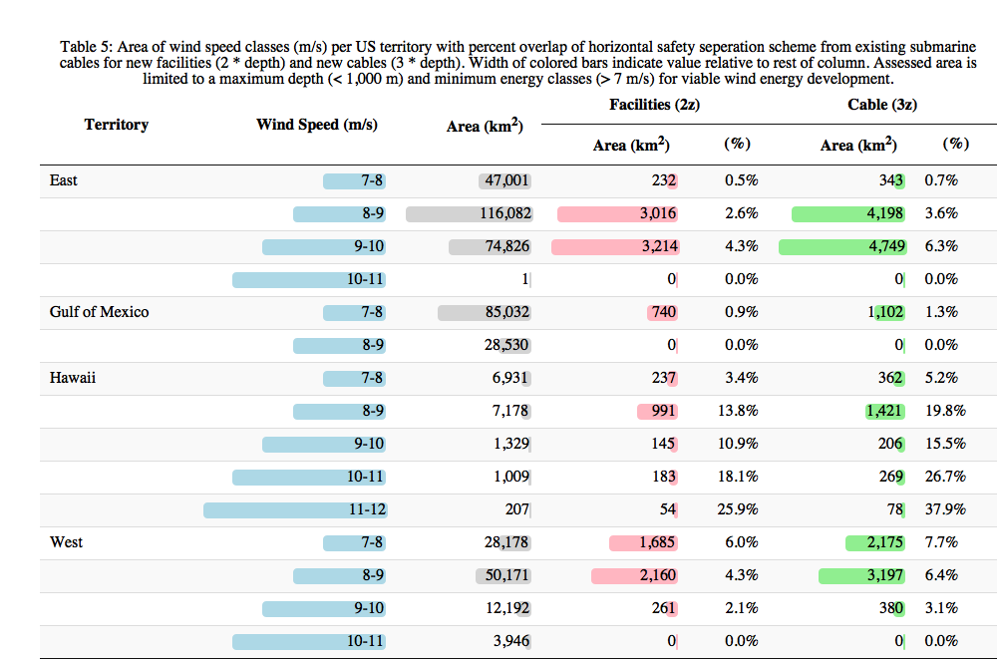

# Conclusions

Given climate change impacts of fossil fuel energy production (Pachauri et al. 2015), development of clean renewable energy alternatives are imperative for the sustainable future of the United States and rest of the planet. These energy sources however vary widely in geographic and temporal availability and may compete with other uses. The submarine cable industry provides critical power and telecommunication services, such that safe operation and maintenance must be heeded as marine renewable energy sources are developed (Communications Security, Reliability and Interoperability Council IV 2014, 2016). The submarine cable safety avoidance zones created and evaluated through this report are products intended to minimize conflict at the plannnig stage between these competing uses.

Although the US currently only has one marine renewable energy facility in full production at Block Island NJ, many more are in pilot and proposal phases with much future potential (Beiter et al. 2017; Lehmann et al. 2017; Uihlein and Magagna 2016). These spatial avoidance zones are advisory. Should there be overlapping interest, negotiations between renewable energy developers and cable operators should be sought.

# (APPENDIX) Appendix

# Maps by US Territory of Cable Buffer and Renewable Energy

## Tide

### Alaska

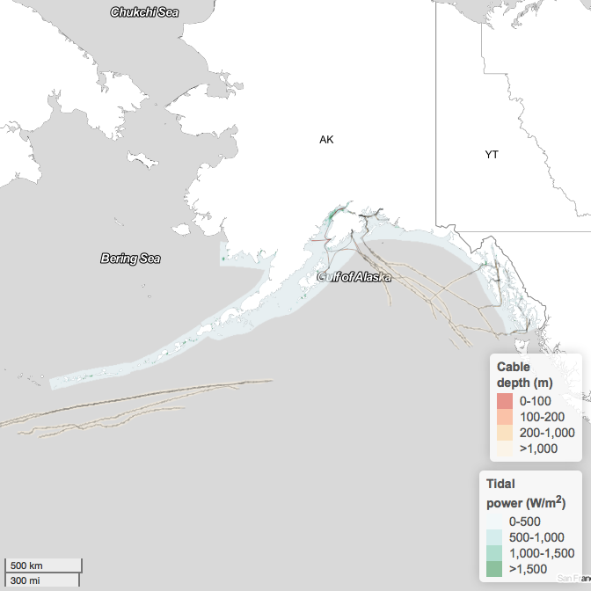

Figure 6 Map of tidal power () in Alaska with submarine cables (black lines) and advisory buffers colored by bottom depth. The buffers are plotted with transparency so the inner more opaque band represents the advised horizontal seperation scheme for new facilities (2 * depth) and outer less opaque band the scheme for new cables (3 * depth). At large scales this detail is not visible. Alternatively, you can zoom and pan interactively on these layers at <http://ecoquants.github.io/nrel-cables/maps.html>.

### East

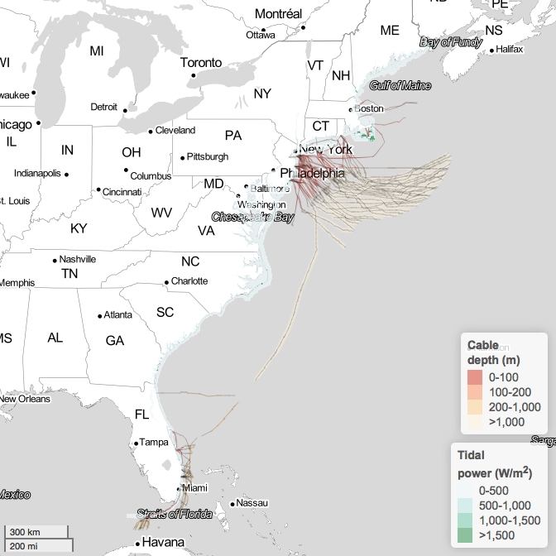

Figure 7 Map of tidal power () in the East with submarine cables (black lines) and advisory buffers colored by bottom depth. The buffers are plotted with transparency so the inner more opaque band represents the advised horizontal seperation scheme for new facilities (2 * depth) and outer less opaque band the scheme for new cables (3 * depth). At large scales this detail is not visible. Alternatively, you can zoom and pan interactively on these layers at <http://ecoquants.github.io/nrel-cables/maps.html>.

### Gulf of Mexico

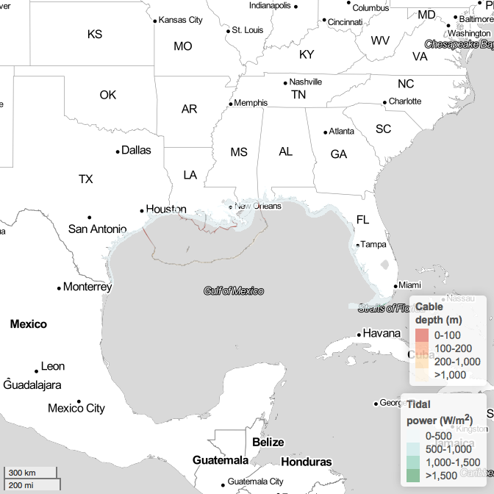

Figure 8 Map of tidal power () in the Gulf of Mexico with submarine cables (black lines) and advisory buffers colored by bottom depth. The buffers are plotted with transparency so the inner more opaque band represents the advised horizontal seperation scheme for new facilities (2 * depth) and outer less opaque band the scheme for new cables (3 * depth). At large scales this detail is not visible. Alternatively, you can zoom and pan interactively on these layers at <http://ecoquants.github.io/nrel-cables/maps.html>.

### Puerto Rico

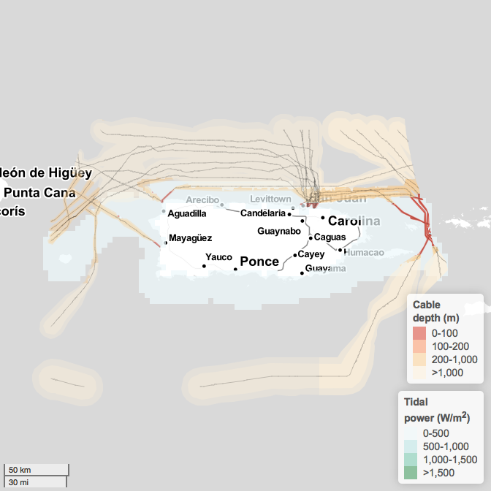

Figure 9 Map of tidal power () in Puerto Rico with submarine cables (black lines) and advisory buffers colored by bottom depth. The buffers are plotted with transparency so the inner more opaque band represents the advised horizontal seperation scheme for new facilities (2 * depth) and outer less opaque band the scheme for new cables (3 * depth). At large scales this detail is not visible. Alternatively, you can zoom and pan interactively on these layers at <http://ecoquants.github.io/nrel-cables/maps.html>.

### US Virgin Islands

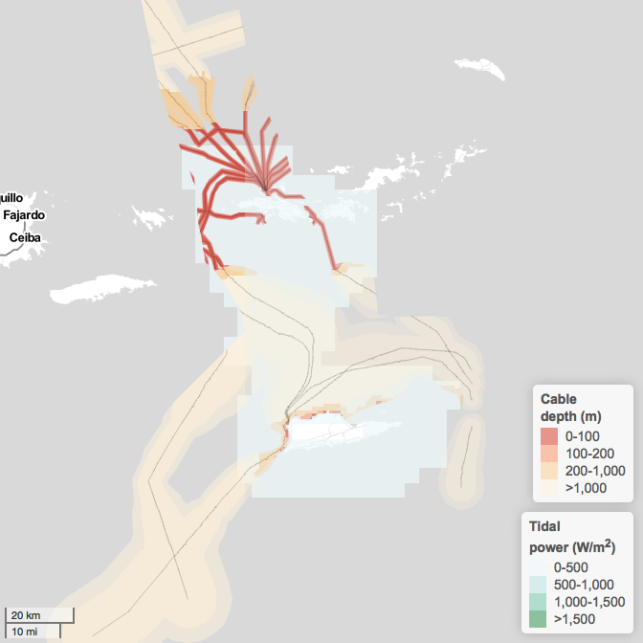

Figure 10 Map of tidal power () in the US Virgin Islands with submarine cables (black lines) and advisory buffers colored by bottom depth. The buffers are plotted with transparency so the inner more opaque band represents the advised horizontal seperation scheme for new facilities (2 * depth) and outer less opaque band the scheme for new cables (3 * depth). At large scales this detail is not visible. Alternatively, you can zoom and pan interactively on these layers at <http://ecoquants.github.io/nrel-cables/maps.html>.

### West

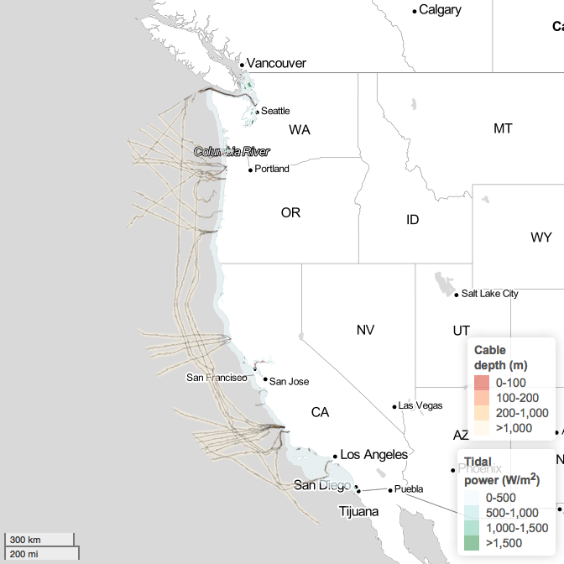

Figure 11 Map of tidal power () in the West with submarine cables (black lines) and advisory buffers colored by bottom depth. The buffers are plotted with transparency so the inner more opaque band represents the advised horizontal seperation scheme for new facilities (2 * depth) and outer less opaque band the scheme for new cables (3 * depth). At large scales this detail is not visible. Alternatively, you can zoom and pan interactively on these layers at <http://ecoquants.github.io/nrel-cables/maps.html>.

## Wave

### Alaska

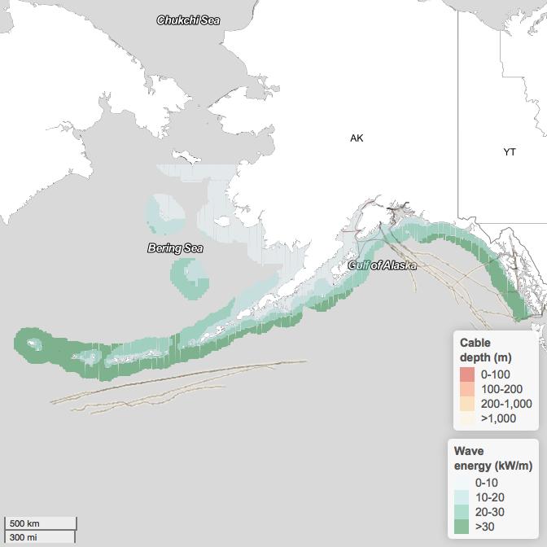

Figure 12 Map of wave energy () in Alaska with submarine cables (black lines) and advisory buffers colored by bottom depth. The buffers are plotted with transparency so the inner more opaque band represents the advised horizontal seperation scheme for new facilities (2 * depth) and outer less opaque band the scheme for new cables (3 * depth). At large scales this detail is not visible. Alternatively, you can zoom and pan interactively on these layers at <http://ecoquants.github.io/nrel-cables/maps.html>.

### East

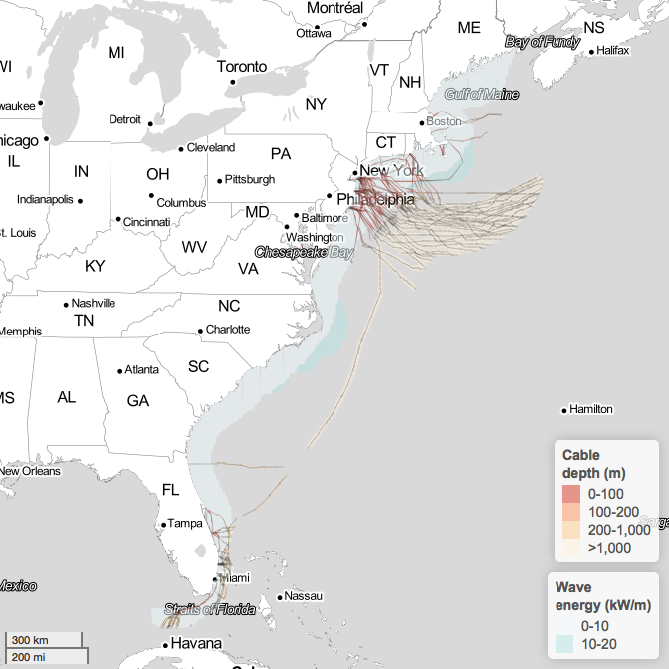

Figure 13 Map of wave energy () in the East with submarine cables (black lines) and advisory buffers colored by bottom depth. The buffers are plotted with transparency so the inner more opaque band represents the advised horizontal seperation scheme for new facilities (2 * depth) and outer less opaque band the scheme for new cables (3 * depth). At large scales this detail is not visible. Alternatively, you can zoom and pan interactively on these layers at <http://ecoquants.github.io/nrel-cables/maps.html>.

### Gulf of Mexico

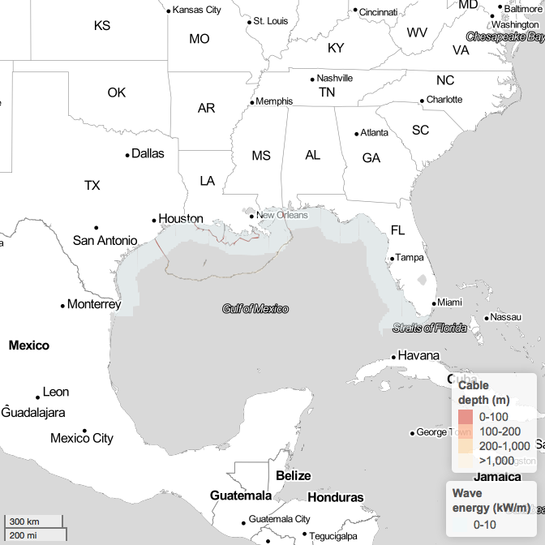

Figure 14 Map of wave energy () in the Gulf of Mexico with submarine cables (black lines) and advisory buffers colored by bottom depth. The buffers are plotted with transparency so the inner more opaque band represents the advised horizontal seperation scheme for new facilities (2 * depth) and outer less opaque band the scheme for new cables (3 * depth). At large scales this detail is not visible. Alternatively, you can zoom and pan interactively on these layers at <http://ecoquants.github.io/nrel-cables/maps.html>.

### Hawaii

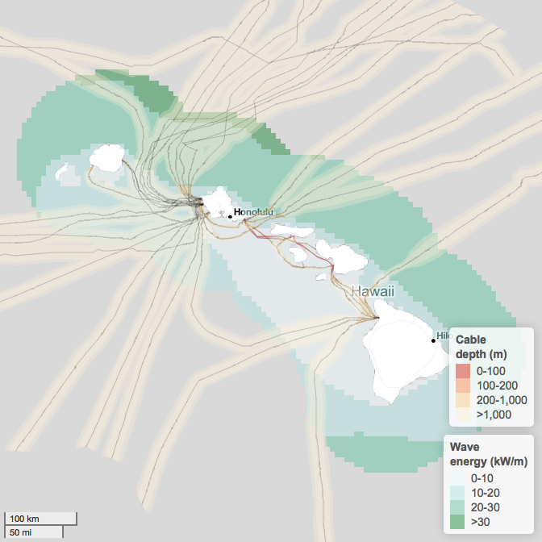

Figure 15 Map of wave energy () in Hawaii with submarine cables (black lines) and advisory buffers colored by bottom depth. The buffers are plotted with transparency so the inner more opaque band represents the advised horizontal seperation scheme for new facilities (2 * depth) and outer less opaque band the scheme for new cables (3 * depth). At large scales this detail is not visible. Alternatively, you can zoom and pan interactively on these layers at <http://ecoquants.github.io/nrel-cables/maps.html>.

### Puerto Rico

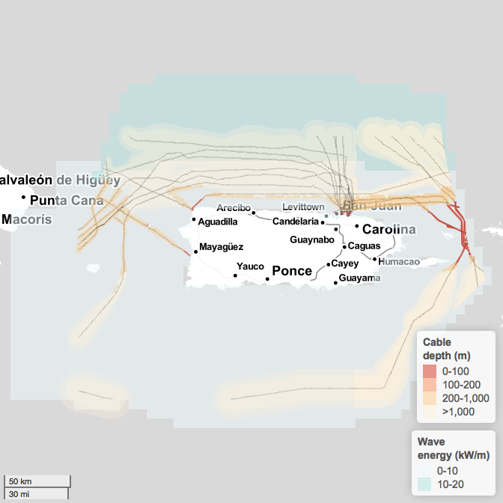

Figure 16 Map of wave energy () in Puerto Rico with submarine cables (black lines) and advisory buffers colored by bottom depth. The buffers are plotted with transparency so the inner more opaque band represents the advised horizontal seperation scheme for new facilities (2 * depth) and outer less opaque band the scheme for new cables (3 * depth). At large scales this detail is not visible. Alternatively, you can zoom and pan interactively on these layers at <http://ecoquants.github.io/nrel-cables/maps.html>.

### US Virgin Islands

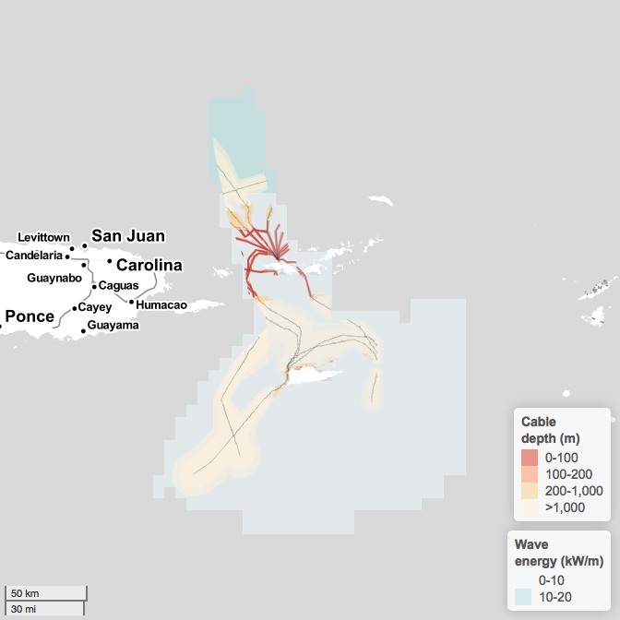

Figure 17 Map of wave energy () in the US Virgin Islands with submarine cables (black lines) and advisory buffers colored by bottom depth. The buffers are plotted with transparency so the inner more opaque band represents the advised horizontal seperation scheme for new facilities (2 * depth) and outer less opaque band the scheme for new cables (3 * depth). At large scales this detail is not visible. Alternatively, you can zoom and pan interactively on these layers at <http://ecoquants.github.io/nrel-cables/maps.html>.

### West

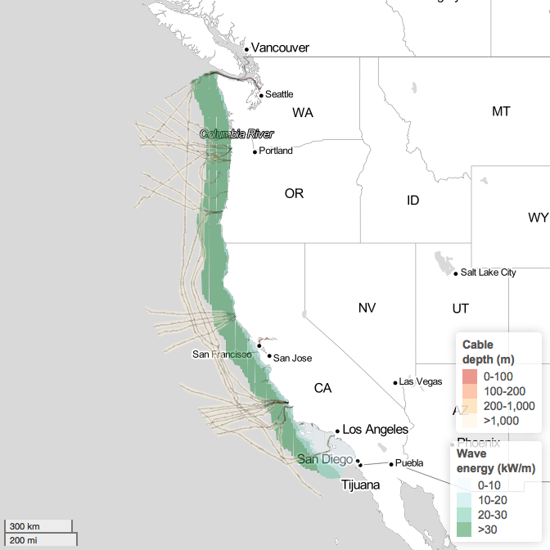

Figure 18 Map of wave energy () in the West with submarine cables (black lines) and advisory buffers colored by bottom depth. The buffers are plotted with transparency so the inner more opaque band represents the advised horizontal seperation scheme for new facilities (2 * depth) and outer less opaque band the scheme for new cables (3 * depth). At large scales this detail is not visible. Alternatively, you can zoom and pan interactively on these layers at <http://ecoquants.github.io/nrel-cables/maps.html>.

## Wind

### East

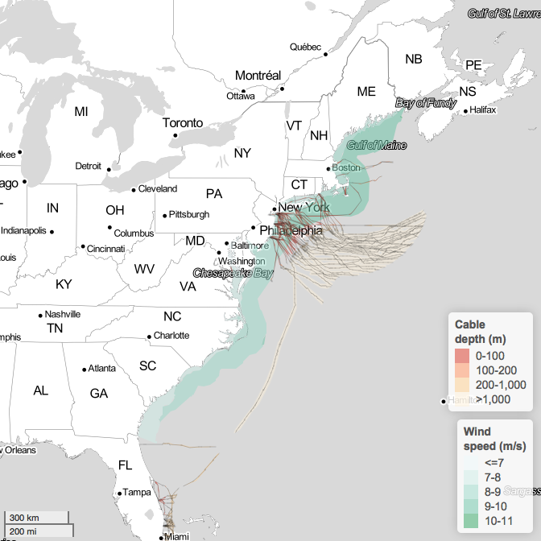

Figure 19 Map of wind speed () in the East with submarine cables (black lines) and advisory buffers colored by bottom depth. The buffers are plotted with transparency so the inner more opaque band represents the advised horizontal seperation scheme for new facilities (2 * depth) and outer less opaque band the scheme for new cables (3 * depth). At large scales this detail is not visible. Alternatively, you can zoom and pan interactively on these layers at <http://ecoquants.github.io/nrel-cables/maps.html>.

### Gulf of Mexico

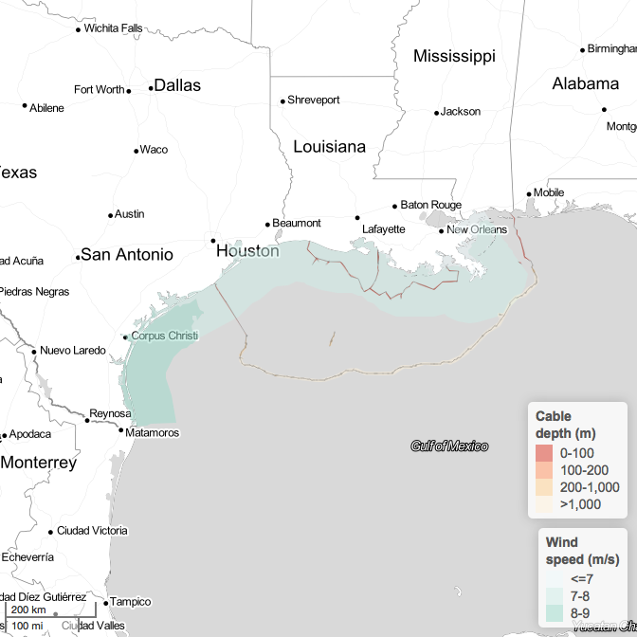

Figure 20 Map of wind speed () in the Gulf of Mexico with submarine cables (black lines) and advisory buffers colored by bottom depth. The buffers are plotted with transparency so the inner more opaque band represents the advised horizontal seperation scheme for new facilities (2 * depth) and outer less opaque band the scheme for new cables (3 * depth). At large scales this detail is not visible. Alternatively, you can zoom and pan interactively on these layers at <http://ecoquants.github.io/nrel-cables/maps.html>.

### Hawaii

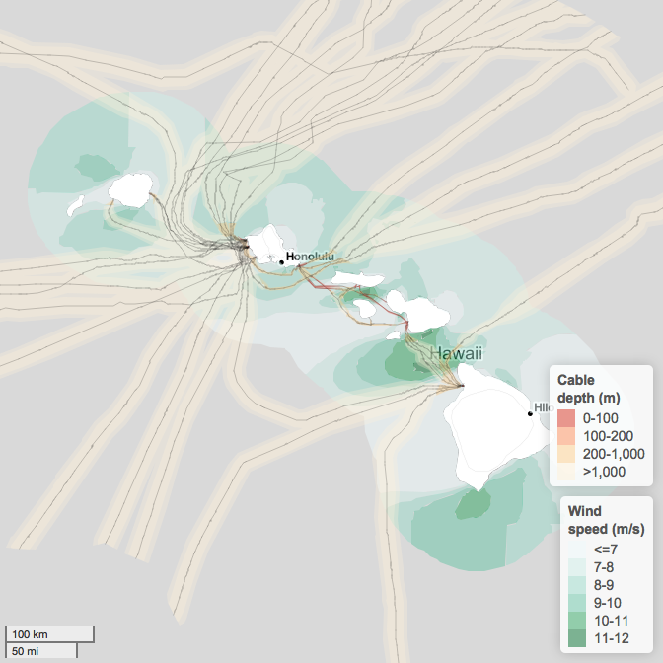

Figure 21 Map of wind speed () in Hawaii with submarine cables (black lines) and advisory buffers colored by bottom depth. The buffers are plotted with transparency so the inner more opaque band represents the advised horizontal seperation scheme for new facilities (2 * depth) and outer less opaque band the scheme for new cables (3 * depth). At large scales this detail is not visible. Alternatively, you can zoom and pan interactively on these layers at <http://ecoquants.github.io/nrel-cables/maps.html>.

### West

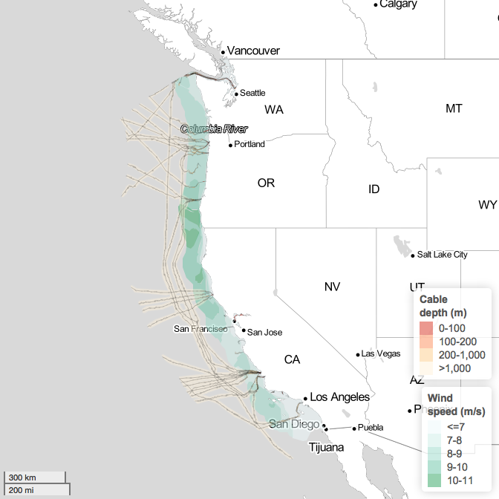

Figure 22 Map of wind speed () in the West with submarine cables (black lines) and advisory buffers colored by bottom depth. The buffers are plotted with transparency so the inner more opaque band represents the advised horizontal seperation scheme for new facilities (2 * depth) and outer less opaque band the scheme for new cables (3 * depth). At large scales this detail is not visible. Alternatively, you can zoom and pan interactively on these layers at <http://ecoquants.github.io/nrel-cables/maps.html>.

# References

Amante, C., Kilcher, L., Roberts, B., & Draxl, C. (2016). *Offshore Cable Analysis: Pilot Study*.

Beiter, P., Musial, W., Kilcher, L., Maness, M., & Smith, A. (2017). *An Assessment of the Economic Potential of Offshore Wind in the United States from 2015 to 2030*. NREL (National Renewable Energy Laboratory (NREL), Golden, CO (United States)). <https://tethys.pnnl.gov/sites/default/files/publications/Beiter-et-al-2017-NETL.pdf>

Communications Security, Reliability and Interoperability Council IV. (2014). *Protection of Submarine Cables Through Spatial Separation*. <http://transition.fcc.gov/pshs/advisory/csric4/CSRIC_IV_WG8_Report1_3Dec2014.pdf>

Communications Security, Reliability and Interoperability Council IV. (2016). *Clustering of Cables and Cable Landings*.

Flanders Marine Institute. (2016). Maritime Boundaries Geodatabase: Maritime Boundaries and Exclusive Economic Zones (200NM), version 9. <http://www.marineregions.org/>. Accessed 25 April 2017

Haas, K. A., Fritz, H. M., French, S. P., Smith, B. T., & Neary, V. (2011). *Assessment of energy production potential from tidal streams in the United States*. Georgia Tech Research Corporation, Atlanta, GA (United States). <https://www.osti.gov/scitech/servlets/purl/1219367>

Jacobson, P. T., Hagerman, G., & Scott, G. (2011). *Mapping and Assessment of the United States Ocean Wave Energy Resource*. <http://www.osti.gov/scitech/servlets/purl/1060943>

Lehmann, M., Karimpour, F., Goudey, C. A., Jacobson, P. T., & Alam, M.-R. (2017). Ocean wave energy in the United States: Current status and future perspectives. *Renewable and Sustainable Energy Reviews*. <http://www.sciencedirect.com/science/article/pii/S1364032116308164>

Pachauri, R. K., Mayer, L., & Intergovernmental Panel on Climate Change (Eds.). (2015). *Climate change 2014: Synthesis report*. Geneva, Switzerland: Intergovernmental Panel on Climate Change.

Uihlein, A., & Magagna, D. (2016). Wave and tidal current energy review of the current state of research beyond technology. *Renewable and Sustainable Energy Reviews*, *58*, 1070–1081. <http://www.sciencedirect.com/science/article/pii/S1364032115016676>

VLIZ. (2017). IHO Sea Areas, version 2. VLIZ. <http://www.marineregions.org/>. Accessed 2 July 2017

Weatherall, P., Marks, K. M., Jakobsson, M., Schmitt, T., Tani, S., Arndt, J. E., et al. (2015). A new digital bathymetric model of the world’s oceans. *Earth and Space Science*, *2*(8), 2015EA000107. doi:[10.1002/2015EA000107](https://doi.org/10.1002/2015EA000107)

1. North American Submarine Cable Association (NASCA): <https://www.n-a-s-c-a.org>
2. MarineCadastre.gov cable metadata: <https://coast.noaa.gov/dataservices/Metadata/TransformMetadata?u=https://coast.noaa.gov/data/Documents/Metadata/harvest/MarineCadastre/NOAAChartedSubmarineCables.xml&f=html>
3. GEBCO_2014 Grid, version 20150318, www.gebco.net
4. NREL Wind Prospector: <https://maps.nrel.gov/wind-prospector/>
5. NREL MHK Atlas: <https://maps.nrel.gov/mhk-atlas>
6. Wind data for 90-meter offshore: <http://www.nrel.gov/gis/data_wind.html>
7. The "one-sixth rule" for Albers Equal Area Conic projection: <http://desktop.arcgis.com/en/arcmap/latest/map/projections/albers-equal-area-conic.htm#GUID-2158C4F9-F197-458E-94F0-84933C1BE6B7>