Ocean Uses and Marine Renewable Energy

Ben Best

2017-12-28 13:22

Table of Contents

## Alaska

### Map of Ocean Use

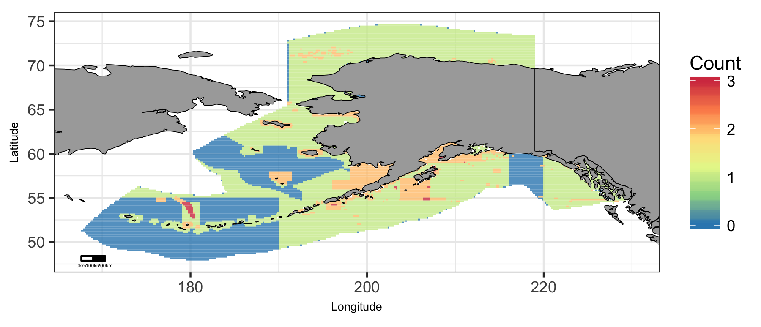

Map of cumulative ocean use in Alaska region.

### Plot of Ocean Use by Depth (m)

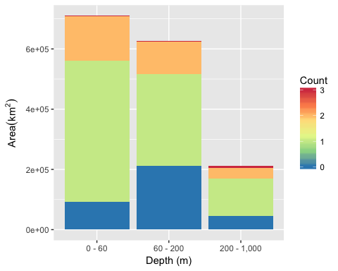

Area of Cumulative Ocean Use by Depth (m) for Alaska region. Cumulative use are counted and summarized by Depth (m) and area.

### Table of Ocean Use by Depth (m)

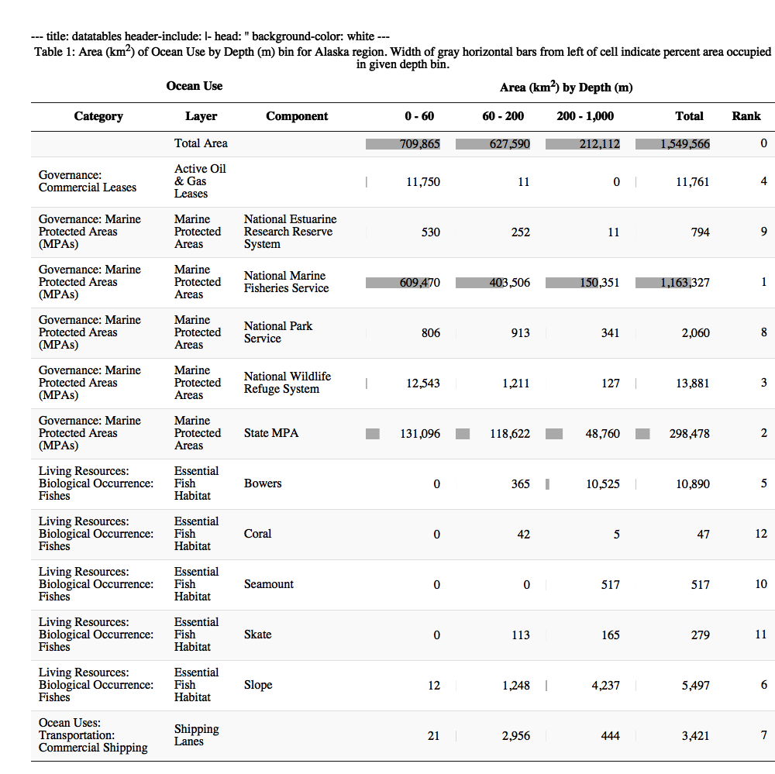

## Atlantic Islands

### Map of Ocean Use

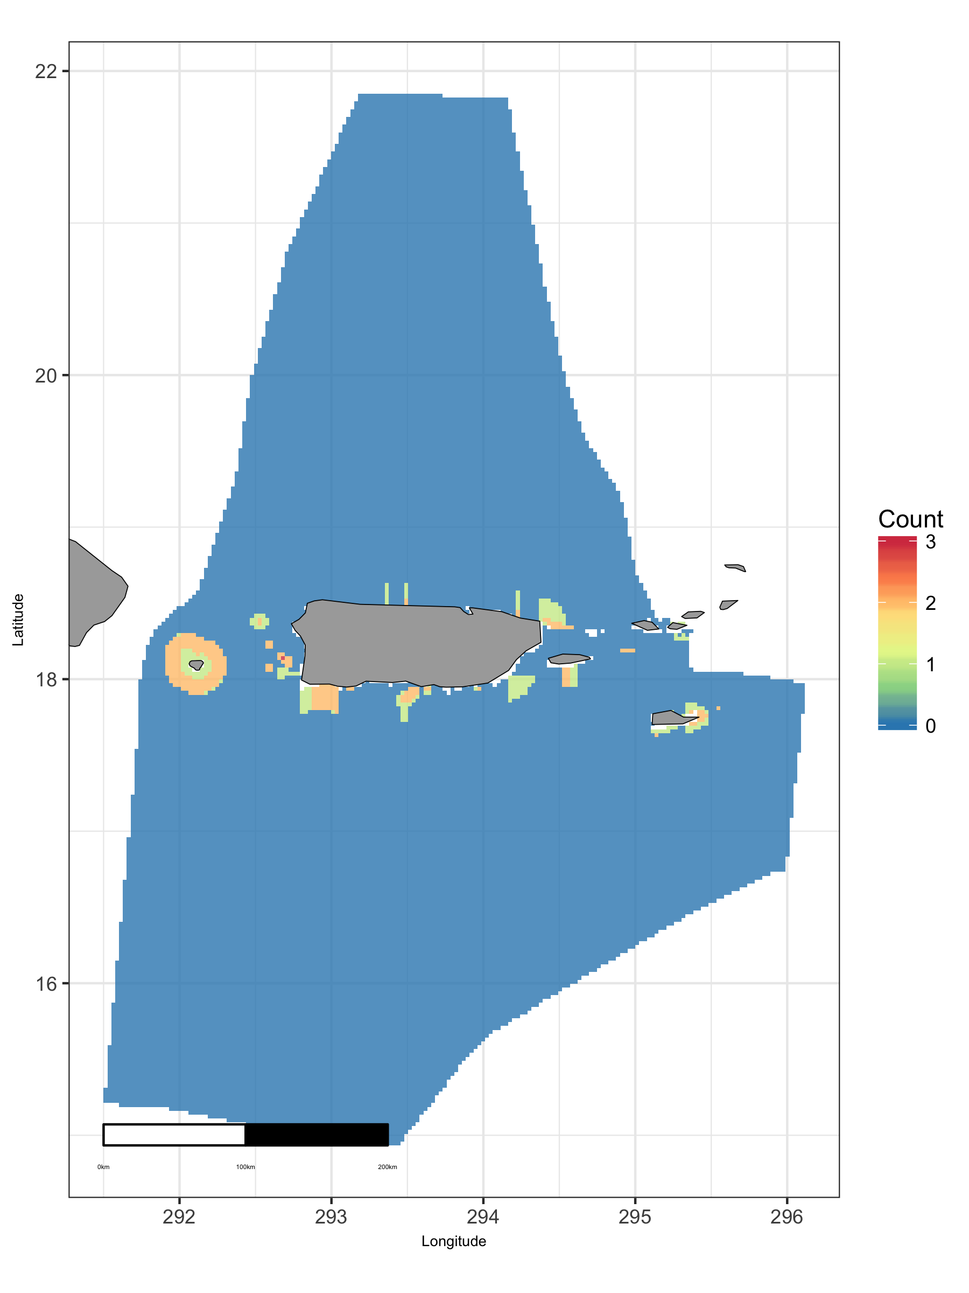

Map of cumulative ocean use in Atlantic Islands region.

### Plot of Ocean Use by Depth (m)

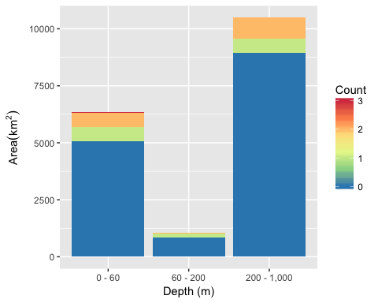

Area of Cumulative Ocean Use by Depth (m) for Atlantic Islands region. Cumulative use are counted and summarized by Depth (m) and area.

### Table of Ocean Use by Depth (m)

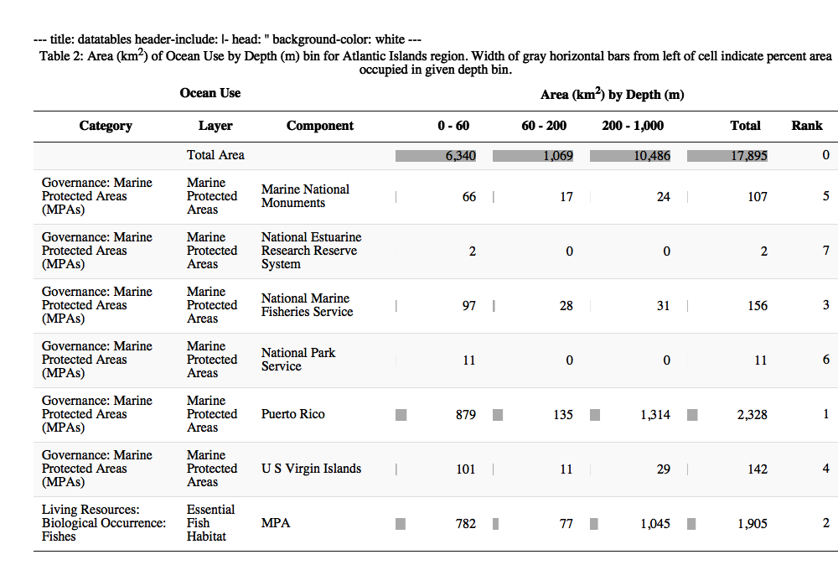

## East

### Map of Ocean Use

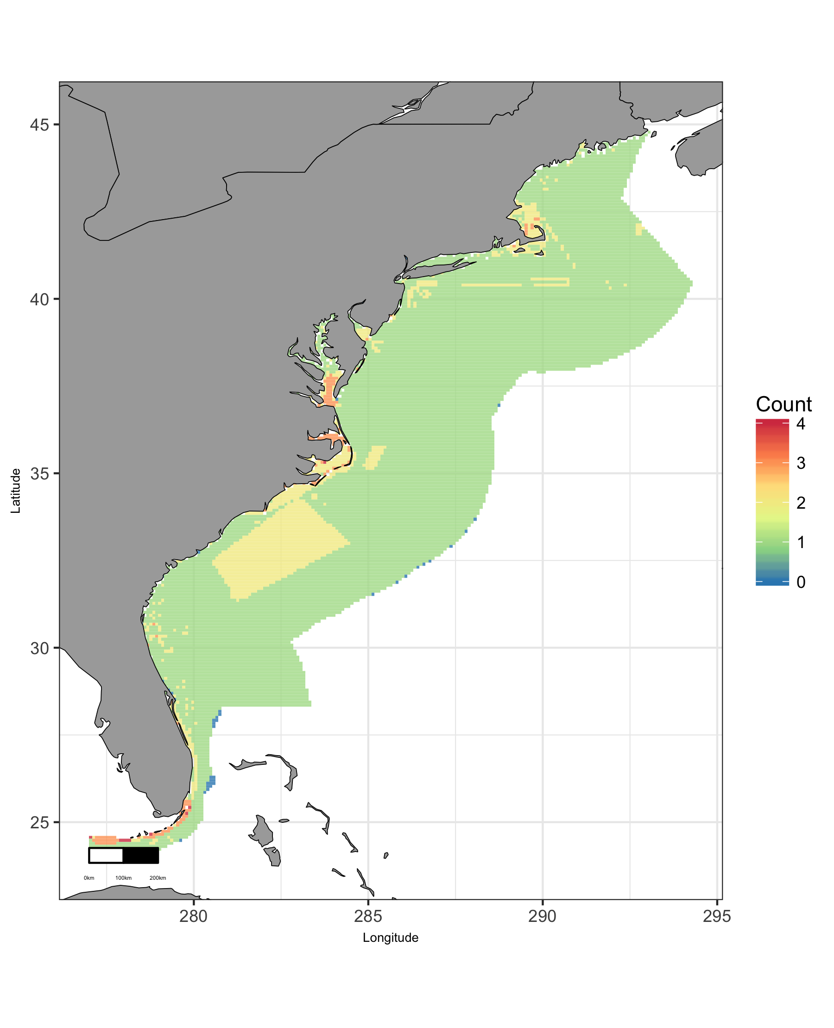

Map of cumulative ocean use in East region.

### Plot of Ocean Use by Depth (m)

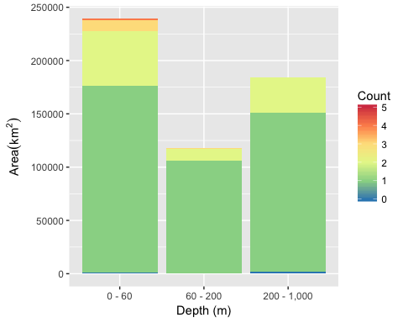

Area of Cumulative Ocean Use by Depth (m) for East region. Cumulative use are counted and summarized by Depth (m) and area.

### Table of Ocean Use by Depth (m)

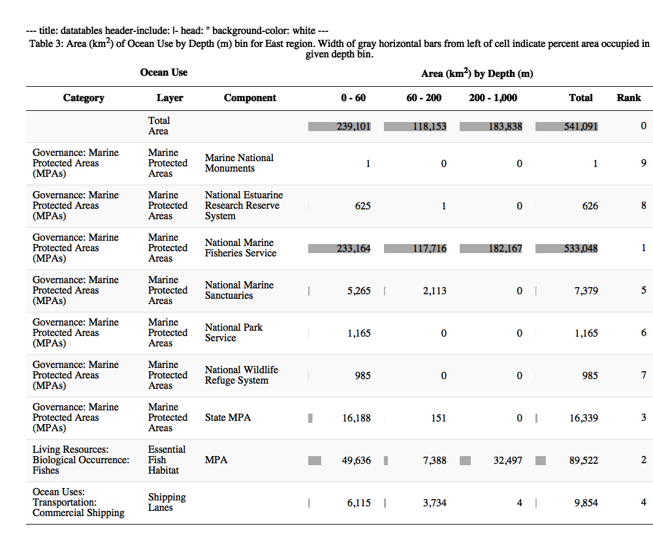

### Plot of Ocean Use by Wind (m/s @ 90m)

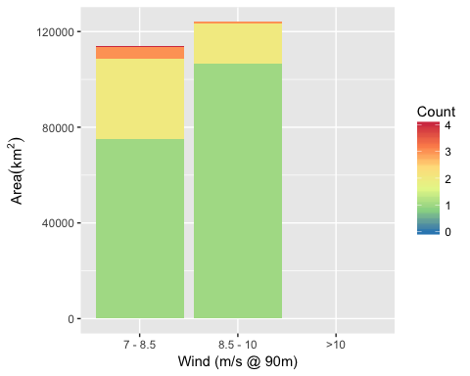

Area of Cumulative Ocean Use by Wind (m/s @ 90m) for East region. Cumulative use are counted and summarized by Wind (m/s @ 90m) and area.

### Table of Ocean Use by Wind (m/s @ 90m)

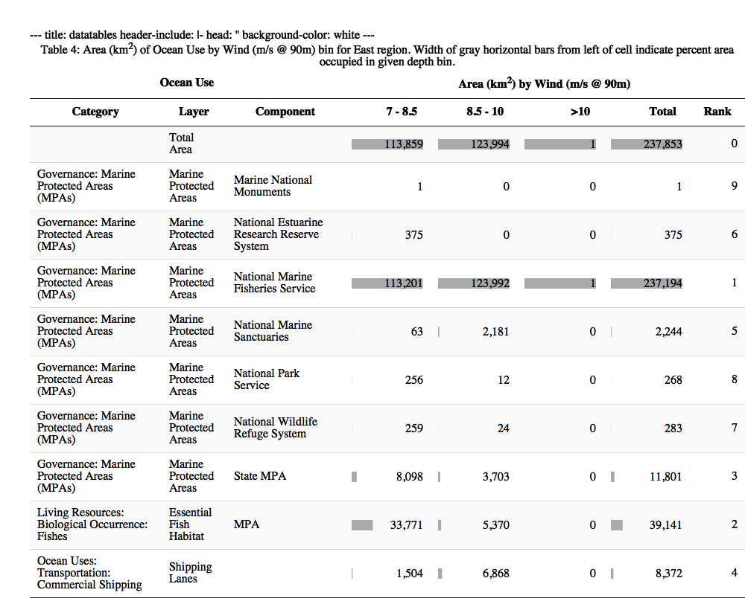

## Great Lakes

### Map of Ocean Use

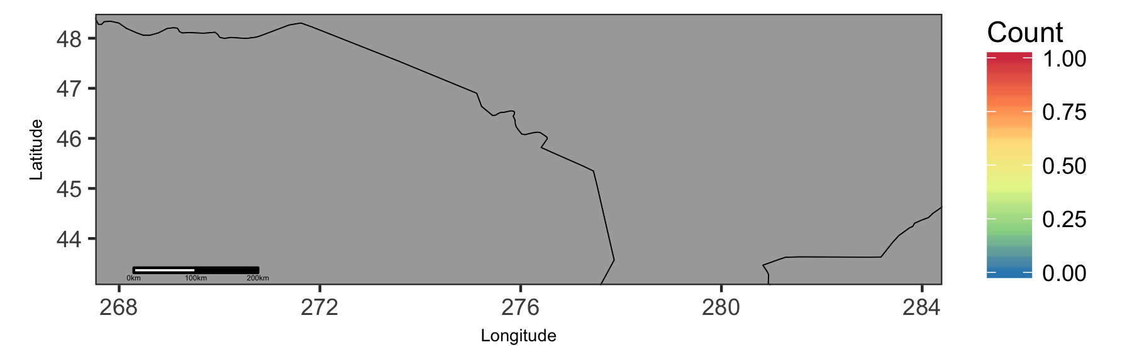

Map of cumulative ocean use in Great Lakes region.

### Plot of Ocean Use by Depth (m)

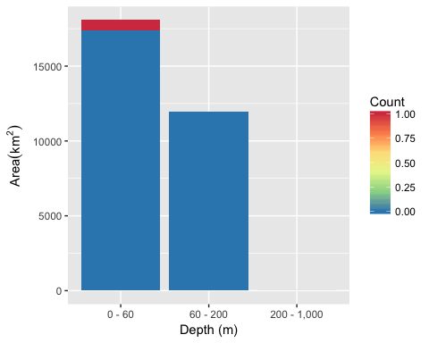

Area of Cumulative Ocean Use by Depth (m) for Great Lakes region. Cumulative use are counted and summarized by Depth (m) and area.

### Table of Ocean Use by Depth (m)

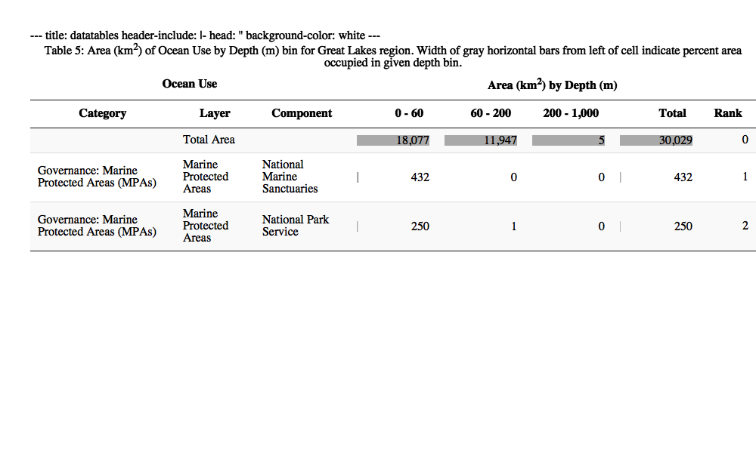

### Plot of Ocean Use by Wind (m/s @ 90m)

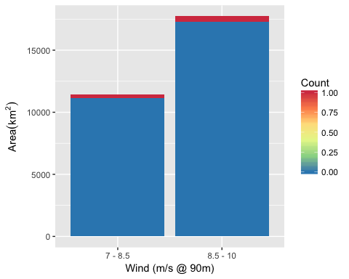

Area of Cumulative Ocean Use by Wind (m/s @ 90m) for Great Lakes region. Cumulative use are counted and summarized by Wind (m/s @ 90m) and area.

### Table of Ocean Use by Wind (m/s @ 90m)

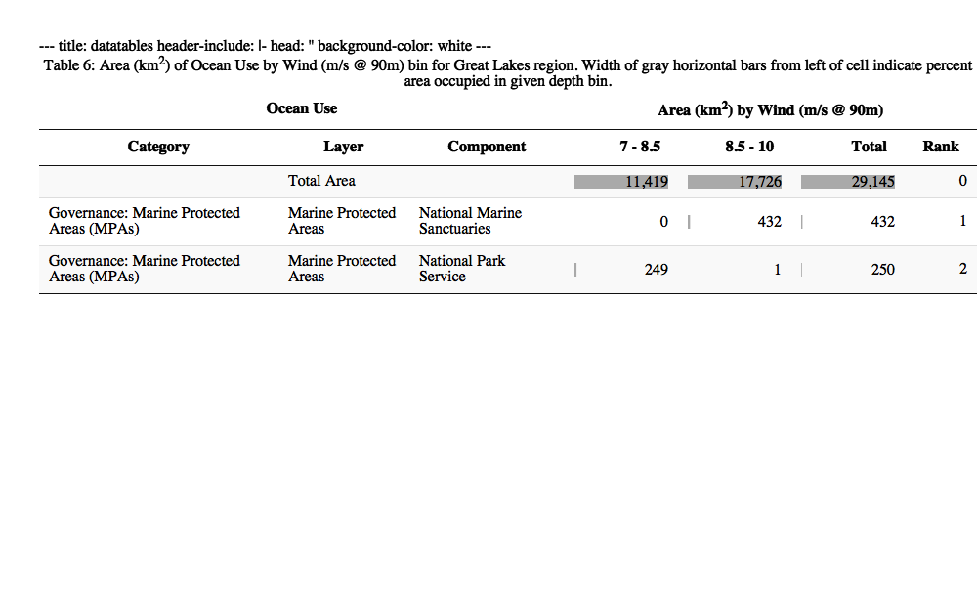

## Gulf of Mexico

### Map of Ocean Use

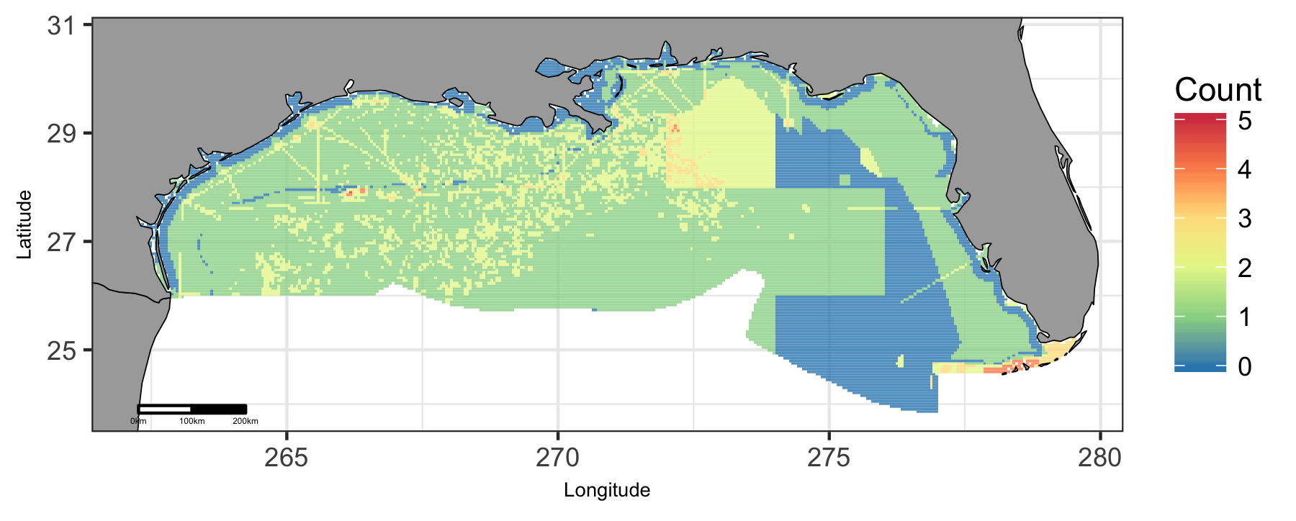

Map of cumulative ocean use in Gulf of Mexico region.

### Plot of Ocean Use by Depth (m)

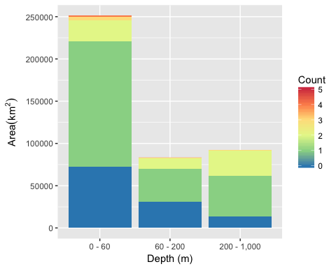

Area of Cumulative Ocean Use by Depth (m) for Gulf of Mexico region. Cumulative use are counted and summarized by Depth (m) and area.

### Table of Ocean Use by Depth (m)

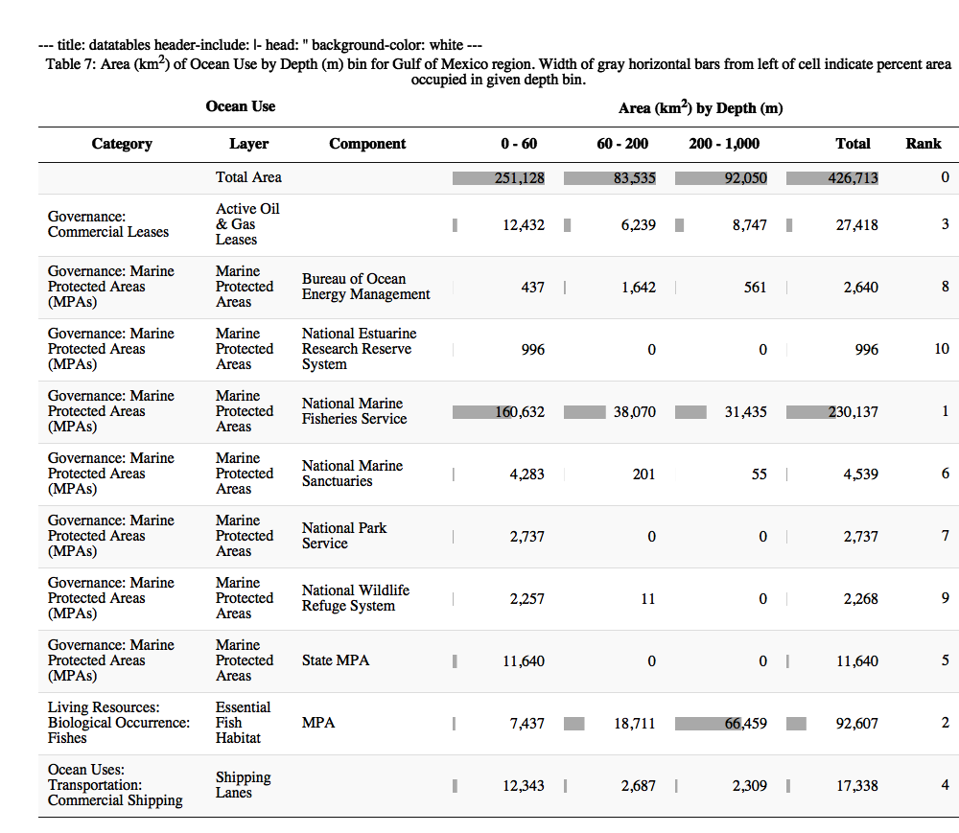

### Plot of Ocean Use by Wind (m/s @ 90m)

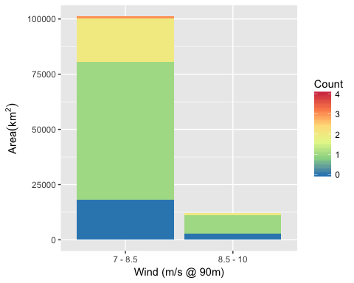

Area of Cumulative Ocean Use by Wind (m/s @ 90m) for Gulf of Mexico region. Cumulative use are counted and summarized by Wind (m/s @ 90m) and area.

### Table of Ocean Use by Wind (m/s @ 90m)

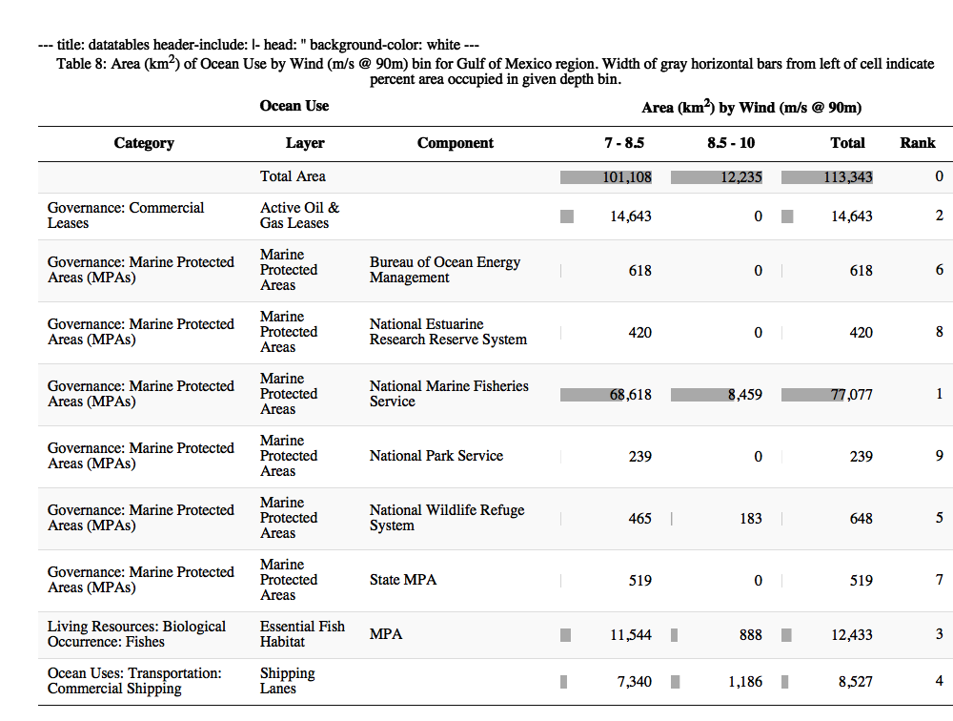

## Hawaii

### Map of Ocean Use

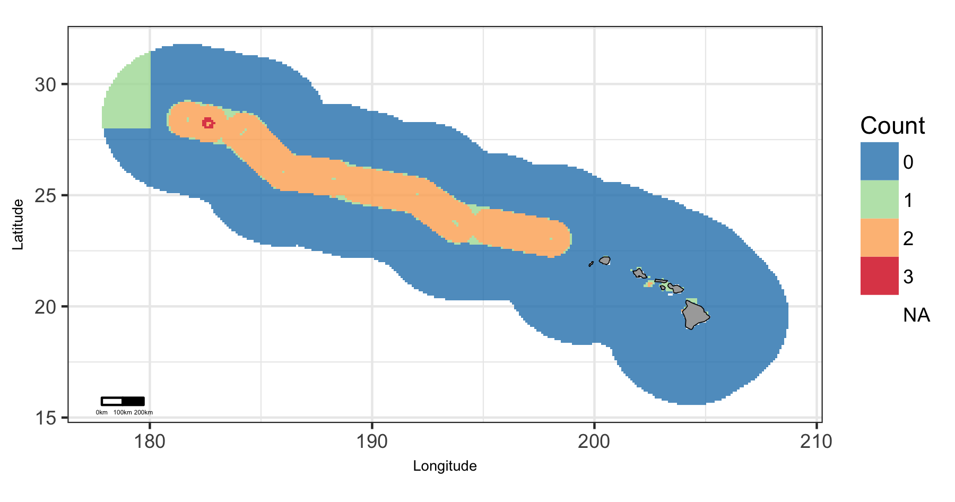

Map of cumulative ocean use in Hawaii region.

### Plot of Ocean Use by Depth (m)

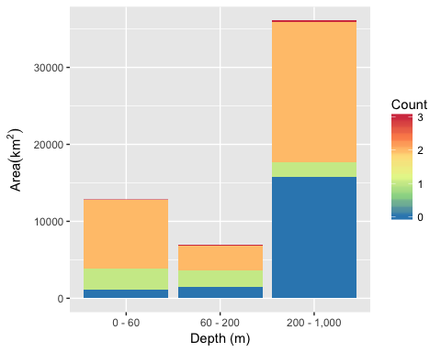

Area of Cumulative Ocean Use by Depth (m) for Hawaii region. Cumulative use are counted and summarized by Depth (m) and area.

### Table of Ocean Use by Depth (m)

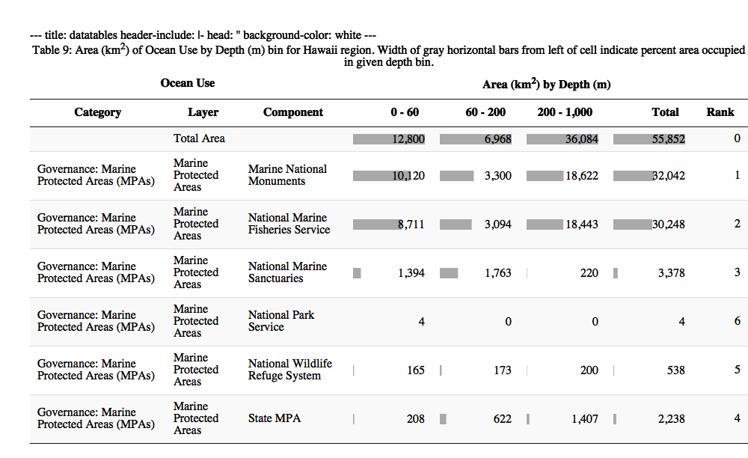

### Plot of Ocean Use by Wind (m/s @ 90m)

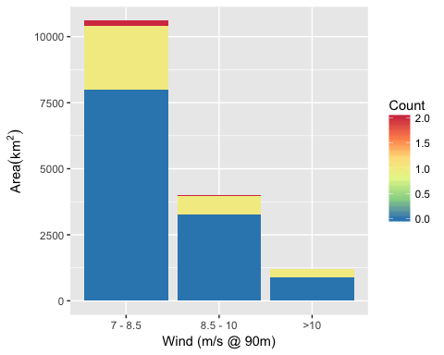

Area of Cumulative Ocean Use by Wind (m/s @ 90m) for Hawaii region. Cumulative use are counted and summarized by Wind (m/s @ 90m) and area.

### Table of Ocean Use by Wind (m/s @ 90m)

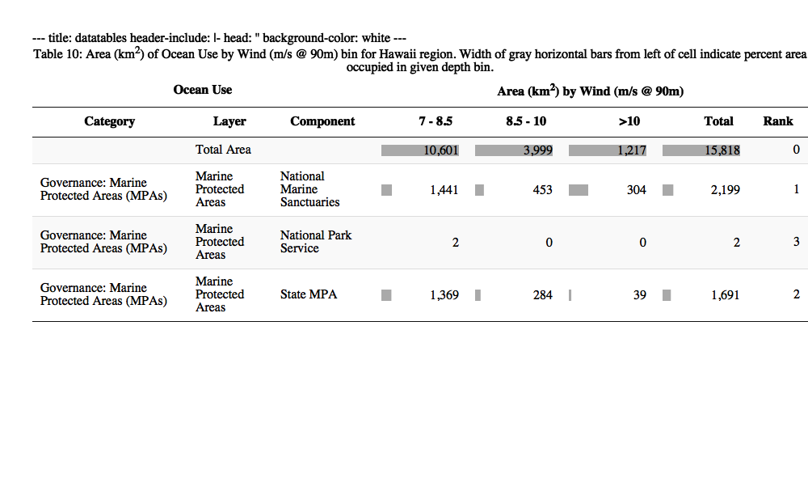

## Pacific Islands

### Map of Ocean Use

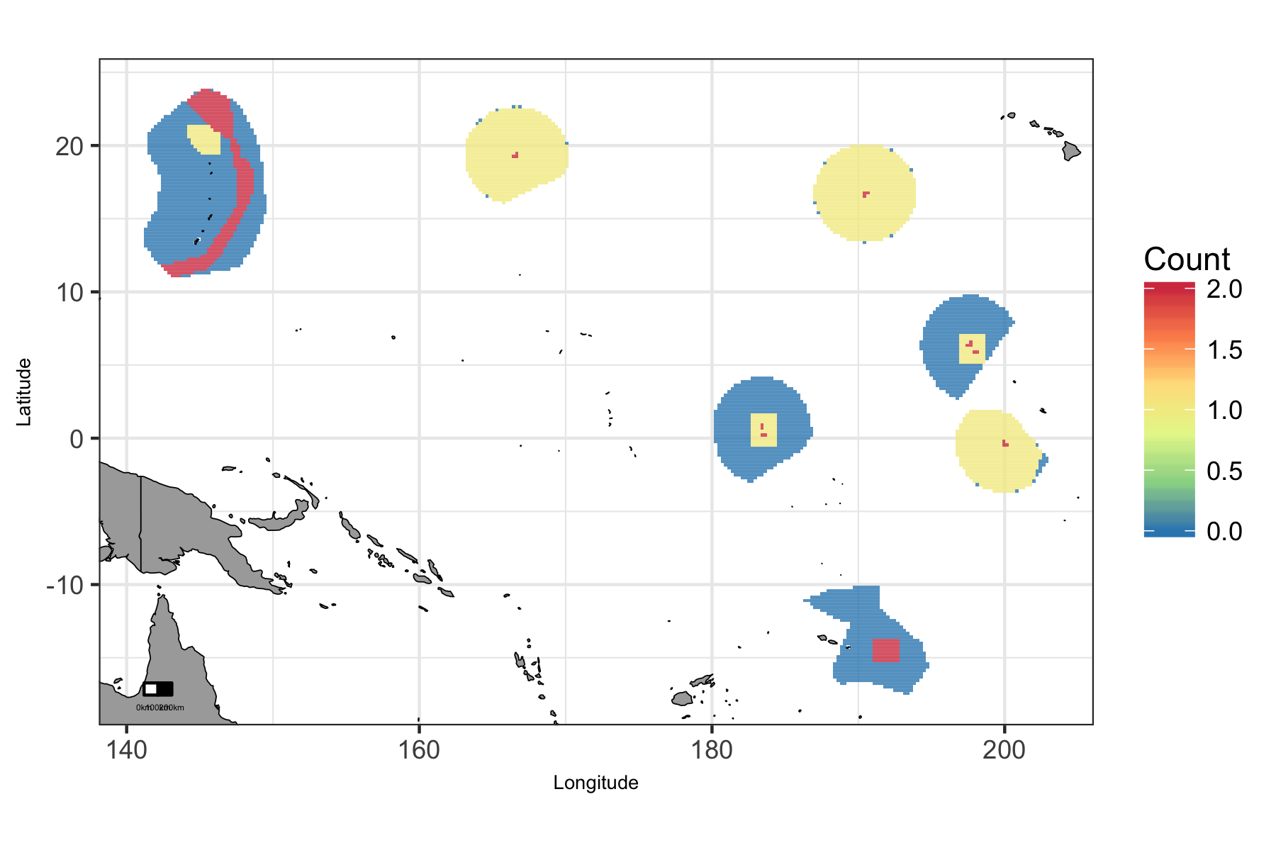

Map of cumulative ocean use in Pacific Islands region.

### Plot of Ocean Use by Depth (m)

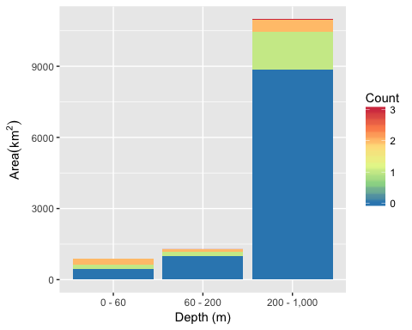

Area of Cumulative Ocean Use by Depth (m) for Pacific Islands region. Cumulative use are counted and summarized by Depth (m) and area.

### Table of Ocean Use by Depth (m)

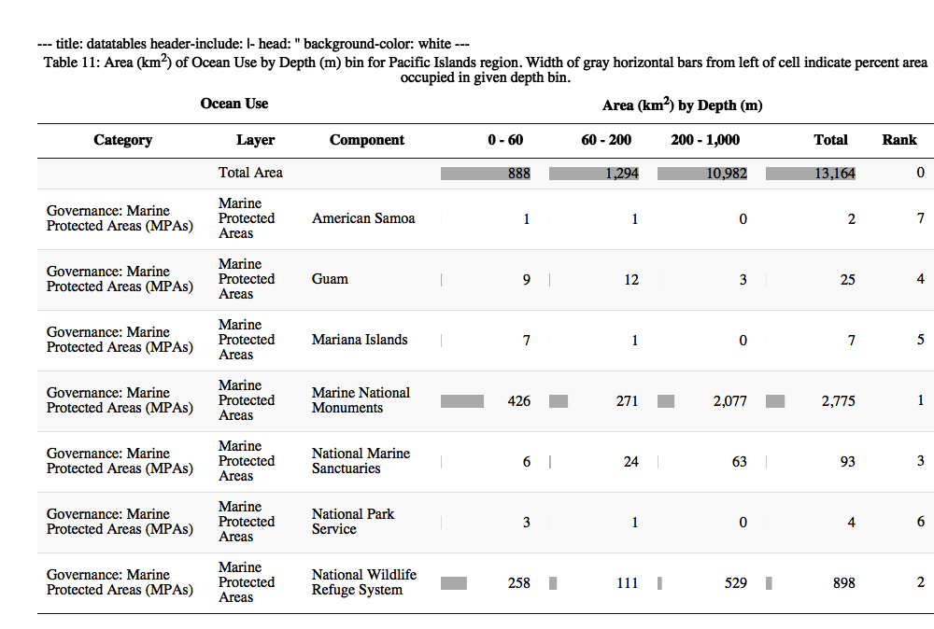

## West

### Map of Ocean Use

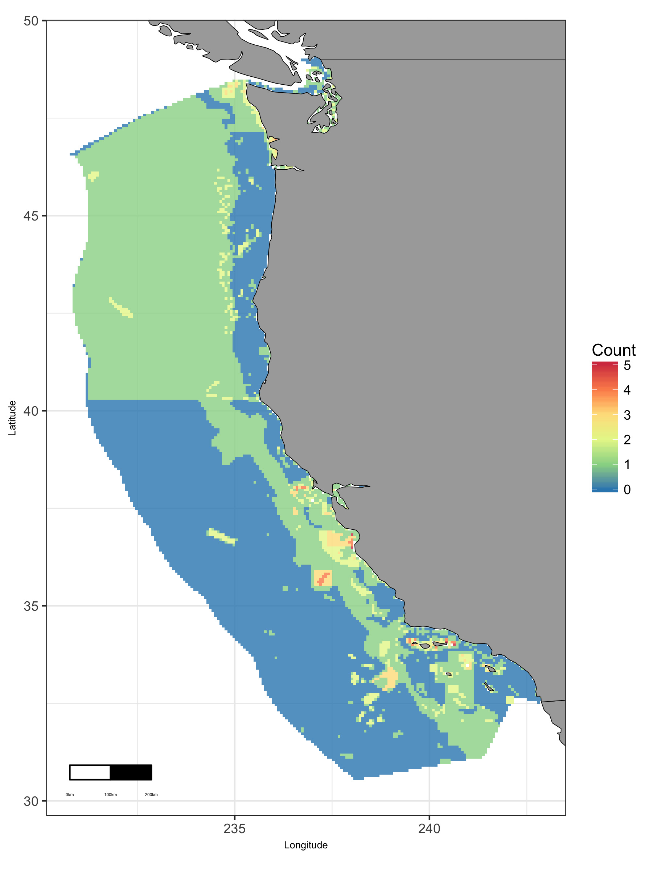

Map of cumulative ocean use in West region.

### Plot of Ocean Use by Depth (m)

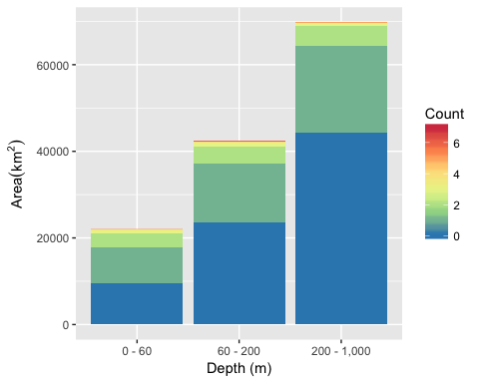

Area of Cumulative Ocean Use by Depth (m) for West region. Cumulative use are counted and summarized by Depth (m) and area.

### Table of Ocean Use by Depth (m)

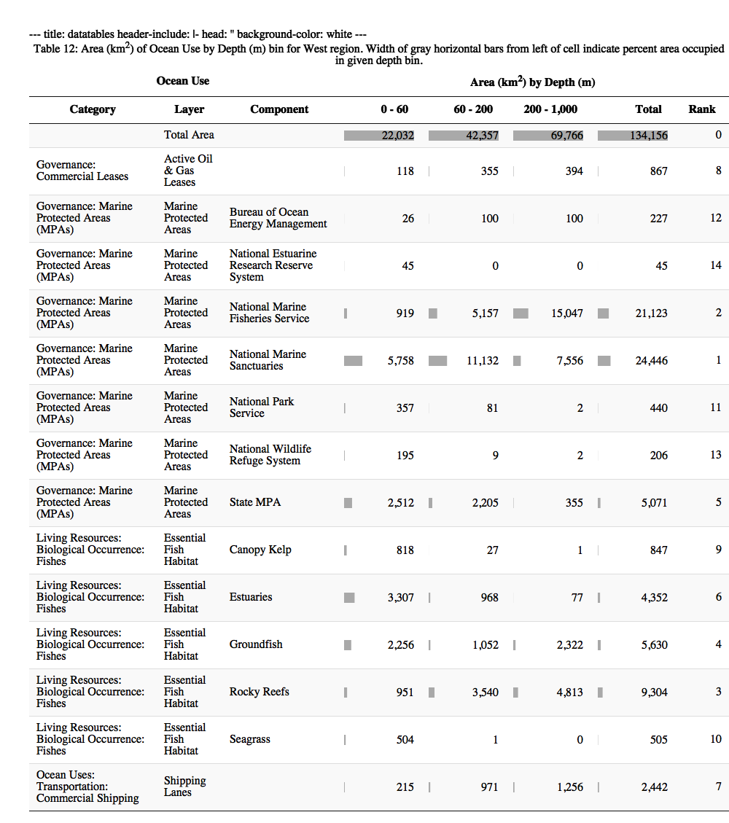

### Plot of Ocean Use by Wind (m/s @ 90m)

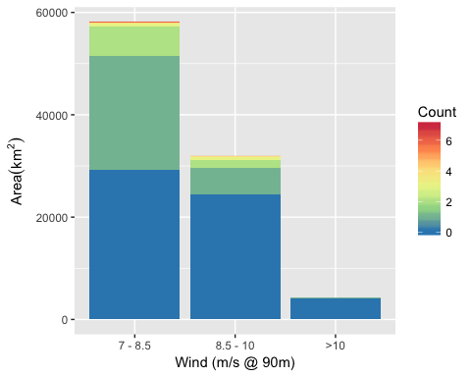

Area of Cumulative Ocean Use by Wind (m/s @ 90m) for West region. Cumulative use are counted and summarized by Wind (m/s @ 90m) and area.

### Table of Ocean Use by Wind (m/s @ 90m)

