Spatial analysis of ship strike risk for Rice’s whale in the Gulf of Mexico

Benjamin D. Best, Ph.D. ([ben@ecoquants.com](mailto:ben@ecoquants.com))

2023-06-27 19:08 (PDT)

Contents

## 1 Background

## 2 Data

## 3 Whale Density, average

Per [Areas Under Restriction | Bureau of Ocean Energy Management](https://www.boem.gov/oil-gas-energy/leasing/areas-under-restriction), for the [Gulf of Mexico Presidential Withdrawals](https://www.boem.gov/oil-gas-energy/gom-planning-withdraw-areas):

The portions of the Central Planning Area and Eastern Planning Area that are subject to the restrictions under GOMESA were further withdrawn until June 30, 2032, by Presidential Memorandum, dated September 8, 2020.

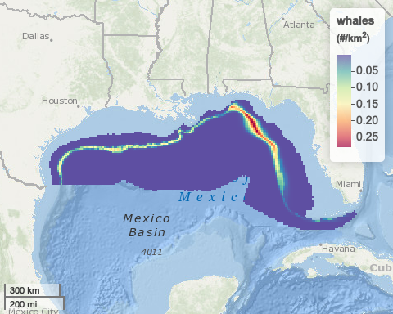

Total individuals (sum): 60.4810734

vs most recent literature from 2017-18 surveys: - Garrison et al. (2020): 51.3 (CV = 0.503) [] - without p0 correction, so expect a higher number - [Table 7] - looks reasonable

* Figures: 63 & 64, 74
* Tables: 49, 50, 51
* p. 292 Bryde’s whale area > This opinion defines the Bryde’s whale area to include the area from 100- to 400- meter isobaths from 87.5° W to 27.5° N as described in the status review (Rosel 2016) plus an additional 10 km around that area. The area designated in the status review was intended to “provide some buffer around the deeper water sightings and to include all sighting locations in the northeastern GOMx, respectively,” and was believed to be an area that the whales inhabit year round. The Bryde’s whale area for this opinion includes an outward expansion of 10 km around the area identified in the status review, for added protection of this extremely small population and accounting for ecological considerations.

## 4 Ship Traffic

### 4.1 OLD

#### Figure 56 (ships-all)

|  |
| --- |
| Figure 56. Vessel Traffic in the Gulf of Mexico. Data represent annual average kilometers (km) of vessel traffic from all vessels based on AIS data from 2014-2018 |

#### Figure 57 (ships-boem)

|  |
| --- |
| Figure 57. Oil and Gas Vessel Traffic in the Gulf of Mexico. Data represent annual average kilometers (km) of vessel traffic from oil and gas related vessels based on AIS data from 2014-2018. |

### 4.2 NEW

#### ships-all

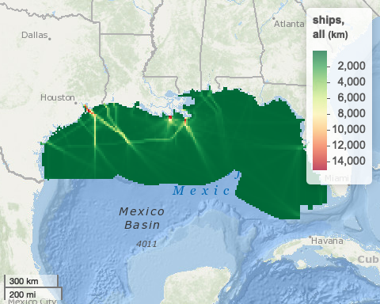

#### ships-boem

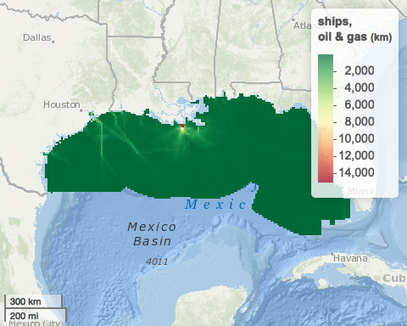

## 5 Ship Risk to Whales

### 5.1 OLD

#### Figure 63 (risk-boem-all)

|  |
| --- |
| Figure 63. Relative vessel strike risk to Bryde’s whales from oil and gas vessel traffic of all speeds. |

#### Figure 64 (risk-boem-gt10)

|  |
| --- |
| Figure 64. Relative vessel strike risk to Bryde’s whales from oil and gas vessel traffic greater than 10 knots. |

### 5.2 NEW

#### risk-boem-all

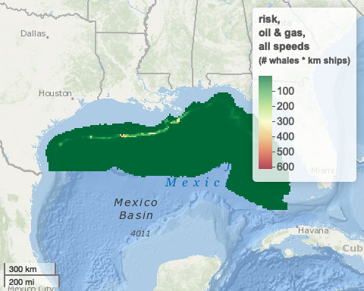

#### risk-boem-gt10

