Self-organizing dominance hierarchies generate the diversity of rank–stress profiles seen in social animals
Simon D. W. Frost
Article type: Research Article
Running title: Emergent hierarchy and rank–stress profiles
Correspondence: Simon D. W. Frost, sdwfrost@gmail.com
Author contributions: [TODO: confirm] S.D.W.F. conceived the study, specified the model and analyses, and wrote the manuscript.
Acknowledgements: [TODO]. The model code, verification suites, analyses and a first draft of this manuscript were produced with the assistance of a large language model coding agent (Claude, Anthropic) working under the author’s direction; all design decisions, analysis rules and interpretations were set or approved by the author, who takes responsibility for the content. [TODO: confirm wording against the journal’s policy on AI-assisted work.]
Conflict of interest statement: [TODO: confirm] The author declares no conflicts of interest.
Data availability statement: No empirical data were used. The simulation package, symbolic and formal verification suites, configuration files for every experiment, frozen analysis plans, run manifests and result tables will be archived at [TODO: repository and DOI].

Abstract
- Glucocorticoid differences between dominant and subordinate animals take many forms: subordinates are higher in some species, dominants in others, top-ranked individuals are sometimes exceptions, and many studies find no rank effect. Reviews invoke social and ecological moderators, but no mechanistic model lets both the hierarchy and the physiological burden emerge from the same local decisions.
- We built a bounded-rational network game in which initially identical individuals forage, contest food patches and mates, yield, escape and affiliate according to their own experience-based beliefs. Each individual carries a fast activation and a slow allostatic load, driven only by realized events: defeat, intimidation, effort, energy deficit and unpredictability. Rank is computed by the analyst and never enters any behavioural or physiological equation. Analytic properties were verified symbolically and by machine-checked proofs.
- Linear hierarchies required resource-holding feedback, in which energetic condition affects contest success, and formed reliably only in conjunction with food scarcity, low choice noise and long memory. Purely dyadic belief dynamics never produced a linear order.
- Where hierarchies formed, predeclared rules distinguished four profiles of load across rank: a graded rise towards the bottom (scarce, monopolizable food), a step (no escape, or mating competition), a peak among contenders at ranks 2–3 below a low-load alpha (rich, contestable food without scarcity) and a middle peak (a guarded breeding monopoly). Rank thirds read the contender peak as an inverted U in groups of 6 but dominant-high in groups of 10–20. Subordinate-high profiles held at group size 20.
- These outputs reproduce subordinate-high glucocorticoids under despotism and constraint, low glucocorticoids in alpha female baboons, and costs of contested positions near the top, and partly reproduce dominant-high patterns. Within declared ranges, neither a mate-guarding cost nor an input from forecast uncertainty produced high-glucocorticoid alpha males or instability effects. With fixed differences in fighting ability, rank largely followed ability, profiles persisted, and stronger or more sociable individuals carried less load than others of the same rank. The model predicts that dominant-high gradients are carried by challengers rather than alphas; identifying mechanisms requires full rank profiles and individual traits, not correlations or rank thirds.
Keywords: agent-based model, allostatic load, bounded rationality, dominance hierarchy, game theory, glucocorticoids, social rank, social stress

Introduction
Social rank is one of the most studied correlates of physiological stress in animals, yet the direction of the relationship is not consistent. In stable, despotic primate hierarchies, subordinates often have higher basal glucocorticoids (Sapolsky 2005; Abbott et al. 2003), as do subordinate female mice in complex groups (Williamson et al. 2019). In many cooperative breeders dominants are higher (Creel 2001; Creel et al. 1997), as are high-ranking male chimpanzees in some communities (Muller and Wrangham 2004; Muller et al. 2021). In Amboseli baboons, glucocorticoids rise with declining rank among males ranked two to eight, but the alpha male is an exception, with values like those of low-ranking males (Gesquiere et al. 2011, 2025). Elsewhere, rank and glucocorticoids are unrelated (Stavisky et al. 2001; Preis et al. 2019; Edwards et al. 2020; Van der Weyde et al. 2016). Comparative analyses converge on a conditional explanation: the individual with the greater relative allostatic burden has the higher glucocorticoids, whichever rank that is (Goymann and Wingfield 2004). Subordinates pay more where hierarchies are despotic, food is monopolizable, harassment is frequent and escape or support is lacking. Dominants pay more where status must be actively defended or reproduction monopolized (Sapolsky 2005; Abbott et al. 2003; Creel 2001).
This explanation is verbal. It names moderators (resource distribution, escape, support, stability, reproductive skew) without showing how a given combination produces a given rank profile. Existing models address the two halves of the problem separately. Winner–loser and self-reinforcement models explain how hierarchies emerge from repeated contests (Dugatkin 1997; Hemelrijk 1999; Chase et al. 2002; van Haeringen and Hemelrijk 2022), and reinforcement-learning models explain how dominance behaviour evolves (Leimar 2021). Reproductive-skew games assign different costs to dominants and subordinates (Rubenstein and Shen 2009; Rubenstein 2007), and network approaches separate status from status certainty (Vandeleest et al. 2016). None of these lets the hierarchy and the physiological burden of each position emerge together from the same decisions. As a result, none can ask which rank–stress profiles a self-organizing hierarchy can generate at all, and which field patterns would need additional mechanisms.
Answering that question imposes two constraints. First, rank must be an output, not an input: if load depends on rank, any rank–load pattern can be produced by assumption. Second, the physiological variable must integrate the events an individual actually experiences, with the same contest never counted twice. Allostatic load (McEwen and Wingfield 2003) provides such a variable. We treat it as a dimensionless burden, not as a glucocorticoid concentration, because hormone levels can rise, fall or stay unchanged under chronic challenge (Dickens and Romero 2013; MacDougall-Shackleton et al. 2019).
We built a model under these constraints and used it to ask three questions. When does a linear dominance hierarchy emerge from local, experience-based decisions? Where it does, what shapes does the profile of load across rank take: monotone increasing or decreasing, U-shaped, inverted U, flat, or with an exceptional alpha? And which of the patterns reported in wild and captive animals can the model reproduce, under which conditions, and which can it not?

Materials and methods
Here we follow the overview elements of the ODD protocol (Grimm et al. 2020); the full description, with every parameter, is in Appendix S1. Figure 1 summarizes the model.
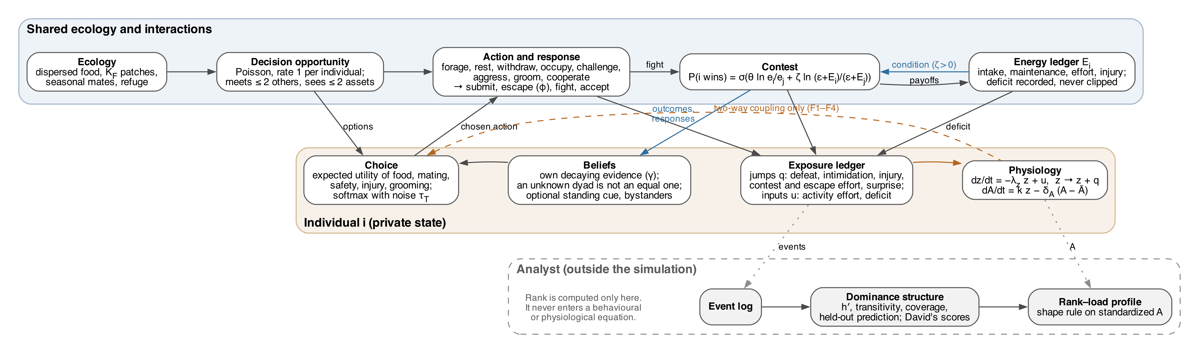
Figure 1: Model structure. Individuals choose actions from their own beliefs and expected utilities (orange box). Interactions, contests and the energy ledger are shared (blue box). Realized events and energy deficit drive activation $z$ and load $A$ through an exposure ledger. Blue arrows: the two feedbacks through which order can emerge, learning from outcomes and condition-dependent contest success ($ζ>0$). Dashed arrow: load affects choices only in the two-way coupling experiments. Rank is computed only by the analyst (grey box) and never enters a behavioural or physiological equation.

Model overview
Individuals and state. A group of $N$ individuals (6–20) starts exchangeable. No rank is assigned and no physiological parameter is linked to status. Each individual $i$ has an energy reserve $E_{i}∈[0,1]$, a fast activation $z_{i}≥0$, a slow load $A_{i}≥0$, a received-support trace, a mode (forage, rest, withdrawn, holding a food patch, consorting) and private beliefs. Time is continuous; each individual receives decision opportunities as a Poisson process of rate 1, so total activity scales with $N$ rather than $N^{2}$.
Ecology and energy. Dispersed food is available to every forager at rate $g_{s}$. A fixed number $K_{F}$ of food patches yield $ρ_{c}g_{s}$ to a single holder. Optional mating seasons add $K_{M}$ consortship assets. Every mode has a basal cost; scarcity is set by the ratio of maintenance cost to dispersed intake ($m/g_{s}$). A conserved energy ledger records intake, maintenance, effort, injury, surplus and deficit. Unpaid maintenance is recorded as a deficit, never silently clipped, and the ledger identity is checked after every event.
Actions. At an opportunity, an individual meets up to two others and sees up to two assets. It may forage, rest, withdraw to a refuge, keep or occupy an asset, challenge a holder, aggress without a stake, or propose grooming or cooperation, choosing low or high effort for contests. A challenged or aggressed individual submits, attempts escape (succeeding with probability $ϕ$) or fights. Positive interactions need the partner’s acceptance. Fights are decided by a Tullock contest success function (Skaperdas 1996),
$$P_{ij}=σ​\left(θln\frac{e_{i}}{e_{j}}+ζln\frac{ε_{c}+E_{i}}{ε_{c}+E_{j}}\right),$$
where $e$ is effort and $ζ$ sets how strongly energetic condition affects outcomes. With $ζ>0$, winning patches raises $E$ and so later win probability: a resource-holding feedback that is earned ecologically, but is a per-individual scalar and is reported as such.
Beliefs. Individuals hold only their own decaying evidence (rate $γ$): wins, losses, yields given and received, partners’ responses and efforts, acceptance of proposals, and the rate at which their holdings are challenged. Win forecasts are Beta posterior means for each partner; a dyad with no evidence is unknown, not equal. Two optional, separately ablated mechanisms couple beliefs across dyads. A standing cue sets the prior for every partner from the individual’s own share of fights won and yields received over all partners; its influence fades as dyadic evidence accumulates. Bystander learning adds discounted pseudo-counts from observed fights. Individuals never observe others’ energy, activation, load or rank.
Decisions. Each option is valued by its expected utility of food (weighted by a concave, state-dependent value of energy), mating, injury, received safety events (attacks that end badly for the recipient, valued at $s_{S}$) and grooming, over a horizon $H$ discounted by the learned hazard of losing a holding. There is no rank term and no load term. The primary policy (P2) chooses by softmax over options with temperature $τ_{T}$ relative to a reference utility. Responses use the same rule. A long-horizon variant (P3-T) and a policy that adds a learned linear critic of the individual’s own state (temporal-difference learning, no actor update; Sutton and Barto (2018)) were also run.
Physiology. Activation and load follow
$${\dot{z}}_{i}=−λ_{z}z_{i}+u_{i}(t), {\dot{A}}_{i}=k z_{i}−δ_{A}(A_{i}−\overset{‾}{A}),$$
with instantaneous jumps $z_{i}→z_{i}+q$ at events. Inputs come from an auditable exposure ledger, and each contest enters exactly once:
- jumps: defeat ($q_{D}$), intimidation on yielding ($q_{S}$), injury ($q_{I}$), contest effort for both fighters ($q_{E}e$, the cost-of-dominance pathway), escape effort ($q_{esc}$), and the surprise of negative outcomes relative to the individual’s own forecast;
- continuous inputs: activity effort and energy deficit.
Support can either buffer threat inputs or speed recovery; the two are tested separately and never subtract load directly. With $λ_{z}=1≫δ_{A}=0.01$, load integrates activation over about 100 decision intervals. Physiology does not feed back into behaviour (one-way coupling) except in the two-way coupling experiments below.
Extensions (Appendices S5, S6). Three optional mechanisms were tested separately.
- Individual traits. Each individual draws a fixed fighting ability $g_{i}$, which adds $g_{i}−g_{j}$ to the logit of $P_{ij}$, and an affiliative motivation that scales its own value of received grooming. The traits have standard deviations $σ_{F}$ and $σ_{S}$ and correlation $r$. No individual observes any trait, its own fighting ability included. Traits vary between individuals but are not inherited.
- Rival-proximity vigilance. An individual guarding a mate receives a threat jump $q_{V}$ whenever an eligible rival encounters it.
- Rank insecurity. A continuous threat input $β_{I} U_{i}$, where $U_{i}$ is the mean of $4{\hat{p}}_{ij}(1−{\hat{p}}_{ij})$ over the individual’s own win forecasts.
Neither new input enters decisions.
Implementation and verification (Appendix S2). The model is a discrete-event simulation in Julia (Bezanson et al. 2017), with one independent random stream for each purpose, so results do not depend on parallel execution order. Between events, physiology is advanced by its closed-form flow map. Verification ran on three levels:
- Symbolic: fixed points, single-pulse responses, the timing-independence of mean load under repeated jumps, and the decision formulas were derived in SymPy (Meurer et al. 2017). The Julia decision code is generated from these derivations and checked against them.
- Formal: nonnegativity of $z$ and $A$ without clipping, the closed-form solution and its uniqueness, energy conservation, bounds on forecasts, properties of the contest function, the bounds of an optional reserve variable and of the insecurity input, and the strong stochastic transitivity of contests decided by fixed abilities were proved in Lean 4 with Mathlib (The mathlib Community 2020).
- Numerical: the simulator passes 15,090 automated tests, including comparison with an independent ODE solver.
Table 1: Main parameters, in dimensionless units (time unit: one individual’s mean interval between decision opportunities). Base point A is the setting where hierarchies formed most reliably at $N=10$; bases B and C are alternative ordered settings at $N=6$, both with long memory and bystander weight $ω_{obs}=1$ (B: no scarcity, $m/g_{s}=0.8$, cue off; C: low noise, $τ_{T}=0.03$). Base A differs from the code defaults in $ζ$, $m$, the cue and $ω_{obs}$; all parameters, defaults and ranges are in Table S1.
Symbol | Meaning | Base point A (range explored)
$N$ | group size | 10 (6 at bases B, C)
$g_{s}$, $m$ | dispersed intake, maintenance | 0.025; $m/g_{s}=1.2$ (0.8–1.2)
$K_{F}$, $ρ_{c}$ | food patches, patch richness | 3, 4
$θ$, $ζ$ | contest decisiveness, condition dependence | 1 (0.5–3), 2 (0–3)
$e_{L}$, $e_{H}$, $c_{e}$ | efforts, energetic cost per unit effort | 0.25, 1, 0.02
$ϕ$, $ϕ_{W}$ | escape success, refuge protection | 0.5, 0.9
$γ$ | belief decay | 0.01 (0.001 at B, C)
$τ_{T}$, $H$ | choice noise, planning horizon | 0.1, 10
$s_{S}$ | subjective cost of a received safety event | 0.02
standing cue, $ω_{obs}$ | belief coupling | on, 0.3
$λ_{z}$, $δ_{A}$, $k$ | activation decay, load recovery, gain | 1, 0.01, 0.01
$q_{D},q_{S},q_{I},q_{E},q_{esc}$ | jump sizes | 1, 0.5, 2, 0.5, 0.2

Analysis
All analysis is done outside the simulation, from the event log, under frozen analysis plans written before the sweeps they govern.
Windows and structure. Each run lasts 3,000 time units. After a burn-in of 1,000, four windows of 500 are analysed, and each of the first three is classified using the next for persistence and prediction. Dominance evidence pools fight outcomes with submissions and escapes. A window is Linear when all four of the following hold:
- Landau’s $h^{′}≥0.8$ (de Vries 1995);
- triangle transitivity exceeds an orientation null at $p<0.05$ (Shizuka and McDonald 2012);
- at least 80% of dyads are observed;
- a linear (Bradley–Terry) order predicts the next window’s outcomes as well as dyad-specific history does.
Ranks for all later analyses are David’s scores (David 1987).
Near-linear windows are transitive, consistent and persistent with $h^{′}≥0.6$. Other classes are nontransitive, egalitarian, unstable and degenerate. The group, not the individual, is the unit of replication: each parameter point has 20–40 independent groups.
Rank–load profile shapes. For each group we take its first Linear or near-linear window. In that window we standardize window-mean excess load ($A−\overset{‾}{A}$) across the group’s members and order individuals by David’s score (position 1 = top). The positions are split into top, middle and bottom thirds, with means $T$, $M$ and $B$. Three contrasts are bootstrapped over groups (2,000 resamples, 95% intervals): $Δ_{1}=M−T$, $Δ_{2}=B−M$ and $Δ_{BT}=B−T$.
- Signs: a contrast is flat if its interval lies within $±0.5$ standard deviations, and up or down if its interval excludes zero.
- Shapes:
  - monotone subordinate-high (both contrasts up or flat, at least one up);
  - monotone dominant-high (the reverse);
  - U-shaped (down, then up);
  - inverted U (up, then down);
  - flat (all three contrasts flat).
- Alpha modifier: an alpha peak or alpha trough is recorded when the alpha contrast $α_{c}=ℓ_{(1)}−(ℓ_{(2)}+ℓ_{(3)})/2$ has an interval entirely above $0.5$ or below $−0.5$.
This rule was declared, and amended once (to make “flat” attainable at the planned replication), before any run that it classifies. Mean activation $z$ was classified in the same way as an acute analogue.
Because thirds contain different ranks at different group sizes, we also report a contender contrast, $κ=(ℓ_{(2)}+ℓ_{(3)})/2−mean(ℓ_{(5)},…,ℓ_{(N)})$, which compares ranks 2–3 with ranks 5 and below on the same profile. It was defined after an exploratory scan at $N=20$ and tested on new seeds (Appendix S4).

Experiments
Earlier experiments (more than 12,000 runs over factorial designs of condition dependence, belief coupling, noise, memory, scarcity and group size) mapped where hierarchies emerge and how the top-versus-bottom load gap divides among input channels. We assessed global sensitivity with Morris screening and Sobol indices (Morris 1991; Saltelli et al. 2010). We re-tested headline claims at four base points, and tested two-way coupling one mechanism at a time: load-dependent effort capacity, load-slowed recovery, and a depletable functional reserve.
For profile shapes we ran two sets of simulations.
- Shape scan: a re-run of the robustness designs at bases A, B and C (111 parameter points × 20 groups). Each design varies the number of food patches and escape, patch richness and contest cost, channel ablations, support, and coupling. The re-run reproduced every previously recorded output bit for bit, confirming that the added profile records did not alter the simulations.
- Wildlife scenarios: 17 scenarios (40 groups each), each translating a social–ecological condition reported in the field into model settings, with predictions fixed in advance (Table 2).
- Confirmation run: one exploratory finding was re-tested on independent seeds.
- Group size: the scenarios were repeated at $N=20$ (40 groups each, windows three times longer), with matched $N=10$ controls, under predictions fixed in advance. A second confirmation run tested the contender contrast on new seeds (Appendix S4).
- Individual differences: fighting-ability spread in five scenarios, and affiliative motivation alone and with fighting ability (1,480 runs; Appendix S5).
- Candidate mechanisms for the patterns not reproduced: a high-stakes mating monopoly, rival-proximity vigilance and rank insecurity (1,440 runs; Appendix S6).
Designs and predictions for the last two were declared before the runs. With the extensions switched off, every earlier output was reproduced bit for bit. Every explanation we offer for a pattern was tested afterwards, together with its corollaries, in exploratory runs (Appendix S7).

Results

Linear hierarchies emerge only through conjunctions of conditions
Under the primary policy, linear hierarchies were rare at default settings. Across 576 parameter points at $N=6$ and 10 (11,680 runs), 28 points produced Linear structure in at least half of their groups, and every one had $ζ=2$ (Figure 2). Purely dyadic belief dynamics ($ζ=0$, no standing cue, no bystander learning) produced at most 2 of 20 Linear groups at any point. Instead they produced stable, asymmetric dyads that did not compose into a transitive order.
The standing cue and bystander learning raised the rate only in combination with condition dependence. The best $N=10$ setting (base A: scarcity, low noise, cue and bystanders) was Linear in 18 of 20 groups.
Global sensitivity analysis showed that structure was interaction-dominated, with first-order Sobol indices near zero and total indices of 0.26–0.71. Belief decay, the safety value, escape, scarcity, contest cost, patch number, choice noise and patch richness all mattered jointly.
High escape success ($ϕ≥0.8$) abolished order rather than gradually weakening the load gradient. Closed groups of 20 did not order at base A. Fast fission–fusion into short-lived subgroups restored Linear hierarchies at $N=20$ (13–17 of 20 groups).
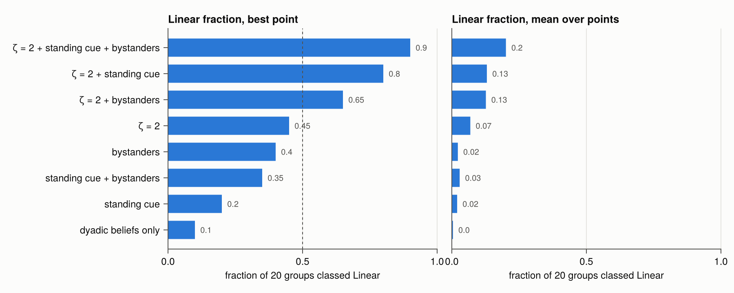
Figure 2: Which mechanisms make a linear hierarchy reachable under the primary policy at $N=6$ and 10. Bars give the fraction of 20 groups classified Linear at the best parameter point (left) and the mean over points (right) for each combination of condition-dependent contests ($ζ=2$), the standing cue and bystander learning. Dashed line: half of groups.

Load gradients follow exposure channels and ecology
Where hierarchies formed under scarcity, load was usually higher in subordinates: 103 of 119 classifiable points in the base-A maps (Figure 3). Channel attribution decomposes the top-versus-bottom gap exactly into input channels, and ablating a channel shifts the gap by its share. The gap was carried by energy deficit and defeat. Subordinates held patches far less: in scenario W0, patch-holding time fell from 46% in the top third to 4% in the bottom third, while deficit input rose from 0 to 0.095 per unit time. Within groups, individuals with more patch time had less deficit (median $ρ=−0.86$; Appendix S7). With many patches, intimidation carried it. At a single rich patch, contest effort paid by dominants nearly offset subordinates’ deficit.
Without scarcity (base B) the gradient was dominant-high ($r_{s}=−0.16$), with dominants receiving more contest-effort and defeat input than subordinates. Support by threat buffering reduced the defeat share (from −0.07 to −0.03 at base A), whereas recovery facilitation shrank the whole gap.
Two-way coupling mechanisms had distinct signatures:
- Load-slowed recovery amplified gaps 4- to 11-fold without changing behaviour.
- Load-limited effort capacity and a depletable reserve were stabilizing, and gaps shrank.
  - Loaded individuals escalated less: the high-effort share of their fights fell by 0.17–0.20, against 0.06–0.09 for the least-loaded third.
  - Yielding rose at every load level, not only among loaded individuals (Appendix S7).
  - Strong reserve depletion reduced Linear groups from 19 to 3 of 20.
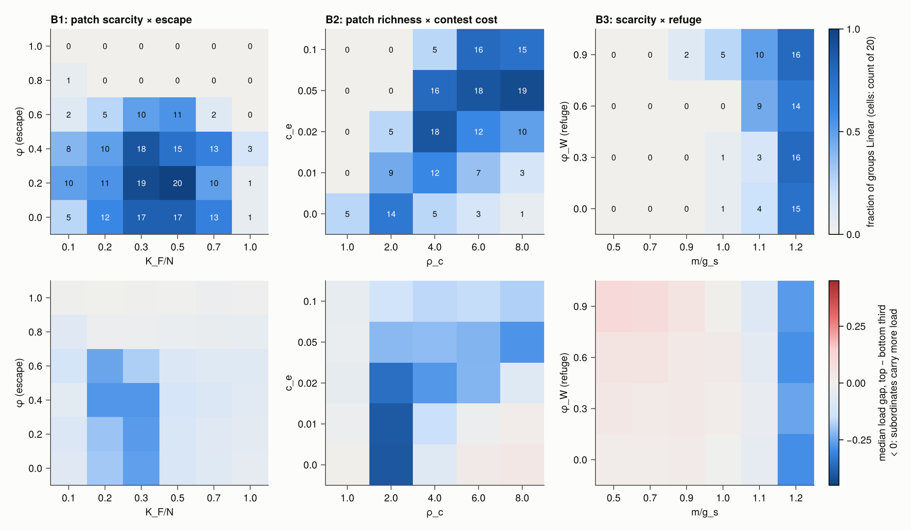
Figure 3: Regime atlas at base point A ($N=10$). Top: fraction of groups classified Linear; bottom: median load gap between the top and bottom thirds by David’s score (blue: subordinates carry more load) across three ecological maps.

Four profiles of load across rank
The shape rule resolved profiles that a correlation coefficient conflates (Figure 4; Table 2).
- Graded subordinate-high profile. Across the base-A scan, 25 of 28 evaluable points showed it, with load rising steadily from top to bottom (scenario W0: $Δ_{BT}=2.01$, 95% interval 1.96–2.06).
- Step. Removing escape (W1) or adding a year-round mating monopoly (W5a) produced one: the top three individuals were low and everyone below was about equally high. In W5a and W7 it came with an alpha trough (W5a: $α_{c}=−0.92$, −1.07 to −0.78).
- Contender peak below a low-load alpha. Ranks 2–3 carried the most load, the alpha little, and everyone below was near the group mean. It appeared without scarcity where several rich patches could be contested. It was common at base B: $κ>0.9$ at all 19 scan points with three patches of richness $ρ_{c}≥4$ (W3b: $κ=1.53$, 1.36–1.69). It also appeared with ample food at base A (W3a: 1.30, 0.95–1.63) and with tolerant contests (W9b: 0.89, 0.37–1.36), although few groups were ordered in those two conditions (7–9 of 40).
- Middle peak. Ample food combined with a guarded breeding monopoly (W4) produced it, with the highest loads at ranks 3–6 ($Δ_{1}=1.02$; $Δ_{2}=−0.52$; $κ=−0.29$). It needed a closed group: with fast fission–fusion the same settings gave a subordinate-high profile with an alpha trough.
The contender peak is one profile that the thirds rule labels differently by group size. At $N=6$, rank 3 lies in the middle third, so the rule reads an inverted U (W3b: $Δ_{1}=0.47$, 0.27 to 0.65; $Δ_{2}=−0.99$, −1.18 to −0.82). At $N=10$ and 20, ranks 2–3 share the top third with the alpha, so it reads dominant-high, the label given to W9b. The frozen correlation-based classes fared worse: of the 24 inverted-U points, 9 had been classed dominant-high, 6 subordinate-high, 7 indeterminate and 2 weak/null. Shapes based on acute activation $z$ agreed with those based on load at 80 of 84 points.
Three shapes did not appear as distinct profiles.
- Flat: no evaluable point at $N=6$ or 10 was flat. The one flat classification, at $N=20$, had a strong contender peak that the thirds averaged away ($κ=1.45$).
- U: one point only.
- Alpha peak: one exploratory scan point (base B, a single rich patch with easy escape) had the alpha carrying the most load ($α_{c}=1.37$, 0.55–2.09; 9 groups). On independent seeds with 40 groups the direction replicated, but the interval (1.17, 0.44–1.80) fell below the declared threshold, so the alpha-exception was not confirmed. A long-horizon planner holding a single rich patch (W5b) placed the alpha above ranks 2–3 ($α_{c}=0.58$, 0.34–0.79) but still below the bottom half of the group.
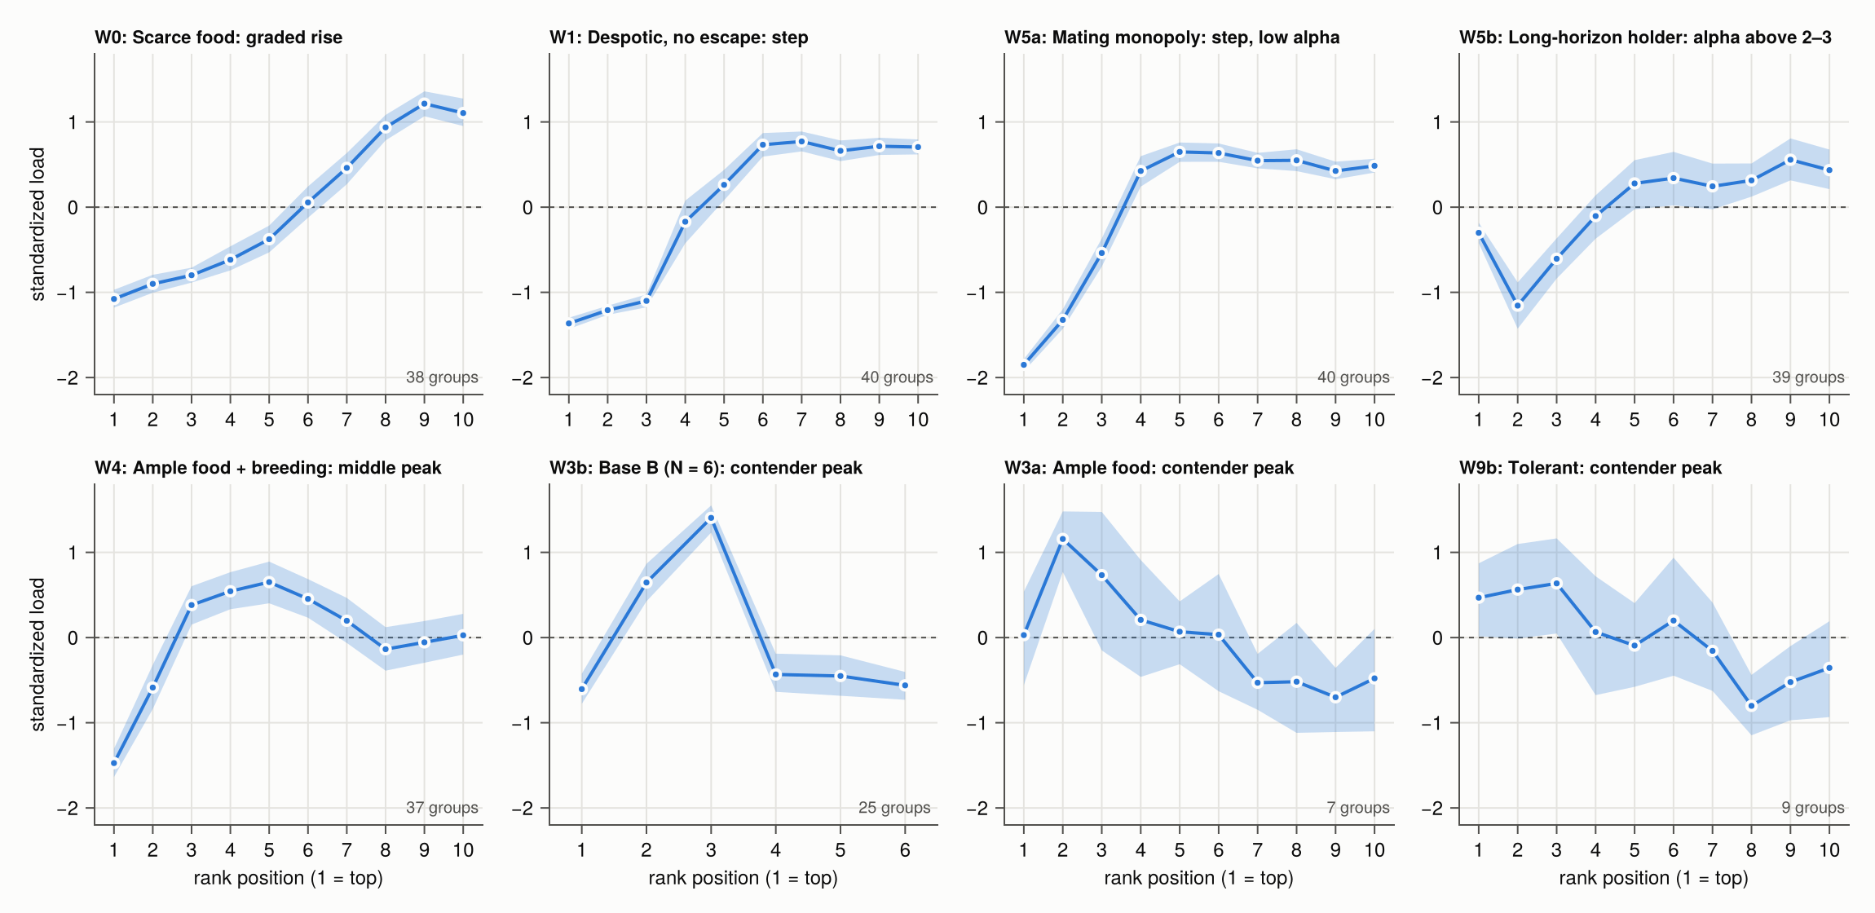
Figure 4: Mean standardized load by rank position in eight wildlife scenarios (first ordered window of each group; band: 95% bootstrap interval over groups). Scenario codes as in Table 2.

Profiles at larger group size
Closed groups of 20 did not order at base A (0 of 40 groups), so we tested the scenarios at $N=20$ under fast fission–fusion, comparing each with an $N=10$ fission–fusion control (Appendix S4, Table S4). Every prediction that could be tested held:
- Graded rise: with and without escape, the subordinate-high profile was unchanged at $N=20$ (40 and 39 of 40 groups ordered; $Δ_{BT}=1.97$ and 1.81, against 2.05 and 2.07 at $N=10$; Figure 5, right).
- Mating monopoly: it again gave subordinate-high load with an alpha trough.
- Base C: it kept its subordinate-high profile with an alpha trough, though only 6 of 40 groups ordered.
Base B did not order at $N=20$, so the inverted U could not be tested there directly. At the nearest settings that did order, base B or C with lower choice noise ($τ_{T}=0.03$) and no scarcity, the profile was a contender peak at ranks 2–3 (Figure 5, left). This was confirmed on new seeds, with 31 and 39 of 40 groups ordered: $κ=1.23$ (0.84–1.62) and 1.45 (1.06–1.79), and $α_{c}=−1.53$ and $−2.13$. The peak therefore stays at the same absolute ranks as groups grow, rather than at the same relative position. The middle peak and the tolerant-contest profile could not be tested at $N=20$, because too few groups ordered.
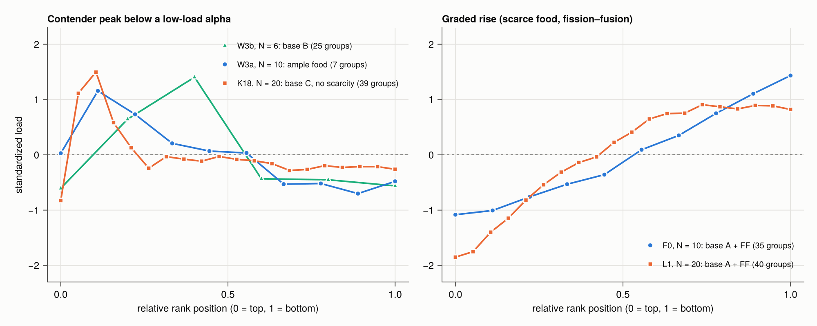
Figure 5: Mean standardized load by relative rank position at $N=6$, 10 and 20. Left: the contender peak sits at ranks 2–3 at every group size (W3b, $N=6$; W3a, $N=10$; base C without scarcity, $N=20$), so on a relative scale it moves towards the top as $N$ grows. Right: the graded subordinate-high profile under fast fission–fusion is the same at $N=10$ and 20. Legends give the number of ordered groups.

Scenario tests against field patterns
Most predictions fixed before the runs held (Table 2):
- Despotic, constrained groups (W0–W2) were subordinate-high without an alpha peak, and support shrank the load gap in 40 of 40 paired groups.
- A mating monopoly with food competition (W5a) was subordinate-high with a low-load alpha.
- Fission–fusion (W8a, W8b) kept subordinate-high profiles.
- Seasonal mating raised mean load in season in 40 of 40 groups.
- Acute activation and load agreed in shape.
Five predictions failed:
- Removing the alpha did not raise load across the hierarchy. Mean load in the following window was lower than in matched unmanipulated groups in 28 of 40 pairs, and fights did not increase.
- Seasonal mating did not enlarge the load gap. Instead the profile changed from a graded rise out of season to a step with a low alpha in season, without reversing.
- Ample food (W3a) was indeterminate rather than dominant-high, with few ordered groups.
- The long-horizon planner showed no alpha peak in acute activation.
- Full tolerance ordered 9 of 40 groups rather than fewer than 5, the same rate as earlier runs.
Table 2: Wildlife scenarios: field conditions, model settings and the shape of the load profile across rank (load: window-mean $A−\overset{‾}{A}$; 40 groups per scenario, base A unless stated).
Code | Field condition (examples) | Model setting | Ordered /40 | Shape of load profile
W0 | reference: scarce, clumped food | base A | 38 | subordinate-high, graded
W1 | despotic, no escape (Sapolsky 2005; Abbott et al. 2003) | $ϕ=0$, $ϕ_{W}=0.1$ | 40 | subordinate-high, step
W2 | as W1 with support (Abbott et al. 2003) | buffering and recovery 0.8 | 40 | subordinate-high, step; gap smaller (40/40)
W3a | ample food, contested holding (Creel et al. 1997; Mech 1999) | $m/g_{s}=0.9$ | 7 | indeterminate by thirds; contender peak
W3b | ample food (alternative base) | base B, $N=6$ | 25 | contender peak (inverted U by thirds), alpha trough
W4 | breeding monopoly, ample food (Creel 2001) | W3a + one guarded consortship | 37 | inverted U (middle peak), alpha trough
W5a | alpha mating monopoly with food competition (Gesquiere et al. 2011; Milich et al. 2018) | one guarded consortship | 40 | subordinate-high, step, alpha trough
W5b | long-horizon holder of a single rich asset | P3-T, one rich patch | 39 | subordinate-high; alpha above ranks 2–3
W5c | W5b with a mating asset | W5b + consortship | 37 | subordinate-high, alpha trough
W6a | alpha removal (Sapolsky 1992; Bergman et al. 2005) | top individual removed at $t=1500$ | 39 | subordinate-high before and after; no load rise
W6b | ongoing turnover | replacement rate 0.01 | 36 | subordinate-high
W7 | seasonal mating (Kotrschal et al. 1998; Milich et al. 2018) | one consortship, half-year season | 40 | step with alpha trough in season; graded out of season
W8a | fission–fusion, slow mixing (Goymann et al. 2003; Davidian et al. 2021) | 2 subgroups, slow | 38 | subordinate-high
W8b | fission–fusion, fast mixing | 4 subgroups, fast | 36 | subordinate-high
W9a | opposing costs at a single rich patch | one rich patch, no escape | 34 | subordinate-high, weaker ($Δ_{BT}=0.92$)
W9b | tolerant hierarchy (Stavisky et al. 2001) | costless patch sharing ($σ_{c}=1$) | 9 | dominant-high by thirds; contender peak
W9c | settled conventions, few fights (Levy et al. 2020) | base C, $N=6$ | 27 | subordinate-high, step, alpha trough

Individual differences in fighting ability and sociability
Sorting versus self-organization. Fixed differences in fighting ability could order groups by themselves. - Without condition feedback ($ζ=0$), identical individuals never ordered (0 of 40 groups). With an ability spread of $σ_{F}=2$, every group ordered, and rank almost matched ability (Spearman $ρ_{F}=0.96$, 0.95–0.97). Such an order is transitive by construction. - With condition feedback (scenario W0), even a small spread ($σ_{F}=0.25$, a quarter of the effect of high versus low effort) gave $ρ_{F}=0.69$ (0.64–0.74). - Where groups ordered both with and without feedback, rank followed ability slightly less closely with feedback (0.93 against 0.96 at $σ_{F}=2$). - In the $N=20$ contender setting rank followed ability less closely ($ρ_{F}=0.77$ at $σ_{F}=2$).
The profiles were robust. - The graded subordinate-high profile held at every ability spread. - The contender peak persisted at $N=6$ ($κ=1.25$ at $σ_{F}=2$), and at $N=20$ up to $σ_{F}=1$ ($κ=1.06$). It fell to 0.71 (0.40–1.02) at $σ_{F}=2$. - Two of 11 predictions failed. Where groups had not ordered without ability differences, unpredictability rose rather than fell as the spread grew. And the contender peak at $N=6$ did not weaken.
Traits changed load at a given rank. - At $σ_{F}=2$, stronger individuals carried less load than others of the same rank in every scenario (within-group coefficients −0.28 to −0.61). - Individuals with higher affiliative motivation groomed more ($ρ=0.54$), ranked lower ($ρ_{S}=−0.37$) and carried less load at a given rank (coefficient $−0.12$, $−0.21$ to $−0.02$). - Motivated individuals chose grooming in place of unprovoked aggression: its share of their decisions fell from 0.19 to 0.04 across motivation thirds. Aggression won by the aggressor produced 43% of all dominance records. When motivation was removed from the proposer’s choice alone, in otherwise identical runs, the association with rank vanished ($ρ=−0.04$; Appendix S7). - The load effect was unchanged with support switched off, and support scaled every individual’s load nearly in proportion (Appendix S7).

Candidate mechanisms for the patterns not reproduced
A cost borne by the top. Neither candidate reproduced the J-shaped alpha exception within the declared ranges (Appendix S6). - A more valuable mating monopoly, with or without mates preferring fight winners, produced no high-load alpha at any of 12 points. - In the mating scenarios the top-ranked individual held the consortship for only 3–12% of consort time, and spent 61% of its time holding food patches (others 16%). - A patch holder cannot take a consortship without first giving up its patch. The top individual was free at only 1–3% of its decisions, and when free with the consortship in view it took it 67–83% of the time (Appendix S7). - A vigilance cost on mate guarders therefore fell no more on the top than on others, and deepened the alpha trough. - Where the top individual did hold the consortship (one rich patch plus a consortship; 48% of consort time), vigilance raised $α_{c}$ only from $−2.31$ to $−2.05$ over the declared range. - In an exploratory run on the same seeds, a gain about ten times the largest declared value produced the J-shape ($α_{c}=1.92$, 1.52–2.29).
Rank insecurity. - The insecurity input added an almost uniform burden: 0.18 for the alpha against 0.21 for others at the largest gain. - It did not strengthen the contender peak. - It did not make load rise after the alpha’s removal: load was lower in the next window in 24 of 40 groups at every gain. - Individuals’ own forecasts were moderate even in linear groups (median 0.76 for the dominant member of a dyad). - At base A, a prior worth two observations outweighed the remembered fight evidence (about 1.7 observations, with memory of about 100 time units). A weaker prior or slower forgetting closed the gap to fight outcomes. - In the contender setting, median forecasts matched fight outcomes (difference $−0.01$), but forecasts there were overconfident (calibration slope 0.77), because yields counted as evidence (Appendix S7).

Discussion
A single set of local rules, in which rank never enters behaviour or physiology, generated four distinct profiles of burden across a dominance hierarchy. Which profile appeared was governed by the moderators named in the comparative literature (Sapolsky 2005; Abbott et al. 2003; Goymann and Wingfield 2004): food scarcity and monopolizability, escape, how quickly contests settle, and whether a breeding position must be guarded. The model therefore turns the verbal “relative allostatic load” hypothesis (Goymann and Wingfield 2004) into a mechanism, with no rank-dependent parameters. It shows that diverse field patterns can arise from self-organized exposure alone, without rank-dependent assumptions.
Patterns the model reproduces. Subordinate-high profiles arose wherever food was scarce and escape limited. In those groups top-ranked individuals held the patches and subordinates carried the energy deficit (Appendix S7). These are the conditions under which primate subordinates show high glucocorticoids (Sapolsky 2005; Abbott et al. 2003) and confined or captive subordinates show sustained activation or altered stress-axis regulation (Øverli et al. 1999; Michopoulos et al. 2012; Kohn et al. 2016). Support shrank the gap, consistent with the support moderator in primate comparisons (Abbott et al. 2003).
A distinctly low-load alpha above a nearly flat plateau was common. This matches female baboons, in which alpha status predicts lower glucocorticoids while proportional rank explains little (Levy et al. 2020). In the model, the top individual fought less than ranks 2–3, received many more yields than it gave, and took less defeat, intimidation and contest-effort input (Appendix S7).
The contender peak matches the finding that baboon males’ cortisol rose with reversals in their dominance relationships with the males immediately below them (Sapolsky 1992). In the contender setting, ranks 2–3 fought more than both the alpha and lower ranks, and forecasts among the top four were the least settled (Appendix S7). The peak stayed at the same absolute ranks whatever the group size. The occasional U-shaped profile parallels susceptibility at both the top and the bottom of hierarchies in some rodent studies (Larrieu et al. 2017; LeClair et al. 2021).
Patterns reproduced only in part. Dominant-high gradients, reported in wild dogs, wolves and competitive male chimpanzees (Creel et al. 1997; Mech 1999; Muller and Wrangham 2004; Muller et al. 2021), arose in the model only as the contender peak, read through coarse rank classes. In groups of 10 or more, a top third that contains a low-load alpha and two high-load contenders averages to “dominant-high”. The high-load individuals were the contenders at ranks 2–3, not the alpha.
This yields a testable prediction. Where dominants as a class have higher glucocorticoids, contrasting the alpha with the next two ranks, as has been done in baboons and rhesus macaques (Gesquiere et al. 2011; Milich et al. 2018), should show that the excess belongs to the contenders, unless the top position bears costs that no other position does.
Mating seasons reshaped the profile and raised everyone’s load but did not reverse it.
Patterns not reproduced. Within its declared ranges, the model did not generate a high-load alpha: neither the J-shaped profile of Amboseli males (Gesquiere et al. 2011, 2025) nor the mating-season alpha cost in rhesus males (Milich et al. 2018). We tested the two candidates most often proposed. - A more valuable mating monopoly did not produce one. - A vigilance cost of mate guarding fell mostly on individuals below the top, because in the model the top individual seldom held the consortship. Where it did, the J-shape appeared only when guarding carried a burden roughly twenty times a forager’s whole activity input.
If the field alpha-exception comes from guarding, the model implies that the alpha must both monopolize consortships and pay a large guarding cost. Consort time by rank and guarding effort can be measured together to test this.
Nor did removing the alpha raise load across ranks, as instability does in baboons, chimpanzees and hyenas (Bergman et al. 2005; Preis et al. 2019). An input from each individual’s uncertainty about its own contest outcomes did not change this. Forecasts were uncertain at every rank, so the input added a nearly uniform burden, and removing the alpha did not increase it. The model therefore does not support uncertainty about outcomes as the route by which instability raises glucocorticoids. Other inputs tied to experienced changes in rank were not tested.
Prior attributes and self-organization. Whether hierarchies reflect prior differences in fighting ability or the dynamics of interaction has long been debated (Chase et al. 2002). In the model both routes produce order, and they can be told apart. Without condition feedback, only ability differences ordered groups, and the order matched ability almost exactly. With feedback, even small differences already predicted rank. Ability differences did not erase the profile shapes, but they changed load at a given rank: stronger and more sociable individuals carried less load than others of the same rank. A rank–glucocorticoid gradient measured without such traits therefore mixes the effects of position and of individual quality. Measuring fighting ability (size, condition) and affiliative behaviour alongside rank would separate them.
Finally, the model never produced a genuinely flat profile within an ordered group; its one flat classification was a contender peak averaged away by thirds. Field nulls (Stavisky et al. 2001; Preis et al. 2019; Edwards et al. 2020) may therefore reflect the absence of a linear order, or small absolute differences that are clear in shape but undetectable against assay noise (as in W3b, where the top-to-bottom gap was 13% of mean load). They need not reflect opposing costs cancelling exactly.
Implications for field studies. Two methodological points follow. First, a correlation coefficient or a coarse high/middle/low contrast cannot distinguish a graded rise, a step, a peak below the top and a contender-driven dominant-high profile, yet these imply different mechanisms. Here the correlation-based classes misread every inverted-U profile. Even a high/middle/low split read the same contender peak as an inverted U, as dominant-high or as flat depending only on group size. Comparisons across species or populations that bin ranks this way can therefore disagree for that reason alone. Reporting load by rank position, with the alpha and the next two ranks separated (Levy et al. 2020), is more informative. Second, the same burden can be carried by different channels (deficit, defeat, intimidation, contest effort) depending on ecology. Measures of energetic state and of aggression given and received are needed alongside hormones to tell these apart, as recent work combining thyroid hormones and glucocorticoids in baboons illustrates (Gesquiere et al. 2025).
Limitations. The model is dimensionless and unfitted. Its outputs are qualitative predictions, not estimates for any species, and simulated parameter recovery would not be validation. Group sizes were 6–20. At $N=20$, closed groups at the main base point did not order, so the larger-group tests relied on fission–fusion or on lower choice noise, and the middle peak could not be tested there. Individual differences were limited to two fixed traits without inheritance, so heritability and selection were not studied. Explanations offered for patterns were tested only after the runs that revealed them (Appendix S7) and are exploratory. Load is a linear integral of activation; hormone dynamics, receptor regulation and feedback, which can make chronic challenge lower rather than raise glucocorticoids (Dickens and Romero 2013), are not represented. Hierarchies formed only with resource-holding feedback, a per-individual scalar. The shapes reported are therefore those of condition-mediated hierarchies, and structure depended on interactions among several parameters rather than on any one.
Within these limits, the model shows that self-organizing dominance can produce most of the rank–stress diversity seen in social animals. The two patterns it does not produce were not recovered by the mechanisms most often proposed for them, within the ranges we tested.

Supporting Information
Additional supporting information can be found online in the Supporting Information section at the end of the article.
- Appendix S1. Full model description following the ODD protocol, and Table S1 (all parameters, defaults and values explored).
- Appendix S2. Verification: symbolic derivations (Table S2), machine-checked proofs (Table S3) and automated tests.
- Appendix S3. Supplementary results: channel attribution (Figure S1), two-way coupling (Figure S2), Morris screening (Figure S3) and Sobol indices (Figure S4).
- Appendix S4. Profiles at group size 20 and the contender contrast (Tables S4, S5).
- Appendix S5. Individual differences in fighting ability and affiliation (Tables S6, S7).
- Appendix S6. Candidate mechanisms for the patterns not reproduced: mating value, vigilance and rank insecurity.
- Appendix S7. Post hoc tests of the explanations offered for model patterns.

References
Abbott, D. H., E. B. Keverne, F. B. Bercovitch, et al. 2003. “Are subordinates always stressed? a comparative analysis of rank differences in cortisol levels among primates.” Hormones and Behavior 43 (1): 67–82. https://doi.org/10.1016/s0018-506x(02)00037-5.
Bergman, T. J., J. C. Beehner, D. L. Cheney, R. M. Seyfarth, and P. L. Whitten. 2005. “Correlates of stress in free-ranging male chacma baboons, Papio hamadryas ursinus.” Animal Behaviour 70 (3): 703–13. https://doi.org/10.1016/j.anbehav.2004.12.017.
Bezanson, Jeff, Alan Edelman, Stefan Karpinski, and Viral B. Shah. 2017. “Julia: A Fresh Approach to Numerical Computing.” SIAM Review 59 (1): 65–98. https://doi.org/10.1137/141000671.
Chase, Ivan D., Craig Tovey, Debra Spangler-Martin, and Michael Manfredonia. 2002. “Individual differences versus social dynamics in the formation of animal dominance hierarchies.” Proceedings of the National Academy of Sciences 99 (8): 5744–49. https://doi.org/10.1073/pnas.082104199.
Creel, Scott. 2001. “Social dominance and stress hormones.” Trends in Ecology & Evolution 16 (9): 491–97. https://doi.org/10.1016/s0169-5347(01)02227-3.
Creel, Scott, Nancy Marusha Creel, Michael G. L. Mills, and Steven L. Monfort. 1997. “Rank and reproduction in cooperatively breeding African wild dogs: behavioral and endocrine correlates.” Behavioral Ecology 8 (3): 298–306. https://doi.org/10.1093/beheco/8.3.298.
David, H. A. 1987. “Ranking from unbalanced paired-comparison data.” Biometrika 74 (2): 432–36. https://doi.org/10.1093/biomet/74.2.432.
Davidian, Eve, Bettina Wachter, Ilja Heckmann, Martin Dehnhard, Heribert Hofer, and Oliver P. Höner. 2021. “The interplay between social rank, physiological constraints and investment in courtship in male spotted hyenas.” Functional Ecology 35 (3): 635–49. https://doi.org/10.1111/1365-2435.13733.
de Vries, Han. 1995. “An improved test of linearity in dominance hierarchies containing unknown or tied relationships.” Animal Behaviour 50 (5): 1375–89. https://doi.org/10.1016/0003-3472(95)80053-0.
Dickens, Molly J., and L. Michael Romero. 2013. “A consensus endocrine profile for chronically stressed wild animals does not exist.” General and Comparative Endocrinology 191: 177–89. https://doi.org/10.1016/j.ygcen.2013.06.014.
Dugatkin, Lee Alan. 1997. “Winner and loser effects and the structure of dominance hierarchies.” Behavioral Ecology 8 (6): 583–87. https://doi.org/10.1093/beheco/8.6.583.
Edwards, Phoebe D., Skyler J. Mooney, Curtis O. Bosson, et al. 2020. “The stress of being alone: Removal from the colony, but not social subordination, increases fecal cortisol metabolite levels in eusocial naked mole-rats.” Hormones and Behavior 121: 104720. https://doi.org/10.1016/j.yhbeh.2020.104720.
Gesquiere, Laurence R., Christine Adjangba, Georgia Young, et al. 2025. “Energetic costs of social dominance in wild male baboons.” Proceedings of the Royal Society B: Biological Sciences 292 (2039): 20241790. https://doi.org/10.1098/rspb.2024.1790.
Gesquiere, Laurence R., Niki H. Learn, M. Carolina M. Simao, Patrick O. Onyango, Susan C. Alberts, and Jeanne Altmann. 2011. “Life at the Top: Rank and Stress in Wild Male Baboons.” Science 333 (6040): 357–60. https://doi.org/10.1126/science.1207120.
Goymann, Wolfgang, Marion L. East, Bettina Wachter, Oliver P. Höner, Erich Möstl, and Heribert Hofer. 2003. “Social status does not predict corticosteroid levels in postdispersal male spotted hyenas.” Hormones and Behavior 43 (4): 474–79. https://doi.org/10.1016/s0018-506x(03)00032-1.
Goymann, Wolfgang, and John C. Wingfield. 2004. “Allostatic load, social status and stress hormones: the costs of social status matter.” Animal Behaviour 67 (3): 591–602. https://doi.org/10.1016/j.anbehav.2003.08.007.
Grimm, Volker, Steven F. Railsback, Christian E. Vincenot, et al. 2020. “The ODD Protocol for Describing Agent-Based and Other Simulation Models: A Second Update to Improve Clarity, Replication, and Structural Realism.” Journal of Artificial Societies and Social Simulation 23 (2): 7. https://doi.org/10.18564/jasss.4259.
Hemelrijk, Charlotte K. 1999. “An individual–orientated model of the emergence of despotic and egalitarian societies.” Proceedings of the Royal Society of London. Series B: Biological Sciences 266 (1417): 361–69. https://doi.org/10.1098/rspb.1999.0646.
Kohn, Jordan N., Noah Snyder-Mackler, Luis B. Barreiro, Zachary P. Johnson, Jenny Tung, and Mark E. Wilson. 2016. “Dominance rank causally affects personality and glucocorticoid regulation in female rhesus macaques.” Psychoneuroendocrinology 74: 179–88. https://doi.org/10.1016/j.psyneuen.2016.09.005.
Kotrschal, Kurt, Katharina Hirschenhauser, and Erich Möstl. 1998. “The relationship between social stress and dominance is seasonal in greylag geese.” Animal Behaviour 55 (1): 171–76. https://doi.org/10.1006/anbe.1997.0597.
Larrieu, Thomas, Antoine Cherix, Aranzazu Duque, et al. 2017. “Hierarchical Status Predicts Behavioral Vulnerability and Nucleus Accumbens Metabolic Profile Following Chronic Social Defeat Stress.” Current Biology 27 (14): 2202–2210.e4. https://doi.org/10.1016/j.cub.2017.06.027.
LeClair, Katherine B., Kenny L. Chan, Manuella P. Kaster, Lyonna F. Parise, Charles Joseph Burnett, and Scott J. Russo. 2021. “Individual history of winning and hierarchy landscape influence stress susceptibility in mice.” eLife 10: e71401. https://doi.org/10.7554/elife.71401.
Leimar, Olof. 2021. “The Evolution of Social Dominance through Reinforcement Learning.” The American Naturalist 197 (5): 560–75. https://doi.org/10.1086/713758.
Levy, Emily J., Laurence R. Gesquiere, Emily McLean, et al. 2020. “Higher dominance rank is associated with lower glucocorticoids in wild female baboons: A rank metric comparison.” Hormones and Behavior 125: 104826. https://doi.org/10.1016/j.yhbeh.2020.104826.
MacDougall-Shackleton, S. A., F. Bonier, L. M. Romero, and I. T. Moore. 2019. “Glucocorticoids and ‘Stress’ Are Not Synonymous.” Integrative Organismal Biology 1 (1): obz017. https://doi.org/10.1093/iob/obz017.
McEwen, Bruce S., and John C. Wingfield. 2003. “The concept of allostasis in biology and biomedicine.” Hormones and Behavior 43 (1): 2–15. https://doi.org/10.1016/s0018-506x(02)00024-7.
Mech, L. David. 1999. “Alpha status, dominance, and division of labor in wolf packs.” Canadian Journal of Zoology 77 (8): 1196–203. https://doi.org/10.1139/z99-099.
Meurer, Aaron, Christopher P. Smith, Mateusz Paprocki, et al. 2017. “SymPy: symbolic computing in Python.” PeerJ Computer Science 3: e103. https://doi.org/10.7717/peerj-cs.103.
Michopoulos, Vasiliki, Katherine M. Reding, Mark E. Wilson, and Donna Toufexis. 2012. “Social subordination impairs hypothalamic–pituitary–adrenal function in female rhesus monkeys.” Hormones and Behavior 62 (4): 389–99. https://doi.org/10.1016/j.yhbeh.2012.07.014.
Milich, Krista M., Alexander V. Georgiev, Rachel M. Petersen, Melissa Emery Thompson, and Dario Maestripieri. 2018. “Alpha male status and availability of conceptive females are associated with high glucocorticoid concentrations in high-ranking male rhesus macaques (Macaca mulatta) during the mating season.” Hormones and Behavior 97: 5–13. https://doi.org/10.1016/j.yhbeh.2017.09.014.
Morris, Max D. 1991. “Factorial Sampling Plans for Preliminary Computational Experiments.” Technometrics 33 (2): 161–74. https://doi.org/10.1080/00401706.1991.10484804.
Muller, Martin N., Drew K. Enigk, Stephanie A. Fox, et al. 2021. “Aggression, glucocorticoids, and the chronic costs of status competition for wild male chimpanzees.” Hormones and Behavior 130: 104965. https://doi.org/10.1016/j.yhbeh.2021.104965.
Muller, Martin N., and Richard W. Wrangham. 2004. “Dominance, cortisol and stress in wild chimpanzees ( Pan troglodytes schweinfurthii ).” Behavioral Ecology and Sociobiology 55 (4): 332–40. https://doi.org/10.1007/s00265-003-0713-1.
Øverli, Øyvind, Charmaine A. Harris, and Svante Winberg. 1999. “Short-Term Effects of Fights for Social Dominance and the Establishment of Dominant-Subordinate Relationships on Brain Monoamines and Cortisol in Rainbow Trout.” Brain, Behavior and Evolution 54 (5): 263–75. https://doi.org/10.1159/000006627.
Preis, Anna, Liran Samuni, Tobias Deschner, Catherine Crockford, and Roman M. Wittig. 2019. “Urinary Cortisol, Aggression, Dominance and Competition in Wild, West African Male Chimpanzees.” Frontiers in Ecology and Evolution 7: 107. https://doi.org/10.3389/fevo.2019.00107.
Rubenstein, Dustin R. 2007. “Stress hormones and sociality: integrating social and environmental stressors.” Proceedings of the Royal Society B: Biological Sciences 274 (1612): 967–75. https://doi.org/10.1098/rspb.2006.0051.
Rubenstein, Dustin R., and Sheng‐Feng Shen. 2009. “Reproductive Conflict and the Costs of Social Status in Cooperatively Breeding Vertebrates.” The American Naturalist 173 (5): 650–62. https://doi.org/10.1086/597606.
Saltelli, Andrea, Paola Annoni, Ivano Azzini, Francesca Campolongo, Marco Ratto, and Stefano Tarantola. 2010. “Variance based sensitivity analysis of model output. Design and estimator for the total sensitivity index.” Computer Physics Communications 181 (2): 259–70. https://doi.org/10.1016/j.cpc.2009.09.018.
Sapolsky, Robert M. 1992. “Cortisol concentrations and the social significance of rank instability among wild baboons.” Psychoneuroendocrinology 17 (6): 701–9. https://doi.org/10.1016/0306-4530(92)90029-7.
Sapolsky, Robert M. 2005. “The Influence of Social Hierarchy on Primate Health.” Science 308 (5722): 648–52. https://doi.org/10.1126/science.1106477.
Shizuka, Daizaburo, and David B. McDonald. 2012. “A social network perspective on measurements of dominance hierarchies.” Animal Behaviour 83 (4): 925–34. https://doi.org/10.1016/j.anbehav.2012.01.011.
Skaperdas, Stergios. 1996. “Contest success functions.” Economic Theory 7 (2): 283–90. https://doi.org/10.1007/bf01213906.
Stavisky, R. C., M. R. Adams, S. L. Watson, and J. R. Kaplan. 2001. “Dominance, Cortisol, and Behavior in Small Groups of Female Cynomolgus Monkeys (Macaca fascicularis).” Hormones and Behavior 39 (3): 232–38. https://doi.org/10.1006/hbeh.2001.1650.
Sutton, Richard S., and Andrew G. Barto. 2018. Reinforcement Learning: An Introduction. 2nd ed. MIT Press.
The mathlib Community. 2020. “The lean mathematical library.” Proceedings of the 9th ACM SIGPLAN International Conference on Certified Programs and Proofs, 367–81. https://doi.org/10.1145/3372885.3373824.
Van der Weyde, L. K., G. B. Martin, and M. C. J. Paris. 2016. “Monitoring stress in captive and free-ranging African wild dogs (Lycaon pictus) using faecal glucocorticoid metabolites.” General and Comparative Endocrinology 226: 50–55. https://doi.org/10.1016/j.ygcen.2015.12.022.
van Haeringen, Erik, and Charlotte Hemelrijk. 2022. “Hierarchical development of dominance through the winner-loser effect and socio-spatial structure.” PLOS ONE 17 (2): e0243877. https://doi.org/10.1371/journal.pone.0243877.
Vandeleest, Jessica J., Brianne A. Beisner, Darcy L. Hannibal, et al. 2016. “Decoupling social status and status certainty effects on health in macaques: a network approach.” PeerJ 4: e2394. https://doi.org/10.7717/peerj.2394.
Williamson, Cait M., Won Lee, Alexandra R. DeCasien, Alesi Lanham, Russell D. Romeo, and James P. Curley. 2019. “Social hierarchy position in female mice is associated with plasma corticosterone levels and hypothalamic gene expression.” Scientific Reports 9 (1): 7324. https://doi.org/10.1038/s41598-019-43747-w.

