Quantum Computing

Report

By

Likun Liu

2IE19337P

# Schrödinger’s CAT

### The Difinition

Schrödinger's cat is a thought experiment, sometimes described as a paradox, devised by Austrian physicist Erwin Schrödinger in 1935, though the idea originated from Albert Einstein. It illustrates what he saw as the problem of the Copenhagen interpretation of quantum mechanics applied to everyday objects. The scenario presents a hypothetical cat that may be simultaneously both alive and dead, a state known as a quantum superposition, as a result of being linked to a random subatomic event that may or may not occur.

The thought experiment is also often featured in theoretical discussions of the interpretations of quantum mechanics. Schrödinger coined the term Verschränkung (entanglement) in the course of developing the thought experiment.

### The original phrase

One can even set up quite ridiculous cases. A cat is penned up in a steel chamber, along with the following device (which must be secured against direct interference by the cat): in a Geiger counter, there is a tiny bit of radioactive substance, so small, that perhaps in the course of the hour one of the atoms decays, but also, with equal probability, perhaps none; if it happens, the counter tube discharges and through a relay releases a hammer that shatters a small flask of hydrocyanic acid. If one has left this entire system to itself for an hour, one would say that the cat still lives if meanwhile no atom has decayed. The first atomic decay would have poisoned it. The psi-function of the entire system would express this by having in it the living and dead cat (pardon the expression) mixed or smeared out in equal parts.

It is typical of these cases that an indeterminacy originally restricted to the atomic domain becomes transformed into macroscopic indeterminacy, which can then be resolved by direct observation. That prevents us from so naively accepting as valid a "blurred model" for representing reality. In itself, it would not embody anything unclear or contradictory. There is a difference between a shaky or out-of-focus photograph and a snapshot of clouds and fog banks.

*-- Erwin Schrödinger, Die gegenwärtige Situation in der Quantenmechanik (The present situation in quantum mechanics)*

### The interpretations

Since Schrödinger's time, other interpretations of quantum mechanics have been proposed that give different answers to the questions posed by Schrödinger's cat of how long superpositions last and when (or whether) they collapse. Below are these interpretations:

1. Copenhagen interpretation
2. Many-worlds interpretation and consistent histories
3. Ensemble interpretation
4. Relational interpretation
5. Transactional interpretation
6. Zeno effects
7. Objective collapse theories

Perhaps among above interpretations, the most famous one is the Copenhagen interpretation.

## The Copenhagen Interpretation

The Copenhagen interpretation is an expression of the meaning of quantum mechanics. According to the Copenhagen interpretation, in quantum mechanics, the quantum state of a quantum system can be described via wave function. The wave function is a math function that used to calculate the probability of a particle’s presents at a certain location or at a certain state. The measurement caused the wave function collapse and the original quantum state will collapse to a measurable quantum state with a probability.

##### The wave functions

Consider the simple case of a non-relativistic single particle, without spin, in one spatial dimension (one spinless particle in one dimension).

###### Position-space wave functions

The quantum state of this particle can be represented with wave function $Ψ\left(x,t\right)$, where x is position and t is time. The wave function is a complex-valued function and the position of the particle is not determined but a probabilistic value. The probability of particle $x$’s position in interval $\left[a,b\right]$ $P_{a≤x≤b}$:

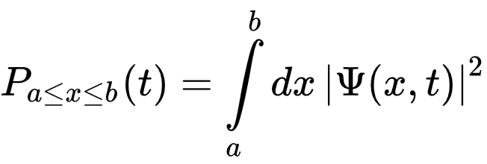

Where t is the time at which the particle was measured. This leads to the normalization condition:

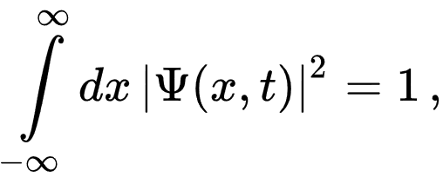

Therefore, if the particle is measured, the probability that it will be somewhere is 100%.

###### Momentum-space wave functions

In momentum space, the wave function of the particle can be represented with $Φ\left(p,t\right)$, where $p$ is one-dimensional momentum and ranges from $-∞$ to $+∞$. The measured result of the particle’s momentum isn’t determined but probabilistic. The momentum $p$ of the particle in interval $\left[a,b\right]$ is:

$$P_{a≤p≤b}=\int_{a}^{b}{{\left|Φ\left(p,t\right)\right|}^{2}dp}$$

Similarly, the momentum-space wave function’s normalization condition:

$$\int_{-∞}^{∞}{{\left|Φ\left(p,t\right)\right|}^{2}dp=1}$$

###### Relationship between two wave functions

The position-space wave function and the momentum-space wave function are each other’s Fourier transform. The information hold by each function is the same. Any kind of wave function can be used to calculate the related property of the particle. The equation relationship between two functions are:

$$Φ\left(p,t\right)=\frac{1}{\sqrt{2πℏ}}\int_{-∞}^{∞}{e^{-ipx/ℏ}Ψ\left(x,t\right)dx}$$

$$Ψ\left(x,t\right)=\frac{1}{\sqrt{2πℏ}}\int_{-∞}^{∞}{e^{ipx/ℏ}Φ\left(p,t\right)dp}$$

### Application in quantum computing

In quantum computing, the phrase “cat state” sometimes refer to GHZ state, wherein several qubits are in an equal superposition of all being 0 and all being 1:

$$|ψ⟩=\frac{1}{\sqrt{2}}(|00…0⟩+|11…1⟩)$$

At least one proposal state that it might be possible to determine the state of the cat before observing it.:

*Patekar, Kartik; Hofmann, Holger F. (2019). "The role of system–meter entanglement in controlling the resolution and decoherence of quantum measurements". New Journal of Physics. 21 (10): 103006. doi:10.1088/1367-2630/ab4451*

## Greenberger-Horne-Zeilinger state (GHZ state)

The GHZ state is a certain type of entangled quantum state of $M>2$ subsystems.

$$\left|GHZ\right\rangle =\frac{1}{\sqrt{d}}\sum_{i=0}^{d-1}{\left|i\right\rangle ⊗⋯⊗\left|i\right\rangle }=\frac{1}{\sqrt{d}}(\left|0\right\rangle ⊗⋯⊗\left|0\right\rangle +⋯+\left|d-1\right\rangle ⊗⋯⊗\left|d-1\right\rangle )$$

In the case of each of the subsystems being 2-dimensional, that is for qubits:

$$\left|GHZ\right\rangle =\frac{{\left|0\right\rangle }^{⊗M}+{\left|1\right\rangle }^{⊗M}}{\sqrt{2}}$$

In simple words, it is a quantum superposition of all subsystems being in state 0 with all of them being in state 1 (states 0 and 1 of a single subsystem are fully distinguishable). The GHZ state is a maximally entangled quantum state.

The simplest one is the 3-qubit GHZ state:

The corresponding 3-qubit GHZ state using quantum logic gates.

# Conclusion

The Schrödinger’s cat experiment is an experiment to explain the entangled quantum state. While the most accepted interpretation in the 20th century is the Copenhagen Interpretation, no interpretation can resolve the complexity of the quantum mechanics.

From the perspective of quantum computing, the Schrödinger’s cat paradox remains to be a thought experiment. The Schrödinger equation, on the other hand, lies the foundations of the quantum mechanics and may be the keys to future computers as well as other research fields.