Each Simulator version will be placed in a folder labeled “Simulator_v#”

The folder will contain the following structure:

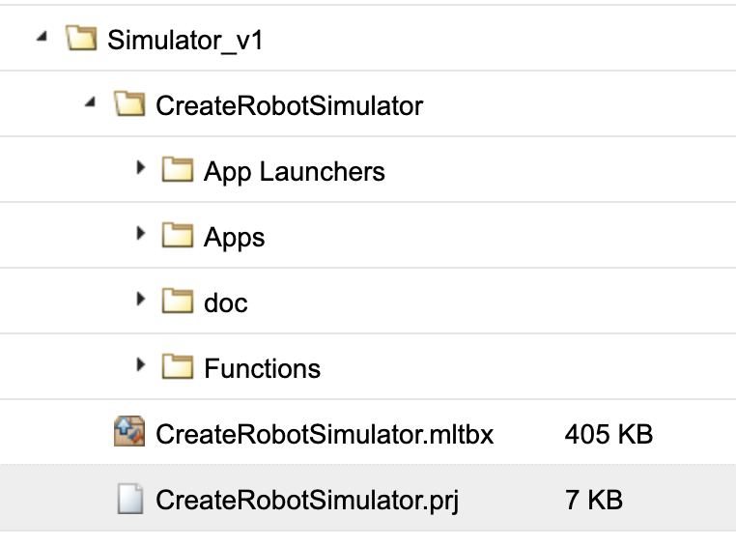

1. CreateRobotSimulator.mltbx # toolbox file
2. CreatrRobotSimuator.prj # project file associated with the toolbox. Contains all of the toolbox’s settings. Can be used for updated toolbox packages when the source files are modified (not to be used if NEW files are added).
3. CreateRobotSimulator # directory containing all source files
   1. App Launchers # dir that contains all of the .mlappinstall files for each “app”
      * ConfigMaker.mlappinstall
      * MapMaker.mlappinstall
      * Replay.mlappinstall (please not, this particular app may never be used)
      * Simulator.mlappinstall
   2. Apps # dir that contains the source files for all of the apps
      * ConfigMaker.mlapp
      * MapMaker.mlapp
      * Replay.mlapp  (please not, this particular app may never be used)
      * Simulator.mlapp
   3. Doc # documentation folder containing documentation for different functions
      * + genLidarHelp.html
        + helpDemoPage.html
        + SetFwdVelAngVelCreateHelp.html
   4. Functions # dir that contains functions used by the simulator app files
      * CreateRobot.m

Note the following:

1. If changes are made to a file’s contents (name of file stays the same), create an updated toolbox package by working with the .proj file (change version number and click the package button)

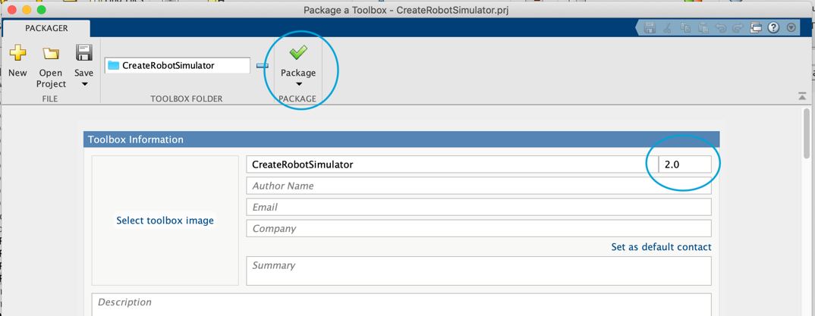

1. If a new app(s) are created, create new corresponding .mlappinstall files and a new toolbox file
   * In Matlab, go to **home tab->Add Ons->Package Toolbox**
   * Add the folder you would like to be packaged into a toolbox:

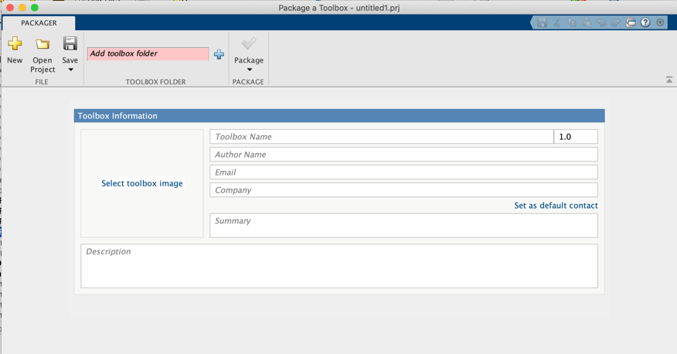

* + Name your toolbox and add version:

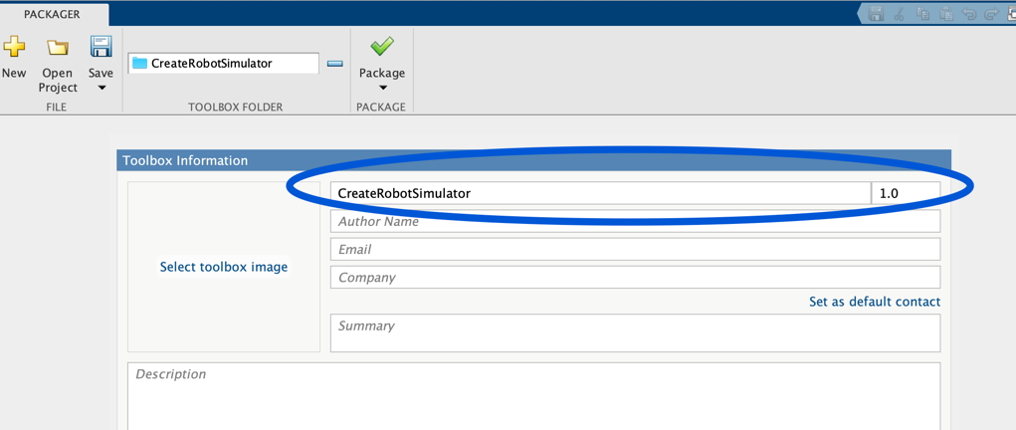

* + Tweak Settings:
    1. Make sure all directories containing necessary files are listed. Click on “exclude files and folders” to exclude files such as “.DS_Store” from being included in the package.
    2. Check requirements and make sure there is a green arrow before “no files outside the toolbox folder are required.” This ensures any functions/classes etc referenced in source files are all contained in the package. If this is not green, click on “Analyze Toolbox” to find missing files.
    3. Make sure the path to all of the files are in the MatlabPath. Click on “Manage the current MATLAB path” to add them. Note: there is a good chance the folders/files selected are not in the path, so perform this step!

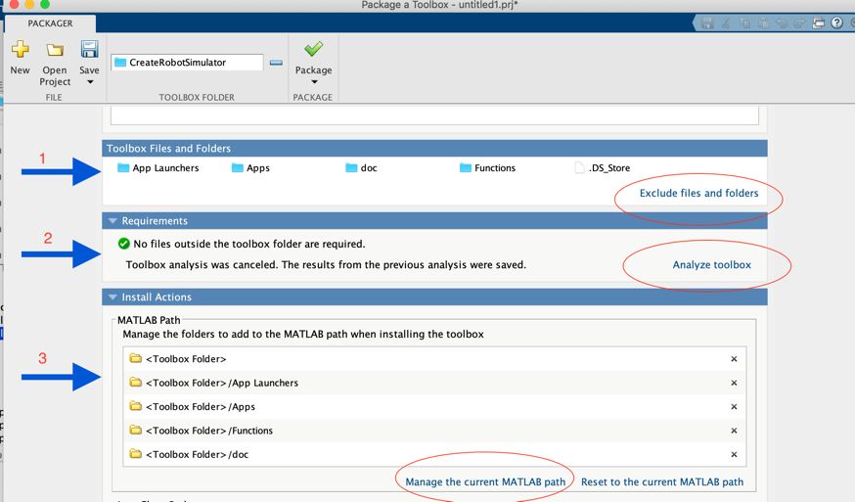

* + 1. Click Package.

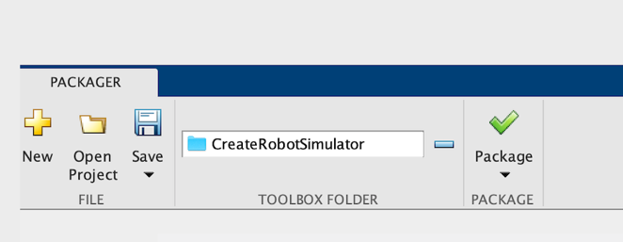

* + 1. This process will create .mltbx and .prj files. The .prj file contains all of the toolbox settings (directories, paths, etc). As stated, when changes are made to a file in the toolbox, use the .prj file to create an updated package.

