Eric Coupe SDEV 120 Module 1 Installing and Experimenting with the Development Tools

Draw.IO)

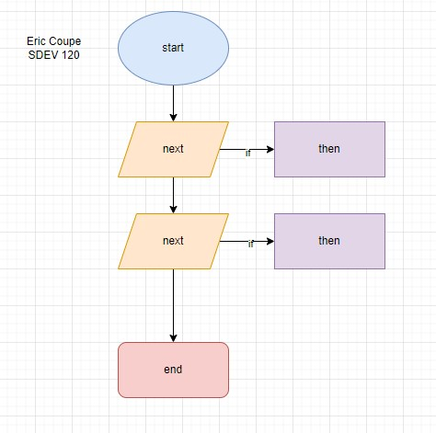

IDLE)

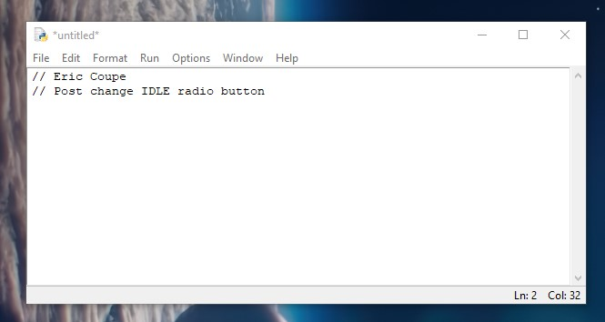

Pseudocode)

While there are no overarching defined rules of Pseudocode, there are general agreed upon rules to follow.

1. Pseudocode is flexible but must maintain readability for others who will read it
2. Maintain simplicity. Pseudocode is not an actual coding language and won’t exectue, so stay simple.
3. Use clear steps throughout the code.
4. Separate logic blocks for readability.
5. Indent when using conditional statements, nesting conditions, and loops.