Soapbox Password Manager & Generator

# User Manual

**Overview:** Soapbox Password Manager & Generator (SPMG) allows you to store usernames and passwords. There is also a random password generator that will automatically populate in the password field.

**Software Requirements:** This application requires Python 3.xx as well as BreezyPythonGUI.

Instructions on where to download both are at the end of the manual. BreezyPythonGUI is included in the zip file.

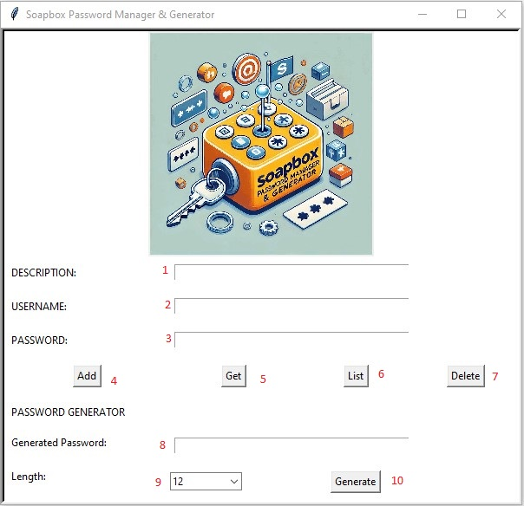

**How to Use:**

1. Description text field. Type in what the username and password are for i.e. website, app etc.
2. Username text field. Type in the username you would like to store/retrieve.
3. Password text field. Type in the password you would like to store/retrieve.
4. Add button. Click this button to save the Description, Username and Password to the application. (Figure 1)
5. Get button. Click this button after typing in a Username and the application will display the associated Password and Description. (Figure2)
6. List button. Click this button to open a new window displaying all stored Usernames and Passwords. The new window also allows the user to highlight and copy the displayed text. (Figure 3)
7. Delete button. Input the Username and Password you want to delete from the application and then click the button. (Figure 4)
8. Generated Password text field. After clicking the Generate button (item 12) the randomly generated password will display here. It will also automatically display in the Password text field. (Figure 5)
9. Password length dropdown selection menu. The default length is 12 but the user can select up to 36 characters.
10. Generate button. When clicked the application will randomly generate a password based on the character length. (Figure 5)

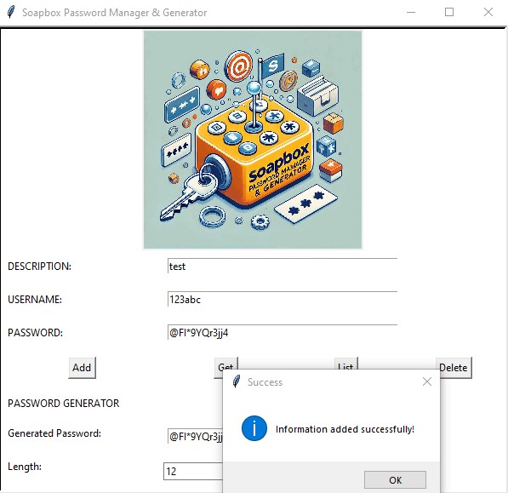

Figure 1

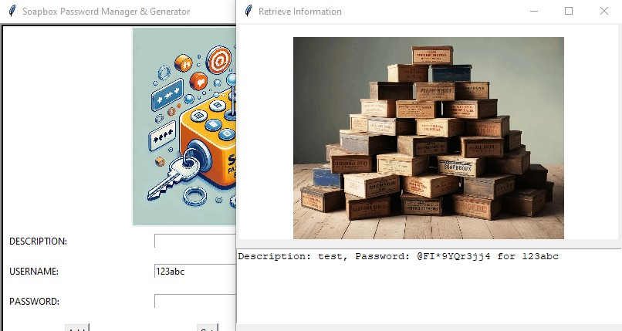

Figure 2

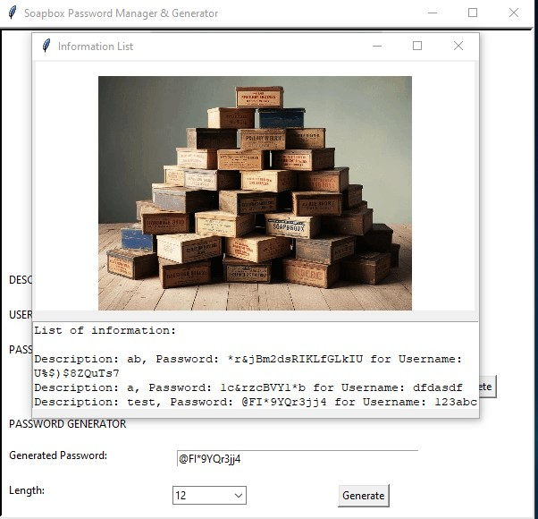

Figure 3

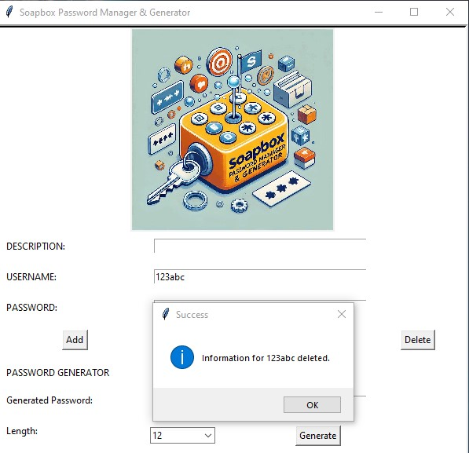

Figure 4

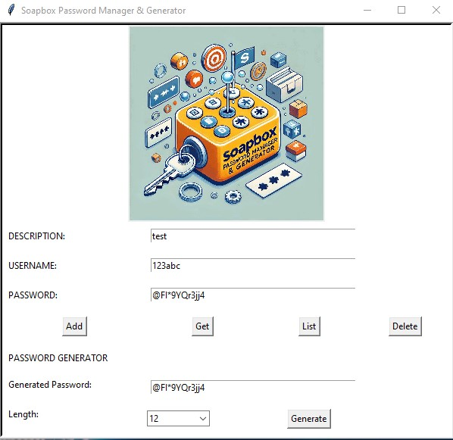

Figure 5

**Common Errors:**

**1)**

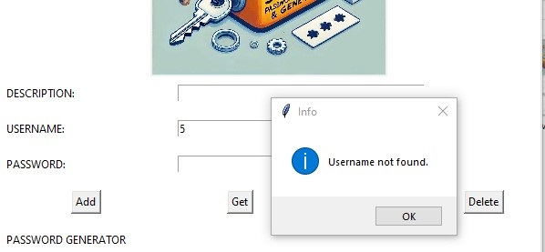

This occurs when an incorrect Username is input. To fix, type in a stored Username.

**2)**

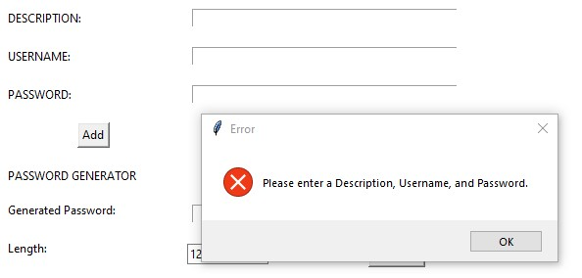

This occurs when no text field has characters and the Add button (4) is clicked. Enter a Description, Username and Password and try again.

**3)**

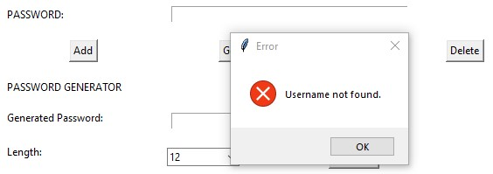

This occurs when the Delete button (7) is clicked with no Username in the text field. Input a valid Username and try again.

**Links:**

Github: <https://github.com/ecoupe/SDEV140_FinalProject.git>

Python: <https://www.python.org/downloads/>

Breezy: <https://lambertk.academic.wlu.edu/breezypythongui/downloads-and-legal-matters/>

Or pip install breezypythongui in your terminal