User interaction
How the code should be run
java -jar cardealer.jar
((((((cd C:\Users\ecous\Documents\OOP\courseworkOOP))))))

User instructions
The first screen the user will see is the login page. Here a username, password and role should be entered (one from the list cars-users.txt); if this login doesn’t match any in the file, a message will show and they will be allowed to try and login again.
- admin1, apple, admin
- staff1, orange, staff
- customer1, lemon, customer
If logged in as staff, they will have 7 options for actions to perform (1 - Add multiple car 2 - Add one car 3 - Sell a car 4 - Print cars 5 – Search 6 - Calculate Revenue 7 – Logout. n
If logged in as admin they will have all the staff member functionality as well as being able to add a user login. This user login will then be added to the login array and to test the user could log back out and log in with the new login successfully.
When adding a login the password will be encrypted and hidden from the other classes unless they are admin.
If logged in as a customer, they will only be able to use the search function (without returning accident history) to find unsold cars. Here a number from the list must be chosen to perform the search that they wish. This is the same as staff and admin, except these roles will return accident history.
- E.g. try a number to show the validation check
- Try ‘white’ for colour (option 2)
- Try 3 for minimum seat number, 6 for max.
Within staff and admin users, to add multiple cars, paste the file location of the file (that must be in the same format as cars-import.txt with commas and the order of attributes); if the file location isn’t found an error message will show and the user can try again or go back to the menu. Note the file cars-import.txt is added by the program at the start and doesn’t need to be added by the user.
To add a single car (within staff and admin) there is multiple validation checks to make sure the input is likely correct (such as only int for price). A car will be added to the memory and the print function will be executed so that the user can view the new car in the file cars-output.txt.
To calculate revenue there are 3 options (for a day, a month or a specified time period). There are validation checks so that date is inputted correctly. It must be in the form YYYY-MM-DD for options 1 and 3, and in the form YYYY-MM for option 2.
All users can logout which will simply take them back to the login screen and past user permissions will not be usable.
The admin and staff may sell a car, here they need to input a number plate which will be searched for and they can then verify whether that is the correct car or not. If it is the correct car and previously unsold, the record will be updated; if the car is found but already sold a message will show and they can chose whether to go back to the menu or input a different number plate. If the number plate isn’t found, they will also have these options.
- Input: UU54IO2 (car that hasn’t been sold)
The print function is available for staff and admin, this will output a list of all the cars available in the current program being run. The cars are organised by sold and unsold and then in date order.

List of packages
I have one package login.privacy; I started with this package and another for logged in but couldn’t implement this while testing so resulted in just using the one which isn’t ideal.

List of functionality not completed
The GUI hasn’t been completed and I have used the console instead so all functions should still be usable.

Description of object orientated style
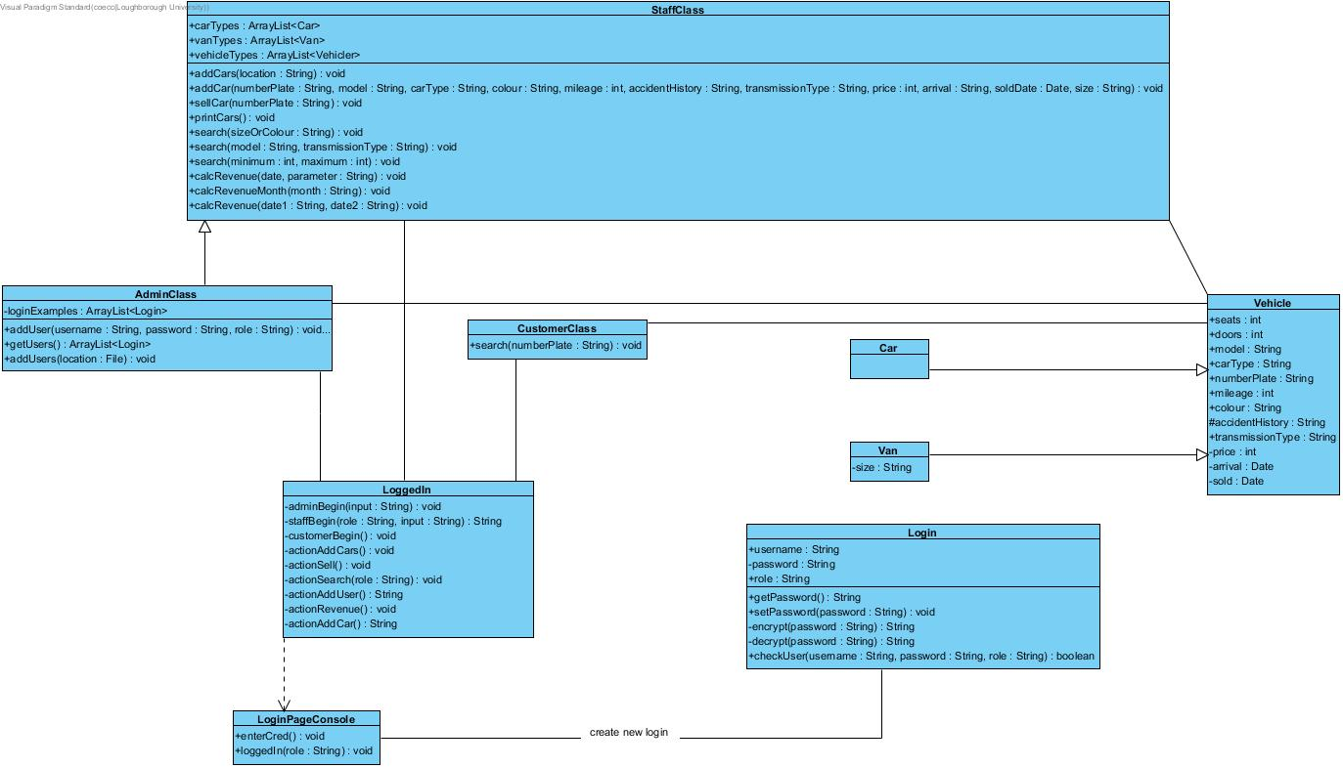
Diagram file called OOP_coursework_car.jpg.
To log onto the program the user will begin with the LoginPageConsole class where they will enter there credentials. This class must then interact/associate with the Login class. The Login class has the attributes username, password and role. The password must be private so get and set methods are used along with encryption and decryption.
The LoggedIn page is dependent on the LoginPageConsole because a role is needed and the methods customerBegin, staffBegin, adminBegin can be accessed from this class in order to access the private methods in LoggedIn.
LoggedIn also has many validation check methods like date, word and integer type checking but I decided it wasn’t necessary to include these in the class diagram.
Once the login is correct the user role will be passed to the LoggedIn class where they can chose the operations (shown in LoggedIn and individual user types. The class logged in has private actions allowing the user to access the methods in their appropriate role; this helps to protect the functionality from anyone not logged on.
The Admin class is a specialisation of the Staff class so that all the functionality that staff class has, the admin class does too. The admin class also has the operation to add a user of the class Login.
The Customer class shouldn’t have access to the functionality that admin or staff do, and should only be able to search unsold cars without the accident history being shown. I didn’t get to implement the search function like this in my program and had to check the role logged on as within the search in staff class.
Vehicles is a generalisation of Van and Car classes. This has the attributes seats, doors, carType, model, numberPlate, mileage, colour, accidentHistory, transmissionType, price, arrival (date) and sold (date). The Van class has the attribute size which can be small or large. This means Car and Van inherit the attributes and methods of Vehicle and for example a Van is a type of Vehicle but a Vehicle is not a type of Van.

