

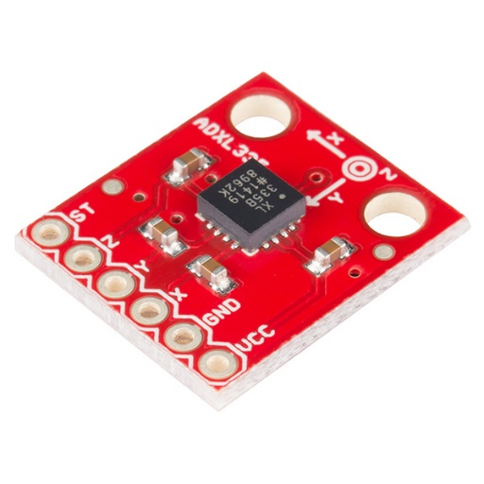**Accelerometer**

|  |  |
| --- | --- |
| An accelerometer is a device that measures acceleration forces. These forces may be static, like gravity, or dynamic - caused by moving or vibrating the accelerometer.   |  | | --- | | **An accelerometer can help your project to understand its surroundings better. Is it driving uphill? Is it going to fall over when it takes another step? Is it flying horizontally?** | |

   [Licença Creative Commons](http://creativecommons.org/licenses/by-nc/4.0/)