normal-fungal-serious-36x36-every-5-test-and-validation-500-epochs

Data loss = 0.1549353152513504; Validation loss = 0.35803407430648804; Test error = 0.3427010178565979

true positives = 88  
true negatives = 522  
false positives = 29  
false negatives = 33  
not confident of any answer = 60  
total = 732

normal-fungal-serious-100x100-every-5-test-and-validation-500-epochs

Data loss = 0.11064949631690979; Validation loss = 0.3411939740180969; Test error = 0.3483753800392151

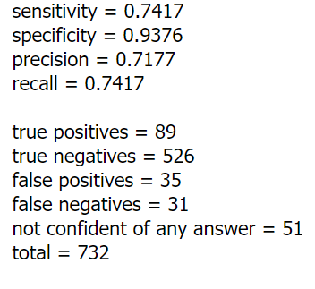

leCunNormal:

Data loss = 0.11090581119060516; Validation loss = 0.3382941782474518; Test error = 0.3492765426635742

normal-fungal-serious-100x100x100-every-5-test-and-validation-500-epochs (425 better)

Data loss = 0.08418463170528412; Validation loss = 0.3631347417831421; Test error = 0.3868394196033478

normal-fungal-serious-2000-every-5-test-and-validation-275-epochs

Data loss = 0.08576856553554535; Validation loss = 0.328652948141098; Data accuracy = 0.9936218857765198; Validation accuracy = 0.8823529481887817; Test loss = 0.34153875708580017; Test accuracy = 0.8825136423110962

true positives = 92  
true negatives = 523  
false positives = 30  
false negatives = 33  
not confident of any answer = 54  
total = 732  
  
sensitivity = 0.736  
specificity = 0.9458  
precision = 0.7541  
recall = 0.736