normal-fungal-serious-1280-every-5-test-and-validation-300-epochs

Data loss = 0.09300931543111801; Validation loss = 0.3349473476409912; Test error = 0.33252185583114624

true positives = 96  
true negatives = 522  
false positives = 32  
false negatives = 33  
not confident of any answer = 49  
total = 732

sensitivity = 0.7442  
specificity = 0.9422  
precision = 0.75  
recall = 0.7442

 check with a GP#377  
**Analysis by this app:**normal = 0%; non-serious = 0%; check with a GP = 100%;   
It is most likely that the nail indicates something that warrants a second opinion and you should seek medical advice. (Confidence score is 100%)×

 check with a GP#297  
**Analysis by this app:**normal = 0%; non-serious = 0%; check with a GP = 100%;   
It is most likely that the nail indicates something that warrants a second opinion and you should seek medical advice. (Confidence score is 100%)×

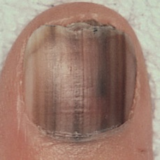  
 check with a GP#617  
**Analysis by this app:**normal = 0%; non-serious = 0%; check with a GP = 100%;   
It is most likely that the nail indicates something that warrants a second opinion and you should seek medical advice. (Confidence score is 100%)×

 check with a GP#447  
**Analysis by this app:**normal = 0%; non-serious = 0%; check with a GP = 100%;   
It is most likely that the nail indicates something that warrants a second opinion and you should seek medical advice. (Confidence score is 100%)×

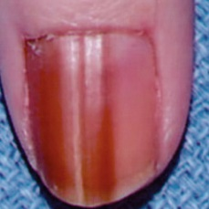  
 check with a GP#587  
**Analysis by this app:**normal = 0%; non-serious = 0%; check with a GP = 100%;   
It is most likely that the nail indicates something that warrants a second opinion and you should seek medical advice. (Confidence score is 100%)×

 check with a GP#202  
**Analysis by this app:**normal = 0%; non-serious = 0%; check with a GP = 100%;   
It is most likely that the nail indicates something that warrants a second opinion and you should seek medical advice. (Confidence score is 100%)×

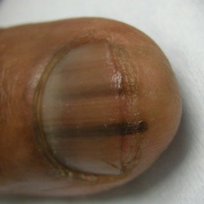  
 check with a GP#532  
**Analysis by this app:**normal = 1%; non-serious = 0%; check with a GP = 99%;   
It is most likely that the nail indicates something that warrants a second opinion and you should seek medical advice. (Confidence score is 99%)×

 check with a GP#372  
**Analysis by this app:**normal = 0%; non-serious = 1%; check with a GP = 99%;   
It is most likely that the nail indicates something that warrants a second opinion and you should seek medical advice. (Confidence score is 99%)×

 check with a GP#337  
**Analysis by this app:**normal = 0%; non-serious = 1%; check with a GP = 99%;   
It is most likely that the nail indicates something that warrants a second opinion and you should seek medical advice. (Confidence score is 99%)×

 check with a GP#177  
**Analysis by this app:**normal = 0%; non-serious = 0%; check with a GP = 99%;   
It is most likely that the nail indicates something that warrants a second opinion and you should seek medical advice. (Confidence score is 99%)×

 check with a GP#227  
**Analysis by this app:**normal = 0%; non-serious = 1%; check with a GP = 99%;   
It is most likely that the nail indicates something that warrants a second opinion and you should seek medical advice. (Confidence score is 99%)×

 check with a GP#197  
**Analysis by this app:**normal = 0%; non-serious = 1%; check with a GP = 99%;   
It is most likely that the nail indicates something that warrants a second opinion and you should seek medical advice. (Confidence score is 99%)×

 check with a GP#192  
**Analysis by this app:**normal = 1%; non-serious = 0%; check with a GP = 99%;   
It is most likely that the nail indicates something that warrants a second opinion and you should seek medical advice. (Confidence score is 99%)×

 check with a GP#132  
**Analysis by this app:**normal = 1%; non-serious = 0%; check with a GP = 99%;   
It is most likely that the nail indicates something that warrants a second opinion and you should seek medical advice. (Confidence score is 99%)×

 check with a GP#232  
**Analysis by this app:**normal = 1%; non-serious = 1%; check with a GP = 99%;   
It is most likely that the nail indicates something that warrants a second opinion and you should seek medical advice. (Confidence score is 99%)×

 check with a GP#417  
**Analysis by this app:**normal = 0%; non-serious = 2%; check with a GP = 98%;   
It is most likely that the nail indicates something that warrants a second opinion and you should seek medical advice. (Confidence score is 98%)×

 check with a GP#27  
**Analysis by this app:**normal = 0%; non-serious = 2%; check with a GP = 98%;   
It is most likely that the nail indicates something that warrants a second opinion and you should seek medical advice. (Confidence score is 98%)×

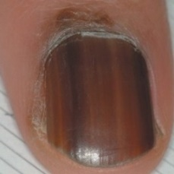  
 check with a GP#677  
**Analysis by this app:**normal = 2%; non-serious = 0%; check with a GP = 98%;   
It is most likely that the nail indicates something that warrants a second opinion and you should seek medical advice. (Confidence score is 98%)×

 check with a GP#167  
**Analysis by this app:**normal = 2%; non-serious = 0%; check with a GP = 98%;   
It is most likely that the nail indicates something that warrants a second opinion and you should seek medical advice. (Confidence score is 98%)×

 check with a GP#327  
**Analysis by this app:**normal = 2%; non-serious = 0%; check with a GP = 98%;   
It is most likely that the nail indicates something that warrants a second opinion and you should seek medical advice. (Confidence score is 98%)×

 check with a GP#67  
**Analysis by this app:**normal = 2%; non-serious = 0%; check with a GP = 98%;   
It is most likely that the nail indicates something that warrants a second opinion and you should seek medical advice. (Confidence score is 98%)×

 check with a GP#162  
**Analysis by this app:**normal = 2%; non-serious = 0%; check with a GP = 98%;   
It is most likely that the nail indicates something that warrants a second opinion and you should seek medical advice. (Confidence score is 98%)×

 check with a GP#362  
**Analysis by this app:**normal = 0%; non-serious = 2%; check with a GP = 98%;   
It is most likely that the nail indicates something that warrants a second opinion and you should seek medical advice. (Confidence score is 98%)×

 check with a GP#157  
**Analysis by this app:**normal = 1%; non-serious = 2%; check with a GP = 97%;   
It is most likely that the nail indicates something that warrants a second opinion and you should seek medical advice. (Confidence score is 97%)×

 check with a GP#322  
**Analysis by this app:**normal = 1%; non-serious = 1%; check with a GP = 97%;   
It is most likely that the nail indicates something that warrants a second opinion and you should seek medical advice. (Confidence score is 97%)×

 check with a GP#242  
**Analysis by this app:**normal = 1%; non-serious = 1%; check with a GP = 97%;   
It is most likely that the nail indicates something that warrants a second opinion and you should seek medical advice. (Confidence score is 97%)×

 check with a GP#72  
**Analysis by this app:**normal = 2%; non-serious = 0%; check with a GP = 97%;   
It is most likely that the nail indicates something that warrants a second opinion and you should seek medical advice. (Confidence score is 97%)×

 check with a GP#347  
**Analysis by this app:**normal = 0%; non-serious = 3%; check with a GP = 97%;   
It is most likely that the nail indicates something that warrants a second opinion and you should seek medical advice. (Confidence score is 97%)×

 check with a GP#282  
**Analysis by this app:**normal = 0%; non-serious = 3%; check with a GP = 97%;   
It is most likely that the nail indicates something that warrants a second opinion and you should seek medical advice. (Confidence score is 97%)×

 check with a GP#437  
**Analysis by this app:**normal = 1%; non-serious = 2%; check with a GP = 96%;   
It is most likely that the nail indicates something that warrants a second opinion and you should seek medical advice. (Confidence score is 96%)×

 check with a GP#312  
**Analysis by this app:**normal = 3%; non-serious = 1%; check with a GP = 95%;   
It is most likely that the nail indicates something that warrants a second opinion and you should seek medical advice. (Confidence score is 95%)×

 check with a GP#212  
**Analysis by this app:**normal = 1%; non-serious = 3%; check with a GP = 95%;   
It is most likely that the nail indicates something that warrants a second opinion and you should seek medical advice. (Confidence score is 95%)×

 check with a GP#442  
**Analysis by this app:**normal = 4%; non-serious = 0%; check with a GP = 95%;   
It is most likely that the nail indicates something that warrants a second opinion and you should seek medical advice. (Confidence score is 95%)×

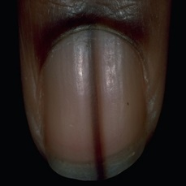  
 check with a GP#642  
**Analysis by this app:**normal = 5%; non-serious = 0%; check with a GP = 95%;   
It is most likely that the nail indicates something that warrants a second opinion and you should seek medical advice. (Confidence score is 95%)×

 check with a GP#467  
**Analysis by this app:**normal = 3%; non-serious = 2%; check with a GP = 95%;   
It is most likely that the nail indicates something that warrants a second opinion and you should seek medical advice. (Confidence score is 95%)×

 check with a GP#332  
**Analysis by this app:**normal = 0%; non-serious = 5%; check with a GP = 95%;   
It is most likely that the nail indicates something that warrants a second opinion and you should seek medical advice. (Confidence score is 95%)×

 check with a GP#267  
**Analysis by this app:**normal = 0%; non-serious = 5%; check with a GP = 95%;   
It is most likely that the nail indicates something that warrants a second opinion and you should seek medical advice. (Confidence score is 95%)×

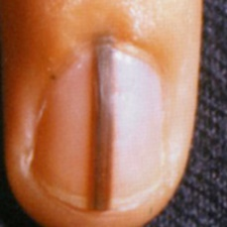  
 check with a GP#682  
**Analysis by this app:**normal = 1%; non-serious = 4%; check with a GP = 95%;   
It is most likely that the nail indicates something that warrants a second opinion and you should seek medical advice. (Confidence score is 95%)×

 check with a GP#432  
**Analysis by this app:**normal = 0%; non-serious = 5%; check with a GP = 95%;   
It is most likely that the nail indicates something that warrants a second opinion and you should seek medical advice. (Confidence score is 95%)×

 check with a GP#462  
**Analysis by this app:**normal = 0%; non-serious = 5%; check with a GP = 95%;   
It is most likely that the nail indicates something that warrants a second opinion and you should seek medical advice. (Confidence score is 95%)×

 check with a GP#457  
**Analysis by this app:**normal = 5%; non-serious = 1%; check with a GP = 94%;   
It is most likely that the nail indicates something that warrants a second opinion and you should seek medical advice. (Confidence score is 94%)×

 check with a GP#452  
**Analysis by this app:**normal = 5%; non-serious = 1%; check with a GP = 94%;   
It is most likely that the nail indicates something that warrants a second opinion and you should seek medical advice. (Confidence score is 94%)×

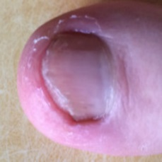  
 check with a GP#672  
**Analysis by this app:**normal = 5%; non-serious = 1%; check with a GP = 94%;   
It is most likely that the nail indicates something that warrants a second opinion and you should seek medical advice. (Confidence score is 94%)×

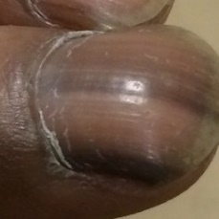  
 check with a GP#547  
**Analysis by this app:**normal = 5%; non-serious = 1%; check with a GP = 94%;   
It is most likely that the nail indicates something that warrants a second opinion and you should seek medical advice. (Confidence score is 94%)×

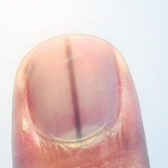  
 check with a GP#637  
**Analysis by this app:**normal = 4%; non-serious = 3%; check with a GP = 93%;   
It is most likely that the nail indicates something that warrants a second opinion and you should seek medical advice. (Confidence score is 93%)×

 check with a GP#247  
**Analysis by this app:**normal = 1%; non-serious = 6%; check with a GP = 93%;   
It is most likely that the nail indicates something that warrants a second opinion and you should seek medical advice. (Confidence score is 93%)×

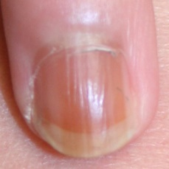  
 check with a GP#542  
**Analysis by this app:**normal = 6%; non-serious = 2%; check with a GP = 92%;   
It is most likely that the nail indicates something that warrants a second opinion and you should seek medical advice. (Confidence score is 92%)×

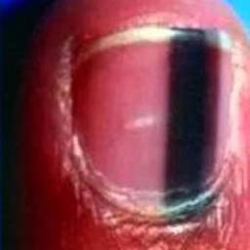  
 check with a GP#627  
**Analysis by this app:**normal = 0%; non-serious = 8%; check with a GP = 92%;   
It is most likely that the nail indicates something that warrants a second opinion and you should seek medical advice. (Confidence score is 92%)×

 check with a GP#127  
**Analysis by this app:**normal = 7%; non-serious = 1%; check with a GP = 92%;   
It is most likely that the nail indicates something that warrants a second opinion and you should seek medical advice. (Confidence score is 92%)×

 check with a GP#277  
**Analysis by this app:**normal = 6%; non-serious = 3%; check with a GP = 92%;   
It is most likely that the nail indicates something that warrants a second opinion and you should seek medical advice. (Confidence score is 92%)×

 check with a GP#137  
**Analysis by this app:**normal = 8%; non-serious = 1%; check with a GP = 92%;   
It is most likely that the nail indicates something that warrants a second opinion and you should seek medical advice. (Confidence score is 92%)×

 check with a GP#182  
**Analysis by this app:**normal = 6%; non-serious = 3%; check with a GP = 91%;   
It is most likely that the nail indicates something that warrants a second opinion and you should seek medical advice. (Confidence score is 91%)×

 check with a GP#287  
**Analysis by this app:**normal = 8%; non-serious = 0%; check with a GP = 91%;   
It is most likely that the nail indicates something that warrants a second opinion and you should seek medical advice. (Confidence score is 91%)×

 check with a GP#62  
**Analysis by this app:**normal = 7%; non-serious = 2%; check with a GP = 91%;   
It is most likely that the nail indicates something that warrants a second opinion and you should seek medical advice. (Confidence score is 91%)×

 check with a GP#97  
**Analysis by this app:**normal = 9%; non-serious = 0%; check with a GP = 91%;   
It is most likely that the nail indicates something that warrants a second opinion and you should seek medical advice. (Confidence score is 91%)×

 check with a GP#142  
**Analysis by this app:**normal = 7%; non-serious = 3%; check with a GP = 89%;   
It is most likely that the nail indicates something that warrants a second opinion and you should seek medical advice. (Confidence score is 89%)×

 check with a GP#52  
**Analysis by this app:**normal = 8%; non-serious = 4%; check with a GP = 88%;   
It is most likely that the nail indicates something that warrants a second opinion and you should seek medical advice. (Confidence score is 88%)×

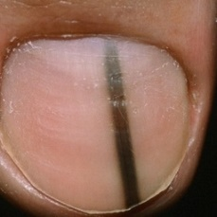  
 check with a GP#552  
**Analysis by this app:**normal = 4%; non-serious = 7%; check with a GP = 88%;   
It is most likely that the nail indicates something that warrants a second opinion and you should seek medical advice. (Confidence score is 88%)×

 check with a GP#17  
**Analysis by this app:**normal = 10%; non-serious = 2%; check with a GP = 88%;   
It is most likely that the nail indicates something that warrants a second opinion and you should seek medical advice. (Confidence score is 88%)×

 check with a GP#487  
**Analysis by this app:**normal = 1%; non-serious = 12%; check with a GP = 87%;   
It is most likely that the nail indicates something that warrants a second opinion and you should seek medical advice. (Confidence score is 87%)×

 check with a GP#367  
**Analysis by this app:**normal = 13%; non-serious = 1%; check with a GP = 86%;   
It is most likely that the nail indicates something that warrants a second opinion and you should seek medical advice. (Confidence score is 86%)×

 check with a GP#422  
**Analysis by this app:**normal = 0%; non-serious = 14%; check with a GP = 85%;   
It is most likely that the nail indicates something that warrants a second opinion and you should seek medical advice. (Confidence score is 85%)×

 check with a GP#512  
**Analysis by this app:**normal = 0%; non-serious = 15%; check with a GP = 85%;   
It is most likely that the nail indicates something that warrants a second opinion and you should seek medical advice. (Confidence score is 85%)×

 check with a GP#402  
**Analysis by this app:**normal = 1%; non-serious = 15%; check with a GP = 85%;   
It is most likely that the nail indicates something that warrants a second opinion and you should seek medical advice. (Confidence score is 85%)×

 check with a GP#392  
**Analysis by this app:**normal = 1%; non-serious = 15%; check with a GP = 84%;   
It is most likely that the nail indicates something that warrants a second opinion and you should seek medical advice. (Confidence score is 84%)×

 check with a GP#502  
**Analysis by this app:**normal = 10%; non-serious = 6%; check with a GP = 84%;   
It is most likely that the nail indicates something that warrants a second opinion and you should seek medical advice. (Confidence score is 84%)×

 check with a GP#302  
**Analysis by this app:**normal = 13%; non-serious = 3%; check with a GP = 84%;   
It is most likely that the nail indicates something that warrants a second opinion and you should seek medical advice. (Confidence score is 84%)×

 check with a GP#517  
**Analysis by this app:**normal = 1%; non-serious = 16%; check with a GP = 83%;   
It is most likely that the nail indicates something that warrants a second opinion and you should seek medical advice. (Confidence score is 83%)×

 check with a GP#482  
**Analysis by this app:**normal = 1%; non-serious = 17%; check with a GP = 83%;   
It is most likely that the nail indicates something that warrants a second opinion and you should seek medical advice. (Confidence score is 83%)×

 check with a GP#107  
**Analysis by this app:**normal = 15%; non-serious = 3%; check with a GP = 82%;   
It is most likely that the nail indicates something that warrants a second opinion and you should seek medical advice. (Confidence score is 82%)×

 check with a GP#497  
**Analysis by this app:**normal = 17%; non-serious = 3%; check with a GP = 80%;   
It is most likely that the nail indicates something that warrants a second opinion and you should seek medical advice. (Confidence score is 80%)×

 check with a GP#352  
**Analysis by this app:**normal = 16%; non-serious = 4%; check with a GP = 80%;   
It is most likely that the nail indicates something that warrants a second opinion and you should seek medical advice. (Confidence score is 80%)×

 check with a GP#117  
**Analysis by this app:**normal = 18%; non-serious = 3%; check with a GP = 79%;   
It is most likely that the nail indicates something that warrants a second opinion and you should seek medical advice. (Confidence score is 79%)×

 check with a GP#122  
**Analysis by this app:**normal = 9%; non-serious = 13%; check with a GP = 78%;   
It is most likely that the nail indicates something that warrants a second opinion and you should seek medical advice. (Confidence score is 78%)×

 check with a GP#87  
**Analysis by this app:**normal = 19%; non-serious = 6%; check with a GP = 75%;   
It is most likely that the nail indicates something that warrants a second opinion and you should seek medical advice. (Confidence score is 75%)×

 check with a GP#382  
**Analysis by this app:**normal = 2%; non-serious = 24%; check with a GP = 74%;   
It is most likely that the nail indicates something that warrants a second opinion and you should seek medical advice. (Confidence score is 74%)×

 check with a GP#472  
**Analysis by this app:**normal = 21%; non-serious = 5%; check with a GP = 73%;   
It is most likely that the nail indicates something that warrants a second opinion and you should seek medical advice. (Confidence score is 73%)×

 check with a GP#407  
**Analysis by this app:**normal = 5%; non-serious = 22%; check with a GP = 73%;   
It is most likely that the nail indicates something that warrants a second opinion and you should seek medical advice. (Confidence score is 73%)×

 check with a GP#187  
**Analysis by this app:**normal = 27%; non-serious = 0%; check with a GP = 73%;   
It is most likely that the nail indicates something that warrants a second opinion and you should seek medical advice. (Confidence score is 73%)×

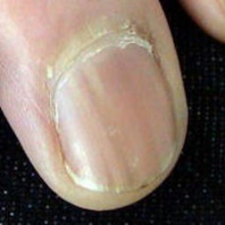  
 check with a GP#657  
**Analysis by this app:**normal = 7%; non-serious = 21%; check with a GP = 72%;   
It is most likely that the nail indicates something that warrants a second opinion and you should seek medical advice. (Confidence score is 72%)×

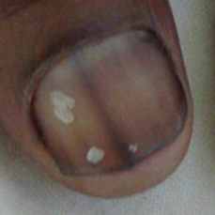  
 check with a GP#622  
**Analysis by this app:**normal = 23%; non-serious = 5%; check with a GP = 71%;   
It is most likely that the nail indicates something that warrants a second opinion and you should seek medical advice. (Confidence score is 71%)×

 check with a GP#507  
**Analysis by this app:**normal = 1%; non-serious = 30%; check with a GP = 69%;   
It is most likely that the nail indicates something that warrants a second opinion and you should seek medical advice. (Confidence score is 69%)×

 check with a GP#237  
**Analysis by this app:**normal = 31%; non-serious = 0%; check with a GP = 68%;   
It is most likely that the nail indicates something that warrants a second opinion and you should seek medical advice. (Confidence score is 68%)×

 check with a GP#37  
**Analysis by this app:**normal = 30%; non-serious = 2%; check with a GP = 68%;   
It is most likely that the nail indicates something that warrants a second opinion and you should seek medical advice. (Confidence score is 68%)×

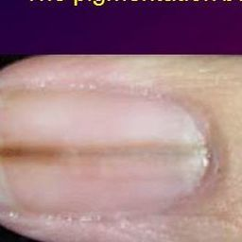  
 check with a GP#612  
**Analysis by this app:**normal = 31%; non-serious = 2%; check with a GP = 67%;   
It is most likely that the nail indicates something that warrants a second opinion and you should seek medical advice. (Confidence score is 67%)×

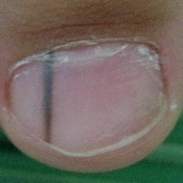  
 check with a GP#667  
**Analysis by this app:**normal = 30%; non-serious = 4%; check with a GP = 66%;   
It is most likely that the nail indicates something that warrants a second opinion and you should seek medical advice. (Confidence score is 66%)×

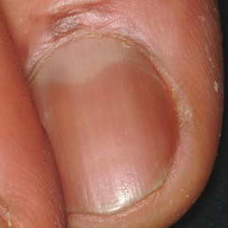  
 check with a GP#577  
**Analysis by this app:**normal = 34%; non-serious = 0%; check with a GP = 66%;   
It is most likely that the nail indicates something that warrants a second opinion and you should seek medical advice. (Confidence score is 66%)×

 check with a GP#217  
**Analysis by this app:**normal = 33%; non-serious = 2%; check with a GP = 65%;   
It is most likely that the nail indicates something that warrants a second opinion and you should seek medical advice. (Confidence score is 65%)×

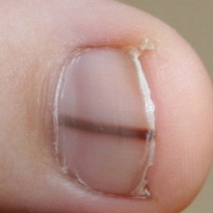  
 check with a GP#527  
**Analysis by this app:**normal = 35%; non-serious = 0%; check with a GP = 65%;   
It is most likely that the nail indicates something that warrants a second opinion and you should seek medical advice. (Confidence score is 65%)×

 check with a GP#172  
**Analysis by this app:**normal = 5%; non-serious = 31%; check with a GP = 64%;   
It is most likely that the nail indicates something that warrants a second opinion and you should seek medical advice. (Confidence score is 64%)×

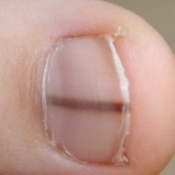  
 check with a GP#537  
**Analysis by this app:**normal = 36%; non-serious = 1%; check with a GP = 63%;   
It is most likely that the nail indicates something that warrants a second opinion and you should seek medical advice. (Confidence score is 63%)×

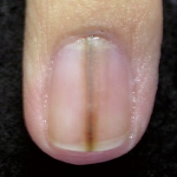  
 check with a GP#592  
**Analysis by this app:**normal = 11%; non-serious = 26%; check with a GP = 63%;   
It is most likely that the nail indicates something that warrants a second opinion and you should seek medical advice. (Confidence score is 63%)×

 check with a GP#292  
**Analysis by this app:**normal = 19%; non-serious = 20%; check with a GP = 61%;   
It is most likely that the nail indicates something that warrants a second opinion and you should seek medical advice. (Confidence score is 61%)×

 check with a GP#47  
**Analysis by this app:**normal = 3%; non-serious = 37%; check with a GP = 61%;   
It is most likely that the nail indicates something that warrants a second opinion and you should seek medical advice. (Confidence score is 61%)×

 check with a GP#427  
**Analysis by this app:**normal = 27%; non-serious = 13%; check with a GP = 60%;   
It is most likely that the nail indicates something that warrants a second opinion and you should seek medical advice. (Confidence score is 60%)×

 check with a GP#222  
**Analysis by this app:**normal = 40%; non-serious = 1%; check with a GP = 60%;   
It is most likely that the nail indicates something that warrants a second opinion and you should seek medical advice. (Confidence score is 60%)×

 check with a GP#82  
**Analysis by this app:**normal = 39%; non-serious = 3%; check with a GP = 59%;   
Not very sure whether the nail is OK or not. Sorry.×

 check with a GP#92  
**Analysis by this app:**normal = 32%; non-serious = 12%; check with a GP = 56%;   
Not very sure whether the nail is OK or not. Sorry.×

 check with a GP#307  
**Analysis by this app:**normal = 8%; non-serious = 40%; check with a GP = 52%;   
Not very sure whether the nail is OK or not. Sorry.×

 check with a GP#387  
**Analysis by this app:**normal = 14%; non-serious = 35%; check with a GP = 51%;   
Not very sure whether the nail is OK or not. Sorry.×

 check with a GP#477  
**Analysis by this app:**normal = 1%; non-serious = 49%; check with a GP = 50%;   
Not very sure whether the nail is OK or not. Sorry.×

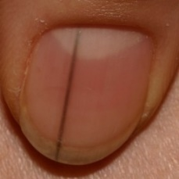  
 check with a GP#567  
**Analysis by this app:**normal = 52%; non-serious = 0%; check with a GP = 48%;   
Not very sure whether the nail is OK or not. Sorry.×

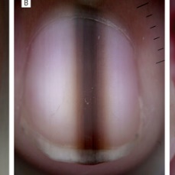  
 check with a GP#607  
**Analysis by this app:**normal = 52%; non-serious = 1%; check with a GP = 46%;   
Not very sure whether the nail is OK or not. Sorry.×

 check with a GP#252  
**Analysis by this app:**normal = 62%; non-serious = 0%; check with a GP = 38%;   
Perhaps a GP should be consulted (confidence score is 38%) ×

 check with a GP#317  
**Analysis by this app:**normal = 2%; non-serious = 62%; check with a GP = 36%;   
Perhaps a GP should be consulted (confidence score is 36%) ×

 check with a GP#152  
**Analysis by this app:**normal = 53%; non-serious = 12%; check with a GP = 36%;   
Not very sure whether the nail is OK or not. Sorry.×

 check with a GP#272  
**Analysis by this app:**normal = 4%; non-serious = 63%; check with a GP = 33%;   
Perhaps a GP should be consulted (confidence score is 33%) ×

 check with a GP#397  
**Analysis by this app:**normal = 2%; non-serious = 68%; check with a GP = 31%;   
Perhaps a GP should be consulted (confidence score is 31%) ×

 check with a GP#257  
**Analysis by this app:**normal = 10%; non-serious = 60%; check with a GP = 30%;   
Perhaps a GP should be consulted (confidence score is 30%) ×

 check with a GP#342  
**Analysis by this app:**normal = 0%; non-serious = 81%; check with a GP = 19%;   
The nail's condition is non-serious with confidence score of 81%.  
The confidence score for consulting a GP is 19%.×

 check with a GP#492  
**Analysis by this app:**normal = 0%; non-serious = 81%; check with a GP = 18%;   
The nail's condition is non-serious with confidence score of 81%.  
The confidence score for consulting a GP is 18%.×

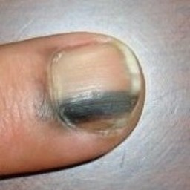  
 check with a GP#562  
**Analysis by this app:**normal = 77%; non-serious = 5%; check with a GP = 18%;   
The nail's condition is normal with confidence score of 77%.  
The confidence score for consulting a GP is 18%.×

 check with a GP#147  
**Analysis by this app:**normal = 18%; non-serious = 64%; check with a GP = 18%;   
The nail's condition is non-serious with confidence score of 64%.  
Otherwise it is normal with confidence score of 18%.×

 check with a GP#22  
**Analysis by this app:**normal = 0%; non-serious = 82%; check with a GP = 18%;   
The nail's condition is non-serious with confidence score of 82%.  
The confidence score for consulting a GP is 18%.×

 check with a GP#522  
**Analysis by this app:**normal = 1%; non-serious = 82%; check with a GP = 17%;   
The nail's condition is non-serious with confidence score of 82%.  
The confidence score for consulting a GP is 17%.×

 check with a GP#32  
**Analysis by this app:**normal = 2%; non-serious = 84%; check with a GP = 14%;   
The nail's condition is non-serious with confidence score of 84%.  
The confidence score for consulting a GP is 14%.×

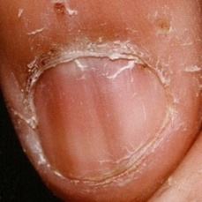  
 check with a GP#582  
**Analysis by this app:**normal = 64%; non-serious = 23%; check with a GP = 14%;   
The nail's condition is normal with confidence score of 64%.  
Otherwise it is non-serious with confidence score of 23%.×

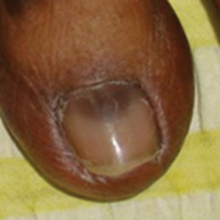  
 check with a GP#647  
**Analysis by this app:**normal = 86%; non-serious = 1%; check with a GP = 13%;   
The nail's condition is normal with confidence score of 86%.  
The confidence score for consulting a GP is 13%.×

  
 check with a GP#602  
**Analysis by this app:**normal = 86%; non-serious = 1%; check with a GP = 13%;   
The nail's condition is normal with confidence score of 86%.  
The confidence score for consulting a GP is 13%.×

 check with a GP#2  
**Analysis by this app:**normal = 1%; non-serious = 87%; check with a GP = 12%;   
The nail's condition is non-serious with confidence score of 87%.  
The confidence score for consulting a GP is 12%.×

 check with a GP#262  
**Analysis by this app:**normal = 1%; non-serious = 88%; check with a GP = 11%;   
The nail's condition is non-serious with confidence score of 88%.  
The confidence score for consulting a GP is 11%.×

 check with a GP#412  
**Analysis by this app:**normal = 1%; non-serious = 89%; check with a GP = 10%;   
The nail's condition is non-serious with confidence score of 89%.  
The confidence score for consulting a GP is 10%.×

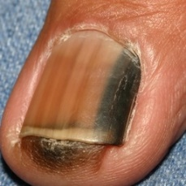  
 check with a GP#597  
**Analysis by this app:**normal = 2%; non-serious = 88%; check with a GP = 10%;   
The nail's condition is non-serious with confidence score of 88%.  
The confidence score for consulting a GP is 10%.×

 check with a GP#7  
**Analysis by this app:**normal = 5%; non-serious = 86%; check with a GP = 9%;   
The nail's condition is non-serious with confidence score of 86%.  
The confidence score for consulting a GP is 9%.×

 check with a GP#112  
**Analysis by this app:**normal = 16%; non-serious = 75%; check with a GP = 8%;   
The nail's condition is non-serious with confidence score of 75%.  
Otherwise it is normal with confidence score of 16%.×

 check with a GP#102  
**Analysis by this app:**normal = 92%; non-serious = 0%; check with a GP = 8%;   
The nail's condition is normal with confidence score of 92%.  
The confidence score for consulting a GP is 8%.×

 check with a GP#77  
**Analysis by this app:**normal = 91%; non-serious = 1%; check with a GP = 8%;   
The nail's condition is normal with confidence score of 91%.  
The confidence score for consulting a GP is 8%.×

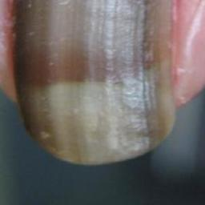  
 check with a GP#652  
**Analysis by this app:**normal = 1%; non-serious = 91%; check with a GP = 7%;   
The nail's condition is non-serious with confidence score of 91%.  
The confidence score for consulting a GP is 7%.×

 check with a GP#42  
**Analysis by this app:**normal = 0%; non-serious = 93%; check with a GP = 7%;   
The nail's condition is non-serious with confidence score of 93%.  
The confidence score for consulting a GP is 7%.×

 check with a GP#12  
**Analysis by this app:**normal = 95%; non-serious = 0%; check with a GP = 5%;   
The nail's condition is normal with confidence score of 95%.  
The confidence score for consulting a GP is 5%.×

 check with a GP#357  
**Analysis by this app:**normal = 5%; non-serious = 91%; check with a GP = 4%;   
The nail's condition is non-serious with confidence score of 91%.  
Otherwise it is normal with confidence score of 5%.×

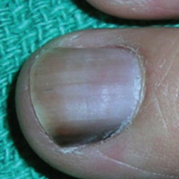  
 check with a GP#557  
**Analysis by this app:**normal = 96%; non-serious = 1%; check with a GP = 3%;   
The nail's condition is normal with confidence score of 96%.  
The confidence score for consulting a GP is 3%.×

 check with a GP#57  
**Analysis by this app:**normal = 31%; non-serious = 67%; check with a GP = 2%;   
The nail's condition is non-serious with confidence score of 67%.  
Otherwise it is normal with confidence score of 31%.×

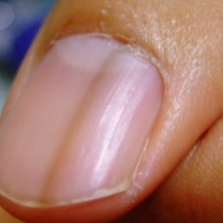  
 check with a GP#662  
**Analysis by this app:**normal = 98%; non-serious = 0%; check with a GP = 2%;   
The nail's condition is normal with confidence score of 98%.  
The confidence score for consulting a GP is 2%.×

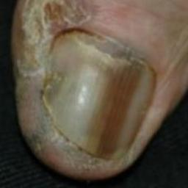  
 check with a GP#632  
**Analysis by this app:**normal = 96%; non-serious = 2%; check with a GP = 1%;   
The nail's condition is normal with confidence score of 96%.  
Otherwise it is non-serious with confidence score of 2%.×

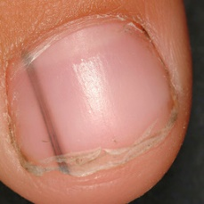  
 check with a GP#572  
**Analysis by this app:**normal = 99%; non-serious = 0%; check with a GP = 1%;   
The nail's condition is normal with confidence score of 99%.  
The confidence score for consulting a GP is 1%.×

 check with a GP#207  
**Analysis by this app:**normal = 1%; non-serious = 98%; check with a GP = 1%;   
The nail's condition is non-serious with confidence score of 98%.  
Otherwise it is normal with confidence score of 1%.×

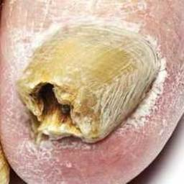  
 non-serious#1214  
**Analysis by this app:**normal = 0%; non-serious = 100%; check with a GP = 0%;   
The nail's condition is non-serious with confidence score of 100%.×

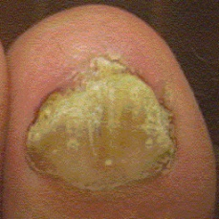  
 non-serious#1394  
**Analysis by this app:**normal = 0%; non-serious = 100%; check with a GP = 0%;   
The nail's condition is non-serious with confidence score of 100%.×

  
 non-serious#1149  
**Analysis by this app:**normal = 0%; non-serious = 100%; check with a GP = 0%;   
The nail's condition is non-serious with confidence score of 100%.×

 non-serious#1004  
**Analysis by this app:**normal = 0%; non-serious = 100%; check with a GP = 0%;   
The nail's condition is non-serious with confidence score of 100%.×

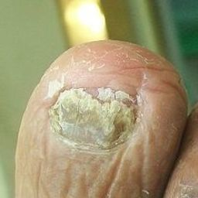  
 non-serious#1364  
**Analysis by this app:**normal = 0%; non-serious = 100%; check with a GP = 0%;   
The nail's condition is non-serious with confidence score of 100%.×

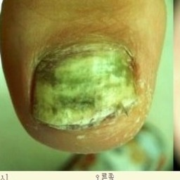  
 non-serious#1564  
**Analysis by this app:**normal = 0%; non-serious = 100%; check with a GP = 0%;   
The nail's condition is non-serious with confidence score of 100%.×

 non-serious#114  
**Analysis by this app:**normal = 0%; non-serious = 100%; check with a GP = 0%;   
The nail's condition is non-serious with confidence score of 100%.×

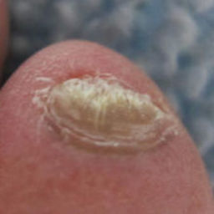  
 non-serious#1534  
**Analysis by this app:**normal = 0%; non-serious = 100%; check with a GP = 0%;   
The nail's condition is non-serious with confidence score of 100%.×

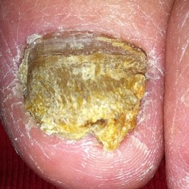  
 non-serious#1464  
**Analysis by this app:**normal = 0%; non-serious = 100%; check with a GP = 0%;   
The nail's condition is non-serious with confidence score of 100%.×

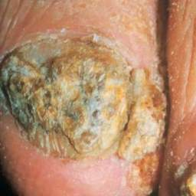  
 non-serious#1239  
**Analysis by this app:**normal = 0%; non-serious = 100%; check with a GP = 0%;   
The nail's condition is non-serious with confidence score of 100%.×

  
 non-serious#1064  
**Analysis by this app:**normal = 0%; non-serious = 100%; check with a GP = 0%;   
The nail's condition is non-serious with confidence score of 100%.×

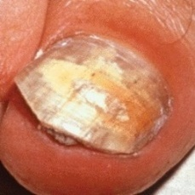  
 non-serious#1199  
**Analysis by this app:**normal = 0%; non-serious = 100%; check with a GP = 0%;   
The nail's condition is non-serious with confidence score of 100%.×

 non-serious#279  
**Analysis by this app:**normal = 0%; non-serious = 100%; check with a GP = 0%;   
The nail's condition is non-serious with confidence score of 100%.×

 non-serious#494  
**Analysis by this app:**normal = 0%; non-serious = 100%; check with a GP = 0%;   
The nail's condition is non-serious with confidence score of 100%.×

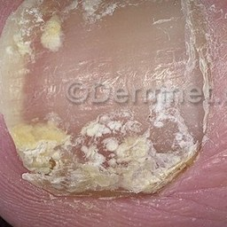  
 non-serious#1114  
**Analysis by this app:**normal = 0%; non-serious = 100%; check with a GP = 0%;   
The nail's condition is non-serious with confidence score of 100%.×

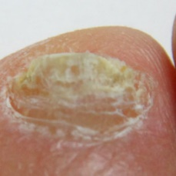  
 non-serious#1604  
**Analysis by this app:**normal = 0%; non-serious = 100%; check with a GP = 0%;   
The nail's condition is non-serious with confidence score of 100%.×

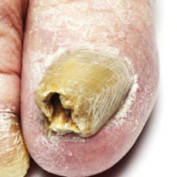  
 non-serious#1189  
**Analysis by this app:**normal = 0%; non-serious = 100%; check with a GP = 0%;   
The nail's condition is non-serious with confidence score of 100%.×

 non-serious#809  
**Analysis by this app:**normal = 0%; non-serious = 100%; check with a GP = 0%;   
The nail's condition is non-serious with confidence score of 100%.×

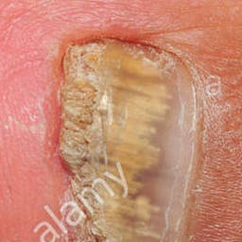  
 non-serious#1184  
**Analysis by this app:**normal = 0%; non-serious = 100%; check with a GP = 0%;   
The nail's condition is non-serious with confidence score of 100%.×

 non-serious#654  
**Analysis by this app:**normal = 0%; non-serious = 100%; check with a GP = 0%;   
The nail's condition is non-serious with confidence score of 100%.×

 non-serious#949  
**Analysis by this app:**normal = 0%; non-serious = 100%; check with a GP = 0%;   
The nail's condition is non-serious with confidence score of 100%.×

 non-serious#449  
**Analysis by this app:**normal = 0%; non-serious = 100%; check with a GP = 0%;   
The nail's condition is non-serious with confidence score of 100%.×

 non-serious#674  
**Analysis by this app:**normal = 0%; non-serious = 100%; check with a GP = 0%;   
The nail's condition is non-serious with confidence score of 100%.×

 non-serious#574  
**Analysis by this app:**normal = 0%; non-serious = 100%; check with a GP = 0%;   
The nail's condition is non-serious with confidence score of 100%.×

 non-serious#739  
**Analysis by this app:**normal = 0%; non-serious = 100%; check with a GP = 0%;   
The nail's condition is non-serious with confidence score of 100%.×

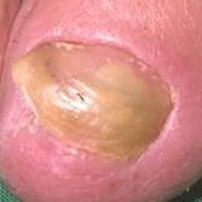  
 non-serious#1119  
**Analysis by this app:**normal = 0%; non-serious = 100%; check with a GP = 0%;   
The nail's condition is non-serious with confidence score of 100%.×

 non-serious#609  
**Analysis by this app:**normal = 0%; non-serious = 100%; check with a GP = 0%;   
The nail's condition is non-serious with confidence score of 100%.×

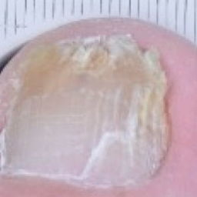  
 non-serious#1419  
**Analysis by this app:**normal = 0%; non-serious = 100%; check with a GP = 0%;   
The nail's condition is non-serious with confidence score of 100%.×

 non-serious#834  
**Analysis by this app:**normal = 0%; non-serious = 100%; check with a GP = 0%;   
The nail's condition is non-serious with confidence score of 100%.×

 non-serious#89  
**Analysis by this app:**normal = 0%; non-serious = 100%; check with a GP = 0%;   
The nail's condition is non-serious with confidence score of 100%.×

 non-serious#49  
**Analysis by this app:**normal = 0%; non-serious = 100%; check with a GP = 0%;   
The nail's condition is non-serious with confidence score of 100%.×

 non-serious#764  
**Analysis by this app:**normal = 0%; non-serious = 100%; check with a GP = 0%;   
The nail's condition is non-serious with confidence score of 100%.×

 non-serious#559  
**Analysis by this app:**normal = 0%; non-serious = 100%; check with a GP = 0%;   
The nail's condition is non-serious with confidence score of 100%.×

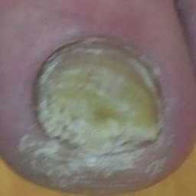  
 non-serious#1109  
**Analysis by this app:**normal = 0%; non-serious = 100%; check with a GP = 0%;   
The nail's condition is non-serious with confidence score of 100%.×

 non-serious#639  
**Analysis by this app:**normal = 0%; non-serious = 100%; check with a GP = 0%;   
The nail's condition is non-serious with confidence score of 100%.×

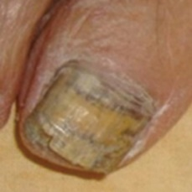  
 non-serious#1434  
**Analysis by this app:**normal = 0%; non-serious = 100%; check with a GP = 0%;   
The nail's condition is non-serious with confidence score of 100%.×

 non-serious#184  
**Analysis by this app:**normal = 0%; non-serious = 100%; check with a GP = 0%;   
The nail's condition is non-serious with confidence score of 100%.×

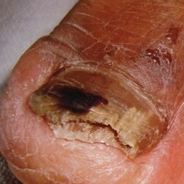  
 non-serious#1014  
**Analysis by this app:**normal = 0%; non-serious = 100%; check with a GP = 0%;   
The nail's condition is non-serious with confidence score of 100%.×

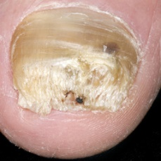  
 non-serious#1129  
**Analysis by this app:**normal = 0%; non-serious = 100%; check with a GP = 0%;   
The nail's condition is non-serious with confidence score of 100%.×

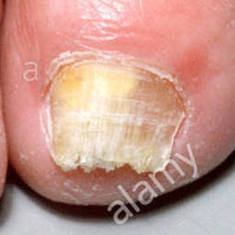  
 non-serious#1054  
**Analysis by this app:**normal = 0%; non-serious = 100%; check with a GP = 0%;   
The nail's condition is non-serious with confidence score of 100%.×

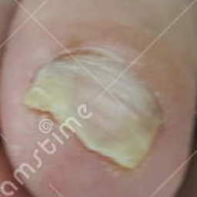  
 non-serious#1104  
**Analysis by this app:**normal = 0%; non-serious = 100%; check with a GP = 0%;   
The nail's condition is non-serious with confidence score of 100%.×

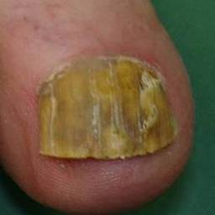  
 non-serious#1474  
**Analysis by this app:**normal = 0%; non-serious = 100%; check with a GP = 0%;   
The nail's condition is non-serious with confidence score of 100%.×

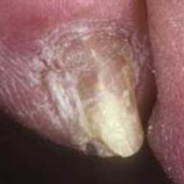  
 non-serious#1449  
**Analysis by this app:**normal = 0%; non-serious = 100%; check with a GP = 0%;   
The nail's condition is non-serious with confidence score of 100%.×

 non-serious#759  
**Analysis by this app:**normal = 0%; non-serious = 100%; check with a GP = 0%;   
The nail's condition is non-serious with confidence score of 100%.×

 non-serious#719  
**Analysis by this app:**normal = 0%; non-serious = 100%; check with a GP = 0%;   
The nail's condition is non-serious with confidence score of 100%.×

 non-serious#659  
**Analysis by this app:**normal = 0%; non-serious = 100%; check with a GP = 0%;   
The nail's condition is non-serious with confidence score of 100%.×

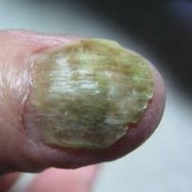  
 non-serious#1529  
**Analysis by this app:**normal = 0%; non-serious = 100%; check with a GP = 0%;   
The nail's condition is non-serious with confidence score of 100%.×

 non-serious#214  
**Analysis by this app:**normal = 0%; non-serious = 100%; check with a GP = 0%;   
The nail's condition is non-serious with confidence score of 100%.×

 non-serious#259  
**Analysis by this app:**normal = 0%; non-serious = 100%; check with a GP = 0%;   
The nail's condition is non-serious with confidence score of 100%.×

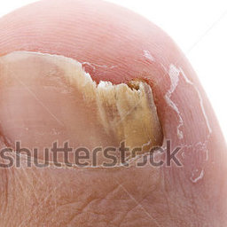  
 non-serious#1099  
**Analysis by this app:**normal = 0%; non-serious = 100%; check with a GP = 0%;   
The nail's condition is non-serious with confidence score of 100%.×

 non-serious#999  
**Analysis by this app:**normal = 0%; non-serious = 100%; check with a GP = 0%;   
The nail's condition is non-serious with confidence score of 100%.×

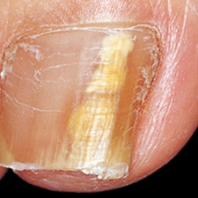  
 non-serious#1494  
**Analysis by this app:**normal = 0%; non-serious = 100%; check with a GP = 0%;   
The nail's condition is non-serious with confidence score of 100%.×

 non-serious#4  
**Analysis by this app:**normal = 0%; non-serious = 100%; check with a GP = 0%;   
The nail's condition is non-serious with confidence score of 100%.×

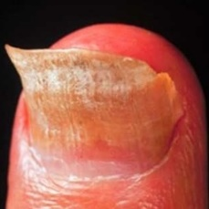  
 non-serious#1249  
**Analysis by this app:**normal = 0%; non-serious = 100%; check with a GP = 0%;   
The nail's condition is non-serious with confidence score of 100%.×

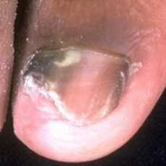  
 non-serious#1164  
**Analysis by this app:**normal = 0%; non-serious = 100%; check with a GP = 0%;   
The nail's condition is non-serious with confidence score of 100%.×

 non-serious#754  
**Analysis by this app:**normal = 0%; non-serious = 100%; check with a GP = 0%;   
The nail's condition is non-serious with confidence score of 100%.×

 non-serious#714  
**Analysis by this app:**normal = 0%; non-serious = 100%; check with a GP = 0%;   
The nail's condition is non-serious with confidence score of 100%.×

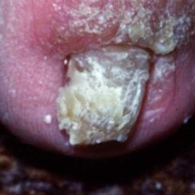  
 non-serious#1194  
**Analysis by this app:**normal = 0%; non-serious = 100%; check with a GP = 0%;   
The nail's condition is non-serious with confidence score of 100%.×

 non-serious#794  
**Analysis by this app:**normal = 0%; non-serious = 100%; check with a GP = 0%;   
The nail's condition is non-serious with confidence score of 100%.×

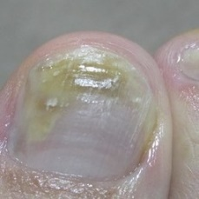  
 non-serious#1539  
**Analysis by this app:**normal = 0%; non-serious = 100%; check with a GP = 0%;   
The nail's condition is non-serious with confidence score of 100%.×

 non-serious#829  
**Analysis by this app:**normal = 0%; non-serious = 100%; check with a GP = 0%;   
The nail's condition is non-serious with confidence score of 100%.×

 non-serious#54  
**Analysis by this app:**normal = 0%; non-serious = 100%; check with a GP = 0%;   
The nail's condition is non-serious with confidence score of 100%.×

 non-serious#689  
**Analysis by this app:**normal = 0%; non-serious = 100%; check with a GP = 0%;   
The nail's condition is non-serious with confidence score of 100%.×

 non-serious#664  
**Analysis by this app:**normal = 0%; non-serious = 100%; check with a GP = 0%;   
The nail's condition is non-serious with confidence score of 100%.×

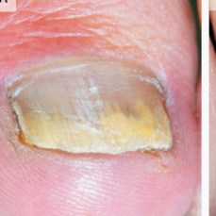  
 non-serious#1569  
**Analysis by this app:**normal = 0%; non-serious = 100%; check with a GP = 0%;   
The nail's condition is non-serious with confidence score of 100%.×

 non-serious#819  
**Analysis by this app:**normal = 0%; non-serious = 100%; check with a GP = 0%;   
The nail's condition is non-serious with confidence score of 100%.×

 non-serious#944  
**Analysis by this app:**normal = 0%; non-serious = 100%; check with a GP = 0%;   
The nail's condition is non-serious with confidence score of 100%.×

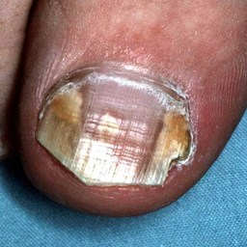  
 non-serious#1379  
**Analysis by this app:**normal = 0%; non-serious = 100%; check with a GP = 0%;   
The nail's condition is non-serious with confidence score of 100%.×

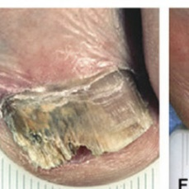  
 non-serious#1039  
**Analysis by this app:**normal = 0%; non-serious = 100%; check with a GP = 0%;   
The nail's condition is non-serious with confidence score of 100%.×

 non-serious#889  
**Analysis by this app:**normal = 0%; non-serious = 100%; check with a GP = 0%;   
The nail's condition is non-serious with confidence score of 100%.×

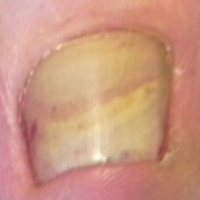  
 non-serious#1309  
**Analysis by this app:**normal = 0%; non-serious = 100%; check with a GP = 0%;   
The nail's condition is non-serious with confidence score of 100%.×

 non-serious#849  
**Analysis by this app:**normal = 0%; non-serious = 100%; check with a GP = 0%;   
The nail's condition is non-serious with confidence score of 100%.×

 non-serious#479  
**Analysis by this app:**normal = 0%; non-serious = 100%; check with a GP = 0%;   
The nail's condition is non-serious with confidence score of 100%.×

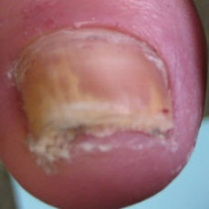  
 non-serious#1484  
**Analysis by this app:**normal = 0%; non-serious = 100%; check with a GP = 0%;   
The nail's condition is non-serious with confidence score of 100%.×

 non-serious#459  
**Analysis by this app:**normal = 0%; non-serious = 100%; check with a GP = 0%;   
The nail's condition is non-serious with confidence score of 100%.×

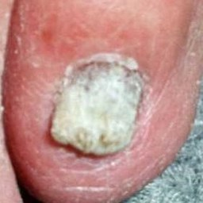  
 non-serious#1314  
**Analysis by this app:**normal = 0%; non-serious = 100%; check with a GP = 0%;   
The nail's condition is non-serious with confidence score of 100%.×

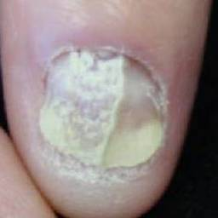  
 non-serious#1354  
**Analysis by this app:**normal = 0%; non-serious = 100%; check with a GP = 0%;   
The nail's condition is non-serious with confidence score of 100%.×

 non-serious#904  
**Analysis by this app:**normal = 0%; non-serious = 100%; check with a GP = 0%;   
The nail's condition is non-serious with confidence score of 100%.×

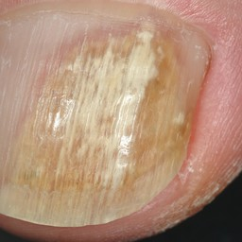  
 non-serious#1374  
**Analysis by this app:**normal = 0%; non-serious = 100%; check with a GP = 0%;   
The nail's condition is non-serious with confidence score of 100%.×

 non-serious#124  
**Analysis by this app:**normal = 0%; non-serious = 100%; check with a GP = 0%;   
The nail's condition is non-serious with confidence score of 100%.×

 non-serious#454  
**Analysis by this app:**normal = 0%; non-serious = 100%; check with a GP = 0%;   
The nail's condition is non-serious with confidence score of 100%.×

 non-serious#469  
**Analysis by this app:**normal = 0%; non-serious = 100%; check with a GP = 0%;   
The nail's condition is non-serious with confidence score of 100%.×

 non-serious#854  
**Analysis by this app:**normal = 0%; non-serious = 100%; check with a GP = 0%;   
The nail's condition is non-serious with confidence score of 100%.×

 non-serious#549  
**Analysis by this app:**normal = 0%; non-serious = 100%; check with a GP = 0%;   
The nail's condition is non-serious with confidence score of 100%.×

 non-serious#354  
**Analysis by this app:**normal = 0%; non-serious = 100%; check with a GP = 0%;   
The nail's condition is non-serious with confidence score of 100%.×

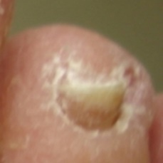  
 non-serious#1549  
**Analysis by this app:**normal = 0%; non-serious = 100%; check with a GP = 0%;   
The nail's condition is non-serious with confidence score of 100%.×

 non-serious#929  
**Analysis by this app:**normal = 0%; non-serious = 100%; check with a GP = 0%;   
The nail's condition is non-serious with confidence score of 100%.×

 non-serious#154  
**Analysis by this app:**normal = 0%; non-serious = 100%; check with a GP = 0%;   
The nail's condition is non-serious with confidence score of 100%.×

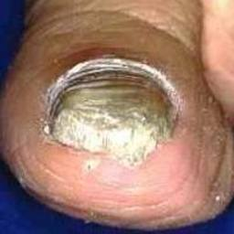  
 non-serious#1259  
**Analysis by this app:**normal = 0%; non-serious = 100%; check with a GP = 0%;   
The nail's condition is non-serious with confidence score of 100%.×

 non-serious#129  
**Analysis by this app:**normal = 0%; non-serious = 100%; check with a GP = 0%;   
The nail's condition is non-serious with confidence score of 100%.×

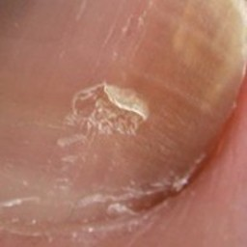  
 non-serious#1019  
**Analysis by this app:**normal = 0%; non-serious = 100%; check with a GP = 0%;   
The nail's condition is non-serious with confidence score of 100%.×

 non-serious#219  
**Analysis by this app:**normal = 0%; non-serious = 100%; check with a GP = 0%;   
The nail's condition is non-serious with confidence score of 100%.×

 non-serious#604  
**Analysis by this app:**normal = 0%; non-serious = 100%; check with a GP = 0%;   
The nail's condition is non-serious with confidence score of 100%.×

 non-serious#514  
**Analysis by this app:**normal = 0%; non-serious = 100%; check with a GP = 0%;   
The nail's condition is non-serious with confidence score of 100%.×

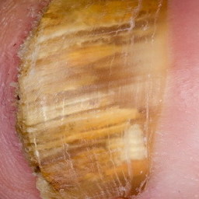  
 non-serious#1089  
**Analysis by this app:**normal = 0%; non-serious = 100%; check with a GP = 0%;   
The nail's condition is non-serious with confidence score of 100%.×

 non-serious#554  
**Analysis by this app:**normal = 0%; non-serious = 100%; check with a GP = 0%;   
The nail's condition is non-serious with confidence score of 100%.×

 non-serious#44  
**Analysis by this app:**normal = 0%; non-serious = 100%; check with a GP = 0%;   
The nail's condition is non-serious with confidence score of 100%.×

 non-serious#984  
**Analysis by this app:**normal = 0%; non-serious = 100%; check with a GP = 0%;   
The nail's condition is non-serious with confidence score of 100%.×

 non-serious#679  
**Analysis by this app:**normal = 0%; non-serious = 100%; check with a GP = 0%;   
The nail's condition is non-serious with confidence score of 100%.×

 non-serious#239  
**Analysis by this app:**normal = 0%; non-serious = 100%; check with a GP = 0%;   
The nail's condition is non-serious with confidence score of 100%.×

 non-serious#179  
**Analysis by this app:**normal = 0%; non-serious = 100%; check with a GP = 0%;   
The nail's condition is non-serious with confidence score of 100%.×

 non-serious#634  
**Analysis by this app:**normal = 0%; non-serious = 100%; check with a GP = 0%;   
The nail's condition is non-serious with confidence score of 100%.×

 non-serious#899  
**Analysis by this app:**normal = 0%; non-serious = 100%; check with a GP = 0%;   
The nail's condition is non-serious with confidence score of 100%.×

 non-serious#649  
**Analysis by this app:**normal = 0%; non-serious = 100%; check with a GP = 0%;   
The nail's condition is non-serious with confidence score of 100%.×

 non-serious#924  
**Analysis by this app:**normal = 0%; non-serious = 100%; check with a GP = 0%;   
The nail's condition is non-serious with confidence score of 100%.×

 non-serious#394  
**Analysis by this app:**normal = 0%; non-serious = 100%; check with a GP = 0%;   
The nail's condition is non-serious with confidence score of 100%.×

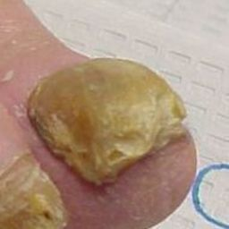  
 non-serious#1459  
**Analysis by this app:**normal = 0%; non-serious = 100%; check with a GP = 0%;   
The nail's condition is non-serious with confidence score of 100%.×

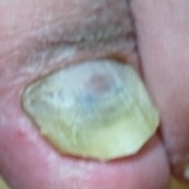  
 non-serious#1489  
**Analysis by this app:**normal = 0%; non-serious = 100%; check with a GP = 0%;   
The nail's condition is non-serious with confidence score of 100%.×

 non-serious#119  
**Analysis by this app:**normal = 0%; non-serious = 100%; check with a GP = 0%;   
The nail's condition is non-serious with confidence score of 100%.×

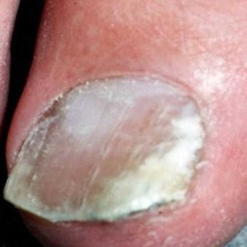  
 non-serious#1059  
**Analysis by this app:**normal = 0%; non-serious = 100%; check with a GP = 0%;   
The nail's condition is non-serious with confidence score of 100%.×

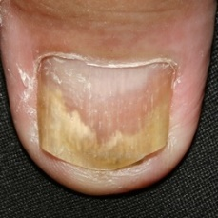  
 non-serious#1289  
**Analysis by this app:**normal = 0%; non-serious = 100%; check with a GP = 0%;   
The nail's condition is non-serious with confidence score of 100%.×

  
 non-serious#1034  
**Analysis by this app:**normal = 0%; non-serious = 100%; check with a GP = 0%;   
The nail's condition is non-serious with confidence score of 100%.×

 non-serious#669  
**Analysis by this app:**normal = 0%; non-serious = 100%; check with a GP = 0%;   
The nail's condition is non-serious with confidence score of 100%.×

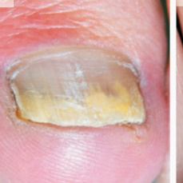  
 non-serious#1574  
**Analysis by this app:**normal = 0%; non-serious = 100%; check with a GP = 0%;   
The nail's condition is non-serious with confidence score of 100%.×

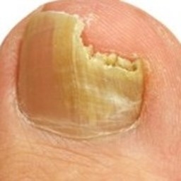  
 non-serious#1444  
**Analysis by this app:**normal = 0%; non-serious = 100%; check with a GP = 0%;   
The nail's condition is non-serious with confidence score of 100%.×

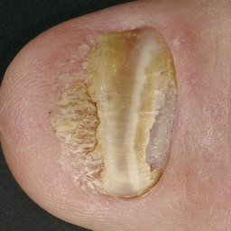  
 non-serious#1369  
**Analysis by this app:**normal = 0%; non-serious = 100%; check with a GP = 0%;   
The nail's condition is non-serious with confidence score of 100%.×

 non-serious#824  
**Analysis by this app:**normal = 0%; non-serious = 100%; check with a GP = 0%;   
The nail's condition is non-serious with confidence score of 100%.×

 non-serious#684  
**Analysis by this app:**normal = 0%; non-serious = 100%; check with a GP = 0%;   
The nail's condition is non-serious with confidence score of 100%.×

 non-serious#424  
**Analysis by this app:**normal = 0%; non-serious = 100%; check with a GP = 0%;   
The nail's condition is non-serious with confidence score of 100%.×

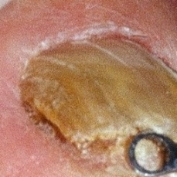  
 non-serious#1329  
**Analysis by this app:**normal = 0%; non-serious = 100%; check with a GP = 0%;   
The nail's condition is non-serious with confidence score of 100%.×

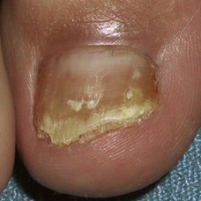  
 non-serious#1084  
**Analysis by this app:**normal = 0%; non-serious = 100%; check with a GP = 0%;   
The nail's condition is non-serious with confidence score of 100%.×

 non-serious#939  
**Analysis by this app:**normal = 0%; non-serious = 100%; check with a GP = 0%;   
The nail's condition is non-serious with confidence score of 100%.×

 non-serious#914  
**Analysis by this app:**normal = 0%; non-serious = 99%; check with a GP = 0%;   
The nail's condition is non-serious with confidence score of 99%.×

 non-serious#314  
**Analysis by this app:**normal = 0%; non-serious = 99%; check with a GP = 0%;   
The nail's condition is non-serious with confidence score of 99%.×

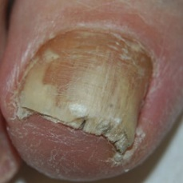  
 non-serious#1479  
**Analysis by this app:**normal = 0%; non-serious = 99%; check with a GP = 0%;   
The nail's condition is non-serious with confidence score of 99%.×

 non-serious#769  
**Analysis by this app:**normal = 0%; non-serious = 99%; check with a GP = 1%;   
The nail's condition is non-serious with confidence score of 99%.  
The confidence score for consulting a GP is 1%.×

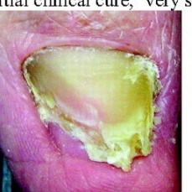  
 non-serious#1224  
**Analysis by this app:**normal = 0%; non-serious = 99%; check with a GP = 0%;   
The nail's condition is non-serious with confidence score of 99%.×

 non-serious#874  
**Analysis by this app:**normal = 0%; non-serious = 99%; check with a GP = 1%;   
The nail's condition is non-serious with confidence score of 99%.  
The confidence score for consulting a GP is 1%.×

 non-serious#249  
**Analysis by this app:**normal = 0%; non-serious = 99%; check with a GP = 1%;   
The nail's condition is non-serious with confidence score of 99%.  
The confidence score for consulting a GP is 1%.×

 non-serious#629  
**Analysis by this app:**normal = 0%; non-serious = 99%; check with a GP = 1%;   
The nail's condition is non-serious with confidence score of 99%.  
The confidence score for consulting a GP is 1%.×

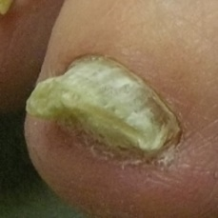  
 non-serious#1029  
**Analysis by this app:**normal = 1%; non-serious = 99%; check with a GP = 0%;   
The nail's condition is non-serious with confidence score of 99%.  
Otherwise it is normal with confidence score of 1%.×

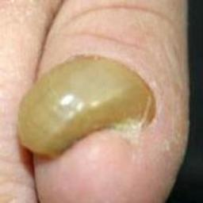  
 non-serious#1594  
**Analysis by this app:**normal = 1%; non-serious = 99%; check with a GP = 0%;   
The nail's condition is non-serious with confidence score of 99%.  
Otherwise it is normal with confidence score of 1%.×

 non-serious#779  
**Analysis by this app:**normal = 0%; non-serious = 99%; check with a GP = 1%;   
The nail's condition is non-serious with confidence score of 99%.  
The confidence score for consulting a GP is 1%.×

 non-serious#294  
**Analysis by this app:**normal = 0%; non-serious = 99%; check with a GP = 1%;   
The nail's condition is non-serious with confidence score of 99%.  
The confidence score for consulting a GP is 1%.×

 non-serious#964  
**Analysis by this app:**normal = 0%; non-serious = 99%; check with a GP = 0%;   
The nail's condition is non-serious with confidence score of 99%.×

 non-serious#839  
**Analysis by this app:**normal = 0%; non-serious = 99%; check with a GP = 1%;   
The nail's condition is non-serious with confidence score of 99%.  
The confidence score for consulting a GP is 1%.×

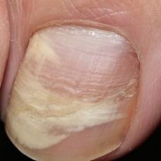  
 non-serious#1144  
**Analysis by this app:**normal = 1%; non-serious = 99%; check with a GP = 0%;   
The nail's condition is non-serious with confidence score of 99%.  
Otherwise it is normal with confidence score of 1%.×

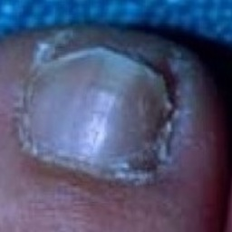  
 non-serious#1299  
**Analysis by this app:**normal = 0%; non-serious = 99%; check with a GP = 0%;   
The nail's condition is non-serious with confidence score of 99%.×

  
 non-serious#1044  
**Analysis by this app:**normal = 0%; non-serious = 99%; check with a GP = 0%;   
The nail's condition is non-serious with confidence score of 99%.×

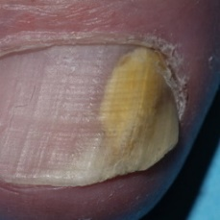  
 non-serious#1349  
**Analysis by this app:**normal = 0%; non-serious = 99%; check with a GP = 0%;   
The nail's condition is non-serious with confidence score of 99%.×

 non-serious#624  
**Analysis by this app:**normal = 0%; non-serious = 99%; check with a GP = 1%;   
The nail's condition is non-serious with confidence score of 99%.  
The confidence score for consulting a GP is 1%.×

 non-serious#799  
**Analysis by this app:**normal = 0%; non-serious = 99%; check with a GP = 1%;   
The nail's condition is non-serious with confidence score of 99%.  
The confidence score for consulting a GP is 1%.×

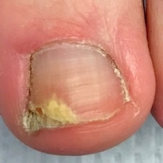  
 non-serious#1179  
**Analysis by this app:**normal = 0%; non-serious = 99%; check with a GP = 1%;   
The nail's condition is non-serious with confidence score of 99%.  
The confidence score for consulting a GP is 1%.×

 non-serious#544  
**Analysis by this app:**normal = 0%; non-serious = 99%; check with a GP = 1%;   
The nail's condition is non-serious with confidence score of 99%.  
The confidence score for consulting a GP is 1%.×

 non-serious#79  
**Analysis by this app:**normal = 0%; non-serious = 99%; check with a GP = 1%;   
The nail's condition is non-serious with confidence score of 99%.  
The confidence score for consulting a GP is 1%.×

 non-serious#24  
**Analysis by this app:**normal = 0%; non-serious = 99%; check with a GP = 0%;   
The nail's condition is non-serious with confidence score of 99%.×

 non-serious#954  
**Analysis by this app:**normal = 0%; non-serious = 99%; check with a GP = 1%;   
The nail's condition is non-serious with confidence score of 99%.  
The confidence score for consulting a GP is 1%.×

 non-serious#234  
**Analysis by this app:**normal = 0%; non-serious = 99%; check with a GP = 1%;   
The nail's condition is non-serious with confidence score of 99%.  
The confidence score for consulting a GP is 1%.×

 non-serious#579  
**Analysis by this app:**normal = 0%; non-serious = 99%; check with a GP = 1%;   
The nail's condition is non-serious with confidence score of 99%.  
The confidence score for consulting a GP is 1%.×

 non-serious#419  
**Analysis by this app:**normal = 0%; non-serious = 99%; check with a GP = 1%;   
The nail's condition is non-serious with confidence score of 99%.  
The confidence score for consulting a GP is 1%.×

 non-serious#204  
**Analysis by this app:**normal = 1%; non-serious = 99%; check with a GP = 0%;   
The nail's condition is non-serious with confidence score of 99%.  
Otherwise it is normal with confidence score of 1%.×

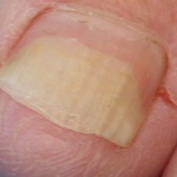  
 non-serious#1254  
**Analysis by this app:**normal = 1%; non-serious = 99%; check with a GP = 0%;   
The nail's condition is non-serious with confidence score of 99%.  
Otherwise it is normal with confidence score of 1%.×

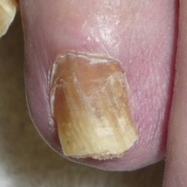  
 non-serious#1274  
**Analysis by this app:**normal = 1%; non-serious = 99%; check with a GP = 0%;   
The nail's condition is non-serious with confidence score of 99%.  
Otherwise it is normal with confidence score of 1%.×

 non-serious#969  
**Analysis by this app:**normal = 0%; non-serious = 99%; check with a GP = 1%;   
The nail's condition is non-serious with confidence score of 99%.  
The confidence score for consulting a GP is 1%.×

 non-serious#789  
**Analysis by this app:**normal = 1%; non-serious = 99%; check with a GP = 0%;   
The nail's condition is non-serious with confidence score of 99%.  
Otherwise it is normal with confidence score of 1%.×

 non-serious#644  
**Analysis by this app:**normal = 0%; non-serious = 99%; check with a GP = 1%;   
The nail's condition is non-serious with confidence score of 99%.  
The confidence score for consulting a GP is 1%.×

 non-serious#9  
**Analysis by this app:**normal = 1%; non-serious = 99%; check with a GP = 0%;   
The nail's condition is non-serious with confidence score of 99%.  
Otherwise it is normal with confidence score of 1%.×

 non-serious#369  
**Analysis by this app:**normal = 1%; non-serious = 99%; check with a GP = 1%;   
The nail's condition is non-serious with confidence score of 99%.  
Otherwise it is normal with confidence score of 1%.×

 non-serious#934  
**Analysis by this app:**normal = 1%; non-serious = 99%; check with a GP = 0%;   
The nail's condition is non-serious with confidence score of 99%.  
Otherwise it is normal with confidence score of 1%.×

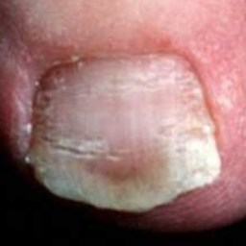  
 non-serious#1154  
**Analysis by this app:**normal = 1%; non-serious = 99%; check with a GP = 0%;   
The nail's condition is non-serious with confidence score of 99%.  
Otherwise it is normal with confidence score of 1%.×

 non-serious#434  
**Analysis by this app:**normal = 0%; non-serious = 99%; check with a GP = 1%;   
The nail's condition is non-serious with confidence score of 99%.  
The confidence score for consulting a GP is 1%.×

 non-serious#144  
**Analysis by this app:**normal = 1%; non-serious = 99%; check with a GP = 1%;   
The nail's condition is non-serious with confidence score of 99%.  
Otherwise it is normal with confidence score of 1%.×

 non-serious#474  
**Analysis by this app:**normal = 0%; non-serious = 99%; check with a GP = 1%;   
The nail's condition is non-serious with confidence score of 99%.  
The confidence score for consulting a GP is 1%.×

 non-serious#569  
**Analysis by this app:**normal = 1%; non-serious = 99%; check with a GP = 0%;   
The nail's condition is non-serious with confidence score of 99%.  
Otherwise it is normal with confidence score of 1%.×

 non-serious#884  
**Analysis by this app:**normal = 0%; non-serious = 99%; check with a GP = 1%;   
The nail's condition is non-serious with confidence score of 99%.  
The confidence score for consulting a GP is 1%.×

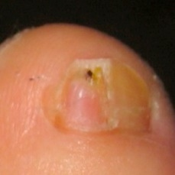  
 non-serious#1334  
**Analysis by this app:**normal = 1%; non-serious = 99%; check with a GP = 0%;   
The nail's condition is non-serious with confidence score of 99%.  
Otherwise it is normal with confidence score of 1%.×

  
 non-serious#1049  
**Analysis by this app:**normal = 1%; non-serious = 99%; check with a GP = 0%;   
The nail's condition is non-serious with confidence score of 99%.  
Otherwise it is normal with confidence score of 1%.×

 non-serious#19  
**Analysis by this app:**normal = 1%; non-serious = 99%; check with a GP = 0%;   
The nail's condition is non-serious with confidence score of 99%.  
Otherwise it is normal with confidence score of 1%.×

 non-serious#344  
**Analysis by this app:**normal = 0%; non-serious = 99%; check with a GP = 1%;   
The nail's condition is non-serious with confidence score of 99%.  
The confidence score for consulting a GP is 1%.×

 non-serious#334  
**Analysis by this app:**normal = 0%; non-serious = 98%; check with a GP = 1%;   
The nail's condition is non-serious with confidence score of 98%.  
The confidence score for consulting a GP is 1%.×

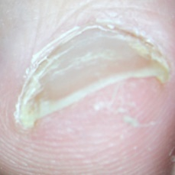  
 non-serious#1159  
**Analysis by this app:**normal = 2%; non-serious = 98%; check with a GP = 0%;   
The nail's condition is non-serious with confidence score of 98%.  
Otherwise it is normal with confidence score of 2%.×

 non-serious#229  
**Analysis by this app:**normal = 2%; non-serious = 98%; check with a GP = 0%;   
The nail's condition is non-serious with confidence score of 98%.  
Otherwise it is normal with confidence score of 2%.×

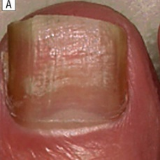  
 non-serious#1169  
**Analysis by this app:**normal = 0%; non-serious = 98%; check with a GP = 1%;   
The nail's condition is non-serious with confidence score of 98%.  
The confidence score for consulting a GP is 1%.×

 non-serious#74  
**Analysis by this app:**normal = 2%; non-serious = 98%; check with a GP = 0%;   
The nail's condition is non-serious with confidence score of 98%.  
Otherwise it is normal with confidence score of 2%.×

 non-serious#589  
**Analysis by this app:**normal = 0%; non-serious = 98%; check with a GP = 1%;   
The nail's condition is non-serious with confidence score of 98%.  
The confidence score for consulting a GP is 1%.×

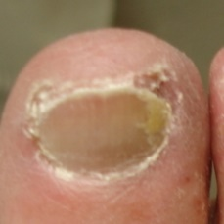  
 non-serious#1589  
**Analysis by this app:**normal = 1%; non-serious = 98%; check with a GP = 1%;   
The nail's condition is non-serious with confidence score of 98%.  
Otherwise it is normal with confidence score of 1%.×

 non-serious#584  
**Analysis by this app:**normal = 1%; non-serious = 98%; check with a GP = 1%;   
The nail's condition is non-serious with confidence score of 98%.  
Otherwise it is normal with confidence score of 1%.×

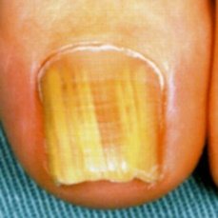  
 non-serious#1599  
**Analysis by this app:**normal = 0%; non-serious = 98%; check with a GP = 2%;   
The nail's condition is non-serious with confidence score of 98%.  
The confidence score for consulting a GP is 2%.×

  
 non-serious#1554  
**Analysis by this app:**normal = 0%; non-serious = 98%; check with a GP = 2%;   
The nail's condition is non-serious with confidence score of 98%.  
The confidence score for consulting a GP is 2%.×

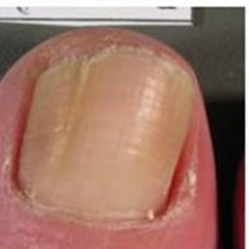  
 non-serious#1069  
**Analysis by this app:**normal = 1%; non-serious = 98%; check with a GP = 1%;   
The nail's condition is non-serious with confidence score of 98%.  
Otherwise it is normal with confidence score of 1%.×

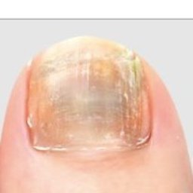  
 non-serious#1509  
**Analysis by this app:**normal = 1%; non-serious = 98%; check with a GP = 1%;   
The nail's condition is non-serious with confidence score of 98%.  
Otherwise it is normal with confidence score of 1%.×

 non-serious#534  
**Analysis by this app:**normal = 1%; non-serious = 98%; check with a GP = 1%;   
The nail's condition is non-serious with confidence score of 98%.  
Otherwise it is normal with confidence score of 1%.×

 non-serious#499  
**Analysis by this app:**normal = 0%; non-serious = 98%; check with a GP = 2%;   
The nail's condition is non-serious with confidence score of 98%.  
The confidence score for consulting a GP is 2%.×

 non-serious#994  
**Analysis by this app:**normal = 0%; non-serious = 98%; check with a GP = 1%;   
The nail's condition is non-serious with confidence score of 98%.  
The confidence score for consulting a GP is 1%.×

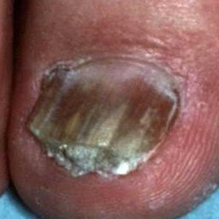  
 non-serious#1209  
**Analysis by this app:**normal = 1%; non-serious = 98%; check with a GP = 1%;   
The nail's condition is non-serious with confidence score of 98%.  
Otherwise it is normal with confidence score of 1%.×

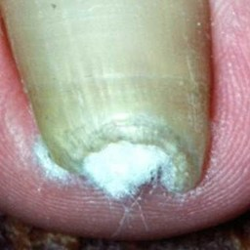  
 non-serious#1429  
**Analysis by this app:**normal = 1%; non-serious = 98%; check with a GP = 1%;   
The nail's condition is non-serious with confidence score of 98%.  
Otherwise it is normal with confidence score of 1%.×

 non-serious#894  
**Analysis by this app:**normal = 0%; non-serious = 98%; check with a GP = 2%;   
The nail's condition is non-serious with confidence score of 98%.  
The confidence score for consulting a GP is 2%.×

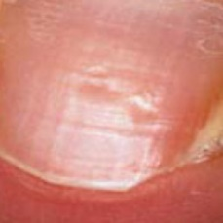  
 non-serious#1139  
**Analysis by this app:**normal = 2%; non-serious = 98%; check with a GP = 0%;   
The nail's condition is non-serious with confidence score of 98%.  
Otherwise it is normal with confidence score of 2%.×

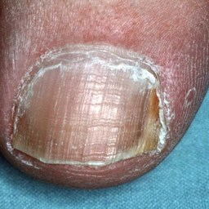  
 non-serious#1269  
**Analysis by this app:**normal = 0%; non-serious = 98%; check with a GP = 2%;   
The nail's condition is non-serious with confidence score of 98%.  
The confidence score for consulting a GP is 2%.×

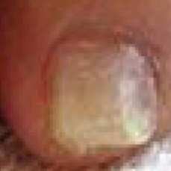  
 non-serious#1124  
**Analysis by this app:**normal = 0%; non-serious = 98%; check with a GP = 2%;   
The nail's condition is non-serious with confidence score of 98%.  
The confidence score for consulting a GP is 2%.×

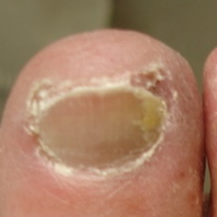  
 non-serious#1544  
**Analysis by this app:**normal = 1%; non-serious = 98%; check with a GP = 1%;   
The nail's condition is non-serious with confidence score of 98%.  
Otherwise it is normal with confidence score of 1%.×

 non-serious#34  
**Analysis by this app:**normal = 0%; non-serious = 98%; check with a GP = 2%;   
The nail's condition is non-serious with confidence score of 98%.  
The confidence score for consulting a GP is 2%.×

 non-serious#709  
**Analysis by this app:**normal = 0%; non-serious = 98%; check with a GP = 2%;   
The nail's condition is non-serious with confidence score of 98%.  
The confidence score for consulting a GP is 2%.×

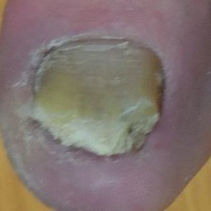  
 non-serious#1344  
**Analysis by this app:**normal = 1%; non-serious = 98%; check with a GP = 1%;   
The nail's condition is non-serious with confidence score of 98%.  
Otherwise it is normal with confidence score of 1%.×

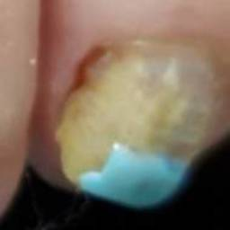  
 non-serious#1584  
**Analysis by this app:**normal = 2%; non-serious = 98%; check with a GP = 1%;   
The nail's condition is non-serious with confidence score of 98%.  
Otherwise it is normal with confidence score of 2%.×

 non-serious#414  
**Analysis by this app:**normal = 0%; non-serious = 98%; check with a GP = 2%;   
The nail's condition is non-serious with confidence score of 98%.  
The confidence score for consulting a GP is 2%.×

 non-serious#399  
**Analysis by this app:**normal = 1%; non-serious = 97%; check with a GP = 2%;   
The nail's condition is non-serious with confidence score of 97%.  
The confidence score for consulting a GP is 2%.×

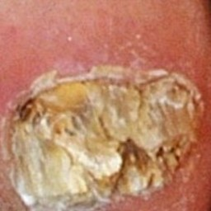  
 non-serious#1079  
**Analysis by this app:**normal = 0%; non-serious = 97%; check with a GP = 3%;   
The nail's condition is non-serious with confidence score of 97%.  
The confidence score for consulting a GP is 3%.×

 non-serious#84  
**Analysis by this app:**normal = 0%; non-serious = 97%; check with a GP = 3%;   
The nail's condition is non-serious with confidence score of 97%.  
The confidence score for consulting a GP is 3%.×

 non-serious#729  
**Analysis by this app:**normal = 3%; non-serious = 97%; check with a GP = 0%;   
The nail's condition is non-serious with confidence score of 97%.  
Otherwise it is normal with confidence score of 3%.×

 non-serious#724  
**Analysis by this app:**normal = 1%; non-serious = 97%; check with a GP = 2%;   
The nail's condition is non-serious with confidence score of 97%.  
The confidence score for consulting a GP is 2%.×

 non-serious#339  
**Analysis by this app:**normal = 2%; non-serious = 97%; check with a GP = 1%;   
The nail's condition is non-serious with confidence score of 97%.  
Otherwise it is normal with confidence score of 2%.×

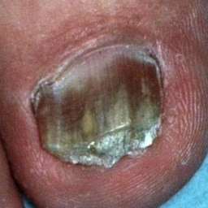  
 non-serious#1174  
**Analysis by this app:**normal = 0%; non-serious = 97%; check with a GP = 3%;   
The nail's condition is non-serious with confidence score of 97%.  
The confidence score for consulting a GP is 3%.×

 non-serious#189  
**Analysis by this app:**normal = 1%; non-serious = 97%; check with a GP = 3%;   
The nail's condition is non-serious with confidence score of 97%.  
The confidence score for consulting a GP is 3%.×

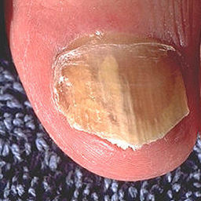  
 non-serious#1499  
**Analysis by this app:**normal = 1%; non-serious = 97%; check with a GP = 3%;   
The nail's condition is non-serious with confidence score of 97%.  
The confidence score for consulting a GP is 3%.×

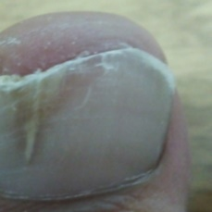  
 non-serious#1514  
**Analysis by this app:**normal = 1%; non-serious = 97%; check with a GP = 2%;   
The nail's condition is non-serious with confidence score of 97%.  
The confidence score for consulting a GP is 2%.×

 non-serious#304  
**Analysis by this app:**normal = 0%; non-serious = 97%; check with a GP = 3%;   
The nail's condition is non-serious with confidence score of 97%.  
The confidence score for consulting a GP is 3%.×

 non-serious#349  
**Analysis by this app:**normal = 0%; non-serious = 97%; check with a GP = 3%;   
The nail's condition is non-serious with confidence score of 97%.  
The confidence score for consulting a GP is 3%.×

 non-serious#194  
**Analysis by this app:**normal = 0%; non-serious = 97%; check with a GP = 3%;   
The nail's condition is non-serious with confidence score of 97%.  
The confidence score for consulting a GP is 3%.×

 non-serious#134  
**Analysis by this app:**normal = 1%; non-serious = 96%; check with a GP = 3%;   
The nail's condition is non-serious with confidence score of 96%.  
The confidence score for consulting a GP is 3%.×

 non-serious#704  
**Analysis by this app:**normal = 0%; non-serious = 96%; check with a GP = 3%;   
The nail's condition is non-serious with confidence score of 96%.  
The confidence score for consulting a GP is 3%.×

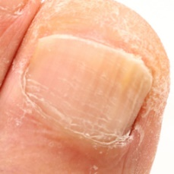  
 non-serious#1454  
**Analysis by this app:**normal = 4%; non-serious = 96%; check with a GP = 0%;   
The nail's condition is non-serious with confidence score of 96%.  
Otherwise it is normal with confidence score of 4%.×

 non-serious#224  
**Analysis by this app:**normal = 4%; non-serious = 96%; check with a GP = 0%;   
The nail's condition is non-serious with confidence score of 96%.  
Otherwise it is normal with confidence score of 4%.×

 non-serious#749  
**Analysis by this app:**normal = 0%; non-serious = 95%; check with a GP = 5%;   
The nail's condition is non-serious with confidence score of 95%.  
The confidence score for consulting a GP is 5%.×

 non-serious#744  
**Analysis by this app:**normal = 4%; non-serious = 95%; check with a GP = 1%;   
The nail's condition is non-serious with confidence score of 95%.  
Otherwise it is normal with confidence score of 4%.×

 non-serious#14  
**Analysis by this app:**normal = 5%; non-serious = 95%; check with a GP = 0%;   
The nail's condition is non-serious with confidence score of 95%.  
Otherwise it is normal with confidence score of 5%.×

 non-serious#299  
**Analysis by this app:**normal = 0%; non-serious = 95%; check with a GP = 5%;   
The nail's condition is non-serious with confidence score of 95%.  
The confidence score for consulting a GP is 5%.×

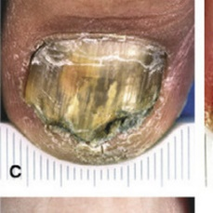  
 non-serious#1294  
**Analysis by this app:**normal = 0%; non-serious = 95%; check with a GP = 5%;   
The nail's condition is non-serious with confidence score of 95%.  
The confidence score for consulting a GP is 5%.×

 non-serious#784  
**Analysis by this app:**normal = 0%; non-serious = 95%; check with a GP = 5%;   
The nail's condition is non-serious with confidence score of 95%.  
The confidence score for consulting a GP is 5%.×

 non-serious#364  
**Analysis by this app:**normal = 2%; non-serious = 95%; check with a GP = 4%;   
The nail's condition is non-serious with confidence score of 95%.  
The confidence score for consulting a GP is 4%.×

 non-serious#989  
**Analysis by this app:**normal = 3%; non-serious = 95%; check with a GP = 2%;   
The nail's condition is non-serious with confidence score of 95%.  
Otherwise it is normal with confidence score of 3%.×

 non-serious#564  
**Analysis by this app:**normal = 1%; non-serious = 95%; check with a GP = 5%;   
The nail's condition is non-serious with confidence score of 95%.  
The confidence score for consulting a GP is 5%.×

 non-serious#284  
**Analysis by this app:**normal = 0%; non-serious = 94%; check with a GP = 6%;   
The nail's condition is non-serious with confidence score of 94%.  
The confidence score for consulting a GP is 6%.×

 non-serious#489  
**Analysis by this app:**normal = 3%; non-serious = 94%; check with a GP = 3%;   
The nail's condition is non-serious with confidence score of 94%.  
Otherwise it is normal with confidence score of 3%.×

 non-serious#804  
**Analysis by this app:**normal = 0%; non-serious = 94%; check with a GP = 6%;   
The nail's condition is non-serious with confidence score of 94%.  
The confidence score for consulting a GP is 6%.×

 non-serious#444  
**Analysis by this app:**normal = 0%; non-serious = 94%; check with a GP = 6%;   
The nail's condition is non-serious with confidence score of 94%.  
The confidence score for consulting a GP is 6%.×

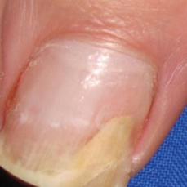  
 non-serious#1399  
**Analysis by this app:**normal = 6%; non-serious = 94%; check with a GP = 0%;   
The nail's condition is non-serious with confidence score of 94%.  
Otherwise it is normal with confidence score of 6%.×

 non-serious#309  
**Analysis by this app:**normal = 0%; non-serious = 94%; check with a GP = 6%;   
The nail's condition is non-serious with confidence score of 94%.  
The confidence score for consulting a GP is 6%.×

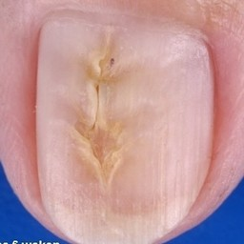  
 non-serious#1234  
**Analysis by this app:**normal = 6%; non-serious = 94%; check with a GP = 0%;   
The nail's condition is non-serious with confidence score of 94%.  
Otherwise it is normal with confidence score of 6%.×

 non-serious#614  
**Analysis by this app:**normal = 5%; non-serious = 94%; check with a GP = 1%;   
The nail's condition is non-serious with confidence score of 94%.  
Otherwise it is normal with confidence score of 5%.×

 non-serious#524  
**Analysis by this app:**normal = 3%; non-serious = 93%; check with a GP = 3%;   
The nail's condition is non-serious with confidence score of 93%.  
Otherwise it is normal with confidence score of 3%.×

 non-serious#59  
**Analysis by this app:**normal = 1%; non-serious = 93%; check with a GP = 6%;   
The nail's condition is non-serious with confidence score of 93%.  
The confidence score for consulting a GP is 6%.×

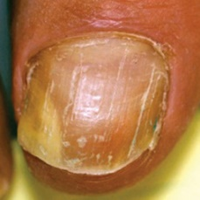  
 non-serious#1204  
**Analysis by this app:**normal = 3%; non-serious = 93%; check with a GP = 4%;   
The nail's condition is non-serious with confidence score of 93%.  
The confidence score for consulting a GP is 4%.×

 non-serious#64  
**Analysis by this app:**normal = 3%; non-serious = 93%; check with a GP = 4%;   
The nail's condition is non-serious with confidence score of 93%.  
The confidence score for consulting a GP is 4%.×

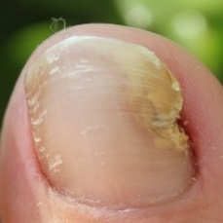  
 non-serious#1524  
**Analysis by this app:**normal = 5%; non-serious = 93%; check with a GP = 2%;   
The nail's condition is non-serious with confidence score of 93%.  
Otherwise it is normal with confidence score of 5%.×

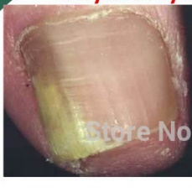  
 non-serious#1219  
**Analysis by this app:**normal = 0%; non-serious = 93%; check with a GP = 7%;   
The nail's condition is non-serious with confidence score of 93%.  
The confidence score for consulting a GP is 7%.×

 non-serious#379  
**Analysis by this app:**normal = 1%; non-serious = 92%; check with a GP = 7%;   
The nail's condition is non-serious with confidence score of 92%.  
The confidence score for consulting a GP is 7%.×

 non-serious#974  
**Analysis by this app:**normal = 3%; non-serious = 92%; check with a GP = 4%;   
The nail's condition is non-serious with confidence score of 92%.  
The confidence score for consulting a GP is 4%.×

 non-serious#389  
**Analysis by this app:**normal = 0%; non-serious = 92%; check with a GP = 8%;   
The nail's condition is non-serious with confidence score of 92%.  
The confidence score for consulting a GP is 8%.×

 non-serious#864  
**Analysis by this app:**normal = 1%; non-serious = 92%; check with a GP = 7%;   
The nail's condition is non-serious with confidence score of 92%.  
The confidence score for consulting a GP is 7%.×

 non-serious#979  
**Analysis by this app:**normal = 2%; non-serious = 92%; check with a GP = 6%;   
The nail's condition is non-serious with confidence score of 92%.  
The confidence score for consulting a GP is 6%.×

 non-serious#409  
**Analysis by this app:**normal = 1%; non-serious = 92%; check with a GP = 7%;   
The nail's condition is non-serious with confidence score of 92%.  
The confidence score for consulting a GP is 7%.×

 non-serious#484  
**Analysis by this app:**normal = 0%; non-serious = 92%; check with a GP = 8%;   
The nail's condition is non-serious with confidence score of 92%.  
The confidence score for consulting a GP is 8%.×

 non-serious#159  
**Analysis by this app:**normal = 0%; non-serious = 90%; check with a GP = 10%;   
The nail's condition is non-serious with confidence score of 90%.  
The confidence score for consulting a GP is 10%.×

 non-serious#859  
**Analysis by this app:**normal = 3%; non-serious = 90%; check with a GP = 8%;   
The nail's condition is non-serious with confidence score of 90%.  
The confidence score for consulting a GP is 8%.×

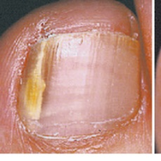  
 non-serious#1519  
**Analysis by this app:**normal = 2%; non-serious = 89%; check with a GP = 9%;   
The nail's condition is non-serious with confidence score of 89%.  
The confidence score for consulting a GP is 9%.×

 non-serious#529  
**Analysis by this app:**normal = 0%; non-serious = 89%; check with a GP = 11%;   
The nail's condition is non-serious with confidence score of 89%.  
The confidence score for consulting a GP is 11%.×

 non-serious#264  
**Analysis by this app:**normal = 1%; non-serious = 89%; check with a GP = 10%;   
The nail's condition is non-serious with confidence score of 89%.  
The confidence score for consulting a GP is 10%.×

 non-serious#99  
**Analysis by this app:**normal = 2%; non-serious = 88%; check with a GP = 10%;   
The nail's condition is non-serious with confidence score of 88%.  
The confidence score for consulting a GP is 10%.×

 non-serious#149  
**Analysis by this app:**normal = 12%; non-serious = 88%; check with a GP = 0%;   
The nail's condition is non-serious with confidence score of 88%.  
Otherwise it is normal with confidence score of 12%.×

 non-serious#429  
**Analysis by this app:**normal = 2%; non-serious = 88%; check with a GP = 10%;   
The nail's condition is non-serious with confidence score of 88%.  
The confidence score for consulting a GP is 10%.×

 non-serious#504  
**Analysis by this app:**normal = 0%; non-serious = 87%; check with a GP = 12%;   
The nail's condition is non-serious with confidence score of 87%.  
The confidence score for consulting a GP is 12%.×

 non-serious#464  
**Analysis by this app:**normal = 1%; non-serious = 87%; check with a GP = 12%;   
The nail's condition is non-serious with confidence score of 87%.  
The confidence score for consulting a GP is 12%.×

 non-serious#519  
**Analysis by this app:**normal = 12%; non-serious = 87%; check with a GP = 0%;   
The nail's condition is non-serious with confidence score of 87%.  
Otherwise it is normal with confidence score of 12%.×

 non-serious#29  
**Analysis by this app:**normal = 4%; non-serious = 87%; check with a GP = 9%;   
The nail's condition is non-serious with confidence score of 87%.  
The confidence score for consulting a GP is 9%.×

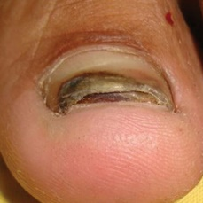  
 non-serious#1024  
**Analysis by this app:**normal = 10%; non-serious = 87%; check with a GP = 4%;   
The nail's condition is non-serious with confidence score of 87%.  
Otherwise it is normal with confidence score of 10%.×

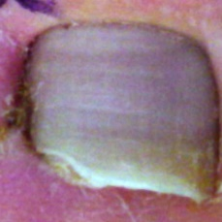  
 non-serious#1324  
**Analysis by this app:**normal = 0%; non-serious = 87%; check with a GP = 13%;   
The nail's condition is non-serious with confidence score of 87%.  
The confidence score for consulting a GP is 13%.×

 non-serious#174  
**Analysis by this app:**normal = 10%; non-serious = 86%; check with a GP = 4%;   
The nail's condition is non-serious with confidence score of 86%.  
Otherwise it is normal with confidence score of 10%.×

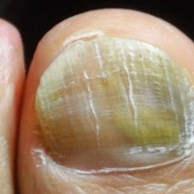  
 non-serious#1579  
**Analysis by this app:**normal = 2%; non-serious = 86%; check with a GP = 12%;   
The nail's condition is non-serious with confidence score of 86%.  
The confidence score for consulting a GP is 12%.×

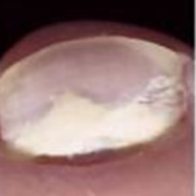  
 non-serious#1469  
**Analysis by this app:**normal = 12%; non-serious = 86%; check with a GP = 2%;   
The nail's condition is non-serious with confidence score of 86%.  
Otherwise it is normal with confidence score of 12%.×

 non-serious#774  
**Analysis by this app:**normal = 1%; non-serious = 85%; check with a GP = 14%;   
The nail's condition is non-serious with confidence score of 85%.  
The confidence score for consulting a GP is 14%.×

 non-serious#599  
**Analysis by this app:**normal = 1%; non-serious = 85%; check with a GP = 14%;   
The nail's condition is non-serious with confidence score of 85%.  
The confidence score for consulting a GP is 14%.×

 non-serious#324  
**Analysis by this app:**normal = 0%; non-serious = 85%; check with a GP = 15%;   
The nail's condition is non-serious with confidence score of 85%.  
The confidence score for consulting a GP is 15%.×

 non-serious#289  
**Analysis by this app:**normal = 12%; non-serious = 84%; check with a GP = 4%;   
The nail's condition is non-serious with confidence score of 84%.  
Otherwise it is normal with confidence score of 12%.×

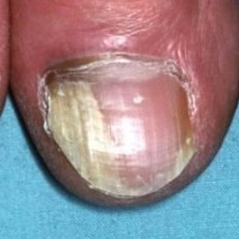  
 non-serious#1319  
**Analysis by this app:**normal = 10%; non-serious = 84%; check with a GP = 6%;   
The nail's condition is non-serious with confidence score of 84%.  
Otherwise it is normal with confidence score of 10%.×

 non-serious#254  
**Analysis by this app:**normal = 3%; non-serious = 83%; check with a GP = 13%;   
The nail's condition is non-serious with confidence score of 83%.  
The confidence score for consulting a GP is 13%.×

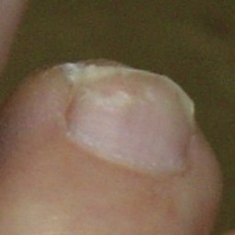  
 non-serious#1284  
**Analysis by this app:**normal = 16%; non-serious = 83%; check with a GP = 0%;   
The nail's condition is non-serious with confidence score of 83%.  
Otherwise it is normal with confidence score of 16%.×

 non-serious#734  
**Analysis by this app:**normal = 0%; non-serious = 83%; check with a GP = 17%;   
The nail's condition is non-serious with confidence score of 83%.  
The confidence score for consulting a GP is 17%.×

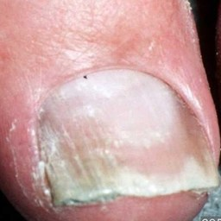  
 non-serious#1359  
**Analysis by this app:**normal = 15%; non-serious = 82%; check with a GP = 2%;   
The nail's condition is non-serious with confidence score of 82%.  
Otherwise it is normal with confidence score of 15%.×

 non-serious#869  
**Analysis by this app:**normal = 2%; non-serious = 82%; check with a GP = 16%;   
The nail's condition is non-serious with confidence score of 82%.  
The confidence score for consulting a GP is 16%.×

 non-serious#104  
**Analysis by this app:**normal = 18%; non-serious = 81%; check with a GP = 1%;   
The nail's condition is non-serious with confidence score of 81%.  
Otherwise it is normal with confidence score of 18%.×

 non-serious#919  
**Analysis by this app:**normal = 13%; non-serious = 81%; check with a GP = 6%;   
The nail's condition is non-serious with confidence score of 81%.  
Otherwise it is normal with confidence score of 13%.×

 non-serious#69  
**Analysis by this app:**normal = 1%; non-serious = 81%; check with a GP = 18%;   
The nail's condition is non-serious with confidence score of 81%.  
The confidence score for consulting a GP is 18%.×

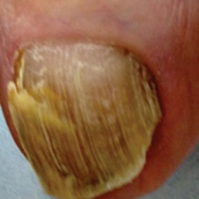  
 non-serious#1229  
**Analysis by this app:**normal = 16%; non-serious = 80%; check with a GP = 4%;   
The nail's condition is non-serious with confidence score of 80%.  
Otherwise it is normal with confidence score of 16%.×

 non-serious#879  
**Analysis by this app:**normal = 7%; non-serious = 77%; check with a GP = 16%;   
The nail's condition is non-serious with confidence score of 77%.  
The confidence score for consulting a GP is 16%.×

 non-serious#959  
**Analysis by this app:**normal = 7%; non-serious = 76%; check with a GP = 17%;   
The nail's condition is non-serious with confidence score of 76%.  
The confidence score for consulting a GP is 17%.×

 non-serious#814  
**Analysis by this app:**normal = 1%; non-serious = 75%; check with a GP = 23%;   
Perhaps a GP should be consulted (confidence score is 23%) ×

 non-serious#329  
**Analysis by this app:**normal = 3%; non-serious = 74%; check with a GP = 24%;   
Perhaps a GP should be consulted (confidence score is 24%) ×

 non-serious#209  
**Analysis by this app:**normal = 22%; non-serious = 74%; check with a GP = 5%;   
The nail's condition is non-serious with confidence score of 74%.  
Otherwise it is normal with confidence score of 22%.×

 non-serious#594  
**Analysis by this app:**normal = 11%; non-serious = 73%; check with a GP = 16%;   
The nail's condition is non-serious with confidence score of 73%.  
The confidence score for consulting a GP is 16%.×

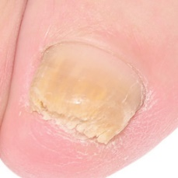  
 non-serious#1414  
**Analysis by this app:**normal = 28%; non-serious = 72%; check with a GP = 0%;   
The nail's condition is non-serious with confidence score of 72%.  
Otherwise it is normal with confidence score of 28%.×

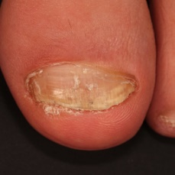  
 non-serious#1339  
**Analysis by this app:**normal = 27%; non-serious = 72%; check with a GP = 2%;   
The nail's condition is non-serious with confidence score of 72%.  
Otherwise it is normal with confidence score of 27%.×

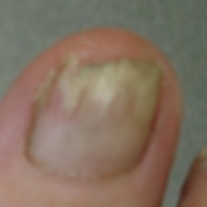  
 non-serious#1559  
**Analysis by this app:**normal = 27%; non-serious = 72%; check with a GP = 1%;   
The nail's condition is non-serious with confidence score of 72%.  
Otherwise it is normal with confidence score of 27%.×

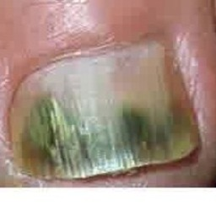  
 non-serious#1074  
**Analysis by this app:**normal = 0%; non-serious = 70%; check with a GP = 30%;   
Perhaps a GP should be consulted (confidence score is 30%) ×

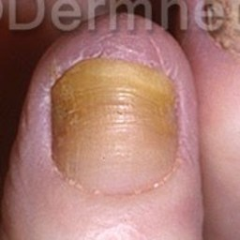  
 non-serious#1244  
**Analysis by this app:**normal = 9%; non-serious = 70%; check with a GP = 21%;   
Perhaps a GP should be consulted (confidence score is 21%) ×

 non-serious#404  
**Analysis by this app:**normal = 12%; non-serious = 69%; check with a GP = 18%;   
The nail's condition is non-serious with confidence score of 69%.  
The confidence score for consulting a GP is 18%.×

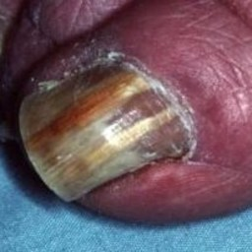  
 non-serious#1009  
**Analysis by this app:**normal = 0%; non-serious = 68%; check with a GP = 32%;   
Perhaps a GP should be consulted (confidence score is 32%) ×

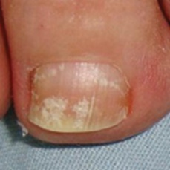  
 non-serious#1439  
**Analysis by this app:**normal = 30%; non-serious = 67%; check with a GP = 3%;   
The nail's condition is non-serious with confidence score of 67%.  
Otherwise it is normal with confidence score of 30%.×

 non-serious#199  
**Analysis by this app:**normal = 34%; non-serious = 66%; check with a GP = 1%;   
The nail's condition is non-serious with confidence score of 66%.  
Otherwise it is normal with confidence score of 34%.×

 non-serious#319  
**Analysis by this app:**normal = 5%; non-serious = 65%; check with a GP = 29%;   
Perhaps a GP should be consulted (confidence score is 29%) ×

 non-serious#269  
**Analysis by this app:**normal = 1%; non-serious = 61%; check with a GP = 38%;   
Perhaps a GP should be consulted (confidence score is 38%) ×

 non-serious#374  
**Analysis by this app:**normal = 2%; non-serious = 58%; check with a GP = 40%;   
Not very sure whether the nail is OK or not. Sorry.×

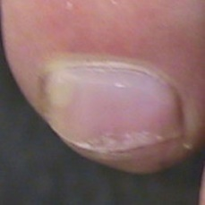  
 non-serious#1094  
**Analysis by this app:**normal = 40%; non-serious = 58%; check with a GP = 2%;   
Not very sure whether the nail is OK or not. Sorry.×

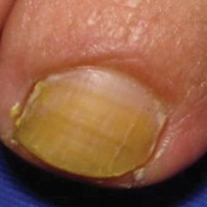  
 non-serious#1389  
**Analysis by this app:**normal = 45%; non-serious = 55%; check with a GP = 0%;   
Not very sure whether the nail is OK or not. Sorry.×

 non-serious#359  
**Analysis by this app:**normal = 15%; non-serious = 54%; check with a GP = 30%;   
Not very sure whether the nail is OK or not. Sorry.×

 non-serious#844  
**Analysis by this app:**normal = 23%; non-serious = 54%; check with a GP = 23%;   
Not very sure whether the nail is OK or not. Sorry.×

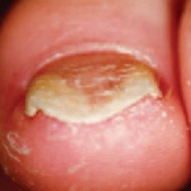  
 non-serious#1134  
**Analysis by this app:**normal = 27%; non-serious = 53%; check with a GP = 20%;   
Not very sure whether the nail is OK or not. Sorry.×

 non-serious#909  
**Analysis by this app:**normal = 1%; non-serious = 53%; check with a GP = 46%;   
Not very sure whether the nail is OK or not. Sorry.×

 non-serious#619  
**Analysis by this app:**normal = 0%; non-serious = 52%; check with a GP = 48%;   
Not very sure whether the nail is OK or not. Sorry.×

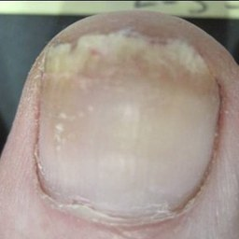  
 non-serious#1279  
**Analysis by this app:**normal = 25%; non-serious = 50%; check with a GP = 24%;   
Not very sure whether the nail is OK or not. Sorry.×

 non-serious#384  
**Analysis by this app:**normal = 39%; non-serious = 49%; check with a GP = 12%;   
Not very sure whether the nail is OK or not. Sorry.×

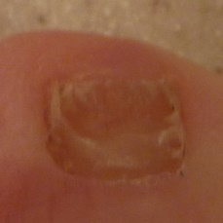  
 non-serious#1409  
**Analysis by this app:**normal = 45%; non-serious = 49%; check with a GP = 6%;   
Not very sure whether the nail is OK or not. Sorry.×

 non-serious#109  
**Analysis by this app:**normal = 31%; non-serious = 48%; check with a GP = 21%;   
Not very sure whether the nail is OK or not. Sorry.×

 non-serious#94  
**Analysis by this app:**normal = 22%; non-serious = 48%; check with a GP = 31%;   
Not very sure whether the nail is OK or not. Sorry.×

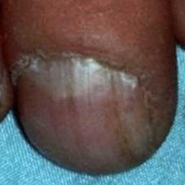  
 non-serious#1404  
**Analysis by this app:**normal = 10%; non-serious = 43%; check with a GP = 47%;   
Not very sure whether the nail is OK or not. Sorry.×

 non-serious#164  
**Analysis by this app:**normal = 2%; non-serious = 39%; check with a GP = 59%;   
Not very sure whether the nail is OK or not. Sorry.×

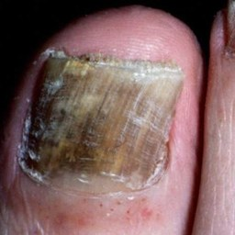  
 non-serious#1384  
**Analysis by this app:**normal = 0%; non-serious = 38%; check with a GP = 62%;   
It is most likely that the nail indicates something that warrants a second opinion and you should seek medical advice. (Confidence score is 62%)×

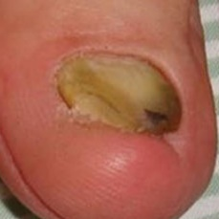  
 non-serious#1424  
**Analysis by this app:**normal = 15%; non-serious = 37%; check with a GP = 48%;   
Not very sure whether the nail is OK or not. Sorry.×

 non-serious#439  
**Analysis by this app:**normal = 6%; non-serious = 30%; check with a GP = 64%;   
It is most likely that the nail indicates something that warrants a second opinion and you should seek medical advice. (Confidence score is 64%)×

 non-serious#139  
**Analysis by this app:**normal = 27%; non-serious = 29%; check with a GP = 44%;   
Not very sure whether the nail is OK or not. Sorry.×

 non-serious#169  
**Analysis by this app:**normal = 54%; non-serious = 29%; check with a GP = 17%;   
Not very sure whether the nail is OK or not. Sorry.×

 non-serious#539  
**Analysis by this app:**normal = 22%; non-serious = 26%; check with a GP = 52%;   
Not very sure whether the nail is OK or not. Sorry.×

 non-serious#39  
**Analysis by this app:**normal = 2%; non-serious = 21%; check with a GP = 77%;   
It is most likely that the nail indicates something that warrants a second opinion and you should seek medical advice. (Confidence score is 77%)×

 non-serious#694  
**Analysis by this app:**normal = 74%; non-serious = 21%; check with a GP = 5%;   
The nail's condition is normal with confidence score of 74%.  
Otherwise it is non-serious with confidence score of 21%.×

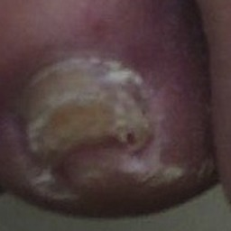  
 non-serious#1264  
**Analysis by this app:**normal = 69%; non-serious = 19%; check with a GP = 12%;   
The nail's condition is normal with confidence score of 69%.  
Otherwise it is non-serious with confidence score of 19%.×

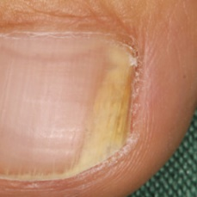  
 non-serious#1504  
**Analysis by this app:**normal = 82%; non-serious = 17%; check with a GP = 1%;   
The nail's condition is normal with confidence score of 82%.  
Otherwise it is non-serious with confidence score of 17%.×

 non-serious#699  
**Analysis by this app:**normal = 47%; non-serious = 17%; check with a GP = 36%;   
Not very sure whether the nail is OK or not. Sorry.×

 non-serious#244  
**Analysis by this app:**normal = 46%; non-serious = 14%; check with a GP = 40%;   
Not very sure whether the nail is OK or not. Sorry.×

 non-serious#509  
**Analysis by this app:**normal = 0%; non-serious = 6%; check with a GP = 93%;   
It is most likely that the nail indicates something that warrants a second opinion and you should seek medical advice. (Confidence score is 93%)×

 non-serious#274  
**Analysis by this app:**normal = 0%; non-serious = 3%; check with a GP = 97%;   
It is most likely that the nail indicates something that warrants a second opinion and you should seek medical advice. (Confidence score is 97%)×

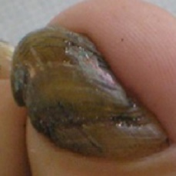  
 non-serious#1304  
**Analysis by this app:**normal = 20%; non-serious = 1%; check with a GP = 80%;   
It is most likely that the nail indicates something that warrants a second opinion and you should seek medical advice. (Confidence score is 80%)×

 normal#726  
**Analysis by this app:**normal = 100%; non-serious = 0%; check with a GP = 0%;   
The nail's condition is normal with confidence score of 100%.×

 normal#396  
**Analysis by this app:**normal = 100%; non-serious = 0%; check with a GP = 0%;   
The nail's condition is normal with confidence score of 100%.×

 normal#576  
**Analysis by this app:**normal = 100%; non-serious = 0%; check with a GP = 0%;   
The nail's condition is normal with confidence score of 100%.×

 normal#356  
**Analysis by this app:**normal = 100%; non-serious = 0%; check with a GP = 0%;   
The nail's condition is normal with confidence score of 100%.×

 normal#241  
**Analysis by this app:**normal = 100%; non-serious = 0%; check with a GP = 0%;   
The nail's condition is normal with confidence score of 100%.×

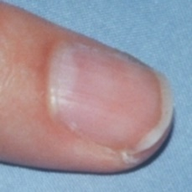  
 normal#1181  
**Analysis by this app:**normal = 100%; non-serious = 0%; check with a GP = 0%;   
The nail's condition is normal with confidence score of 100%.×

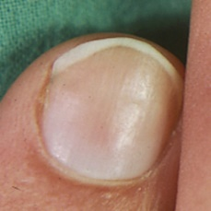  
 normal#1196  
**Analysis by this app:**normal = 100%; non-serious = 0%; check with a GP = 0%;   
The nail's condition is normal with confidence score of 100%.×

 normal#521  
**Analysis by this app:**normal = 100%; non-serious = 0%; check with a GP = 0%;   
The nail's condition is normal with confidence score of 100%.×

 normal#76  
**Analysis by this app:**normal = 100%; non-serious = 0%; check with a GP = 0%;   
The nail's condition is normal with confidence score of 100%.×

 normal#426  
**Analysis by this app:**normal = 100%; non-serious = 0%; check with a GP = 0%;   
The nail's condition is normal with confidence score of 100%.×

 normal#976  
**Analysis by this app:**normal = 100%; non-serious = 0%; check with a GP = 0%;   
The nail's condition is normal with confidence score of 100%.×

 normal#981  
**Analysis by this app:**normal = 100%; non-serious = 0%; check with a GP = 0%;   
The nail's condition is normal with confidence score of 100%.×

 normal#301  
**Analysis by this app:**normal = 100%; non-serious = 0%; check with a GP = 0%;   
The nail's condition is normal with confidence score of 100%.×

 normal#986  
**Analysis by this app:**normal = 100%; non-serious = 0%; check with a GP = 0%;   
The nail's condition is normal with confidence score of 100%.×

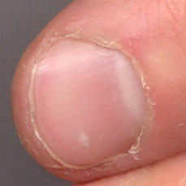  
 normal#1266  
**Analysis by this app:**normal = 100%; non-serious = 0%; check with a GP = 0%;   
The nail's condition is normal with confidence score of 100%.×

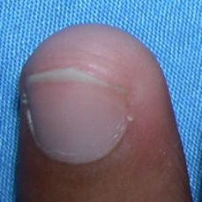  
 normal#1021  
**Analysis by this app:**normal = 100%; non-serious = 0%; check with a GP = 0%;   
The nail's condition is normal with confidence score of 100%.×

 normal#1  
**Analysis by this app:**normal = 100%; non-serious = 0%; check with a GP = 0%;   
The nail's condition is normal with confidence score of 100%.×

 normal#756  
**Analysis by this app:**normal = 100%; non-serious = 0%; check with a GP = 0%;   
The nail's condition is normal with confidence score of 100%.×

 normal#716  
**Analysis by this app:**normal = 100%; non-serious = 0%; check with a GP = 0%;   
The nail's condition is normal with confidence score of 100%.×

 normal#26  
**Analysis by this app:**normal = 100%; non-serious = 0%; check with a GP = 0%;   
The nail's condition is normal with confidence score of 100%.×

 normal#6  
**Analysis by this app:**normal = 100%; non-serious = 0%; check with a GP = 0%;   
The nail's condition is normal with confidence score of 100%.×

 normal#16  
**Analysis by this app:**normal = 100%; non-serious = 0%; check with a GP = 0%;   
The nail's condition is normal with confidence score of 100%.×

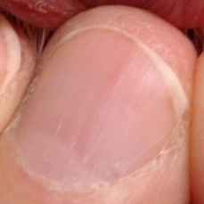  
 normal#1131  
**Analysis by this app:**normal = 100%; non-serious = 0%; check with a GP = 0%;   
The nail's condition is normal with confidence score of 100%.×

 normal#801  
**Analysis by this app:**normal = 100%; non-serious = 0%; check with a GP = 0%;   
The nail's condition is normal with confidence score of 100%.×

 normal#751  
**Analysis by this app:**normal = 100%; non-serious = 0%; check with a GP = 0%;   
The nail's condition is normal with confidence score of 100%.×

 normal#806  
**Analysis by this app:**normal = 100%; non-serious = 0%; check with a GP = 0%;   
The nail's condition is normal with confidence score of 100%.×

 normal#626  
**Analysis by this app:**normal = 100%; non-serious = 0%; check with a GP = 0%;   
The nail's condition is normal with confidence score of 100%.×

 normal#511  
**Analysis by this app:**normal = 100%; non-serious = 0%; check with a GP = 0%;   
The nail's condition is normal with confidence score of 100%.×

 normal#256  
**Analysis by this app:**normal = 100%; non-serious = 0%; check with a GP = 0%;   
The nail's condition is normal with confidence score of 100%.×

 normal#401  
**Analysis by this app:**normal = 100%; non-serious = 0%; check with a GP = 0%;   
The nail's condition is normal with confidence score of 100%.×

 normal#496  
**Analysis by this app:**normal = 100%; non-serious = 0%; check with a GP = 0%;   
The nail's condition is normal with confidence score of 100%.×

 normal#811  
**Analysis by this app:**normal = 100%; non-serious = 0%; check with a GP = 0%;   
The nail's condition is normal with confidence score of 100%.×

 normal#741  
**Analysis by this app:**normal = 100%; non-serious = 0%; check with a GP = 0%;   
The nail's condition is normal with confidence score of 100%.×

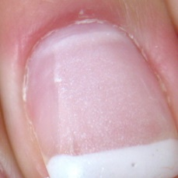  
 normal#1351  
**Analysis by this app:**normal = 100%; non-serious = 0%; check with a GP = 0%;   
The nail's condition is normal with confidence score of 100%.×

 normal#666  
**Analysis by this app:**normal = 100%; non-serious = 0%; check with a GP = 0%;   
The nail's condition is normal with confidence score of 100%.×

 normal#956  
**Analysis by this app:**normal = 100%; non-serious = 0%; check with a GP = 0%;   
The nail's condition is normal with confidence score of 100%.×

 normal#916  
**Analysis by this app:**normal = 100%; non-serious = 0%; check with a GP = 0%;   
The nail's condition is normal with confidence score of 100%.×

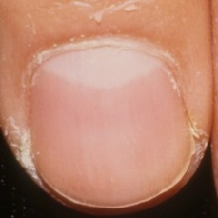  
 normal#1006  
**Analysis by this app:**normal = 100%; non-serious = 0%; check with a GP = 0%;   
The nail's condition is normal with confidence score of 100%.×

 normal#1001  
**Analysis by this app:**normal = 100%; non-serious = 0%; check with a GP = 0%;   
The nail's condition is normal with confidence score of 100%.×

 normal#171  
**Analysis by this app:**normal = 100%; non-serious = 0%; check with a GP = 0%;   
The nail's condition is normal with confidence score of 100%.×

 normal#486  
**Analysis by this app:**normal = 100%; non-serious = 0%; check with a GP = 0%;   
The nail's condition is normal with confidence score of 100%.×

 normal#151  
**Analysis by this app:**normal = 100%; non-serious = 0%; check with a GP = 0%;   
The nail's condition is normal with confidence score of 100%.×

 normal#786  
**Analysis by this app:**normal = 99%; non-serious = 0%; check with a GP = 1%;   
The nail's condition is normal with confidence score of 99%.  
The confidence score for consulting a GP is 1%.×

 normal#966  
**Analysis by this app:**normal = 99%; non-serious = 0%; check with a GP = 1%;   
The nail's condition is normal with confidence score of 99%.  
The confidence score for consulting a GP is 1%.×

 normal#776  
**Analysis by this app:**normal = 99%; non-serious = 0%; check with a GP = 0%;   
The nail's condition is normal with confidence score of 99%.×

 normal#951  
**Analysis by this app:**normal = 99%; non-serious = 0%; check with a GP = 1%;   
The nail's condition is normal with confidence score of 99%.  
The confidence score for consulting a GP is 1%.×

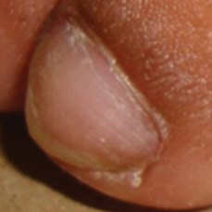  
 normal#1126  
**Analysis by this app:**normal = 99%; non-serious = 1%; check with a GP = 0%;   
The nail's condition is normal with confidence score of 99%.  
Otherwise it is non-serious with confidence score of 1%.×

 normal#836  
**Analysis by this app:**normal = 99%; non-serious = 0%; check with a GP = 0%;   
The nail's condition is normal with confidence score of 99%.×

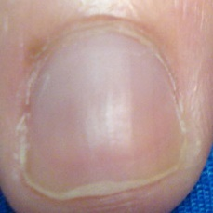  
 normal#1111  
**Analysis by this app:**normal = 99%; non-serious = 1%; check with a GP = 0%;   
The nail's condition is normal with confidence score of 99%.  
Otherwise it is non-serious with confidence score of 1%.×

 normal#481  
**Analysis by this app:**normal = 99%; non-serious = 0%; check with a GP = 0%;   
The nail's condition is normal with confidence score of 99%.×

 normal#551  
**Analysis by this app:**normal = 99%; non-serious = 0%; check with a GP = 1%;   
The nail's condition is normal with confidence score of 99%.  
The confidence score for consulting a GP is 1%.×

 normal#791  
**Analysis by this app:**normal = 99%; non-serious = 0%; check with a GP = 1%;   
The nail's condition is normal with confidence score of 99%.  
The confidence score for consulting a GP is 1%.×

 normal#761  
**Analysis by this app:**normal = 99%; non-serious = 0%; check with a GP = 0%;   
The nail's condition is normal with confidence score of 99%.×

 normal#121  
**Analysis by this app:**normal = 99%; non-serious = 0%; check with a GP = 1%;   
The nail's condition is normal with confidence score of 99%.  
The confidence score for consulting a GP is 1%.×

 normal#886  
**Analysis by this app:**normal = 99%; non-serious = 0%; check with a GP = 1%;   
The nail's condition is normal with confidence score of 99%.  
The confidence score for consulting a GP is 1%.×

 normal#996  
**Analysis by this app:**normal = 99%; non-serious = 0%; check with a GP = 1%;   
The nail's condition is normal with confidence score of 99%.  
The confidence score for consulting a GP is 1%.×

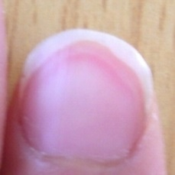  
 normal#1311  
**Analysis by this app:**normal = 99%; non-serious = 0%; check with a GP = 1%;   
The nail's condition is normal with confidence score of 99%.  
The confidence score for consulting a GP is 1%.×

 normal#336  
**Analysis by this app:**normal = 99%; non-serious = 0%; check with a GP = 1%;   
The nail's condition is normal with confidence score of 99%.  
The confidence score for consulting a GP is 1%.×

 normal#61  
**Analysis by this app:**normal = 99%; non-serious = 1%; check with a GP = 0%;   
The nail's condition is normal with confidence score of 99%.  
Otherwise it is non-serious with confidence score of 1%.×

 normal#391  
**Analysis by this app:**normal = 99%; non-serious = 1%; check with a GP = 0%;   
The nail's condition is normal with confidence score of 99%.  
Otherwise it is non-serious with confidence score of 1%.×

 normal#451  
**Analysis by this app:**normal = 99%; non-serious = 0%; check with a GP = 1%;   
The nail's condition is normal with confidence score of 99%.  
The confidence score for consulting a GP is 1%.×

 normal#531  
**Analysis by this app:**normal = 99%; non-serious = 0%; check with a GP = 1%;   
The nail's condition is normal with confidence score of 99%.  
The confidence score for consulting a GP is 1%.×

 normal#691  
**Analysis by this app:**normal = 99%; non-serious = 0%; check with a GP = 1%;   
The nail's condition is normal with confidence score of 99%.  
The confidence score for consulting a GP is 1%.×

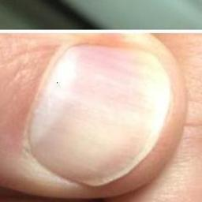  
 normal#1201  
**Analysis by this app:**normal = 99%; non-serious = 0%; check with a GP = 1%;   
The nail's condition is normal with confidence score of 99%.  
The confidence score for consulting a GP is 1%.×

  
 normal#1036  
**Analysis by this app:**normal = 99%; non-serious = 0%; check with a GP = 1%;   
The nail's condition is normal with confidence score of 99%.  
The confidence score for consulting a GP is 1%.×

 normal#116  
**Analysis by this app:**normal = 99%; non-serious = 0%; check with a GP = 1%;   
The nail's condition is normal with confidence score of 99%.  
The confidence score for consulting a GP is 1%.×

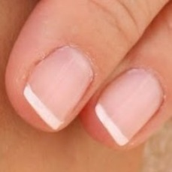  
 normal#1171  
**Analysis by this app:**normal = 99%; non-serious = 1%; check with a GP = 0%;   
The nail's condition is normal with confidence score of 99%.  
Otherwise it is non-serious with confidence score of 1%.×

 normal#736  
**Analysis by this app:**normal = 99%; non-serious = 0%; check with a GP = 1%;   
The nail's condition is normal with confidence score of 99%.  
The confidence score for consulting a GP is 1%.×

 normal#526  
**Analysis by this app:**normal = 99%; non-serious = 0%; check with a GP = 1%;   
The nail's condition is normal with confidence score of 99%.  
The confidence score for consulting a GP is 1%.×

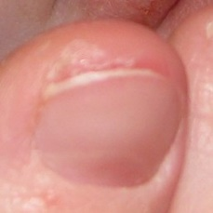  
 normal#1331  
**Analysis by this app:**normal = 99%; non-serious = 1%; check with a GP = 1%;   
The nail's condition is normal with confidence score of 99%.  
Otherwise it is non-serious with confidence score of 1%.×

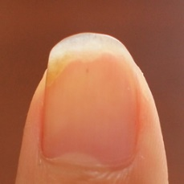  
 normal#1286  
**Analysis by this app:**normal = 98%; non-serious = 1%; check with a GP = 0%;   
The nail's condition is normal with confidence score of 98%.  
Otherwise it is non-serious with confidence score of 1%.×

 normal#501  
**Analysis by this app:**normal = 98%; non-serious = 0%; check with a GP = 1%;   
The nail's condition is normal with confidence score of 98%.  
The confidence score for consulting a GP is 1%.×

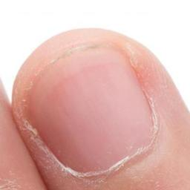  
 normal#1136  
**Analysis by this app:**normal = 98%; non-serious = 0%; check with a GP = 2%;   
The nail's condition is normal with confidence score of 98%.  
The confidence score for consulting a GP is 2%.×

 normal#491  
**Analysis by this app:**normal = 98%; non-serious = 0%; check with a GP = 1%;   
The nail's condition is normal with confidence score of 98%.  
The confidence score for consulting a GP is 1%.×

 normal#161  
**Analysis by this app:**normal = 98%; non-serious = 1%; check with a GP = 0%;   
The nail's condition is normal with confidence score of 98%.  
Otherwise it is non-serious with confidence score of 1%.×

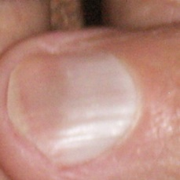  
 normal#1236  
**Analysis by this app:**normal = 98%; non-serious = 0%; check with a GP = 1%;   
The nail's condition is normal with confidence score of 98%.  
The confidence score for consulting a GP is 1%.×

 normal#686  
**Analysis by this app:**normal = 98%; non-serious = 1%; check with a GP = 0%;   
The nail's condition is normal with confidence score of 98%.  
Otherwise it is non-serious with confidence score of 1%.×

 normal#131  
**Analysis by this app:**normal = 98%; non-serious = 0%; check with a GP = 2%;   
The nail's condition is normal with confidence score of 98%.  
The confidence score for consulting a GP is 2%.×

 normal#646  
**Analysis by this app:**normal = 98%; non-serious = 2%; check with a GP = 0%;   
The nail's condition is normal with confidence score of 98%.  
Otherwise it is non-serious with confidence score of 2%.×

 normal#771  
**Analysis by this app:**normal = 98%; non-serious = 0%; check with a GP = 2%;   
The nail's condition is normal with confidence score of 98%.  
The confidence score for consulting a GP is 2%.×

 normal#946  
**Analysis by this app:**normal = 98%; non-serious = 2%; check with a GP = 0%;   
The nail's condition is normal with confidence score of 98%.  
Otherwise it is non-serious with confidence score of 2%.×

 normal#571  
**Analysis by this app:**normal = 98%; non-serious = 0%; check with a GP = 2%;   
The nail's condition is normal with confidence score of 98%.  
The confidence score for consulting a GP is 2%.×

 normal#821  
**Analysis by this app:**normal = 98%; non-serious = 0%; check with a GP = 2%;   
The nail's condition is normal with confidence score of 98%.  
The confidence score for consulting a GP is 2%.×

 normal#321  
**Analysis by this app:**normal = 98%; non-serious = 0%; check with a GP = 2%;   
The nail's condition is normal with confidence score of 98%.  
The confidence score for consulting a GP is 2%.×

 normal#856  
**Analysis by this app:**normal = 98%; non-serious = 1%; check with a GP = 1%;   
The nail's condition is normal with confidence score of 98%.  
Otherwise it is non-serious with confidence score of 1%.×

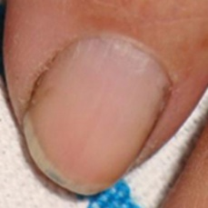  
 normal#1246  
**Analysis by this app:**normal = 98%; non-serious = 2%; check with a GP = 1%;   
The nail's condition is normal with confidence score of 98%.  
Otherwise it is non-serious with confidence score of 2%.×

 normal#991  
**Analysis by this app:**normal = 98%; non-serious = 1%; check with a GP = 2%;   
The nail's condition is normal with confidence score of 98%.  
The confidence score for consulting a GP is 2%.×

 normal#221  
**Analysis by this app:**normal = 98%; non-serious = 1%; check with a GP = 2%;   
The nail's condition is normal with confidence score of 98%.  
The confidence score for consulting a GP is 2%.×

 normal#186  
**Analysis by this app:**normal = 98%; non-serious = 2%; check with a GP = 1%;   
The nail's condition is normal with confidence score of 98%.  
Otherwise it is non-serious with confidence score of 2%.×

 normal#631  
**Analysis by this app:**normal = 98%; non-serious = 2%; check with a GP = 0%;   
The nail's condition is normal with confidence score of 98%.  
Otherwise it is non-serious with confidence score of 2%.×

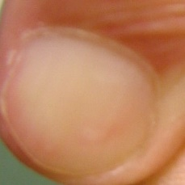  
 normal#1071  
**Analysis by this app:**normal = 98%; non-serious = 0%; check with a GP = 2%;   
The nail's condition is normal with confidence score of 98%.  
The confidence score for consulting a GP is 2%.×

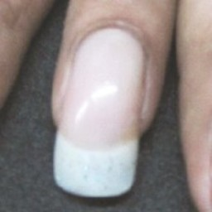  
 normal#1101  
**Analysis by this app:**normal = 97%; non-serious = 2%; check with a GP = 1%;   
The nail's condition is normal with confidence score of 97%.  
Otherwise it is non-serious with confidence score of 2%.×

 normal#141  
**Analysis by this app:**normal = 97%; non-serious = 2%; check with a GP = 1%;   
The nail's condition is normal with confidence score of 97%.  
Otherwise it is non-serious with confidence score of 2%.×

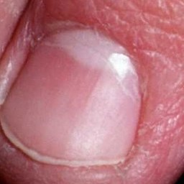  
 normal#1016  
**Analysis by this app:**normal = 97%; non-serious = 0%; check with a GP = 3%;   
The nail's condition is normal with confidence score of 97%.  
The confidence score for consulting a GP is 3%.×

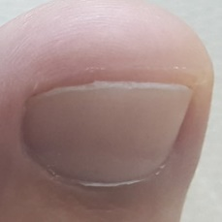  
 normal#1366  
**Analysis by this app:**normal = 97%; non-serious = 1%; check with a GP = 2%;   
The nail's condition is normal with confidence score of 97%.  
The confidence score for consulting a GP is 2%.×

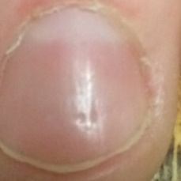  
 normal#1121  
**Analysis by this app:**normal = 97%; non-serious = 0%; check with a GP = 2%;   
The nail's condition is normal with confidence score of 97%.  
The confidence score for consulting a GP is 2%.×

 normal#581  
**Analysis by this app:**normal = 97%; non-serious = 0%; check with a GP = 3%;   
The nail's condition is normal with confidence score of 97%.  
The confidence score for consulting a GP is 3%.×

 normal#926  
**Analysis by this app:**normal = 97%; non-serious = 0%; check with a GP = 3%;   
The nail's condition is normal with confidence score of 97%.  
The confidence score for consulting a GP is 3%.×

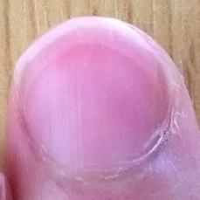  
 normal#1281  
**Analysis by this app:**normal = 97%; non-serious = 0%; check with a GP = 3%;   
The nail's condition is normal with confidence score of 97%.  
The confidence score for consulting a GP is 3%.×

 normal#376  
**Analysis by this app:**normal = 97%; non-serious = 0%; check with a GP = 3%;   
The nail's condition is normal with confidence score of 97%.  
The confidence score for consulting a GP is 3%.×

 normal#386  
**Analysis by this app:**normal = 97%; non-serious = 2%; check with a GP = 2%;   
The nail's condition is normal with confidence score of 97%.  
Otherwise it is non-serious with confidence score of 2%.×

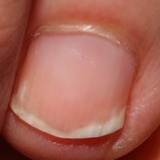  
 normal#1141  
**Analysis by this app:**normal = 97%; non-serious = 0%; check with a GP = 3%;   
The nail's condition is normal with confidence score of 97%.  
The confidence score for consulting a GP is 3%.×

 normal#876  
**Analysis by this app:**normal = 97%; non-serious = 3%; check with a GP = 1%;   
The nail's condition is normal with confidence score of 97%.  
Otherwise it is non-serious with confidence score of 3%.×

 normal#706  
**Analysis by this app:**normal = 97%; non-serious = 0%; check with a GP = 3%;   
The nail's condition is normal with confidence score of 97%.  
The confidence score for consulting a GP is 3%.×

 normal#841  
**Analysis by this app:**normal = 97%; non-serious = 1%; check with a GP = 2%;   
The nail's condition is normal with confidence score of 97%.  
The confidence score for consulting a GP is 2%.×

 normal#361  
**Analysis by this app:**normal = 96%; non-serious = 2%; check with a GP = 1%;   
The nail's condition is normal with confidence score of 96%.  
Otherwise it is non-serious with confidence score of 2%.×

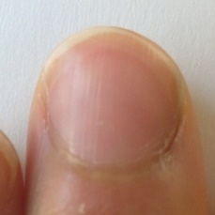  
 normal#1306  
**Analysis by this app:**normal = 96%; non-serious = 0%; check with a GP = 3%;   
The nail's condition is normal with confidence score of 96%.  
The confidence score for consulting a GP is 3%.×

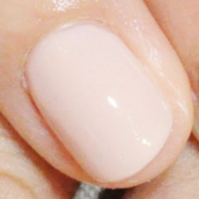  
 normal#1296  
**Analysis by this app:**normal = 96%; non-serious = 2%; check with a GP = 2%;   
The nail's condition is normal with confidence score of 96%.  
Otherwise it is non-serious with confidence score of 2%.×

 normal#31  
**Analysis by this app:**normal = 96%; non-serious = 1%; check with a GP = 3%;   
The nail's condition is normal with confidence score of 96%.  
The confidence score for consulting a GP is 3%.×

 normal#636  
**Analysis by this app:**normal = 96%; non-serious = 0%; check with a GP = 3%;   
The nail's condition is normal with confidence score of 96%.  
The confidence score for consulting a GP is 3%.×

 normal#281  
**Analysis by this app:**normal = 96%; non-serious = 0%; check with a GP = 3%;   
The nail's condition is normal with confidence score of 96%.  
The confidence score for consulting a GP is 3%.×

 normal#556  
**Analysis by this app:**normal = 96%; non-serious = 1%; check with a GP = 3%;   
The nail's condition is normal with confidence score of 96%.  
The confidence score for consulting a GP is 3%.×

 normal#471  
**Analysis by this app:**normal = 96%; non-serious = 0%; check with a GP = 4%;   
The nail's condition is normal with confidence score of 96%.  
The confidence score for consulting a GP is 4%.×

 normal#941  
**Analysis by this app:**normal = 96%; non-serious = 0%; check with a GP = 3%;   
The nail's condition is normal with confidence score of 96%.  
The confidence score for consulting a GP is 3%.×

 normal#906  
**Analysis by this app:**normal = 96%; non-serious = 4%; check with a GP = 0%;   
The nail's condition is normal with confidence score of 96%.  
Otherwise it is non-serious with confidence score of 4%.×

 normal#831  
**Analysis by this app:**normal = 96%; non-serious = 1%; check with a GP = 3%;   
The nail's condition is normal with confidence score of 96%.  
The confidence score for consulting a GP is 3%.×

 normal#561  
**Analysis by this app:**normal = 96%; non-serious = 0%; check with a GP = 3%;   
The nail's condition is normal with confidence score of 96%.  
The confidence score for consulting a GP is 3%.×

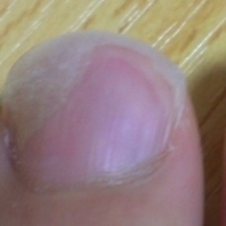  
 normal#1321  
**Analysis by this app:**normal = 96%; non-serious = 4%; check with a GP = 0%;   
The nail's condition is normal with confidence score of 96%.  
Otherwise it is non-serious with confidence score of 4%.×

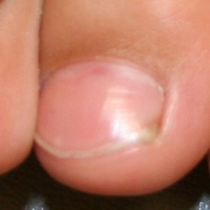  
 normal#1206  
**Analysis by this app:**normal = 96%; non-serious = 1%; check with a GP = 3%;   
The nail's condition is normal with confidence score of 96%.  
The confidence score for consulting a GP is 3%.×

  
 normal#1041  
**Analysis by this app:**normal = 96%; non-serious = 1%; check with a GP = 3%;   
The nail's condition is normal with confidence score of 96%.  
The confidence score for consulting a GP is 3%.×

 normal#516  
**Analysis by this app:**normal = 96%; non-serious = 0%; check with a GP = 4%;   
The nail's condition is normal with confidence score of 96%.  
The confidence score for consulting a GP is 4%.×

 normal#911  
**Analysis by this app:**normal = 96%; non-serious = 3%; check with a GP = 1%;   
The nail's condition is normal with confidence score of 96%.  
Otherwise it is non-serious with confidence score of 3%.×

 normal#671  
**Analysis by this app:**normal = 96%; non-serious = 0%; check with a GP = 4%;   
The nail's condition is normal with confidence score of 96%.  
The confidence score for consulting a GP is 4%.×

 normal#406  
**Analysis by this app:**normal = 96%; non-serious = 2%; check with a GP = 2%;   
The nail's condition is normal with confidence score of 96%.  
Otherwise it is non-serious with confidence score of 2%.×

 normal#81  
**Analysis by this app:**normal = 96%; non-serious = 2%; check with a GP = 2%;   
The nail's condition is normal with confidence score of 96%.  
Otherwise it is non-serious with confidence score of 2%.×

 normal#731  
**Analysis by this app:**normal = 96%; non-serious = 4%; check with a GP = 0%;   
The nail's condition is normal with confidence score of 96%.  
Otherwise it is non-serious with confidence score of 4%.×

 normal#436  
**Analysis by this app:**normal = 96%; non-serious = 3%; check with a GP = 2%;   
The nail's condition is normal with confidence score of 96%.  
Otherwise it is non-serious with confidence score of 3%.×

 normal#621  
**Analysis by this app:**normal = 96%; non-serious = 0%; check with a GP = 4%;   
The nail's condition is normal with confidence score of 96%.  
The confidence score for consulting a GP is 4%.×

 normal#881  
**Analysis by this app:**normal = 95%; non-serious = 2%; check with a GP = 3%;   
The nail's condition is normal with confidence score of 95%.  
The confidence score for consulting a GP is 3%.×

 normal#266  
**Analysis by this app:**normal = 95%; non-serious = 0%; check with a GP = 4%;   
The nail's condition is normal with confidence score of 95%.  
The confidence score for consulting a GP is 4%.×

 normal#901  
**Analysis by this app:**normal = 95%; non-serious = 2%; check with a GP = 3%;   
The nail's condition is normal with confidence score of 95%.  
The confidence score for consulting a GP is 3%.×

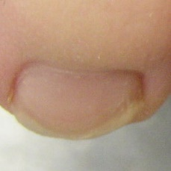  
 normal#1226  
**Analysis by this app:**normal = 95%; non-serious = 4%; check with a GP = 0%;   
The nail's condition is normal with confidence score of 95%.  
Otherwise it is non-serious with confidence score of 4%.×

 normal#111  
**Analysis by this app:**normal = 95%; non-serious = 0%; check with a GP = 5%;   
The nail's condition is normal with confidence score of 95%.  
The confidence score for consulting a GP is 5%.×

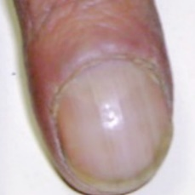  
 normal#1091  
**Analysis by this app:**normal = 95%; non-serious = 2%; check with a GP = 3%;   
The nail's condition is normal with confidence score of 95%.  
The confidence score for consulting a GP is 3%.×

 normal#536  
**Analysis by this app:**normal = 95%; non-serious = 2%; check with a GP = 3%;   
The nail's condition is normal with confidence score of 95%.  
The confidence score for consulting a GP is 3%.×

 normal#896  
**Analysis by this app:**normal = 95%; non-serious = 0%; check with a GP = 5%;   
The nail's condition is normal with confidence score of 95%.  
The confidence score for consulting a GP is 5%.×

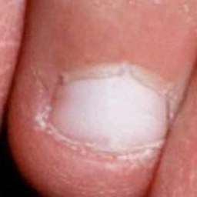  
 normal#1271  
**Analysis by this app:**normal = 94%; non-serious = 6%; check with a GP = 0%;   
The nail's condition is normal with confidence score of 94%.  
Otherwise it is non-serious with confidence score of 6%.×

 normal#596  
**Analysis by this app:**normal = 94%; non-serious = 5%; check with a GP = 0%;   
The nail's condition is normal with confidence score of 94%.  
Otherwise it is non-serious with confidence score of 5%.×

 normal#181  
**Analysis by this app:**normal = 94%; non-serious = 0%; check with a GP = 6%;   
The nail's condition is normal with confidence score of 94%.  
The confidence score for consulting a GP is 6%.×

 normal#446  
**Analysis by this app:**normal = 94%; non-serious = 1%; check with a GP = 5%;   
The nail's condition is normal with confidence score of 94%.  
The confidence score for consulting a GP is 5%.×

 normal#411  
**Analysis by this app:**normal = 94%; non-serious = 2%; check with a GP = 4%;   
The nail's condition is normal with confidence score of 94%.  
The confidence score for consulting a GP is 4%.×

 normal#466  
**Analysis by this app:**normal = 94%; non-serious = 5%; check with a GP = 1%;   
The nail's condition is normal with confidence score of 94%.  
Otherwise it is non-serious with confidence score of 5%.×

 normal#651  
**Analysis by this app:**normal = 94%; non-serious = 0%; check with a GP = 6%;   
The nail's condition is normal with confidence score of 94%.  
The confidence score for consulting a GP is 6%.×

 normal#96  
**Analysis by this app:**normal = 94%; non-serious = 1%; check with a GP = 5%;   
The nail's condition is normal with confidence score of 94%.  
The confidence score for consulting a GP is 5%.×

 normal#246  
**Analysis by this app:**normal = 94%; non-serious = 1%; check with a GP = 5%;   
The nail's condition is normal with confidence score of 94%.  
The confidence score for consulting a GP is 5%.×

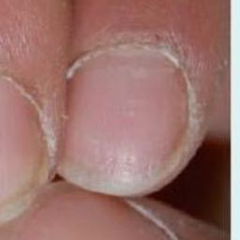  
 normal#1216  
**Analysis by this app:**normal = 93%; non-serious = 4%; check with a GP = 2%;   
The nail's condition is normal with confidence score of 93%.  
Otherwise it is non-serious with confidence score of 4%.×

 normal#431  
**Analysis by this app:**normal = 93%; non-serious = 5%; check with a GP = 2%;   
The nail's condition is normal with confidence score of 93%.  
Otherwise it is non-serious with confidence score of 5%.×

 normal#931  
**Analysis by this app:**normal = 93%; non-serious = 0%; check with a GP = 7%;   
The nail's condition is normal with confidence score of 93%.  
The confidence score for consulting a GP is 7%.×

 normal#846  
**Analysis by this app:**normal = 93%; non-serious = 7%; check with a GP = 0%;   
The nail's condition is normal with confidence score of 93%.  
Otherwise it is non-serious with confidence score of 7%.×

 normal#311  
**Analysis by this app:**normal = 93%; non-serious = 7%; check with a GP = 0%;   
The nail's condition is normal with confidence score of 93%.  
Otherwise it is non-serious with confidence score of 7%.×

 normal#21  
**Analysis by this app:**normal = 93%; non-serious = 6%; check with a GP = 1%;   
The nail's condition is normal with confidence score of 93%.  
Otherwise it is non-serious with confidence score of 6%.×

 normal#591  
**Analysis by this app:**normal = 93%; non-serious = 7%; check with a GP = 1%;   
The nail's condition is normal with confidence score of 93%.  
Otherwise it is non-serious with confidence score of 7%.×

 normal#611  
**Analysis by this app:**normal = 93%; non-serious = 3%; check with a GP = 4%;   
The nail's condition is normal with confidence score of 93%.  
The confidence score for consulting a GP is 4%.×

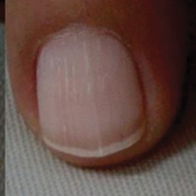  
 normal#1176  
**Analysis by this app:**normal = 93%; non-serious = 2%; check with a GP = 5%;   
The nail's condition is normal with confidence score of 93%.  
The confidence score for consulting a GP is 5%.×

 normal#36  
**Analysis by this app:**normal = 93%; non-serious = 0%; check with a GP = 7%;   
The nail's condition is normal with confidence score of 93%.  
The confidence score for consulting a GP is 7%.×

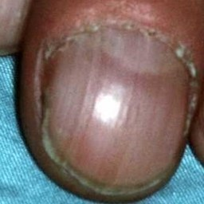  
 normal#1106  
**Analysis by this app:**normal = 92%; non-serious = 1%; check with a GP = 6%;   
The nail's condition is normal with confidence score of 92%.  
The confidence score for consulting a GP is 6%.×

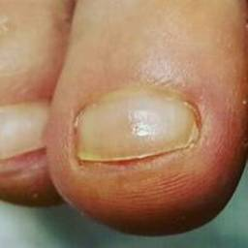  
 normal#1346  
**Analysis by this app:**normal = 92%; non-serious = 7%; check with a GP = 1%;   
The nail's condition is normal with confidence score of 92%.  
Otherwise it is non-serious with confidence score of 7%.×

 normal#126  
**Analysis by this app:**normal = 92%; non-serious = 3%; check with a GP = 5%;   
The nail's condition is normal with confidence score of 92%.  
The confidence score for consulting a GP is 5%.×

 normal#816  
**Analysis by this app:**normal = 92%; non-serious = 0%; check with a GP = 8%;   
The nail's condition is normal with confidence score of 92%.  
The confidence score for consulting a GP is 8%.×

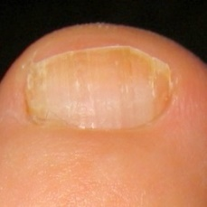  
 normal#1056  
**Analysis by this app:**normal = 92%; non-serious = 8%; check with a GP = 0%;   
The nail's condition is normal with confidence score of 92%.  
Otherwise it is non-serious with confidence score of 8%.×

 normal#866  
**Analysis by this app:**normal = 92%; non-serious = 8%; check with a GP = 0%;   
The nail's condition is normal with confidence score of 92%.  
Otherwise it is non-serious with confidence score of 8%.×

 normal#56  
**Analysis by this app:**normal = 91%; non-serious = 0%; check with a GP = 8%;   
The nail's condition is normal with confidence score of 91%.  
The confidence score for consulting a GP is 8%.×

 normal#441  
**Analysis by this app:**normal = 91%; non-serious = 2%; check with a GP = 7%;   
The nail's condition is normal with confidence score of 91%.  
The confidence score for consulting a GP is 7%.×

 normal#601  
**Analysis by this app:**normal = 91%; non-serious = 0%; check with a GP = 9%;   
The nail's condition is normal with confidence score of 91%.  
The confidence score for consulting a GP is 9%.×

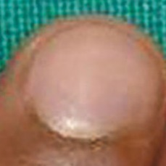  
 normal#1241  
**Analysis by this app:**normal = 91%; non-serious = 4%; check with a GP = 5%;   
The nail's condition is normal with confidence score of 91%.  
The confidence score for consulting a GP is 5%.×

 normal#211  
**Analysis by this app:**normal = 91%; non-serious = 0%; check with a GP = 9%;   
The nail's condition is normal with confidence score of 91%.  
The confidence score for consulting a GP is 9%.×

 normal#661  
**Analysis by this app:**normal = 90%; non-serious = 0%; check with a GP = 9%;   
The nail's condition is normal with confidence score of 90%.  
The confidence score for consulting a GP is 9%.×

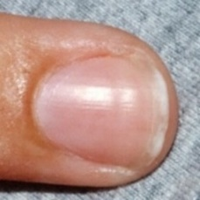  
 normal#1086  
**Analysis by this app:**normal = 90%; non-serious = 2%; check with a GP = 8%;   
The nail's condition is normal with confidence score of 90%.  
The confidence score for consulting a GP is 8%.×

 normal#346  
**Analysis by this app:**normal = 90%; non-serious = 1%; check with a GP = 9%;   
The nail's condition is normal with confidence score of 90%.  
The confidence score for consulting a GP is 9%.×

 normal#46  
**Analysis by this app:**normal = 90%; non-serious = 3%; check with a GP = 7%;   
The nail's condition is normal with confidence score of 90%.  
The confidence score for consulting a GP is 7%.×

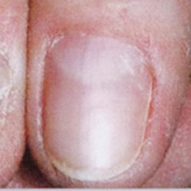  
 normal#1326  
**Analysis by this app:**normal = 89%; non-serious = 10%; check with a GP = 0%;   
The nail's condition is normal with confidence score of 89%.  
Otherwise it is non-serious with confidence score of 10%.×

 normal#91  
**Analysis by this app:**normal = 89%; non-serious = 9%; check with a GP = 2%;   
The nail's condition is normal with confidence score of 89%.  
Otherwise it is non-serious with confidence score of 9%.×

 normal#326  
**Analysis by this app:**normal = 89%; non-serious = 10%; check with a GP = 1%;   
The nail's condition is normal with confidence score of 89%.  
Otherwise it is non-serious with confidence score of 10%.×

 normal#251  
**Analysis by this app:**normal = 89%; non-serious = 0%; check with a GP = 11%;   
The nail's condition is normal with confidence score of 89%.  
The confidence score for consulting a GP is 11%.×

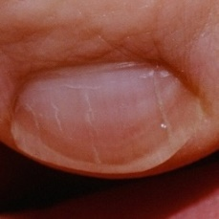  
 normal#1076  
**Analysis by this app:**normal = 89%; non-serious = 9%; check with a GP = 2%;   
The nail's condition is normal with confidence score of 89%.  
Otherwise it is non-serious with confidence score of 9%.×

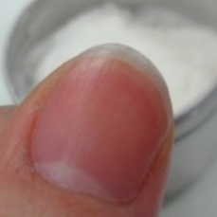  
 normal#1356  
**Analysis by this app:**normal = 89%; non-serious = 0%; check with a GP = 11%;   
The nail's condition is normal with confidence score of 89%.  
The confidence score for consulting a GP is 11%.×

 normal#261  
**Analysis by this app:**normal = 88%; non-serious = 1%; check with a GP = 11%;   
The nail's condition is normal with confidence score of 88%.  
The confidence score for consulting a GP is 11%.×

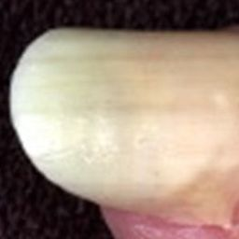  
 normal#1046  
**Analysis by this app:**normal = 88%; non-serious = 12%; check with a GP = 0%;   
The nail's condition is normal with confidence score of 88%.  
Otherwise it is non-serious with confidence score of 12%.×

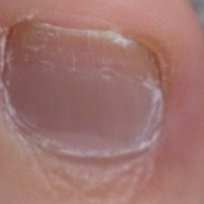  
 normal#1301  
**Analysis by this app:**normal = 87%; non-serious = 3%; check with a GP = 10%;   
The nail's condition is normal with confidence score of 87%.  
The confidence score for consulting a GP is 10%.×

 normal#566  
**Analysis by this app:**normal = 86%; non-serious = 2%; check with a GP = 12%;   
The nail's condition is normal with confidence score of 86%.  
The confidence score for consulting a GP is 12%.×

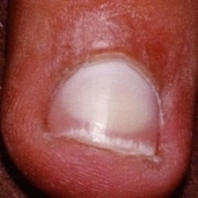  
 normal#1256  
**Analysis by this app:**normal = 86%; non-serious = 7%; check with a GP = 7%;   
The nail's condition is normal with confidence score of 86%.  
Otherwise it is non-serious with confidence score of 7%.×

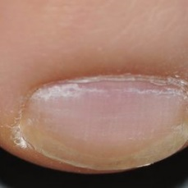  
 normal#1336  
**Analysis by this app:**normal = 86%; non-serious = 10%; check with a GP = 4%;   
The nail's condition is normal with confidence score of 86%.  
Otherwise it is non-serious with confidence score of 10%.×

 normal#191  
**Analysis by this app:**normal = 86%; non-serious = 0%; check with a GP = 14%;   
The nail's condition is normal with confidence score of 86%.  
The confidence score for consulting a GP is 14%.×

 normal#676  
**Analysis by this app:**normal = 86%; non-serious = 5%; check with a GP = 9%;   
The nail's condition is normal with confidence score of 86%.  
The confidence score for consulting a GP is 9%.×

 normal#476  
**Analysis by this app:**normal = 85%; non-serious = 9%; check with a GP = 5%;   
The nail's condition is normal with confidence score of 85%.  
Otherwise it is non-serious with confidence score of 9%.×

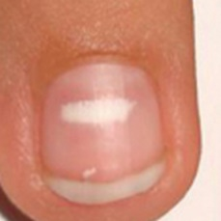  
 normal#1276  
**Analysis by this app:**normal = 85%; non-serious = 5%; check with a GP = 10%;   
The nail's condition is normal with confidence score of 85%.  
The confidence score for consulting a GP is 10%.×

 normal#656  
**Analysis by this app:**normal = 85%; non-serious = 12%; check with a GP = 3%;   
The nail's condition is normal with confidence score of 85%.  
Otherwise it is non-serious with confidence score of 12%.×

 normal#826  
**Analysis by this app:**normal = 84%; non-serious = 13%; check with a GP = 3%;   
The nail's condition is normal with confidence score of 84%.  
Otherwise it is non-serious with confidence score of 13%.×

 normal#541  
**Analysis by this app:**normal = 84%; non-serious = 7%; check with a GP = 10%;   
The nail's condition is normal with confidence score of 84%.  
The confidence score for consulting a GP is 10%.×

 normal#201  
**Analysis by this app:**normal = 83%; non-serious = 0%; check with a GP = 17%;   
The nail's condition is normal with confidence score of 83%.  
The confidence score for consulting a GP is 17%.×

 normal#366  
**Analysis by this app:**normal = 82%; non-serious = 10%; check with a GP = 8%;   
The nail's condition is normal with confidence score of 82%.  
Otherwise it is non-serious with confidence score of 10%.×

 normal#316  
**Analysis by this app:**normal = 82%; non-serious = 16%; check with a GP = 2%;   
The nail's condition is normal with confidence score of 82%.  
Otherwise it is non-serious with confidence score of 16%.×

 normal#781  
**Analysis by this app:**normal = 81%; non-serious = 2%; check with a GP = 17%;   
The nail's condition is normal with confidence score of 81%.  
The confidence score for consulting a GP is 17%.×

 normal#156  
**Analysis by this app:**normal = 80%; non-serious = 18%; check with a GP = 2%;   
The nail's condition is normal with confidence score of 80%.  
Otherwise it is non-serious with confidence score of 18%.×

 normal#421  
**Analysis by this app:**normal = 80%; non-serious = 20%; check with a GP = 0%;   
The nail's condition is normal with confidence score of 80%.  
Otherwise it is non-serious with confidence score of 20%.×

 normal#136  
**Analysis by this app:**normal = 79%; non-serious = 9%; check with a GP = 12%;   
The nail's condition is normal with confidence score of 79%.  
The confidence score for consulting a GP is 12%.×

 normal#286  
**Analysis by this app:**normal = 79%; non-serious = 4%; check with a GP = 18%;   
The nail's condition is normal with confidence score of 79%.  
The confidence score for consulting a GP is 18%.×

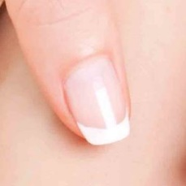  
 normal#1341  
**Analysis by this app:**normal = 78%; non-serious = 5%; check with a GP = 17%;   
The nail's condition is normal with confidence score of 78%.  
The confidence score for consulting a GP is 17%.×

 normal#296  
**Analysis by this app:**normal = 78%; non-serious = 2%; check with a GP = 20%;   
Perhaps a GP should be consulted (confidence score is 20%) ×

 normal#971  
**Analysis by this app:**normal = 78%; non-serious = 22%; check with a GP = 1%;   
The nail's condition is normal with confidence score of 78%.  
Otherwise it is non-serious with confidence score of 22%.×

 normal#546  
**Analysis by this app:**normal = 77%; non-serious = 9%; check with a GP = 14%;   
The nail's condition is normal with confidence score of 77%.  
The confidence score for consulting a GP is 14%.×

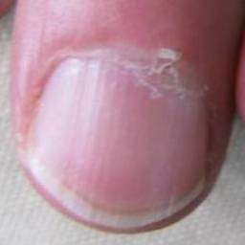  
 normal#1116  
**Analysis by this app:**normal = 77%; non-serious = 2%; check with a GP = 21%;   
Perhaps a GP should be consulted (confidence score is 21%) ×

 normal#291  
**Analysis by this app:**normal = 77%; non-serious = 10%; check with a GP = 13%;   
The nail's condition is normal with confidence score of 77%.  
The confidence score for consulting a GP is 13%.×

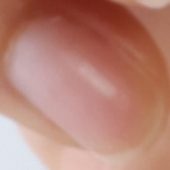  
 normal#1361  
**Analysis by this app:**normal = 77%; non-serious = 2%; check with a GP = 21%;   
Perhaps a GP should be consulted (confidence score is 21%) ×

 normal#796  
**Analysis by this app:**normal = 77%; non-serious = 18%; check with a GP = 5%;   
The nail's condition is normal with confidence score of 77%.  
Otherwise it is non-serious with confidence score of 18%.×

 normal#306  
**Analysis by this app:**normal = 76%; non-serious = 7%; check with a GP = 17%;   
The nail's condition is normal with confidence score of 76%.  
The confidence score for consulting a GP is 17%.×

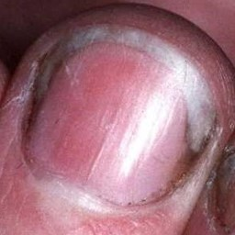  
 normal#1251  
**Analysis by this app:**normal = 76%; non-serious = 7%; check with a GP = 17%;   
The nail's condition is normal with confidence score of 76%.  
The confidence score for consulting a GP is 17%.×

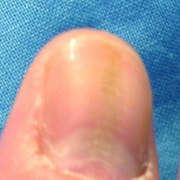  
 normal#1096  
**Analysis by this app:**normal = 76%; non-serious = 18%; check with a GP = 6%;   
The nail's condition is normal with confidence score of 76%.  
Otherwise it is non-serious with confidence score of 18%.×

 normal#146  
**Analysis by this app:**normal = 75%; non-serious = 13%; check with a GP = 12%;   
The nail's condition is normal with confidence score of 75%.  
Otherwise it is non-serious with confidence score of 13%.×

 normal#166  
**Analysis by this app:**normal = 75%; non-serious = 3%; check with a GP = 22%;   
Perhaps a GP should be consulted (confidence score is 22%) ×

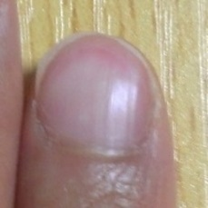  
 normal#1316  
**Analysis by this app:**normal = 75%; non-serious = 5%; check with a GP = 20%;   
Perhaps a GP should be consulted (confidence score is 20%) ×

 normal#891  
**Analysis by this app:**normal = 74%; non-serious = 0%; check with a GP = 26%;   
Perhaps a GP should be consulted (confidence score is 26%) ×

 normal#371  
**Analysis by this app:**normal = 74%; non-serious = 6%; check with a GP = 20%;   
Perhaps a GP should be consulted (confidence score is 20%) ×

 normal#506  
**Analysis by this app:**normal = 73%; non-serious = 5%; check with a GP = 22%;   
Perhaps a GP should be consulted (confidence score is 22%) ×

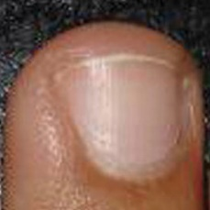  
 normal#1061  
**Analysis by this app:**normal = 73%; non-serious = 1%; check with a GP = 26%;   
Perhaps a GP should be consulted (confidence score is 26%) ×

 normal#641  
**Analysis by this app:**normal = 72%; non-serious = 0%; check with a GP = 28%;   
Perhaps a GP should be consulted (confidence score is 28%) ×

 normal#616  
**Analysis by this app:**normal = 72%; non-serious = 0%; check with a GP = 28%;   
Perhaps a GP should be consulted (confidence score is 28%) ×

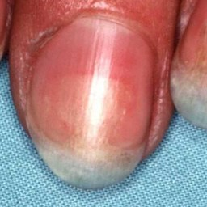  
 normal#1151  
**Analysis by this app:**normal = 71%; non-serious = 1%; check with a GP = 28%;   
Perhaps a GP should be consulted (confidence score is 28%) ×

 normal#51  
**Analysis by this app:**normal = 70%; non-serious = 26%; check with a GP = 4%;   
The nail's condition is normal with confidence score of 70%.  
Otherwise it is non-serious with confidence score of 26%.×

 normal#861  
**Analysis by this app:**normal = 70%; non-serious = 4%; check with a GP = 26%;   
Perhaps a GP should be consulted (confidence score is 26%) ×

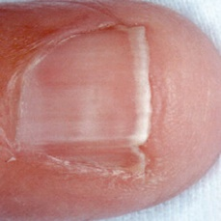  
 normal#1156  
**Analysis by this app:**normal = 69%; non-serious = 10%; check with a GP = 21%;   
Perhaps a GP should be consulted (confidence score is 21%) ×

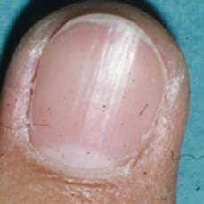  
 normal#1186  
**Analysis by this app:**normal = 67%; non-serious = 0%; check with a GP = 33%;   
Perhaps a GP should be consulted (confidence score is 33%) ×

 normal#871  
**Analysis by this app:**normal = 67%; non-serious = 3%; check with a GP = 30%;   
Perhaps a GP should be consulted (confidence score is 30%) ×

 normal#101  
**Analysis by this app:**normal = 66%; non-serious = 15%; check with a GP = 19%;   
The nail's condition is normal with confidence score of 66%.  
The confidence score for consulting a GP is 19%.×

 normal#456  
**Analysis by this app:**normal = 65%; non-serious = 3%; check with a GP = 32%;   
Perhaps a GP should be consulted (confidence score is 32%) ×

 normal#416  
**Analysis by this app:**normal = 63%; non-serious = 1%; check with a GP = 36%;   
Perhaps a GP should be consulted (confidence score is 36%) ×

 normal#341  
**Analysis by this app:**normal = 63%; non-serious = 2%; check with a GP = 35%;   
Perhaps a GP should be consulted (confidence score is 35%) ×

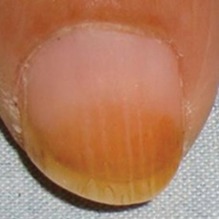  
 normal#1231  
**Analysis by this app:**normal = 63%; non-serious = 1%; check with a GP = 37%;   
Perhaps a GP should be consulted (confidence score is 37%) ×

 normal#206  
**Analysis by this app:**normal = 62%; non-serious = 38%; check with a GP = 0%;   
The nail's condition is normal with confidence score of 62%.  
Otherwise it is non-serious with confidence score of 38%.×

 normal#271  
**Analysis by this app:**normal = 62%; non-serious = 5%; check with a GP = 33%;   
Perhaps a GP should be consulted (confidence score is 33%) ×

 normal#936  
**Analysis by this app:**normal = 60%; non-serious = 8%; check with a GP = 32%;   
Perhaps a GP should be consulted (confidence score is 32%) ×

 normal#586  
**Analysis by this app:**normal = 58%; non-serious = 13%; check with a GP = 29%;   
Not very sure whether the nail is OK or not. Sorry.×

 normal#696  
**Analysis by this app:**normal = 58%; non-serious = 0%; check with a GP = 41%;   
Not very sure whether the nail is OK or not. Sorry.×

 normal#711  
**Analysis by this app:**normal = 57%; non-serious = 1%; check with a GP = 42%;   
Not very sure whether the nail is OK or not. Sorry.×

 normal#226  
**Analysis by this app:**normal = 54%; non-serious = 46%; check with a GP = 0%;   
Not very sure whether the nail is OK or not. Sorry.×

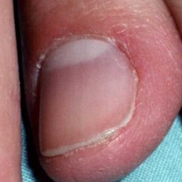  
 normal#1011  
**Analysis by this app:**normal = 53%; non-serious = 1%; check with a GP = 45%;   
Not very sure whether the nail is OK or not. Sorry.×

 normal#681  
**Analysis by this app:**normal = 52%; non-serious = 47%; check with a GP = 0%;   
Not very sure whether the nail is OK or not. Sorry.×

 normal#196  
**Analysis by this app:**normal = 52%; non-serious = 6%; check with a GP = 41%;   
Not very sure whether the nail is OK or not. Sorry.×

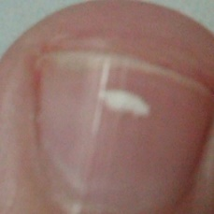  
 normal#1166  
**Analysis by this app:**normal = 51%; non-serious = 33%; check with a GP = 16%;   
Not very sure whether the nail is OK or not. Sorry.×

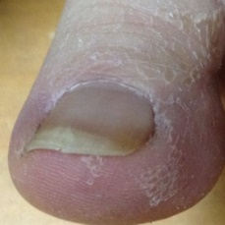  
 normal#1051  
**Analysis by this app:**normal = 50%; non-serious = 41%; check with a GP = 9%;   
Not very sure whether the nail is OK or not. Sorry.×

 normal#961  
**Analysis by this app:**normal = 48%; non-serious = 28%; check with a GP = 24%;   
Not very sure whether the nail is OK or not. Sorry.×

 normal#86  
**Analysis by this app:**normal = 46%; non-serious = 12%; check with a GP = 42%;   
Not very sure whether the nail is OK or not. Sorry.×

 normal#851  
**Analysis by this app:**normal = 45%; non-serious = 52%; check with a GP = 4%;   
Not very sure whether the nail is OK or not. Sorry.×

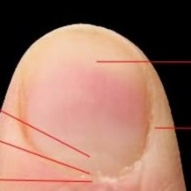  
 normal#1261  
**Analysis by this app:**normal = 45%; non-serious = 37%; check with a GP = 18%;   
Not very sure whether the nail is OK or not. Sorry.×

 normal#41  
**Analysis by this app:**normal = 44%; non-serious = 2%; check with a GP = 54%;   
Not very sure whether the nail is OK or not. Sorry.×

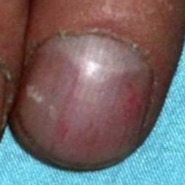  
 normal#1221  
**Analysis by this app:**normal = 43%; non-serious = 35%; check with a GP = 22%;   
Not very sure whether the nail is OK or not. Sorry.×

 normal#176  
**Analysis by this app:**normal = 40%; non-serious = 58%; check with a GP = 1%;   
Not very sure whether the nail is OK or not. Sorry.×

 normal#746  
**Analysis by this app:**normal = 40%; non-serious = 19%; check with a GP = 40%;   
Not very sure whether the nail is OK or not. Sorry.×

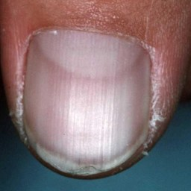  
 normal#1211  
**Analysis by this app:**normal = 39%; non-serious = 1%; check with a GP = 60%;   
It is most likely that the nail indicates something that warrants a second opinion and you should seek medical advice. (Confidence score is 60%)×

 normal#71  
**Analysis by this app:**normal = 39%; non-serious = 61%; check with a GP = 0%;   
The nail's condition is non-serious with confidence score of 61%.  
Otherwise it is normal with confidence score of 39%.×

 normal#351  
**Analysis by this app:**normal = 35%; non-serious = 26%; check with a GP = 39%;   
Not very sure whether the nail is OK or not. Sorry.×

 normal#606  
**Analysis by this app:**normal = 35%; non-serious = 0%; check with a GP = 65%;   
It is most likely that the nail indicates something that warrants a second opinion and you should seek medical advice. (Confidence score is 65%)×

 normal#216  
**Analysis by this app:**normal = 33%; non-serious = 61%; check with a GP = 6%;   
The nail's condition is non-serious with confidence score of 61%.  
Otherwise it is normal with confidence score of 33%.×

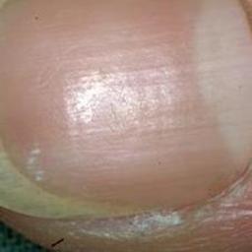  
 normal#1291  
**Analysis by this app:**normal = 32%; non-serious = 50%; check with a GP = 18%;   
Not very sure whether the nail is OK or not. Sorry.×

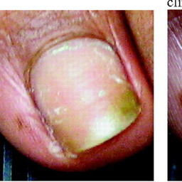  
 normal#1081  
**Analysis by this app:**normal = 29%; non-serious = 70%; check with a GP = 2%;   
The nail's condition is non-serious with confidence score of 70%.  
Otherwise it is normal with confidence score of 29%.×

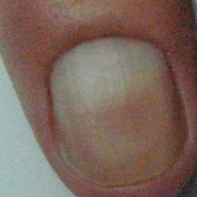  
 normal#1066  
**Analysis by this app:**normal = 28%; non-serious = 51%; check with a GP = 21%;   
Not very sure whether the nail is OK or not. Sorry.×

 normal#231  
**Analysis by this app:**normal = 25%; non-serious = 75%; check with a GP = 0%;   
The nail's condition is non-serious with confidence score of 75%.  
Otherwise it is normal with confidence score of 25%.×

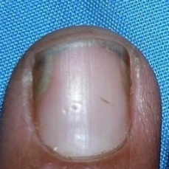  
 normal#1146  
**Analysis by this app:**normal = 23%; non-serious = 2%; check with a GP = 75%;   
It is most likely that the nail indicates something that warrants a second opinion and you should seek medical advice. (Confidence score is 75%)×

  
 normal#1031  
**Analysis by this app:**normal = 23%; non-serious = 2%; check with a GP = 75%;   
It is most likely that the nail indicates something that warrants a second opinion and you should seek medical advice. (Confidence score is 75%)×

 normal#766  
**Analysis by this app:**normal = 20%; non-serious = 0%; check with a GP = 80%;   
It is most likely that the nail indicates something that warrants a second opinion and you should seek medical advice. (Confidence score is 80%)×

 normal#921  
**Analysis by this app:**normal = 19%; non-serious = 1%; check with a GP = 80%;   
It is most likely that the nail indicates something that warrants a second opinion and you should seek medical advice. (Confidence score is 80%)×

 normal#276  
**Analysis by this app:**normal = 17%; non-serious = 80%; check with a GP = 3%;   
The nail's condition is non-serious with confidence score of 80%.  
Otherwise it is normal with confidence score of 17%.×

 normal#236  
**Analysis by this app:**normal = 8%; non-serious = 92%; check with a GP = 0%;   
The nail's condition is non-serious with confidence score of 92%.  
Otherwise it is normal with confidence score of 8%.×

 normal#106  
**Analysis by this app:**normal = 8%; non-serious = 9%; check with a GP = 83%;   
It is most likely that the nail indicates something that warrants a second opinion and you should seek medical advice. (Confidence score is 83%)×

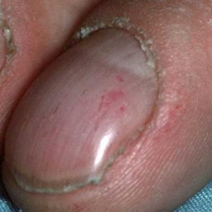  
 normal#1161  
**Analysis by this app:**normal = 7%; non-serious = 92%; check with a GP = 1%;   
The nail's condition is non-serious with confidence score of 92%.  
Otherwise it is normal with confidence score of 7%.×

 normal#721  
**Analysis by this app:**normal = 6%; non-serious = 3%; check with a GP = 91%;   
It is most likely that the nail indicates something that warrants a second opinion and you should seek medical advice. (Confidence score is 91%)×

 normal#331  
**Analysis by this app:**normal = 5%; non-serious = 32%; check with a GP = 63%;   
It is most likely that the nail indicates something that warrants a second opinion and you should seek medical advice. (Confidence score is 63%)×

 normal#381  
**Analysis by this app:**normal = 4%; non-serious = 81%; check with a GP = 15%;   
The nail's condition is non-serious with confidence score of 81%.  
The confidence score for consulting a GP is 15%.×

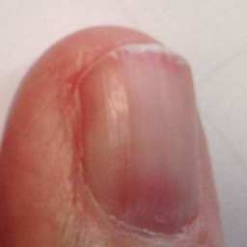  
 normal#1026  
**Analysis by this app:**normal = 3%; non-serious = 12%; check with a GP = 85%;   
It is most likely that the nail indicates something that warrants a second opinion and you should seek medical advice. (Confidence score is 85%)×

 normal#11  
**Analysis by this app:**normal = 3%; non-serious = 16%; check with a GP = 81%;   
It is most likely that the nail indicates something that warrants a second opinion and you should seek medical advice. (Confidence score is 81%)×

 normal#66  
**Analysis by this app:**normal = 3%; non-serious = 4%; check with a GP = 93%;   
It is most likely that the nail indicates something that warrants a second opinion and you should seek medical advice. (Confidence score is 93%)×

 normal#461  
**Analysis by this app:**normal = 2%; non-serious = 1%; check with a GP = 96%;   
It is most likely that the nail indicates something that warrants a second opinion and you should seek medical advice. (Confidence score is 96%)×

 normal#701  
**Analysis by this app:**normal = 2%; non-serious = 97%; check with a GP = 1%;   
The nail's condition is non-serious with confidence score of 97%.  
Otherwise it is normal with confidence score of 2%.×

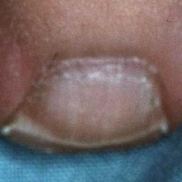  
 normal#1191  
**Analysis by this app:**normal = 1%; non-serious = 99%; check with a GP = 0%;   
The nail's condition is non-serious with confidence score of 99%.  
Otherwise it is normal with confidence score of 1%.×