**normal-fungal-serious-160-200-epochs-all-varianceScaling-no-originals**

true positives = 95  
true negatives = 523  
false positives = 36  
false negatives = 29  
not confident of any answer = 49  
total = 732  
  
sensitivity = 0.7661  
specificity = 0.9356  
precision = 0.7252  
recall = 0.7661

 check with a GP#317  
**Analysis by this app:**normal = 2%; non-serious = 53%; check with a GP = 45%;   
Not very sure whether the nail is OK or not. Sorry. ×

 check with a GP#477  
**Analysis by this app:**normal = 1%; non-serious = 56%; check with a GP = 43%;   
Not very sure whether the nail is OK or not. Sorry. ×

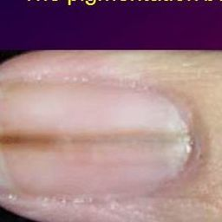  
 check with a GP#612  
**Analysis by this app:**normal = 55%; non-serious = 3%; check with a GP = 42%;   
Not very sure whether the nail is OK or not. Sorry. ×

 check with a GP#152  
**Analysis by this app:**normal = 53%; non-serious = 6%; check with a GP = 40%;   
Not very sure whether the nail is OK or not. Sorry. ×

 check with a GP#427  
**Analysis by this app:**normal = 49%; non-serious = 12%; check with a GP = 40%;   
Not very sure whether the nail is OK or not. Sorry. ×

 check with a GP#257  
**Analysis by this app:**normal = 8%; non-serious = 52%; check with a GP = 39%;   
Not very sure whether the nail is OK or not. Sorry. ×

 check with a GP#397  
**Analysis by this app:**normal = 1%; non-serious = 66%; check with a GP = 32%;   
Perhaps a GP should be consulted (confidence score is 32%)  ×

 check with a GP#22  
**Analysis by this app:**normal = 0%; non-serious = 70%; check with a GP = 30%;   
Perhaps a GP should be consulted (confidence score is 30%)  ×

 check with a GP#252  
**Analysis by this app:**normal = 74%; non-serious = 0%; check with a GP = 26%;   
Perhaps a GP should be consulted (confidence score is 26%)  ×

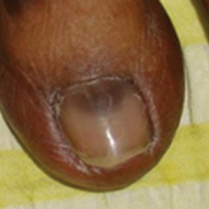  
 check with a GP#647  
**Analysis by this app:**normal = 73%; non-serious = 1%; check with a GP = 26%;   
Perhaps a GP should be consulted (confidence score is 26%)  ×

  
 check with a GP#602  
**Analysis by this app:**normal = 73%; non-serious = 1%; check with a GP = 26%;   
Perhaps a GP should be consulted (confidence score is 26%)  ×

 check with a GP#342  
**Analysis by this app:**normal = 0%; non-serious = 75%; check with a GP = 24%;   
Perhaps a GP should be consulted (confidence score is 24%)  ×

 check with a GP#272  
**Analysis by this app:**normal = 5%; non-serious = 72%; check with a GP = 23%;   
Perhaps a GP should be consulted (confidence score is 23%)  ×

 check with a GP#492  
**Analysis by this app:**normal = 1%; non-serious = 79%; check with a GP = 20%;   
Perhaps a GP should be consulted (confidence score is 20%)  ×

 check with a GP#2  
**Analysis by this app:**normal = 2%; non-serious = 78%; check with a GP = 19%;   
The nail's condition is non-serious with confidence score of 78%.  
The confidence score for consulting a GP is 19%. ×

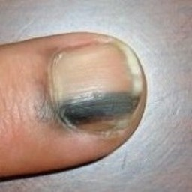  
 check with a GP#562  
**Analysis by this app:**normal = 79%; non-serious = 4%; check with a GP = 17%;   
The nail's condition is normal with confidence score of 79%.  
The confidence score for consulting a GP is 17%. ×

 check with a GP#522  
**Analysis by this app:**normal = 1%; non-serious = 82%; check with a GP = 17%;   
The nail's condition is non-serious with confidence score of 82%.  
The confidence score for consulting a GP is 17%. ×

 check with a GP#7  
**Analysis by this app:**normal = 3%; non-serious = 82%; check with a GP = 15%;   
The nail's condition is non-serious with confidence score of 82%.  
The confidence score for consulting a GP is 15%. ×

 check with a GP#412  
**Analysis by this app:**normal = 2%; non-serious = 83%; check with a GP = 15%;   
The nail's condition is non-serious with confidence score of 83%.  
The confidence score for consulting a GP is 15%. ×

 check with a GP#32  
**Analysis by this app:**normal = 2%; non-serious = 83%; check with a GP = 15%;   
The nail's condition is non-serious with confidence score of 83%.  
The confidence score for consulting a GP is 15%. ×

 check with a GP#147  
**Analysis by this app:**normal = 12%; non-serious = 73%; check with a GP = 14%;   
The nail's condition is non-serious with confidence score of 73%.  
The confidence score for consulting a GP is 14%. ×

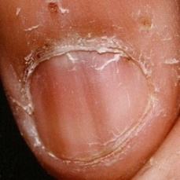  
 check with a GP#582  
**Analysis by this app:**normal = 63%; non-serious = 23%; check with a GP = 14%;   
The nail's condition is normal with confidence score of 63%.  
Otherwise it is non-serious with confidence score of 23%. ×

 check with a GP#262  
**Analysis by this app:**normal = 1%; non-serious = 89%; check with a GP = 10%;   
The nail's condition is non-serious with confidence score of 89%.  
The confidence score for consulting a GP is 10%. ×

 check with a GP#77  
**Analysis by this app:**normal = 90%; non-serious = 1%; check with a GP = 9%;   
The nail's condition is normal with confidence score of 90%.  
The confidence score for consulting a GP is 9%. ×

 check with a GP#112  
**Analysis by this app:**normal = 32%; non-serious = 59%; check with a GP = 9%;   
Not very sure whether the nail is OK or not. Sorry. ×

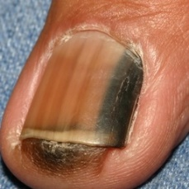  
 check with a GP#597  
**Analysis by this app:**normal = 1%; non-serious = 92%; check with a GP = 7%;   
The nail's condition is non-serious with confidence score of 92%.  
The confidence score for consulting a GP is 7%. ×

 check with a GP#102  
**Analysis by this app:**normal = 93%; non-serious = 0%; check with a GP = 7%;   
The nail's condition is normal with confidence score of 93%.  
The confidence score for consulting a GP is 7%. ×

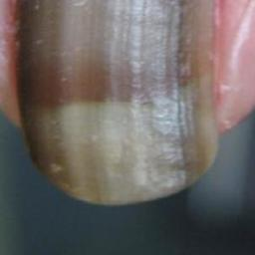  
 check with a GP#652  
**Analysis by this app:**normal = 2%; non-serious = 92%; check with a GP = 7%;   
The nail's condition is non-serious with confidence score of 92%.  
The confidence score for consulting a GP is 7%. ×

 check with a GP#42  
**Analysis by this app:**normal = 0%; non-serious = 94%; check with a GP = 6%;   
The nail's condition is non-serious with confidence score of 94%.  
The confidence score for consulting a GP is 6%. ×

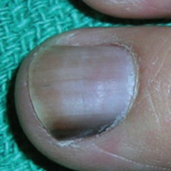  
 check with a GP#557  
**Analysis by this app:**normal = 94%; non-serious = 1%; check with a GP = 5%;   
The nail's condition is normal with confidence score of 94%.  
The confidence score for consulting a GP is 5%. ×

 check with a GP#57  
**Analysis by this app:**normal = 37%; non-serious = 59%; check with a GP = 4%;   
Not very sure whether the nail is OK or not. Sorry. ×

 check with a GP#12  
**Analysis by this app:**normal = 96%; non-serious = 0%; check with a GP = 4%;   
The nail's condition is normal with confidence score of 96%.  
The confidence score for consulting a GP is 4%. ×

 check with a GP#357  
**Analysis by this app:**normal = 3%; non-serious = 95%; check with a GP = 2%;   
The nail's condition is non-serious with confidence score of 95%.  
Otherwise it is normal with confidence score of 3%. ×

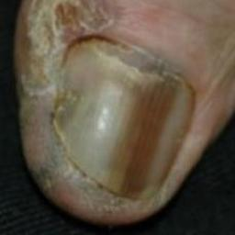  
 check with a GP#632  
**Analysis by this app:**normal = 93%; non-serious = 5%; check with a GP = 2%;   
The nail's condition is normal with confidence score of 93%.  
Otherwise it is non-serious with confidence score of 5%. ×

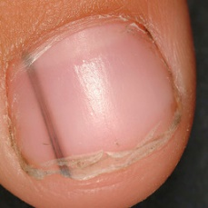  
 check with a GP#572  
**Analysis by this app:**normal = 99%; non-serious = 0%; check with a GP = 1%;   
The nail's condition is normal with confidence score of 99%.  
The confidence score for consulting a GP is 1%. ×

 check with a GP#207  
**Analysis by this app:**normal = 1%; non-serious = 98%; check with a GP = 1%;   
The nail's condition is non-serious with confidence score of 98%.  
Otherwise it is normal with confidence score of 1%. ×

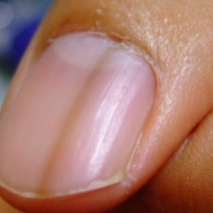  
 check with a GP#662  
**Analysis by this app:**normal = 99%; non-serious = 0%; check with a GP = 1%;   
The nail's condition is normal with confidence score of 99%.  
The confidence score for consulting a GP is 1%. ×

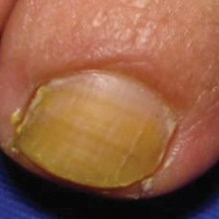  
 non-serious#1389  
**Analysis by this app:**normal = 52%; non-serious = 48%; check with a GP = 1%;   
Not very sure whether the nail is OK or not. Sorry. ×

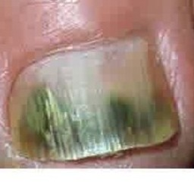  
 non-serious#1074  
**Analysis by this app:**normal = 0%; non-serious = 43%; check with a GP = 57%;   
Not very sure whether the nail is OK or not. Sorry. ×

 non-serious#909  
**Analysis by this app:**normal = 1%; non-serious = 37%; check with a GP = 61%;   
It is most likely that the nail indicates something that warrants a second opinion and you should seek medical advice. (Confidence score is 61%) ×

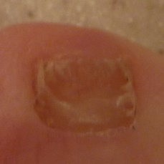  
 non-serious#1409  
**Analysis by this app:**normal = 61%; non-serious = 36%; check with a GP = 2%;   
The nail's condition is normal with confidence score of 61%.  
Otherwise it is non-serious with confidence score of 36%. ×

 non-serious#164  
**Analysis by this app:**normal = 2%; non-serious = 35%; check with a GP = 64%;   
It is most likely that the nail indicates something that warrants a second opinion and you should seek medical advice. (Confidence score is 64%) ×

 non-serious#169  
**Analysis by this app:**normal = 45%; non-serious = 32%; check with a GP = 23%;   
Not very sure whether the nail is OK or not. Sorry. ×

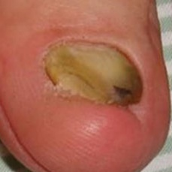  
 non-serious#1424  
**Analysis by this app:**normal = 18%; non-serious = 32%; check with a GP = 50%;   
Not very sure whether the nail is OK or not. Sorry. ×

 non-serious#844  
**Analysis by this app:**normal = 21%; non-serious = 31%; check with a GP = 49%;   
Not very sure whether the nail is OK or not. Sorry. ×

 non-serious#539  
**Analysis by this app:**normal = 29%; non-serious = 27%; check with a GP = 45%;   
Not very sure whether the nail is OK or not. Sorry. ×

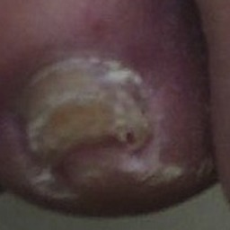  
 non-serious#1264  
**Analysis by this app:**normal = 66%; non-serious = 24%; check with a GP = 10%;   
The nail's condition is normal with confidence score of 66%.  
Otherwise it is non-serious with confidence score of 24%. ×

 non-serious#439  
**Analysis by this app:**normal = 9%; non-serious = 24%; check with a GP = 67%;   
It is most likely that the nail indicates something that warrants a second opinion and you should seek medical advice. (Confidence score is 67%) ×

 non-serious#384  
**Analysis by this app:**normal = 69%; non-serious = 23%; check with a GP = 8%;   
The nail's condition is normal with confidence score of 69%.  
Otherwise it is non-serious with confidence score of 23%. ×

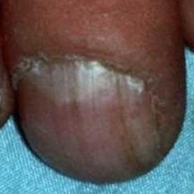  
 non-serious#1404  
**Analysis by this app:**normal = 12%; non-serious = 20%; check with a GP = 68%;   
It is most likely that the nail indicates something that warrants a second opinion and you should seek medical advice. (Confidence score is 68%) ×

 non-serious#39  
**Analysis by this app:**normal = 3%; non-serious = 20%; check with a GP = 76%;   
It is most likely that the nail indicates something that warrants a second opinion and you should seek medical advice. (Confidence score is 76%) ×

 non-serious#699  
**Analysis by this app:**normal = 56%; non-serious = 16%; check with a GP = 28%;   
Not very sure whether the nail is OK or not. Sorry. ×

 non-serious#694  
**Analysis by this app:**normal = 83%; non-serious = 15%; check with a GP = 3%;   
The nail's condition is normal with confidence score of 83%.  
Otherwise it is non-serious with confidence score of 15%. ×

 non-serious#139  
**Analysis by this app:**normal = 30%; non-serious = 13%; check with a GP = 56%;   
Not very sure whether the nail is OK or not. Sorry. ×

 non-serious#244  
**Analysis by this app:**normal = 33%; non-serious = 12%; check with a GP = 55%;   
Not very sure whether the nail is OK or not. Sorry. ×

 non-serious#509  
**Analysis by this app:**normal = 0%; non-serious = 6%; check with a GP = 94%;   
It is most likely that the nail indicates something that warrants a second opinion and you should seek medical advice. (Confidence score is 94%) ×

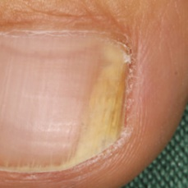  
 non-serious#1504  
**Analysis by this app:**normal = 94%; non-serious = 5%; check with a GP = 1%;   
The nail's condition is normal with confidence score of 94%.  
Otherwise it is non-serious with confidence score of 5%. ×

 non-serious#274  
**Analysis by this app:**normal = 0%; non-serious = 1%; check with a GP = 98%;   
It is most likely that the nail indicates something that warrants a second opinion and you should seek medical advice. (Confidence score is 98%) ×

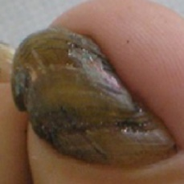  
 non-serious#1304  
**Analysis by this app:**normal = 18%; non-serious = 1%; check with a GP = 82%;   
It is most likely that the nail indicates something that warrants a second opinion and you should seek medical advice. (Confidence score is 82%) ×

 normal#696  
**Analysis by this app:**normal = 45%; non-serious = 0%; check with a GP = 55%;   
Not very sure whether the nail is OK or not. Sorry. ×

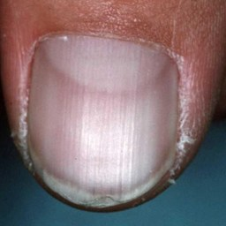  
 normal#1211  
**Analysis by this app:**normal = 44%; non-serious = 1%; check with a GP = 55%;   
Not very sure whether the nail is OK or not. Sorry. ×

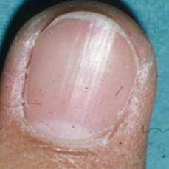  
 normal#1186  
**Analysis by this app:**normal = 43%; non-serious = 0%; check with a GP = 57%;   
Not very sure whether the nail is OK or not. Sorry. ×

 normal#681  
**Analysis by this app:**normal = 43%; non-serious = 57%; check with a GP = 0%;   
Not very sure whether the nail is OK or not. Sorry. ×

 normal#41  
**Analysis by this app:**normal = 43%; non-serious = 2%; check with a GP = 56%;   
Not very sure whether the nail is OK or not. Sorry. ×

 normal#216  
**Analysis by this app:**normal = 42%; non-serious = 51%; check with a GP = 6%;   
Not very sure whether the nail is OK or not. Sorry. ×

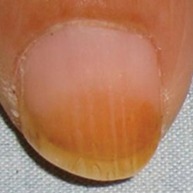  
 normal#1231  
**Analysis by this app:**normal = 41%; non-serious = 1%; check with a GP = 58%;   
Not very sure whether the nail is OK or not. Sorry. ×

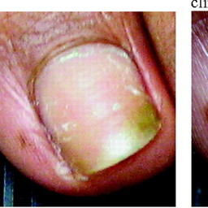  
 normal#1081  
**Analysis by this app:**normal = 39%; non-serious = 60%; check with a GP = 1%;   
The nail's condition is non-serious with confidence score of 60%.  
Otherwise it is normal with confidence score of 39%. ×

 normal#606  
**Analysis by this app:**normal = 38%; non-serious = 0%; check with a GP = 62%;   
It is most likely that the nail indicates something that warrants a second opinion and you should seek medical advice. (Confidence score is 62%) ×

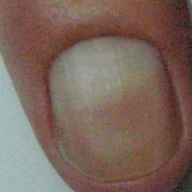  
 normal#1066  
**Analysis by this app:**normal = 36%; non-serious = 37%; check with a GP = 27%;   
Not very sure whether the nail is OK or not. Sorry. ×

 normal#851  
**Analysis by this app:**normal = 34%; non-serious = 64%; check with a GP = 1%;   
The nail's condition is non-serious with confidence score of 64%.  
Otherwise it is normal with confidence score of 34%. ×

 normal#226  
**Analysis by this app:**normal = 32%; non-serious = 68%; check with a GP = 0%;   
The nail's condition is non-serious with confidence score of 68%.  
Otherwise it is normal with confidence score of 32%. ×

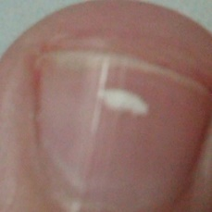  
 normal#1166  
**Analysis by this app:**normal = 27%; non-serious = 56%; check with a GP = 17%;   
Not very sure whether the nail is OK or not. Sorry. ×

 normal#176  
**Analysis by this app:**normal = 27%; non-serious = 72%; check with a GP = 1%;   
The nail's condition is non-serious with confidence score of 72%.  
Otherwise it is normal with confidence score of 27%. ×

 normal#276  
**Analysis by this app:**normal = 26%; non-serious = 69%; check with a GP = 5%;   
The nail's condition is non-serious with confidence score of 69%.  
Otherwise it is normal with confidence score of 26%. ×

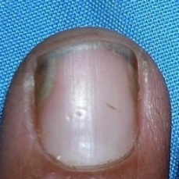  
 normal#1146  
**Analysis by this app:**normal = 23%; non-serious = 1%; check with a GP = 76%;   
It is most likely that the nail indicates something that warrants a second opinion and you should seek medical advice. (Confidence score is 76%) ×

  
 normal#1031  
**Analysis by this app:**normal = 23%; non-serious = 1%; check with a GP = 76%;   
It is most likely that the nail indicates something that warrants a second opinion and you should seek medical advice. (Confidence score is 76%) ×

 normal#766  
**Analysis by this app:**normal = 23%; non-serious = 0%; check with a GP = 77%;   
It is most likely that the nail indicates something that warrants a second opinion and you should seek medical advice. (Confidence score is 77%) ×

 normal#921  
**Analysis by this app:**normal = 19%; non-serious = 0%; check with a GP = 81%;   
It is most likely that the nail indicates something that warrants a second opinion and you should seek medical advice. (Confidence score is 81%) ×

 normal#231  
**Analysis by this app:**normal = 19%; non-serious = 81%; check with a GP = 0%;   
The nail's condition is non-serious with confidence score of 81%.  
Otherwise it is normal with confidence score of 19%. ×

 normal#106  
**Analysis by this app:**normal = 14%; non-serious = 9%; check with a GP = 77%;   
It is most likely that the nail indicates something that warrants a second opinion and you should seek medical advice. (Confidence score is 77%) ×

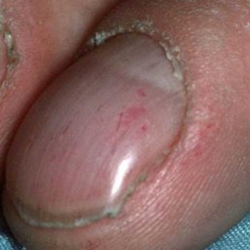  
 normal#1161  
**Analysis by this app:**normal = 10%; non-serious = 89%; check with a GP = 1%;   
The nail's condition is non-serious with confidence score of 89%.  
Otherwise it is normal with confidence score of 10%. ×

 normal#236  
**Analysis by this app:**normal = 8%; non-serious = 92%; check with a GP = 0%;   
The nail's condition is non-serious with confidence score of 92%.  
Otherwise it is normal with confidence score of 8%. ×

 normal#721  
**Analysis by this app:**normal = 8%; non-serious = 4%; check with a GP = 88%;   
It is most likely that the nail indicates something that warrants a second opinion and you should seek medical advice. (Confidence score is 88%) ×

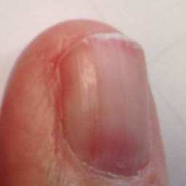  
 normal#1026  
**Analysis by this app:**normal = 8%; non-serious = 7%; check with a GP = 85%;   
It is most likely that the nail indicates something that warrants a second opinion and you should seek medical advice. (Confidence score is 85%) ×

 normal#331  
**Analysis by this app:**normal = 6%; non-serious = 33%; check with a GP = 61%;   
It is most likely that the nail indicates something that warrants a second opinion and you should seek medical advice. (Confidence score is 61%) ×

 normal#66  
**Analysis by this app:**normal = 3%; non-serious = 3%; check with a GP = 95%;   
It is most likely that the nail indicates something that warrants a second opinion and you should seek medical advice. (Confidence score is 95%) ×

 normal#11  
**Analysis by this app:**normal = 3%; non-serious = 6%; check with a GP = 92%;   
It is most likely that the nail indicates something that warrants a second opinion and you should seek medical advice. (Confidence score is 92%) ×

 normal#381  
**Analysis by this app:**normal = 2%; non-serious = 75%; check with a GP = 23%;   
Perhaps a GP should be consulted (confidence score is 23%)  ×

 normal#461  
**Analysis by this app:**normal = 1%; non-serious = 1%; check with a GP = 98%;   
It is most likely that the nail indicates something that warrants a second opinion and you should seek medical advice. (Confidence score is 98%) ×

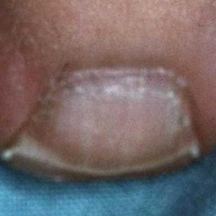  
 normal#1191  
**Analysis by this app:**normal = 1%; non-serious = 98%; check with a GP = 0%;   
The nail's condition is non-serious with confidence score of 98%.  
Otherwise it is normal with confidence score of 1%. ×

 normal#701  
**Analysis by this app:**normal = 1%; non-serious = 99%; check with a GP = 0%;   
The nail's condition is non-serious with confidence score of 99%.  
Otherwise it is normal with confidence score of 1%. ×