**normal-fungal-serious-320-150-epochs-all-varianceScaling-no-originals**

true positives = 94  
true negatives = 521  
false positives = 28  
false negatives = 28  
not confident of any answer = 61  
total = 732  
  
sensitivity = 0.7705  
specificity = 0.949  
precision = 0.7705  
recall = 0.7705

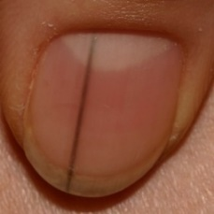  
 check with a GP#567  
**Analysis by this app:**normal = 52%; non-serious = 0%; check with a GP = 48%;   
Not very sure whether the nail is OK or not. Sorry. ×

 check with a GP#477  
**Analysis by this app:**normal = 2%; non-serious = 52%; check with a GP = 46%;   
Not very sure whether the nail is OK or not. Sorry. ×

 check with a GP#317  
**Analysis by this app:**normal = 2%; non-serious = 52%; check with a GP = 46%;   
Not very sure whether the nail is OK or not. Sorry. ×

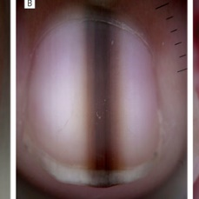  
 check with a GP#607  
**Analysis by this app:**normal = 55%; non-serious = 1%; check with a GP = 45%;   
Not very sure whether the nail is OK or not. Sorry. ×

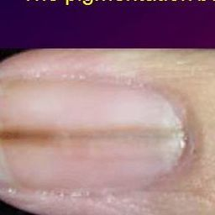  
 check with a GP#612  
**Analysis by this app:**normal = 53%; non-serious = 3%; check with a GP = 44%;   
Not very sure whether the nail is OK or not. Sorry. ×

 check with a GP#152  
**Analysis by this app:**normal = 45%; non-serious = 11%; check with a GP = 44%;   
Not very sure whether the nail is OK or not. Sorry. ×

 check with a GP#257  
**Analysis by this app:**normal = 9%; non-serious = 47%; check with a GP = 44%;   
Not very sure whether the nail is OK or not. Sorry. ×

 check with a GP#252  
**Analysis by this app:**normal = 56%; non-serious = 0%; check with a GP = 44%;   
Not very sure whether the nail is OK or not. Sorry. ×

 check with a GP#272  
**Analysis by this app:**normal = 4%; non-serious = 58%; check with a GP = 37%;   
Not very sure whether the nail is OK or not. Sorry. ×

 check with a GP#492  
**Analysis by this app:**normal = 1%; non-serious = 65%; check with a GP = 34%;   
Perhaps a GP should be consulted (confidence score is 34%)  ×

 check with a GP#397  
**Analysis by this app:**normal = 2%; non-serious = 68%; check with a GP = 29%;   
Perhaps a GP should be consulted (confidence score is 29%)  ×

 check with a GP#22  
**Analysis by this app:**normal = 0%; non-serious = 77%; check with a GP = 23%;   
Perhaps a GP should be consulted (confidence score is 23%)  ×

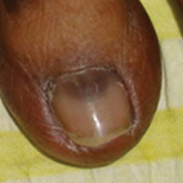  
 check with a GP#647  
**Analysis by this app:**normal = 79%; non-serious = 1%; check with a GP = 20%;   
Perhaps a GP should be consulted (confidence score is 20%)  ×

  
 check with a GP#602  
**Analysis by this app:**normal = 79%; non-serious = 1%; check with a GP = 20%;   
Perhaps a GP should be consulted (confidence score is 20%)  ×

 check with a GP#342  
**Analysis by this app:**normal = 0%; non-serious = 81%; check with a GP = 19%;   
The nail's condition is non-serious with confidence score of 81%.  
The confidence score for consulting a GP is 19%. ×

 check with a GP#32  
**Analysis by this app:**normal = 2%; non-serious = 80%; check with a GP = 18%;   
The nail's condition is non-serious with confidence score of 80%.  
The confidence score for consulting a GP is 18%. ×

 check with a GP#262  
**Analysis by this app:**normal = 2%; non-serious = 80%; check with a GP = 18%;   
The nail's condition is non-serious with confidence score of 80%.  
The confidence score for consulting a GP is 18%. ×

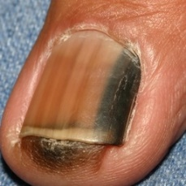  
 check with a GP#597  
**Analysis by this app:**normal = 2%; non-serious = 81%; check with a GP = 17%;   
The nail's condition is non-serious with confidence score of 81%.  
The confidence score for consulting a GP is 17%. ×

 check with a GP#522  
**Analysis by this app:**normal = 1%; non-serious = 84%; check with a GP = 15%;   
The nail's condition is non-serious with confidence score of 84%.  
The confidence score for consulting a GP is 15%. ×

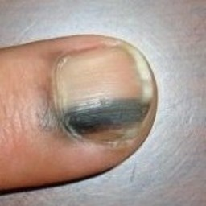  
 check with a GP#562  
**Analysis by this app:**normal = 78%; non-serious = 8%; check with a GP = 14%;   
The nail's condition is normal with confidence score of 78%.  
The confidence score for consulting a GP is 14%. ×

 check with a GP#102  
**Analysis by this app:**normal = 86%; non-serious = 0%; check with a GP = 14%;   
The nail's condition is normal with confidence score of 86%.  
The confidence score for consulting a GP is 14%. ×

 check with a GP#77  
**Analysis by this app:**normal = 84%; non-serious = 2%; check with a GP = 14%;   
The nail's condition is normal with confidence score of 84%.  
The confidence score for consulting a GP is 14%. ×

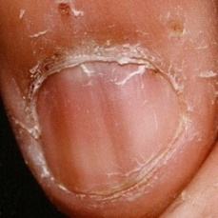  
 check with a GP#582  
**Analysis by this app:**normal = 68%; non-serious = 20%; check with a GP = 12%;   
The nail's condition is normal with confidence score of 68%.  
Otherwise it is non-serious with confidence score of 20%. ×

 check with a GP#147  
**Analysis by this app:**normal = 11%; non-serious = 78%; check with a GP = 11%;   
The nail's condition is non-serious with confidence score of 78%.  
Otherwise it is normal with confidence score of 11%. ×

 check with a GP#412  
**Analysis by this app:**normal = 1%; non-serious = 89%; check with a GP = 10%;   
The nail's condition is non-serious with confidence score of 89%.  
The confidence score for consulting a GP is 10%. ×

 check with a GP#2  
**Analysis by this app:**normal = 1%; non-serious = 91%; check with a GP = 8%;   
The nail's condition is non-serious with confidence score of 91%.  
The confidence score for consulting a GP is 8%. ×

 check with a GP#42  
**Analysis by this app:**normal = 0%; non-serious = 92%; check with a GP = 8%;   
The nail's condition is non-serious with confidence score of 92%.  
The confidence score for consulting a GP is 8%. ×

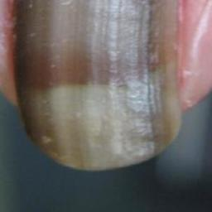  
 check with a GP#652  
**Analysis by this app:**normal = 3%; non-serious = 90%; check with a GP = 7%;   
The nail's condition is non-serious with confidence score of 90%.  
The confidence score for consulting a GP is 7%. ×

 check with a GP#7  
**Analysis by this app:**normal = 4%; non-serious = 90%; check with a GP = 6%;   
The nail's condition is non-serious with confidence score of 90%.  
The confidence score for consulting a GP is 6%. ×

 check with a GP#112  
**Analysis by this app:**normal = 17%; non-serious = 78%; check with a GP = 5%;   
The nail's condition is non-serious with confidence score of 78%.  
Otherwise it is normal with confidence score of 17%. ×

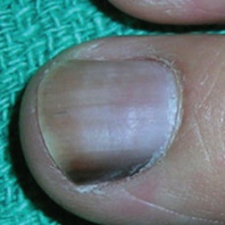  
 check with a GP#557  
**Analysis by this app:**normal = 94%; non-serious = 1%; check with a GP = 5%;   
The nail's condition is normal with confidence score of 94%.  
The confidence score for consulting a GP is 5%. ×

 check with a GP#57  
**Analysis by this app:**normal = 43%; non-serious = 53%; check with a GP = 4%;   
Not very sure whether the nail is OK or not. Sorry. ×

 check with a GP#12  
**Analysis by this app:**normal = 97%; non-serious = 0%; check with a GP = 3%;   
The nail's condition is normal with confidence score of 97%.  
The confidence score for consulting a GP is 3%. ×

 check with a GP#357  
**Analysis by this app:**normal = 4%; non-serious = 94%; check with a GP = 2%;   
The nail's condition is non-serious with confidence score of 94%.  
Otherwise it is normal with confidence score of 4%. ×

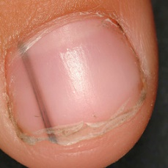  
 check with a GP#572  
**Analysis by this app:**normal = 98%; non-serious = 0%; check with a GP = 1%;   
The nail's condition is normal with confidence score of 98%.  
The confidence score for consulting a GP is 1%. ×

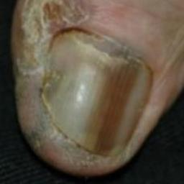  
 check with a GP#632  
**Analysis by this app:**normal = 93%; non-serious = 5%; check with a GP = 1%;   
The nail's condition is normal with confidence score of 93%.  
Otherwise it is non-serious with confidence score of 5%. ×

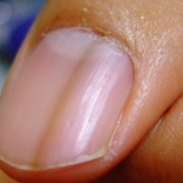  
 check with a GP#662  
**Analysis by this app:**normal = 99%; non-serious = 0%; check with a GP = 1%;   
The nail's condition is normal with confidence score of 99%.  
The confidence score for consulting a GP is 1%. ×

 check with a GP#207  
**Analysis by this app:**normal = 1%; non-serious = 98%; check with a GP = 1%;   
The nail's condition is non-serious with confidence score of 98%.  
Otherwise it is normal with confidence score of 1%. ×

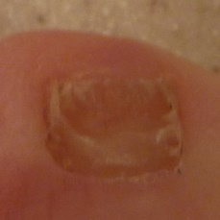  
 non-serious#1409  
**Analysis by this app:**normal = 49%; non-serious = 48%; check with a GP = 3%;   
Not very sure whether the nail is OK or not. Sorry. ×

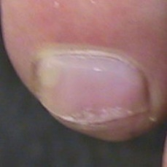  
 non-serious#1094  
**Analysis by this app:**normal = 50%; non-serious = 48%; check with a GP = 2%;   
Not very sure whether the nail is OK or not. Sorry. ×

 non-serious#164  
**Analysis by this app:**normal = 1%; non-serious = 45%; check with a GP = 54%;   
Not very sure whether the nail is OK or not. Sorry. ×

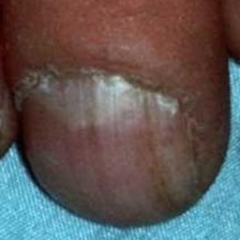  
 non-serious#1404  
**Analysis by this app:**normal = 10%; non-serious = 41%; check with a GP = 49%;   
Not very sure whether the nail is OK or not. Sorry. ×

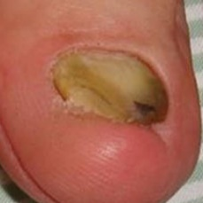  
 non-serious#1424  
**Analysis by this app:**normal = 13%; non-serious = 41%; check with a GP = 46%;   
Not very sure whether the nail is OK or not. Sorry. ×

 non-serious#439  
**Analysis by this app:**normal = 8%; non-serious = 41%; check with a GP = 52%;   
Not very sure whether the nail is OK or not. Sorry. ×

 non-serious#384  
**Analysis by this app:**normal = 49%; non-serious = 40%; check with a GP = 11%;   
Not very sure whether the nail is OK or not. Sorry. ×

 non-serious#909  
**Analysis by this app:**normal = 1%; non-serious = 37%; check with a GP = 61%;   
It is most likely that the nail indicates something that warrants a second opinion and you should seek medical advice. (Confidence score is 61%) ×

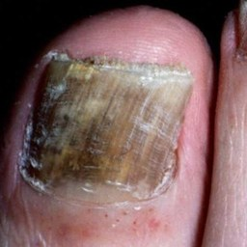  
 non-serious#1384  
**Analysis by this app:**normal = 0%; non-serious = 36%; check with a GP = 64%;   
It is most likely that the nail indicates something that warrants a second opinion and you should seek medical advice. (Confidence score is 64%) ×

 non-serious#169  
**Analysis by this app:**normal = 50%; non-serious = 30%; check with a GP = 19%;   
Not very sure whether the nail is OK or not. Sorry. ×

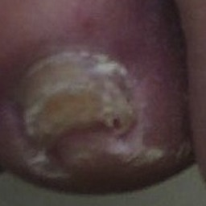  
 non-serious#1264  
**Analysis by this app:**normal = 60%; non-serious = 28%; check with a GP = 12%;   
The nail's condition is normal with confidence score of 60%.  
Otherwise it is non-serious with confidence score of 28%. ×

 non-serious#139  
**Analysis by this app:**normal = 36%; non-serious = 27%; check with a GP = 37%;   
Not very sure whether the nail is OK or not. Sorry. ×

 non-serious#539  
**Analysis by this app:**normal = 23%; non-serious = 24%; check with a GP = 53%;   
Not very sure whether the nail is OK or not. Sorry. ×

 non-serious#39  
**Analysis by this app:**normal = 2%; non-serious = 21%; check with a GP = 76%;   
It is most likely that the nail indicates something that warrants a second opinion and you should seek medical advice. (Confidence score is 76%) ×

 non-serious#699  
**Analysis by this app:**normal = 59%; non-serious = 21%; check with a GP = 20%;   
Not very sure whether the nail is OK or not. Sorry. ×

 non-serious#694  
**Analysis by this app:**normal = 84%; non-serious = 12%; check with a GP = 5%;   
The nail's condition is normal with confidence score of 84%.  
Otherwise it is non-serious with confidence score of 12%. ×

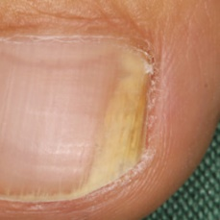  
 non-serious#1504  
**Analysis by this app:**normal = 89%; non-serious = 9%; check with a GP = 1%;   
The nail's condition is normal with confidence score of 89%.  
Otherwise it is non-serious with confidence score of 9%. ×

 non-serious#509  
**Analysis by this app:**normal = 0%; non-serious = 9%; check with a GP = 91%;   
It is most likely that the nail indicates something that warrants a second opinion and you should seek medical advice. (Confidence score is 91%) ×

 non-serious#244  
**Analysis by this app:**normal = 43%; non-serious = 8%; check with a GP = 49%;   
Not very sure whether the nail is OK or not. Sorry. ×

 non-serious#274  
**Analysis by this app:**normal = 0%; non-serious = 1%; check with a GP = 98%;   
It is most likely that the nail indicates something that warrants a second opinion and you should seek medical advice. (Confidence score is 98%) ×

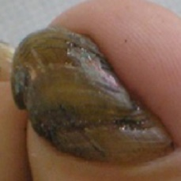  
 non-serious#1304  
**Analysis by this app:**normal = 8%; non-serious = 0%; check with a GP = 92%;   
It is most likely that the nail indicates something that warrants a second opinion and you should seek medical advice. (Confidence score is 92%) ×

 normal#226  
**Analysis by this app:**normal = 47%; non-serious = 52%; check with a GP = 0%;   
Not very sure whether the nail is OK or not. Sorry. ×

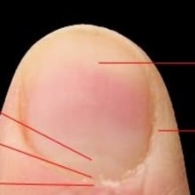  
 normal#1261  
**Analysis by this app:**normal = 46%; non-serious = 47%; check with a GP = 7%;   
Not very sure whether the nail is OK or not. Sorry. ×

 normal#41  
**Analysis by this app:**normal = 46%; non-serious = 3%; check with a GP = 52%;   
Not very sure whether the nail is OK or not. Sorry. ×

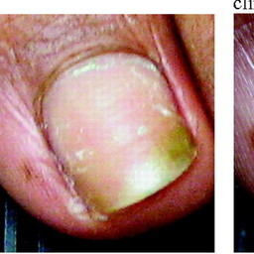  
 normal#1081  
**Analysis by this app:**normal = 45%; non-serious = 53%; check with a GP = 2%;   
Not very sure whether the nail is OK or not. Sorry. ×

 normal#176  
**Analysis by this app:**normal = 44%; non-serious = 54%; check with a GP = 1%;   
Not very sure whether the nail is OK or not. Sorry. ×

 normal#51  
**Analysis by this app:**normal = 44%; non-serious = 49%; check with a GP = 7%;   
Not very sure whether the nail is OK or not. Sorry. ×

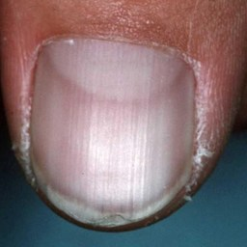  
 normal#1211  
**Analysis by this app:**normal = 37%; non-serious = 1%; check with a GP = 62%;   
It is most likely that the nail indicates something that warrants a second opinion and you should seek medical advice. (Confidence score is 62%) ×

 normal#766  
**Analysis by this app:**normal = 36%; non-serious = 0%; check with a GP = 64%;   
It is most likely that the nail indicates something that warrants a second opinion and you should seek medical advice. (Confidence score is 64%) ×

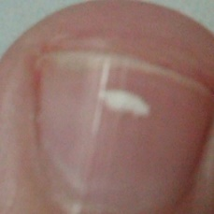  
 normal#1166  
**Analysis by this app:**normal = 35%; non-serious = 48%; check with a GP = 17%;   
Not very sure whether the nail is OK or not. Sorry. ×

 normal#216  
**Analysis by this app:**normal = 34%; non-serious = 59%; check with a GP = 7%;   
Not very sure whether the nail is OK or not. Sorry. ×

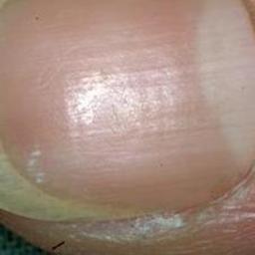  
 normal#1291  
**Analysis by this app:**normal = 33%; non-serious = 38%; check with a GP = 29%;   
Not very sure whether the nail is OK or not. Sorry. ×

 normal#606  
**Analysis by this app:**normal = 33%; non-serious = 0%; check with a GP = 67%;   
It is most likely that the nail indicates something that warrants a second opinion and you should seek medical advice. (Confidence score is 67%) ×

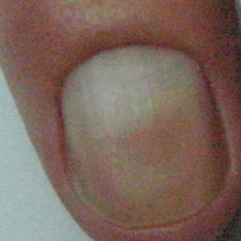  
 normal#1066  
**Analysis by this app:**normal = 31%; non-serious = 46%; check with a GP = 23%;   
Not very sure whether the nail is OK or not. Sorry. ×

 normal#231  
**Analysis by this app:**normal = 19%; non-serious = 81%; check with a GP = 0%;   
The nail's condition is non-serious with confidence score of 81%.  
Otherwise it is normal with confidence score of 19%. ×

 normal#276  
**Analysis by this app:**normal = 18%; non-serious = 79%; check with a GP = 3%;   
The nail's condition is non-serious with confidence score of 79%.  
Otherwise it is normal with confidence score of 18%. ×

 normal#921  
**Analysis by this app:**normal = 18%; non-serious = 0%; check with a GP = 82%;   
It is most likely that the nail indicates something that warrants a second opinion and you should seek medical advice. (Confidence score is 82%) ×

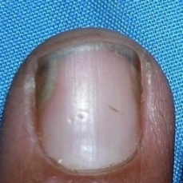  
 normal#1146  
**Analysis by this app:**normal = 13%; non-serious = 1%; check with a GP = 86%;   
It is most likely that the nail indicates something that warrants a second opinion and you should seek medical advice. (Confidence score is 86%) ×

  
 normal#1031  
**Analysis by this app:**normal = 13%; non-serious = 1%; check with a GP = 86%;   
It is most likely that the nail indicates something that warrants a second opinion and you should seek medical advice. (Confidence score is 86%) ×

 normal#236  
**Analysis by this app:**normal = 12%; non-serious = 88%; check with a GP = 0%;   
The nail's condition is non-serious with confidence score of 88%.  
Otherwise it is normal with confidence score of 12%. ×

 normal#106  
**Analysis by this app:**normal = 9%; non-serious = 11%; check with a GP = 79%;   
It is most likely that the nail indicates something that warrants a second opinion and you should seek medical advice. (Confidence score is 79%) ×

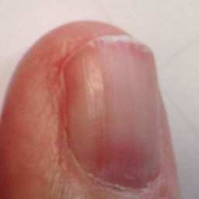  
 normal#1026  
**Analysis by this app:**normal = 8%; non-serious = 18%; check with a GP = 74%;   
It is most likely that the nail indicates something that warrants a second opinion and you should seek medical advice. (Confidence score is 74%) ×

 normal#331  
**Analysis by this app:**normal = 7%; non-serious = 53%; check with a GP = 41%;   
Not very sure whether the nail is OK or not. Sorry. ×

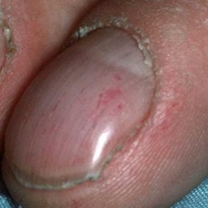  
 normal#1161  
**Analysis by this app:**normal = 6%; non-serious = 93%; check with a GP = 1%;   
The nail's condition is non-serious with confidence score of 93%.  
Otherwise it is normal with confidence score of 6%. ×

 normal#721  
**Analysis by this app:**normal = 5%; non-serious = 3%; check with a GP = 92%;   
It is most likely that the nail indicates something that warrants a second opinion and you should seek medical advice. (Confidence score is 92%) ×

 normal#11  
**Analysis by this app:**normal = 4%; non-serious = 8%; check with a GP = 87%;   
It is most likely that the nail indicates something that warrants a second opinion and you should seek medical advice. (Confidence score is 87%) ×

 normal#461  
**Analysis by this app:**normal = 3%; non-serious = 1%; check with a GP = 95%;   
It is most likely that the nail indicates something that warrants a second opinion and you should seek medical advice. (Confidence score is 95%) ×

 normal#381  
**Analysis by this app:**normal = 2%; non-serious = 86%; check with a GP = 12%;   
The nail's condition is non-serious with confidence score of 86%.  
The confidence score for consulting a GP is 12%. ×

 normal#66  
**Analysis by this app:**normal = 2%; non-serious = 4%; check with a GP = 94%;   
It is most likely that the nail indicates something that warrants a second opinion and you should seek medical advice. (Confidence score is 94%) ×

 normal#701  
**Analysis by this app:**normal = 2%; non-serious = 98%; check with a GP = 0%;   
The nail's condition is non-serious with confidence score of 98%.  
Otherwise it is normal with confidence score of 2%. ×

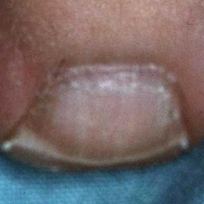  
 normal#1191  
**Analysis by this app:**normal = 1%; non-serious = 99%; check with a GP = 0%;   
The nail's condition is non-serious with confidence score of 99%.  
Otherwise it is normal with confidence score of 1%. ×