normal-fungal-serious-36x36-every-5-test-and-validation-500-epochs

Data loss = 0.1549353152513504; Validation loss = 0.35803407430648804; Test error = 0.3427010178565979

true positives = 88  
true negatives = 522  
false positives = 29  
false negatives = 33  
not confident of any answer = 60  
total = 732

normal-fungal-serious-100x100-every-5-test-and-validation-500-epochs

Data loss = 0.11064949631690979; Validation loss = 0.3411939740180969; Test error = 0.3483753800392151

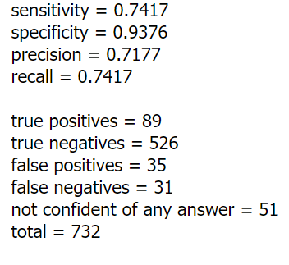

leCunNormal:

Data loss = 0.11090581119060516; Validation loss = 0.3382941782474518; Test error = 0.3492765426635742

normal-fungal-serious-100x100x100-every-5-test-and-validation-500-epochs (425 better)

Data loss = 0.08418463170528412; Validation loss = 0.3631347417831421; Test error = 0.3868394196033478

**normal-fungal-serious-2000-every-5-test-and-validation-275-epochs**

Data loss = 0.08576856553554535; Validation loss = 0.328652948141098; Data accuracy = 0.9936218857765198; Validation accuracy = 0.8823529481887817; Test loss = 0.34153875708580017; Test accuracy = 0.8825136423110962

true positives = 92  
true negatives = 523  
false positives = 30  
false negatives = 33  
not confident of any answer = 54  
total = 732  
  
sensitivity = 0.736  
specificity = 0.9458  
precision = 0.7541  
recall = 0.736

**normal-fungal-serious-4000-every-5-test-and-validation-300-epochs**

Data loss = 0.05320379510521889; Validation loss = 0.3252640962600708; Data accuracy = 0.998177707195282; Validation accuracy = 0.8932968974113464; Test loss = 0.33764347434043884; Test accuracy = 0.8825136423110962

**normal-fungal-serious-1280-every-5-test-and-validation-250-epochs-and-originals**

Data loss = 0.1665160208940506; Validation loss = 0.38897213339805603; Data accuracy = 0.9619541764259338; Validation accuracy = 0.850843071937561; Test loss = 0.3789363205432892; Test accuracy = 0.8652849793434143

**normal-fungal-serious-1280-every-5-test-and-validation-300-epochs-and-originals-no-korean-tests**

Data loss = 0.09084915369749069; Validation loss = 0.3370601236820221; Data accuracy = 0.9920245409011841; Validation accuracy = 0.8876610994338989; Test loss = 0.3753749132156372; Test accuracy = 0.8694853186607361

**normal-fungal-serious-2000-every-5-test-and-validation-300-epochs-and-originals**

Data loss = 0.11597578972578049; Validation loss = 0.38778436183929443; Data accuracy = 0.9814094305038452; Validation accuracy = 0.8612191677093506; Test loss = 0.37769922614097595; Test accuracy = 0.8639895915985107

**normal-fungal-serious-1280-every-5-test-and-validation-80-epochs-and-originals-batch-256**

Data loss = 0.11704792827367783; Validation loss = 0.38507431745529175; Data accuracy = 0.979680061340332; Validation accuracy = 0.8664072751998901; Test loss = 0.3812200427055359; Test accuracy = 0.8588082790374756

