**Instructions for downloading LLaMA LLM model**

1. Go to [huggingface.co](https://huggingface.co/) and sign up for a free account.
   1. You should receive an email to confirm your account. Please confirm before proceeding
2. The model currently used is [Llama-3.1-8B-Instruct](https://huggingface.co/meta-llama/Llama-3.1-8B-Instruct). Expand the license agreement and enter requested information to request access to this repository. This typically takes <30 mins, but may take longer.

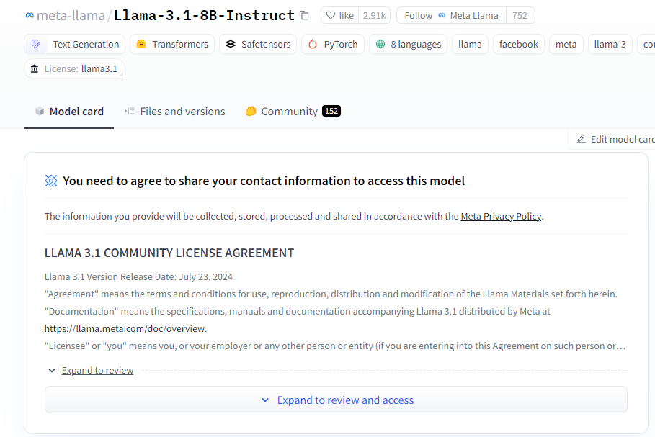

1. Next, you must create a token that is linked to your account. This can be done by clicking your profile picture at the top right of the webpage and then accessing **Settings**:

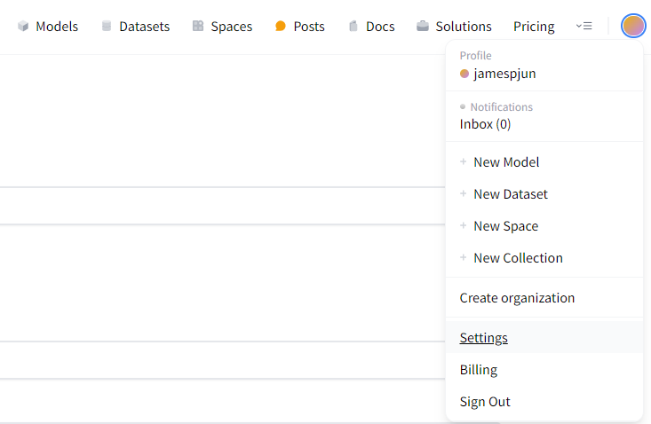

* 1. Then, open the **Access Tokens** bar from the sidebar options.
  2. Click **Create new token** and name your token as appropriate.
  3. For basic model access, you will need the following 2 permissions to be granted:
     1. *Read access to contents of all repos under your personal namespace*
     2. *Read access to contents of all public gated repos you can access*
  4. Click **Save Token** to generate an account token.
  5. Save your access token in a secure location for future reference.

1. We will now be downloading the **huggingface-cli** library to allow us to download and store the model locally.
   1. Open a command-line interface (Command Prompt, Anaconda Prompt, etc.) and run:

**pip install -U "huggingface_hub[cli]"** to install huggingface-cli.

* 1. Next, run **huggingface-cli** **login** to connect your local instance of huggingface to your account. Follow the instructions using your account’s access token.
  2. Lastly, navigate to the directory where your model should be stored and then run the following to download the model:

**huggingface-cli download meta-llama/Meta-Llama-3.1-8B-Instruct --include "original/*" --local-dir Meta-Llama-3.1-8B-Instruct**

1. Llama-3.1-8B-Instruct should now be downloaded in the directory of your choice and ready for use!