A Fatigue Module for ACT-R: Introduction and User Manual

Rick Moore
Glenn Gunzelmann
Tim Halverson
Bella Veksler
Kevin Gluck
Michael Krusmark

Cognitive Models and Agents Branch
Air Force Research Laboratory

May 20, 2017

Introduction
The fatigue module provides mechanisms to moderate a model’s performance as might be expected under conditions of sleep loss and time on task effects. Although there are likely many cognitive effects under such conditions, the fatigue module is currently focused on the production system and declarative retrievals.

The theory behind the fatigue module is discussed in detail in Gunzelmann, Gross, Gluck, & Dinges, 2009. However, a brief overview is provided here to facilitate usage. Unfortunately, depending upon the complexity of the model and the ACT-R mechanisms it relies upon, usage of the fatigue module will require some modifications to the model and/or task code. An understanding of the basic theory behind the fatigue module will help the modeler make informed decisions about necessary changes.

The fatigue module works by attenuating production utilities and declarative chunk activations based on the influence of homeostatic and circadian fatigue effects. A biomathematical model of fatigue (McCauley, Kalachev, Mollicone, Banks, Dinges, Van Dongen, 2013) is used to compute a value of alertness that is then used to calculate moment-by-moment attenuations to utility and activation calculations in ACT-R. This is further combined with a time-on-task component to create a “fatigued” utility value during each production cycle.

Utilities and activations are also influenced by microlapses (Gunzelmann et al., 2009). If the model reaches a state where no productions rise above threshold and there are no perceptual tasks in progress, the model will momentarily delay for the duration of a single production cycle. This is referred to as a microlapse. Each time a microlapse occurs, utility and activation calculations are attenuated even further. This increases the likelihood of another microlapse, which will cause further declines in utility and activation calculations.

As a compensatory mechanism, it is theorized that production selection becomes less selective. In ACT-R, this is achieved by attenuating the utility threshold. The same activation / threshold mechanisms have been used to simulate within-task fatigue, as well, and the fatigue module will include these effects automatically in its calculations.

The fatigue module has several parameters that directly influence performance changes during model execution (biomathematical parameters :fpbmc and :utbmc, and time-on-task parameters :fpmc and :utmc, discussed below). There are also several ACT-R parameters specific to a task that contribute to model behavior, including :ut, :iu, and :egs. The fatigue module will directly manipulate :ut based on the biomathematical model of fatigue and time-on-task effects. The :iu must be set specific to a task such that productions are appropriately raised above the utility threshold (which the fatigue module subsequently manipulates), and :egs (suggested setting of .25) enables noise in the production system which is important for generating and recovering from random microlapses.

Due to its biomathematical component, the fatigue module allows the modeler to specify a sleep/wake schedule. By default, the fatigue module will assume that the model has had a good night’s sleep (8 hours in bed) and has woken at 7:30AM. The modeler can then specify what hour it is since midnight the night before waking (:hour). There is a set-schedule command that allows the modeler to specify a custom sleep schedule specific to the task/study.

The following sections will walk you through how to install the module and describe how it works.

Installation
There are two ways to install the fatigue module:

- The fatigue module can be permanently installed by simply copying it to the “other-files” directory in ACT-R. The fatigue module depends upon other ACT-R components being loaded first, and placing it in the “other-files” directory ensures that the sequencing dependency is satisfied.
- It can also be loaded on demand using the require-extra command in ACT-R:(require-extra "fatigue"). Placing that call into a model file after the clear-all command will load the extension if it has not previously been loaded. Using require-extra is recommended if the model file is being distributed because it does not require users to move or explicitly load the extension.

By default the fatigue module is “turned off.” To enable the fatigue module, set the ACT-R :fatigue-enabled parameter to T. Also, each individual fatigue mechanism can be turned on and off independently. By default, only the procedural mechanism (which influences utility calculations) is activated.

The procedural mechanism can be disabled or enabled by setting :fp (default of 1) to nil or any non-zero value, respectively. When it is active, the fatigue module will calculate :ut and influence production utility calculations.

Similarly, setting :fd to nil (which is the default) will disable the declarative fatigue mechanism, while any non-zero value will activate it. When :fd is non-nil, the fatigue module will attenuate chunk base level activations.

For example, to turn on the fatigue module and both mechanisms, the modeler might issue an ACT-R statement such as: (sgp :enable-fatigue t :fp 1 :fd 1).

Basic Operation
The fatigue module interjects itself into ACT-R by using three hook functions: conflict -set-hook, utility-hook, and bl-hook. Each of these will be described in turn.

Conflict-Set-Hook (Microlapses)
Microlapses are enabled whenever the fatigue module is enabled (sgp :enable-fatigue t). They are implemented through the procedural module’s :conflict-set-hook parameter to determine whether a microlapse should occur because either no productions reach threshold or no productions are in the conflict set (if enabled). That hook function in turn schedules the event DECREMENT-FP-FD which updates :fp-percent and :fd-percent parameters (effectively causing a microlapse). This then triggers another conflict resolution to occur. Figure 1 depicts the specific functions within the fatigue module that get triggered during conflict resolution.

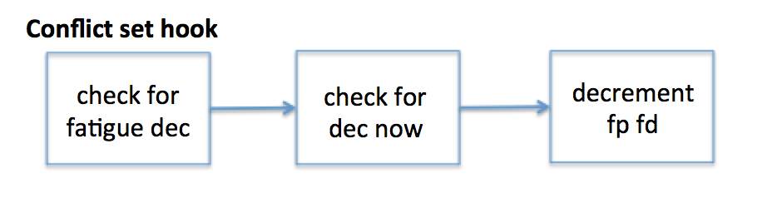
Figure 1: Conflict set hook functions flowchart

The :fp-percent and :fd-percent parameters represent the accumulated effect of microlapses on utility and activation calculations. They both default to 1 and have no initial effect. During a microlapse, the fatigue module will reduce :fp-percent by :fp-dec.

:fd-percent is also reduced by :fd-dec, however, our work has shown that :fd-dec can be 0, so by default there is no effect. The mechanism remains, however, to support possible future work.

Rescheduling the conflict resolution induces a tiny lapse in model behavior, from a macro perspective, can appear as cognitive slowing. Decrementing :fp-percent reduces overall production utilities and increases the likelihood of another microlapse in the future.

Any task delay where no productions are matching and firing (e.g. a trial wait time), will cause :fp-percent to quickly decay to the point where production utilities will be too low to fire because of the repeated microlapses. To counterbalance this effect there are two options:

- One option is to reset the :stimulus parameter to “awaken” the model. This can be done by calling (reset-stimulus) which should be called just after any new task presentation (audio or visual). This will reset :fp-percent back to 1 (100%). That can be useful regardless of the decaying utility issue.

- Another option is helpful in the case when task delays which occur between the presentation of stimuli are not relevant to the task. In that case, setting the :lapse-on-empty parameter to nil will help (and nil is the default value). That parameter controls whether or not microlapses will occur when there are no productions in the conflict set and there is not a future conflict resolution event scheduled (the situation which usually arises when there are ‘unmodeled’ delays). With the default setting of nil, the model will not repeatedly microlapse to the point of non-responsiveness in those situations. Note however, that if microlapsing during a delay is important for the task then this parameter will need to be set to t instead. If setting :stimulus is being done at each trial presentation, then microlapses during the delay time are not necessary and the default of nil will work appropriately. Setting the :lapse-on-empty parameter to t may necessitate changes to the task code, depending on how it is implemeneted, because the model will no longer ‘stop’ when there are no productions left to fire and no pending actions because the microlapses will continue to execute events. If the code assumed that the model would stop automatically, it may be necessary to use the run-until-time-or-condition function described below instead of just run.

***For ACT-R 7: there is a new parameter in ACT-R 7 that was not present in ACT-R 6 which controls whether the visual-location buffer gets ‘unstuffed’ after a particular amount of time (defined by :visual-onset-span). For models which rely on information that was stuffed into the visual-location buffer being maintained in the visual-location buffer indefinitely, it’s important to either increase the :visual-onset-span or set this new parameter :UNSTUFF-VISUAL-LOCATION to nil. [When updating models from ACT-R 6 to ACT-R 7, the latter is the easiest approach.]. The reason this can be a problem is that microlapses could result in delaying the production(s) which would harvest the stuffed visual-location chunk and then because of the automatic unstuffing of the visual-location buffer it could result in the model altogether missing the stimulus. That would then need to be compensated by having additional productions that actively request a new visual-location (which would need to somehow detect that it missed one through some other means which further complicates things). The potential problem however (which the unstuffing was added to correct in many tasks) is that if the model is delayed so long that a new stimulus presentation occurs before the model has detected and cleared a previously stuffed chunk then the chunk in the visual-location buffer is no longer an appropriate representation of the current stimulus which requires either additional productions to correct, or, as was often the case with ACT-R 6 models, the experiment code which presented the task explicitly cleared the information from the model’s buffers when “necessary”.

Utility-Hook
The fatigue module uses ACT-R’s :utility-hook to attenuate production utility calculations and the value of the utility threshold. (This is done automatically—there is no action required on the part of the modeler.) The amount of utility attenuation (as a proportion of the normally calculated utility) is defined as follows and assumes that utility values are positive:

FP = :fp-percent * ( 1-:fpbmc * biomath-prediction)*(1+time-on-task)^ :fpmc

Reasonable defaults for :fpbmc (fatigue-procedural biomathematical model constant), :fpmc (fatigue-procedural minute exponent) are provided in the section outlining parameter values. They relate time awake / time of day (biomath-prediction) and time on task (time-on-task) to the utility attenuation mechanism which in turn is further moderated by :fp-percent (which is decremented during microlapses as per the previous section).

This is then used to compute the final utility of the production:

Utility= alertUtility*FP

Of course, a microlapse will never occur with matching productions available unless they all fall below the utility threshold, :ut. Therefore, the fatigue module will automatically manipulate :ut based on a similar equation to the one used to attenuate utility. Setting :ut directly will be overridden by the fatigue module.

UT = :ut0*( 1-:utbmc * biomath-prediction)*(1+time-on-task)^ :utmc

where :ut0 is an Initial Utility Threshold parameter which the modeler sets. Again, reasonable defaults for :utbmc (utility threshold biomathematical model constant), :utmc (utility threshold minute constant) are suggested in the parameters section.

Although the fatigue module does not manipulate :iu directly, the WSU PVT fits suggest that it should be set to 2.292. If a model sets production utilities per production, those individual values should be "lifted" by 2.292 (assuming they are centered around 0) with their relative utilities left intact. It is also necessary to enable production utility noise (:egs .25) to ensure that productions always have some chance of rising above the utility threshold to execute, even when the model is heavily fatigued.

BL-Hook
The fatigue module has the capacity to modify declarative chunk activation and does so using the :bl-hook function. Chunk activation is attenuated by the following equation:
FD = :fd-percent * ( :fdbmc * biomath-prediction + :fdc )

Again, reasonable defaults for :fdmc (fatigue-delcarative biomathematical model constant) and :fdc (fatigue-declarative constant) are provided, and :fd-percent is discussed in further detail below.

Components of Utility Calculation

Biomathematical Component
Biomathematical alertness predictions (referred to as biomath-prediction in the equations above) are based on the Washington State University (WSU) biomathematical model of fatigue (McCauley et al., 2013), which has been reproduced within the fatigue module using their default parameters. Changes to the parameters for that model of fatigue can be made, but requires accessing the underlying biomath object in the code, which is not currently covered in this documentation.

In order to use the fatigue module with the biomathematical component, the modeler must provide the sleep schedule that the participant is currently on. To do this, call the function set-schedule with the list of the times awake/times asleep for that particular participant. For example, if the participant was part of an 88-hr sleep deprivation study in which s/he had two acclimation days and on the third day stayed awake through the night and the following two days, the schedule would look like this:

Day | Woke Up | Fell Asleep | Input to set-schedule
1 | 7:30am | 11:30pm | (7.5 23.5)
2 | 7:30am | 11:30pm | (31.5 47.5)
3 | 7:30am | No | (55.5
4 | No | No | …
5 | No | No | …
6 | No | 11:30pm | 143.5)
7 | 7:30am | 11:30pm | (151.5 167.5)

The resultant command would thus be:

(set-schedule '((7.5 23.5)(31.5 47.5)(55.5 143.5)(151.5 167.5)))

Note that the first number in each tuple is the time the participant awoke that day and the second number is the time they subsequently went to bed (either that day or another).

Set the :hour ACT-R parameter to reflect the sequential hour in the entire schedule that the participant is being run. For example, in the above schedule, setting :hour to 9 would be the equivalent of running the experiment at 9am on the first day of the study. Setting :hour to 60 would be like running the experiment on Day 3 at noon.

Note that when setting the schedule, the :hour the participant is run must be included in the list of sleep/wake cycles (between the two bold braces in table above). For example, if the participant had a session at hour 180, then the above sleep schedule would need to have another day of a sleep/wake cycle encompassing the hour 180. Attempting to set an :hour value outside the schedule will result in a warning and disabling of the fatigue module.

If no schedule is set, the model will assume a schedule for one day of the participant having woken up at 7:30am and gone to bed at 10:30pm, and :hour set to 7:30am. [fatigue module has a reset command of (set-schedule '((7.5 22.5)))]

As the model runs, the biomathematical alertness value gets updated to include the time on task contribution to the :hour.

Figure 2 shows a sample timeline of non-microlapsed :fp values with the :fpbmc parameter set to .01
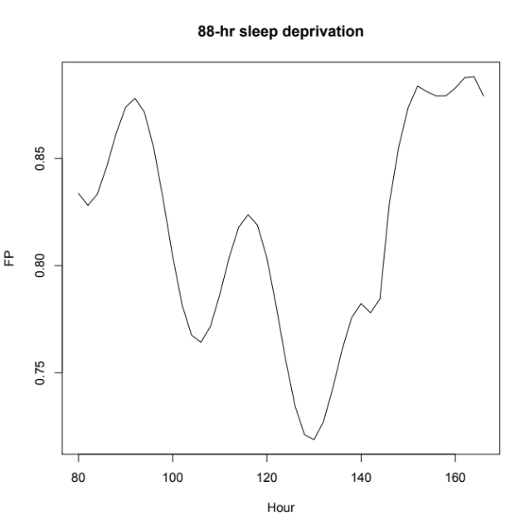
Figure 2: FP values over 88 hr sleep deprivation

Alertness Value Output
It is possible to produce an output file that lists the alertness values of a given schedule. The three sample sleep schedules for a sleep study are below:

Control:
(print-hash-table-ordered (set-schedule '((7.5 23.5)(31.5 47.5)(55.5 71.5)(79.5 94.5)))(translate-logical-pathname "ACT-R:actrschedcontrol.txt"))

62hr sleep deprivation study:
(print-hash-table-ordered (set-schedule '((8 22)(32 46)(56 118)(128 142))) (translate-logical-pathname "ACT-R:actrscheddep.txt"))

Sleep restriction (4 hr sleep for 13 days):
(print-hash-table-ordered (set-schedule '((7.5 23.5)(31.5 47.5)(55.5 71.5)(79.5 99.5)(103.5 123.5)(127.5 147.5)(151.5 171.5)(175.5 195.5)(199.5 219.5)(223.5 243.5)(247.5 267.5)(271.5 291.5)(295.5 315.5)(319.5 339.5)(343.5 363.5)(367.5 387.5)(391.5 407.5)))(translate-logical-pathname "ACT-R:actrschedrest.txt"))

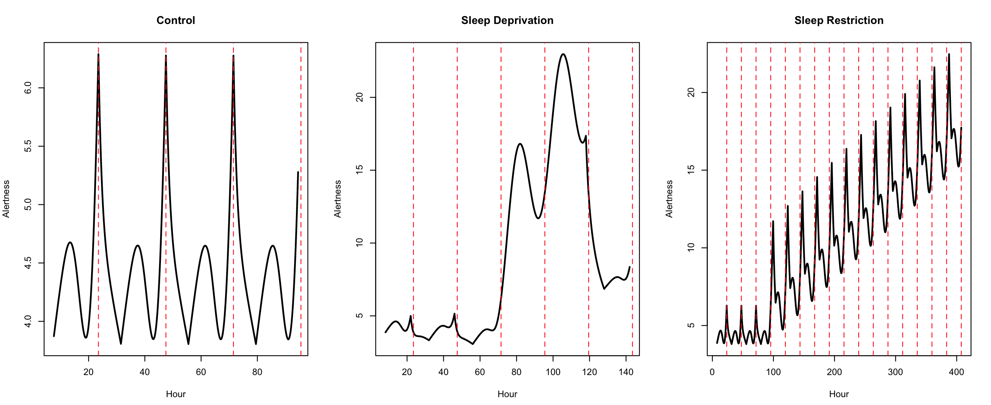
Figure 3: Alertness values from the set-schedule command for three sleep conditions. Control=8 hours of sleep every night, Sleep Deprivation=No sleep for 62 hours, Sleep Restriction=4 hours of sleep for 13 days. Note that higher alertness values are indicative of worse performance on tasks in sleep studies.

Time on task Component
Time-on-task is based on the amount of time that has passed since the session was started. The start of the session is signaled by setting the :hour parameter. Time-on-task is calculated automatically while the model is run, using the difference of mp-time from when :hour was set to the moment that a production utility is calculated.

Parameter Values
The main parameters that the modeler would need to modify are listed below along with suggested ranges.
Parameter | Meaning | Reasonable Range | Default | Suggested
:iu | Initial Utility | 2 to 3 | 0 | 2.292
:ut0 | Initial Utility Threshold | 2 to 3 | 0 | 2.064
:fpbmc | FP Biomath Constant | 0 to .04 | 0 | 0.02
:fpmc | Time on Task Exponent for FP | 0 to -.1 | 0 | -.05
:utbmc | UT Biomath Constant | 0 to .04 | 0 | 0.01
:utmc | Time on Task Exponent for UT | 0 to -.1 | 0 | -.01
:hour | Sequential Hour Session Began | Depends on sched | 0 | Depends
:fdbmc | FD Biomath Constant | 0 to -.1 | -0.02681 | -0.02681
:fdc | FD Constant | 0 to 1 | 0.95743 | 0.95743

New commands

run-until-time-or-condition
Syntax:

run-until-time-or-condition run-time condition {:real-time real-time?} -> [ t ]

Arguments and Values:

run-time ::= a number greater than 0 indicating the number of seconds to run
condition ::= a function or the name of a function that takes no parameters
real-time? ::= a generalized boolean to indicate whether to run in real time (default is nil)

Description:

run-until-time-or-condition will run the current meta-process until either the specified number of seconds have elapsed, or the provided condition function returns non-nil. If the real-time? keyword parameter is provided with a non-nil value then the model will be run in real time. This function can be convenient when creating tasks for which either a response or a time limit determines when a trial ends. If condition is not a function or the name of a function, or there is no current meta-process then a warning is printed and nil is returned.

Example:

Here is a snippet of code from the ACT-R Tutorial Unit 2 demo model:

(if (not (eq who 'human))
(progn

(install-device window)
(proc-display)
(run 10 :real-time t))

(while (null *response*)
(allow-event-manager window)))

That could be changed to this since the *response* variable is set when the model responds:

(if (not (eq who 'human))
(progn

(install-device window)
(proc-display)
(run-until-time-or-condition 10 #'(lambda() *response*)
:real-time t))

(while (null *response*)
(allow-event-manager window)))

This task is not affected by this change since it is only running one trial, but in a task that was being run over multiple trials it may be more convenient than scheduling events through the keypress hook or other means to control the experiment.
set-schedule

Syntax:

set-schedule schedule {:p0 :u0 :k0} -> [ hash-table]

Arguments and Values:

schedule ::= a schedule of the form ‘((awake1 asleep1) (awake2 asleep2)….)
p0 ::= a starting value for process p from McCauley 2013 model
u0 ::= a starting value for process u
k0 ::= a starting value for process k

Description:

Set-schedule will build a hash table containing alertness values for each minute of the schedule. It also sets the :hour parameter in the module to the first hour in the schedule. Keys in the hash-table are time stamps. The starting values p0, u0, k0 are all set to defaults assuming the participant had 8 hours of sleep last night and woke at 7:30am. The hash-table generated will then be available for query using the compute-biomath-value-for-hour command when calculating the production utility augmentation, however this is all part of the inner workings of the fatigue module.
Example:
When running a model with the fatigue mechanism enabled the sleep schedule needs to be set before resetting the model and before it is run if a schedule other than the default is needed.

An example looks like:

(set-schedule '((7.5 23.5)(31.5 47.5)(55.5 143.5)(151.5 167.5)))
(reset)
(clear-exp-window)
****add some things to the experimental window****
(proc-display)
****run the model as needed****

reset-stimulus

Syntax:

reset-stimulus {:stimulus} -> [1]

Arguments and Values:

stimulus ::= a numeric value for the stimulus parameter

Description:

Reset-stimulus will reset the stimulus parameter to 1 or any numeric value the modeler specifies.
Example:
This is a useful function particularly when trials are long. Typically the modeler would reset the stimulus every time the screen changed or a new stimulus was added to the screen.

An example looks like:

(while (< trial 10)
(clear-exp-window)
****add some things to the experimental window****
(proc-display)
(reset-stimulus)
****run the model as needed****
)

References
Gunzelmann, G., Gross, J. B., Gluck, K. A., & Dinges, D. F. (2009). Sleep deprivation and sustained attention performance: Integrating mathematical and cognitive modeling. Cognitive Science, 33(5), 880-910.
McCauley, P., Kalachev, L. V, Mollicone, D. J., Banks, S., Dinges, D. F., & Van Dongen, H. P. a. (2013). Dynamic circadian modulation in a biomathematical model for the effects of sleep and sleep loss on waking neurobehavioral performance. Sleep, 36(12), 1987–97.
Moore, L. R., & Gunzelmann, G. (2014). An interpolation approach for fitting
computationally intensive models. Cognitive Systems Research, 29-30, 53-65.
Veksler, B. Z., & Gunzelmann, G. (2013). Modeling the Vigilance Decrement in the
Mackworth Clock Task. In D. N. Cassenti (Ed.), Proceedings of the 22nd Annual Conference on Behavior Representation in Modeling and Simulation (BRIMS). San Antonio, TX: BRIMS.
Veksler, B. Z., & Gunzelmann, G. (2017). Functional Equivalence of Sleep Loss
and Time on Task Effects in Sustained Attention. Cognitive Science.
Walsh, M. M., & Gunzelmann, G., & Van Dongen, H. P.A. (2014). Comparing accounts
of psychomotor vigilance impairment due to sleep loss. In P. Bello, M. Guarini, M. McShane, & B. Scassellati (Eds.), Proceedings of the 36th Annual Conference of the Cognitive Science Society (pp. 877-882). Austin, TX: Cognitive Science Society.
Walsh, M. M., Gunzelmann, G., & Van Dongen, H. P. A. (in press). Computational
cognitive models of the temporal dynamics of fatigue from sleep loss. Psychonomic Bulletin and Review.

In fact, setting :stimulus will set :fp-percent to whatever value is provided, thus allowing partial restorations. Partial restorations have not yet been studied, however, so no guidance can be provided about the circumstances and amounts of restoration that might be reasonable.

