TestWork Currency Convertor Vladimir Malchevskiy

Тестовое задание Currency Convertor

Оглавление

1 Репозитории 1

2 Used Docker commands 2

2.1 docker commands 2

2.2 docker-compose commands 2

3 Logfiles: 2

3.1 Logfile Docker-compose build 2

3.2 Logfile docker-compose up 2

4 Screenshots: 3

4.1 docker-compose build 3

4.2 docker-compose up 3

4.3 Brouser screenshot 1 (documentation) 4

4.4 Brouser screenshot 2 4

# Репозитории

GitHub link <https://github.com/ecrvmal/Currency_Converter/tree/master>

# Used Docker commands

Following Docker commands were used:

## docker commands

|  |  |
| --- | --- |
| docker images | list of docker images |
| docker build --no-cache -t app_name . | build image |
| docker rmi | del image |
|  |  |
| docker ps | list of working containers |
| docker stop container_id | Stop container (not delete) |
| docker stop $(docker ps -a -q) | Stop all containers |
| docker ps -a | see stopped container |
| docker rm container_id | delete container |
| docker rm $(docker ps -a -q) | delete all containers |

## docker-compose commands

|  |  |
| --- | --- |
| docker-compose build | make a container package |
| docker-compose up -d | run a container package  -d указывает Docker запускать контейнер в фоновом режиме.  иначе открыто терминальное окно |
|  |  |
| docker exec -it container_id python manage.py createsuperuser  docker exec -it 31df256d3e02 python manage.py createsuperuser  docker exec -it <mycontainer> bash | run linux command in container |

# Logfiles:

## Logfile Docker-compose build



## Logfile docker-compose up



# Screenshots:

## docker-compose build

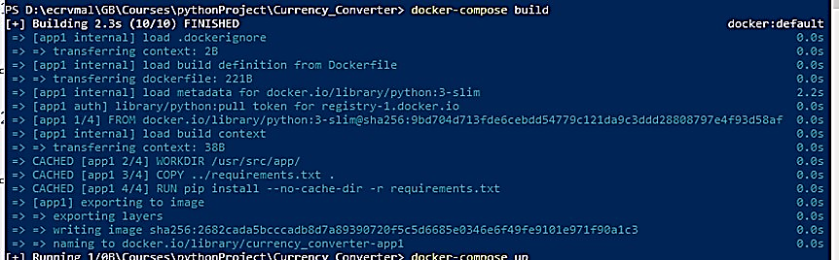

Figure

## docker-compose up

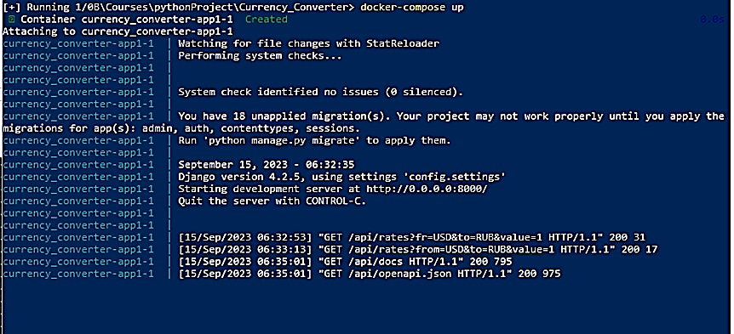

Figure

## Browser screenshot 1 (documentation)

<http://127.0.0.1:8000/api/docs>

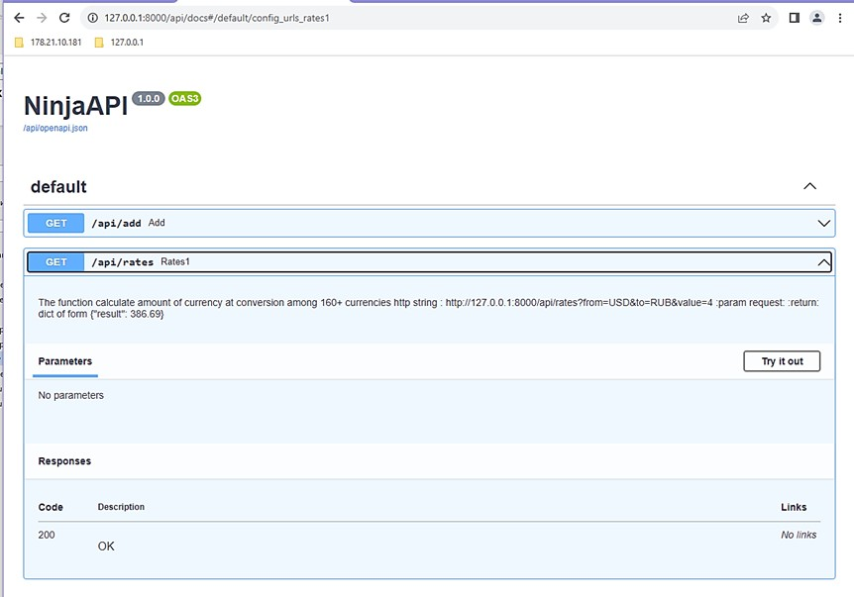

Figure

## Browser screenshot 2

<http://127.0.0.1:8000/api/rates?from=USD&to=RUB&value=5>

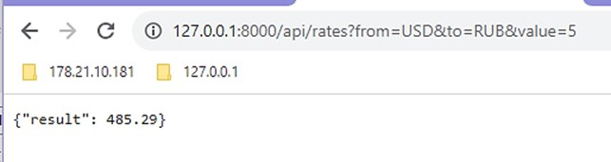

Figure