Biotic Interaction Detection from Scientific Literature:
Knowledge Distillation and Multi-task Learning
with Named Entity Recognition
Anonymous

Introduction
Species interactions shape ecosystem structure, drive disease dynamics, and determine the response of ecological communities to perturbation. Cataloguing these interactions requires synthesising knowledge distributed across millions of scientific publications. The Global Biotic Interactions database (GloBI; Poelen, Simons, and Mungall (2014)) aggregates over 13 million structured interaction records from more than 700 data sources, yet covers only a fraction of the interaction types documented across the biodiversity literature. The SIBiLS platform (Gobeill et al. 2020), the Swiss Institute of Bioinformatics Literature Services, provides federated semantic search over Biodiversity PMC (Pasche et al. 2023), a curated corpus of over 80 million biomedical and biodiversity documents encompassing both PubMed Central and MEDLINE content. BiotXplorer (Ruch et al. 2024), built on this infrastructure, is a semantic search and navigation tool for biotic interactions in this corpus, indexing a substantially broader range of interaction types than those currently represented in GloBI.
Automated information extraction from scientific text has a well-established tradition in the biomedical domain. Named entity recognition (NER) and relation classification methods have been applied to protein–protein interactions (Bunescu et al. 2005), drug–drug interactions (Lim et al. 2018), and gene–disease associations, with deep learning substantially improving entity detection accuracy (Habibi et al. 2017). A widely used strategy for generating labelled training data at scale is distant supervision: known interaction databases are aligned with text to produce labels automatically, without exhaustive manual annotation (Mintz et al. 2009). These approaches are predominantly designed for molecular and clinical literature; ecological interaction types (predation, parasitism, pollination, herbivory, mutualism) span a broader taxonomic scope and a more heterogeneous publication landscape, with direct consequences for model generalisation (Badenes-Pérez, Ponce-Gordo, and Cano-Maque 2020).
A particular challenge in literature-based interaction mining is the co-occurrence problem: a sentence may mention two organism names and an interaction term together without actually describing an interaction between them. Co-occurrence-based retrieval achieves high recall but suffers from substantial false-positive rates (Bunescu et al. 2005); sentence-level classifiers that discriminate true interactions from co-occurrence artefacts are a standard component of text-mining pipelines for biomedical relation extraction. At the downstream end, structured interaction triples extracted from text can populate biodiversity knowledge graphs supporting species-level reasoning about disease spread, food web dynamics, and conservation planning (Chen, Zhang, and Zhang 2023; Poisot et al. 2021). Despite this potential, knowledge gaps in ecological interaction networks remain large, particularly for field-observed interactions published in ecology journals outside the PubMed index (Poisot et al. 2021).
We address this gap with three primary contributions:
- A two-stage teacher chain combining large-LLM binary annotation with ensemble-based soft probability distillation, yielding a 44K-sentence training corpus with calibrated labels.
- A multi-task BiomedBERT architecture with automatic NER auxiliary supervision, trained in two phases to prime the shared encoder.
- A quantitative distribution mismatch analysis identifying the interaction types responsible for the current performance ceiling and guiding future data collection.

Methods

Task Definition
Given a sentence $s$ from scientific literature, predict $y∈\{0,1\}$ where $y=1$ indicates that $s$ describes a biotic interaction between two or more named organisms. Interaction types in scope: predation, parasitism, pathogen infection, pollination, herbivory, mutualism, symbiosis, seed dispersal, competition, and vector-borne transmission.

Training Corpus Construction

Sentence sources.
Two sentence origins are combined into a single 44,178-sentence corpus.
Template-derived sentences (synthetic). Structured triples from GloBI (e.g. parasitizes(Anisakis simplex, Gadus morhua)) are injected into hand-written sentence templates covering nine interaction categories. Every positive sentence was individually validated by a large language model to remove formulaic or linguistically implausible candidates, yielding 25,081 clean sentences (7,251 positive).
PMC-harvested sentences (real). Articles co-mentioning known GloBI species pairs were queried from Biodiversity PMC (Pasche et al. 2023) ($≈$39K sentences in total, queried both by species co-occurrence and by interaction category via the SIBiLS API (Gobeill et al. 2020)). Co-occurrence sentences were extracted and labeled by a local Qwen3.5-122B model using the prompt: “Does this sentence describe a biotic interaction between two named organisms? Answer yes or no only.” Of 44,178 harvested sentences, 4,065 (9.2%) were accepted as positives.

Soft label generation.
The accepted 44,178 sentences were re-scored by the trained BiomedBERT $×$ FLAN-T5-base ensemble, producing a soft probability $p_{\text{ensemble}}∈[0,1]$ per sentence. These soft labels constitute the distillation teacher signal (Section 2.4). Figure 1 summarises test F1 across training data configurations.
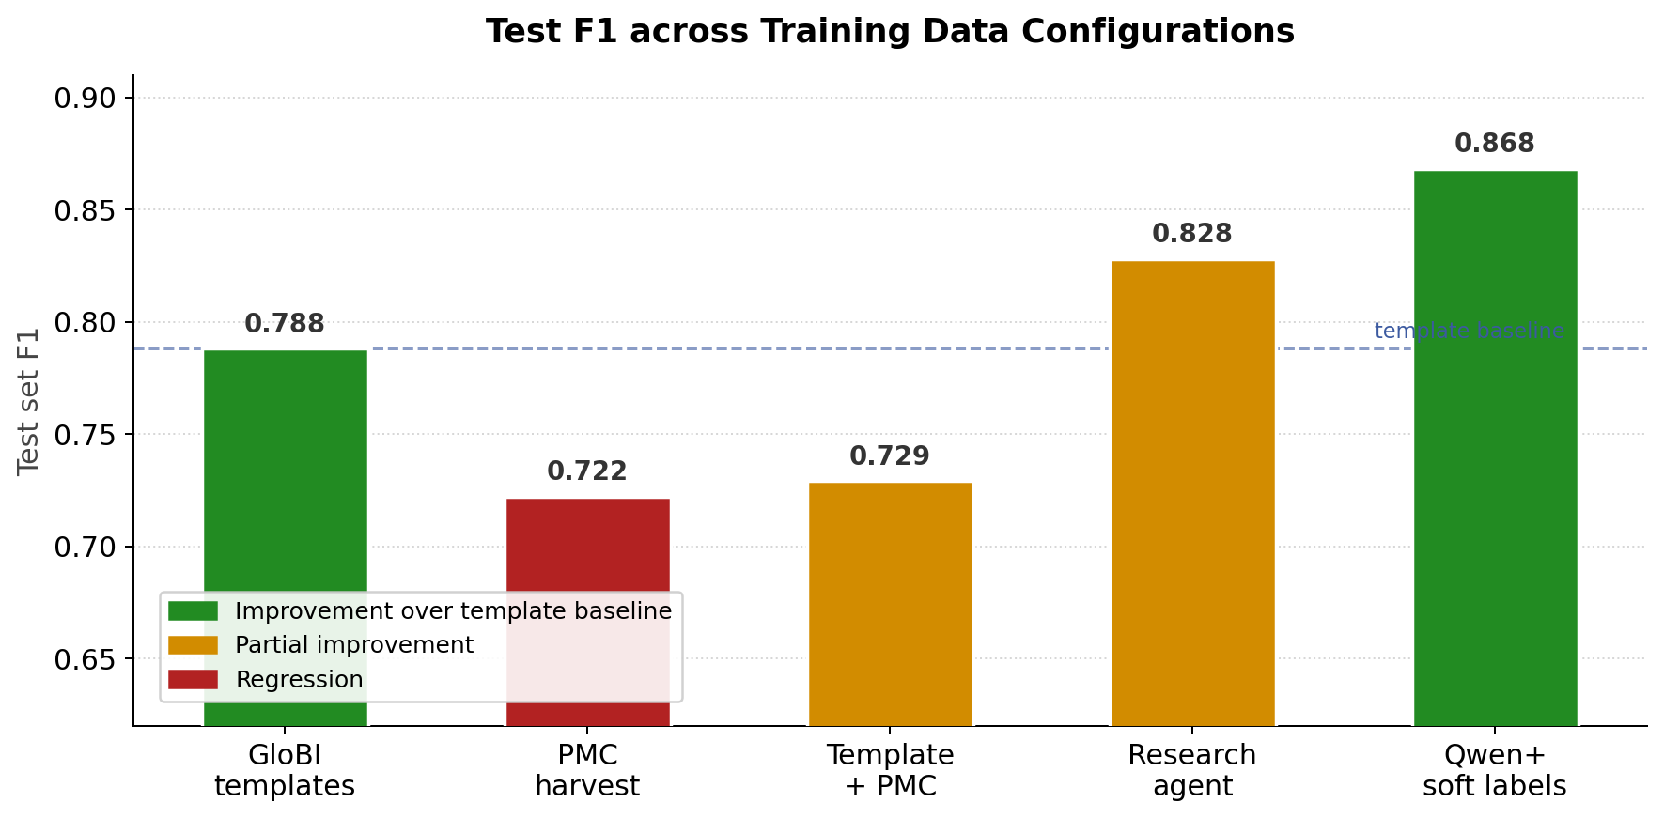
Test F1 across training data configurations. The rightmost bar (Qwen YES/NO labeling with ensemble soft labels) achieves the best result.

Model Architecture Evolution
We evaluated five approaches in order of increasing complexity.

Classical baselines.
SVM and Random Forest on TF-IDF features achieved F1 $≈$ 0.62, establishing the need for contextual representations.

Fine-tuned BiomedBERT.
We use the BiomedBERT model (Gu et al. 2021) (microsoft/BiomedNLP-BiomedBERT-base-uncased-abstract-fulltext), a BERT-base model (110M parameters, 12 transformer layers, 768-dimensional hidden states) pre-trained from scratch on PubMed abstracts and PubMed Central full-text articles. A linear classification head on the [CLS] token representation is fine-tuned using 5-fold cross-validation, AdamW optimiser ($η=2×{10}^{−5}$, weight decay = 0.01), and threshold optimisation on the validation split. BiomedBERT trained on the template-derived corpus achieves F1 = 0.788.

BiomedBERT $×$ FLAN-T5-base ensemble.
FLAN-T5-base (Chung et al. 2022), a sequence-to-sequence model trained with instruction tuning, was fine-tuned as a binary classifier by prompting for a yes/no answer and scoring the first generated token. The geometric mean of BiomedBERT and FLAN-T5-base predicted probabilities, with joint threshold optimisation, achieves F1 = 0.865. The gain is attributable to model complementarity: BiomedBERT handles precise, template-like language while FLAN-T5-base generalises better to paraphrased ecological sentences.
The two subsequent stages, knowledge distillation and multi-task NER, are described in Sections 2.4 and 2.5 respectively. Figure [fig:model_evolution] summarises the F1 progression across architecture stages.
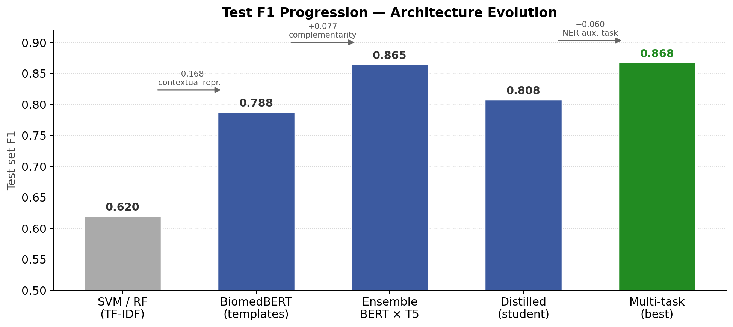

Knowledge Distillation
Knowledge distillation (Hinton, Vinyals, and Dean 2015) transfers calibrated uncertainty from a teacher to a student by training on soft probability distributions rather than hard labels (Buciluă, Caruana, and Niculescu-Mizil 2006). A teacher score of 0.7 instructs the student that a sentence is probably positive but not certain; the student is penalised for predicting 0.4, not merely for predicting the wrong class. This information transfer is especially valuable for borderline sentences.

Training objective.
The student BiomedBERT is trained using KL divergence against the ensemble teacher:
$$L_{\text{KL}}=T^{2}⋅KL​\left(σ(z_{s}/T) ∥ σ(z_{t}/T)\right)$$
where $T$ is the temperature, $z_{s}$ and $z_{t}$ are student and teacher logits, and $σ$ denotes the softmax function. Rows without soft labels use hard cross-entropy. The combined loss is $L=α⋅L_{\text{KL}}+(1−α)⋅L_{\text{CE}}$.
Optimal hyperparameters ($T=2$, $α=0.5$) were identified by grid search over six student configurations (Appendix 6). Temperature $T=2$ spreads the teacher distribution sufficiently to transfer calibrated uncertainty without over-smoothing. The best-performing student achieves F1 = 0.808, a gain of +0.020 over the single-task BiomedBERT baseline.

Multi-task BiomedBERT with NER Auxiliary Task

Architecture.
The BiomedBERT encoder is extended with two linear output heads that share all encoder weights:
- Classification head: reads the [CLS] token vector ($R^{768}→R^{2}$), produces $P(\text{interaction})$.
- NER head: reads every token vector ($R^{768}→R^{|L|}$), produces BIO label logits.

NER label scheme.
A gazetteer is a curated lookup dictionary of known entity names used for efficient dictionary-based recognition. We index $≈$4.2 million binomial species names plus 21K common names, matched against text via Aho-Corasick automata (Aho and Corasick 1975) for exact string lookup.
We use the full_typed scheme with $|L|=9$ labels: O (background), B/I-HOST (hosting organism), B/I-PATHOGEN (infecting or parasitic agent), B/I-SPECIES (ambiguous role in symmetric interactions), B/I-INT (interaction verb or phrase). In addition to species gazetteers, labeling relies on an interaction lexicon developed within SIBiLS (Gobeill et al. 2020), containing 591 terms derived from the GloBI relation ontology (ROBI), covering all interaction types indexed by BiotXplorer, supplemented by 50 biomedical terms for pathogen-host vocabulary not represented in ROBI. Gold species annotations from training metadata override gazetteer lookup when available.
Table [tab:ner_schemes] compares the four label schemes evaluated. The HOST/PATHOGEN distinction encodes the direction of the relation: who acts and who is acted upon. This directional labelling is motivated by the downstream KG construction task, where edge direction is semantically significant.
Scheme | # labels | Label set | Best test F1
basic | 3 | O, B/I-SPECIES | 0.841
typed | 5 | O, B/I-HOST, B/I-PATHOGEN | 0.852
full | 5 | O, B/I-SPECIES, B/I-INT | 0.854
full_typed | 9 | O, B/I-HOST, B/I-PATHOGEN, B/I-SPECIES, B/I-INT | 0.868

Two-phase training.
Training proceeds in two phases designed to avoid interference between the NER and classification objectives (Liu et al. 2019):
Phase 1: NER pre-train ($E_{\text{NER}}$ epochs).
The classification head is frozen. Only the encoder and NER head receive gradient updates from token-level cross-entropy loss $L_{\text{NER}}$. This phase primes the shared encoder to locate species names and interaction verbs before the classification signal is introduced.
Phase 2: Joint training ($E_{\text{joint}}$ epochs).
All parameters are unfrozen. Combined loss:
$$L=α⋅L_{\text{cls}}+(1−α)⋅L_{\text{NER}}$$
where $L_{\text{cls}}$ is soft KL divergence against ensemble soft labels when available, and hard CE otherwise.
We find that initialising Phase 1 from the best fine-tuned BiomedBERT checkpoint degrades performance (F1 = 0.862 vs. cold-start 0.868): NER gradient updates disrupt the task-specific representations built during classification fine-tuning, and the subsequent joint phase does not fully recover them. Cold-starting from the pretrained BiomedBERT weights is therefore preferred.

Evaluation Protocol
All models are evaluated on a 100-sentence test set (48 positive) drawn from ecological literature, curated with relaxed annotation criteria (any biotic interaction type accepted). The set has no overlap with training data. We report precision, recall, and F1-score.
Bootstrap confidence intervals are estimated with 10,000 resamples (Efron and Tibshirani 1993). Pairwise significance is assessed using McNemar’s test (McNemar 1947) with continuity correction. For each model, the decision threshold $τ$ is optimised on the validation split by sweeping $τ∈[0.05,0.95]$ and selecting the value maximising F1.
Model | F1 | P | R
Multi-task BiomedBERT (full_typed, $α$=0.5, 2 NER ep) | 0.868 | 0.793 | 0.958
Same arch., hard cross-entropy (soft label ablation) | 0.816 | 0.764 | 0.875
Distilled student (BiomedBERT, $T$=2, $α$=0.5) | 0.808 | 0.750 | 0.875
Ensemble BiomedBERT $×$ FLAN-T5-base | 0.865 | — | —
Fine-tuned BiomedBERT (single-task baseline) | 0.788 | — | —

Results

Multi-task Configuration Analysis
Table [tab:ablation] compares the best multi-task configuration against key baselines; the full sweep over all NER schemes, $α$ values, and pre-training epochs is given in Appendix 7.
Three consistent findings emerge from the analysis:

1. Soft labels are the largest single lever (+0.052 F1).
The hardce configuration uses the same architecture and data with hard cross-entropy labels and achieves F1 = 0.816. The soft-KL variant reaches 0.868: a difference of +0.052 F1, which is larger than any architectural change, including the multi-task NER head (+0.021).

2. NER pre-training is necessary.
Adding 2 NER pre-training epochs improves full_typed from 0.847 to 0.868. Extending joint training beyond 3 epochs causes performance to degrade (F1 = 0.816), confirming that a short joint phase after encoder priming is optimal.

3. Richer NER schemes perform better.
Performance increases consistently from basic (0.841) through typed (0.852) and full (0.854) to full_typed (0.868 with pre-training). The HOST/PATHOGEN distinction provides directional supervision that builds richer encoder representations than undifferentiated species tagging.

Statistical Significance
McNemar’s test (McNemar 1947) is appropriate for this comparison because predictions are binary (correct or incorrect per sentence), the models are evaluated on the same test examples (paired observations), and the test specifically targets prediction disagreements rather than assuming a continuous performance metric. Under the null hypothesis that two models commit errors on the same sentences, the reported $p$-value is the probability of observing prediction disagreements as extreme as those measured.
Figure 2 shows 95% bootstrap confidence intervals on the test set.
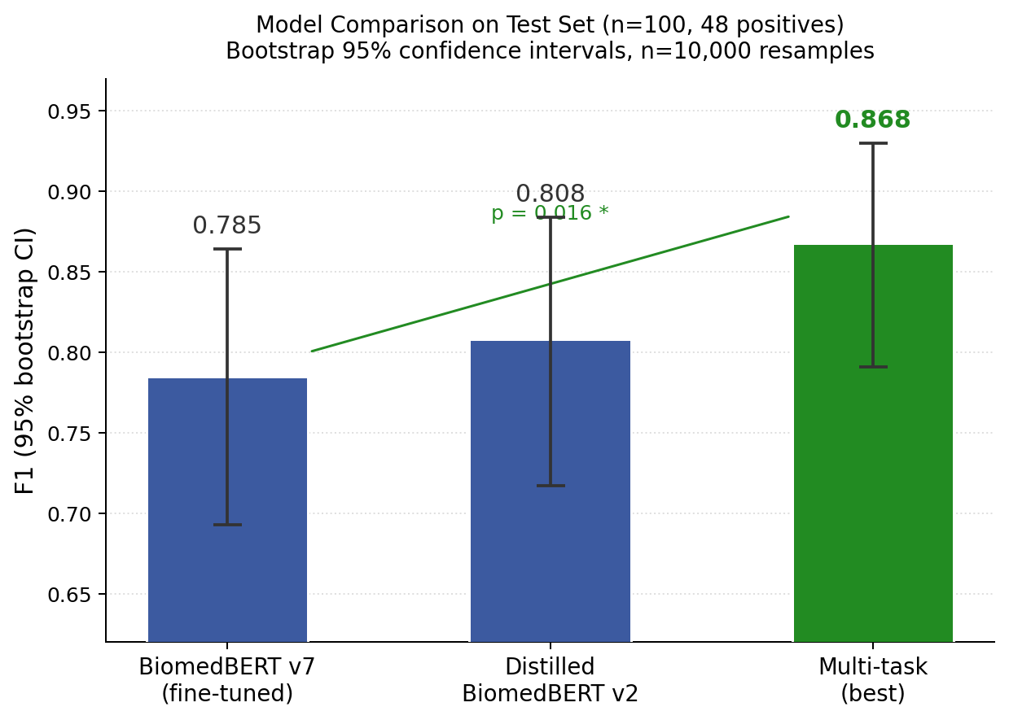
Bootstrap 95% confidence intervals for three models on the test set (n=100, 48 positives). The significance annotation refers to McNemar’s test between the multi-task model and the single-task baseline ($p=0.016$).
The multi-task model significantly outperforms the single-task BiomedBERT baseline ($p=0.016$): under the null hypothesis that both models commit the same prediction errors, the probability of observing prediction disagreements as extreme as those measured is 1.6%. The margin over the distilled student is not individually significant ($p=0.149$, 12 prediction disagreements), reflecting the limited statistical power of a 100-sentence test set. The 95% confidence intervals span approximately $±$0.06–0.07 F1; a test set of 500–1000 sentences would substantially narrow these intervals.
Threshold sensitivity and operating-point trade-offs are analysed in Appendix 8.

Distribution Mismatch
Figure [fig:distribution] reveals a structural mismatch between training and test interaction type distributions. The training corpus, harvested from PubMed-indexed articles, is dominated by predation (42%), herbivory (22%), and pollination (22%) sentences sourced via targeted PMC queries. Parasitism/Host interactions represent only 10% of training positives, and Pathogen/Infection only 3%, yet together these two types constitute 77% of test-set positives.
This mismatch reflects a structural property of the biomedical literature: ecological host-parasite field observations are published primarily in ecology journals (Web of Science, BioOne) that are not indexed by PubMed, while clinical and biomedical pathogen papers dominate PubMed’s open-access content. Importantly, this distributional gap is expected and desirable: a training corpus whose distribution closely matched the test set would raise concerns about data leakage or evaluation bias. The F1 = 0.868 reported here is achieved on a test set that is genuinely out-of-distribution relative to training, demonstrating real generalisation across interaction types. The gap identifies precisely where to invest in future data collection to break the F1 $≈$ 0.87 ceiling: harvesting from non-PubMed ecological literature to build a more representative and balanced corpus with broader coverage of parasitism and host-interaction types.
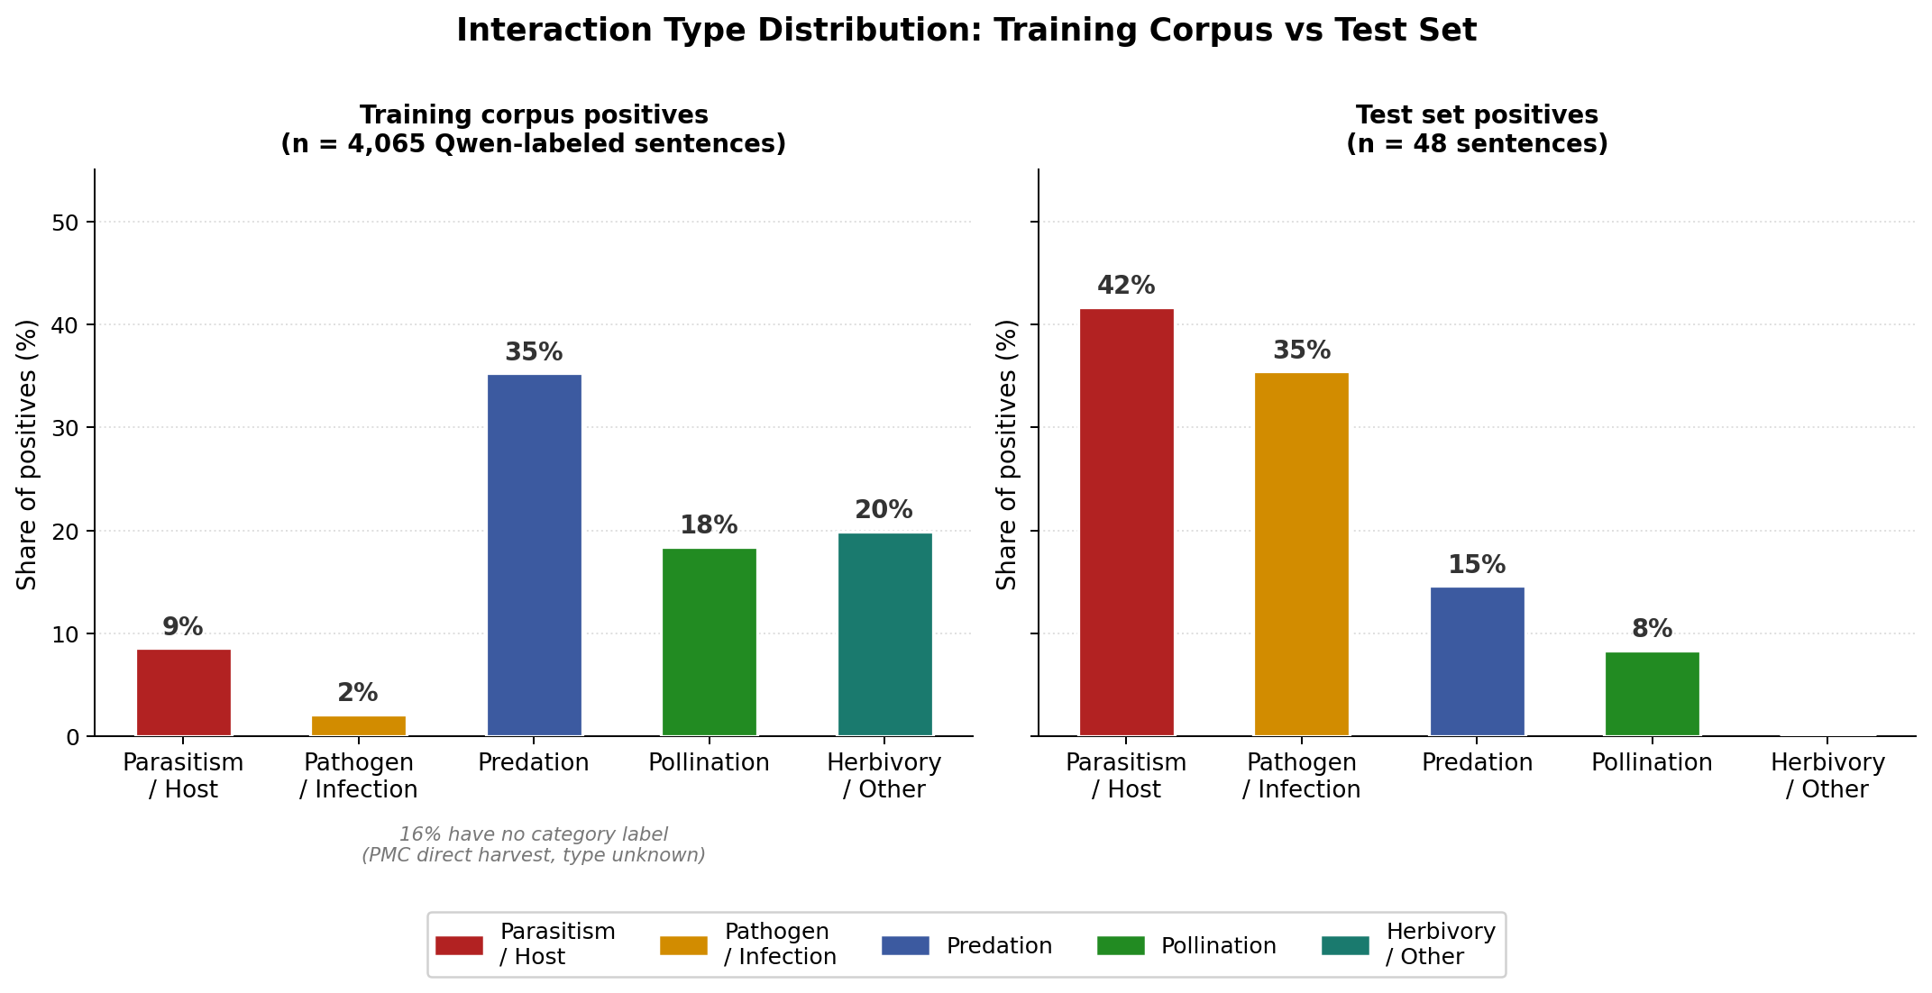

Discussion

Soft Labels as the Primary Driver of Improvement
The most actionable finding is that soft label supervision provides the largest performance gain of any intervention tested: +0.052 F1, more than the NER auxiliary task (+0.021) and more than switching from a single model to an ensemble (+0.077 cumulatively, but requiring 3.3$×$ inference cost). The mechanism is consistent with the knowledge distillation literature (Hinton, Vinyals, and Dean 2015; Tang et al. 2019): a teacher model that has been exposed to diverse linguistic expressions of interactions assigns calibrated probabilities to borderline sentences, encoding genuine semantic uncertainty that hard labels cannot represent.

NER as Zero-Cost Auxiliary Supervision
The NER auxiliary task improves classification without requiring any additional manually annotated data. BIO labels are derived automatically from species gazetteers and interaction lexicons, making this a form of distant supervision (Mintz et al. 2009). The improvement mechanism is indirect: NER pre-training updates the shared encoder to be more sensitive to species names and interaction verbs, producing richer [CLS] token representations for the classification head.
This approach is distinct from standard NER-augmented pipelines (Habibi et al. 2017) in which entity detection and relation classification are performed sequentially. Here, NER supervision modifies the encoder representations used for classification; the NER output itself is not used at inference time.

Utility for BiotXplorer and Knowledge Graph Construction
The classifier provides two concrete operational benefits for BiotXplorer. First, as an upstream filter, it eliminates sentences that merely co-mention species without describing an interaction, reducing index noise and improving search relevance. Second, the calibrated probability output allows the BiotXplorer platform to rank results by interaction confidence rather than simple keyword match, enabling more nuanced retrieval.
For downstream knowledge graph construction, the multi-task model’s NER labels provide additional structure at no extra cost: the HOST/PATHOGEN distinction produced by the NER head directly encodes the direction of the knowledge graph edge (who interacts with whom), enabling the downstream relation extractor to assign typed edges rather than undirected links. This is particularly relevant for pathogen-host and parasite-host pairs where edge direction is biologically meaningful.
A further downstream application is under active development in the context of the MetaPlantCode research project, which combines amplicon sequencing workflows with biodiversity knowledge graph querying. Amplicon sequencing pipelines produce a ranked species list for a given environmental sample; the interaction knowledge indexed by BiotXplorer can then be used to support ecological coherence re-ranking of that list. A species with many known interaction partners also present in the same sample is ecologically more plausible than an isolated detection, providing prior probability weighting for species identification from environmental DNA. This application represents a direct integration of the classifier into a biodiversity field survey context and is planned for evaluation prior to manuscript submission.

The PubMed Distribution Ceiling
The distribution mismatch analysis identifies a concrete obstacle to improvement: parasitism/host and pathogen/infection interactions account for 77% of test-set positives but fewer than 13% of training positives. These sentence types cannot be reliably harvested from PubMed because the relevant literature (field ecology, ecological entomology, parasitology monographs) is predominantly published in journals not indexed by PubMed.
The path beyond F1 $≈$ 0.87 requires harvesting sentences from non-PubMed ecological literature, re-running the Qwen3.5-122B annotation pipeline, and updating the ensemble soft labels on the expanded corpus. This is a data problem, not a modelling problem: the current architecture can accommodate improved training data without modification.

Limitations
- Test set size. 100 sentences yields 95% CIs of $±$0.06–0.07 F1. Most pairwise model comparisons are not individually significant; a test set of 500–1000 sentences is needed for publication-quality model selection.
- Binary classification. The classifier detects interactions but does not classify interaction type. Downstream relation extraction is needed to produce typed knowledge graph edges.
- English only. Training and evaluation are exclusively English-language.

Conclusion
We have presented a multi-task BiomedBERT classifier for sentence-level biotic interaction detection that achieves F1 = 0.868 on an ecological test set. The model is built on three components: a two-stage teacher chain that combines large-LLM binary annotation with ensemble soft probability distillation; a multi-task NER auxiliary task that primes the shared encoder at zero additional annotation cost; and a two-phase training protocol that separates entity-level supervision from joint optimisation.
The central quantitative finding is that soft labels are the single most impactful intervention in the pipeline, contributing +0.052 F1 on identical architecture and data. The current performance ceiling at F1 $≈$ 0.87 is explained by a structural distribution mismatch between PubMed-sourced training data and the ecological interaction types dominant in the test set, pointing directly to the data collection strategy needed to break this ceiling.
The classifier is deployed in BiotXplorer (https://biotxplorer.sibils.org/) as an upstream quality filter and constitutes the first component of a knowledge graph construction pipeline for biodiversity and host-pathogen interactions. Future work will address: (1) harvesting from non-PubMed ecological literature to expand training coverage of parasitism and host-interaction types; (2) typed relation extraction to produce directed knowledge graph triples; (3) integration with amplicon sequencing species detection for automated interaction retrieval from biodiversity field surveys.

Ethics Statement
This work raises no ethical concerns. Training data consists of sentences automatically extracted from open-access scientific literature and labeled by automated models; no personal data was collected or used. The classifier is designed to support literature mining for biodiversity knowledge graph construction and carries no foreseeable potential for misuse.

Data and Code Availability
Training code, evaluation scripts, and the test set are available at https://github.com/ecsltae/biotic-interaction-classifier. Model weights can be reproduced from the provided training configuration.

Knowledge Distillation Hyperparameter Search
Full distillation hyperparameter grid. All variants use BiomedBERT as student model except v4 (DistilBERT) and v5 (SciBERT).
Student | $T$ | $α$ | Test F1
v1 BiomedBERT | 4 | 0.7 | 0.785
v2 BiomedBERT (best) | 2 | 0.5 | 0.808
v3 BiomedBERT | 4 | 0.9 | 0.808
v4 DistilBERT | 2 | 0.5 | 0.792
v5 SciBERT | 2 | 0.5 | 0.793
v6 BiomedBERT ($T=1.5$) | 1.5 | 0.5 | 0.779

Full Multi-task Configuration Analysis
All multi-task configurations evaluated on the test set (100 sentences, 48 positives). NER pt = NER pre-train epochs before joint training. All configurations use soft labels except hardce.
Config | NER scheme | $α$ | NER pt | F1 | P | R
basic_a05 | basic | 0.5 | 0 | 0.841 | 0.763 | 0.938
typed_a05 | typed | 0.5 | 0 | 0.852 | 0.767 | 0.958
full_a03 | full | 0.3 | 0 | 0.854 | 0.854 | 0.854
full_typed_a05 | full_typed | 0.5 | 0 | 0.847 | 0.746 | 0.979
full_a05_ner2 | full | 0.5 | 2 | 0.824 | 0.778 | 0.875
full_typed_a03_ner2 | full_typed | 0.3 | 2 | 0.830 | 0.759 | 0.917
full_typed_a05_ner2 | full_typed | 0.5 | 2 | 0.868 | 0.793 | 0.958
full_typed (5 joint ep) | full_typed | 0.5 | 2+5 | 0.816 | 0.764 | 0.875
hardce (same arch.) | full_typed | 0.5 | 2 | 0.816 | 0.764 | 0.875
distilled student | — | — | — | 0.808 | 0.750 | 0.875
Ensemble BERT$×$T5 | — | — | — | 0.865 | — | —

Threshold Analysis
Figure 3 shows precision, recall, and F1 as a function of the decision threshold on the test set.
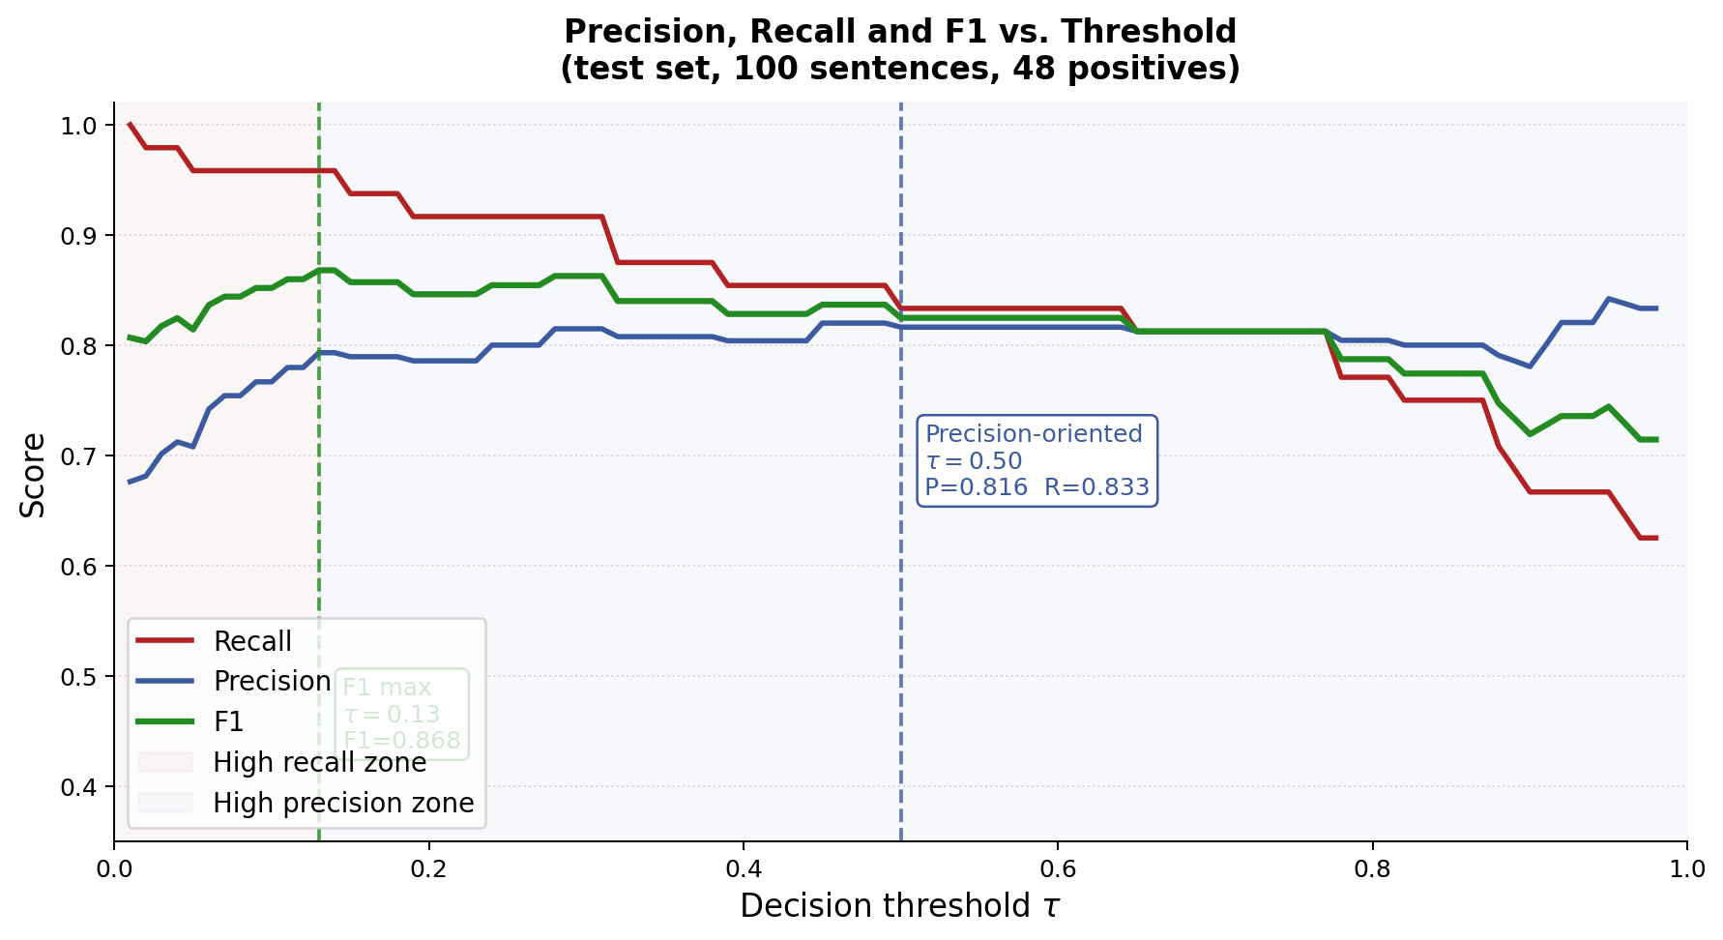
Precision, recall, and F1 versus decision threshold. The F1-optimal threshold ($τ=0.13$) and a precision-oriented threshold ($τ=0.50$) are annotated.
The F1-optimal threshold ($τ=0.13$) is lower than typical because the model is calibrated conservatively: genuine interactions score predominantly in the range 0.3–0.7 rather than near 1.0. The curve shows high and relatively stable F1 across $τ≈0.10$–$0.45$, after which recall drops as an increasing fraction of true positives fall below the threshold. For applications where false positives entering a knowledge base are costly, operating at $τ=0.50$ reduces false positives from 12 to 9 at the cost of 6 additional missed interactions (P = 0.816, R = 0.833). The threshold curve makes this precision-recall trade-off explicitly visible and allows operators to choose the operating point appropriate to their downstream task.
Aho, Alfred V, and Margaret J Corasick. 1975. “Efficient String Matching: An Aid to Bibliographic Search.” Communications of the ACM 18 (6): 333–40.
Badenes-Pérez, Francisco R, Francisco Ponce-Gordo, and Lucila Cano-Maque. 2020. “Detecting Biotic Interactions in the Literature.” Ecological Indicators 119: 106876.
Buciluă, Cristian, Rich Caruana, and Alexandru Niculescu-Mizil. 2006. “Model Compression,” 535–41.
Bunescu, Razvan C, Ruifang Ge, Rohit J Kate, Edward M Marcotte, Raymond J Mooney, Arun K Ramani, and Yuk Wah Wong. 2005. “A Comparative Study of Kernels for Protein-Protein Interaction Extraction.” In Proceedings of the Smbm.
Chen, Huajun, Wen Zhang, and Ningyu Zhang. 2023. “Knowledge Graphs for Biodiversity: Challenges and Opportunities.” Briefings in Bioinformatics 24 (3).
Chung, Hyung Won, Le Hou, Shayne Longpre, Barret Zoph, Yi Tay, William Fedus, Eric Li, et al. 2022. “Scaling Instruction-Finetuned Language Models.” arXiv Preprint arXiv:2210.11416.
Efron, Bradley, and Robert J Tibshirani. 1993. An Introduction to the Bootstrap. Chapman & Hall.
Gobeill, Julien, Déborah Caucheteur, Pierre-André Michel, Luc Mottin, Emilie Pasche, and Patrick Ruch. 2020. “SIB Literature Services: RESTful Customizable Search Engines in Biomedical Literature, Enriched with Automatically Mapped Biomedical Concepts.” Nucleic Acids Research 48 (W1): W12–W16.
Gu, Yu, Robert Tinn, Hao Cheng, Michael Lucas, Naoto Usuyama, Xiaodong Liu, Tristan Naumann, Jianfeng Gao, and Jinfeng Peng. 2021. “Domain-Specific Language Model Pretraining for Biomedical Natural Language Processing.” ACM Transactions on Computing for Healthcare 3 (1): 1–23.
Habibi, Maryam, Leon Weber, Mariana Neves, David L Wiegandt, and Ulf Leser. 2017. “Deep Learning with Word Embeddings Improves Biomedical Named Entity Recognition.” In Bioinformatics, 33:i37–i48. 14.
Hinton, Geoffrey, Oriol Vinyals, and Jeff Dean. 2015. “Distilling the Knowledge in a Neural Network.” In NIPS Deep Learning and Representation Learning Workshop.
Lim, Sangrak, Kyubum Lee, Kihyun Choi, and Jaewoo Kang. 2018. “Drug-Drug Interaction Extraction from the Literature Using a Recursive Neural Network.” PloS ONE 13 (1): e0190926.
Liu, Xiaodong, Pengcheng He, Weizhu Chen, and Jianfeng Gao. 2019. “Multi-Task Deep Neural Networks for Natural Language Understanding.” In Proceedings of Acl, 4487–96.
McNemar, Quinn. 1947. “Note on the Sampling Error of the Difference Between Correlated Proportions or Percentages.” Psychometrika 12 (2): 153–57.
Mintz, Mike, Steven Bills, Rion Snow, and Dan Jurafsky. 2009. “Distant Supervision for Relation Extraction Without Labeled Data,” 1003–11.
Pasche, Emilie, Julien Gobeill, Donat Agosti, Lyubomir Penev, Quentin Groom, Teodor Georgiev, Esteban Gaillac, et al. 2023. “From SIBiLS to Biodiversity PMC: Foundations for the One Health Library.” Biodiversity Information Science and Standards 7: e111660. https://doi.org/10.3897/biss.7.111660.
Poelen, Jorrit H, James D Simons, and Chris J Mungall. 2014. “Global Biotic Interactions: An Open Infrastructure to Share and Analyze Species-Interaction Datasets.” Ecological Informatics 24: 148–59.
Poisot, Timothée, Gabriel Bergeron, Kevin Cazelles, Tad Dallas, Dominique Gravel, Andrew MacDonald, Benjamin Mercier, Clément Violet, and Steve Vissault. 2021. “Global Knowledge Gaps in Species Interaction Networks Data.” Journal of Biogeography 48 (7): 1552–63.
Ruch, Patrick, Emilie Pasche, Pierre-André Michel, and Déborah Caucheteur. 2024. “BiotXplorer: Navigating Evidence-Based Biotic Interactions.” Biodiversity Information Science and Standards 8: e135453. https://doi.org/10.3897/biss.8.135453.
Tang, Raphael, Yao Lu, Linqing Liu, Lili Mou, Olga Vechtomova, and Jimmy Lin. 2019. “Distilling Task-Specific Knowledge from BERT into Simple Neural Networks.” arXiv Preprint arXiv:1903.12136.

