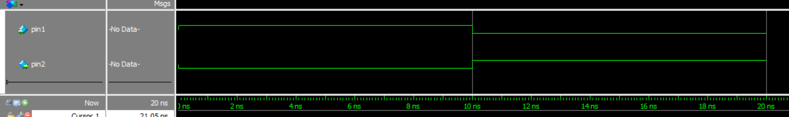NOT (7404):

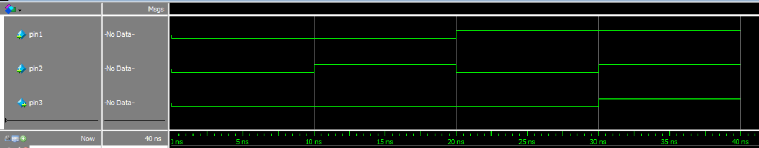AND (7408)

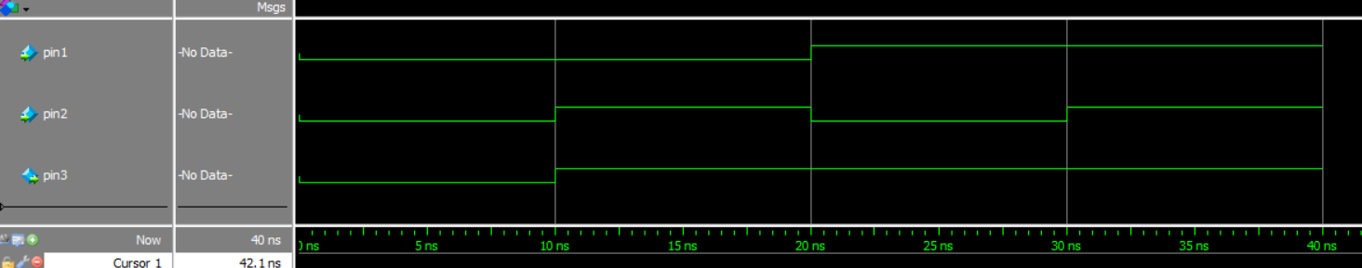OR (7432):

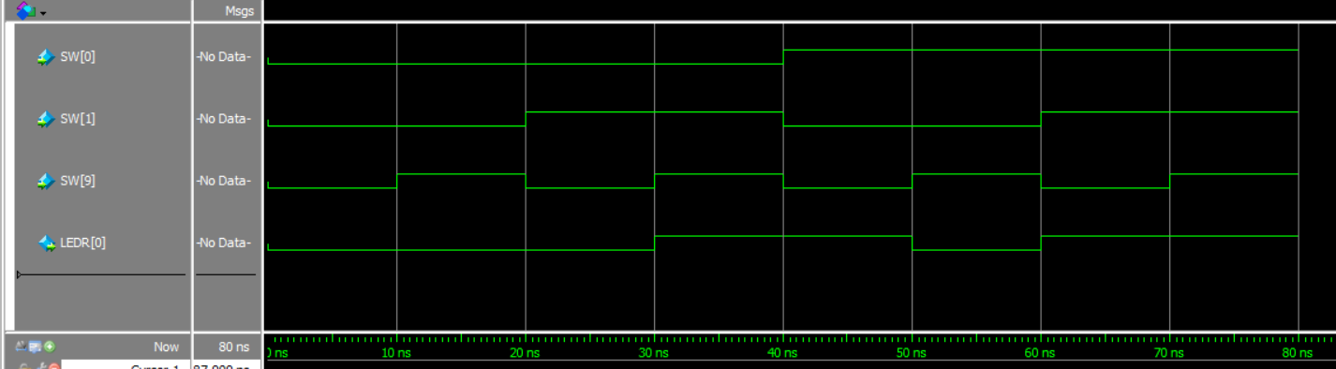Part II:

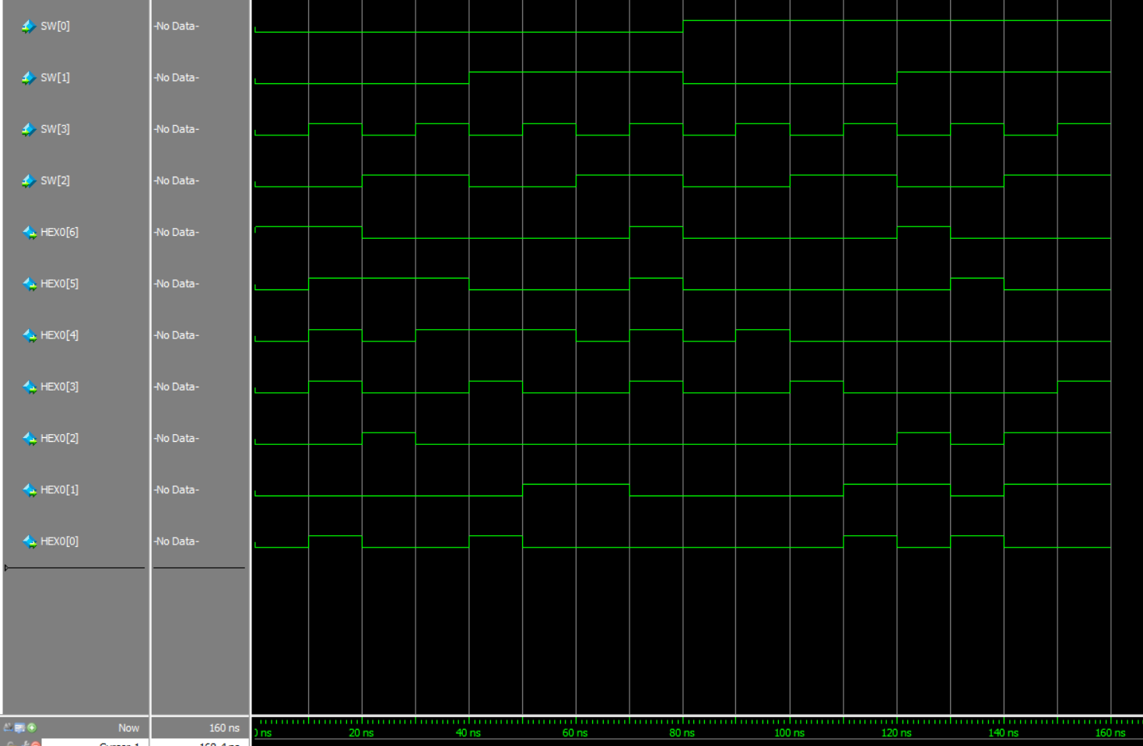Part III: