Andrew Zourob
Program 1
CIS 427

Readme:

Functions implemented:
- Query: Used for the client to retrieve the sequence numbers of the Alice in Wonderland input text file.
Running instructions:
- Open MCPServer and MCPClient project's in netbeans IDE 8.1
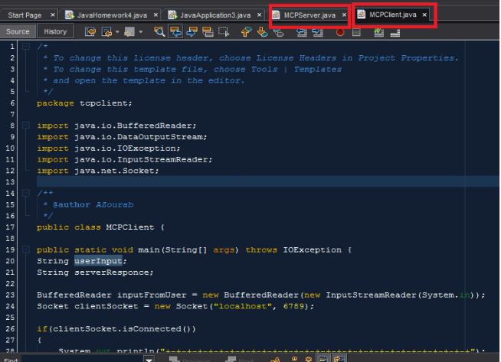
- Select MCPServer project and hit the green arrow at the top to start the server. You will notice the bar say running at the bottom right
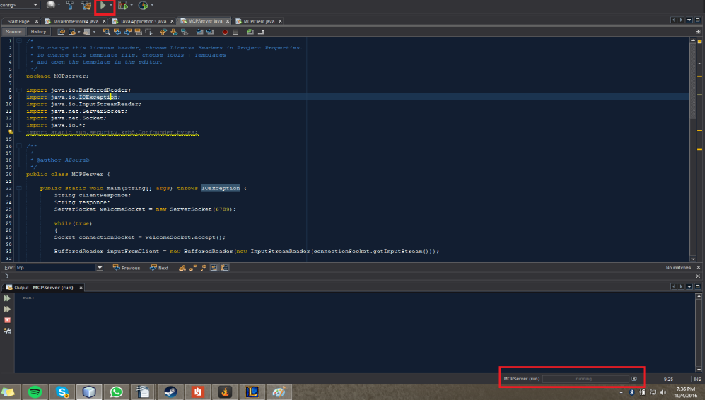
- Select the MCPClient program now and hit the green arrow at the top to start the client. If the connection was successful you will see the message. And again notice the bar at the bottom right to ensure it is running.
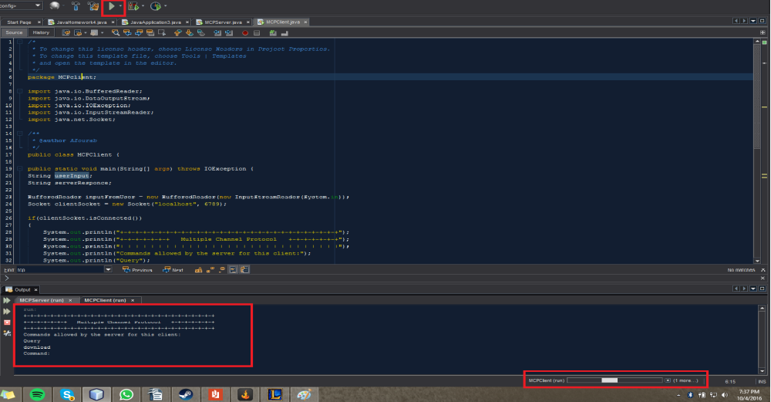
- In the output window for MCPCerver next to command: click and type in query then hit enter. The program will then execute the command.
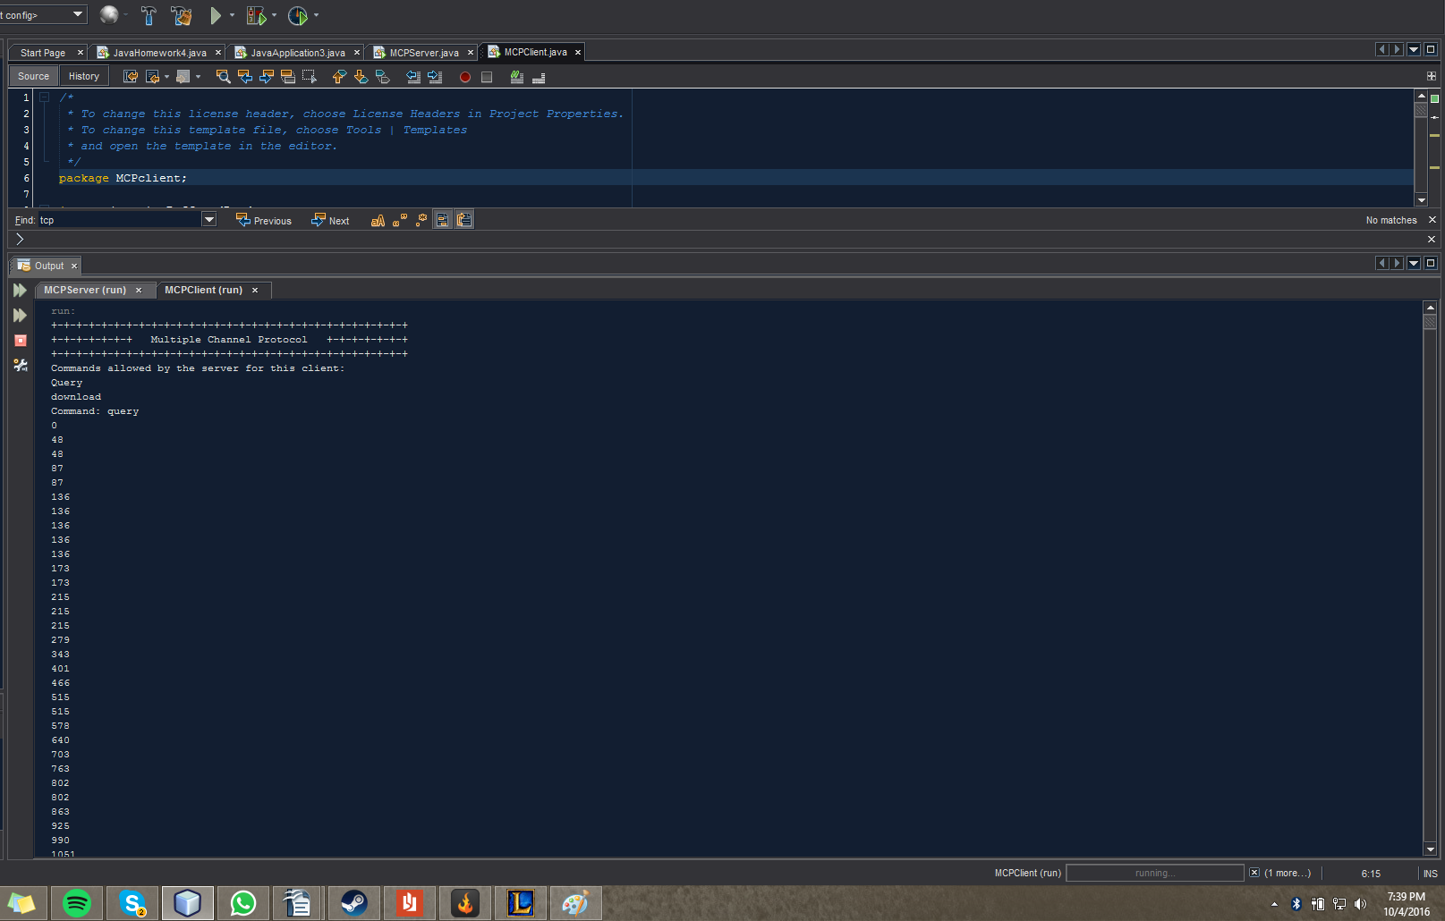
Known bugs:
- N/A

