Andrew Zourob
Program 1 Report
CIS 427

Contributions:

Done Alone by: Andrew Zourob – Programming and Documentation

Testing / Screenshots:

The first screenshot attached is of me running the program then using the query as my command. The screenshot has my name and the time and date enclosed in the red box, this just shows the beginning of the program where it has the welcome message as long as the first few responces.

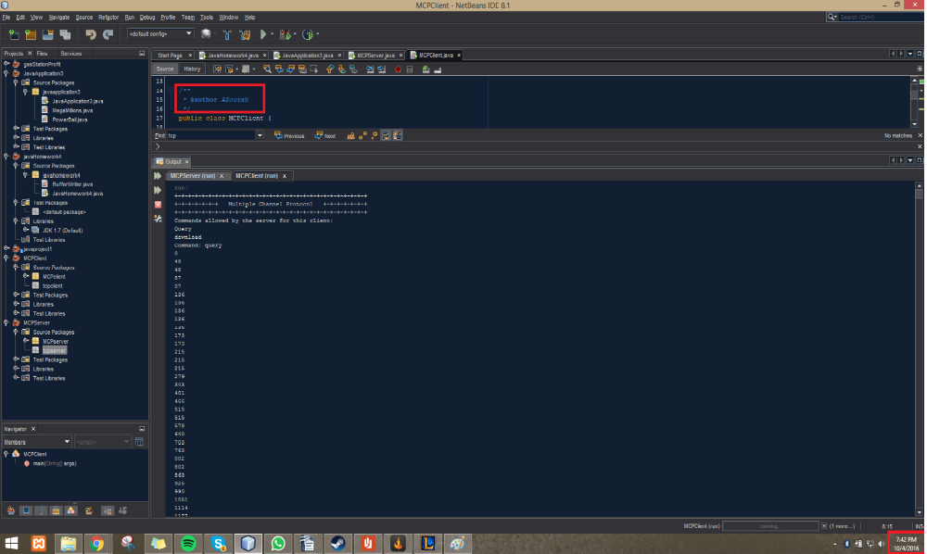

The Second screenshot shows has my name and the date and time enclosed in the red boxes. This shows the end of the program where it ends after completing the query command.
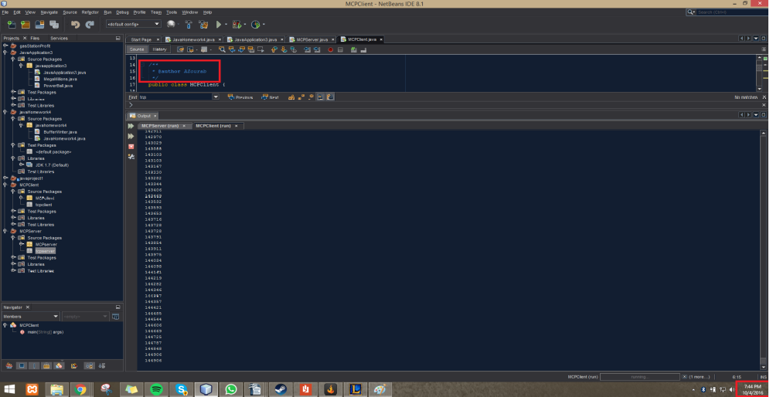

Source Code:

MCPClient:
package MCPclient;

import java.io.BufferedReader;
import java.io.DataOutputStream;
import java.io.IOException;
import java.io.InputStreamReader;
import java.net.Socket;

/**
* @author AZourab
*/
public class MCPClient {

public static void main(String[] args) throws IOException {
String userInput;
String serverResponce;

BufferedReader inputFromUser = new BufferedReader(new InputStreamReader(System.in));
Socket clientSocket = new Socket("localhost", 6789);

if(clientSocket.isConnected())
{
System.out.println("+-+-+-+-+-+-+-+-+-+-+-+-+-+-+-+-+-+-+-+-+-+-+-+-+-+-+-+-+");
System.out.println("+-+-+-+-+-+-+ Multiple Channel Protocol +-+-+-+-+-+-+");
System.out.println("+-+-+-+-+-+-+-+-+-+-+-+-+-+-+-+-+-+-+-+-+-+-+-+-+-+-+-+-+");
System.out.println("Commands allowed by the server for this client:");
System.out.println("Query");
System.out.println("download");
System.out.print("Command: ");

while(true)
{
DataOutputStream outputToServer = new DataOutputStream(clientSocket.getOutputStream());
//outToServer.writeBytes(Choice);
BufferedReader inputFromServer = new BufferedReader(new InputStreamReader(clientSocket.getInputStream()));
userInput = inputFromUser.readLine();
outputToServer.writeBytes(userInput + '\n');
while(true)
{
serverResponce = inputFromServer.readLine();
System.out.println(serverResponce);
if("END".equals(serverResponce))
break;
}
clientSocket.close();
}
}

}
}

MCPServer:
package MCPserver;

import java.io.BufferedReader;
import java.io.IOException;
import java.io.InputStreamReader;
import java.net.ServerSocket;
import java.net.Socket;
import java.io.*;
import static sun.security.krb5.Confounder.bytes;

/**
*
* @author AZourab
*/
public class MCPServer {

public static void main(String[] args) throws IOException {
String clientResponce;
String responce;
ServerSocket welcomeSocket = new ServerSocket(6789);

while(true)
{
Socket connectionSocket = welcomeSocket.accept();

BufferedReader inputFromClient = new BufferedReader(new InputStreamReader(connectionSocket.getInputStream()));

DataOutputStream outputToClient = new DataOutputStream(connectionSocket.getOutputStream());

clientResponce = inputFromClient.readLine();

if("query".equals(clientResponce))
{
// Open the file
FileInputStream fstream = new FileInputStream("alice.txt");
BufferedReader br = new BufferedReader(new InputStreamReader(fstream));
String strLine;
byte[] byteCounter;
int byteTotalCounter = 0;
int bytes = 0;

//Read File Line By Line
while ((strLine = br.readLine()) != null) {

responce = Integer.toString(byteTotalCounter) + '\n';
outputToClient.writeBytes(responce);

//increase sequence number
byteCounter = strLine.getBytes();
bytes = byteCounter.length;
byteTotalCounter = byteTotalCounter + bytes;

}

// byte[] bytes = null;
// bytes = strLine.getBytes().length;
//outToClient.write(bytes);
//System.out.print("Its the IF " + clientSentence + " " + phrase.getBytes().length);
}
else if("download".equals(clientResponce))
{
outputToClient.writeBytes("You choose download");
//System.out.print("its the if else " + clientSentence );
}
else
{
// System.out.print("its the else" + clientSentence);
}
}
}

}

