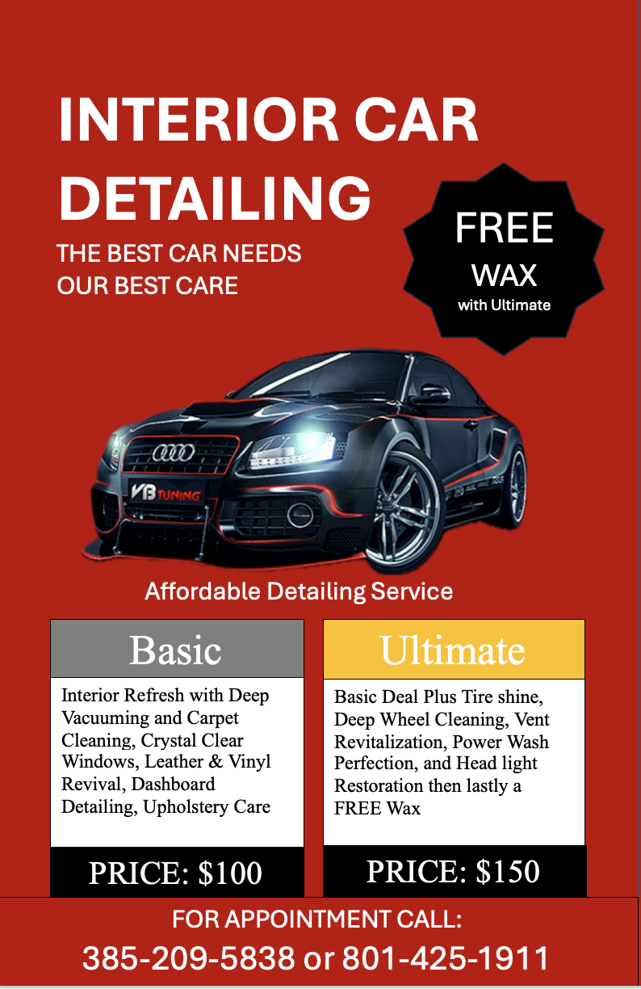**INTERIOR CAR**

**DETAILING**

FREE WAX

with Ultimate

THE BEST CAR NEEDS

OUR BEST CARE

Affordable Detailing Service

Basic

Ultimate

Interior Refresh with Deep Vacuuming and Carpet Cleaning, Crystal Clear Windows, Leather & Vinyl Revival, Dashboard Detailing, Upholstery Care

Basic Deal Plus Tire shine, Deep Wheel Cleaning, Vent Revitalization, Power Wash Perfection, and Head light Restoration then lastly a FREE Wax

FOR APPOINTMENT CALL:

385-209-5838 or 801-425-1911

PRICE: $150

PRICE: $100