The degree of precipitation uncertainty across multiple precipitation products is evaluated for a large set of landslide-triggering storm events across North America. The impact of precipitation uncertainties on the identification of landslides is investigated using published intensity-duration thresholds. To the right, darker circles above threshold lines indicate correctly identified landslides.

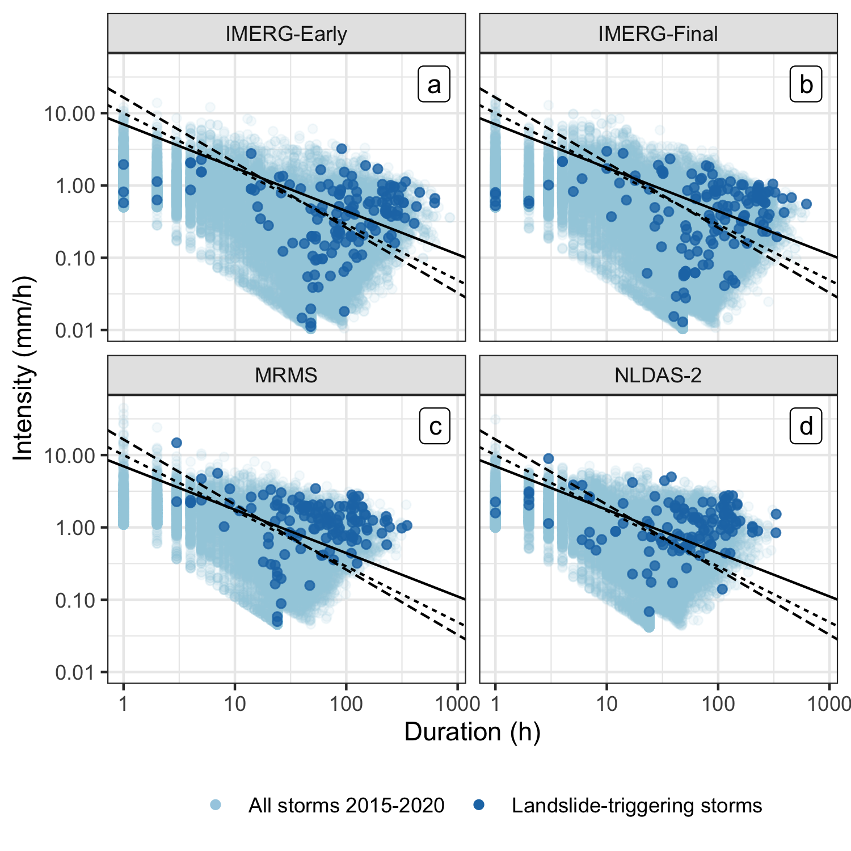

**A Multi-sensor Evaluation of Precipitation Uncertainty for Landslide-triggering Storm Events**

Elsa S. Culler*

Andrew M. Badger

J. Toby Minear

Kristy F. Tiampo

Spencer D. Zeigler

Ben Livneh