The degree of uncertainty across multiple precipitation products is evaluated for 228 landslide-triggering storm events across North America. Estimates of storm magnitudes varied by as much as 296 mm with an average range of 51 mm. Products more reliant upon ground-based observations (MRMS and NLDAS-2) were better at identifying landslides according to published intensity-duration storm thresholds (see figure). We recommend practitioners consider low-latency products and would be well-served considering more than one product as a way to confirm intense storm signals.

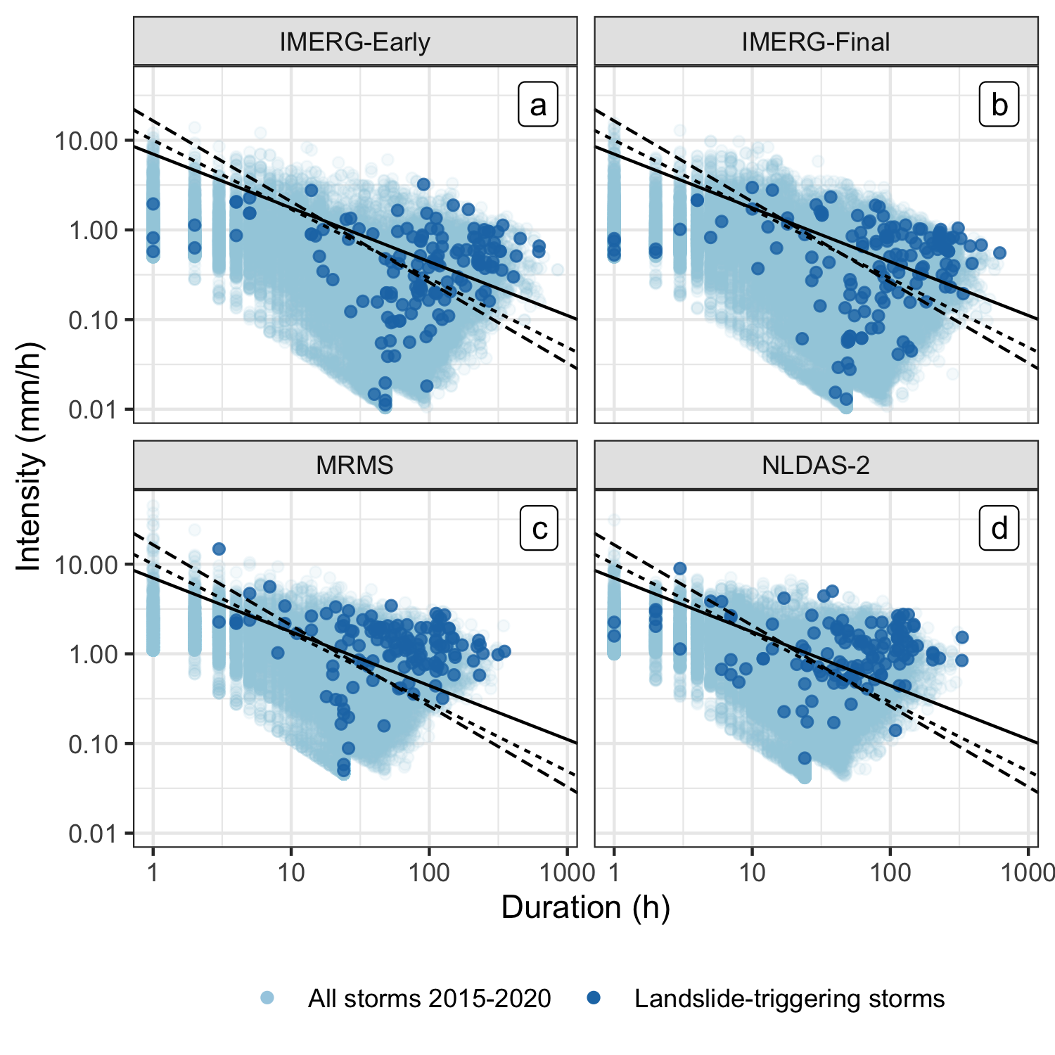

**A Multi-sensor Evaluation of Precipitation Uncertainty for Landslide-triggering Storm Events**

Elsa S. Culler*

Andrew M. Badger

J. Toby Minear

Kristy F. Tiampo

Spencer D. Zeigler

Ben Livneh